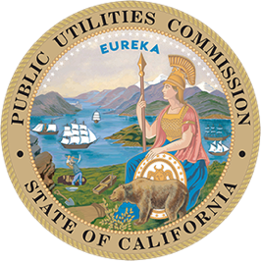
California Public Utilities Commission
505 Van Ness Ave., San Francisco

_________________________________________________________________________________
FOR IMMEDIATE RELEASE MEDIA ADVISORY
Media Contact: Terrie Prosper, 415.703.1366, news@cpuc.ca.gov Docket #: A.25-03-016;
A.25-03-017

CPUC to Hold Public Forums on Keene Water System

SAN FRANCISCO, February 2, 2026 – The California Public Utilities Commission (CPUC) will hold in-person Public Forums for customers of Keene Water System to provide feedback on the company’s rates request and the application for the company to be relieved of its water service obligations.
When: March 3, 2026, 2 p.m. and 6 p.m.
Where: Tehachapi Police Department Community Room, 220 W. C St., Tehachapi, CA 93561
About the Proceeding
To stay in operation, Keene Water System in Kern County contends it must raise revenue by more than 500 percent compared to 2024, meaning residential ratepayers could see an average increase of $860 per month while others with larger meters could experience larger increases. The other option is to be relieved of its public utility status and water service obligations. Applications for a rate change and to be relieved of its public utility status are both pending before the CPUC. These Public Forums seek customer feedback on both issues.
While a quorum of Commissioners may attend, no official action will be taken at the Public Forums.

Accommodations
If specialized accommodations are needed to attend, such as non-English or American Sign Language interpreters, please contact the CPUC’s Public Advisor’s Office at least five business days in advance of the Public Forum:
- Email: public.advisor@cpuc.ca.gov
- Toll free phone: 866-849-8390
More Information
- Ruling setting the Public Forums
- Proceeding Documents and Public Comment Portal (Docket Card)
- Public Forum Webpage
- Sign up to receive electronic updates on CPUC proceedings
###
About the California Public Utilities Commission
The CPUC regulates services and utilities, protects consumers, safeguards the environment, and assures Californians access to safe and reliable utility infrastructure and services. Visit www.cpuc.ca.gov for more information.

