February 13, 2026 | Proposed Resolution W-5313
 | Agenda ID: 24030
To: All Interested Persons

Enclosed is Proposed Resolution W-5313 of the Water Division, which authorizes Sonora Water Resources' general rate increase, producing additional annual revenues of $194,619, or 56.05% over two years, test year 2026 and escalation year 2027, to be paid by the ratepayers. Proposed Resolution W-5313 is scheduled to appear on the DATE Commission Meeting Agenda (ID#24030).

The Commission may act on this resolution, or it may postpone action until later. When the Commission acts on a proposed resolution, the Commission may adopt all or part of the proposed resolution, as written, or amend or modify the proposed resolution; or the Commission may set the proposed resolution aside and prepare a different resolution. Only when the Commission acts does the resolution become binding.

Interested persons may submit comments on Proposed Resolution W-5313 via email to Water.Division@cpuc.ca.gov on or before March 5, 2026. Please reference “Proposed Resolution W-5313” in the subject line.

Interested persons must also serve a copy of their comments on the utility on the same date that the comments are submitted to the Water Division. If email is unavailable, please submit comments to:

California Public Utilities Commission
Water Division
505 Van Ness Avenue, Third Floor
San Francisco, CA 94102

Comments should focus on factual, legal, technical errors, or policy issues in the proposed resolution.

Persons interested in receiving comments submitted may contact the Water Division at Water.Division@cpuc.ca.gov or (415) 703-1133. Please reference “Proposed Resolution W-5313.”

/s/TERENCE SHIA
Terence Shia, Director
Water Division

Enclosures: Proposed Resolution W-5313
Certificate of Service

PUBLIC UTILITIES COMMISSION OF THE STATE OF CALIFORNIA
WATER DIVISION | RESOLUTION W-5313
 | March 19, 2026

R E S O L U T I O N
Resolution W-5313 Sonora Water Resources General Rate Case
PROPOSED OUTCOME:
- Grants Sonora Water Resources (SWR) a general rate increase of $194,619, or 56.05%, estimated to provide a Rate of Margin (ROM) of 27.50%.
- This rate increase is phased in over two years: Test Year (TY) 2026, and Escalation Year (EY) 2027.
SAFETY CONSIDERATIONS:
- SWR has no major outstanding compliance issues with the State Water Resources Control Board, Division of Drinking Water.
- This general rate increase provides additional funding to SWR to ensure the utility remains current with its infrastructure updates and system repairs
ESTIMATED COST:
- Producing an increase in gross annual revenues of $97,310, or 28.02%, for test year 2026, and an increase of $97,310, or 21.89%, for escalation year 2027.
By Advice Letter 90-W, Filed on August 6, 2025

SUMMARY
By Advice Letter (AL) No. 90-W, filed on August 6, 2025, Sonora Water Resources (Sonora) seeks a general rate increase producing additional annual revenues of $220,700, or 63.56%, based on a Rate of Margin (ROM) of 27.50%, for Test Year (TY) 2025.
This Resolution grants Sonora a general rate increase, producing additional annual revenues of $194,619, or 56.05%, based on a ROM of 27.50%. In order to minimize the proposed rate increase, this increase will be phased in over two years. This increase will be split evenly to produce additional revenues of $97,310, or 28.02%, based on a ROM of 15.72% for TY 2026 and additional revenues of $97,310 for EY 2027, or 21.89%, based on a ROM of 27.50%.
The monthly bill for an average residential customer with a 5/8 x 3/4-inch metered rate service using 11.7 hundred cubic feet (CCF) will increase from $121.00 to $150.26, or 24.18%, for TY 2026, and to $179.51, or 19.47% for EY 2027.

BACKGROUND
By submission of AL 90-W to the WD, Sonora requested authority under General Order (GO) 96-B, Rule 1.7 and 7.6.2, Water Industry Rules 7.3.3(5), and Section 454 of the Public Utilities Code to increase its annual revenues by $220,794, or 63.5% for TY 2026 based on a ROM of 27.50%.
Sonora’s present rates became effective on May 7, 2025, with the approval of AL 89-W, which authorized a Consumer Price Index (CPI) increase of $53,760 or 6.5%. Sonora’s last GRC increase became effective on January 13, 2022, pursuant to Res. W-5249, which authorized a general rate increase $56,232, or 20.95% for TY 2021 based on an authorized ROM of 24.00%.
Sonora is a Class D investor-owned water utility with 146 service connections consisting of 146 retail customers in Tuolumne County. Sonora’s service area is located at Fairway Acres and vicinity, located approximately one mile east of Jamestown in Tuolumne County. The median household income (MHI) for Tuolumne County is $72,259.
Sonora’s source of water supply is entirely purchased water from Tuolumne Utilities District (TUD). TUD water is received through an interconnection in the Mill Villa Estates (MVE) mobile home subdivision and delivered to a storage tank, where gravity feeds water to the rest of the system, as noted below

Tank Name | Capacity Gallons | Year Built | Last Cleaned & Inspected | Material
100,000-gallon bolted steel tank | 100,000 (93,000 gallons usable) | 2006 | 11/2023 | Steel

PURCHASE AND SALE OF OWNERSHIP
By AL 85-W and subsequently approved by Resolution W-5269, a purchase and sale agreement from Sonora Water Company (SWC) to Sonora Water Resources, Inc. (Sonora or SWR) was made effective on January 11, 2024. The purchase agreement relevant to this purchase and sale was signed on October 19, 2022, by which Sonora purchased SWC for $350,000. As discussed in Res. W-5269, “As part of the purchase agreement, SWR agrees not to include the purchase price in the rate base for SWC, and therefore, the purchase price does not have a material impact on rate base and rates.” Application of this purchase condition is discussed below in the rate base section.
As part of the transfer, Sonora was required to obtain a domestic water supply permit from the State Water Resources Control Board (SWRCB) to operate the water system under new ownership. Sonora’s application for a water supply permit was submitted on November 17, 2023, and was issued on March 5, 2024, by the SWRCB’s Division of Drinking Water (DDW). Sonora’s water supply permit number is 03-28-24P-006.

NOTICE, PROTESTS, AND PUBLIC MEETING
In accordance with GO 96-B, Sonora served a copy of AL 90-W to its service list on August 6, 2025. A customer notice regarding both the proposed rate increase and the date for a public meeting was mailed to each customer and to the general service list on August 25, 2025.

Public Meeting
An informal public meeting was held on September 29, 2025, at 5:30 PM, at the Ukiah Sonora Memorial Veterans Hall, located at 9 Washington Street, in Sonora, California. There were approximately 15 customers in attendance. WD staff provided an overview of the Commission’s GRC process for Class D water utilities. Sonora’s owner, Mr. Morales, explained the need for the proposed rate increase and fielded questions from customers regarding concerns over the rate increase, service and operational issues, and how the utility plans to return the system to compliance.
During the public meeting, Sonora’s customers were given an opportunity to ask questions of Sonora and the WD, and to comment on Sonora’s proposed rate increase and quality of service. Comments were mainly directed towards the rate increase, and ratepayers suggested phasing in the increase over multiple years.
Customers noted that the operating costs of the system should be low since the system is gravity-fed and treated water is purchased from TUD, but Mr. Morales responded by noting the costs of unexpected repairs and the costs of additional testing, including bacteriological and total trihalomethanes (TTHM). Mr. Morales also explained his plans for making capital improvements of the system, such as GIS infrastructure to help timely detect leaks to prevent larger main breaks.
One subject raised by customers involved the Mill Villa Estates mobile home park (MVE), which is billed as one master meter by Sonora, as Sonora does not bill Mill Villa customers directly. Sonora had a significant problem with unaccounted-for water, which was later discovered to be caused by a leak on the customer’s side of the Mill Villa meter. Mr. Morales discovered the leak by comparing billed consumption from TUD with actual usage at the Mill Villa meter. Subsequently, Sonora billed the Mill Villa corporate office in Irvine.
A Board Member from TUD was in attendance and provided valuable context about Sonora in relation to surrounding utilities. The idea was proposed that Sonora should receive TUD water at a wholesale price to help minimize the cost of purchased water to Sonora customers.

After the meeting, SWR reviewed their TUD agreement. It is a 25-year agreement that terminates in 2038 based on current TUD rates. Regardless of the agreement, SWR plans to renegotiate that rate in 2026.

Site Visit
SWR’s system water that enters the storage tank is pre-treated by TUD using
a conventional filtration surface water treatment plant and two wells with
iron and manganese treatment, therefore, SWR does not require further water treatment as per the 2024 Sanitary Survey. The service area is fully served by the single 100,000-gallon tank.

The single storage tank is located on a hill providing gravity feed to the Sonora water system. Water then travels downhill to the neighborhood surrounding Sonora and across a freeway to several mobile home parks, including Mill Villa Estates (MVE), and other mobile home parks. During the site visit, Mr. Morales explained that accessibility to the tank, as well as its age, is the reason Sonora plans to replace the tank with a new tank further down the hill. As the entire system is gravity-fed, a backup generator is not required to provide necessary water pressure.
During the visit, staff walked to MVE and inspected the master meter maintained by Sonora, who checks the master meter weekly. MVE has about 150 residents who receive their water through the master meter. MVE residents are billed separately by the mobile home company.

Customer Comments and Protests
One (1) written comment was received from a customer regarding Sonora’s rate increase request. The complaint dealt with the magnitude of the increase and was concerned about the rate impacts to low and fixed-income customers. The letter was responded to by Sonora.

DISCUSSION
In reviewing Sonora’s rate increase request, the WD independently analyzed the utility’s rate increase request and its operations. Appendix A provides Sonora's current Summary of Earnings (SOE); Sonora’s requested rates; and WD’s recommended rates. The WD also provided Sonora with WD’s recommended revenues, expenses, and rate base. Sonora agrees with WD’s recommended revenue requirement for TY 2026 and EY 2027 shown in Appendix A, and the recommended rates are shown in Appendix B.
The WD, in its analysis, escalated Sonora’s cost data for the years 2022 through 2025 in its expense calculations where necessary or accepted the requested expense values that were deemed reasonable.

Operating Expenses
The WD verified Sonora’s operating expenses estimates for TY 2026 by reviewing supporting documents for substantiation, accuracy, and including the amounts that were deemed reasonable and prudent. For EY 2027, all operating expenses were the same as 2026 except for Purchased Water, for which the requested amount was escalated for EY 2027, while the same method for other expense categories was used for TY 2026. The previous discussion about Sonora purchasing TUD water at wholesale price will not be taken into consideration in this GRC as nothing has been decided between the parties.
Year | Purchased Water Amount ($)
TY 2026 | $155,672
EY 2027 | $171,331
Request | $171,331

Sonora developed most of its operating expense estimates for TY 2026 using the recorded amounts from 2022 through 2025 and applying a CPI adjustment factor to escalate the recorded amounts to TY 2026.
WD expense estimates used a four-year average (2022-2025) of recorded expenses. WD’s recommended expense estimates are shown in the Summary of Earnings and calculation of rates.
WD accepted Sonora’s expense estimates as shown in the Summary of Earnings and the utility’s methodology as just and reasonable for six expense categories: transportation expenses, other plant maintenance, office salaries, employee pensions and benefits, office supplies and expenses, regulatory commission expense, and general expenses.

Taxes
The WD’s State and Federal Income Taxes estimates for Sonora’s income tax expense are based on income tax rates of 8.84% for State and 21.00% for Federal Income Taxes. Sonora is structured as a C-Corporation, and in its 2023 and 2024 annual reports reported paying State and Federal Income Taxes at the applicable income tax rates for C-Corporations.
The state and federal tax estimates for the test year and one escalation year are outlined below in the following table. Due to a significant increase in net revenues as noted in Appendix A, the State and Federal Taxes had a dramatic increase from present rates to TY 2026 and EY 2027. While comparable, the requested rates were slightly higher than WD’s recommended taxes for EY 2027.
 | Present | Sonora Requested TY 2026 | WD Estimate TY 2026 | WD Estimate EY 2027
State | $800 | $13,256 | $6,178 | $13,172
Federal | $480 | $28,078 | $13,618 | $28,526

Accordingly, the WD’s State and Federal Income Tax expense estimates for Sonora’s TY 2026 are $6,178 and $13,172, respectively, and for Sonora’s EY 2027 are $13,618 and $28,526, respectively. WD’s income tax calculations are provided in Appendix D of this Resolution.

Utility Plant and Rate Base
As noted above in the purchase and sale section, the purchase price of SWC was disallowed. In 2024, when SWR acquired SWC, the total plant in service was $225,854, and this value was used for the average rate base. There was a net plant addition in 2024 of $125,856, leading to a total plant in service of $351,710. Given the stipulation in Res. W-5269, this value is not used, and instead, the beginning-of-year value of $225,854 was used for rate-making purposes. Sonora’s rate base estimate does not include the disallowed purchase price.
For TY 2026 and EY 2027, the WD’s analysis of Sonora’s rate base estimate examined utility plant-in-service, depreciation, materials and supplies, and working cash based on the utility’s annual reports from the last five years (2020 through 2025). No new plant was added after 2024. The total plant in service remains at $225,854 for both TY 2026 and EY 2027, reflecting the 2024 recorded amount. After subtracting the accumulated depreciation of $98,103 for TY 2026 and $99,432 for EY 2027, the net plant values are $127,751 and $126,422, respectively. These net plant values differ from Sonora’s historical net plant amounts of $144,330 in 2022, $139,260 in 2023, and $133,806 in 2024 due to WD’s adjustment to accumulated depreciation.

Rate Base
The rate base encompasses net plant (plant in service less accumulated depreciation), plus materials and supplies, and working cash. The working cash is calculated by dividing the operating expenses by 12, and there are no requested dollars in materials and supplies. WD's recommended rate base is $157,841 for TY 2026 and $158,028 for EY 2027. This is lower than Sonora's requested rate base of $159,537, due to WD's adjustment to working cash and accumulated depreciation as noted above.
For TY 2026, Sonora requested $32,087 for working cash. WD adjusted the working cash amount to $30,090 for TY 2026 and $31,606 for EY 2027 due to lower recommended operating expenses, which directly impact the working cash calculation. Since WD's total recommended operating expenses are lower than Sonora's requested expenses, both the working cash and the overall rate base were adjusted accordingly.

Rate of Return and Rate of Margin
Sonora’s rate increase request was based on a rate of margin (ROM) of 27.50%. In accordance with the Commission ratemaking policy adopted by D.92-03-09, two methods are available for the Water Division to utilize for ratemaking for Class C and D water utilities, the Rate of Return (ROR) and Rate of Margin (ROM) methods. D. 92-03-09 directs the WD to calculate the company’s rates and revenue requirement using both methods and to recommend the ratemaking method resulting in the greater return. In this case, the WD determined that the ROM method produced the higher revenue requirement and therefore recommends that the ROM method be used for Sonora’s TY 2026 GRC.
The WD’s 2025 memorandum for the recommended ROR and ROM for Class C and D water utilities was issued on March 12, 2025. For Class D water utilities, the WD recommends a ROR range of 12.80% to 14.30% and a ROM of 27.50%. Sonora agrees with the WD’s recommended ROM. Using the recommended ROM of 27.50% and evenly splitting the increase over two years, the WD calculated a revenue requirement of $444,557 for TY 2026, providing a net revenue of $105,339 in TY 2026 and a ROM of 15.72%. There will be a subsequent revenue requirement of $541,866 for EY 2027, with net revenue and ROM of $107,314 and 27.50%, respectively.
The Summary of Earnings (SOE), and comparable revenue requirements are shown in Appendix A.
The WD recommends that the increase be phased in over two years based on customer responses and comments during the informal public meeting.
Sonora agrees with the two-year phase-in of revenues that has been recommended by WD to balance earnings and affordability.

Rates and Rate Design
Sonora’s rate structure consists of three (3) rate schedules: Schedule No. 1, General Metered Service; Schedule No. 4, Private Fire Protection Service; and Schedule F, Facilities Fees. Its requested rate design included 65% of the Fixed Costs being recovered through the service charge. This led to $212,789 of the $327,368 in fixed costs to be recovered through the service charge and $327,609 to be recovered through the quantity ate.
The rates proposed by the WD are shown in Appendix B. For the rate design of Sonora’s General Metered Service Schedule No. 1, in order to minimize the rate increase effect on customers, WD recommends that the increase in gross annual water revenues be implemented over two years, the Test Year of 2026 and the subsequent escalation year 2027. WD agrees with Sonora’s rate design of 65% of revenue requirement allocated to the service charge and 35% to the quantity rate. Based on this rate design for water service, the total two-year increase in revenues from present rates will be $194,619 or 56.05% for EY 2027. Sonora agrees with WD’s recommended rates.
At the recommended rates, the monthly bill for an average metered customer with a 5/8 x ¾” service consuming 11.7 CCF per month under Sonora’s General Metered Schedule No. 1 will increase from $121.00 to $150.26, a $29.25 increase (24.18%) for TY 2026, and $179.51 an additional $29.25 increase (19.47%) for EY 2027. A comparison of customer bills at present recommended rates for a 5/8 x ¾ inch meter size is shown below, and in Appendix B.
 | A | B | C | D
Year | Service Charge ($) | Quantity Rate ($) | Usage (ccf) | Bill (A + B x C)
Present | 57.42 | 5.45 | 11.7 | 121.00
TY 2026 | 64.97 | 7.31 | 11.7 | 150.26
EY 2027 | 72.53 | 9.17 | 11.7 | 179.51

Affordability of Proposed Rates
As discussed above, with the recommended rates for TY 2026, a monthly water bill for an average metered customer consuming 11.7 CCF per month under Sonora’s General Metered Schedule No. 1 will increase from $121.00 to $150.26, or 24.18%, which is 2.49% of the 2023 annual median household income (MHI) of $72,259 for Tuolumne County.
With the recommended rates for EY 2027, a monthly water bill for an average metered customer consuming 11.7 CCF per month under Sonora’s General Metered Schedule No. 1 will increase from $150.26 to $179.51, or 19.46%, which is 2.98% of MHI for Tuolumne County.
Commission D.20-07-032, adopted in Rulemaking (R.) 18-07-006, defines affordability as the degree to which a representative household can pay for an essential utility service, given its socioeconomic status. D. 20-07-032 also adopts three metrics and supporting methodologies to be used for assessing the affordability of essential electricity, gas, water, and communications utility services in California. The three adopted metrics include: 1) the hours of minimum wage (HM) required to pay for essential utility services, 2) the socioeconomic vulnerability index (SEVI) of various communities in California, and 3) the ratio of essential utility service charges to non-disposable household income - known as the affordability ratio (AR). The affordability criteria were later revised to no longer include SEVI as a metric. Instead, the Commission utilizes the definition of Disadvantaged Community (DAC) under the California Communities Environmental Health Screening Tool, Version 4 (CalEnviroScreen 4.0). CalEnviroScreen 4.0, provided by the California Office of Environmental Health Hazard Assessment (OEHHA), identifies DACs by collecting multiple metrics and outputting a single value at the census tract scale. The census tract for Sonora’s service area is not a DAC census tract.
The WD continues to adhere to the Commission’s cost-of-service regulatory principles in developing rates for its jurisdictional utilities, and Sonora may also file for subsequent consumer price index (CPI) rate increases before its next general rate case.

Environmental and Social Justice
In February 2019, the Commission adopted an Environmental and Social Justice Action Plan (ESJ Action Plan) to serve as a roadmap to expand public inclusion in Commission decision-making processes to targeted communities across California. The ESJ Action Plan establishes a series of goals related to health and safety, consumer protection, program benefits, and enforcement in all the sectors the Commission regulates. On April 7, 2022, the Commission adopted Version 2.0 of the ESJ Action Plan to guide its decisions and determine that its broad regulatory authority continues to advance equity throughout the state. With this Resolution, the Commission addresses Goal #1 of the ESJ Action Plan, “Consistently integrate equity and access considerations throughout Commission regulatory activities,” and Goal #3: “Strive to improve access to high-quality water, communications, and transportation services for ESJ communities.”
Although the community of Sonora and its vicinity served by Sonora is not classified as a disadvantaged community, the WD considered equity and access considerations through its review of the proposed transaction in this resolution. CalEnviroScreen 4.0 ranks Sonora’s area in the 54th percentile meaning it is close to the average of vulnerability for census tracts statewide. Given the WD’s review of these current definitions and considerations, the WD recommended revenues for Sonora should lead to improvements in service for the existing conditions within the utility’s service area.

COMPLIANCE
The WD reviewed the utility’s compliance with water quality standards, financial regulations, and required User Fees to the Commission as part of the GRC analysis.

DDW Sanitary Survey
Sonora had nine recommendations noted in its most recent Sanitary Survey in 2024 conducted by DDW’s Yosemite District. DDW finds the system has been in compliance with Title 22 standards for water system construction.
There are currently no outstanding compliance requirements by DDW. All of the nine recommendations identified in the 2024 sanitary survey have been addressed.

Financial Audit
The WD reviewed the Commission’s Utility Audit Branch’s (UAB) August 2020 review of Sonora’s financial statements for the year ended December 31, 2019. UAB noted a total of 3 deficiencies with recommendations for Sonora to address. Sonora concurred with the audit results and agreed to post UAB’s proposed adjusting entries to account for the misstatements. On July 1, 2020, Sonora submitted the revised financial statements to UAB to correct the identified material misstatements.

USER FEES
Pursuant to Public Utilities Code section 433(a), public utilities are required to pay an annual Public Utilities Reimbursement Fee (annual fee) to the Commission. The WD confirmed with the Commission’s Fiscal Office that Sonora was current on its user fee payments. The exception is that Sonora paid its 2024 user fees late, but Water Division elected to waive the late payment charges since Sonora notified Water Division of its new contact information but that information was not updated in the utility contact information system, so Sonora Water Resources never received its invoices until recently. Therefore, Sonora does not have any outstanding user fee payments due.

UTILITY SAFETY
Safety for water utilities considers several factors such as water quality, system design, operation and maintenance, and service. One of the highest safety priorities for the Commission is ensuring that water utilities serving water for human consumption provide water that is not harmful or dangerous to health. As noted above, Sonora currently has no outstanding DDW compliance issues. The WD’s recommended revenues will serve to provide the utility with additional revenues needed to address these non-compliance issues and improve utility safety.

COMMENTS
Public Utilities Code section 311(g)(1) provides that resolutions generally must be served on all parties and subject to at least 30 days public review and comment prior to a vote of the Commission.

FINDINGS AND CONCLUSIONS
- The Summary of Earnings (Appendix A) recommended by the Water Division (WD) is reasonable and should be adopted.

- The rates recommended by the WD (Appendix B) are reasonable and should be adopted.

- The quantities (Appendix D) used to develop the WD’s recommendations are reasonable and should be adopted.

- Sonora Water Resources agrees with the Water Division’s recommended Summary of Earnings, rates, and quantities (Appendices A, B, and D).

- The water rate increase authorized herein is justified and the resulting rates are just and reasonable.

- Based on Water Division’s evaluation of Sonora’s operating expenses, Water Division finds Sonora's operating expense estimates for TY 2026 reasonable, except where noted.

- Sonora’s requested ROM of 27.50% for its TY 2026 GRC is reasonable and within the Water Division’s recommended range of ROM for Class D water utilities.

- Authorizing a ROM of 15.72% for TY 2026 provides for an authorized revenue requirement of $444,557.

- Authorizing a ROM of 27.50% for EY 2027 provides for an authorized revenue requirement of $541,866.

- Sonora’s proposed metered service and quantity charges conform to the rate design policy established by D. 92-03-093, which allows a Class D utility to recover up to 100% of fixed costs through the service charges.

- After the rates approved by this Resolution become effective, Sonora should be allowed to file a supplement to Advice Letter No. 9-W to incorporate the revised rate schedules (Appendix B) and to concurrently cancel its presently effective rate schedules.

- Sonora currently has zero outstanding DDW enforcement actions from its last sanitary survey. The WD’s recommended rates for this GRC through this Resolution should act as the first step towards bringing the necessary revenues to sufficiently support Sonora in meeting its required water operations and compliance efforts.

THEREFORE, IT IS ORDERED THAT:
- Authority is granted under Public Utilities Code Section 454 to Sonora Water Resources to file a supplement to Advice Letter No. 91-W within five (5) days of this resolution to implement the revised rate schedules attached to this Resolution as Appendix B for Test Year 2026 and concurrently cancel its presently effective rate Schedules: Schedule No. 1, General Metered Service; Schedule No. 4, Private Fire Protection Service; and Tank Service, Water from Hydrants on Main Lines, and Schedule No. F, Facilities Fee. The revised rate schedules are made effective April 1, 2026.
- Sonora Water Resources shall file a Tier 1 Advice Letter 30 days prior to April 1, 2027, to implement revised rate schedule attached to this Resolution as Appendix B for Escalation Year 2027. The effective dates of the revised schedules shall be April 1, 2027.

This Resolution is effective today.

I certify that the foregoing resolution was duly introduced, passed, and adopted at a conference of the Public Utilities Commission of the State of California held on March 19, 2026; the following Commissioners voting favorably thereon:

APPENDIX A
Sonora Water Resources
Summary of Earnings
TY 2026 & EY 2027
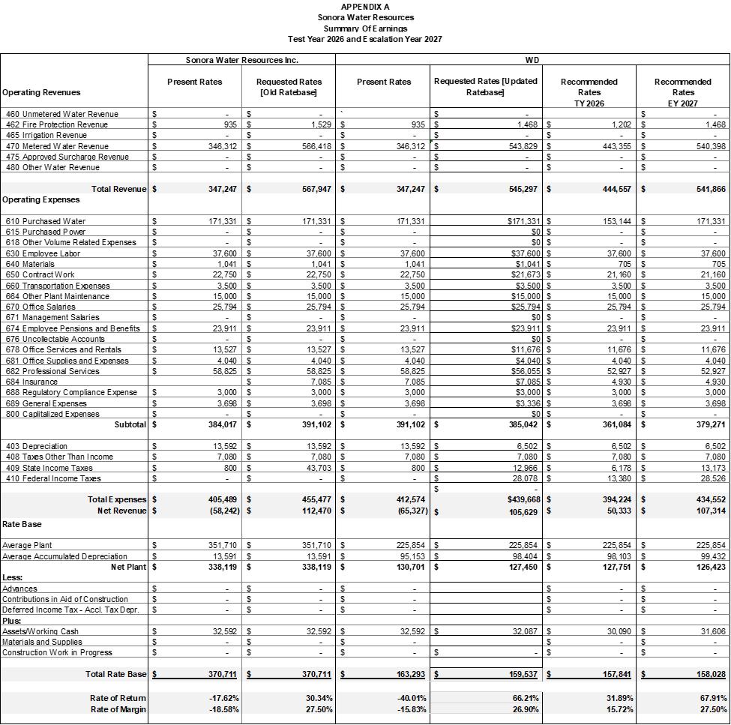
END OF APPENDIX A

APPENDIX B
Sonora Water Resources
TY 2026
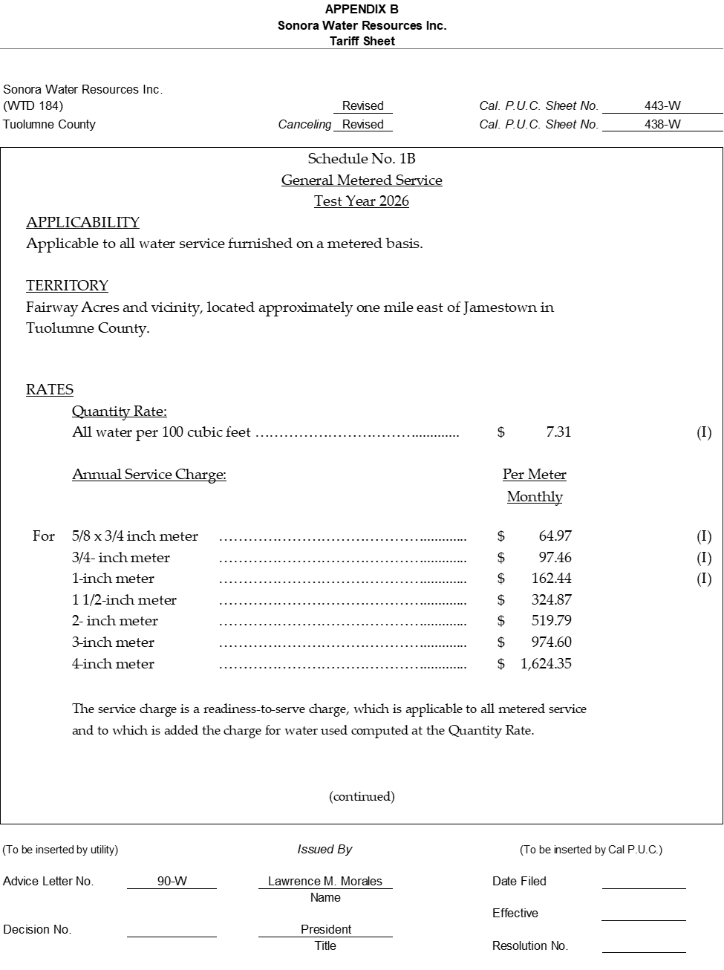

APPENDIX B
Sonora Water Resources
EY 2027
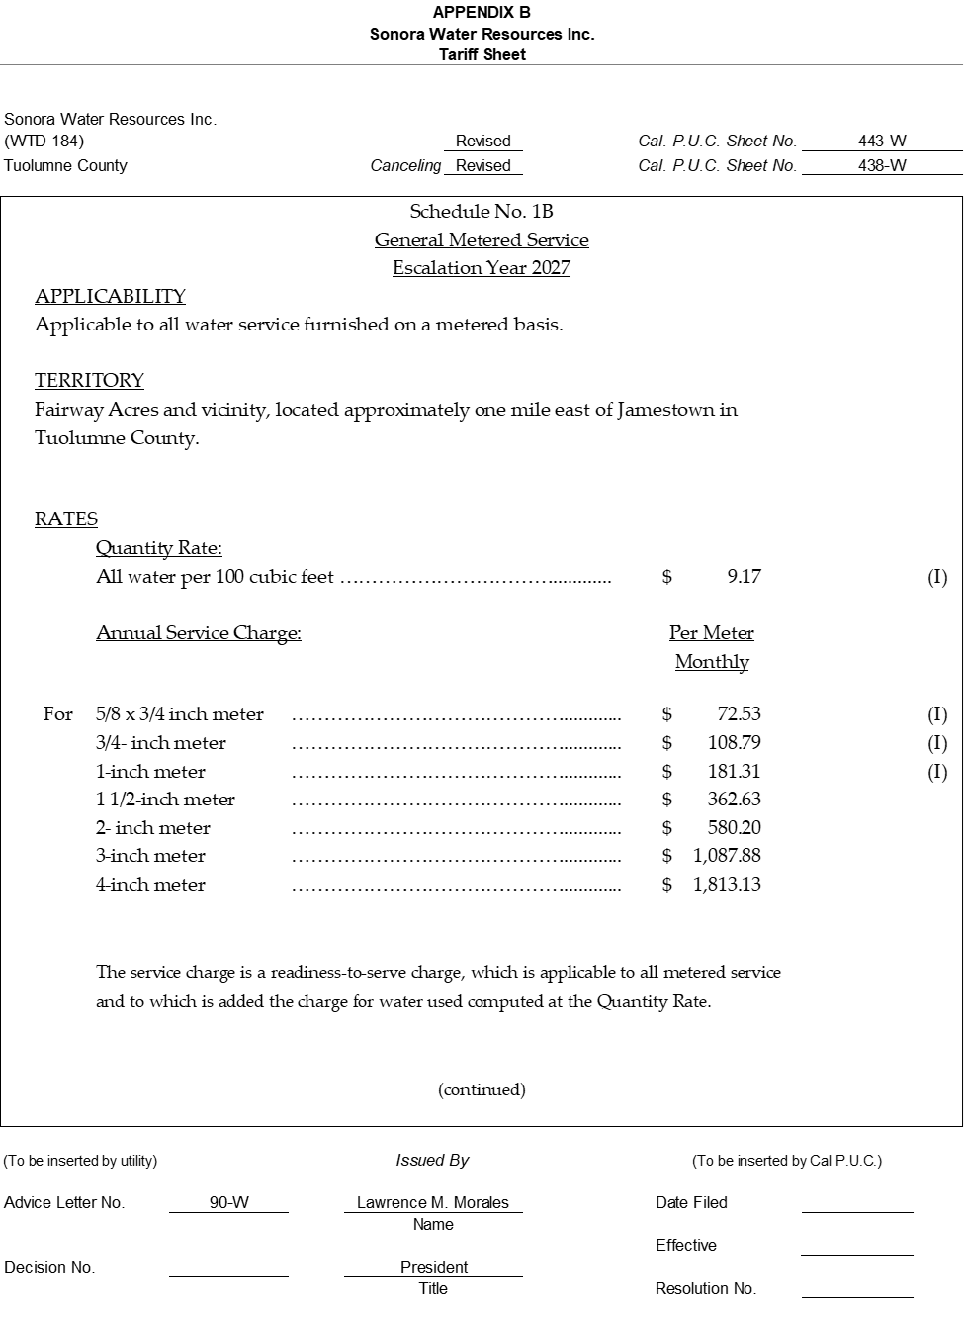

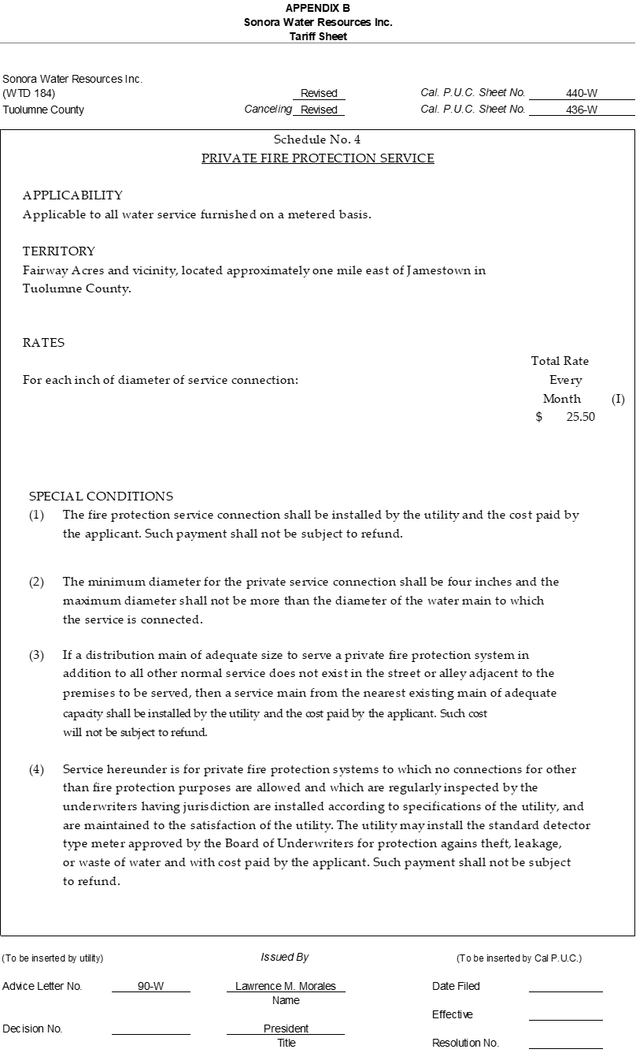

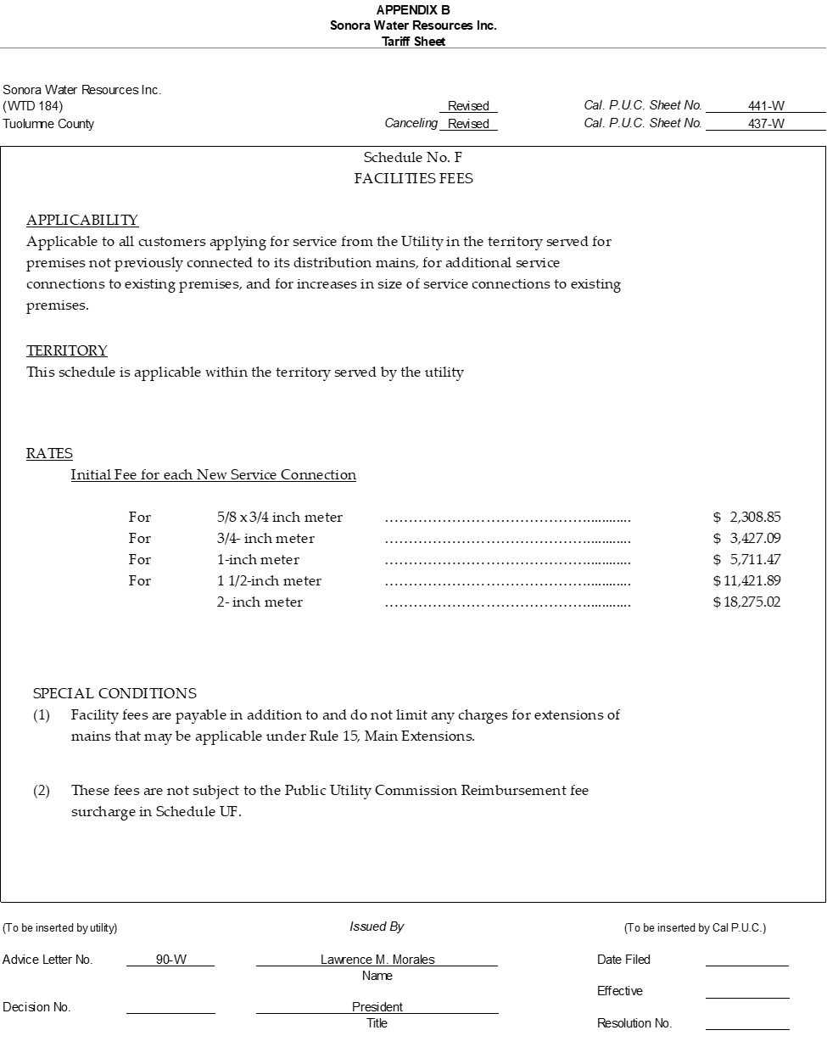
END OF APPENDIX B

APPENDIX C
Sonora Water Resources
Comparison of Rates
TY 2026 & EY 2027

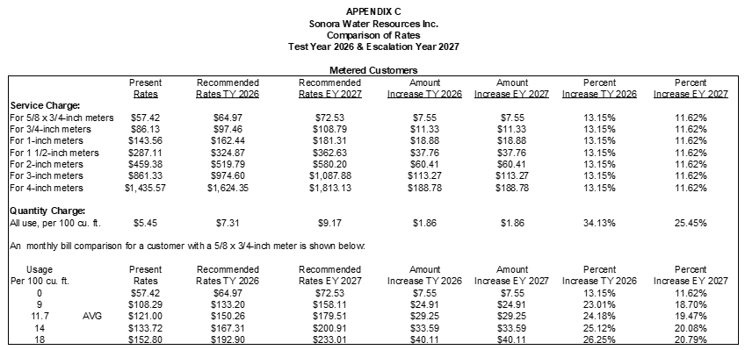
END OF APPENDIX C

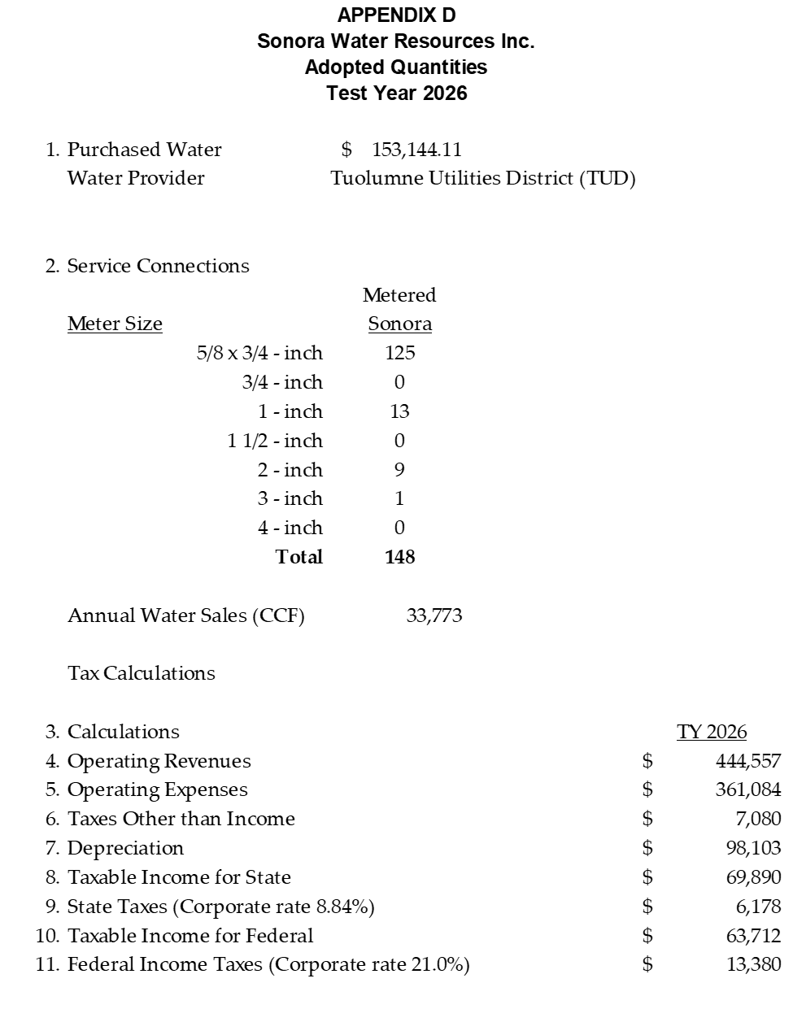
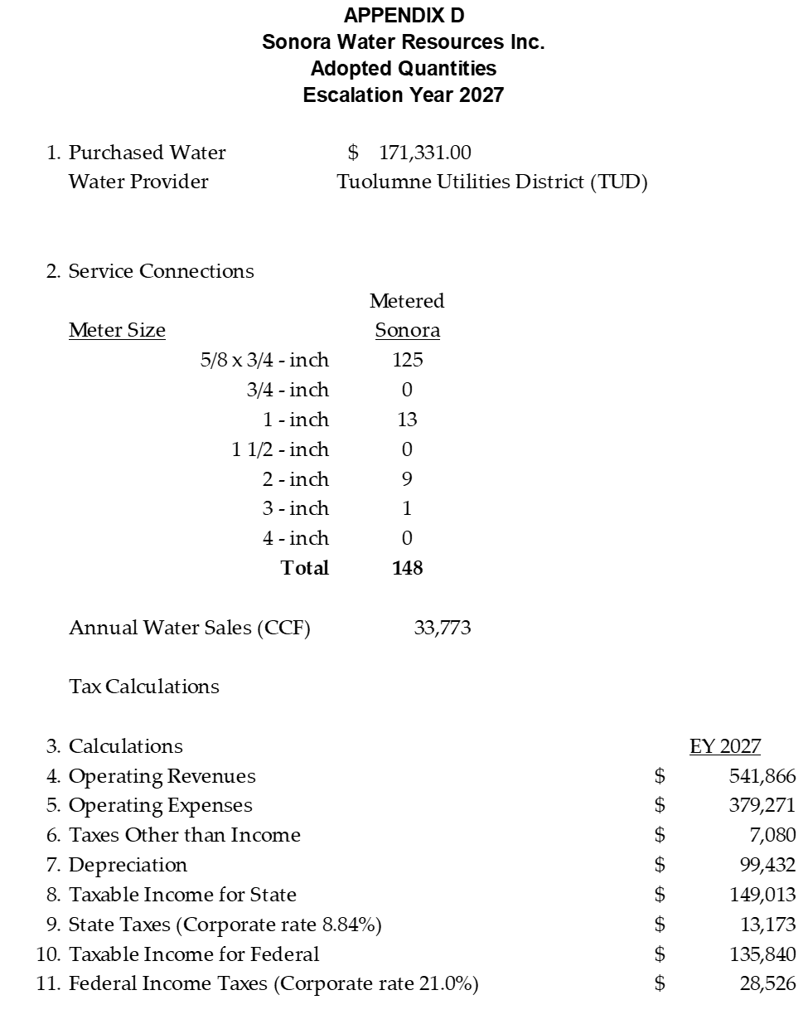
END OF APPENDIX D

CERTIFICATE OF SERVICE
I certify that I have, by either electronic mail or postal mail, this day, served a true copy of Proposed Resolution No. W-5313 on all parties in these filings or their attorneys as shown on the attached lists.
Dated February 13, 2026, at San Francisco, California.

LEVI GOLDMAN
Levi Goldman

Parties should notify the Water Division, Third Floor, California Public Utilities Commission, 505 Van Ness Avenue, San Francisco, CA 94102, of any change of address to ensure that they continue to receive documents. You must indicate the Resolution number on which your name appears.

SONORA WATER RESOURCES

ADVICE LETTER NO. 90-W SERVICE LIST

Jamestown Sanitary District
18351 Main Street
Jamestown, CA 95327

Tuolumne County
Department of Environmental Health
48 W. Yaney Street
Sonora, CA 95370

Tuolumne Utilities District
18/885 Nugget Blvd.
Sonora, CA 95370

Eda Bankie
19086 Outlook Dr
Jamestown, CA 95327
209-694-3535
Edabankie@aol.com

Harry Duarte
18717 Mill Villa Rd #544
Jamestown, CA 95327
925-787-1702

Randy Siglet
10678 Wigwam Rd Space #19
Jamestown, CA 95327
209-532-0668

Carol Reel
18717 Mill Villa Rd #106
Jamestown, CA 95327
Jamestown, CA 95327
209-604-0648

Lance Lester
19018 North Dr
Jamestown, CA 95327
209-505-3101
Lancelester52@yahoo.com

Ron Neri
18717 Mill Villa Rd #436
209-532-2554
Mighty49@yahoo.com

Robert Ditler
18996 North Drive
Jamestown, CA 95327
209-743-9944

Sue Villarreal
10678 Wigwam Rd #20
209-743-9944
Jamestown, CA 95327

Richard Welsh
19058 North Dr
Jamestown, CA 95327
209-533-1347

Bill Tuller
19100 Martha Ln
Jamestown, CA 95327
209-533-1047

One CCF is equivalent to 748 gallons.
AL 50-W originally requested a 2025 Test Year, but given that over half of 2025 had passed by the time AL 50-W was filed, Water Division found a 2026 TY more appropriate.
As defined in G.O. 96-B Water Industry Rules Section 1.2., Class B, C, and D investor-owned water utilities serve 2,001 through 10,000, 501 through 2,000, and less than 500 service connections, respectively.
This information is from the U.S. Census Bureau, American Community Survey (ACS) and Puerto Rico Community Survey (PRCS), 5-Year Estimates, U.S. Census Bureau QuickFacts: Mendocino County, California)
Resolution W-5269 SONORA WATER COMPANY. ORDER AUTHORIZING THE SALE AND ACQUISITION OF SONORA WATER COMPANY BY SONORA WATER RESOURCES, INC.; AND THE TRANSFER OF SONORA WATER COMPANY’S CERTIFICATE OF PUBLIC CONVENIENCE AND NECESSITY AS A RESULT OF THE ACQUISITION. Page 4 “Impact of the Purchase Price on Rate Base”
State Income Tax Rate for C-Corporations, https://www.ftb.ca.gov/file/business/types/corporations/c-corporations.html
The revenue requirement and rates under the ROR method are based on company’s rate base and under the ROM method the revenue requirement is based on the company’s overall expenses which include operating and maintenance and depreciation expenses, income and other taxes, and an operating margin.
D. 92-03-093, Ordering Paragraph 8
The ROR/ROM memorandum can be found at rorandrom-classcd2025.pdf
United States Census Bureau: Median Household Income 2023: U.S. Census Bureau QuickFacts: Tuolumne County, California
Decision adopting metrics and methodologies for assessing the relative affordability of utility service in Rulemaking 18-07-006.
https://oehha.ca.gov/calenviroscreen
State Water Resources Control Board Division of Drinking Water 2019 Sanitary Survey Sonora Water Resources (System No. CA5510024) report date March 5, 2024, inspection date February 14, 2024.
May 5, 2020, Financial Audit of Sonora Water Resources Financial Statements for the Years Ended December 31, 2018.

