PUBLIC UTILITIES COMMISSION OF THE STATE OF CALIFORNIA

Agenda ID# 24114
ENERGY DIVISION RESOLUTION E-5417
April 30, 2025

REDACTED
RESOLUTION

Resolution E-5417. Implementation of Liberty Utilities (CalPeco Electric) LLC’s (“Liberty Utilities” or “Liberty”) (U 933 E) Income-Graduated Fixed Charges Pursuant to Ordering Paragraph 3(b) of Decision (D.) 24-05-028.

PROPOSED OUTCOME:
- Approves, pending modifications to the proposed ME&O plan, Liberty’s proposal for implementation of the Base Services Charge (BSC) pursuant to D. 24-05-028.
- Orders Liberty to file a Tier 2 Advice Letter at least 60 days before the implementation of the BSC with updated total rates, tariff sheets, applicability, and bill analysis information.
- Orders Liberty to file another Tier 2 Advice Letter with an updated BSC Marketing, Education, and Outreach plan consistent with
D. 24-05-028 at least 60 days before the implementation of the BSC.

SAFETY CONSIDERATIONS:
- There are no safety considerations associated with this Resolution.

ESTIMATED COST:
- Authorizes up to $110,890 of actual incremental implementation costs to be recorded in the IGFCMA (Income Graduated Fixed Charge) Memorandum Account.

By Advice Letters 248-E, submitted September 12, 2024, 248-E-A submitted May 8, 2025, and 248-E-B, submitted October 24, 2025, to service list (R.22-07-005). __________________________________________________________

SUMMARY
This Resolution approves with modifications Liberty Utilities (CalPeco Electric)
LLC’s (“Liberty Utilities” or “Liberty”) (U 933 E) Advice Letters (AL) 248-E, 248-E-A, and 248-E-B to implement an income-graduated fixed charge (IGFC, fixed charge, Base Services Charge, or BSC) for residential customers pursuant to D.24-05-028 (the Decision) to accelerate the state’s clean energy transition.
The Decision changes how investor-owned utilities (IOUs) bill residential customers for infrastructure-related costs. We anticipate that the fixed charge will not only lower the price for a unit of electricity for all customers but also makes it more affordable to electrify homes and vehicles, regardless of income.
The BSC will be applied based on income tiers, with lower-income customers paying a lower charge and higher-income customers paying a higher charge. This means that the burden of the fixed charge is distributed more fairly and does not disproportionately affect lower-income households, including customers participating in the California Alternate Rates for Energy (CARE) program. CARE customers who earn 100% of the federal poverty guidelines or less are now eligible for additional savings through the new CARE Plus designation, which offers the lowest fixed charge level.
Liberty’s Advice Letter and its supplements demonstrate sufficient detail for a reasonableness review consistent with the Decision, pending the calculation, implementation, and marketing of final rates, tariff sheets, and bill analysis which will be addressed via subsequent advice letters that are ordered by this resolution.

BACKGROUND
On June 30, 2022, California Assembly Bill (AB) 205 (Committee on Budget, Stats. 2022, ch. 61) became law, paving the way for the Commission to adopt a more equitable rate structure for residential customers and to direct the electric IOUs to collect a reasonable portion of the fixed costs of providing electric service for residential customers through a fixed charge. AB 205 required a fixed charge be established on an income-graduated basis, with no fewer than three income thresholds.
On July 14, 2022, the Commission initiated Rulemaking (R.) 22-07-005 to establish demand flexibility policies and modify electric rates to advance the following objectives: (a) enhance the reliability of California’s electric system; (b) make electric bills more affordable and equitable; (c) reduce the curtailment of renewable energy and greenhouse gas emissions associated with meeting the state’s future system load; (d) enable widespread electrification of buildings and transportation to meet the state’s climate goals; (e) reduce long-term system costs through more efficient pricing of electricity; and (f) enable participation in demand flexibility by both bundled and unbundled customers. Phase 1 of R.22-07-005 is organized into two concurrent tracks, and Track A established the fixed charge for residential rates for all electric IOUs in accordance with AB 205, including small and
multi-jurisdictional electric utilities.
Whereas the fixed charge tier structure that was adopted for Pacific Gas and Electric (PG&E), Southern California Edison (SCE), San Diego Gas & Electric (SDG&E) (collectively, the Large Utilities) relied on enrollment in the CARE and Family Electric Rate Assistance (FERA) programs, a different tier structure was required for Bear Valley Electric Service, Inc., Liberty Utilities, and PacifiCorp d/b/a Pacific Power (collectively, the Small Utilities or SMJUs). Because the Small Utilities do not operate a FERA program, CARE is currently the only income-qualified rate discount available to customers served by the Small Utilities. Therefore, a different data collection and tier assignment process needed to be designed, developed, communicated, and implemented to comply with the three-income threshold requirement of AB 205.
Liberty Utilities (DBA CalPeco Electric) is a subsidiary of Algonquin Power & Utilities Corp, with ~1,265,000 connections and $7.86 billion in rate base. It acquired California electric utility, CalPeco in 2011 which serves 17,712 permanent residential customers and 26,580 residential non-permanent customers.
On January 16, 2024, Bear Valley Electric Service, Inc., Liberty Utilities, and PacifiCorp d/b/a Pacific Power (collectively, Small Utilities or SMJUs) and the Public Advocates Office at the California Public Utilities Commission (Cal Advocates) filed a joint motion (Settlement Motion) for adoption of a Track A settlement agreement (Settlement Agreement). On February 14, 2024, CforAT, the Large Utilities, Sierra Club/California Environmental Justice Alliance (CEJA), the Solar Energy Industries Association (SEIA), and The Utility Reform Network (TURN), and the Natural Resources Defense Council (NRDC) (Collectively TURN/NRDC) filed comments on the Settlement Motion. On March 1, 2024, the Small Utilities, CEJA, and the Large Utilities filed replies to comments on the Settlement Motion.

Decision 24-05-028
On May 15, 2024, the Commission adopted D.24-05-028, authorizing all electric
IOUs—Pacific Gas and Electric (PG&E), Southern California Edison (SCE), San Diego Gas & Electric (SDG&E) (collectively, Large Utilities), and the Small Utilities—to change the structure of residential customer bills in accordance with AB 205. The Decision generally requires the IOUs to change the structure of residential customer bills by shifting the recovery of a portion of fixed costs from volumetric rates to a separate, fixed amount on bills without changing the total costs that utilities may recover from customers.
D.24-05-028 adopted a gradual, incremental approach to implementing AB 205 requirements, including the requirement that the fixed charge be “established on an income-graduated basis with no fewer than three income thresholds.” For the Large Utilities, the Commission opted to utilize the current income-verification processes of the utilities’ existing income-qualified programs, which are already divided into three groups:
- CARE for customers whose household income falls below 200% of the Federal Poverty Level (FPL),
- FERA (Family Electric Rate Assistance), which offers an 18% discount on customer electricity bills for households with incomes between 200% and 250% of FPL, and
- all other customers, who pay the default electric rate.
D.24-05-028 approved some components of the Settlement Agreement, while noting that the record of the proceeding lacked sufficient evidence regarding which portion of each Small Utilities’ base revenues are fixed costs. The Settlement Agreement summarized the agreed-upon, Liberty-specific Base Revenue Income Graduated Fixed Charge amounts as follows:
- Tier 1 will be assigned to CARE customers with incomes of 0 to 100 percent of the Federal Poverty Guideline levels. Customers will need to attest to having eligible incomes; the initial base revenue fixed charge would be no more than $5.00/month.
- Tier 2 will be assigned to CARE customers with incomes above 100 percent and at or below 200 percent of the Federal Poverty Guideline levels; the initial base revenue fixed charge would be no more than $10.00/month.
- Tier 3 will be assigned to customers who do not qualify for the first or second tiers. The initial total base revenue fixed charge would be no more than $32.76/month.
While the Total Income Graduated Fixed Charges of $5.00, $10.00, and $32.76 are listed as Illustrative in the Appendix of the Settlement Agreement, the text of the Settlement Agreement lists these charges as the Total IGFC and further notes that parties agree to “adopt fixed charge amounts as shown in the first version of the income-graduated fixed charge.”

The price table as included in the Settlement is excerpted below.
Figure 1: Settled BSC Levels
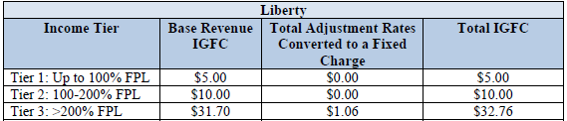

The reasonableness of the “Base Revenue IGFC” is to be determined through this Advice Letter process, which will be addressed in Discussion section 3 covering Rate Design.
D.24-05-028 directed the SMJUs to provide details on the costs proposed for recovery through the base revenue IGFC, hence this resolution will only approve that component of the fixed charge.
While the Settlement Agreement describes no specific methodology for calculating base revenue fixed charges, the base revenue fixed charge for the first version of the total IGFC is set at a level that the settling parties asserted reasonably balances the interests and considerations of the parties. The adjustment schedules, the second component of the IGFC, are based on the recovery of specific revenue requirements that represent fixed costs for the SMJUs which include costs for CARE, Energy Savings Assistance, and Catastrophic Events that are incurred regardless of customer energy usage.
As noted elsewhere in this document, The “Adjustment Rate” component, and thus the “Total IGFC”, will be reviewed in the pending Tier 2 Advice Letter described in Ordering Paragraph 2.
The new billing structure will apply to all residential rates of the electric IOUs, except for master-metered rates that are not sub-metered, separately metered electric vehicle rates for customers whose primary meter has a fixed charge, or rate schedules that are scheduled to be eliminated by the second quarter of 2026. The revenues from fixed charges will be applied to reduce volumetric rates equally across all time-of-use (TOU) periods.
D.24-05-028 established an Implementation Working Group (IWG) that is facilitated by the Commission’s staff to assess and evaluate fixed charges and (a) identify problems with implementation and ME&O efforts and suggest solutions at meetings, and (b) provide written recommendations to the Commission’s staff about how lessons learned from the implementation of the fixed charge should influence the design of future fixed charges or alternative rate mechanisms.
From a Tier Assignment and Marketing perspective, the Decision did not adopt the statewide ME&O approach the Small Utilities had proposed to inform customers about how volumetric rates will decline, how income-graduated fixed charges will function, and how the income-graduated fixed charges will impact overall electric bills. Instead, the Decision ordered the IOUs to participate in the Large IOUs joint ME&O workshop, and include a line-item budget for ME&O activity costs and a justification for each proposed line-item cost in their respective Tier 3 advice letters for implementing income-graduated fixed charges utility-specific ME&O plans. The Decision also specifically requested a detailed plan for reducing barriers to enrollment in the new Tier 1 CARE Plus designation for customers living at or below 100% of the Federal Poverty Line (FPL).
Advice Letters 243-E, 243-E-A, and 243-E-B
As directed in D.24-05-028 for implementation of the fixed charge, Liberty (1) submitted a Tier 1 AL (AL 243-E) on June 14, 2024, to establish a new IGFC memorandum account (IGFCMA), (2) participated in the Large utilities’ Fixed Charge ME&O Workshop on
July 10, 2024, and (3) filed this timely Tier 3 advice letter.
This advice letter must contain:
- a list of all base revenue cost categories that the utility proposes to recover through its income-graduated fixed charges and the revenue requirement associated with each cost category;
- an explanation of why each listed base revenue cost category is a fixed cost similar to a category approved for recovery through this decision;
- the revenue requirement for each of the fixed cost categories approved in this decision, if applicable to the utility;
- an explanation of how each base revenue cost category was converted from the current volumetric rate to a new per customer rate, if it is incremental to the current fixed charges;
- proposed fixed charge levels
- a bill impact analysis demonstrating that both Tier 1 and Tier 2 customers with average electricity usage in each baseline territory will realize a bill savings compared to currently effective rates;
- a proposed marketing, education, and outreach plan, a line-item budget for implementation costs, and a justification for each proposed line-item cost; and
- Information about how and when customers will be informed about the opportunity to be placed in Tier 1 and how to reduce barriers to enrolling in Tier 1.

On September 12, 2024, Liberty filed AL 248-E. On May 8, 2025, Liberty filed supplemental AL 248-E-A. On October 24, 2025, Liberty filed supplemental AL 248-E-B. This section discusses the deficiencies in Liberty’s original filing, organized by topic, and what was addressed through the supplementals.

Tier 1 Enrollment
The Commission had expressed concern “that customers eligible for Tier 1 will not be aware of how to enroll in Tier 1 or will face barriers to enrolling in Tier 1.” In response, the Commission explicitly ordered each Small Utility to provide information in their Tier 3 implementation advice letter about when and how customers will be informed about the opportunity to be placed in Tier 1 and how to reduce barriers to enrolling in Tier 1.
Liberty AL-248-E and AL-248-E-A did not provide this information and indeed, Cal Advocates in its protest specifically calls out the “limited detail on how Liberty will share information with customers about how to enroll in Tier 1, which it is required to provide under D.24-05-028.” Liberty states that it will “provide targeted, direct communication to certain customers that highlights bill impacts” without specifying who these certain, targeted customers will be. It states that it will direct these customers to the website for more information, but did not specify what information would be included. Liberty provided no information in its initial Advice Letter or its first supplemental on how it plans to reach out to eligible customers who are not enrolled in CARE to ensure they are enrolled in Tier 1.
Liberty AL-248-E-B added a new section titled CARE/CARE Plus Enrollment, which includes information which had not been included previously, and is discussed further in section 5.1.1: Tier 1- CARE Plus Tier Assignment.

ME&O Objectives and Approach
Liberty’s AL 248-E indicated the objectives of its ME&O plan are awareness, understanding, and support among customers. Liberty proposed a two-phased approach as described below:

Phase 1 – Awareness: Informs customers about "what" the fixed charge is, "why" it is being implemented, and "when" it will take effect. Customers will receive information on timing and bill impacts, including the fixed charge amounts. These materials will emphasize the availability of additional resources to help customers understand how their bills will change and the resulting impacts. In addition, these materials will include resources for low-income and CARE customers.
- Website: Publish and maintain IGFC web copy outlining details about the Company’s upcoming implementation of the fixed charge, including information specific to CARE customers and what CARE customers need to do to qualify for lower income fixed charges.
- Bill insert/mail: Provide targeted, direct communication to certain customers that highlights bill impacts. This direct email and mail communication will include a hypothetical example of an average customer’s fixed charge amount, the estimated reduced volumetric usage charge, and a bill comparison estimating the impact on the bill. These communications will reference the website for additional information and resources, as well as resources for CARE customers.
- Customer email: Send customer emails reinforcing the messaging described in bill insert/mail above.
- Targeting mailings to CARE customers: These mailings will include additional explanation to reassure customers that their program participation benefits will not be impacted. It will also provide CARE customers with information on how to apply for lower income fixed charges.
- Toolkits: Distribute fixed charge educational pamphlets, flyers, and checklists in accessible formats.
- Social media: Post content to Facebook and Twitter [X] notifying customers of Liberty’s fixed charge implementation with links to resources.
- Paid advertisements: Digital and print advertisements in local publications discuss the “what,” “why” and “when” for additional customer awareness.
Phase 2 – Implementation: Prepare employees to support customers throughout implementation of the fixed charge and provide continued support and resources to customers throughout the transition.
- Employee Education: Prepare customer service and field operations employees with talking points and frequently asked questions (FAQs) to answer customer questions, including information specific to CARE customers. Internal customer-facing groups may be leveraged to help drive early education about the fixed charge for utility employees, especially those whose work is customer-facing. Customer-facing groups may include the customer contact centers, payment locations and branch offices, field service teams, and credit and collections groups. Employees may be engaged through internal channels, including internal events, emails, and internal online resources.
- Website: Publish and maintain fixed charge web copy outlining details about the Liberty’s upcoming implementation of the fixed charge, including information specific to CARE customers and what CARE customers need to do to qualify for lower income fixed charges.
- Bill insert/mail: Provide targeted, direct communication to certain customers that highlights bill impacts. This direct email and mail communication will include a hypothetical example of an average customer’s fixed charge amount, the estimated reduced volumetric usage charge, and a bill comparison estimating the impact on the bill. These communications will reference the website for additional information and resources, as well as resources for CARE customers.
- Customer email: Send customer emails reinforcing the messaging described in bill/insert mail above.
- Targeting mailings to CARE customers: These mailings will include additional explanation to reassure customers that their program participation benefits will not be impacted. It will also provide CARE customers with information on how to apply for lower income fixed charges.
- Social media: Post content to Facebook and Twitter [X] notifying customers of Liberty’s fixed charge implementation with links to resources.
AL 248-E did not include any specific information about what messages Liberty would convey to customers regarding key customer concerns, including a lack of messaging concerning why the BSC was being implemented and an absence of differentiated Messaging Considerations and key messages targeted towards specific customers such as unenrolled CARE-eligible customers, enrolled CARE customers, and customers in
multi-family dwellings.
AL 248-E-A added “Tier 1” in parentheses to the existing marketing plan, but did not include any additional information addressing barriers to CARE and CARE Plus enrollment, nor did it include sufficient information – as required in the Decision and as protested by Cal Advocates as described in section 2.1– on how it plans to reach out to eligible customers who are not enrolled in CARE to ensure they are enrolled in Tier 1.

Notice
Notice of AL 248-E was made by publication in the Commission’s Daily Calendar. Liberty states that a copy of the AL and its supplement were mailed and distributed in accordance with Section 4 of General Order (GO) 96-B on September 12, 2024.
On May 8, 2025, Liberty filed AL-248-E-A. The stated purpose of this supplemental advice letter was to revise the fixed charge amount proposed in AL-248, and to provide additional detail on Liberty’s marketing, education and outreach (“ME&O”) budget and messaging on Tier 1 customer enrollment.
On October 24, 2025, Liberty filed AL-248-E-B. This supplement provided additional detail on Liberty’s ME&O budget and messaging on CARE/CARE Plus customer enrollment, budget, and messaging. In addition to these supplements, Liberty provided confidential Slipsheets submitted to Cal Advocates and Energy Division on November 11, 2025, which provided additional documentation on how it estimated each budget-line.

Protests
Liberty's AL 248-E was timely protested on October 2, 2024 by Cal Advocates. Cal Advocates’ protests centered around three issues:
- Rate Design: Liberty’s proposed Tier 3 IGFC Fixed Charge of $39.95 per month is significantly higher than the amount of $32.76 from the Settlement Agreement and lacks sufficient documentation on the basis of the adjustment rates that will convert into fixed charges for each tier level.
- ME&O Budget: Liberty’s ME&O plan failed to provide sufficient detail and budget justification.
- Tier 1 Enrollment: Liberty provided limited detail on how it would share Tier 1 enrollment with customers, and how it would communicate to eligible customers who are not enrolled in CARE to ensure they are enrolled in Tier 1.
Cal Advocates asserts that without the budget line justifications and messaging information required under D.24-05-028, Liberty’s ME&O plan does not include the level of detail necessary to properly evaluate the reasonableness of Liberty’s requested budgets or the efficacy of its plan in fully informing and preparing its customers for IGFC implementation. Cal Advocates further asserts that it will be difficult for the Commission and interested stakeholders to evaluate costs that Liberty will later seek to recover in rates. In all cases, Cal Advocates recommended that a supplement be filed.

Rate Design

Cal Advocates’ Protest
Cal Advocates protested Liberty’s proposed income-graduated fixed charge in AL 248-E citing in particular the $39.95 per month proposed charge for non-CARE customers. Cal Advocates noted that this is significantly higher than the maximum total fixed charge (including adjustment rates) of $32.76, which was included in the SMJU Settlement Agreement. However, the Decision does not approve the fixed charge levels in the Settlement Agreement. Instead, the Decision makes the determination of fixed charge levels subject to an analysis of the total revenue requirement for the fixed cost categories.
In its protest, Cal Advocates contends that the Decision approved a value of $32.76 for Tier 3 non-CARE customers. However, the Commission refrained from approving the Settlement Agreement’s fixed charge values. Cal Advocates also notes that Liberty did not provide a narrative justification for the increased fixed charge value or a cost breakdown of the components that comprise the proposed $39.95 charge.
Cal Advocates contrasted Liberty’s AL 248-E with the Tier 3 IGFC values proposed by PacifiCorp and Bear Valley Electric Service (BVES) in their implementation advice letters, which are closely aligned with the Settlement Agreement’s values. Cal Advocates also noted that PacifiCorp and BVES’s proposed fixed charges slightly deviated from the adjustment schedule values in the Settlement Agreement but that these deviations were anticipated since the Settlement Agreement allowed the SMJUs “to collect the full authorized revenue requirements in any given year.”
Cal Advocates noted in its protest that it sent a data request to Liberty on September 18, 2024, requesting documentation from Liberty to explain why its proposed Tier 3 fixed charge deviates from the settled fixed charge. Liberty responded on October 2, 2024. However, Cal Advocates asserted that the response did not address its concern that Liberty’s proposed Tier 3 fixed charge exceeds the settled values. Cal Advocates included a table in its protest showing that Liberty’s Tier 3 fixed charge is solely comprised of a $39.95 base rate and $0 values across all adjustment schedule components. Cal Advocates noted that a key difference between Liberty and the other Small Utilities was that Liberty failed to cap the base charge at the settled base rate and thus the Commission should reduce Liberty’s Tier 3 base rate to $31.70.
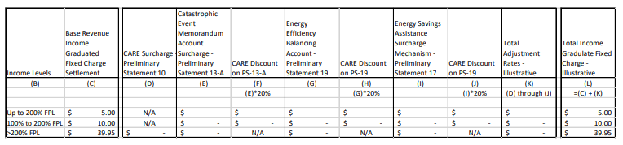

Liberty’s Reply to Cal Advocates' Protest
On October 8, 2024, Liberty replied to Cal Advocates’ Protest of AL 248-E. In its reply, Liberty admitted that its approach differs from the initial settlement agreement figure of $32.76 for non-CARE customers. Liberty asserts that its submitted values reflect its updated cost analysis and current authorized revenue requirement, which it noted includes expenses such as wildfire mitigation and infrastructure investments.
Liberty also disputed Cal Advocates’ assertions that Liberty did not provide a detailed breakdown of the base revenue cost categories it proposes to recover through the IGFC. Liberty noted that its marginal customer access costs (e.g., meters, services, distribution plant), basic customer services (e.g., billing, meter reading, customer care), and
wildfire-related costs were essential to maintain customer access to the grid and should be classified as fixed, non-volumetric costs that do not vary based on electricity consumption. Liberty further noted that its proposed fixed charges in AL 248-E aimed to align with its current revenue requirements. However, it argued that those requirements had increased since the original settlement agreement due to regulatory and operational changes.

Tier Assignment Marketing

Cal Advocates’ Protest
Cal Advocates argued that Liberty’s ME&O plan does not comply with the requirements of D.24-05-028 and that the Commission should reject Liberty’s M&EO plan and require it to submit a supplemental AL that includes adequate detail on Liberty’s ME&O budget and its messaging on Tier 1 customer enrollment.
According to Cal Advocates, Liberty’s AL failed to provide sufficient justification for each of the line-items in its proposed ME&O budget, and Liberty does not explain how it arrived at each line-item’s total cost.² For example, Cal Advocates stated that Liberty requested a $94,000 bill insert/mail budget but does not provide any information on how it calculated the budget. Information that Cal Advocates asserts Liberty should have provided includes:
- a breakdown between direct mail and bill insert sub-costs,
- the difference in its approach to these types of mailings between Phase 1 and 2 of its ME&O plan,
- the total number of customers that will receive each type of mailing,
- the message frequency each customer will receive,
- the audience(s), and
- how its mail campaign will complement its email outreach and low-income mailing budget lines.³
Cal Advocates requested this information through a data request, and indicated that Liberty provided message frequency estimates for direct mail, email, and bill insert budget lines based on current or historical costs, but Liberty did not provide any documentation of those costs or explain how it extrapolated from historical costs of its fixed charge budget estimates. Cal Advocates recommended that the supplemental AL should explain how Liberty arrived at each of its budget lines, including (1) identification of all sub-costs and how they were calculated, and (2) documentation of previously incurred costs which Liberty used to inform its cost estimates.
In addition, Cal Advocates argued that AL 248-E provided no information on how it plans to reach out to unenrolled CARE-eligible customers about the opportunity to be placed in Tier 1 and how to reduce barriers to enrolling in Tier 1. Liberty provided Cal Advocates with information on what information will “likely be included or referenced in its data request response” without specifics. Cal Advocates recommended that Liberty should submit these details in a supplemental AL so that the Commission, other parties in this proceeding, and the IWG would have the opportunity to review this information for reasonableness and efficacy.

Liberty’s Reply to Cal Advocates’ Protest
Liberty contended its AL included an ME&O plan to inform customers about the new fixed charge. The plan included customer communications through bill inserts, mail, email, social media, and targeted outreach to provide awareness of how to enroll in lower-income tiers. Liberty stated that its ME&O plan would help customers understand the impact of the new rate structure on customer bills and equip customers with the necessary information to benefit from available low-income programs.
Liberty also contended that its AL provided high-level explanations for its ME&O budget and that it provided additional detail in response to Cal Advocates’ data request. Liberty subsequently submitted a supplemental AL with additional line-item information to support its ME&O budget justifications.
Liberty stated its Tier 1 customer enrollment messaging already included details on how it would share information with non-CARE customers about how to enroll for a low-income tier of fixed charges but agreed to provide additional information in a supplemental AL to address Cal Advocates’ concerns.
Liberty requested that the Commission reject Cal Advocates’ protest and approve its AL as submitted, with Liberty’s commitment to addressing the ME&O and customer messaging in a supplemental AL.

Liberty’s Supplemental Filings
Following the submittal of Cal Advocates’ protest, on May 8, 2025 Liberty filed supplemental AL 248-E-A to revise the Tier 3 fixed charge amount proposed in AL 248-E. Liberty also claimed the supplemental provided additional detail on Liberty’s ME&O budget and messaging on Tier 1 enrollment. This filing still failed to provide the level of detail on its ME&O budget or its messaging on Tier 1 enrollment efforts as required by D.24-05-028.
AL 248-E-B, which included further clarification on the CARE application and Tier 1 communication, was filed on October 24, 2025. This supplement substantially refined Liberty’s ME&O Plan, introduced the term CARE Plus consistent with the other Small Utilities, and reduced its ME&O budget from $145,700 to $110,890. AL 248-E-B still lacked the detail required by the Decision and detailed in the Cal Advocates protest. In response to Cal Advocates’ protest, Liberty submitted confidential “slipsheets” on November 11, 2025, with justification for each of the line-items in its proposed ME&O budget as required under D.24-05-028. These slipsheets are redacted, and included as Appendix A for completeness.

Discussion
The Commission has reviewed the AL, protests, supplemental advice letters, slipsheets, and Liberty's responses to data requests submitted by Cal Advocates and Energy Division staff.

Rate Design
Ordering Paragraph 8 of the Decision approved the majority of the Settlement Agreement (Settlement) between the Small Utilities and the Cal Advocates, including the income graduated fixed charge income tiers and rate design, income verification methodology, recovery of implementation and administration costs, and balancing of revenue methodology. However, OP 8 explicitly did not approve the Small Utilities’ proposals to recover their base revenues and fixed charge levels, citing a lack of justification in the Settlement.
Instead, the Commission ordered the Small Utilities to justify the base revenue requirements they had each proposed in the Settlement through a subsequent Advice Letter. OP 10 of the Decision required each Small Utility to include the following information in a Tier 3 advice letter:
- a list of all base revenue cost categories that the utility proposes to recover through its income-graduated fixed charges and the revenue requirement associated with each cost category;
- an explanation of why each listed base revenue cost category is a fixed cost similar to a category approved for recovery through D.24-05-028;
- the revenue requirement for each of the fixed cost categories approved in
D.24-05-028, if applicable to the utility;
- an explanation of how each base revenue cost category was converted from the current volumetric rate to a new per customer rate, if it is incremental to the current fixed charges;
- proposed fixed charge levels; and
- a bill impact analysis demonstrating that both Tier 1 and Tier 2 customers with average electricity usage in each baseline territory will realize bill savings compared to currently effective rates.

Each of these elements is discussed below.

Base Revenue Cost Categories
D.24-05-028, OP 10 directs each of the SMJUs to provide a list of all base revenue cost categories to recover through their respective income-graduated fixed charges and an explanation of why each listed base revenue cost category is a fixed cost similar to a category approved for recovery through D.24-05-028. COL 7 of the Decision also defined fixed costs as costs that do not directly vary based on the electricity usage of the customer from whom the revenue is being collected. The Decision identified fixed cost categories as Marginal Customer Access Costs (MCACs), Public Purpose Program non-bypassable charges, New System Generation charges, Local Generation charges, and Nuclear Decommissioning non-by passable charges. Finally, the Decision defined MCACs as marginal customer equipment costs consisting of final line transformer, service line drops and meter costs, and the ongoing customer service costs associated with keeping customers connected to the grid, as well as revenue cycle services such as billing and customer care.
In its Tier 3 AL, Liberty defined the MCACs and other fixed cost base revenue categories that it proposed to recover through the fixed charge. It primarily focused on MCACs and noted that these costs represent $79.90 per customer per month across 44,293 permanent and
non-permanent residential customers. This was based on the results of Liberty’s marginal cost study filed in its 2021 General Rate Case (“GRC”) proceeding in Application
(A.) 21-05-017, which qualified $42.5 million in costs as varying with the number of residential customers rather than with usage or demand.
In determining $42.5 million in customer-related costs, Liberty first classified relevant costs from its 2024 authorized base revenue requirement as customer-related based on either direct assignment or indirect assignment. Liberty explained in its Tier 3 AL that direct assignments allocate customer-related expenses directly using the company’s financial data, covering costs such as meter reading, customer care, certain infrastructure investments, and portions of the distribution network. The distribution plant costs are determined using an eight-year regression analysis linking plant investments to customer numbers and peak demand. In contrast, indirect assignments of customer-related costs use composite allocators, derived from both direct and indirect costs, to distribute expenses for broader investments like general plant and administrative functions.
In total, Liberty classified $61.5 million (58.29 %) of the company’s 2024 authorized base rate revenue requirement of $105.45 million (excluding supply costs) as customer costs. This classification reflects 36.27% of the company’s plant classified as customer-related, including meters, services, and a portion of distribution plant related to providing customers access to the electric grid. Liberty then allocates to the residential rate class
$42.5 million (69.10%) of the customer portion of the 2024 base rate revenue requirement.
D.24-05-028, COL 56 notes the following: “If the Commission determines in a resolution of the Tier 3 advice letter that the total revenue requirement for all of the Small Utilities’ fixed cost categories is sufficient to support the fixed charge levels in the Settlement Agreement, then it would be reasonable for the resolution to approve the Settlement Agreement’s fixed charge levels.” Additionally, COL 57 of the Decision states: “If the Commission resolution determines that the total revenue requirement for all of the Small Utilities’ fixed cost categories does not support the fixed charge levels in the Settlement Agreement, it would be reasonable for the Commission resolution to reduce the Small Utilities’ fixed charge levels accordingly.”
As aforementioned, OP 10 of the Decision also ordered the Small Utilities to specify information and provide a justification for the proposed fixed charges from the Settlement Agreement in a subsequent Tier 3 Advice Letter. When reading the COLs and OP 10 together, it is clear that the Decision instructed Commission staff to resolve the instant AL by either proposing approval of the Settlement Agreement’s fixed charge levels (if substantiated by information provided in the Tier 3 AL), or to reduce the proposed fixed charge to the Settlement Agreement level or lower (if not substantiated by information provided in the AL). The Decision does not allow for Commission staff to propose approval of a fixed charge level for the Small Utilities beyond the Settlement Agreement amounts.
The Commission affirms that the aforementioned customer-driven costs such as poles, underground conduits, and distribution plant costs fall within COL 7’s definition of fixed costs and indeed do not vary based on the electricity usage of ratepayers.
In AL 248-E, Liberty initially proposed a non-CARE fixed charge of $39.95 per month, which significantly exceeded the total fixed charge amount of $32.76 proposed by Liberty in the Settlement Agreement (including Adjustment Rates converted to a fixed charge). The Commission found that the base revenue cost categories and total revenue requirement presented in Liberty’s initial filing exceeded the fixed charge levels proposed by the Settlement Agreement. As a result, Liberty’s original AL 248-E failed to meet the requirements of Ordering Paragraph 10 of D.24-05-028. On December 2, 2024, Energy Division staff met with Liberty to discuss the discrepancy between the proposed and settled fixed charge amounts, and Liberty subsequently agreed to file a supplement reducing its non-CARE fixed charge. On May 8, 2025, Liberty filed supplemental AL 248-E-A, revising the proposed fixed charge to $31.70, consistent with the Settlement Agreement approved in D.24-05-028. The Commission finds Liberty’s revised base monthly fixed charges to be reasonable and compliant with Ordering Paragraph 10 of D.24-05-028.

Volumetric Rate Conversion to Customer Rate
In its Tier 3 AL, Liberty did not include a table detailing plans to convert current volumetric adjustment rates to monthly tiered fixed charges. However, in correspondence with Energy Division Staff, Liberty noted that they intend to follow the methodology for converting volumetric adjustment rates to a monthly charge as outlined in the Settlement Agreement approved in D.24-05-028.
The Commission will direct Liberty to file a Tier 2 AL at least 60 days prior to the implementation of the BSC to finalize its adjustment schedule conversion and total fixed charge. The Commission also notes that Liberty has not filed updated Tariff Sheets with its advice letters, and orders Liberty to include updated Tariff Sheets for each modified rate with this filing.
Liberty also noted that it hoped to maintain revenue neutrality by increasing its fixed charge revenues for the residential permanent rate class by $4.19 million and the
non-permanent rate class by $8.3 million, while reducing usage charge revenues by the same amounts. This proposal was uncontested, and the Commission finds
Liberty’s proposed base monthly fixed charges as proposed in AL 248-E-A reasonable and compliant with OP 10 of D.24-05-028.

Proposed Fixed Charge Levels
In AL 248-E, Liberty initially proposed income-graduated residential monthly fixed charges of $39.95 per month for Tier 3 non-CARE customers, $10.00 per month for Tier 1 CARE customers, and $5.00 per month for Tier 2 CARE customers. This proposal was protested by Cal Advocates. As aforementioned, Liberty filed supplemental AL 248-E-A on May 8, 2025, which revises the proposed base revenue fixed charge amount for Tier 3 non-CARE customers to $31.70.
The proposed fixed charges represent the base revenue fixed charge and do not include adjustment rates converted to a fixed charge. The Commission finds this reasonable and compliant with OP 10 of D. 24-05-028.

Bill Impact Analysis
Liberty also included analysis of present rates and proposed base fixed charges for residential customers and the subsequent bill impacts. It included three Tables (copied below) that summarized the impact for an average residential customer. Liberty showed that both CARE and CARE Plus customers will receive a monthly bill decrease under the proposed BSC rate design compared to rates approved in their Test Year 2023 GRC.
Figure 2: Customer Bill Impacts (Non-CARE customers)
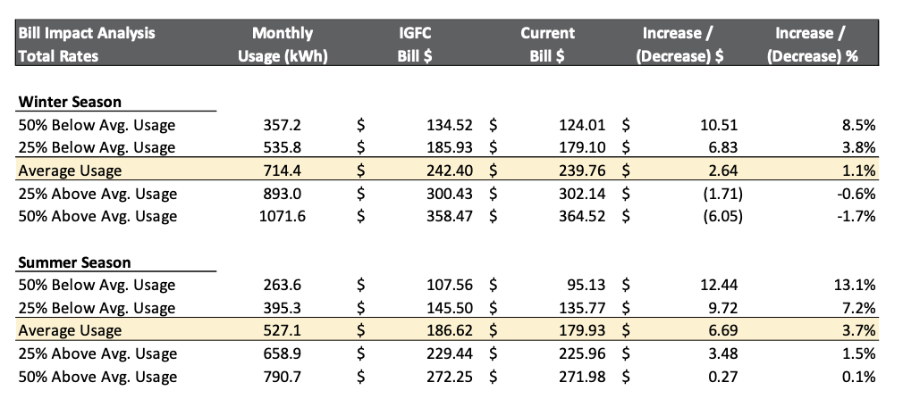
Figure 2 shows bill increases under the IGFC rate design as compared to 2024 authorized rates for non-CARE customers based on 714 kWh during the winter months and 527 kWh during the summer month.
Figure 3: Customer Bill Impacts (Tier 1 CARE)
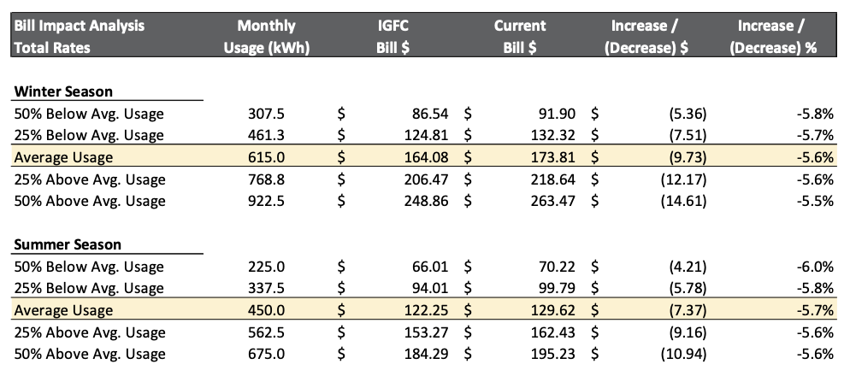
Figure 3 shows bill decreases under the IGFC rate design as compared to the 2024 authorized rates for Tier 1 CARE customers based on 615 kWh during the winter months and 450 kWh during the summer month.
Figure 4: Customer Bill Impacts (Tier 2 CARE)
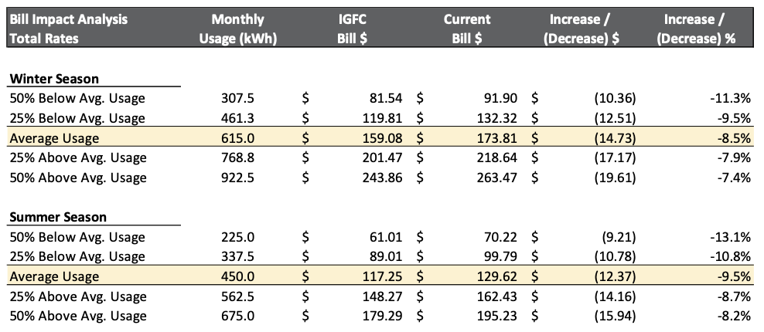
Figure 4 shows bill decreases under the IGFC rate design as compared to 2024 authorized rates proceeding for Tier 2 CARE customers based on 615 kWh during the winter months and 450 kWh during the summer month.
Since ALs 248-E and 248-E-A only provided bill impact analysis using the BSC base rate design, the Commission directs Liberty to file an additional bill analysis in a Tier 2 AL at least 60 days prior to the implementation of the BSC. This subsequent Tier 2 AL will use the BSC total fixed charge, which comprises the base fixed charge and most current adjustment schedule rates converted to a monthly charge.

Exceptions to the Base Services Charge
The Small Utilities, including Liberty, argued that applying fixed charges to all residential rates would prevent rate shopping and will allow for a more equitable allocation of costs to customers. They highlighted that the unique characteristics of the SMJUs, namely the high percentages of seasonal vacation home customers who are not full-time residents, and their intended desire to “avoid a piecemeal approach to rate reform and unintended rate shopping.”
The Decision, however, noted that an exception should be made to “master-metered rates that are not sub-metered, separately-metered electric vehicle rates for customers whose primary meter has an income-graduated fixed charge, and rate schedules that are scheduled to be eliminated by the second quarter of 2026.”
In balancing administrative efficiency while minimizing rate shopping and equity and consistent with the Decision, the Commission continues to find it reasonable to authorize income-graduated fixed charges for all of the Small Utilities’ default and optional residential rate schedules, with the following exceptions: master-metered rates that are not sub-metered, separately-metered electric vehicle rates for customers whose primary meter has an income- graduated fixed charge, and rate schedules that are scheduled to be eliminated by the second quarter of 2026. AL 248-E and its supplements did not provide any information indicating which specific rates would be exempted from the Base Services Charge, nor did it explicitly highlight which rate schedules already include a Customer Charge.
In response to a Commission request, the Large Utilities each provided a comprehensive list of their residential rates, whether each rate currently has a fixed charge, and whether it would include an income graduated fixed charge in the future: Although the Small Utilities were not required to supply similar information in the Decision, we find that it would be useful to ensure a common understanding. It is also unclear whether customers served by some of Liberty’s residential rates have a customer charge or minimum charge. For example, the “DS-1: Multi-Unit Domestic Service – Submetered” and “DM-1 Multi-Unit Domestic Service – Not-Submetered Tariff Sheets” both reference a Minimum Charge, but it is unclear if these customers are actually billed an additive Customer Charge of $13.83/month rather than a minimum charge, regardless of volumetric kWh usage.
Liberty’s tariff sheets could be clarified to ensure these exceptions are correctly communicated and implemented. Likewise, it is unclear whether Liberty Employees would be exempt from the Base Services Charge, as they appear to be exempt from a current fixed charge.
Accordingly, we direct Liberty to provide information in its forthcoming Tier 2 Advice Letter as shown in the sample table below, including a column specifying each residential rate offered, its current Fixed or Minium Charge, and its proposed BSC, Fixed, or Minimum Charge.
Table 5: Current Rate Schedules and Fixed Charge Applicability
Schedule Abbreviation | Common Rate Name | Current Fixed Charge | Minimum Charge | Charge Going Foward
D-1 | Domestic Service | $13.83/month |  | BSC $31.70
TOU D-1 | TIME-OF-USE DOMESTIC SERVICE | $13.83/month
D-1 EV | Time-of-Use Electric Vehicle Service | $13.83/month
CARE | CARE Domestic Service | $11.07/ month |  | BSC $10, $5 for CARE Plus
DS-1 | Multi-Unit Domestic Service – Submetered |  | Minimum Charge?
DM-1 | Multi-Unit Domestic Service – Not-Submetered |  | Minimum Charge?
DE | Domestic Service to Company Employees |  | Minimum Charge $2.25 per month
Other

Tier Assignments
AB 205 required that the “fixed charge shall be established on an income-graduated basis with no fewer than three income thresholds.” The Decision thus required each utility to design its income-graduated fixed charges accordingly. The Large IOUs assigned their customers to three tiers based on their two existing income-qualified programs, CARE and the Family Electric Rate Assistance Program (FERA).
It would not be possible to apply the same criteria to Liberty, because the small utilities do not administer a FERA program. Therefore, a different rate structure was adopted, as proposed by the Settlement Agreement:
- Tier 1 marketed as “CARE Plus” will be assigned to CARE customers with incomes of 0 to 100 percent of the Federal Poverty Guideline levels. Current customers on CARE who qualify for the Tier 1 CARE Plus rate must take additional action to be assigned to the lowest Base Services Charge.
- Tier 2, marketed as CARE, will be assigned to CARE customers with incomes above 100 percent or below 200 percent of Federal Poverty Guideline levels. Like CARE customers served by the Large Utilities, these customers will not need to take action to remain on the CARE rate and qualify for this Base Services Charge level.
- Tier 3 will be assigned to non-CARE customers who do not qualify for the first or second tiers.
While TURN/NRDC did not oppose the Settlement Agreement, they did express concerns about the method of assigning customers between the two low-income tiers. Specifically, they noted that the Settlement Agreement did not provide clear guidance on how CARE customers would be assigned to one of the two low-income tiers, as Liberty claimed it did not store customer income and household data. TURN correctly noted that the
SMJUs’ proposal to “verify income using the existing California Alternative Rates for Energy (CARE) application process, to obtain information for the additional 0-100% of FPL level” would be unachievable with the current CARE application process. Until the CARE application process is amended, it does not appear that the SMJUs will have adequate income data to reasonably determine to which low-income tier CARE customers should be assigned.
The Commission is “similarly concerned that customers eligible for Tier 1 will not be aware of how to enroll in Tier 1 or will face barriers to enrolling in Tier 1.” In response, the Commission explicitly ordered each Small Utility to provide information in their Tier 3 implementation advice letter about when and how customers will be informed about the opportunity to be placed in Tier 1 and how to reduce barriers to enrolling in Tier 1.

Tier Assignment by Income
Liberty proposes in AL-248-E-B to assign customers to their appropriate tiers through a self-attestation process, similar to the current CARE application process which allows customers to determine CARE eligibility based on full-time residency and enrollment in other income-qualified programs or household income.
Accordingly, Liberty proposes the following tier assignment processes:
- CARE Plus: (Tier 1) Liberty will assign customers who attest to having eligible incomes through the revised CARE application process.
- CARE: (Tier 2) Liberty will assign all customers currently enrolled in CARE to Tier 2 without the need for the customer to take any action. Going forward, customers who enroll in CARE and do not attest to earning a household income level that would qualify them for CARE Plus will automatically be enrolled in this tier.
- Non-CARE: (Tier 3) all other customers are defaulted to this rate.

Tier 1 – CARE Plus Tier Assignment
The Commission had already found it “reasonable for the Small Utilities’ income-graduated fixed charges to rely on their existing CARE income verification processes as amended to obtain income information from customers with incomes between 0 to 100 percent of Federal Poverty Guideline levels.”
Liberty’s initial advice letter and first supplement did not provide sufficient detail as to how the existing CARE income verification process would be amended to allow customers to self-attest that their incomes fall between 0 percent to 100 percent of Federal Poverty Guideline levels, or whether customers would qualify through a separate process. No amended draft CARE Application was included for approval, nor did the Advice Letter nor first supplement include any sample language.
In its second supplement, Liberty clarifies that it will reduce barriers to CARE Plus enrollment by providing both non-CARE and current CARE customers with additional information, including the benefits of CARE and CARE Plus, eligibility criteria, the enrollment process and timeline, and how to apply online. Instead of limiting bill impact information to an unspecified set of “targeted” customers as noted earlier, Liberty will now provide direct communication to all customers, which “will include a hypothetical example of an average customer’s fixed charge amount, the estimated reduced volumetric usage charge, and a bill comparison estimating the impact on the bill. These communications will reference the website for additional information and resources, as well as resources for CARE and CARE Plus-eligible customers.” Sample marketing collateral clarifies that CARE customers “will see a reduction in monthly bills for the same usage” as required in the Decision.
Whereas Liberty indicated that it did not store income information previously,
AL 248-E-B explains that Liberty will now store this information and apply the CARE Plus Base Services Charge to all eligible customers at the time of implementation. Customers eligible for CARE or CARE Plus can complete the application with necessary income information at any time in advance of the planned 2026 implementation.
Liberty also introduced in AL 248-E-B a draft single CARE/CARE Plus Application that differentiates between the two programs. This proposed CARE /CARE Plus application introduces the BSC and CARE Plus rate and informs applicants that “CARE customers will pay a $10 Base Services Charge and CARE Plus will pay a $5 Base Services Charge.” It does not require household income from all CARE applicants, but makes clear that income information is required for customers to receive the lowest BSC and directs customers with the following statement “If your total household income falls below the maximum listed under CARE Plus in Option 2, you will qualify for a lower Base Services Charge beginning in 2026. In that case, please complete 2B.”
This section 2B reiterates that “Customers must complete this section to qualify for CARE Plus.” The revised CARE/CARE Plus Application provides information about why income data is being collected but does not obligate CARE/CARE Plus customers applying for the standard CARE program to provide income information if they qualify through categorical eligibility. However, the application makes it clear that customers who apply for CARE Plus will receive substantial savings.

Tier 2 – CARE Tier Assignment
As proposed by Liberty, by process CARE customers would be automatically defaulted to the Tier 2 CARE Base Services Charge unless they qualify for the new Tier 1 category by providing specific income information through the revised CARE/CARE Plus application as described in the prior section. As noted earlier, Liberty currently does not store specific income details, just CARE eligibility information. Therefore, Liberty does not currently have any income information to determine whether any CARE customers are earning the 100% or less of FPL that is required to qualify for Tier 1. Rather, Liberty currently only requires self-attestation that these customers earn less than 200% of FPL, or self-attestation that they qualify for CARE through categorical eligibility.
In AL 248-E-B, Liberty introduced a new CARE/CARE Plus Enrollment procedure. It introduced a new CARE application, which includes options for applying to CARE and CARE Plus. CARE Plus will specifically require self-attested income information, as described previously. Customers applying for CARE who are not applying for CARE Plus retain the same options that were previously available to CARE applicants: self-attestation that they earn 200% of FPL or less or self-attestation of categorical eligibility. The Commission finds this process to be consistent with the Decision.

Tier 3 Placement and Charge
Liberty notes that all residential customers not assigned to Tier 1 or Tier 2 as described above will be assigned to Tier 3 and will be assessed the default monthly Tier 3 Fixed Charge.
Liberty also provided draft marketing collateral which indicates that “The new Base Services Charge is coming in early 2026” and notes that “a new Base Services Charge for CARE customers will be lowered to $10.00 per month. If customers qualify for CARE Plus, the new Base Services Charge will be lowered to $5.00 per month.”
Although the example provides some context, Liberty’s draft marketing materials fail to convey the most basic information and do not accomplish Liberty’s stated topline marketing goal, “Awareness: Informs customers about ‘what’ the fixed charge is." At a minimum, this “what” must include information about the actual cost: that most residential customers’ monthly base revenue fixed charge will be $31.70 per month. Customers should understand what the default initial BSC charge would be, and that if they are eligible for CARE but do not enroll, that they will be assessed the much higher default BSC.
The Decision (at OP 2.e) ordered Liberty to include BSC marketing materials that include the proposed monthly BSC for all tiers in its Tier 2 Advice Letters. While the Commission understands that the BSC is likely to change and there is some uncertainty as to what the prices will be in the future, there is no reason why Liberty could not include these charges with an effective date. Customers should understand that the difference in BSC for customers enrolled in CARE Plus, CARE and non-CARE will be substantial.
Liberty’s proposed marketing materials do not convey the magnitude of this change.

Proposed ME&O Plan and Budget
The Decision noted that the “The Settlement Agreement did not include a proposal for ME&O for the Small Utilities’ income-graduated fixed charges,” but subsequently highlighted that an approach to collaboration with the Large Utilities would be efficient and cost-effective plan for informing the Small Utilities’ ME&O efforts and communications. In that regard, the Commission found it reasonable for Large
Utilities’ ME&O to address the following itemized topics:
- When the new fixed charge will be applied;
- Why and how the new fixed charge will reduce volumetric rates;
- The amount of the fixed charge and how the fixed charge will affect customers’ bills;
- How tiers will be assigned and how to move to a different income tier;
- Different rate options and rate comparison tools;
- Options to enroll in CARE or FERA [or CARE Plus] and other ways to manage energy costs;

- Assure CARE and FERA [or CARE Plus] customers that their assistance program discounts will not be affected by the fixed charge and that they may see lower bills as a result of the fixed charge; and
- Why and how the fixed charge will encourage the adoption of electrification technologies and associated reduced use of fossil fuels and how customers can find rebates to electrify.
The Commission further stated that “the Small Utilities must leverage the Large
Utilities’ existing ME&O research and best practices rather than conducting additional research.” It expected the SMJUs to collaborate with the Large Utilities to learn more about the Large Utilities’ research findings, best practices, and detailed ME&O plans for
income-graduated fixed charges. The Small Utilities would then participate in the Large Utilities’ joint ME&O workshop to discuss the Large Utilities’ ME&O plans, research findings, and messaging, and then file a utility-specific ME&O plan as part of their Tier 3 Advice letters which would be closely aligned with their statewide peers.
The Commission could potentially authorize some deviation from the Large Utilities ME&O plans, such as in timing and approach, to account for the smaller size of the utility. For example, there are some differentiating factors which could justify Liberty’s ME&O approach as tailored to its unique circumstances and distinct from those facing the large IOUs. Generally, residential customers currently served by the large IOUs were not charged an additive fixed customer charge before the Decision, so the fixed charge is new to large IOU customers but not new to Liberty customers. Therefore, the extensive customer marketing and engagement needed for large IOU customers may not be as necessary for Liberty customers, and the Commission finds the more abbreviated ME&O timeline and budget introduced in AL 248-E-B appropriate.
However, in all cases, the Decision required each utility to address the itemized topics above to explain the when, why, and how the new fixed charges will be applied, how customer bills will be affected, and what their rate options will be. For example, it was not clear, while reviewing the entirety of Liberty’s marketing materials, what the actual Base Services Charge will be, and that residential fixed charges are likely to more than double for default non-CARE customers.
In another example, Liberty ‘s ME&O plans fail to explain why and how the new fixed charge will reduce volumetric rate. Liberty claims that it has complied with this requirement as excerpted below:
Bill insert/mail: Provide direct communication to all customers that highlights bill impacts. This direct email and mail communication will include a hypothetical example of an average customer’s fixed charge amount, the estimated reduced volumetric usage charge, and a bill comparison estimating the impact on the bill. These communications will reference the website for additional information and resources, as well as resources for CARE and CARE Plus-eligible customers. Refer to Appendix B for sample draft marketing collateral and web content.
Yet, a review of the sample draft marketing collateral and web content at Appendix B shows no such hypothetical example of an average customer’s fixed charge amount, nor the estimated reduced volumetric usage charge, nor a bill comparison estimating the impact on the bill.
It is critical that Liberty’s marketing messages align more closely with that shared with the Decision, the Fixed Charge ME&O Workshop on July 10, 2024, and the basic information about the BSC, as Bear Valley Electric Service has done, so the content of their draft marketing plans are in compliance with the Decision. If Liberty’s circumstances are unique in some way, it can explain which itemized topic is not relevant to its customers. Liberty has not done this.
Over a year ago, Cal Advocates recommended that the Commission reject Liberty’s ME&O plan and require Liberty to submit a supplemental advice letter with revised ME&O budget line-item justifications and updated messaging details. This still has not been done. Liberty shall provide draft marketing materials which address the itemized topics listed in the Decision and referenced again at the beginning of this section. Liberty’s marketing plan must be modified through a subsequent Tier 2 AL to include this information.
On October 24, 2025, Liberty Utilities filed AL 248-E-B to provide further detail on the ME&O budget, introduced the term CARE Plus, and added information about CARE/CARE Plus messaging and enrollment. This supplemental filing also included an updated CARE and CARE Plus Application Form, updated marketing materials, and an updated ME&O Budget, which reduced the total budget from $145,700 to $110,890 and provided substantially more detail on their proposed marketing budget.
The Decision also ordered each of the Small Utilities to provide information in this implementation advice letter about when and how customers will be informed about the opportunity to be placed in Tier 1 and how the Small Utilities will reduce barriers to enrolling in Tier 1. Liberty specifies in its ME&O plan that it will provide enhanced outreach to CARE customers and non-CARE customers which includes additional information to inform them of the CARE Plus program. Liberty proposes targeted outreach to CARE customers to highlight that customers who earn 100% of FPL or less are eligible for extra savings through a discounted fixed charge, and will provide targeted mailings to existing CARE customers. These mailings will include additional explanations to reassure customers that their program participation benefits will not be impacted and provide CARE customers with information on how to apply for lower income fixed charges (Tier 1).
This second supplement still lacked the budget line justifications and messaging information required under D.24-05-028 and did not include the level of detail necessary to properly evaluate the reasonableness of Liberty’s requested budgets. Without this level of detail, the Commission and stakeholders are unable to evaluate costs that Liberty will later seek to recover in rates.
On November 11, 2025, Liberty provided confidential slipsheets to Cal Advocates and Energy Division. These slipsheets helped explain “how Liberty arrived at each of its budget lines, including (1) identification of all sub-costs and how they were calculated, and (2) documentation of previously incurred costs which Liberty used to inform its cost estimates.” Energy Division has reviewed these slipsheets, and finds that they provide adequate substantiation to support its costs.
Proposed ME&O Budget
In each iteration of its Advice Letters, Liberty has provided incrementally more information to aid in an evaluation of its ME&O Expenses. The first version supplied almost no detail, with minimal justification, as shown below.
Figure 6: Original ME&O Budget
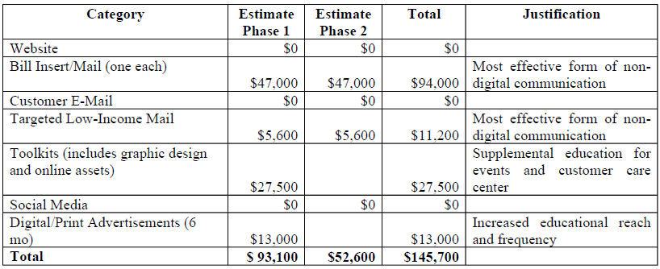
Liberty’s Justification
- Bill Insert/Mail: One for each phase. Most effective form of non-digital communication.
- Customer Email: No justification for costs provided in AL.
- Targeted Low-Income Mail: Includes graphic design and online access. Most effective form of non-digital communication.
- Toolkits (includes graphic design and online assets): Supplemental education for events and customer care center.
- Digital/Print Advertisements (6 months): Increased educational reach and frequency.
The Liberty AL 248-E-A supplemental added a description for each marketing expense, but Energy Division was still unable to determine how Liberty had derived their costs.
Figure 7: Second ME&O Budget
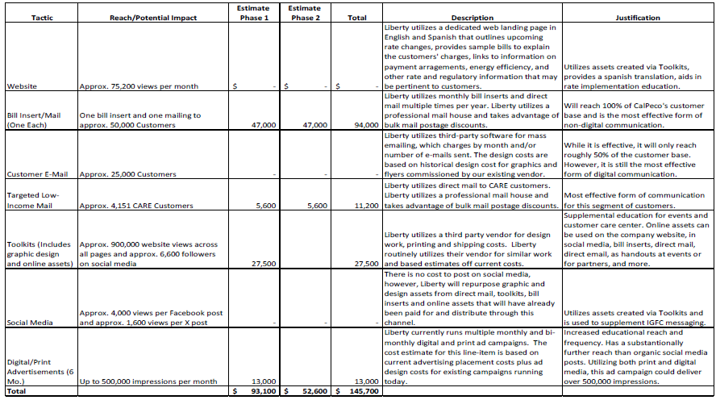
Finally, Liberty AL 248-E-B provided a third, refined budget which included per-unit costs in its estimate. This resulted in a substantial budget decrease from $145,700 to $110,890.
Energy Division finds the dollar amount of this ME&O budget to be reasonable. However, as noted in section 4.1.3 and OP 4.3, Liberty’s proposed marketing materials continue to lack fundamental information about the BSC, such as an indication of (or at least a placeholder) what the default non-CARE fixed charge will be.
Figure 8: Final ME&O Budget

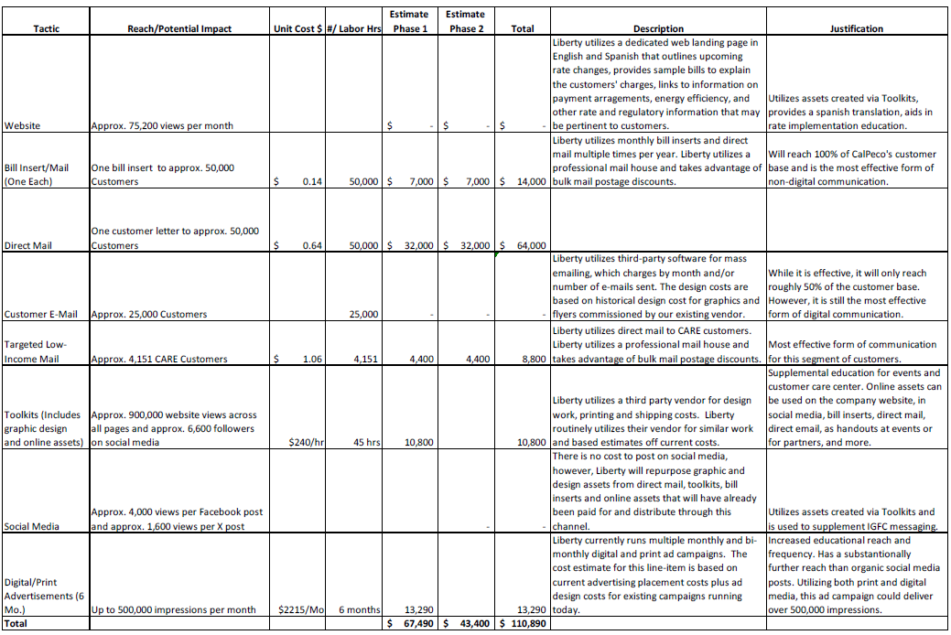

Comments
Public Utilities Code section 311(g)(1) provides that this Resolution must be served on all parties and subject to at least 30 days public review. Any comments are due within 20 days of the date of its mailing and publication on the Commission’s website and in accordance with any instructions accompanying the notice. Section 311(g)(2) provides that this 30-day review period and 20-day comment period may be reduced or waived upon the stipulation of all parties in the proceeding.

The 30-day review and 20-day comment period for the draft of this resolution was neither waived nor reduced. Accordingly, this draft resolution was mailed to parties for comments, and will be placed on the Commission's agenda no earlier than 30 days from today.

Findings
- Assembly Bill (AB) 205 (Stats. 2022, ch. 61) authorized the California Public Utilities Commission (Commission) to adopt an equitable rate structure for residential customers and to direct the electric investor-owned utilities to collect a reasonable portion of the fixed costs of providing electric services for residential customers.
- Decision (D.) 24-05-028 authorized all electric investor-owned utilities to change the structure of residential bills in accordance with AB 205.
- D.24-05-028 adopted a three-tier structure for the income graduated fixed charge for each investor-owned utility to adopt and set specific rate design guidelines addressing which revenues may be collected through the fixed charge.
- It is reasonable for the Small Utilities Base Services Charge Marketing, Education, and Outreach materials to be aligned with the Large Utilities to address the following topics:
- When the new fixed charge will be applied;
- Why and how the new fixed charge will reduce volumetric rates;
- The amount of the fixed charge and how the fixed charge will affect customers’ bills;
- How tiers will be assigned and how to move to a different income tier;
- Different rate options and rate comparison tools;
- Options to enroll in CARE or CARE Plus and other ways to manage energy costs;

- Assure CARE and CARE Plus customers that their assistance program discounts will not be affected by the fixed charge and that they may see lower bills as a result of the fixed charge; and
- Why and how the fixed charge will encourage the adoption of electrification technologies and associated reduced use of fossil fuels and how customers can find rebates to electrify.
- Liberty has not provided marketing materials, updated tariff sheets, or a plan that contain sufficient information to indicate:
- Why and how the new fixed charge will reduce volumetric rates;
- The amount of the fixed charge, particularly for default non-CARE customers, and how the fixed charge will affect customers’ bills;
- Different rate options and rate comparison tools;
- Other ways to manage energy costs;

- Why and how the fixed charge will encourage the adoption of electrification technologies and associated reduced use of fossil fuels and how customers can find rebates to electrify.

Therefore it is ordered that:
- The request of Liberty Utilities to implement the fixed charge for residential customers as proposed in Advice Letter 248-E, Advice Letter 248-E-A, and Advice Letter 248-E-B is approved with modifications. Liberty shall file supplemental Tier 2 compliance Advice Letters at least 60 days before the implementation of the Base Services Charge to incorporate the modifications ordered herein, as described further in Ordering Paragraphs 2 and 3.
- Liberty shall file a Tier 2 Rate Design Advice Letter at least 60 days before the implementation of the Base Services Charge with changes to the volumetric rate components of all residential tariffs active in 2025. This must include the following:
  - Specification of the proposed loading order and cost component breakdown for each tier of the fixed charge utilizing the latest revenue requirement data.
  - Updated Bill Impact Rate Analysis workpapers with the updated total (“net”) Base Services Charge, including converted adjustment rates.
  - Plans to convert volumetric adjustment rates to monthly tiered fixed charges to be layered on top of the base fixed charge to create a “total fixed charge”, using the most current values and revenue requirements.
- Revised tariff sheets for every modified rate.
- A table with a column specifying the name of each residential rate, its current fixed or minimum charge, and its future fixed or minimum charge.
- Liberty shall file a Tier 2 Marketing, Education, and Outreach Advice Letter at least
30 days before the implementation of the Base Services Charge with draft marketing materials consistent with the Decision which explain:
  - When the Base Services Charge will be applied;
  - Why and how the Base Services Charge will affect volumetric rates;
  - The amount of the fixed charge for all tiers and how the fixed charge will affect customers’ bills;
  - How tiers will be assigned and how to move to a different income tier;
  - Different rate options and rate comparison tools;
  - Options to enroll in CARE or CARE Plus and other ways to manage energy costs;

  - Assure CARE and CARE Plus customers that their assistance program discounts will not be affected by the fixed charge and that they may see lower bills as a result of the fixed charge; and
  - Why and how the fixed charge will encourage the adoption of electrification technologies and associated reduced use of fossil fuels and how customers can find rebates to electrify.
This Resolution is effective today.

The foregoing resolution was duly introduced, passed and adopted at a conference of the Public Utilities Commission of the State of California held on April 30, 2026; the following Commissioners voting favorably thereon:

Commissioner Signature blocks to be added
upon adoption of the resolution

Dated April 30, 2026, at California.

Confidential Appendix A

Liberty Slipsheets with Estimated ME&O Cost Details

REDACTED

Qualifying low-income Liberty households currently receive a 20% discount on electric bills from CARE.
Algonquin Power and Utilities Corp. 2024 Annual Report at IV. “Regulated Services Group”
https://libertyutilities.com/who-we-are.html
CalPeco IGFC Residential Rate Design workpapers, Customer Charge Tab at cells C14:D14.
AB-205.
The Federal Poverty Level or Federal Poverty Guideline Level (FPGL) is determined by the Department of Health and Human Services. Required by Section 673(2) of the Omnibus Budget Reconciliation Act (OBRA) of 1981 (42 U.S.C. 9902(2)) to be adjusted on at least an annual basis, based on the Consumer Price Index for All Urban Consumers , The poverty guidelines are used as an eligibility criterion for a number of need-based federal, state, and local programs.
The Settlement Agreement is included as Attachment C of the Decision and included as the following link on the CPUC website. https://docs.cpuc.ca.gov/PublishedDocs/Published/G000/M531/K686/531686022.pdf
The settlement at 9 included “Total Adjustment Rates Converted to a Fixed Charge” of $0.77 for Tiers 1-2, and $2.02 for Tier 3. This Advice letter only approves the base fixed charge, and not the “Total IGFC” which includes the adjustment component based on the recovery of specific revenue requirements.
Settlement Agreement at Attachment 1, page 40, D.24-05-028 at 120.
Settlement Agreement at Attachment 1, page 40.
Settlement Agreement at 9.
Settlement Agreement at Attachment 1, page 38.
Settlement Agreement at 9.
Settlement Agreement at 14.
D.24-05-028 at 101.
D.24-05-028 at 133 and 144.
D.24-05-028 at 121.
Ibid., OP 9. Ibid., OP 9. Liberty submitted AL 243-E, and Energy Division approved the unprotested AL on September 6, 2024.
Ibid., OP 10 (a). At this workshop, the Joint Utilities proposed an aligned terminology and messaging strategy which renamed the Income Graduated Fixed Charge (IGFC) to a Base Services Charge (BSC). This naming convention was adopted by the Commission through Resolutions SCE Res E-5356, SDG&E Res E-5355, PG&E Res E-5354.
Ibid., OP 10 (b).
Id. at OP 10.
Conclusion of Law 51.
D.24-05-028 at 121.
D.24-05-028 Ordering Paragraph 51 at 157.
CalAdvocates Protest to Liberty Utilities AL 249-E at 5.
Liberty AL 248-E at 8, Item 2.
Liberty AL 248-E, at 8.
Id., at 8-9.
See Appendix A
D.24-05-028 at COL 46.
PacifiCorp AL 744-E, 744-E-A, 744-E-B, and BVES ALs 495-E and 495-E-A.
Cal Advocates Protest to Liberty Utilities AL 249-E at 4.
Cal Advocates Protest, at 4.
Id., Attachment 1, Liberty Response to R.22-07-005 Demand Flexibility OIR Data Request No. CAL ADVOCATES Liberty 003, Response to Request No. 3, at 2-4.
Id., at 5.
Cal Advocates Protest, at 6.
Cal Advocates Protest, at 3.
Id., Attachment 1, Liberty Response to R.22-07-005 Demand Flexibility OIR Data Request No. CAL ADVOCATES Liberty 003, Response to Request No. 2, at 2.
Cal Advocates Protest, at 4.
Liberty’s Reply to Cal Advocates’ Protest, at 2.
Id.
Id., at 4.
Id.
Id.
Id.
The deficiencies are described in detail in Section 5. Proposed ME&O Plan and Budget of this document.
CARE Plus refers to “Tier 1” CARE customers who earn 100% of federal poverty guidelines or less who are now eligible for additional savings and the lowest fixed charge level.
Liberty AL-248-E at 10.
Liberty AL 248-E-B at 9.
Protest of Cal Advocates at 4.
Liberty Utilities AL 248-E-A at 4.
Liberty Utilities AL 248-E-A at 5.
Liberty Utilities AL 248-E-A at 5.
Joint Opening Brief of Bear Valley Electric Service, Inc. (U 913 E), Liberty Utilities (Calpeco Electric) Llc (U 933 E), and PacifiCorp (U 901 E) in Rulemaking 22-07-005 filed October 6, 2023 at 7.
Id. at 7-8.
D.24-05-028 at 133.
D.24-05-028 at 133.
Opening Comments in response to the Budget and Timing Ruling of Administrative Law Judge Wang in R.22-07-005, filed December 18, 2023.
Accessed from https://california.libertyutilities.com/truckee/residential/rates-and-tariffs/electrical.html
Per “Tariff Sheet Domestic Service to Company Employees” at 1: “Rates: The regular filed rate schedules applicable to domestic service in the territory where service is supplied, less 50% discount. Minimum Charge: $2.25 per month.” Effective July 15, 2013. https://california.libertyutilities.com/uploads/CalPeco%20Tariffs/Schedule_DE.pdf
AB 205 amending Section 739.9 of the Public Utilities Code 739.9. (e)(1)
D.24-05-028 FOF 23.
Both Bear Valley Electric Utilities and PacifiCorp have marketed their Tier 1 rate as CARE Plus. In their supplemental filings, Liberty follows this naming convention in AL 248-E-B, dated October 24, 2025.
D.24-05-028 at 120.
Response of NRDC and TURN to the Joint Motion for Adoption of the Track A Settlement Regarding First Version Income-Graduated Fixed Charges for the Small IOUs. February 14, 2024 at 2.
D.24-05-028 at 121.
D.24-05-028 Ordering Paragraph 51 at 157.
Liberty AL 248-E-B at Appendix A, at 12-13 (see CARE Application).
D.24-05-028, Conclusion of Law 48 at 157.
Liberty AL 248-E. Liberty AL 248-E-A.
Liberty AL-E-A at 8.
Liberty AL 248-E-B at 7, Item 2.
Liberty AL 248-E-B at 19 (Appendix B).
D.24-05-028 at 122.
Liberty AL 248-E-B at 12. Appendix A, Modified CARE/CARE Plus Application at 1.
Liberty AL 248-E-B at 13. Appendix A, Modified CARE/CARE Plus Application at 2.
Joint Motion for Adoption of The Track A Settlement Agreement Regarding First Version Income-Graduated Fixed Charges for Bear Valley Electric Service, Inc. (U 913 E), Liberty Utilities (Calpeco Electric) Llc (U 933 E), and Pacificorp (U 901 E) at 9.
AL 248-E-B at 8.
Liberty AL 248-E-B at 19.
Liberty AL 248-E-B at 6.
D.24-05-028 at 133.
D.24-05-028 at 134.
D.24-05-028 at 94 and 95.
D.24-05-028 at 141.
D.24-05-028 at 134 and OP 10.
PG&E Electric Rate Schedule E-1 at Sheet 1, accessed at https://www.pge.com/tariffs/assets/pdf/tariffbook/ELEC_SCHEDS_E-1.pdf, effective September 1, 2025. Customers with minimal usage were
Liberty AL-E-B at 7.
https://www.bvesinc.com/customer-service/income-graduated-fixed-charge-igfc
Protest of Cal Advocates at 6.
Advice Letter 248-E-B, Appendix A.
Advice Letter 248-E-B, Appendix B.
D.24-05-028. Conclusion of Law 51 at 157.
Liberty AL 248-E at 7.
Protest of CalAdvocates at 6.
Advice Letter 248-E at 10.
Id., at 10.
D.24-05-028 at 94 and 95.
Id.

