March 26, 2026 Agenda ID: 24117
RESOLUTION T-17857

TO: CASF Distribution List

This is Draft Resolution T-17857 of the Communications Division. This Draft Resolution will appear on the agenda at the next Commission meeting to be held April 30, 2026, which is at least 30 days after the date of this letter. The Commission may vote on this Resolution at that time, or it may postpone a vote until a later meeting. To confirm when the item will be heard, please see the Business Meeting agenda, which is posted on the Commission’s website 10 days before each Business Meeting. When the Commission votes on a Draft Resolution, it may adopt all or part of it as written, amend, modify, or set it aside and prepare a different Resolution. Only when the Commission acts does the Resolution become binding on the parties.

Any member of the public may serve comments on the Draft Resolution as provided in Public Utilities Code, § 311(g) and Rule 14.5 of the Commission’s Rules of Practice and Procedure (Rules).

Comments along with a certificate of service (COS) shall be sent via email to: the CASF Service List, Heyward.Daluz@cpuc.ca.gov by April 16, 2026, at 5:00 PM.

Those submitting comments on the Draft Resolution must serve their comments on the entire service list the Draft Resolution was served to on the same date that the comments are submitted to the Communications Division.

Comments shall focus on factual, legal, or technical errors in the proposed Draft Resolution. Comments should list the recommended changes to the Draft Resolution. Comments shall be limited to three pages in length and shall include a subject index listing the recommendations to the draft resolution, a table of authorities, and an appendix setting forth the proposed revised findings and ordering paragraphs.

Replies to comments must be submitted no later than April 21, 2026. Replies shall be submitted and served in the same manner as opening comments.

Sincerely,

/s/
Maria Ellis
Director for Broadband Initiatives
Communications Division
California Public Utilities Commission

PUBLIC UTILITIES COMMISSION OF THE STATE OF CALIFORNIA

Agenda ID#24117
Communications Division | RESOLUTION T-17857
CD/HD1 | April 30, 2026

R E S O L U T I O N

Resolution T-17857: Approves additional funding of up to $10,514,163 to the Karuk Tribe (U-7235-C) for the Klamath River Rural Broadband Initiative Project, approves the modification of the project to remove 181 of the originally approved 616 households and removes the Yurok Reservation from the project area.

PROPOSED OUTCOME:
- Approves up to $10,514,163 in additional funding from the California Advanced Services Fund (CASF) Infrastructure Grant Account for the Klamath River Rural Broadband Initiative (KRRBI) Project.
- Approves additional funding requested due to changes in permitting, engineering, and wage laws not in effect in 2013 when resolution T-17418 was approved.
- Approves the removal of 181 households from the original 616 households, resulting in 435 households.
- Approves removal of the Yurok Reservation from the KRRBI project area.

SAFETY CONSIDERATIONS:
- Access to broadband service will improve public safety, enabling access to government, e-health, and online education opportunities for the Karuk tribal community.

ESTIMATED COST:
- Up to $10,514,163 from the CASF Broadband Infrastructure Grant Account.
__________________________________________________________

SUMMARY

This Resolution approves additional funding of up to $10,514,163 from the CASF Infrastructure Grant Account for the Karuk Tribe to complete the KRRBI Project. This additional funding supplements the previously approved CASF funding amounts of $6,602,422 and $10,820,150 to deploy high-speed broadband services to 616 unserved households and numerous anchor institutions on the Karuk homelands.

The additional funding enables the Karuk Tribe to cover costs associated with:
(1) re-engineering and re-routing of cables and associated infrastructure due to the Yurok Tribe rescinding the original permission granted to the Karuk to deploy broadband cables and associated facilities on Yurok-owned land; (2) increased costs of materials and labor since 2013; and (3) increased costs of upgraded technology to make the KRRBI project compliant with the latest CASF broadband standard of 100 Mbps downstream and 20 Mbps upstream for projects receiving CASF grant funding. (4) costs associated with ownership agreements between the Yurok and Karuk tribes.

This Resolution approves a modification of the KRRBI project to reduce the number of households served in the project area from 616 to 435 due to the overlap in locations with the Karuk Tribe’s approved Fiber-To-The-Home Last Mile Federal Funding Account (FFA) grant which serves different locations than those funded by this Resolution. This Resolution also approves the removal of territory belonging to the Yurok Reservation from the project area. The Yurok Tribe requested that the Karuk Tribe remove the Yurok territory from the project area, and that any middle mile fiber on the Yurok reservation be built, owned, and maintained by the Yurok Telecommunications Corporation (YTEL).

The critical need, and community support, for this project has remained unchanged since the original approval. The Karuk tribal lands are located in a highly rural, isolated and unserved area of Humboldt County. Completion of this project will provide the final step required to provide high-speed internet access to tribal members living in hard to reach and geographically challenging terrain.

BACKGROUND

On February 1, 2013, the Karuk Tribe, in collaboration with its project partner, the
Yurok Tribe, submitted an application for CASF funding to bring broadband to the unserved communities of Orleans, Weitchpec, Orick and the underserved areas of Johnsons, Wautec, and other unincorporated areas of Humboldt County.

On October 17, 2013, the Commission adopted Resolution T-17418, conditionally authorizing a CASF grant of $6,602,422 to the Karuk Tribe for its KRRBI Project in Humboldt County, subject to the Commission’s completion of California Environmental Quality Act (CEQA) review. At the time, the grant represented 51.5% of the total estimated project cost of $12,815,748. The Karuk and Yurok Tribes would contribute the remaining 48.5% funding of $6,213,326, from grants that the Tribes obtained from the U.S. Department of Agriculture’s Rural Utilities Service (USDA-RUS).

On May 8, 2020, the Commission adopted Resolution T-17690, approving additional funding from CASF for the grant application of the Karuk Tribe in the amount of $10,820,150 requested for the KRRBI Project. The additional funding enabled the Karuk Tribe to cover costs associated with: (1) extending the middle-mile infrastructure to an interconnection point in McKinleyville (adding approximately 21.8 miles to the previously approved route of 82.3 miles); (2) providing the project with the appropriate level of management, permitting, engineering and environmental review; and (3) increased labor costs from changes to prevailing wage laws that were not in effect when the original grant was approved in 2013.

On December 1, 2022, the Commission adopted Resolution T-17772 approving the Final Initial Study/Environmental Assessment and Mitigated Negative Declaration for the KRRBI Project, prepared in compliance with CEQA, and authorized the release of CASF grant monies to the Karuk Tribe to construct the KRRBI Project.

In April of 2024, the Yurok Tribe asked for their land on the Yurok Reservation to be removed from the KRRBI project area, and that any middle mile fiber on the Yurok reservation be built, owned, and maintained by the YTEL. All portions of the KRRBI Project that are not located on the Yurok Reservation will remain part of the project. As a result of this change, an Indefeasible Right of Use (IRU) between the Karuk Tribe and YTEL is required so the Karuk Tribe can access infrastructure necessary to complete its project. This segment of approximately 11.5 miles on land owned by the Yurok Tribe was not funded with the YTEL FTTH Project Federal Funding Account grant. .

On August 2, 2024, the Karuk Tribe submitted a request for additional funding of $7,638,641 to complete the project, as well as a modification of the original geographic coverage of the KRRBI Project to remove the Yurok Reservation from the KRRBI project area.

On May 16, 2025, the Karuk Tribe submitted a revised request for additional funding, increasing their original request of $7,638,641 to $10,514,163 to complete the project, citing increased costs associated with construction, permitting and deployment to the remaining locations, which due to the nature of the environment and terrain are difficult to access and expensive to serve with high-speed internet.

In mid-June 2025, CASF Staff and the Karuk Tribe collaborated to identify and confirm the overlapping locations between the CASF’s KRRBI project and the Karuk Tribe’s Fiber-to-the-Home Last-Mile grant funded by the FFA. The Karuk Tribe reduced the reported number of households to be served from the KRRBI project from 616 to 435

Details are outlined in Table 1.

Table 1. Additional Funding Request Details

Project | Unserved Households  (number) | Last/Middle Infrastructure  (miles) | Funding (dollars)
Approved per Resolution  T-17418 | 616 | 82.3 | $6,602,422
Additional  Funding per Resolution  T-17690 | 616 | 104.1 | $10,820,150
Proposed Additional Funding | 435 | 73.5 (removing Yurok portion) | $10,514,163
Total | 435 | 73.5 | $27,936,735

CASF Guidelines for Requests of Additional Funding

CASF Program rules and guidelines, along with previously adopted Commission Decisions related to the CASF Program, do not discuss a process for addressing requests for additional funding. Staff review requests on a case-by-case basis and make recommendations to the Commission if a determination is made that exogenous factors beyond the applicant's control are the main reason for cost increases.

Legislative Changes to the CASF Infrastructure Account Since Approval of Resolution T-17690

The Commission approved the KRRBI project prior to the enactment of Senate Bill (SB) 156, which became effective July 20, 2021. Among other things, SB 156 changed the requirements for infrastructure funded by the CASF program. Pursuant to Public Utilities Code Section 281(f)(5), the Commission may only fund projects that "deploy infrastructure capable of providing broadband access at speeds of a minimum of 100 Mbps downstream and 20 Mbps upstream…" The Karuk Tribe will comply with the requirement of providing speeds at a minimum of 100 Mbps downstream and 20 Mbps upstream, using the proposed additional funds. This represents an increase from the previous approved Resolutions, where the requirements were 6 Mbps/1Mbps (Resolution T-17418) and 10 Mbps/1Mbps (Resolution T-17690). The tribal members will receive more reliable and consistent levels of service as a result of the additional funding provided.

The Legislature also added the requirement that each entity that receives CASF funding must report any expenses incurred of more than $25,000 when it uses a licensed
contractor or subcontractor for any work funded by CASF, and that the Commission
must publicly post this information on a monthly basis. The Karuk Tribe will be expected to comply with this new requirement.

DISCUSSION

In April of 2024, the Yurok Tribe made a request to the Karuk Tribe to remove the Yurok Reservation from the KRBBI project area. The impact of removing the Yurok Reservation from the project area was significant enough to warrant budget revision.
In May of 2025, the Karuk Tribe sent Communications Division (CD) Staff a comprehensive request with a breakdown of the $10,514,163 in additional expenses required to complete the project. The major cost changes are re-engineering and re-routing of infrastructure, the increase in the cost of materials and labor, and the cost to make the KRRBI project compliant with SB 156 minimum speeds requirements of 100 Mbps downstream and 20 Mbps upstream.

Table 2 summarizes the costs associated with the Karuk Tribe’s request for an additional $10,514,163 in CASF funding. The Karuk Tribe had a savings in easement costs from the 2020 KRRBI approved budget due to an easement that is no longer needed which was originally budgeted for $200,000.

Table 2. Summary of Additional Funds for the KRRBI Project
Item | Additional Cost Requests
Permitting Costs | $281,446
Management and Compliance | $298,602
Fiber Deployment Costs | $8,256,421
Wireless Last Mile | $1,743,544
Tower and Central Office | $134,150
Easement Cost Savings | $-200,000
Total | $10,514,163

The removal of the Yurok Reservation from the KRRBI project reduced the length of the middle mile portion to 73.5 miles, compared to the original 104 miles.

In June of 2025, CASF Staff and KRRBI representatives found 181 overlapping locations between the KRRBI project and Karuk’s Fiber-To-The-Home Last Mile FFA grant and agreed to remove the 181 overlapping locations (funded by their FFA grant) and reduce the KRRBI project’s original households from 616 to 435.

STAFF RECOMMENDATION

Staff have determined that the Karuk Tribe’s increased project costs are the result of exogenous and unforeseen factors. KRRBI started in 2013 as a collaborative project between the Karuk Tribe and the Yurok Tribe. The Karuk Tribe could not have anticipated Yurok’s request to be removed from the project in 2024. Staff reviewed the Karuk Tribe’s revised additional budget request and noted that the estimates correlate to increases in costs associated with re-engineering, materials and labor. Staff received confirmation from the grantee that this will be the last funding request for this project. The KRBBI project is located within a Tier 2 Fire-Threat District where reliable broadband Internet service is crucial for public safety, emergency response and recovery from future fires. Additionally, the KRRBI project will serve low-income communities and schools; 70% of students in the project area are economically disadvantaged. Based on this analysis, Staff recommends granting the Karuk Tribe $10,514,163 of additional CASF funds, modifying the project to remove the Yurok Reservation from the project area for the KRRBI project approved by T-17418 and T-17690 and reducing the number of households served by the KRBBI project to 435 to account for FFA overlap. These actions will not only provide much-needed infrastructure for successful deployment of high-speed internet service but also give the Karuk Tribe the autonomy and self-governance over their own network and facilities.

SAFETY IMPACT

The CASF program encourages the deployment of broadband throughout the State to enable the public to access Internet-based safety applications, tele-health services, emergency services, and to allow first responders to communicate and collaborate during emergencies. The project is highly supported by the tribal and surrounding communities for its potential to remove barriers to economic and workforce development, health care, education and public safety.

The KRRBI Project will provide a broadband network capable of supporting enhanced communications services in a Tier 2 High Fire-Threat District. Reliable broadband connectivity is crucial for public safety and rapid response and recovery from wildfires and other potential disasters.

California Environmental Quality Act (CEQA)

All CASF grants are subject to CEQA requirements unless the project qualifies for a statutory or categorical exemption under the CEQA Guidelines. The Commission previously found the project to be categorically exempt from CEQA review, pursuant to CEQA Guidelines, sections 15301 (Existing Facilities) and 15303 (New Construction or Conversion of Small Structures).

The Energy Division’s CEQA Staff reviewed the KRRBI Minor Project Refinement (MPR) authorized via Resolution T-17772. The changes in the project consist of removing certain segments from KRRBI’s original project area. CEQA Staff noted that the MPR is acceptable. The segments to be removed, as detailed in Appendix-C, include:

- A short portion of Segment 1 between Weitchpec and Orleans
- All of Segment 2, and
- the portion of Segment 3, between Martins Ferry Bridge and the western boundary of the Yurok Reservation (30.8 miles).

The Yurok Tribe will manage the removed sections, which include Segment 2 and other minor portions of Segments 1 and 3. This MPR will not require further CEQA review.

Removal of the above listed portions of the KRRBI Project will not impact the existing CEQA determination. Therefore, the Energy Division’s CEQA Staff does not have any concerns about the changes to the project.

COMMENTS

In compliance with Public Utilities Code, Section 311(g), a notice letter was emailed on March 26, 2026 informing parties on the CASF Distribution List of this draft Resolution, and of the opportunity for comment, at the Commission’s website at http://www.cpuc.ca.gov/documents/. The letter also informed parties that the final conformed Resolution adopted by the Commission will be posted and available at the same website.

FINDINGS AND CONCLUSIONS

- The Commission adopted Resolution T-17418 on October 17, 2013, authorizing $6,602,422 to the Karuk Tribe to construct the Klamath River Rural Broadband Initiative Project (KRRBI Project). The grant represented 51.5% of the total estimated project cost.

- The Commission adopted Resolution T-17690 on May 7, 2020, authorizing additional funding of $10,820,150 to the Karuk Tribe for its KRRBI Project.

- The Commission adopted Resolution T-17772 on December 1, 2022, approving the Final Initial Study/Environmental Assessment and Mitigated Negative Declaration prepared in compliance with the California Environmental Quality Act (CEQA) for the KRRBI Project; and authorizing the release of California Advanced Services Fund (CASF) grant monies to the Karuk Tribe to construct the KRRBI Project.

- On August 2, 2024, the Karuk Tribe submitted a request for additional funding of $7,638,641 to complete the project, as well as a modification in the original scope of the KRRBI Project to remove the Yurok Reservation from the KRRBI project area.

- On May 16, 2025, the Karuk Tribe submitted a revised request for additional funding, increasing their original request of $7,638,641 to $10,514,163 to complete the project citing increased costs associated with construction and permitting.

- In June 2025, CASF Staff found 181 overlapping households between the KRRBI project and the Karuk Tribe’s Fiber-To-The-Home Last Mile Federal Funding Account grant. The Karuk Tribe agreed to remove the 181 overlapping households from the KRBBI project.

- Based on its review, Staff determined that the increases in costs associated with re-engineering, materials and labor as a result of the Yurok’s request to remove the Yurok Reservation area from the KRRBI project area were attributable to factors beyond the control of the Karuk Tribe. The modified KRRBI project will serve 435 households, none of which are within the Yurok Reservation, nor overlap with Karuk’s Fiber-To-The-Home Last Mile Federal Funding Account grant.

- The Indefeasible Right of Use (IRU) between the Karuk Tribe and the Yurok Telecommunications Corporation (YTEL) is necessary for the Karuk Tribe to complete its project.

- Based on its review, Staff determined that $10,514,163 in cost increases for eligible households were attributable to factors beyond the control of the Karuk Tribe.

- A notice letter was e-mailed on March 26, 2026, informing all parties on the CASF Distribution List of the availability of this draft Resolution and the opportunity to comment. The draft Resolution was publicized on the Commission’s website at http://www.cpuc.ca.gov. This letter also informed parties that the final confirmed Resolution adopted by the Commission will be posted and available at this same website.

THERFORE, IT IS ORDERED THAT:

- The Commission shall approve the modification in project scope and additional funding of $10,514,163 from the original CASF Infrastructure Grant to the Karuk Tribe to complete the Klamath River Rural Broadband Initiative Project (KRRBI Project) in Humboldt County.

- The Karuk Tribe shall comply with all guidelines, requirements and conditions associated with a CASF award, as specified in D. 22-11-023 and its Attachment 1, and all requirements for this project included in this Resolution including Appendices D and E, in addition to conditions associated with the CASF funds award as specified in Resolution T-17418, Resolution T- 17690, Resolution T-17772, and Resolution T-17857.

- The Karuk Tribe shall complete the KRRBI Project as specified in Resolution T-17418, Resolution T- 17690, Resolution T-17772, and Resolution T-17857. If the Karuk Tribe fails to complete the project in accordance with the approval granted by the Commission and this Resolution, it will be required to reimburse some or all the CASF funds it has received.

4. This additional funding award constitutes the final allocation of California Advanced Services Fund monies for this project. No additional funding requests for this project will be considered.

This resolution is effective today.

Commissioner Signature blocks to be added
upon adoption of the resolution

The foregoing resolution was duly introduced, passed and adopted at a conference of the Public Utilities Commission of the State of California held on April 30, 2026, the following Commissioners voting favorably thereon:
Dated , at <Voting meeting location>, California

APPENDIX A
Resolution T–17857
The Karuk Tribe Klamath River Rural Broadband Initiative Project Key Information

Project Name | Klamath River Rural Broadband Initiative Project
Project Plan | The project will install a 73.5 -mile middle-mile fiber optic network as well as provide last mile fixed wireless broadband access to eight first responder agencies and fourteen other anchor institutions, as well as 435 households, in Orleans, Orick, Trinidad, Six Rivers National Park, and Hoopa.
Project Size (in square miles) | 34.3 square miles
Download/ upload speed (in Mbps) | 100/20 Mbps for $30.00/month (Low Income Plan) 100/100 Mbps for $84.00/month  200/200 Mbps for $124.00/month  500/500 Mbps for $204.00/month
Location | Humboldt County
Community Name | Orleans, Orick, Trinidad, Six Rivers National Park, Hoopa
CBGs/ Household Income | 060230101021 - $80,381  060239400002 - $63,491  060230101024 - $71,087  060230102004 - $44,110  060230101023 - $28,187
Census Blocks | 193
Estimated Potential Subscriber Size Households/ Subscribers | 435
Deployment Schedule (from Commission approval date) | 18 months
Amount of CASF Funds Requested | $10,514,163
Amount of CASF Funds Awarded | $10,514,163

APPENDIX B
Resolution T–17857
Original Project Area
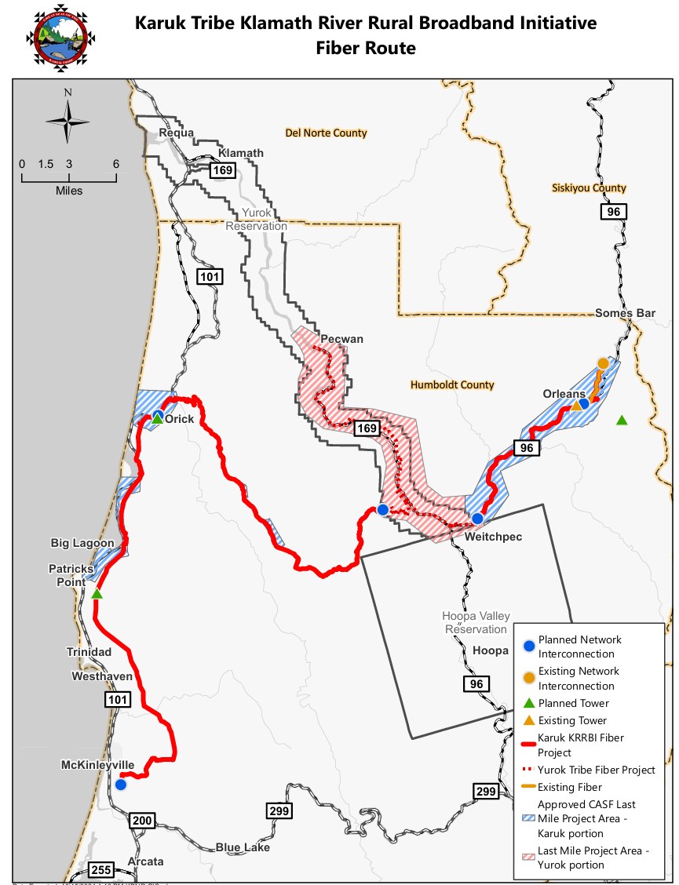

APPENDIX B
Resolution T–17857
New Project Area
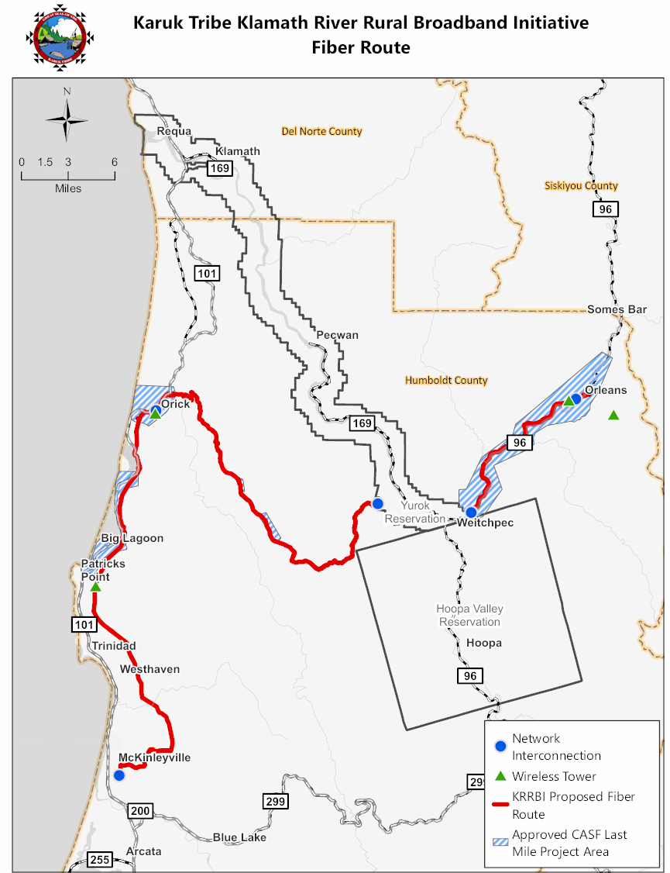

APPENDIX C
Resolution T–17857
The Karuk Tribe Klamath River Rural Broadband Initiative Project Area Segments
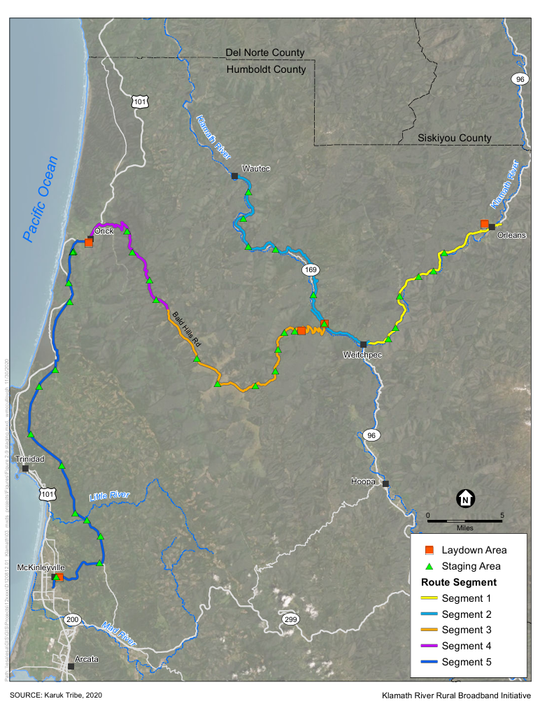

APPENDIX D
Resolution T-17857
Compliance Requirements

- Deployment Schedule
The Commission requires the Karuk Tribe to complete the Klamath River Rural Broadband Initiative Project within 18 months. If the applicant is unable to complete the proposed project within the 18-month timeframe requirements, the Karuk Tribe must notify the Director of the Communications Division as soon as the Karuk Tribe becomes aware of this possibility. If such notice is not provided, the Commission may reduce payment for failure to satisfy this requirement of timely notification to the Director.

- Execution and Performance
Staff and the Karuk Tribe shall determine a project start date after the CASF grant recipient has obtained all approvals, including permits. Should the Karuk Tribe or any contractor it retains fail to commence work by the designated date, upon five days’ written notice the Commission may terminate the grant. If the Karuk Tribe fails to complete the project in accordance with the terms of Commission approval as set forth in this resolution, the Karuk Tribe shall reimburse some or all of the CASF funds that it has received. The Karuk Tribe must complete all construction covered by the grant on or before the grant’s termination date.

- Letter of Credit
The Commission exempts Certificate of Public Convenience and Necessity (CPCN) holders from providing a letter of credit, on the basis that the company submitted a performance bond to the Commission to maintain its CPCN and that the Commission has other means to enforce compliance. In its application, the Karuk Tribe provided proof of CPCN registration and thus is exempt from the requirement of providing a letter of credit.

- Project Audit
The Commission has the right to conduct any necessary audit, verification, and discovery during project implementation/construction to ensure that CASF funds are spent in accordance with Commission approval. The Karuk Tribe’s invoices may be subject to a financial audit by the Commission at any time within three years of completion of the work.

- Providing Voice Service
If the KRRBI Project plans to provide voice service in the project area, it must meet the Federal Communications Commission (FCC) standards for E-911 service and battery backup.

- Reporting
All grantees must submit biannual progress reports on the status of the project, irrespective of whether grantees request reimbursement or payment. These reports are due semi-annually, in March and September, until the project is completely built and operational. Progress reports shall describe the schedule for deployment, major construction milestones and costs submitted in the proposal; indicate the actual date of completion of each task/milestone as well as problems and issues encountered, and the actions taken to resolve these problems and issues during project implementation and construction; and identify future risks to the project.

Before full payment of the project is made, the Karuk Tribe must submit a project completion report. The Karuk Tribe shall also include test results on the download and upload speeds at a representative sample of locations in the final completion report, per CASF Guidelines, Section 13: Reporting Requirements. The Karuk Tribe must certify that each progress report is true and correct under penalty of perjury.

Additionally, grantees must report annually by responding to the Commission’s annual request for data required for the CASF Annual Report and/or other reporting purposes. Responding to this annual data request is a program requirement.

- Prevailing Wage
Section 1720 of the California Labor Code specifies that CASF-subsidized projects are subject to prevailing wage requirements. The Karuk Tribe has committed to following state prevailing wage requirements with regards to these projects.
- Contractor Reporting
The Karuk Tribe must comply with the contractor reporting requirements of Section 281(l)(1) of the California Public Utilities Code, which requires reporting of certain information for all contractors and subcontractors undertaking a contract or subcontract in excess of twenty-five thousand dollars on CASF-subsidized projects.
APPENDIX E
Resolution T-17857
Payments to CASF Recipients

Pub. Util. Code § 281(f)(10) defines the costs the Commission may reimburse as follows:
- Costs directly related to the deployment of infrastructure;
- Costs to lease access to property or for Internet backhaul services for a period not to exceed five years; and
- Costs incurred by an existing facility-based broadband provider to upgrade its existing facilities to provide for interconnection.

Additionally, D.22-11-023, Attachment 1, Section 7 caps administrative expenses directly related to the project at 10 percent of the grant amount.
The grantee may submit reimbursement requests at the following intervals:
- 10 percent completion;
- 35 percent completion;
- 60 percent completion;
- 85 percent completion; and
- 100 percent completion.

The final 15 percent payment request (from 85 to 100 percent) will not be paid without an approved completion report. Payments are based on submitted receipts, invoices and other supporting documentation showing expenditures incurred for the project in accordance with the approved CASF funding budget included in the CASF grantee’s application.

Payment to grantees shall follow the process adopted for funds created under Public Utilities Code § 270. The Commission generally processes payments within 20-25 business days, including Communications Division and Administrative Services review time. The State Controller’s Office (SCO) requires an additional 14-21 days to issue payment from the day that requests are received by SCO from Administrative Services. The project is funded at 100%, CASF will not accept invoices that include a handling fee.

California Public Utilities Commission Resolution T-17418, October 21, 2013. (Resolution T-17418)
California Public Utilities Commission Resolution T-17690, May 7, 2020. (Resolution T-17690)
California Public Utilities Commission Resolution T-17846, September 26, 2024. (Resolution T-17846)
Resolution T-17772.
California Public Resources Code Sections 21000 et seq.
Resolution T-17846.
SB 156 enacted on July 20, 2021, and effective immediately, requires the Commission to fund projects that “deploy infrastructure capable of providing broadband access at a minimum of 100 Mbps downstream and 20 Mbps upstream . . .” See Pub. Util. Code Sec. 281(f)(5).
See Pub. Util. Code Sec. 281(1).
Resolution T-17690 approved May 8, 2020.
Fire-Threat Maps & the High Fire-Threat District (HFTD). See: https://www.cpuc.ca.gov/FireThreatMaps/.
See D. 22-11-023, Attachment 1.
Ibid., Section 13
Administrative costs are defined as “indirect overhead costs attributable to a project, per generally accepted accounting principles (GAAP), and the direct cost of complying with Commission administrative and regulatory requirements related to the grant itself.” Applicants seeking additional funds will require a Commission exemption included in a draft resolution.

