PUBLIC UTILITIES COMMISSION OF THE STATE OF CALIFORNIA
WATER DIVISION | RESOLUTION W-5312
 | April 9, 2026

R E S O L U T I O N
(RES. W-5312) Mountain Mesa Water Company General Rate Case.
PROPOSED OUTCOME:
- Grants Mountain Mesa Water Company (MMWC) a general rate increase of $220,932, or 52.65%, estimated to provide a Rate of Margin (ROM) of 27.50%.
- This rate increase is phased in over two years: Test Year (TY) 2026, and Escalation Year (EY) 2027.
SAFETY CONSIDERATIONS:
- MMWC has no major outstanding compliance issues with the State Water Resources Control Board, Division of Drinking Water.
- This general rate increase provides additional funding to MMWC to ensure the utility remains current with its infrastructure updates and system repairs.
ESTIMATED COST:
- Producing an increase in gross annual revenues of $110,466, or 26.32% for TY 2026, and an increase of $110,466, or 20.84% for EY 2027.
By Advice Letter 50-W, Filed on August 14, 2025

SUMMARY
By Advice Letter (AL) No. 50-W, filed on August 14, 2025, Mountain Mesa Water Company (MMWC) seeks a general rate increase producing additional annual revenues of $226,875, or 54.065%, based on a Rate of Margin (ROM) of 27.50%, for Test Year (TY) 2025.
This Resolution grants MMWC a general rate increase, producing additional annual revenues of $220,932, or 52.65%, and a ROM of 27.50% for TY 2026. To reduce rate shock to customers who have also commented on the significant increase, this increase will be phased in over two years. The increase will be $110,466, or 26.32%, for the first year and $110,466, or 20.84%, for the second year, for a total increase of 52.65%.
The monthly bill for an average residential customer with a 5/8 x 3/4-inch metered rate service using 10 hundred cubic feet (CCF) will increase from $82.72 to $97.08, or 17.36%, for TY 2026, and from $97.08 to $111.44, or 14.79%, for EY 2027.

BACKGROUND
By submission of AL 50-W to the WD, filed on August 14, 2025, MMWC requested authority under General Order (GO) 96-B, Rule 1.7 and 7.6.2, Water Industry Rules 7.3.3(5), and Section 454 of the Public Utilities Code to increase its annual revenues by $226,875, or 54.065%, for TY 2025 based on a ROM of 27.50%. MMWC initially filed its GRC for TY 2025, but TY 2026 will be used because of the GRC processing timeline.
MMWC’s present rates became effective on December 27, 2024, with the approval of AL 48-W, which authorized a Consumer Price Index (CPI) increase of $10,579 or 3.4%. MMWC’s last GRC increase became effective on May 30, 2012, pursuant to Res. W-4919, which authorized a general rate increase of $71,853, or 33.6% for TY 2012 and additional revenue of $25,153, or 8.08% for EY 2013, providing a ROR of 12.25% by 2013.
MMWC is a Class D investor-owned water utility with 396 service connections consisting of 327 single-family residential, 38 commercial, and 31 public fire protection customers in Kern County. MMWC’s service area is located in the unincorporated area adjacent to State Highway 178 and approximately three miles east of the community of Lake Isabella, Kern County. The median household income (MHI) for Kern County in 2023 is $67,660.
MMWC’s sources of supply are two active wells (Ranch Well 1 and Ranch Well 3) and two inactive wells, as well as an interconnection with California Water Service’s Southlake District, which have a capacity of 150 gallons per minute (gpm), 120 gpm, and 100 gpm, respectively. The primary sources Ranch Well 1 and Ranch Well 3 have a total capacity of 270 gpm which is adequate for the estimated maximum day demand (MDD) of 215 gpm. The interconnection from Southlake is used to enable the system to have a redundant water supply for its customers, allowing MMWC to purchase up to 420 gpm as a secondary source of supply. The interconnection serves as the primary source of supply when active sources or storage tanks are out of service or down for cleaning and inspections.
The utility has a total of two storage tanks (Ranch Tank and Hill Tank). The tanks are in good condition and well maintained. The total storage capacity is 300,000 gallons, which is slightly below the estimated MDD of 309,600. However, MWWC is considered to meet the MDD requirements because it has two primary sources in addition to its two storage tanks.
MMWC contracts a significant portion of its maintenance work to Erskine Creek Water Company (ECWC), a nearby CPUC-regulated class C water company with 1,133 connections.

NOTICE, PROTESTS, AND PUBLIC MEETING
In accordance with GO 96-B, MMWC served a copy of AL 50-W to its service list on August 14, 2025. A customer notice regarding both the proposed rate increase and the date for a public meeting was mailed to each customer and to the general service list on or before September 1st.

Customer Comments and Protests
Eight (8) written comments were received from customers regarding MMWC’s rate increase request. The complaints dealt mainly with the magnitude of the increase and expressed concerns about the impacts on low and fixed-income customers. All letters were responded to by MMWC.

Site Visit
WD staff, with the assistance of the vice president, Scott Kissack, and the main contractor from Erskine Creek Water Company, Justin Slinkard, inspected the water system on October 6, 2025. The major system components consisted of three wells (Wells 1, 2, and 3), two storage tanks (100,000-gallon Ranch Tank and 200,000-gallon Hill Tank), a backup generator, and a booster pump system.
The first location visited was the treatment plant, which contained multiple upright cylindrical treatment vessels, several of which were added in 2024. The vessels are designed to allow operators to replace media and contain gravel at the bottom with treatment media above. Well 3 uses a hybrid ion exchange resin to treat for arsenic, while Well 1 is treated for nitrates. A nitrate analyzer is installed on the exterior of the treatment area that monitors nitrate levels and alerts the operator when flow adjustments are needed. Chlorine is added after treatment and is stored in an enclosed tank with a pump. Staff observed an eye wash station available for safety purposes. All treatment system components were in good working condition.
WD staff observed the booster pump system, which connects the Ranch Tank to the Hill Tank located uphill from the treatment house. The system includes variable frequency drives and treatment boosters for both Well 1 and Well 3. All electronic components were well-labeled and protected, with no visible rust on the booster pump system. From the Hill Tank, the distribution system is gravity-fed to the rest of the community. The owner indicated that a backup generator has been installed within the last five years and is available as required, though it has not been needed.
Staff also inspected Well 2, which is currently inactive but available if needed. The well is periodically used for non-potable irrigation purposes and is flushed as required. Well 2 was observed to be in moderate condition.
WD staff drove through the service area and observed a representative sample of the distribution system, including hydrants and piping. The system maintains a pressure of 60-70 psi throughout. MMWC operates 37 hydrants, and no fire flow issues were reported. At the conclusion of the visit, staff observed the hospital and park facilities, which are the two largest customers on the system, with the hospital being served by a 4-inch meter. All system appurtenances appeared to be in working order.

Public Meeting
An informal public meeting was held on Monday Oct. 6th from 5:30pm to 7:30pm in Mountain Mesa, at the Kern River Vally Eagle Lodge in Lake Isabella. There were approximately 12 customers in attendance. WD staff provided an overview of the Commission’s GRC process for Class D water utilities. MMWC’s owner explained the need for the proposed rate increase and fielded questions from customers regarding concerns over the rate increase, service and operational issues, and how the utility plans to file for more consistent rate increases to minimize the effects of rate shock in the future.
During the public meeting, MMWC’s customers were given an opportunity to ask questions of MMWC and the WD, and to comment on MMWC’s proposed rate increase and quality of service. Several customers stated they are satisfied with the water quality and service and understood the need for the rate increase. Negative comments were mainly directed towards the magnitude of the rate increase, especially for minimal users and ratepayers with fixed incomes. Some suggested phasing the increase over multiple years. Other comments suggested MMWC offset the rate increase through grant funding. Mr. Kissack indicated he does not have plans to seek grants at this time. Mr. Kissack also explained the plan for filing future Consumer Price Increase (CPI) increases due to the need for reserves. Finally, he described the utility’s valve turning, fire hydrant, and flushing programs.
Customers had questions about water quality and what other contaminants required treatment.; Mr. Kissack stated that while arsenic levels are manageable, nitrate levels are more of a problem. MMWC’s plans to treat the elevated nitrate levels are discussed in the “Other Volume Related Expenses” section.

DISCUSSION
In reviewing MMWC’s rate increase request, the WD independently analyzed the utility’s rate increase request and its operations. Appendix A provides MMWC's current Summary of Earnings (SOE); MMWC’s requested rates; and WD’s recommended rates. The WD also provided MMWC with WD’s recommended revenues, expenses, and rate base. MMWC agrees with WD’s recommended revenue requirement for TY 2026 and EY 2027 shown in Appendix A, and the recommended rates shown in Appendix B.
The WD, in its analysis, escalated MMWC’s cost data for the years 2022 through 2025 in its expense calculations where necessary or accepted the requested expense values that were deemed reasonable.

Operating EXPENSES
The WD verified MMWC’s operating expense estimates for TY 2026 by reviewing supporting documents for substantiation and accuracy and included the amounts that were deemed reasonable and prudent.
MMWC developed most of its operating expense estimates for TY 2026 using the recorded amounts from 2022 through 2024 and applying the respective escalation factors to escalate the recorded amounts to TY 2026. WD provided alternative estimates either based on 3-year average of recorded years 2022 through 2024 or accepting MMWC’s requested expenses for TY 2026. WD’s recommended expense estimates are used in the Summary of Earnings and used to calculate rates.
Some of MMWC’s requested amounts were not within 5% of the three-year average, escalated three-year average, and value trending from the past three years, as directed by Standard Practice U-3-SM paragraph 16 and 19. This occurred for four operating expenses: other volume-related expenses, management salaries, office supplies & expenses, and general expenses. Additionally, two of MMWC’s requested amounts had items that were wrongly allocated. This occurred for transportation expenses and general expenses. The following table shows MMWC’s requested amounts, the escalated three-year averages, and WD’s recommendation for each expense.

Category | Requested | Escalated Three-Year Average | WD Recommended
Other Volume Related Expenses | $91,847 | $63,565 | $91,847
Transportation Expenses | $3,689 | $3,459 | $3,901
Management Salaries | $36,000 | $10,324 | $36,000
Office Supplies & Expenses | $11,055 | $563 | $11,055
General Expenses | $2,199 | $12,668 | $1,431

Transportation Expenses
For the transportation expenses, WD recommends moving the average fuel expense of $442 from general expenses to transportation expenses, as directed by Standard Practice U-39-W. Adding $442 into the escalated three-year average amount of $3,459 for transportation expenses, the recommended transportation expenses estimate is $3,901.

Other Volume Related Expenses
In 2024, Ranch Well 3 was taken offline due to elevated levels of nitrate. Although Ranch Well 1 is intended to be used to meet seasonal demand, it was taken online because it uses a nitrate selective resin that also removes arsenic. Ranch Well 3 was returned to service in August 2024. MMWC has also experienced increased arsenic in its groundwater, which requires the treatment media used to remove arsenic in the water to be replaced every 6 months, when it usually lasts a year. The increase costs are due to groundwater production in Ranch Well 1, which requires salt treatment to regenerate the media, resulting in brine disposal costs and more media being required due to the increased arsenic levels. The elevated nitrate and arsenic levels were caused by unusually high rainfall in 2024. Similar patterns occurred in 2025 and are expected to continue in 2026. Therefore, WD recommends MMWC’s requested amount of $91,847 for other volume related expenses to address the ongoing changes in their groundwater quality.

Management Salaries

MMWC requested management salaries to increase from $9,000 to $36,000 in order to recognize fair compensation for the water system manager, Scott Kissack. The manager works an average of 540 hours annually, resulting in an hourly rate of $66.66 based on the requested $36,000 expense for management salaries. WD finds this request reasonable as Mr. Kissack has full responsibility of MMWC’s operations including plant maintenance, system repairs, monthly and annual reporting, coordination with the DDW, collaboration with Erskine Creek Water Company, and makes all operating decisions.

General Expenses
The difference in MMWC’s general expenses compared to previous years is because the utility correctly reclassified its banking, phone, and trash expenses totaling $10,795 from general expenses to office supplies and expenses. As stated above, WD recommends moving the fuel expense of $442 from general expenses to transportation expenses. The escalated three-year average amount for general expenses of $12,668, subtracted by $442, leaves $12,226 for the general expenses. Moving the $10,795 reclassification amount from general expenses to office supplies and expenses results in a general expenses total of $1431. MMWC’s requested amount of $2,199 for general expenses does not fall within 5% of WD’s estimate. Therefore, WD recommends $1,431 for general expenses.

Office Supplies & Expenses
As discussed above, the $10,795 reclassification from general expenses to office supplies and expenses results in the escalated three-year average amount of $563 being increased to $11,358. MMWC’s requested amount for office supplies & expenses falls within 5% of WD’s estimate. Therefore, WD recommends using MMWC’s requested amount of $11,055 for office supplies & expenses.

Taxes
The WD’s State and Federal Income Taxes estimates for MMWC’s income tax expense are based on income tax rates of 8.84% for State and 21.00% for Federal Income Taxes. MMWC is structured as a C-Corporation. In previous years, MMWC had negative net income. Therefore, on its 2022 and 2023 annual reports, MMWC had been paying only the minimum franchise tax of $800 and no federal tax.
The state and federal tax estimates for TY 2026 and EY 2027 are outlined below in the following table.
 | TY 2026 | EY 2027
State | $5,807 | $15,572
Federal | $12,575 | $33,723

Accordingly, the WD’s State and Federal Income Tax expense estimates for MMWC’s TY 2026 are $5,807 and $12,575, respectively. Tax expense estimates for EY 2027 increase substantially as the estimated net revenue calculated using the authorized ROM is fully reflected in EY 2027 rates. WD’s income tax calculations are provided in Appendix D of this Resolution.

Utility Plant and Rate Base
For TY 2026, the WD’s analysis of MMWC’s rate base estimate included examining utility plant-in-service, materials and supplies, working cash, and depreciation reserve based on the utility’s annual reports from the last three years (2022 through 2024).

Rate Base
The total plant in service recommended by WD for TY 2026 is $1,352,765. Most of the plant items have undergone depreciation, resulting in net plant values of $682,209 in 2024, $708,296 for 2025, $722,883 for TY 2026, and $693,311 for EY 2027. The increase in this net plant value for 2025 is a result of a net plant addition of $81,349 in 2024, which reflects $22,581 in Water Treatment Plant and $58,768 for Reservoirs, Tanks, and Sandpipes.
MMWC requested $700,136 for average rate base in this GRC. WD’s rate base calculation incorporated the net plant value along with working cash, materials, and supplies, resulting in a total rate base of $702,778 for TY 2026, and a total rate base of $673,266 for EY 2027. The difference in total rate base amount between MMWC and WD is due to the differences in average accumulated depreciation and a small difference in working cash.
Working Cash
For TY 2026, MMWC requested $35,706 for working cash. The WD adjusted the working cash amount to $35,345 due to the lower recommended operating expenses. Since the WD’s total recommended operating expenses are $4,325 lower than MMWC’s requested expenses, the working cash and the recommended rate base amount were adjusted accordingly.
Depreciation
MMWC’s requested depreciation expense of $29,971 was accepted for both TY 2026 and EY 2027.
For Accumulated Depreciation Reserve, MMWC requested $632,885 for TY 2026, and WD recommends $629,882 for TY 2026 and $659,455 for EY 2027. The difference between MMWC's requested accumulated depreciation and WD's recommendation stems from different starting values used in the calculations. WD calculated the TY 2026 accumulated depreciation reserve by averaging the EOY 2023 Annual Report value of $615,295 and the EOY 2024 value of $644,469 (calculated as the 2023 balance of $615,295 plus the 2024 depreciation expense of $29,174 from Account 403). MMWC's calculation used $617,650 for the 2024 accumulated reserve, which differs from the Annual Report-based value, resulting in a higher requested average of $632,885. For EY 2027, WD calculated accumulated depreciation by averaging the TY 2026 EOY value of $644,469 and the EY 2027 EOY value of $674,440 (the TY 2026 EOY value plus the accepted depreciation expense of $29,971). MMWC agrees with WD's recommendation.

Rate of Return and Rate of Margin
MMWC’s rate increase request is based on a ROM of 27.50%. In accordance with the Commission ratemaking policy adopted by D.92-03-09, two methods are available for the Water Division to utilize for ratemaking for Class C and D water utilities, the Rate of Return (ROR) and Rate of Margin (ROM) methods. D. 92-03-09 directs the WD to calculate the company’s rates and revenue requirement using both methods and to recommend the ratemaking method resulting in the greater return.
For class D utilities, the WD recommends a ROR range of 12.80% to 14.30% and a ROM of 27.50%, as provided in the Commission’s 2025 memorandum for the recommended ROR and ROM for Class C and D water utilities issued on March 12, 2025. WD used both methods to determine the method resulting in a greater return. The calculations indicated that adopting a ROR of 14.30% produces an increase in revenue of $190,347, for a revenue requirement of $609,982, while adopting a ROM of 27.50% produces an increase in revenue of $220,932, for a revenue requirement of $640,566. In this case, the WD determined that the ROM method produced the higher revenue requirement and therefore recommends that the ROM method be used for MMWC’s TY 2026 GRC. Using the recommended ROM of 27.50%, the WD calculated a revenue increase of $110,466, or operating revenues of $530,101, in TY 2026, and a revenue increase of $110,466, or operating revenues of $640,566, in EY 2027.
In Appendix A, also referred to as the Summary of Earnings (SOE), the revenue requirement is provided for this GRC. MMWC requested an increase in revenues of $226,875, with a total estimated operating expense of $428,469. WD recommended an increase in revenues of $220,932, with a total estimated operating expense of $424,144. This recommendation is based on the utility’s requested ROM of 27.50%.
The decision to apply the rate increase as a phased increase over two years is based on customer feedback from protests and the informal public meeting. This will lessen the effect of rate shock and make the revenue increase more tolerable for MMWC’s customers. MMWC agrees with the recommended two-year phase-in.

Rates and Rate Design
MMWC’s rate structure consists of three rate schedules: Schedule No.1, Metered Service; Schedule LC, Late Payment Charge; and Schedule UF, Surcharge to Fund Public Utility Commission Reimbursement Fee. The rates proposed by the WD are shown in Appendix B. For the rate design of MMWC’s Schedule No. 1, Metered Service, the WD recommends that the increase in gross annual water revenues be implemented over two years, the Test Year of 2026 and the escalation year of 2027. WD further recommends that to provide a balance between fixed and volumetric charge cost recovery, 95% of Fixed Costs be recovered in Service Charge, and 5% be allocated to volumetric charges. Based on a 95% fixed cost recovery, for water service, the increase in revenues from present rates will be $110,466, or 26.32%, for the TY 2026 and $110,466, or 20.84%, for EY 2027, for a total increase of 52.65%.
At the recommended rates, the monthly bill for an average metered customer with a 5/8” x 3/4” service consuming 10 CCF per month under MMWC’s Schedule No. 1, Metered Service, will increase from $82.72 to $97.08, a $14.36 increase (17.36%), for TY 2026; and will increase from $97.08 to $111.44, a $14.36 increase (14.79%), for EY 2027. A comparison of monthly bills for customers with a 5/8” x 3/4” service at present and recommended rates is shown below, and in Appendix B. It should also be noted that MMWC was previously on a tiered rate structure with three tiers, increasing from $1.58 for Tier 1 to $2.53 for Tier 2, and finally $3.53 per CCF for Tier 3. For this comparison, 10 CCF falls within the second-tier quantity rate at $2.53 per CCF. The utility’s request to change the tier structure is intended to simplify calculations and comparisons. WD agrees with MMWC to switch to a single-tier quantity charge, given that the service area has not had a specific need for conservation measures, and that MMWC’s ratepayers are not regularly reaching Tier 3 water usage. Additionally, a single-tier rate design facilitates the recovery of the authorized revenue requirement
 | A | B | C | D
Year | Fixed Charge ($) | Quantity Rate ($) | Usage (CCF) | Bill (A + B x C)
Present | 57.42 | 2.53 | 10 | 82.72
TY 2026 | 64.89 | 3.22 | 10 | 97.08
EY 2027 | 72.36 | 3.91 | 10 | 111.44

Affordability of Proposed Rates
As discussed above at the recommended rates for TY 2026, the monthly water bill for an average metered customer consuming 10 CCF per month under MMWC’s Schedule No. 1, Metered Service, will increase from $82.72 to $97.08 in Test Year 2026 (17.36%) and from $97.08 to $111.44 (14.79%) for Escalation Year 2027. This amounts to a total increase of $28.72 (34.72%).
The annual water bill that WD recommends for an average customer will be 1.72% of median household income (MHI) for TY 2026 and 1.97% of MHI for EY 2027, based on Kern County’s MHI of $67,660.
Commission D.20-07-032, adopted in Rulemaking (R.) 18-07-006, defines affordability as the degree to which a representative household can pay for an essential utility service, given its socioeconomic status. D. 20-07-032 also adopts three metrics and supporting methodologies to be used for assessing the affordability of essential electricity, gas, water, and communications utility services in California. The three adopted metrics include: 1) the hours of minimum wage (HM) required to pay for essential utility services, 2) the socioeconomic vulnerability index (SEVI) of various communities in California, and 3) the ratio of essential utility service charges to non-disposable household income - known as the affordability ratio (AR). The affordability criteria were later revised to no longer include SEVI as a metric. Instead, the Commission utilizes the definition of Disadvantaged Community (DAC) under the California Communities Environmental Health Screening Tool, Version 4 (CalEnviroScreen 4.0). CalEnviroScreen 4.0, provided by the California Office of Environmental Health Hazard Assessment (OEHHA), identifies DACs by collecting multiple metrics and outputting a single value at the census tract scale. The census tract for MMWC’s service area is not a DAC census tract.
The WD continues to adhere to the Commission’s cost-of-service regulatory principles in developing rates for its jurisdictional utilities, and MMWC may also file for subsequent Consumer Price Index (CPI) rate increases.

Environmental and Social Justice
In February 2019, the Commission adopted an Environmental and Social Justice Action Plan (ESJ Action Plan) to serve as a roadmap to expand public inclusion in Commission decision-making processes to targeted communities across California. The ESJ Action Plan establishes a series of goals related to health and safety, consumer protection, program benefits, and enforcement in all the sectors the Commission regulates. On April 7, 2022, the Commission adopted Version 2.0 of the ESJ Action Plan to guide its decisions and determine that its broad regulatory authority continues to advance equity throughout the state. With this Resolution, the Commission addresses Goal #1 of the ESJ Action Plan, “Consistently integrate equity and access considerations throughout Commission regulatory activities,” and Goal #3: “Strive to improve access to high-quality water, communications, and transportation services for ESJ communities.”
Although the community of Mountain Mesa and its vicinity served by MMWC is not classified as a disadvantaged community, the WD considered equity and access considerations through its review of the proposed transaction in this resolution. CalEnviroScreen 4.0 ranks MMWC’s area (Mountain Mesa) in the 39th percentile meaning it is less vulnerable than census tracts statewide. Given the WD’s review of these current definitions and considerations, the WD recommended revenues for MMWC should lead to improvements in service for the existing conditions within the utility’s service area.

COMPLIANCE
The WD reviewed the utility’s compliance with water quality standards, financial regulations including regular submittal of annual reports, and required User Fees to the Commission as part of the GRC analysis.

Sanitary Survey
MMWC had 5 minor findings in its most recent Sanitary Survey in 2024 conducted by the SWRCB-Division of Drinking Water (DDW) District 19/Tehachapi District, mainly consisting of monitoring contaminants in the upcoming years, submitting updated plans, and reporting production data. DDW determined that the system has been in compliance with Title 22 standards for water system construction and operation.

Outstanding DDW Compliance Issues
There are no outstanding compliance items with DDW. MMWC’s last violation was in 2020 for failure to properly and timely report lead service lines, which was addressed with one of DDW’s District 19 sanitary engineers.

Financial Audit
The WD also reviewed the Commission’s Utility Audit Branch’s (UAB) 2023 financial review of MMWC’s financial statements for the year ended December 31, 2021. UAB noted a total of 5 findings with recommendations for MMWC to address, to which MMWC responded with a corrective action plan to address the relevant findings. MMWC has regularly submitted annual reports to the Commission.

USER FEES
Pursuant to Public Utilities Code section 433(a), public utilities are required to pay an annual Public Utilities Reimbursement Fee (annual fee) to the Commission. The WD confirmed with the Commission’s Fiscal Office that MMWC is current with all its annual fee payments, as verified in the Water Division’s Compliance Monitoring and Enforcement Program worksheet.

UTILITY SAFETY
Safety for water utilities considers several factors such as water quality, system design, operation and maintenance, and service. One of the highest safety priorities for the Commission is ensuring that water utilities serving water for human consumption provide water that is not harmful or dangerous to health. As previously noted, MMWC does not have any outstanding compliance matters with DDW. The WD’s recommended revenues will allow the utility to maintain its record of compliance and improve utility safety.

COMMENTS
Public Utilities Code section 311(g)(1) provides that resolutions generally must be served on all parties and subject to at least 30 days public review and comment prior to a vote of the Commission.
No comments were received.

FINDINGS AND CONCLUSIONS
- The Summary of Earnings (Appendix A) recommended by the Water Division (WD) is reasonable and should be adopted.

- The rates recommended by the WD (Appendix B) are reasonable and should be adopted.

- The quantities (Appendix D) used to develop the WD’s recommendations are reasonable and should be adopted.

- Mountain Mesa Water Company agrees with the Water Division’s recommended Summary of Earnings, rates, and quantities (Appendices A, B, and D).

- The water rate increase authorized herein is justified and the resulting rates are just and reasonable.

- Based on Water Division’s evaluation of MMWC’s operating expenses, Water Division finds MMWC's operating expense estimates for TY 2026 and EY 2027 reasonable, except where noted.

- MMWC’s requested ROM of 27.50% for its TY 2026 GRC is reasonable and within the Water Division’s recommended range of ROM for Class D water utilities.

- Authorizing a ROM of 27.50% provides for an authorized revenue requirement of $530,101 for TY 2026 and $640,566 for EY 2027.

- After the rates approved by this Resolution become effective, MMWC should be allowed to file a supplement to Advice Letter No. 50-W to incorporate the revised rate schedules (Appendix B) and to concurrently cancel its presently effective rate schedules.

- MMWC currently has no outstanding DDW enforcement actions from its last sanitary survey. The WD’s recommended rates for this GRC through this Resolution should act as the first step towards bringing the necessary revenues to sufficiently support MMWC in continuing to meet its required water operations and compliance efforts.

THEREFORE, IT IS ORDERED THAT:
- Authority is granted under Public Utilities Code Section 454 to Mountain Mesa Water Company to file a supplement to Advice Letter No. 50-W within five (5) days of this resolution to implement the revised rate schedules attached to this Resolution as Appendix B for TY 2026 and concurrently cancel its presently effective rate Schedules: Schedule No. 1, General Metered Service. The revised rate schedules are made effective May 1, 2026.
- Mountain Mesa Water Company shall submit a Tier 1 Advice Letter, at least 30 days before the effective date, to implement the revised rates attached to this Resolution as Appendix B for EY 2027 and concurrently cancel its then presently effective rate: Schedule No. 1, General Metered Service. The revised rate schedules shall be made effective May 1, 2027.

This Resolution is effective today.

I certify that the foregoing resolution was duly introduced, passed, and adopted at a conference of the Public Utilities Commission of the State of California held on April 9, 2026; the following Commissioners voting favorably thereon:

CERTIFICATE OF SERVICE
I certify that I have, by either electronic mail or postal mail, this day, served a true copy of Proposed Resolution No. W-5212 on all parties in these filings or their attorneys as shown on the attached lists.
Dated March 6, 2026, at San Francisco, California.

LEVI GOLDMAN
Levi Goldman

Parties should notify the Water Division, Third Floor, California Public Utilities Commission, 505 Van Ness Avenue, San Francisco, CA 94102, of any change of address to ensure that they continue to receive documents. You must indicate the Resolution number on which your name appears.

APPENDIX A
Mountain Mesa Water Company
Summary of Earnings
TY 2026 & EY 2027
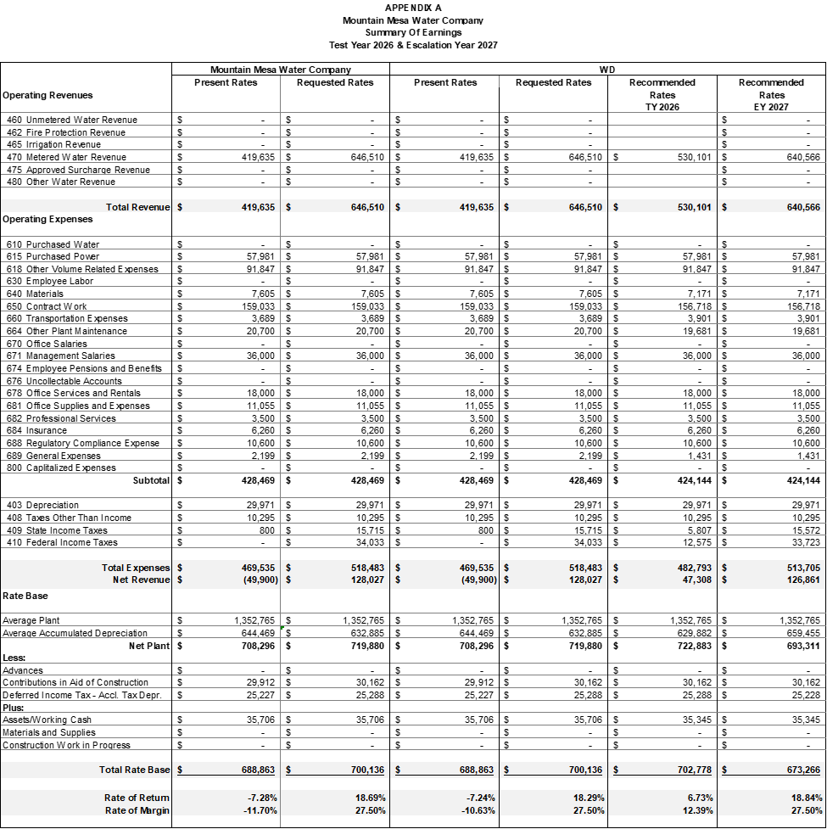END OF APPENDIX A

APPENDIX B
Mountain Mesa Water Company
TY 2026
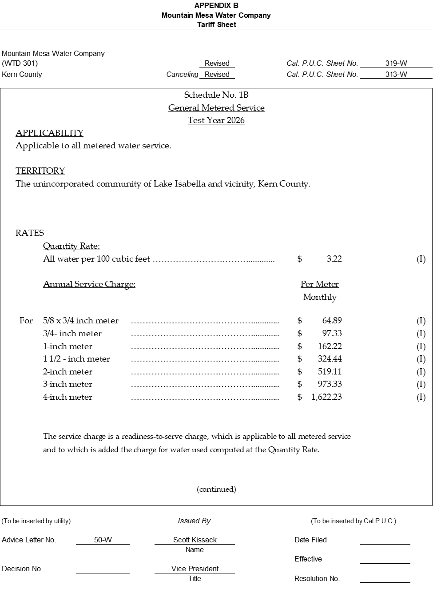
APPENDIX B
Mountain Mesa Water Company
EY 2027
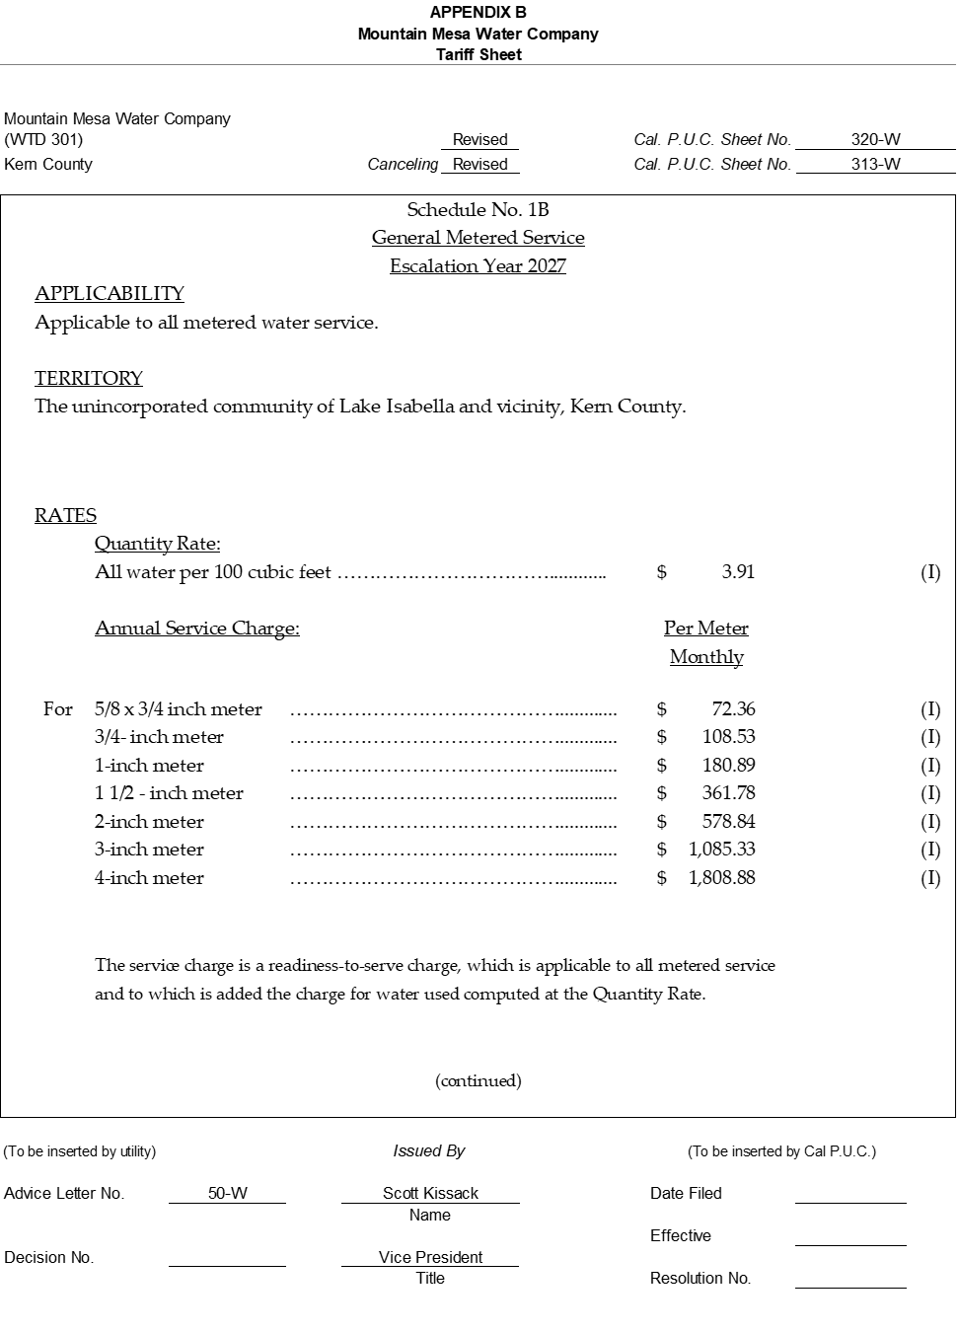
END OF APPENDIX B

APPENDIX C
Mountain Mesa Water Company
Comparison of Rates
TY 2026 & EY 2027
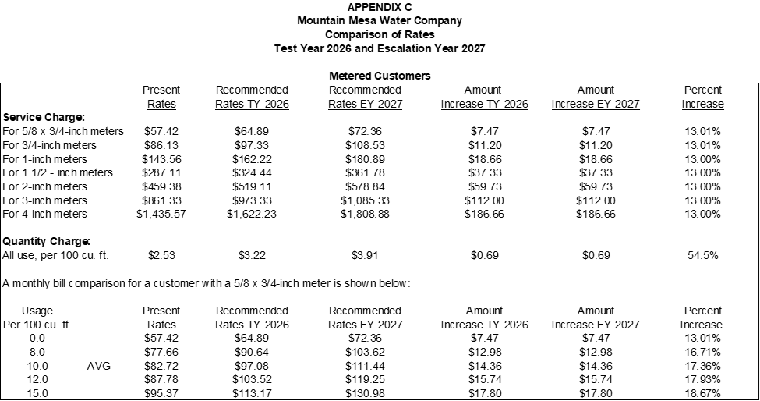END OF APPENDIX C

APPENDIX D
Mountain Mesa Water Company
Adopted Qualities
Test Year 2026
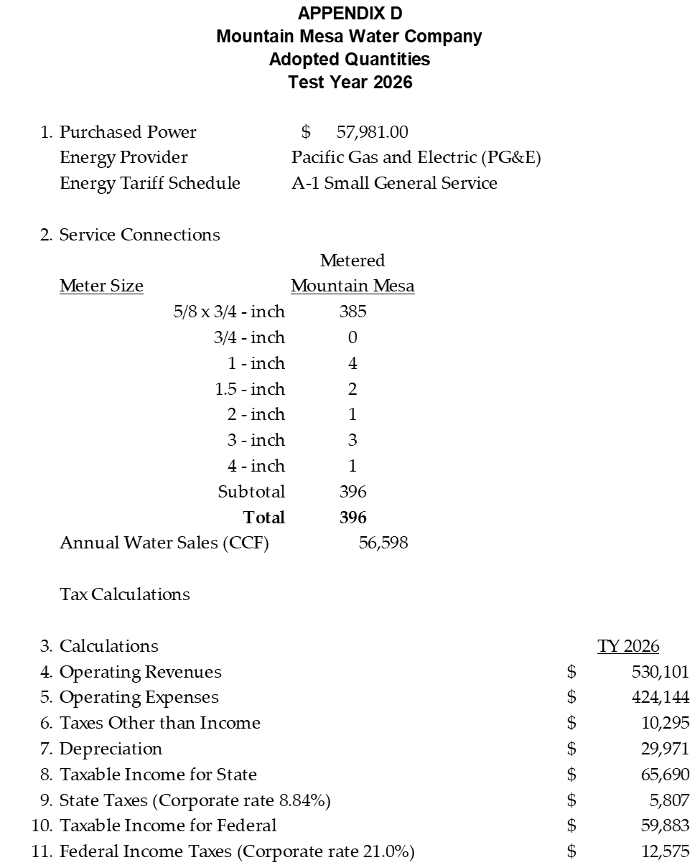
APPENDIX D
Mountain Mesa Water Company
Adopted Qualities
Escalation Year 2027
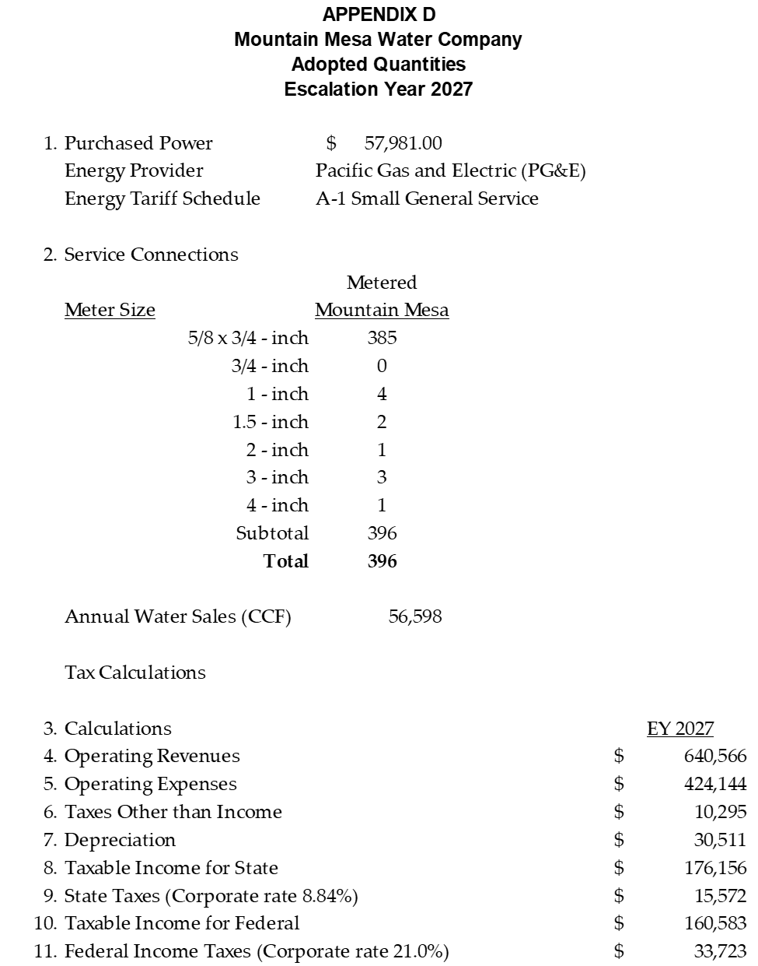
END OF APPENDIX D

MOUNTAIN MESA WATER COMPANY

ADVICE LETTER NO. 50-W SERVICE LIST

County of Kern Doris Poole
1115 Truxtun Avenue 5th Floor 6300 Park Ave
Bakersfield, CA 93301 Lake Isabella, CA 93240
planning@kerncounty.com

California Water Service Company Donna Zundel
Jon Yasin 4712 Mobile Dr
jyasin@calwater.com Lake Isabella, CA 93240

Erskine Creek Water Company
P.O. Box 656
Lake Isabella, CA 93240
Erskinecreekh20@aol.com

George Mumaw
6600 Dogwood Ave
Lake Isabella, CA 93240

Joe & Irma Franke
6521 Dogwood Ave
Lake Isabella, CA 93240

Herb Snell
6513 Lynch Canyon Dr
Lake Isabella, CA 93240

Karen Northcutt
4220 Poplar St
Lake Isabella, CA 93240

AL 50-W originally requested a 2025 Test Year, but given that over half of 2025 had passed by the time AL 50-W was filed, Water Division found a 2026 TY more appropriate.
One CCF is equivalent to 748 gallons with 10.48 CCF equivalent to 7840 gallons.
As defined in G.O. 96-B Water Industry Rules Section 1.2., Class B, C, and D investor-owned water utilities serve 2,001 through 10,000, 501 through 2,000, and less than 500 service connections, respectively.
This information is from the U.S. Census Bureau, American Community Survey (ACS) and Puerto Rico Community Survey (PRCS), 5-Year Estimates, U.S. Census Bureau QuickFacts: Kern County, California)
State Water Resources Control Board, Division of Drinking Water, Sanitary Survey of the Mountain Mesa Water Company Water Supply System, Public Water System No. CA150042
Maximum Day Demand is defined in the California Code of Regulations, Section 64551.30 as the amount of water utilized by consumers during the highest day of use (midnight to midnight) excluding fire flow.
Mountain Mesa Water Company’s Operation and Maintenance Plan for Well 1, Well 3
As directed by Standard Practice U-27-W, each Class B, C and D water utility earning less than the rate of return authorized in its most recent general rate case that is not in its test year and is not subject to a second test year or attrition year adjustment may file once each year by advice letter for a rate increase based on the most recent year-end increase in the Consumer Price Index for All Urban Consumers (CPI-U).
State Income Tax Rate for C-Corporations, https://www.ftb.ca.gov/file/business/types/corporations/c-corporations.html
US Corporate Income Tax Guide, https://taxrep.us/tax_guide/us-business-tax-guide/us-corporate-income-tax-guide/
Working cash is calculated by taking the total operating expenses and dividing by 12.
The revenue requirement and rates under the ROR method are based on company’s rate base and under the ROM method the revenue requirement is based on the company’s overall expenses which include operating and maintenance and depreciation expenses, income and other taxes, and an operating margin.
D. 92-03-093, Ordering Paragraph 8
The ROR/ROM memorandum can be found at https://www.cpuc.ca.gov/-/media/cpuc-website/divisions/water-division/reports/wd-memorandum/rorandrom-classcd2025.pdf
Decision adopting metrics and methodologies for assessing the relative affordability of utility service in Rulemaking 18-07-006.
https://oehha.ca.gov/calenviroscreen
State Water Resources Control Board Division of Drinking Water 2024 Sanitary Survey Mountain Mesa Water Company (System No. 1510042) report date November 20, 2025, inspection date June 24, 2024.
May 15, 2023, Review of Financial Statements for Mountain Mesa Water Company for the Years Ended December 31, 2021.

