Agenda # 3579
Agenda Item #30

State of California

M e m o r a n d u m

Date: 3/10/2026

To: All Commissioners, All Advisors, Executive Director Leuwam Tesfai, Chief ALJ Michelle Cooke, General Counsel Christine J. Hammond

From: Terra Curtis, Director
Consumer Protection and Enforcement Division

Subject: Agenda ID # 24018 before the Commission at its April 9, 2026, meeting

In this memorandum, the Commission will be asked to approve the designation of the following individuals as employees authorized to exercise the limited powers of a peace officer within the scope of their duties as specified in Penal Code Section 830.11 and Public Utilities Code Section 308.5.

In the scope of their duties, these individuals “investigate the laws administered by the Commission or commence directly or indirectly any criminal prosecution arising from any investigation conducted under these laws.” Penal Code Section 830.11 authorizes these individuals to exercise the powers of arrest, the power to serve search warrants. The Commission’s policy is to rely upon local law enforcement to make arrests and serve search warrants. Consequently, the appointment of the below-listed individuals enables them to assist local law enforcement in conducting searches after local law enforcement has served the warrant and secured the area when such activities are undertaken in the course of investigating entities subject to the Commission’s jurisdiction.

- Amber J Acosta
- Azita Jackson
- Grisel Reyes
- James Barbarick
- Kingsley Melton
- Mary Sekyi-Appiah
- Mingfeng Li
- Monisha Gangopadhyay

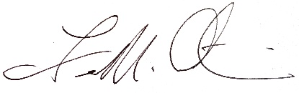
Terra Curtis, Director, Consumer Protection and Enforcement Division

CS#604029999

