May 28, 2026 Agenda ID: 24252
RESOLUTION T-17909

TO: Parties on the CASF Distribution (Service) List

This is Draft Resolution T-17909 of the ​Communications​ Division. This Draft Resolution will appear on the agenda at the next Commission meeting to be held July 2, 2026, which is at least 30 days after the date of this letter. The Commission may vote on this Resolution at that time, or it may postpone a vote until a later meeting. To confirm when the item will be heard, please see the Business Meeting agenda, which is posted on the Commission’s website 10 days before each Business Meeting. When the Commission votes on a Draft Resolution, it may adopt all or part of it as written, amend, modify, or set it aside and prepare a different Resolution. Only when the Commission acts does the Resolution become binding on the parties.

Any member of the public may serve comments on the Draft Resolution as provided in Public Utilities Code § 311(g) and Rule 14.5 of the Commission’s Rules of Practice and Procedure (Rules).

Comments along with a certificate of service (COS) shall be sent via email to: the CASF Service List, Benjamin.Swearingen@cpuc.ca.gov and casf_infrastructure_grant_administrator@cpuc.ca.gov by June 17, 2026, at 5:00 PM.

Those submitting comments on the Draft Resolution must serve their comments on the entire service list the Draft Resolution was served to on the same date that the comments are submitted to the ​Communications​ Division.

Comments shall focus on factual, legal, or technical errors in the proposed Draft Resolution. Comments should list the recommended changes to the Draft Resolution. Comments shall be limited to three pages in length and shall include a subject index listing the recommendations to the draft resolution, a table of authorities, and an appendix setting forth the proposed revised findings and ordering paragraphs.

Replies to comments must be submitted no later than June 22, 2026. Replies shall be submitted and served in the same manner as opening comments. Replies shall be submitted and served in the same manner as opening comments.

Sincerely,

/s/
Maria Ellis
Director for Broadband Initiatives
​​Communications​ Division
California Public Utilities Commission

PUBLIC UTILITIES COMMISSION OF THE STATE OF CALIFORNIA

Communications Division | Agenda ID #24252
Broadband Video and Marketing Branch | RESOLUTION T-17909
CD/BSW | July 2, 2026

R E S O L U T I O N

RESOLUTION T-17909: Approves up to $3,006,387 from the California Advanced Services Fund (CASF) for the Broadband Infrastructure Grant Account application of Stimulus Technologies of California, LLC for the Stimulus Tech Darwin Project and The Siskiyou Telephone Company (U-1017-C) for the Siskiyou CASF Deployment Project.

PROPOSED OUTCOME:

- Awards up to $3,006,387 from the CASF Infrastructure Funding Account to Stimulus Technologies of California, LLC for its project in Inyo County and to Siskiyou Telephone Company for its project in Siskiyou and Humboldt Counties.

SAFETY CONSIDERATIONS:
- There are no adverse safety considerations identified by the Communications Division. The projects to be funded by this award have the potential to improve communications resiliency and redundancy.

ESTIMATED COST:
- There are no costs associated with this Resolution.

SUMMARY

This Resolution approves grant funding in the amount of up to $706,754 from the California Advanced Services Fund (CASF) Broadband Infrastructure Grant Account (Infrastructure Account) to Stimulus Technologies of California, LLC (Stimulus Technologies) for the Stimulus Tech Darwin Project (Darwin Project) and up to $2,299,634 to The Siskiyou Telephone Company (STC) for the Siskiyou CASF Deployment Project (Siskiyou Project). Together, these projects will provide broadband connectivity to a total of 463 unserved locations in Inyo, Siskiyou and Humboldt Counties.

This Resolution recommends two individual grant awards to two grantees: Stimulus Technologies and STC. The following grant applications listed below in Table 1 are recommended for approval by the California Public Utilities Commission (Commission). Associated maps and project information summaries are included in the appendices.

Table 1: Summary of Grant Funding
Applicant | Project Name | Unserved Locations | Initial Requested Amount | Revised Amount | CASF Approved Amount
Stimulus Technologies of California, LLC | Stimulus Tech Darwin | 46 | $486,300 | $706,754 | $706,754
The Siskiyou Telephone Company | Siskiyou CASF Deployment Project | 417 | $2,395,775 | $2,299,633 | $2,299,633

- BACKGROUND

The CASF Infrastructure Account provides grant funding to Internet Service Providers (ISPs)/eligible entities to build or upgrade broadband infrastructure in areas that are unserved by existing broadband providers. The CASF program was initiated in 2008, after the program was first adopted by the Commission in Decision (D.) 07-12-054 and enacted into statute pursuant to Senate Bill (SB) 1193.

On July 20, 2021, Governor Newsom signed historic broadband legislation to help bridge the digital divide; SB 156 changed the definition of “unserved area,” allowing, but not requiring, funding for “an area for which there is no facility-based broadband provider offering at least one tier of broadband service at speeds of at least 25 Megabits per second (Mbps) downstream, 3 Mbps upstream.” Additionally, SB 156 requires grantees to “deploy infrastructure capable of providing broadband access at speeds of a minimum of 100 Mbps downstream and 20 Mbps upstream” and that any grantees receiving CASF funding must report subcontracted work in excess of $25,000. The Commission must post such information monthly on its website.

On November 17, 2022, the Commission issued D.22-11-023, adopting programmatic changes to the CASF Infrastructure Account. Attachment 1 of D.22-11-023 (“CASF Guidelines”) set forth the rules, application requirements, and guidelines for the CASF Infrastructure Account.

- APPLICATION REVIEW AND EVALUATION

On October 31, 2025, Stimulus Technologies submitted a CASF application requesting 100 percent funding of $486,300 to deploy a last-mile Fixed Wireless Access (FWA) network and provide broadband access to 46 unserved households in Inyo County. On the same date, STC submitted a CASF application requesting 100 percent funding of $2,395,775 to deploy a mixed fiber-to-the-home (FTTH) and FWA network and provide broadband access to 565 unserved households in Siskiyou and Humboldt Counties. On April 12, 2026, Stimulus Technologies amended their funding request to $706,754 to account for additional equipment and operational expenses. STC decreased their CASF funding request to $2,299,633 after reducing the proposed project to 417 locations due to overlap with the 141 FWA and FTTH locations the Broadband Equity Access and Deployment (BEAD) program will fund, six locations Commission staff determined to be already served and thus ineligible, and one location STC identified as located on Karuk Tribal land and voluntarily removed. STC’s total project amount of up to $3,006,387 will cover the complete deployment costs of the two projects.

For the 2025 CASF Infrastructure Grant application cycle, applicants determined eligibility for funding based on the California Interactive Broadband Map which relied on 2023 broadband availability mapping data. Because the evaluation and review period occurred while the Commission was collecting 2024 broadband availability location data, staff verified program eligibility using the current 2024 dataset to ensure all locations reflected the most recent broadband availability data and to prevent the awarding of program funds in areas already served.

Staff’s review and evaluation of these applications is summarized below.

- Stimulus Tech Darwin Project, Stimulus Technologies of California, LLC

Background
Stimulus technology was founded in 1995 by current CEO Nathan Whitaker. Initially focused on building custom computers and networks, Stimulus Technologies has grown into a comprehensive managed Information Technology (IT) Services company including cloud computing, broadband and Voice over Internet Protocol (VoIP) services. Stimulus Technologies specializes in providing high speed FWA broadband services to areas where fiber-based broadband service is not available. The company provides service in Nevada, Missouri, California, New Mexico, and Oregon. The company’s base of operations for California is in Long Beach, California with current subscribers in and around Inyo County.

This Resolution recommends approval of up to $706,754 in CASF Infrastructure Account funding for the Stimulus Technologies project application to deliver FWA to 46 unserved locations in Inyo County.

Project Summary
This resolution recommends approval of a grant of up to $706,754 to Stimulus Technologies for the Darwin Project. In compliance with D.22-11-023, staff determined that Stimulus Technologies’ Darwin Project is eligible to receive up to $706,754 in CASF Infrastructure Account grant funding.

Stimulus Technologies proposes to serve 46 unserved locations by constructing a FWA network providing up to 300 megabits per second (Mbps) download and 100 Mbps upload in Inyo County.

Challenges
Pursuant to Pub. Util. Code Section 281(f)(8) and as required by D.22-11-023, the Commission provided an opportunity for entities to challenge the application. Challenges were due on December 5, 2025. The Darwin Project received no challenges.

Revisions
The Darwin Project does not overlap with other BEAD projects or with Last Mile Federal Funding Account (FFA) projects that are providing terrestrial broadband services (FTTH or Fixed-Wireless access). Therefore, no locations were removed from Darwin Project due to overlap.

Technology Deployment
Stimulus Technologies will construct a fixed wireless network between Lone Pine and Darwin. The network will consist of three antennae and associated equipment collocated on two existing towers at Lone Pine and Cerro Gordo and four antennae placed on a new 100-foot tower on Bureau of Land Management land just outside of Darwin. The Darwin Project network will be fed by an existing middle-mile connection in Lone Pine and will deliver speeds up to 300 Mbps download and 100 Mbps upload.

Median Household Income and Low-Income Service
The median household income (MHI) for the Darwin Project area is approximately $65,245. This MHI meets the definition of low-income as set forth in D.22-11-023 as it falls at or below the low-income threshold of $76,750 for a family of four in Inyo County set by the Department of Housing and Community Development’s (HCD) list of state income limits.

As part of the project, Stimulus Technologies will provide a FWA low-income plan for $30 at speeds of 100 Mbps download and 20 Mbps upload. Stimulus Technologies stated that it intends to participate in the Home Broadband Pilot under the California LifeLine program. Installation and connection charges will be waived for five years from completion of the project.

Safety Considerations
The proposed Darwin Project enables the public to access the public safety benefits of reliable broadband infrastructure. While Darwin is not located in a Commission-designated High Fire-Threat District, it is a very rural, active mining town with no school, hospital or fire department. Residents lack access to broadband service, and the nearest cell phone signal is 26 miles away. The installation of broadband internet service with VoIP telephony will bring critical connectivity to the community of Darwin.

Funding Determination
Stimulus Technologies projects the proposed Darwin Project to cost $706,754. The CASF Infrastructure account will fund up to 100 percent of this cost.

Viability
Both Stimulus Technologies and the Darwin Project were determined to be financially viable, and the applicant’s engineering design meets the program standards. The applicant demonstrated the administrative, technical, and operational capacity to provide broadband service at the scale of this project.

Stimulus Technologies received a letter of support for the Darwin Project from Scott Marcellin, Chairperson, Inyo County Board of Supervisors.

California Environmental Quality Act
Based on the information received, the Commission’s Energy Division has determined that the Darwin project has not yet met the requirements of California Environmental Quality Act (CEQA) categorical exemption at this time. Stimulus Technologies must comply with the CEQA requirements discussed in the appendices. If Stimulus Technologies provides additional documentation demonstrating that the project qualifies for a CEQA exemption, then the project can be exempted by letter from the Communications Division Director or the director’s delegate or designee.

- Siskiyou CASF Deployment Project, The Siskiyou Telephone Company

Background
STC is one of 13 Small Incumbent Local Exchange Carriers (Small ILECs) operating in California in accordance with Public Utilities Code Section 275.6 in furtherance of the state’s universal service commitment to affordability and availability of safe, reliable, high-quality communications services in rural areas of the state. STC is eligible to draw revenue from the California High Cost Fund (CHCF-A) program. With over 125 years of telecommunications experience in Siskiyou County, STC provides broadband service to CASF-funded locations throughout Siskiyou’s service areas. STC has successfully deployed and managed broadband networks for over 30 years, including fiber, licensed fixed wireless, and unlicensed fixed wireless.

For three decades, STC has deployed and maintained licensed and unlicensed fixed wireless systems throughout its incumbent local exchange carrier (ILEC) territory for redundancy. STC’s wireless backhaul networks have enabled it to serve remote areas with broadband speeds up to 1 gigabit per second (Gbps). In 2024, STC deployed its first multipoint wireless system using state-of-the art technology to modernize its wireless network and provide higher speeds to customers.

Today, the company operates a wholesale open access interexchange network serving
approximately 4,200 locations across Siskiyou County. Over the last two decades, STC has built more than 1,500 miles of copper and fiber infrastructure with over 800 miles of fiber currently in its territory. Fiber-to-the-premise is now available to over 84 percent of locations it serves.

Project Summary
This resolution recommends that the Commission approve a grant of up to $2,299,633 for the Siskiyou Project. In compliance with D.22-11-023, staff determined that STC’s Siskiyou Project is eligible to receive up to $2,299,633 in CASF Infrastructure Account grant funding.

STC proposes to serve 417 unserved locations by constructing a mixed FTTH and FWA network with speeds up to 2.5 Gigabits per second (Gbps) download and 2.5 Gbps upload (fiber) and speeds up to 500 Mbps download and 100 Mbps download (wireless) in Siskiyou and Humboldt Counties. The project will serve 37 locations with FTTH and the remaining 380 with FWA. Of the total project cost of up to $2,299,633, approximately 73% will be allocated to the FTTH portion of the project and 27% will fund the FWA portion.

Challenges
Pursuant to Pub. Util. Code Section 281(f)(8) and as required by D.22-11-023, the Commission provided an opportunity for entities to challenge the application. Challenges were due on December 5, 2025. The Siskiyou Project received no challenges.

Revisions
In its original application for the Siskiyou Project, STC proposed to serve 565 locations. Staff determined that the Siskiyou Project does not overlap with FFA projects that are providing terrestrial broadband services (FTTH or Fixed-Wireless access). Staff analysis determined that STC should remove a total of 148 locations from the proposed project. STC agreed to remove 141 locations in which BEAD projects will provide the same locations with terrestrial broadband services and six locations that staff identified as already being served. STC also removed one location on the Karuk Tribal land to simplify their grant application. The revised Siskiyou Project proposes to serve 417 locations.

Technology Deployment
STC will deploy a combination of FTTH and FWA infrastructure to extend broadband access to 417 CASF-eligible locations within and adjacent to STC’s incumbent service territory. The Siskiyou Project’s network infrastructure will be 96 percent underground and 4 percent aerial. Adjacent to the east of its ILEC territory, STC will deliver FWA broadband service from its existing Antelope tower to 37 locations. The majority of project locations fall within Siskiyou County; 29 project locations are in Humboldt County.

The proposed project will leverage a combination of existing middle-mile fiber assets and new point-to-point (PTP) wireless backhaul connections to support the last-mile fiber and fixed wireless deployments. Within the Somes Bar area, the new FWA build will tie directly into STC’s existing middle-mile network which already interconnects with California’s statewide Middle-Mile Broadband Network. This interconnection provides the necessary transport and backhaul capacity to deliver reliable broadband services to the project area, while maintaining consistency with the state’s open-access objectives.

For the wireless component east of its ILEC territory, broadband service will be supported via point-to-point microwave backhaul to the Antelope tower, connecting it to STC’s existing network core.

Median Household Income and Low-Income Service
The MHI for the Siskiyou Project area is approximately $61,836. This MHI meets the definition of low-income as set forth in D.22-11-023 as it falls at or below the low-income threshold of $75,100 for a family of four in both Siskiyou and Humboldt Counties set by the Department of Housing and Community Development’s (HCD) list of state income limits.

As part of the project, STC will provide two low-income plans: a fiber optic plan for $35 at speeds of 100 Mbps download and 100 Mbps upload and a FWA plan for $30 at speeds of 100 Mbps download and 20 Mbps upload. Installation and connection charges will be waived for five years from completion of the project. STC intends to participate in the Home Broadband Pilot program to offer discounted plans to eligible households.

Safety Considerations
The proposed Siskiyou Project enables the public to access the public safety benefits of reliable broadband infrastructure. The project is located in rural census blocks with rocky and mountainous terrain in Siskiyou and Humboldt Counties. A significant portion of the project is in a Commission-designated Tier 2 High Fire-Threat District. The installation of high-speed broadband internet service will bring critical connectivity to the project area.

Funding Determination
STC projects the proposed Siskiyou Project to cost $2,299,633. The CASF account will fund 100 percent of the project cost.

Viability
Both STC and the proposed Siskiyou Project were determined to be financially viable, and the applicant’s engineering design meets the program standards. The applicant demonstrated the administrative, technical, and operational capacity to provide broadband service at the scale of this project.

STC received letters of support from Karuk Tribe Chairman Rusell Atteberry and from Northeastern California Connect Consortium and Jason Schwenkler of the Northeastern California Connect Consortium.

California Environmental Quality Act
Based on the information received, the Commission’s Energy Division has determined that the project meets the criteria for CEQA categorical exemption under 14 California Code of Regulation (C.C.R.) Section 15301 (Existing Facilities), Section 15303 (New Construction or Conversion of Small Structures) and Section 15304 (Minor Alternations to Land). Thus, the STC – Siskiyou Project is categorically exempt from CEQA review, and the Commission may authorize funds for the construction activities.

- NOTICE

On October 31, 2025, the Communications Division (CD) received 41 grant applications for CASF Infrastructure Account funding. On November 14, 2025 staff posted the proposed project area map and project summary for the Darwin and Siskiyou Projects on the Commission’s CASF Infrastructure Project Summaries webpage and sent notice regarding the project to the CASF Distribution and Service Lists.

- COMMENTS

In compliance with Public Utilities Code Section 311(g), a notice letter was emailed on May 28, 2026, informing all parties on the CASF Distribution List of the availability of the draft of this Resolution for public comments at the Commission’s documents website at http://www.cpuc.ca.gov/documents. This letter also informed parties that the final conformed Resolution adopted by the Commission will be posted and available on the same website.

- FINDINGS

- On October 31, 2025, Stimulus Technologies of California submitted an application for CASF funding for its Stimulus Tech Darwin Project to deploy a last-mile broadband infrastructure to enable Fixed Wireless Access (FWA) at speeds of up to 300 megabits per second (Mbps) download and 100 Mbps upload to 46 CASF Eligible locations in Inyo County.

- On October 31, 2025, the Siskiyou Telephone Company submitted an application for CASF funding for the Siskiyou CASF Deployment Project to deploy last-mile broadband infrastructure to enable fiber-to-the-home at service speeds of up to 2500 Mbps symmetrical and to enable FWA speeds of up to 500 Mbps upload and 100 Mbps per second download to 417 CASF eligible locations in Siskiyou and Humboldt Counties.

- On November 14, 2025, staff posted the proposed project area maps and project summaries of the Stimulus Tech Darwin and Siskiyou CASF Deployment Projects on the Commission’s CASF Infrastructure Proposed Project Summaries webpage.

- Staff received no challenges to the Stimulus Tech Darwin and Siskiyou CASF Deployment Projects.

- The Commission has determined that Siskiyou CASF Deployment Project is exempt from California Environmental Quality Act (CEQA) review at this time. The Stimulus Tech Darwin Project’s CEQA status is currently under review by the Commission.

- Based on its review, staff determined that both projects qualify for an Infrastructure Account grant pursuant to D. 22-11-023 and its Attachment 1 and recommends Commission approval of CASF funding of up to $3,006,387.

- A notice letter was emailed on May 28, 2026, informing all parties on the CASF Distribution List of the availability of the draft of this Resolution for public comments at the Commission’s documents website at http://www.cpuc.ca.gov/documents/.

THEREFORE, IT IS ORDERED that:

- The Commission shall award up to $706,754 in CASF Broadband Infrastructure Grant Account funds to Stimulus Technologies of California, LLC, for the Stimulus Tech Darwin Project as described herein and summarized in the appendices of this Resolution.

- The Commission shall award up to $2,299,633 in CASF Broadband Infrastructure Grant Account funds to The Siskiyou Telephone Company for the Siskiyou CASF Deployment Project as described herein and summarized in the appendices of this Resolution.

- Awardees shall comply with all guidelines, requirements and conditions associated with a CASF award, as specified in D.22-11-023 and its Attachment 1, and all requirements for this project included in this Resolution including Appendices A through G.

- If Stimulus Technologies of California fails to complete the project in accordance with the CASF guidelines and requirements outlined in D.22-11-023 and its Attachment 1, and the terms outlined in this Resolution, Stimulus Technologies of California, LLC, must reimburse some or all the CASF funds that it has received.

- If The Siskiyou Telephone Company fails to complete the project in accordance with the CASF guidelines and requirements outlined in D.22-11-023 and its Attachment 1, and the terms outlined in this Resolution, Stimulus Technologies of California, LLC, must reimburse some or all the CASF funds that it has received.

- The Commission has determined that The Siskiyou Telephone Company – Siskiyou CASF Deployment Project is exempt from California Environmental Quality Act review pursuant to 14 California Code of Regulation (C.C.R.) Section 15301 (Existing Facilities), Section 15303 (New Construction or Conversion of Small Structures) and Section 15304 (Minor Alternations to Land). The Commission may authorize funds for the construction activities.

- For the Stimulus Tech Darwin Project, the Commission cannot release funds for construction activities until California Environmental Quality Act (CEQA) review is complete. Stimulus Technologies of California, LLC must comply with the requirements set forth in the CEQA Section of the Resolution. Stimulus Technologies of California, LLC must provide their Proponent’s Environmental Assessment for the Stimulus Tech Darwin Project prior to the first payment. If staff evaluation finds the Stimulus Tech Darwin Project can be exempt from the California Environmental Quality Act, then the project can be exempted by letter from the Communications Division Director or the director’s delegate or designee.

- Awardees must complete and execute the consent forms (to be sent to the grantee after this Resolution is adopted) agreeing to the conditions set forth in this Resolution and return to CASF Staff within 30 calendar days from the date of the adoption of this Resolution. Failure to submit the consent form within 30 calendar days from the adoption date of this Resolution may result in the Commission voiding the grant award.

This resolution is effective today.

Commissioner Signature blocks to be added
upon adoption of the resolution

The foregoing resolution was duly introduced, passed and adopted at a conference of the California Public Utilities Commission of the State of California held on July 2, 2026, the following Commissioners voting favorably thereon:

Dated , at ______________, California

APPENDIX A

Compliance Requirements

- Deployment Schedule
The Commission requires a grantee to complete their projects within 18 months, or 24 months if not California Environmental Quality Act (CEQA)-exempt. If the grantee is unable to complete the proposed project within the timeframe requirements, the grantee must notify the Director of the Communications Division as soon as the grantee becomes aware of this possibility. If such notice is not provided, the Commission may reduce payment for failure to satisfy this requirement of timely notification to the Director.

- Execution and Performance
Staff and awardee shall determine a project start date after the CASF grant recipient has obtained all approvals, including permits. Should the grantee or any contractor it retains fail to commence work by the designated date, upon five days’ written notice the Commission may terminate the grant. If the grantee fails to complete the project in accordance with the terms of Commission approval as set forth in this resolution, the awardee shall reimburse some or all of the CASF funds that it has received. The grantee must complete all construction covered by the grant on or before the grant’s termination date.

- Minimum Performance Criteria
 | CASF Performance Criteria | Proposed Projects
 | CASF Performance Criteria | Darwin Project | Siskiyou Project
Project Completion | CEQA-exempt projects must be  completed within 18 months; all other projects shall be completed within 24 months after receiving authorization to construct | within 18 months of permitting approval  (if CEQA Exempt) | within 18 months of permitting approval  (CEQA except)
Pricing | Prices committed for five years after completion of the project | 5-year commitment | 5-year commitment
Speed | At least 100/20 Mbps | 300 Mbps/100 Mbps | Fiber: 2.5Gbps/ 2.5 Gbps  FWA: 500 Mbps/  100 Mbps
Latency | Maximum of 100 ms of latency | < 100 ms | < 100 ms
Data Caps | Minimum of 190 GBs per month | No data cap | No data cap
Affordability | Must offer low-income plan | FWA: $30.00/month at 100/20 Mbps | Fiber: $35.00/month at 100/100 Mbps  FWA: $30.00/month  at 100/20 Mbps

- Letter of Credit
The Commission exempts Certificate of Public Convenience and Necessity (CPCN) holders from providing a letter of credit since a CPCN holder must submit a performance bond to the Commission to maintain its CPCN and given the Commission has other means to enforce compliance. In its application, STC provided proof of CPCN registration and thus is exempt from the requirement of providing a letter of credit.

Stimulus Technologies does not hold a CPCN and provided a letter from Live Oak Bank stating the bank will provide the company with a Letter of Credit for this grant program subject to program approval and underwriting diligence. Stimulus Technologies must submit a letter of credit before receiving CASF grant funding.

- Project Audit
The Commission has the right to conduct any necessary audit, verification, and discovery during project implementation/construction to ensure that CASF funds are spent in accordance with Commission approval.

Grantee invoices may be subject to a financial audit by the Commission at any time within three years of completion of the work.

- Providing Voice Service
Stimulus Technologies has attested that its Voice Over Internet Protocol (VoIP) service for the Darwin Project will meet the FCC standards for E-911 service and battery backup. STC has attested that its current VoIP service in the ILEC territory overlapping the Siskiyou Project meets FCC standards for E-911 service and battery backup. STC will offer voice service within its ILEC territory. STC will offer VoIP service in project areas outside its ILEC territory to customers who sign up for broadband service.

- Reporting
All grantees must submit biannual progress reports on the status of the project, irrespective of whether grantees request reimbursement or payment. These reports are due semi-annually, in March and September, until the project is completely built and operational. Progress reports shall describe the schedule for deployment, major construction milestones and costs submitted in the proposal; indicate the actual date of completion of each task/milestone as well as problems and issues encountered, and the actions taken to resolve these problems and issues during project implementation and construction; and identify future risks to the project.
Before full payment of the project is made, grantees must submit a project completion report. Grantees shall also include test results on the download and upload speeds at a representative sample of locations in the final completion report per CASF Guidelines, Section 13: Reporting Requirements. Grantees must certify that each progress report is true and correct under penalty of perjury.

- Prevailing Wage
Section 1720 of the California Labor Code specifies that CASF-subsidized projects are subject to prevailing wage requirements. Grantees committed to following state prevailing wage requirements with regards to these projects.

- Contractor Reporting
Grantees must comply with the contractor reporting requirements of Section 281(l)(1) of the California Public Utilities Code, which requires reporting of certain information for all contractors and subcontractors undertaking a contract or subcontract in excess of twenty-five thousand dollars, on CASF-subsidized projects.

APPENDIX B

Payments to CASF Recipients

Pub. Util. Code Section 281(f)(10) defines the costs the Commission may reimburse as follows:
- Costs directly related to the deployment of infrastructure;
- Costs to lease access to property or for Internet backhaul services for a period not to exceed five years; and
- Costs incurred by an existing facility-based broadband provider to upgrade its existing facilities to provide for interconnection.

Additionally, D.22-11-023, Attachment 1, Section 7 caps administrative expenses directly related to the project at 10 percent of the grant amount.

The grantee may submit reimbursement requests at the following intervals:
- 10 percent completion;
- 35 percent completion;
- 60 percent completion;
- 85 percent completion; and
- 100 percent completion.

The final 15 percent payment request (from 85 to 100 percent) will not be paid without an approved completion report. Payments are based on submitted receipts, invoices and other supporting documentation showing expenditures incurred for the project in accordance with the approved CASF funding budget included in the CASF grantee’s application.

Payment to grantees shall follow the process adopted for funds created under Public Utilities Code Section 270. The Commission generally processes payments within 20-25 business days, including Communications Division and Administrative Services review time. The State Controller’s Office (SCO) requires an additional 14-21 days to issue payment from the day that requests are received by SCO from Administrative Services. The project is funded at 100%, CASF will not accept invoices that include a handling fee.

APPENDIX C

California Environmental Quality Act Requirements

Stimulus Tech Darwin Project
The Stimulus Tech Darwin Project is subject to California Environmental Quality Act (CEQA) review:

The Commission must complete CEQA review prior to disbursing CASF funds for construction activities. The initial funding granted in this Resolution may be used for project development and other Stimulus Technologies activities that do not involve construction or any activities that would have any direct or indirect effect on the physical environment. Prior to any construction activity for the project, Stimulus Technologies is required to seek further authority from the Commission for such activity by filing a Proponent’s Environmental Assessment (PEA) pursuant to Commission Rule of Practice and Procedure 2.4; and must undergo an environmental review pursuant to CEQA (California Public Resources Code § 21000 et seq.).

Stimulus Technologies should contact the Supervisor of the Commission’s Energy Division Infrastructure Planning and CEQA Section well in advance of a contemplated filing to (a) consult with staff regarding the process of developing and filing a PEA ; (b) provide for cost recovery per Rule of Practice and Procedure 2.5; and (c) enter into a Memorandum of Understanding to allow the Energy Division to initiate the retention of an environmental contractor to perform the environmental review. Stimulus Technologies must provide a PEA prior to the first payment. The Commission cannot release funds for the construction phase of this project until the Commission has completed CEQA review.

Siskiyou CASF Deployment Project
The Siskiyou CASF Deployment Project was subject to CEQA review and determined to be Categorically exempt.

The Siskiyou CASF Deployment Project (Siskiyou Project) is located in Siskiyou and Humbolt Counties. Siskiyou Telephone Company (STC) provided the Commission with its project plans to construct 7.12 miles of fiber optic cable (.26 miles aerial, 6.86 miles underground), conduit and handholes. The remainder of the project will be served with licensed fixed wireless. The STC fixed wireless deployment will involve no ground disturbance and installation of equipment is limited to an existing tower and at customer premises.

All project infrastructure will be built under or along state and county-maintained roads, previously disturbed land and existing right-of-way used by utilities. There will be no placement of project infrastructure in new right-of-way or previously undisturbed ground. Following the completion of construction activities, STC will return the site to its original condition. Based on the information that STC provided, the Commission’s Energy Division has confirmed that the project meets the criteria for the CEQA categorical exemptions under 14 California Code of Regulation (C.C.R.) Section 15301 (Existing Facilities), Section 15303 (New Construction or Conversion of Small Structures) and Section 15304 (Minor Alterations to Land). Thus, STC – Siskiyou Project is categorically exempt from CEQA review, and the Commission may authorize funds for construction activities.
APPENDIX D
Key Information

Stimulus Technologies of California
Stimulus Tech Darwin Project
Project Name | Stimulus Tech Darwin Project
Project Plan | The project proposes to deploy FWA across one county to 46 unserved locations.
County | Inyo
Communities | Darwin
Project Size | 0.13 sq miles
Download / Upload speed | 300 Mbps/100 Mbps
Median Household Income | $61,836
Pricing Plan  (Monthly) | Tier 1 (50 Mbps/20 Mbps): $40.00  Tier 2 (100 Mbps/50 Mbps): $85.00  Tier 3 (200 Mbps/75 Mbps): $115.00  Tier 4 (300 Mbps/100 Mbps): $145.00
Affordability | FWA Low-income Plan (100 Mbps/20 Mbps): $30.00
Unserved Locations | 46
Subscriber Take Rate | 70%
High Fire Threat Districts | No
Deployment Schedule (from permit approval date) | 18 Months (CEQA-exempt)  24 Months (non-CEQA exempt)
Proposed Project Budget | $706,754
Original Grant Request | $486,300
CASF Grant Amount | $706,754
Cost per Eligible Location | $15,364
Census Blocks | 060270008002072  060270008002073  060270008002074  060270008002083  060270008002084 | 060270008002086  060270008002088  060270008002089  060270008002130 | 060270008002131  060270008002132  060270008002133  060270008002134

APPENDIX E
Project Location Map

Stimulus Technologies of California, LLC
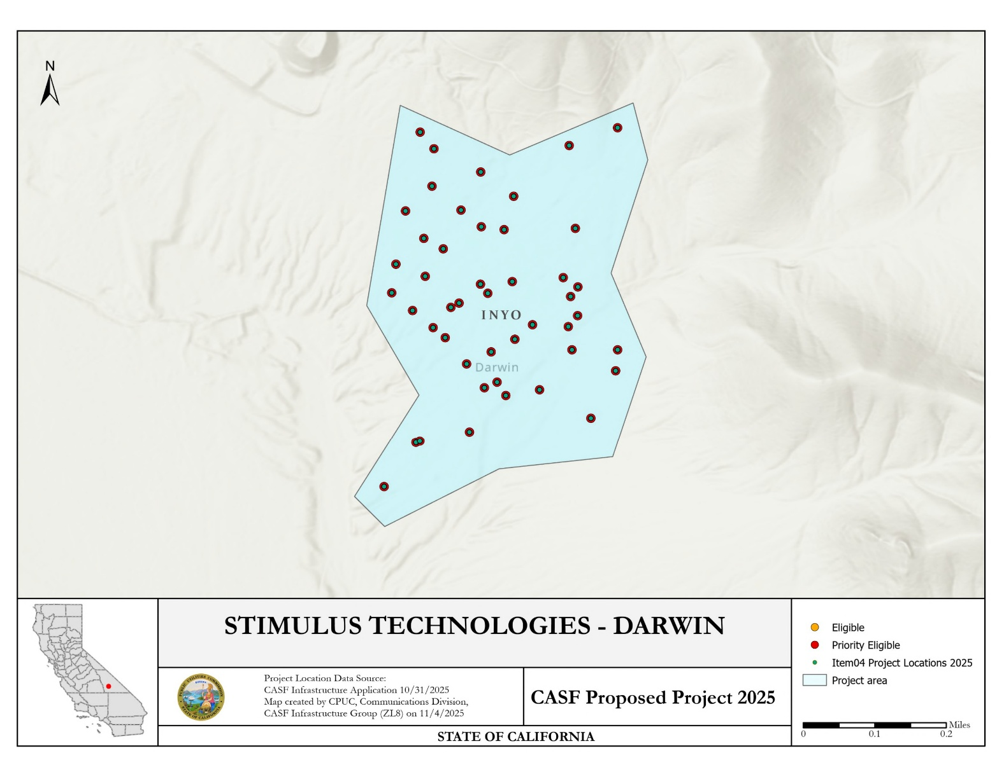
Stimulus Tech Darwin Project

APPENDIX F
Key Information

The Siskiyou Telephone Company
Siskiyou CASF Deployment Project
Project Name | Siskiyou CASF Deployment Project
Project Plan | The project proposes to deploy FTTH and FWA across two counties to 417 unserved locations.
County | Siskiyou & Humboldt
Communities | Little Shasta, Edgewood, Weed, Carrick, Igerna, Gazelle, Grenada, Lake Shastina, Big Springs
Project Size | 156.62 sq miles
Download / Upload speed | 2.5 Gbps/2.5 Gbps (fiber); 500 Mbps/100 Mbps (FWA)
Median Household Income | $65,245
Pricing Plan  (Monthly) | Tier 1 - Fiber 100 (100 Mbps/100 Mbps): $44.95  Tier 2 - Fiber 250 (250 Mbps/250 Mbps): $69.95  Tier 3 - Fiber Max (1000 Mbps/1000 Mbps): $99.95
Affordability | Fiber Low-income Plan (100 Mbps /100 Mbps): $35.00  FWA Low-income Plan (100 Mbps/20 Mbps): $30.00
Unserved Locations | 417
Subscriber Take Rate | FWA 42%; FTTH 92%
High Fire Threat Districts | Yes - Tier 2
Deployment Schedule  (from permit approval date) | 18 Months (CEQA-exempt)
Proposed Project Budget | $2,299,633
Original Grant Request | $2,395,775
CASF Grant Amount | $2,299,633
Cost per household | $5,515
Census Blocks | 060230101024001  060230101024014  060230101024015  060230101024016  060230101024017  060230101024021  060930003001230  060930003001232  060930003001287  060930003002088  060930003002105  060930003002111  060930003002112  060930003003023  060930003003025  060930003003038  060930003003044  060930003003045  060930003003046  060930003003047  060930003003048  060930003003055  060930003003058  060930003003064  060930003003076  060930003003077  060930003003079  060930003003082  060930003003106  060930003003111  060930003003118  060930003003121  060930003003122  060930003003124  060930003003167  060930003003173  060930003003174  060930003003175  060930003003179  060930003003180  060930007011011  060930007011013  060930007011015  060930007011018  060930007011019  060930007011022  060930007011024  060930007011027  060930007011028  060930007011032  060930007011034  060930007011036  060930007011051  060930007011054  060930007014000  060930007014001  060930007014002  060930007014003  060930007014007  060930007014008  060930007014009  060930007014011  060930007014013  060930007014014 | 060930007014015  060930007014017  060930007014024  060930007014029  060930007014030  060930007014032  060930007014033  060930007014034  060930007014041  060930007014042  060930007014043  060930007014049  060930007014052  060930007014057  060930007014058  060930007014063  060930007014064  060930007014066  060930007014067  060930007014069  060930007014075  060930007022023  060930007022038  060930007023019  060930007023020  060930009011011  060930009011021  060930009011024  060930009011042  060930009011043  060930009014018  060930009014020  060930009014023  060930009021004  060930009021017  060930009021019  060930009021021  060930009021023  060930009021025  060930009021028  060930009021031  060930009021032  060930009021034  060930009021049  060930009021050  060930009021060  060930009021066  060930009021069  060930009021071  060930009021072  060930009021073  060930009021074  060930009021075  060930009021076  060930009021077  060930009021079  060930009021080  060930009021081  060930009021082  060930009021083  060930009021085  060930009021087  060930009021088  060930009021089 | 060930009021090  060930009021091  060930009021092  060930009021093  060930009021094  060930009021095  060930009021096  060930009021097  060930009021099  060930009021100  060930009021101  060930009021102  060930009021103  060930009021104  060930009021105  060930009021106  060930009021107  060930009021109  060930009021110  060930009021112  060930009021113  060930009021114  060930009021115  060930009021116  060930009021117  060930009021118  060930009021119  060930009021120  060930009021121  060930009021122  060930009021123  060930009021124  060930009021125  060930009021126  060930009021129  060930009021138  060930009021139  060930009021140  060930009021141  060930009022000  060930009022001  060930009022005  060930009022010  060930009022034  060930009022071  060930009023004  060930009023011  060930009023013  060930009023014  060930009023018  060930009023019  060930009023030  060930009023035  060930009023036  060930009023037  060930009023051  060930009023054  060930009023059  060930009023060  060930009023067  060930013003330  060930013003331  060930013003332

APPENDIX G
Project Location Map

The Siskiyou Telephone Company
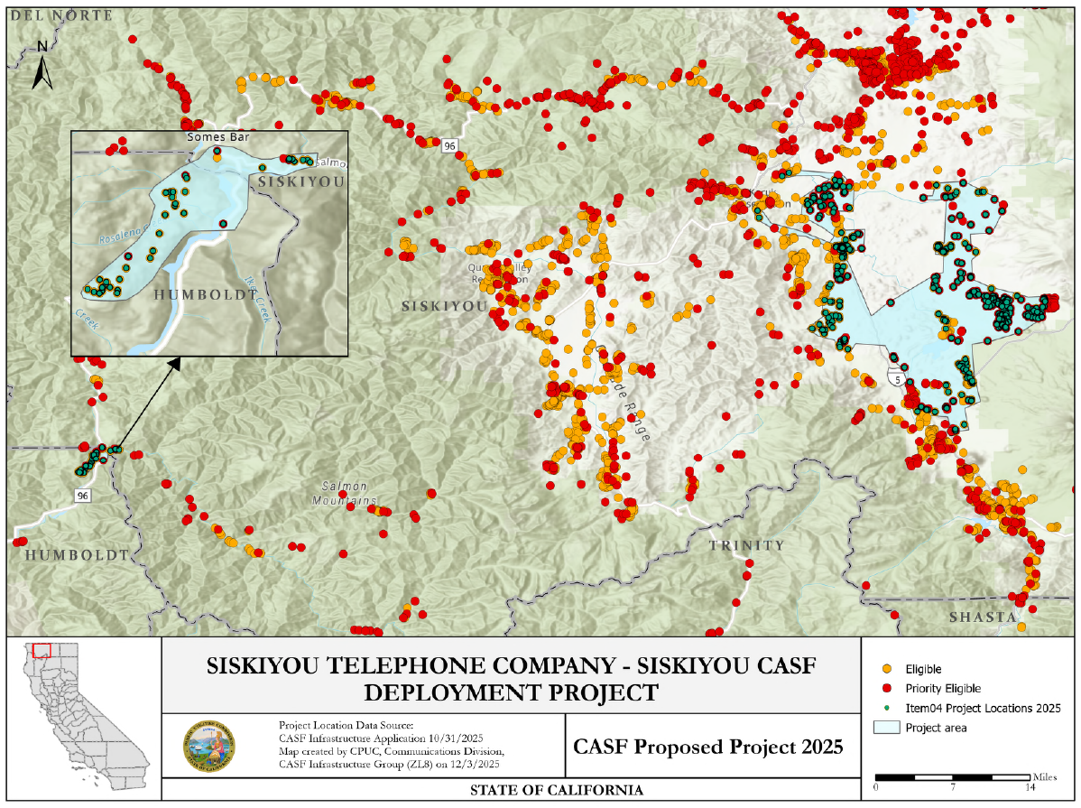
Siskiyou CASF Deployment Project

Public Utilities (Pub. Util.) Code § 281(f)(4)
See Public Utilities (Pub. Util.) Code § 281(b)(1)(B)(ii)(I).
See Pub. Util. Code § 281(f)(5)
See Pub. Util. Code § 281(l)
See CASF Grantee Monthly Contractor Reporting.
California Interactive Broadband Map available at https://www.broadbandmap.ca.gov.
See https://www.hcd.ca.gov/sites/default/files/docs/grants-and-funding/income-limits-2025.pdf
See https://docs.cpuc.ca.gov/PublishedDocs/Published/G000/M577/K860/577860183.PDF
See D. 22-11-023, Attachment 1, § 8.11, Pricing Commitment
See https://leginfo.legislature.ca.gov/faces/codes_displaySection.xhtml?lawCode=PUC&sectionNum=275.6
See https://www.cpuc.ca.gov/industries-and-topics/internet-and-phone/california-high-cost-fund-a
See https://www.hcd.ca.gov/sites/default/files/docs/grants-and-funding/income-limits-2025.pdf
See D. 22-11-023, Attachment 1, § 8.11, Pricing Commitment
See https://docs.cpuc.ca.gov/PublishedDocs/Published/G000/M578/K668/578668809.PDF
See https://www.cpuc.ca.gov/industries-and-topics/internet-and-phone/california-advanced-services-fund/casf-infrastructure-project-summaries for project summaries and https://www.cpuc.ca.gov/industries-and-topics/internet-and-phone/california-advanced-services-fund/casf-infrastructure-grant/casf-infrastructure-approved-projects for approved projects.
The Commission extended the CASF Infrastructure application deadline from April 1 to October, 2025, and all subsequent deadlines were moved back by six months.
See CASF Infrastructure Project Summaries at https://www.cpuc.ca.gov/industries-and-topics/internet-and-phone/california-advanced-services-fund/casf-infrastructure-project-summaries
See D. 22-11-023, Attachment 1.
Administrative costs are defined as “indirect overhead costs attributable to a project, per generally accepted accounting principles (GAAP), and the direct cost of complying with Commission administrative and regulatory requirements related to the grant itself.” Applicants seeking additional funds will require a Commission exemption included in a draft resolution.

