May 28, 2026 Agenda ID: 24253
RESOLUTION T-17911

TO: Parties on the CASF Distribution (Service) List

This is Draft Resolution T-17911 of the ​Communications​ Division. This Draft Resolution will appear on the agenda at the next Commission meeting to be held July 2, 2026, which is at least 30 days after the date of this letter. The Commission may vote on this Resolution at that time, or it may postpone a vote until a later meeting. To confirm when the item will be heard, please see the Business Meeting agenda, which is posted on the Commission’s website 10 days before each Business Meeting. When the Commission votes on a Draft Resolution, it may adopt all or part of it as written, amend, modify, or set it aside and prepare a different Resolution. Only when the Commission acts does the Resolution become binding on the parties.

Any member of the public may serve comments on the Draft Resolution as provided in Public Utilities Code § 311(g) and Rule 14.5 of the Commission’s Rules of Practice and Procedure (Rules).

Comments along with a certificate of service (COS) shall be sent via email to: the CASF Service List, Benjamin.Swearingen@cpuc.ca.gov and casf_infrastructure_grant_administrator@cpuc.ca.gov by June 17, 2026, at 5:00 PM.

Those submitting comments on the Draft Resolution must serve their comments on the entire service list the Draft Resolution was served to on the same date that the comments are submitted to the ​Communications​ Division.

Comments shall focus on factual, legal, or technical errors in the proposed Draft Resolution. Comments should list the recommended changes to the Draft Resolution. Comments shall be limited to three pages in length and shall include a subject index listing the recommendations to the draft resolution, a table of authorities, and an appendix setting forth the proposed revised findings and ordering paragraphs.

Replies to comments must be submitted no later than June 22, 2026. Replies shall be submitted and served in the same manner as opening comments. Replies shall be submitted and served in the same manner as opening comments.

Sincerely,

/s/
Maria Ellis
Director for Broadband Initiatives
​​Communications​ Division
California Public Utilities Commission

PUBLIC UTILITIES COMMISSION OF THE STATE OF CALIFORNIA

Communications Division | Agenda ID #24253
Broadband Video and Marketing Branch | RESOLUTION T-17911
CD/BSW | July 2, 2026

R E S O L U T I O N

RESOLUTION T-17911: Approves up to $49,954,375 from the California Advanced Services Fund (CASF) for the Broadband Infrastructure Grant Account applications of the Iipay Nation of Santa Ysabel for the Iipay Nation of Santa Ysabel Infrastructure Project and the Pauma Band of Luiseño Indians for the Pauma Band of Luiseño Indians Infrastructure Project.

PROPOSED OUTCOME:

- Awards two grants for up to $49,954,375 from the CASF Infrastructure Funding Account to the Iipay Nation of Santa Ysabel and the Pauma Band of Luiseño Indians in San Diego County.

SAFETY CONSIDERATIONS:

- There are no adverse safety considerations identified by the Communications Division. The projects to be funded by this award have the potential to improve communications resiliency and redundancy.

ESTIMATED COST:

- There are no costs associated with this Resolution.

SUMMARY

This Resolution approves grant funding for two grants in the amount of up to $49,954,375 from the California Advanced Services Fund (CASF) Broadband Infrastructure Grant Account (Infrastructure Account) for the grant applications of the Iipay Nation of Santa Ysabel (INSY) for the Iipay Nation of Santa Ysabel CASF Infrastructure Project (INSY Infrastructure Project) and for the grant applications of the Pauma Band of Luiseño Indians (Pauma) for the Pauma Band of Luiseño Indians CASF Infrastructure Project (Pauma Infrastructure Project). These projects will provide broadband access to a total of 565 unserved locations in San Diego County.

This Resolution recommends two grant awards to two grantees: the INSY and the Pauma. The following grant applications listed below in Table 1 are recommended for approval by the Commission. Associated maps and project information summaries are included in the appendices.

Table 1: Summary of Grant Funding
Applicant | Project Name | Unserved Locations | Initial  Requested Amount | CASF  Approved Amount
Iipay Nation of Santa Ysabel | Iipay Nation of Santa Ysabel CASF Infrastructure | 182 | $24,970,970 | $24,970,970
Pauma Band of Luiseño Indians | Pauma Band of Luiseño Indians CASF Infrastructure | 383 | $24,983,405 | $24,983,405

BACKGROUND

The CASF Infrastructure Account provides grant funding to Internet service providers (ISP) or other eligible entities to build or upgrade broadband infrastructure in areas that are unserved by existing broadband providers. The CASF program was initiated in 2008, after the program was first adopted by the California Public Utilities Commission (Commission) in Decision (D.) 07-12-054 and enacted into statute pursuant to Senate Bill (SB) 1193.

On July 20, 2021, Governor Newsom signed historic broadband legislation to help bridge the digital divide; Senate Bill (SB) 156 changed the definition of “unserved area,” allowing, but not requiring, funding for “an area for which there is no facility-based broadband provider offering at least one tier of broadband service at speeds of at least 25 Megabits per second (Mbps) downstream, 3 Mbps upstream.” Additionally, SB 156 requires grantees to “deploy infrastructure capable of providing broadband access at speeds of a minimum of 100 Mbps downstream and 20 Mbps upstream” and that any grantees receiving CASF funding must report subcontracted work in excess of $25,000. The Commission must post such information monthly on its website.

On November 17, 2022, the Commission issued D.22-11-023, adopting programmatic changes to the CASF Infrastructure Account. Attachment 1 of D.22-11-023 (“CASF Guidelines”) set forth the rules, application requirements, and guidelines for the CASF Infrastructure Account.

APPLICATION REVIEW AND EVALUATION

On October 31, 2025, the INSY submitted a CASF Infrastructure application requesting 100 percent funding for a total of $24,970,970 to deploy hybrid middle-mile and last-mile fiber-to-the-home (FTTH) and broadband access to 182 unserved households in San Diego County. On the same date, the Pauma Band of Luiseño Indians submitted a CASF Infrastructure application requesting 100 percent funding for a total of $24,983,405 to deploy a hybrid middle-mile and last-mile FTTH and Fixed Wireless Access (FWA) network to provide broadband access to 383 unserved households in San Diego County. The total amount of up to $49,954,375 for the two projects will cover the complete project deployment costs of the projects.

For the 2025 CASF Infrastructure Grant application cycle, applicants determined eligibility for funding based on the California Interactive Broadband Map which relied on 2023 mapping data for the 2025 application cycle. Because the evaluation and review period occurred while the Commission was collecting 2024 broadband location data, Communications Division (CD) Staff (Staff) verified eligibility using the current 2024 dataset to ensure the eligibility of all locations reflected the most recently available data and to prevent the awarding of program funds in areas already served.

Background of the Iipay Nation of Santa Ysabel
The INSY, part of the Kumeyaay Nation, has been a federally recognized tribe since 1875. The Tribe’s presence in and around the Santa Ysabel Valley dates back thousands of years. The INSY will fully own and operate the broadband network through a new tribally managed ISP. This aligns with Commission goals by supporting tribal sovereignty and sustainable broadband development. Through its partnership with EnerTribe, Inc. (EnerTribe), INSY-employed program managers and technicians will train alongside EnerTribe staff to learn how to construct, operate and maintain the new broadband network. EnerTribe is a Native American-owned infrastructure development and consulting firm specializing in the planning, funding and building of broadband, water and energy infrastructure for tribes and providers.

Background of Pauma Band of Luiseño Indians CASF Infrastructure
The Pauma, one of seven Bands of the Luiseño groups located in Southern California, has been a federally recognized tribe since 1891. The Tribe’s presence in and around the Pauma Valley dates back thousands of years. The Pauma is engaged in agriculture, farming citrus fruits, avocados and other crops, and since 2001, have operated Casino Pauma on their reservation.

The Pauma will fully own and operate the broadband network through a new tribally managed ISP. Through its partnership with EnerTribe, Pauma-employed program managers and technicians will train alongside EnerTribe staff to learn how to construct, operate and maintain the new broadband network.

Staff’s review and evaluation of these applications is summarized below.

- Iipay Nation of Santa Ysabel CASF Infrastructure Project

Project Summary
This resolution recommends that the Commission approve a grant of up to $24,970,970 to the INSY for the INSY Infrastructure Project. In compliance with D.22-11-023, Staff determined that the INSY is eligible to receive up to $24,970,70 in CASF Infrastructure Account funding for the INSY Infrastructure Project.

With CASF funding, the INSY proposes to serve 182 unserved locations by constructing a hybrid, open-access middle-mile and last-mile FTTH network with up to 1 Gigabit per second (Gbps) download and 1 Gbps upload in San Diego County.

Challenges
Pursuant to Public Utilities Code Section 281(f)(8) and as required by D.22-11-023, the Commission provided an opportunity for entities to challenge the application. Challenges were due on December 5, 2025. The INSY Infrastructure Project received no challenges.

Revisions
The proposed INSY Project does not overlap with any proposed terrestrial Broadband Equity Access and Deployment (BEAD) projects. Additionally, the INSY Project does not overlap with any Last Mile Federal Funding Account (FFA) projects, therefore, no locations were removed from INSY Project

Technology Deployment
The INSY will deploy approximately 20 miles of underground middle-mile fiber and 40 miles of underground last-mile fiber. The INSY Infrastructure Project requires new middle‑mile infrastructure because no existing facilities in or near the project area can support the needed backhaul broadband connectivity to enable the last-mile broadband service. The closest middle-mile interconnection point is approximately 20 miles from the reservation boundary, making new transport infrastructure essential for delivering adequate backhaul to last‑mile services.

The middle-mile fiber lines will run along California Highway (CA) 79 and CA-78 W and have one interconnection point to California’s open-access statewide Middle-Mile Broadband Network (MMBN) at the intersection of CA-78 and CA-67 in Ramona, California. The middle-mile and last-mile fiber optic infrastructure will be installed underground and accessed via handholes. Above-ground infrastructure will be limited to cabinets to house network equipment and power systems.

The applicant has contacted the California Department of Technology (CDT) and will consult with them within three (3) months of Commission approval to ensure the middle-mile component of the project will complement and augment—rather than duplicate or compete with—California’s statewide MMBN.

The applicant also commits to meeting all CASF open‑access requirements making any funded middle‑mile infrastructure available to qualified service providers.

Median Household Income and Low-Income Service
The median household income for the project area is approximately $61,620, which is below the low-income threshold of $132,400 for a family of four in San Diego County set by the Department of Housing and Community Development’s (HCD) list of state income limits. Thus, the INSY Infrastructure Project meets the definition of low-income as set forth in D.22-11-023.

The project will provide broadband service to INSY Tribal members at no charge and a low-income plan of $15 per month for non-tribal members at speeds of 100 Mbps download and 100 Mbps upload.

Safety Considerations
The INSY Infrastructure Project will enable the public to access the public safety benefits of reliable broadband infrastructure.

The project is in a Commission-designated Tier 3 High Fire-Threat District and will bring critical communication redundancy to an area within the highest level of wildfire risk. Within the project area, existing emergency communications currently rely primarily on commercial cellular networks and land mobile radio (LMR) systems utilized by the Tribe’s Fire Department, Emergency Medical Services (EMS), and Public Safety personnel. These systems provide essential emergency response coordination; however, they are vulnerable to service disruptions during power outages, wildfire events, and periods of network congestion.

The INSY Infrastructure Project will provide mission-critical backup to these existing emergency communication systems by introducing a resilient fiber-based broadband network with dedicated middle-mile connectivity. The proposed infrastructure will enable redundant transport pathways for VoIP communications, support interoperability with dispatch and mutual-aid systems, and provide reliable broadband connectivity to tribal government facilities, fire stations, and other community anchor institutions.

By diversifying transport beyond reliance on existing cellular networks and introducing fiber-based connectivity with a minimum 72-hour backup power capability, the project enhances continuity of operations during emergencies. This redundancy will strengthen public safety response capacity, improve coordination with regional emergency service providers, and increase overall network resiliency within the project area.

Project Viability
Both the INSY and the INSY Infrastructure Project were determined to be financially viable, and the applicant’s engineering design meets the program standards. The applicant demonstrated the administrative, technical, and operational capacity to provide broadband service at the scale of this project.

The INSY received three letters of support from local government and community representatives for the INSY Infrastructure Project: Chief M.A. Monticelli, Office of the Chief of Police - Iipay Nation of Santa Ysabel; Kelly A. Martinez, Sherrif, San Diego County Sheriff’s Office; and Missy Pico-Barnett, Chairwoman, Santa Ysabel Economic Development Corporation.

Funding Determination
The CASF Infrastructure Account will fund 100 percent of the proposed project cost of up to $24,970,970.

California Environmental Quality Act
Based on the information received, the Commission’s Energy Division has determined that the INSY Project has not met the requirements of California Environmental Quality Act (CEQA) categorical exemption at this time. The INSY must comply with the CEQA requirements discussed in the appendices. If the INSY provides additional documentation demonstrating that the project qualifies for a CEQA exemption, then the project can be exempted by letter from the Communications Division Director or the director’s delegate or designee.

- The Pauma Band of Luiseño CASF Infrastructure Project

Project Summary
This resolution recommends that the Commission approve up to $24,983,405 in CASF Infrastructure Account funding to the Pauma for the Pauma Infrastructure Project. In compliance with D.22-11-023, Staff determined that the Pauma are eligible to receive up to $24,983,405 in CASF Infrastructure Account grant funding for this project.

With CASF funding, the Pauma propose to provide broadband access to 383 unserved locations in San Diego County by constructing a hybrid, open-access middle-mile and last-mile network consisting of both FTTH with speeds up to 1 Gbps download and 1 Gbps per second upload and fixed wireless access (FWA) with speeds up to 100 Mbps upload and 20 Mbps download. The Pauma will provide broadband access to the 309 locations through FTTH and to 74 locations through FWA.

Challenges
Pursuant to Public Utilities Code Section 281(f)(8) and as required by D.22-11-023, the Commission provided an opportunity for entities to challenge the application. Challenges were due on December 5, 2025. The Pauma Infrastructure Project received no challenges.

Revisions
The proposed INSY Project does not overlap with any proposed terrestrial Broadband Equity Access and Deployment (BEAD) projects. Additionally, the Pauma Project does not overlap with any Last Mile Federal Funding Account (FFA) projects, therefore, no locations were removed from Pauma Project.

Technology Deployment
The Pauma will deploy approximately 38 miles of underground fiber consisting of 18 miles of middle-mile fiber and 20 miles of last-mile fiber as well as one 150-foot FWA tower to serve locations where extending fiber is infeasible. The Pauma Infrastructure Project requires new middle‑mile infrastructure because no existing facilities in or near the project area can support the needed broadband connectivity. The closest viable interconnection point is approximately 18 miles from the project area, making new transport infrastructure essential for delivering adequate backhaul to last‑mile services.

The middle-mile cable will run along California Highway (CA) 76 and interconnect with the statewide open-access MMBN at the intersection of CA-76 and Old Highway 395 in Pala Mesa, California. Both the middle-mile and last-mile fiber optic cables will be installed underground and accessed via handholes. Above-ground infrastructure for the fiber component will be limited to cabinets to house network equipment and power systems.

The Pauma have contacted the CDT and will consult with them within three (3) months of Commission approval to ensure the middle-mile component of the project will complement and augment—rather than duplicate or compete with—California’s statewide MMBN.

The Pauma also commits to meeting all CASF open‑access requirements making any funded middle‑mile infrastructure available to qualified service providers.

Median Household Income and Low-Income Service
The median household income (MHI) for the Pauma Project area is approximately $94,163 and meets the low-income standard for a family of four set by the Department of Housing and Community Development’s (HCD) list of state income limits.

The project will provide a low-income plan of $15 per month at speeds of 100 Mbps download and 100 Mbps upload for fiber and 100 Mbps download and 20 Mbps upload for FWA.

Safety Considerations
The Pauma Infrastructure Project will provide the public with improved access to the public safety benefits of reliable broadband infrastructure.

The project overlaps both Commission-designated Tier 2 and Tier 3 High Fire-Threat Districts and will bring critical communication redundancy to an area with a high level of wildfire risk. Currently, emergency communications within the project area rely primarily on commercial cellular networks and LMR systems utilized by the Tribe’s Fire Department, EMS, and Public Safety personnel. While these systems provide essential emergency response coordination, they remain vulnerable to service disruptions during power outages, wildfire events, and periods of network congestion.

The Pauma Infrastructure Project will strengthen these systems by introducing a resilient, fiber-based broadband network with dedicated middle-mile connectivity. This infrastructure will enable redundant transport pathways for VoIP communications, support interoperability with dispatch and mutual-aid systems, and provide reliable broadband service to tribal government facilities, fire stations, and other community anchor institutions.

By reducing reliance on cellular networks and introducing fiber-based connectivity with a minimum 72-hour backup power capability, the project enhances continuity of operations during emergencies. This redundancy will increase overall network resilience, strengthen public safety response capacity, and improve coordination with regional emergency service providers.

Project Viability
Both the Pauma and the Pauma Infrastructure Project were determined to be financially viable, and the applicant’s engineering design meets the program standards. The applicant demonstrated the administrative, technical, and operational capacity to provide broadband service at the scale of this project.

The Pauma received three letters of support for the Pauma Infrastructure Project from local government and community representatives: Oscar Garcia, General Manager at Casino Pauma; Skye McMichael, MBA, Managing Principal/Owner; and Orvin Hanson, Chief Executive Officer, Indian Health Council, Inc.

Funding Determination
The CASF Infrastructure Account will fund 100 percent of the proposed project cost of up to $24,983,405.

California Environmental Quality Act
Based on the information received, the Commission’s Energy Division has determined that this project has not met the requirements of CEQA categorical exemption at this time. The Pauma must comply with CEQA requirements discussed in the appendices. If the Pauma provides additional documentation demonstrating that the project qualifies for a CEQA exemption, then the project can be exempted by letter from the Communications Division Director or the director’s delegate or designee.

NOTICE

On October 31, 2025, the CD received 41 grant applications for CASF Infrastructure Account funding. On November 14, 2025, Staff posted all the proposed project area maps and project summaries for The Iipay Nation of Santa Ysabel CASF Infrastructure Project and the Pauma Band of Luiseño Indians CASF Infrastructure Project on the Commission’s CASF Infrastructure Project Summaries webpage and sent notice regarding the project to the CASF Distribution and Service Lists.

COMMENTS

In compliance with Public Utilities Code Section 311(g)(1), a notice letter was emailed on May 28, 2026, informing all parties on the CASF Distribution List of the availability of the draft of this Resolution for public comments at the Commission’s documents website at http://www.cpuc.ca.gov/documents/. This letter also informed parties that the final conformed Resolution adopted by the Commission will be posted and available on the same website.

FINDINGS

- On October 31, 2025, the Iipay Nation of Santa Isabel submitted an application for CASF funding for the Iipay Nation of Sant Ysabel CASF Infrastructure Project to deploy middle-mile and last-mile broadband infrastructure to enable fiber-to-the-home service at speeds of up to 1000 Mbps symmetrical to 182 CASF eligible locations in San Diego County; and, the Pauma Band of Luiseño Indians submitted an application for CASF funding for the Pauma Band of Luiseño Indians CASF Infrastructure Project to deploy middle-mile and last-mile broadband infrastructure to enable fiber-to-the-home service at speeds of up to 1000 Mbps symmetrical and Fixed Wireless Access at speeds of up to 120 Mbps upload and 20 Mbps download to 383 CASF eligible locations in San Diego County.

- On November 14, 2025, Staff posted all the proposed project area maps and project summaries for the Iipay Nation of Sant Ysabel CASF Infrastructure Project and the Pauma Band of Luiseño Indians CASF Infrastructure Project on the Commission’s CASF Infrastructure Project Summaries webpage.

- Staff received no challenges to either the Iipay Nation of Sant Ysabel CASF Infrastructure Project or the Pauma Band of Luiseño Indians CASF Infrastructure Project.

- The Iipay Nation of the Santa Ysabel and Pauma Band of Luiseño Indians have committed to consulting with the California Department of Technology within three (3) months of Commission approval to ensure that middle-mile components of Iipay Nation of the Santa Ysabel CASF Infrastructure Project and the Pauma Band of Luiseño Indians CASF Infrastructure Project, respectively, will complement the Statewide Middle-Mile Network proposed by the California Middle-Mile Broadband Initiative.

- The Commission has determined that the Iipay Nation of the Santa Ysabel Infrastructure Project and the Pauma Band of Luiseño Indians CASF Infrastructure Project are not exempt from California Environmental Quality Act review at this time.
- Based on its review, Staff determined that both projects qualify for a CASF Broadband Infrastructure Account pursuant to D. 22-11-023 and its Attachment 1 and recommends Commission approval of CASF funding of up to $49,954,375.

- A notice letter was emailed on May 28, 2026, informing all parties on the CASF Distribution List of the availability of the draft of this Resolution for public comments at the Commission’s documents website at http://www.cpuc.ca.gov/documents/.

THEREFORE, IT IS ORDERED that:

- The Commission shall award up to $24,970,970 in CASF Broadband Infrastructure Grant Account funds to the Iipay Nation of Santa Ysabel for the Iipay Nation of Santa Ysabel CASF Infrastructure Project as described herein and summarized in the appendices of this Resolution.

- The Commission shall award up to $24,983,405 in CASF Broadband Infrastructure Grant Account funds to the Pauma Band of Luiseño Indians for the Pauma Band of Luiseño Indians CASF Infrastructure Project as described herein and summarized in the appendices of this Resolution.

- Awardees shall comply with all guidelines, requirements and conditions associated with a CASF award, as specified in D.22-11-032 and its Attachment 1, and all requirements for this project included in this Resolution and in Appendices A through G.

- Awardees must offer open access to last-mile communications service providers requesting to use middle-mile infrastructure funded by CASF grants, as set forth in D.22-11-023, Attachment 1, Section 5.2.

- If the Iipay Nation of Santa Ysabel fails to complete the project in accordance with the CASF guidelines and requirements outlined in D.22-11-023 and its Attachment 1, and the terms outlined in this Resolution, it must reimburse some or all the CASF funds that it has received.

- If the Pauma Band of Luiseño Indians fails to complete the project in accordance with the CASF guidelines and requirements outlined in D.22-11-023 and its Attachment 1, and the terms outlined in this Resolution, it must reimburse some or all the CASF funds that it has received.

- For those projects not determined to be categorically exempt, the Commission cannot release funds for construction activities until California Environmental Quality Act (CEQA) review is complete. Funds for preconstruction activities such as permitting and CEQA compliance may be awarded prior to commencement of construction. The awardees must comply with the requirements set forth in the CEQA Section of the Resolution. The awardees must provide their Proponent’s Environmental Assessment for each project prior to the first payment.

- If Staff evaluation finds the Iipay Nation of Santa Ysabel CASF Infrastructure Project can be exempt from the California Environmental Quality Act, then the project can be exempted by letter from the Communications Division Director or the director’s delegate or designee.

- If Staff evaluation finds the Pauma Band of Luiseño Indians CASF Infrastructure Project can be exempt from the California Environmental Quality Act, then the project can be exempted by letter from the Communications Division Director or the director’s delegate or designee.

- Awardees must complete and execute the consent forms (to be sent to the grantee after this Resolution is adopted) agreeing to the conditions set forth in this Resolution and return to CASF Staff within 30 calendar days from the date of the adoption of this Resolution. Failure to submit the consent form within 30 calendar days from the adoption date of this Resolution may result in the Commission voiding the grant award.

This resolution is effective today.

Commissioner Signature blocks to be added
upon adoption of the resolution

The foregoing resolution was duly introduced, passed and adopted at a conference of the California Public Utilities Commission of the State of California held on July 2, 2026, the following Commissioners voting favorably thereon:

Dated , at ______________, California

APPENDIX A

Compliance Requirements

- Deployment Schedule
The Commission requires a grantee to complete their projects within 24 months of CEQA approval or within 18 months if CEQA-exempt. If the grantee is unable to complete the proposed project within the timeframe requirements, the grantee must notify the Director of the Communications Division as soon as the grantee becomes aware of this possibility. If such notice is not provided, the Commission may reduce payment for failure to satisfy this requirement of timely notification to the Director.

- Execution and Performance
Staff and awardee shall determine a project start date after the CASF grant recipient has obtained all approvals, including permits. Should the grantee or any contractor it retains fail to commence work by the designated date, upon five days’ written notice the Commission may terminate the grant. If the grantee fails to complete the project in accordance with the terms of Commission approval as set forth in this resolution, the awardee shall reimburse some or all the CASF funds that it has received.
The grantee must complete all construction covered by the grant on or before the grant’s termination date.

- Minimum Performance Criteria
 | CASF Performance Criteria | Proposed Projects
 | CASF Performance Criteria | INSY Infrastructure Project | Pauma Infrastructure Project
Project Completion | CEQA-exempt projects must be  completed within 18 months; all other projects shall be completed within 24 months after receiving authorization to construct | within 18 months of permitting approval  (if CEQA Exempt) | within 18 months of permitting approval  (CEQA except)
Pricing | Prices committed for five years after completion of the project | 5-year commitment | 5-year commitment
Speed | At least 100/20 Mbps | 1 Gbps/1 Gbps | Fiber: 1 Gbps/1 Gbps  FWA: 100 Mbps/  20 Mbps
Latency | Maximum of 100 ms of latency | < 100 ms | < 100 ms
Data Caps | Minimum of 190 GBs per month | No data cap | No data cap
Affordability | Must offer low-income plan | Tribal Members: $0.00/month at 100/100 Mbps  Non-Tribal Members: $15.00/month at 100/100 Mbps | Fiber: $15.00/month at 100/100 Mbps  FWA: $15.00/month at 100/20 Mbps

- Letter of Credit
Applicants to the CASF Broadband Infrastructure Grant Account which are not a local agency, are required to submit a Letter of Credit as evidence of good financial standing. Sovereign tribal governments are local agencies and therefore not required to submit a Letter of Credit.

- Project Audit
The Commission has the right to conduct any necessary audit, verification, and discovery during project implementation/construction to ensure that CASF funds are spent in accordance with Commission approval.

Grantee invoices may be subject to a financial audit by the Commission at any time within three years of completion of the work.

- Providing Voice Service
Both the INSY and Pauma will provide Voice over Internet Protocol (VoiP) service that meets FCC standards for E-911 service and battery back-up, list the types of voice services offered, and a timeframe for providing any voice service offerings.

- Reporting
All grantees must submit biannual progress reports on the status of the project, irrespective of whether grantees request reimbursement or payment. These reports are due semi-annually, in March and September, until the project is completely built and operational. Progress reports shall describe the schedule for deployment, major construction milestones and costs submitted in the proposal; indicate the actual date of completion of each task/milestone as well as problems and issues encountered, and the actions taken to resolve these problems and issues during project implementation and construction; and identify future risks to the project.

Before full payment of the project is made, grantees must submit a project completion report. Grantees shall also include test results on the download and upload speeds at a representative sample of locations in the final completion report per CASF Guidelines, Section 13 Reporting Requirements. Grantees must certify that each progress report is true and correct under penalty of perjury.

- Prevailing Wage
Section 1720 of the California Labor Code specifies that CASF-subsidized projects are subject to prevailing wage requirements. Grantees committed to following state prevailing wage requirements with regards to these projects.
- Contractor Reporting
Grantees must comply with the contractor reporting requirements of Section 281(l)(1) of the California Public Utilities Code, which requires reporting of certain information for all contractors and subcontractors undertaking a contract or subcontract in excess of twenty-five thousand dollars on CASF-subsidized projects.

APPENDIX B

Payments to CASF Recipients

Public Utilities Code Section 281(f)(10) defines the costs the Commission may reimburse as follows:
- Costs directly related to the deployment of infrastructure;
- Costs to lease access to property or for Internet backhaul services for a period not to exceed five years; and
- Costs incurred by an existing facility-based broadband provider to upgrade its existing facilities to provide for interconnection.

Additionally, D.22-11-023, Attachment 1, Section 7 caps administrative expenses directly related to the project at 10 percent of the grant amount.

The grantee may submit reimbursement requests at the following intervals:
- 10 percent completion;
- 35 percent completion;
- 60 percent completion;
- 85 percent completion; and
- 100 percent completion.

The final 15 percent payment request (from 85 to 100 percent) will not be paid without an approved completion report. Payments are based on submitted receipts, invoices and other supporting documentation showing expenditures incurred for the project in accordance with the approved CASF funding budget included in the CASF grantee’s application.

Payment to grantees shall follow the process adopted for funds created under Public Utilities Code Section 270. The Commission generally processes payments within 20-25 business days, including Communications Division and Administrative Services review time. The State Controller’s Office (SCO) requires an additional 14-21 days to issue payment from the day that requests are received by SCO from Administrative Services. The project is funded at 100%, CASF will not accept invoices that include a handling fee.

APPENDIX C

California Environmental Quality Act Requirements

The following two projects are subject to California Environmental Quality Act (CEQA) review:

- Iipay Nation of Santa Ysabel CASF Infrastructure Project
- Pauma Band of Luiseño Indians CASF Infrastructure Project

The Commission must complete CEQA review prior to disbursing CASF funds for construction activities. The initial funding granted in this Resolution may be used for project development and other grantee activities that do not involve construction or any activities that would have any direct or indirect effect on the physical environment. Prior to any construction activity for the project, each grantee is required to seek further authority from the Commission for such activity by filing a Proponent’s Environmental Assessment (PEA) pursuant to Commission Rule of Practice and Procedure 2.4; and must undergo an environmental review pursuant to CEQA (California Public Resources Code § 21000 et seq.).

The Iipay Nation of Santa Ysabel and Pauma Band of Luiseño Indians or their representative should contact the Supervisor of the Commission’s Energy Division Infrastructure Planning and CEQA Section well in advance of a contemplated filing to (a) consult with Staff regarding the process of developing and filing a PEA; (b) provide for cost recovery per Rule of Practice and Procedure 2.5; and (c) enter into a Memorandum of Understanding to allow the Energy Division to initiate the retention of an environmental contractor to perform the environmental review. Each grantee must provide a PEA prior to the first payment. The Commission cannot release funds for the construction phase of this project until the Commission has completed CEQA review.

APPENDIX D

Key Information

Iipay Nation of Santa Ysabel

Iipay Nation of Santa Ysabel CASF Infrastructure Project
Project Name | Iipay Nation of Santa Ysabel CASF Infrastructure Project
Project Plan | The project proposes to deploy FTTH to 182 unserved locations.
County | San Diego
Community | Santa Ysabel/Mesa Grande
Project Size  (Square Miles) | 16.05
Download/Upload Speed | 1 Gbps/1 Gbps
Median Household Income | $61,620
Pricing Plan (Monthly) | Tribal Member Basic Residential (100/100 Mbps): $0  Non-Tribal Basic Residential (100/100 Mbps): $45  Plus Residential (300/300 Mbps): $55  Intermediate Residential (500/500 Mbps): $65  Premium Residential (1000/1000 Mbps): $80  Business/Commercial (1000/1000 Mbps): $130
Affordability  (Low Income Plan - Monthly) | Non-tribal Members (100/100 Mbps): $15
Unserved Locations | 182
Subscriber Take Rate | Tribal Members Basic Residential: 100%  Low Income Residential Plan: 50%  Non-Tribal Basic Residential Plan: 24%  Intermediate Residential Plan: 12.5%  Premium Residential Plan: 13.5%
High Fire-Threat Districts in Project Area | Yes
Connection to Public Open-Access Middle-Mile | Yes
Deployment Schedule  (from permit and CEQA approval date) | 24 Months
Proposed Project Budget | $24,970,969.75
Grant Requested Amount | $24,970,969.75
CASF Grant Amount  (100 percent) | $24,970,969.75
Cost per Eligible Location | $62,772.38
Census Blocks | 060730209032029  060730209032044  060730209032045  060730209032048  060730209032058 | 060730209032074  060730209032094  060730209032096  060730209032099  060730209032105 | 060730209032121  060730209032127  060730209032145  060730209032146  060730209032171

APPENDIX E

Project Location Map

Iipay Nation of Santa Ysabel

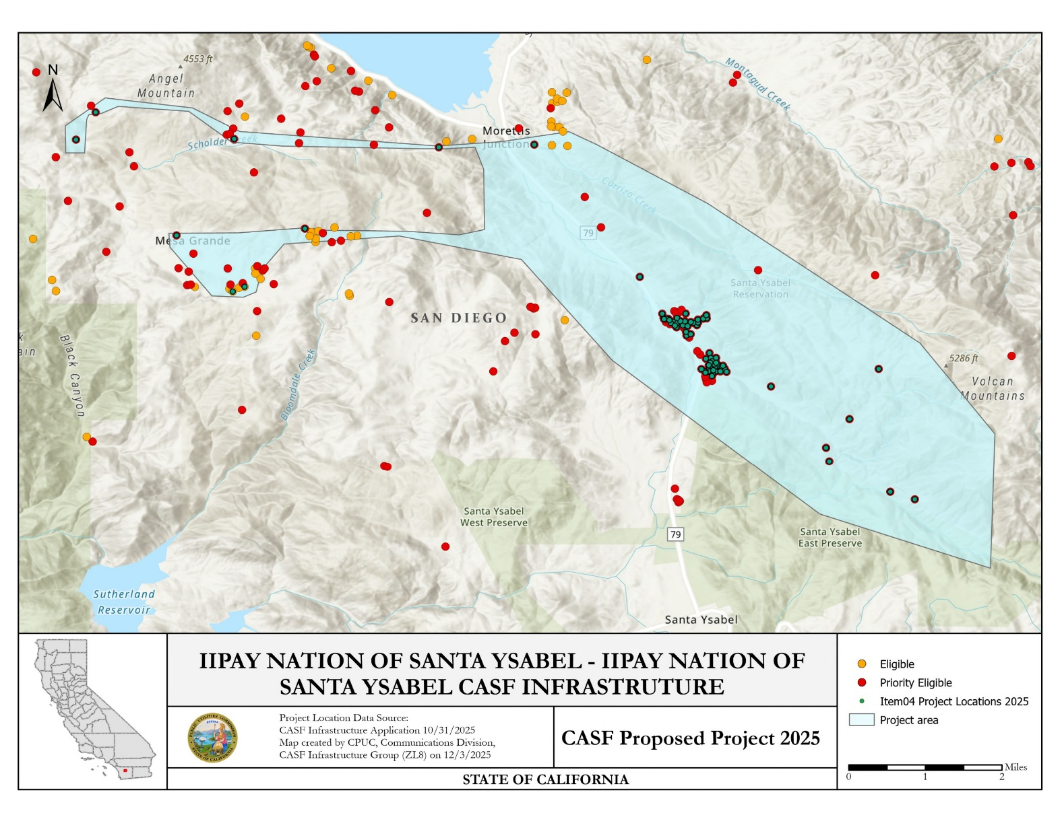
Iipay Nation of Santa Ysabel CASF Infrastructure Project

APPENDIX E

Project Location Map – Middle Mile

Iipay Nation of Santa Ysabel

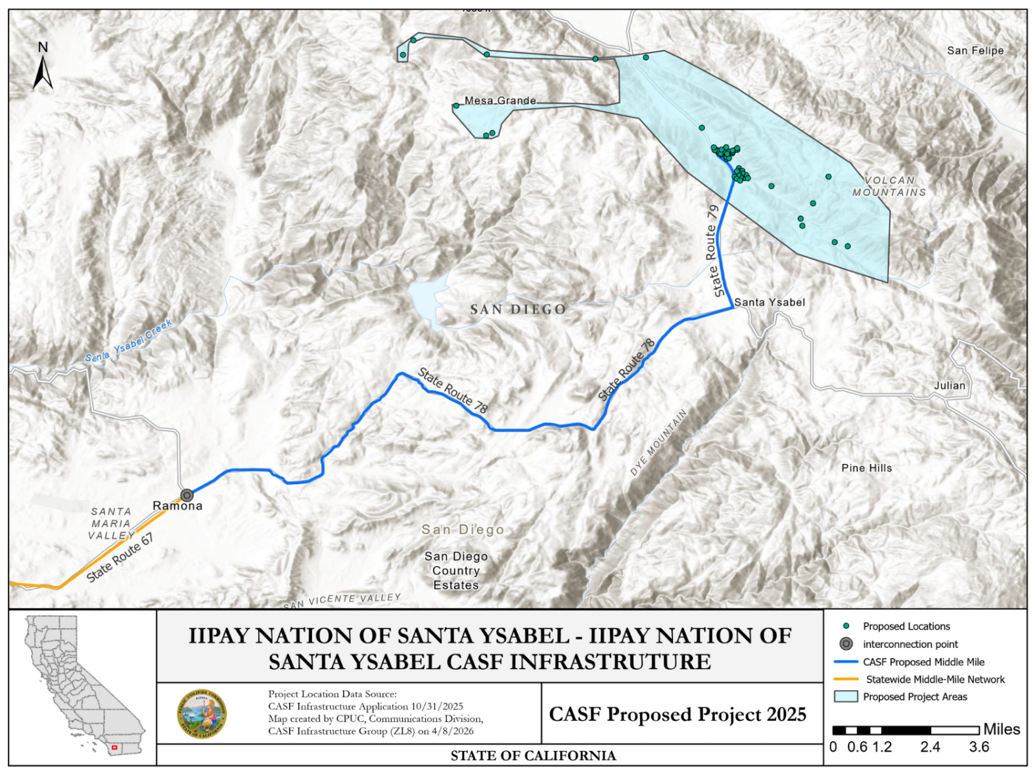
Iipay Nation of Santa Ysabel CASF Infrastructure Project

APPENDIX F
Key Information

Pauma Band of Luiseño Indians

Pauma Band of Luiseño Indians CASF Infrastructure Project
Project Name | Pauma Band of Luiseño Indians CASF Infrastructure Project
Project Plan | The project proposes to deploy FTTH and FWA to 383 unserved locations.
County | San Diego
Community | Pauma Valley
Project Size (Square Miles) | 6.6
Download/Upload speed | 1 Gbps/1 Gbps (fiber); 100 Mbps/20 Mbps (FWA)
Median Household Income | $94,163
Pricing Plan (Monthly) | Fiber Subscriptions:  Basic Residential (100/100 Mbps): $15  Plus Residential (300/300 Mbps): $45  Intermediate Residential (500/500 Mbps): $65  Premium Residential (1000/1000 Mbps): $85  Business/Commercial (1000/1000 Mbps): $150  Wireless Subscriptions:  Basic Residential (100/20 Mbps): $40  Plus Residential (125/25 Mbps): $55  Intermediate Residential (150/30 Mbps): $65  Premium Residential (200/50 Mbps): $85  Business/Commercial (150/50 Mbps): $150
Affordability Plan (Monthly) | Fiber Low-Income Plan (100/100 Mbps): $15  Wireless Low-Income Plan (100/20 Mbps): $15
Unserved Locations | 383
Subscriber Take Rate | Basic Residential: 50%  Intermediate Residential: 24%  Premium Residential: 13%
High Fire-Threat Districts in Project Area | Yes
Connection to Public Open-Access Middle-Mile | Yes
Deployment Schedule  (from permit and CEQA approval date) | 24 Months
Proposed Project Budget | $24,983,405.42
Grant Requested Amount | $24,983,405.42
CASF Grant Amount (100 percent) | $24,983,405.42
Cost per Eligible Location | $137,203.13
Census Blocks | 060730191081017  060730191081018  060730191081019  060730191081020  060730191081022  060730191081031 | 060730191081032  060730191081035  060730191081036  060730191081038  060730191081039  060730191081047 | 060730191081089  060730191092010  060730191092028  060730191092029  060730191101001  060730191101005

APPENDIX G
Project Location Map

Pauma Band of Luiseño Indians

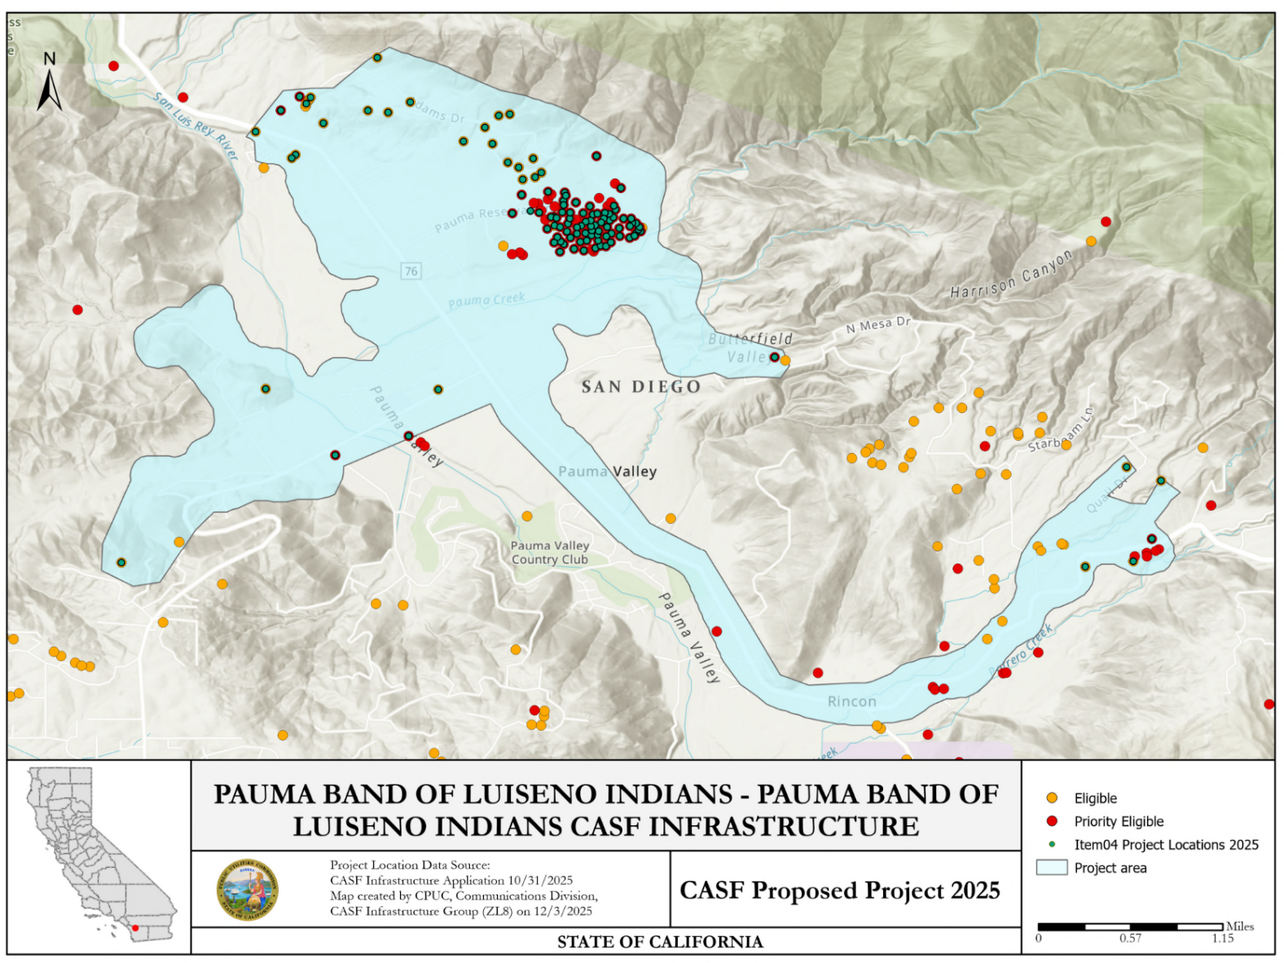
Pauma Band of Luiseño Indians CASF Infrastructure Project

APPENDIX G

Project Location Map – Middle Mile

Pauma Band of Luiseño Indians

Pauma Band of Luiseño Indians CASF Infrastructure Project
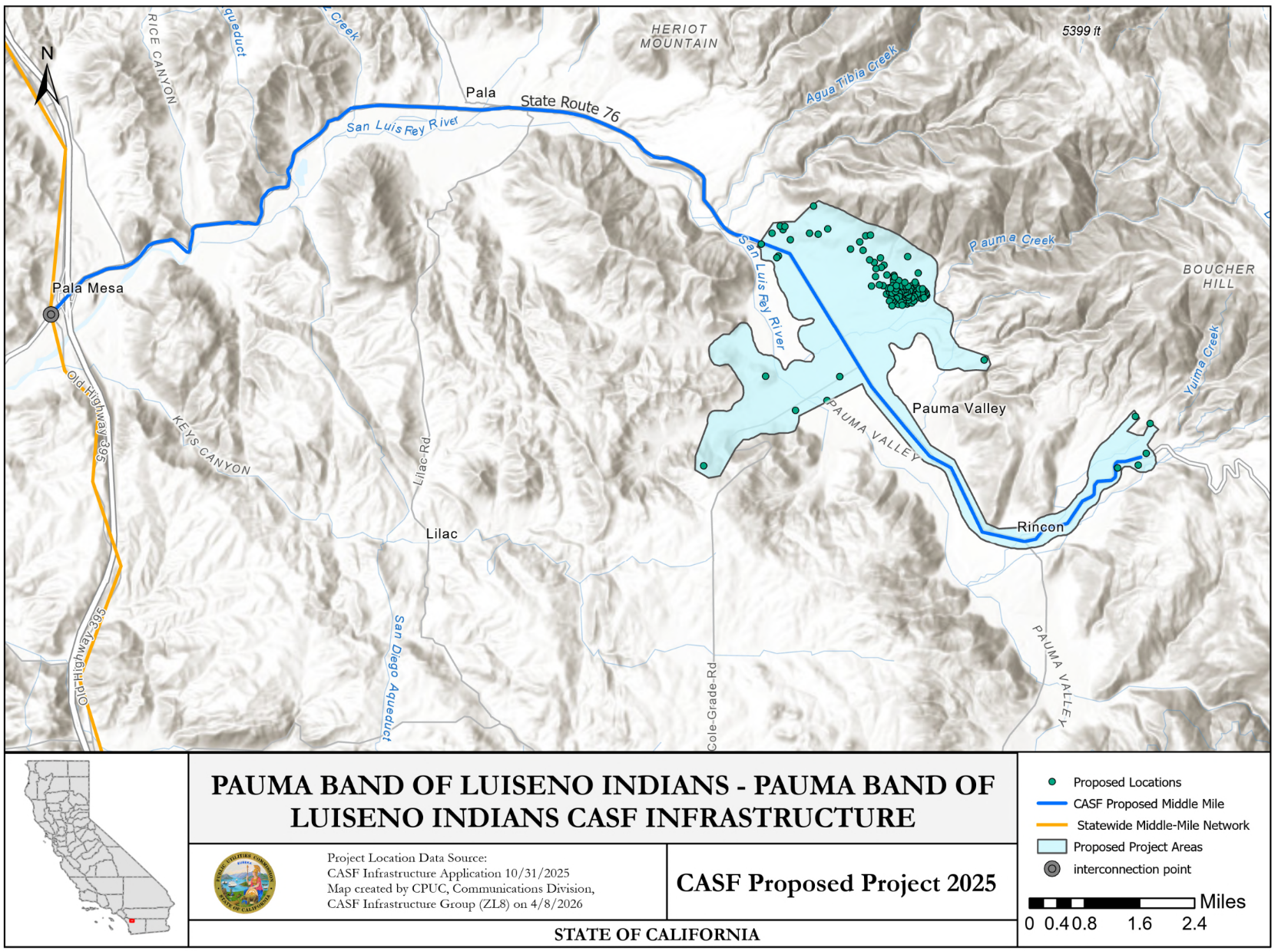

Public Utilities (Pub. Util.) Code § 281(f)(4)
See Bill Text - SB-1193 Telecommunications: universal service: California Advanced Services Fund.
See Bill Text - SB-156 Communications: broadband.
See Public Utilities (Pub. Util.) Code § 281(b)(1)(B)(ii)(I).
See Pub. Util. Code § 281(f)(5)
See Pub. Util. Code § 281(l)
See CASF Grantee Monthly Contractor Reporting.
See California Interactive Broadband Map.
See CPUC Tribal Consultation Policy endorsed March 21, 2018, Rulemaking (R.)20-08-021 Tribal Technical Assistance Application Requirements and Guidelines, and Executive Order B-10-11.
See California Interactive Broadband Map.
See https://www.hcd.ca.gov/sites/default/files/docs/grants-and-funding/income-limits-2025.pdf.
See the High Fire Threat District (HFTD) App and the California Interactive Broadband Map.
See https://www.hcd.ca.gov/sites/default/files/docs/grants-and-funding/income-limits-2025.pdf.
See the High Fire Threat District (HFTD) App and the California Interactive Broadband Map.
See https://www.cpuc.ca.gov/industries-and-topics/internet-and-phone/california-advanced-services-fund/casf-infrastructure-project-summaries for project summaries and https://www.cpuc.ca.gov/industries-and-topics/internet-and-phone/california-advanced-services-fund/casf-infrastructure-grant/casf-infrastructure-approved-projects for approved projects.
The Commission extended the CASF Infrastructure application deadline from April 1 to October 31, 2025, and all subsequent deadlines were moved back by six months.
See CASF Infrastructure Project Summaries at https://www.cpuc.ca.gov/industries-and-topics/internet-and-phone/california-advanced-services-fund/casf-infrastructure-project-summaries.
See D. 22-11-023, Attachment 1.
Administrative costs are defined as “indirect overhead costs attributable to a project, per generally accepted accounting principles (GAAP), and the direct cost of complying with Commission administrative and regulatory requirements related to the grant itself.” Applicants seeking additional funds will require a Commission exemption included in a draft resolution.

