PUBLIC UTILITIES COMMISSION OF THE STATE OF CALIFORNIA

Communications Division | RESOLUTION T- 17921
Consumer Programs Branch | June 11, 2026
R E S O L U T I O N

Resolution T- 17921: Three projects will receive funding through the Digital Divide Account as part of the Digital Divide Grant Program and adopting a ministerial review process for future qualifying applications.

PROPOSED OUTCOME:

Approves $199,659.00 in funding for three Digital Divide Grant Program (DDGP) projects, and the adoption of ministerial review process for qualifying future DDGP applications.

SAFETY CONSIDERATIONS:

There are no safety considerations associated with this resolution.

ESTIMATED COST:

There are no costs associated with this resolution.

SUMMARY

This Resolution approves three grants totaling $199,659.00 from the Digital Divide Account nested within the California Teleconnect Fund Administrative Committee Fund to advance access to broadband service in low-income urban and rural areas. The program will award $99,659 to Human-I-T (HIT) for a project serving low-income schools, and $50,000 each to the United We Lead Foundation (UWLF) and the Education and Leadership Foundation (ELF), for projects led by Community-Based Organizations (CBOs).

Further, the California Public Utilities Commission (CPUC or Commission) Communications Division (CD) staff request, as permitted by Ordering Paragraph 8 of Decision (D.) 21-10-020, ministerial authority to utilize an Administrative Letter to announce DDGP Awardees for qualifying applications rather than through a resolution in future rounds.

BACKGROUND

Public Utilities Code (Pub. Util. Code) section 280.5, enacted by AB 855 (Ch. 820, Stats. 2003), established the Digital Divide Grant Program (DDGP) and requires the Commission to award grants to fund digital divide programs. The program is funded through an allocation of a percentage of revenues generated from lease agreements for wireless telecommunications facilities located on state-owned property, which is then deposited into the Digital Divide Account. Currently, the Digital Divide Account maintains a balance of approximately $200,000 dollars.
Section 280.5(c)(2) requires the Commission to award grants to community-based nonprofit organizations (also known as Community Based Organizations (CBOs), on a competitive basis subject to criteria to be established by the commission and in a way that disburses the funds widely, including to urban and rural areas for the purpose of funding community technology programs. The statute defines “digital divide projects” as community technology programs involved in activities that include, but are not limited to, the following:
- Providing open access to and opportunities for training in technology.
- Developing content relevant to the interests and wants of the local community.
- Preparing youth for opportunities in the new economy through multimedia training and skills.
- Harnessing technology for e-government services.
On September 18, 2020, the Commission initiated Rulemaking (R.) 20-09-001 (the “Broadband for All” proceeding) to set the strategic direction and changes necessary to expeditiously deploy reliable, fast, and affordable broadband. The rulemaking sought comment on how the Commission should use the roughly $1 million in the Digital Divide Account to help schools and students. In Decision (D.) 21-10-020, Ordering Paragraph 7, the Commission authorized CD to initiate a pilot program and delegated to staff the authority to approve grants using the following criteria:
a. Grants are limited to serving urban and rural low-income small school districts.
b. The beneficiary school must be in an urban or small rural school district, as identified by the California Department of Education.
c. The beneficiary school must have a free lunch participation rate of at least 50 percent.
d. The grant recipient must be a CBO non-profit with a demonstrated record of work to address the digital divide.
e. CBO administrative expenses are limited to no more than 10 percent of the grant amount.
f. Grants must provide a holistic solution including, but not limited, to:
    - Student home broadband connection.
    - Student required hardware including laptop, Chromebook and/or hotspots.
    - Student curriculum focused on the use of technology.
    - Software to enable distance learning for student and teacher; and
    - Training for teachers in the use of technology for distance learning.
              - The term of the project is limited to one school year.
              - Ongoing subsidies for the Commission’s California Teleconnect Fund eligible services may be available for the participating school; and
              - Grants shall not exceed $250,000 per pilot project.
On October 6, 2022, the Commission issued Resolution (Res.) T-17770, defining eligibility criteria, the application process, required documentation, and the scoring system for the DDGP pilot projects. The methodology ensured competitive selection of four grant recipients in compliance with statutory requirements.

The resolution states that the projects must provide a holistic solution including, but not limited to:
- Student home broadband connection.
- Student required hardware including laptop, Notebook and/or hotspots.
- Student curriculum focused on the use of technology.
- Software to enable distance learning for students and teachers; and
- Training for teachers in the use of technology for distance learning.

The resolution indicated CD’s intent to support projects that foster community engagement and student success. The resolution also encouraged CBOs and schools to sustain projects for at least one full school year beyond the initial grant period. After funding ends, the Commission will evaluate the projects and may consider additional funding or expanding the program to other community technology initiatives.

On August 2023, the Commission adopted Res. T-17794, where it awarded $999,480 in funds for four grants to: Outside the Lens, Human-IT, the Small School District Association, and Thrive.

Due to the success of the DDGP pilot program, on December 5, 2024, Res. T-17842 made the DDGP program permanent for eligible Community Technology Programs. The total grant amount available for the permanent program is $200,000 annually, on an ongoing basis until funds are exhausted or otherwise discontinued. This resolution authorized up to $100,000 to projects for low-income rural and urban schools, and up to two $50,000 awards to projects for CBOs.

DISCUSSION

DDGP Outreach
Once the Commission adopted Res. T-17842, CD staff developed an outreach plan targeting qualified CBOs with the necessary expertise and experience to submit a project proposal and DDGP application. The CPUC News and Outreach division promoted the DDGP by creating promotional materials, issuing a press release, and sharing information about the pilot program on the Commission’s webpage and social media platforms. Staff emailed the DDGP promotional materials to the last California Teleconnect Fund (CTF) proceeding service list, for R. 13-01-010 (the CTF program includes CBO participants offering educational and technological services to the community) and reached out to the Education sector representative of the CTF Administrative Committee to ensure this information reached the California Department of Education. Staff also ensured the grant opportunity was published on the Cal Grants website. Finally, staff held a DDGP public webinar on May 6, 2025, where staff promoted DDGP and discussed the eligibility criteria, who can apply, the application process and deadline, and its success stories.

Application review and scoring

The Commission set and announced a DDGP Round 3 application window from December 12, 2025, to February 12, 2026. To assist applicants, CD staff published detailed instructions—along with the application package and staff contact information—on the Commission DDGP webpage. Staff timely received a total of 14 applications.
A Scoring Panel of seven analysts evaluated the applications in three stages: (1) Baseline Review, (2) Individual Scores, and (3) Final Scores and Determination. Each panelist conducted an independent assessment of the applications, considering predetermined evaluation criteria. Afterward, the panelists convened to deliberate and discuss the composite scores and rankings of the applications. This collaborative discussion played a crucial role in finalizing the assessment and determining the final scores for each application.
Panelists first evaluated the applications against baseline requirements to determine eligibility for the second stage of review. Of the 14 applications received, five did not meet the basic requirements and were notified that their applications would not advance to the next stage.
During the second stage of evaluation, the Scoring Panel evaluated the remaining nine applications based on four key categories: Scope of Work, Experience, Budget, and Overall. Each category received a score, with a maximum score of 100 points:

Category | Points (Maximum)
Scope of Work | 40
Experience | 30
Budget | 20
Overall | 10
Total | 100

In the final scoring stage, the Scoring Panel engaged in discussions to collectively evaluate the applications and assign a final composite score to each. The purpose of these deliberations was to ensure a comprehensive assessment and consideration of all relevant factors. Based on the assigned scores, the applications were then ranked in descending order to determine the finalists. The three projects with the highest total scores were identified and recommended for funding, as they demonstrated exceptional merit and alignment with the program’s objectives.

Staff Determination-Finalists

Based on the review conducted by the Scoring Panel, the staff recommend that the Commission award grants to one school: (1) Human-I-T, and two CBOs: (2) United We Lead Foundation and (3) Education and Leadership Foundation. Details of each project are described below.

- Human-I-T
Wonderful College Prep Academy (Delano campus and Lost Hills campus)
Combined Free or Reduced-Price Meal (FRPM) participation: 87.3%

Project budget: $99,659
Total students served: 257
Final Composite Score: 79.16

Human-I-T (HIT) received the highest score among the rural and urban school applications. Under Scope, HIT received a score based on their proposal to provide digital literacy to 257 homeless or underserved students at the two locations (Delano and Lost Hills) of Wonderful College Prep Academy (WCPA) and provide each of the 257 students with an Asus Chromebook 11 equipped with Google Management Console licenses.

For Experience, HIT was previously awarded a DDGP grant during the pilot phase of DDGP and successfully completed the project, meeting all goals. For that project, HIT was also working with WCPA at the same two campuses. HIT successfully completed that DDGP project, meeting all deliverables and benchmarks. This proposed project is almost identical to HIT’s previous DDGP project except both WCPA campuses now have broadband access and do not need the broadband access component of the previous project.

HIT also scored the highest in Overall because they have demonstrated the proposed project is simple to implement and effective, with their successful completion of their previous DDGP project at the same WCPA campuses.

- United We Lead Foundation (UWLF)
Community-Based Organization

Project budget: $50,000
Total student served: 50
Final Composite Score: 73.86

United We Lead Foundation (UWLF) ranked second overall of the three proposed projects and first in the CBO category. For the Scope of Work, UWLF earned its score based on its proposed project called “Digital Empowerment for Parents and Caregivers.” Participants will primarily be parents and caregivers who face economic, linguistic, and systemic barriers to effective technology use. The program will provide digital literacy training and support to 50 low-income, adult students, each with a laptop/Chromebooks for them to keep after completing the program.

For Experience, UWLF has demonstrated experience in implementing adult digital literacy programming, managing grant-funded initiatives, and collaborating with public and community institutions to serve low-income families.

UWLF’s Overall score was determined by the project’s integrated approach to reach, educate and bridge the digital divide of low-income families in the Fresno area.

- Education and Leadership Foundation (ELF)
Community-Based Organization.

Project budget: $50,000
Total community members served: 25
Final Composite Score: 70.00

Education and Leadership Foundation (ELF) received the second highest score in the CBO category. Their Scope of Work score was based on their proposal to reach and educate 25 mature students with a curriculum focusing on computer literacy and cybersecurity. The program will provide each student with broadband access via 4G LTE Wi-Fi hotspot for the duration of the 12-month project, as well as a laptop during the project period. The 25 laptops funded by this grant will remain with ELF at the end of the project to be used in future computer literacy and cybersecurity training classes.

For Experience, ELF has prior experience implementing community technology projects and, working in partnership with United Way Fresno and Madera Counties, it coordinated outreach efforts to help targeted populations complete online application for the United States Department of Agriculture’s $600 flat-rate financial support for eligible workers during the COVID-19 pandemic.

ELF’s Overall score was influenced by their proposed project to bridge the digital divide by offering computer literacy and cybersecurity training, along with access to a laptop and wireless broadband access for its mature adult students in California’s undeserved, Central Valley communities.

Funding Determination

Staff reviewed the proposed budgets of each finalist’s application to ensure the budget did not exceed $100,000 per project and the 5% administrative expense limit for schools and $50,000 budget maximum for CBOs, with a 10% administrative expense limit. Staff determined the budget items and services proposed by the finalists are reasonable. Accordingly, staff recommends the Commission allocate a total of $199,659 from the Digital Divide Account to award three grants based on the amounts below:

- Human-I-T: $99,659
- United We Lead Foundation: $50,000, and
- Education and Leadership Foundation: 50,000

Detailed budget information can be found in Appendix A of the final version of this Resolution.

Upon issuance of this resolution, CD staff will send a Notice of Award letter to the finalist schools and CBOs. The selected school and CBOs will be required to immediately complete a Payee Data Record Form, Standard (STD) 204, to receive the allocated funding.

Compliance requirements

As a condition of accepting DDGP funds, the grant recipients agree to comply with all the rules and guidelines of the program, as specified in the signed acknowledgement included in each applicant package. Grant recipients are required to timely submit two project reports, along with any invoices or other supporting documentation of program expenses:

- Progress Report: due no later than December 1, 2026. Grantees must submit information on the progress of the project, including the status of milestones, for the first four months of implementation.
- Completion Report: due no later than June 1, 2027. Grantees shall report on the completion of the overall project, milestones met, and metrics to assess outcomes.

A sample template is provided in Appendix C. Staff will generate a final report template and make it available on the DDGP website (www.cpuc.ca.gov/ddgp) ahead of each due date.

The grantee must submit the reports to DigitalDivideGrantProgram@cpuc.ca.gov via email or using the Commission’s secure file transfer tool Kiteworks (https://kwftp.cpuc.ca.gov).

Payments to DDGP Recipients

In both required reports, Grantees must include all invoices and supporting documentation of project expenses incurred. The Commission will reimburse grantee expenses in accordance with the disbursement schedule described in Appendix D of this resolution, and within the time specified in Government Code Section 927, et seq.

Project Audit and Review

Grantee agrees that the digital divide project is subject to audit and review by the Commission. The grantee shall implement a document retention policy and maintain all files, invoices, and other related documentation for a period of three years after final payment is received. The grantee shall make these records available to the Commission upon request. Staff may also conduct site visits if necessary.

Should the grantee fail to complete the project or incur any unreasonable expenses beyond the project's proposed scope of work or budget, the Commission may either: (1) disallow those expenditures against any of the grantee’s remaining funds, or (2) order reimbursement of some or all of the Digital Divide Account funds received. Any costs incurred beyond the funding amount awarded in the grant shall be borne by the grantee and/or the beneficiary school.

Future Application Cycles for the Digital Divide Grant Program
CD staff propose that the Commission assign them the authority to open future DDGP application rounds via the Commission Administrative Letter process and to award grants for projects meeting a list of preset criteria, through a ministerial process.

The Administrative Letter will include detailed application instructions and deadlines. The Administrative Letter will be available for download at the DDGP webpage at http://www.cpuc.ca.gov/ddgp. A Community-Based Organization (CBO) may submit its completed application, including all required documents, by email to: DigitalDivideGrantProgram@cpuc.ca.gov.

The Administrative Letter will be published on the Commission website, and a copy of the letter will be distributed through the latest CTF proceeding service list, R. 13-01-010 (the CTF program includes CBO participants offering educational and technological services to the community).

Once a round’s application window is closed, staff anticipate completing reviews and selecting awardees within 90 days. Staff will subsequently publish an award letter for applications approved via ministerial review. For DDGP applicants who do not meet Staff’s proposed criteria for ministerial review, they will continue to be awarded through the Commission Resolution process. Award is subject to the Commission’s approval, and applicants will receive a notice of award upon adoption of the Final Resolution.

Ministerial Review

As permitted by Ordering Paragraph 8 of Decision (D.) 21-10-020, CD staff propose adopting a ministerial review process for approving DDGP applications that meet certain criteria. Ministerial review would ease the administrative burden for Staff, Commissioners, and applicants, compared to issuing and responding to projects approved through the formal Commission Resolution process. This proposed review process is patterned after the Commission’s California Advanced Service Fund (CASF) Adoption program’s ministerial review process with modifications to meet the DDGP’s unique requirements and goals.

Below are Staff’s recommendations for ministerial review Requirements:

- A project can be approved by the Communications Division through ministerial review if it meets specified list of review criteria. Applications that do not meet the review requirements will continue requiring approval through a Commission Resolution which requires a full Commission review. Criteria meeting ministerial criteria include:
  - Applicant meets the eligibility requirements under Pub. Util. Code, § 280.5(d) and (e).
  - CBO applicants partnering with a school(s) request a grant amount of $100,000 or less.
  - CBO applicants working directly with communities request a grant amount of $50,000 or less for each project.
  - The CBO nonprofit organization has existed for more than one year.
  - The applicant has at least one year of experience conducting digital literacy training or broadband access projects, or if they have completed at least one digital literacy training or broadband access project.
  - The applicant has designated in person or virtual space for training, public computer access, or has provided detailed information on how such in person or virtual space will be obtained.
  - The application meets all other Digital Divide Grant Program application requirements.
Ministerial Approval

Applications approved through ministerial review will follow the same reporting and reimbursement requirements as applications awarded through Commission Resolution.

The Communications Division will notify grantees of awards made through ministerial review by letter. Award letters will be posted to the Commission’s website.

Resolution Approval

Applications not meeting the above criteria for ministerial review may be approved for award via the Commission Resolution process.

The Commission assigns staff the task to propose administrative changes to the Adoption Account program by Resolution for Commission review and approval of those changes.

COMMENTS ON DRAFT RESOLUTION

In compliance with Public Utilities Code Section 311(g), a notice letter was emailed on May 1, 2026, informing all parties on the CTF Distribution List of the availability of the draft of this Resolution and the opportunity for public comments, at the Commission’s documents website at http://www.cpuc.ca.gov/documents/. This letter also informed parties that the final conformed Resolution adopted by the Commission will be posted and available at the same website. The Commission received no public comments.

FINDINGS

- Public Utilities Code Section 280.5 established the Digital Divide Grant Program (DDGP), authorizing the Commission to award grants to community-based nonprofit organizations to fund community technology programs that reduce the digital divide in low-income urban and rural communities.

- The DDGP is funded by an allocation of a percentage of fees collected from the lease of certain state-owned property to wireless telecommunications service providers for wireless telecommunications facilities, pursuant to Government Code Section 14666.8.

- Decision (D.) 21-10-020 authorized staff to implement a pilot program with specific eligibility and program criteria for the DDGP, and Resolution T-17842 established the DDGP as a permanent program with an annual funding of $200,000.

- D.21-10-020 delegated to Communications Division staff the authority to select grants from the Digital Divide Account that meet the criteria set forth in Ordering Paragraph 7 and Public Utilities Code Section 280.5.

- The Digital Divide Account currently has a balance of $200,000.

- Grant participants must be a Community Based Organization nonprofit with a demonstrated record of work in addressing the Digital Divide.

- Resolution T-17770 set forth the Community Based Organization and beneficiary school eligibility criteria, application process, application package, application scoring, project reporting and compliance requirements for the DDGP pilot projects.

- Staff developed an outreach program to target potential Community Based Organizations with expertise in education and technology.

- The Commission received 14 submissions for the DDGP by the application deadline of February 12, 2026.

- Five applicants failed to meet the Basic Requirements set forth in Resolution T-17770 and did not advance to the Scoring stage.

- After individually scoring the nine finalists, staff assigned composite scores and selected three finalists.

- Staff recommend awarding the following grants:
- $99,659 to Human-I-T
- $50,000 to United We Lead Foundation
- $50,000 to Education and Leadership Foundation

- It is reasonable to condition the digital divide grants by requiring a recipient to submit Project Status Reports, invoices, and other documentation, and for staff to conduct audits, reviews, or site visits as needed, to ensure all funds are being spent in accordance with Public Util. Code Section 280.5.

- Human-I-T, United We Lead Foundation, and Education and Leadership Foundation each signed an agreement which is included in their application package that “if selected as a grant award recipient, the organization and any of its officers, employees, agents will carry out the approved project in good faith and shall adhere to terms and conditions of the California Public Utilities Commission, the Digital Divide Grant Program, California Public Utilities Code § 280.5, Decision 21-10-020, and Resolution T-17770, and any successor decisions.”

- There are no safety issues concerning the awarding of the grants.

- The use of Commission Administrative Letter to open future DDGP application rounds, along with the introduction of Ministerial review and award for applications meeting preset criteria reduces administrative burden and shortens the overall review and approval timeframe, which allows an approved project to start delivering much needed DDGP services to the project’s intended recipients.

- The Commission e-mailed a Notice of Availability of this Resolution on May 1, 2026 that the draft of this Resolution is available at the Commission’s website http://www.cpuc.ca.gov/ and is available for public comments. The Commission received no public comments.

THEREFORE, IT IS ORDERED that:

- The Commission shall award $99,690 Human-I-T, $50,000 to United We Lead Foundation, and $50,000 to Education and Leadership Foundation to fund the proposed projects submitted in their respective application packages.

- Human-I-T, United We Lead Foundation, and Education and Leadership Foundation shall comply with all guidelines, requirements and conditions associated with a Digital Divide Grant program award, as specified in D.21-10-020, Resolution T-17770 and this Resolution.

- Human-I-T, United We Lead Foundation, and Education and Leadership Foundation shall complete all work and achieve all workplans submitted with its application.

- By receiving a Digital Divide Grant Program grant, Human-I-T, United We Lead Foundation and Education and Leadership Foundation agree to comply with the terms, conditions and requirements of the grant and thus submit to the jurisdiction of the Commission regarding disbursement and administration of the grant.

- Human-I-T, United We Lead Foundation and Education and Leadership Foundation shall submit a Progress Report on the first four months of implementation, including the status of milestones. The Progress Report must include any invoices and supporting documentation of all expenses incurred and is due no later than December 1, 2026.

- Human-I-T, United We Lead Foundation and Education and Leadership Foundation shall submit a Completion Report of the overall project, milestones, and metrics to assess outcomes. The Completion Report must include any invoices and supporting documentation of all expenses incurred and is due no later than June 1, 2027.

- Human-I-T, United We Lead Foundation and Education and Leadership Foundation shall implement a document retention policy and maintain files, invoices, and other related documentation for three years after final payment. The records must be available to the Commission upon request and are subject to audit and review by the Commission at any time.

- If Human-I-T, United We Lead Foundation and Education and Leadership Foundation fails to complete the project or incurs any unreasonable expenses outside the project's scope of work or budget, the Commission may either: (1) disallow those expenditures against any of the grantee’s remaining funds, or (2) order reimbursement of some or all of the Digital Divide Account funds received. Any costs incurred beyond the funding amount awarded in the grant shall be borne by the grantee and/or the beneficiary school.

- Staff’s proposed Ministerial review process, as described in this Resolution is approved and staff have the authority to determine that applications meet preset criteria and may receive Digital Divide Grant Program grants.

This Resolution is effective today.

I certify that the foregoing resolution was adopted by the California Public Utilities Commission at its regular meeting on _________________, and the following Commissioners approved favorably thereon:

/s/ ____________________
Leuwam Tesfai
Executive Director

APPENDIX A
Approved Project Budgets and Number of Students/Community Members Served by Project

Human-I-T
13000 Montague St., Pacoima, California 91331

Human-I-T
Budget Line Item | Price Per Item | Number of Units | Total Amount
Student Chromebook Devices (ASUS Chromebook 11) | $349.00 | 257 | $89,693.00
Administrative Costs * | n/a | n/a | $9,966.00
Total Requested |  |  | $99,659.00
Total Approved |  |  | $99,659.00
Number of Students Served by Project |  |  | 257

United We Lead Foundation (UWLF)
2010 N Fine Ave Suite 104, Fresno, CA 93727

United We Lead Foundation (UWLF)
Budget Line Item | Number of Units | Unit Price | CPUC Digital Equity Grant Request Total
Adult Laptops/Chromebooks/hotspots | 50 | $600 | $30,000
Protective Cases & Accessories | 50 | $50 | $2,500
Adult Digital Literacy Curriculum (Structured Program Materials & Licensing) | 50 | $150 | $7,500
Workshop Supplies & Printing | - | $1,500 | $1,500
Instructor/Facilitator Stipend (In-Person Delivery) | - | $2,500 | $2,500
Technical Support & Troubleshooting Assistance | - | $1,000 | $1,000
Administrative Costs (10% Maximum) | - | $5,000 | $5,000
Total Requested |  |  | $50,000
Total Approved |  |  | $50,000
Total Number of Community Members Served by Project |  |  | 50

Education and Leadership Foundation (ELF)
1308 E. Olive Avenue, Fresno, CA 93728

Education and Leadership Foundation (ELF)
Budget Line Item | Number of Units | Unit Price | CPUC Digital Equity Grant Request Total
Student Laptops and required accessories (mice, carrying case) | 25 | $1,250 | $31,250
Student Hardware - Solis by SIMO Lite Hotspot & Power Bank | 25 | $108 | $2,700
Student Software – USA GoData 5GB  ($15 monthly x 12 months = $180) | 25 | $180 | $4,500
Curriculum – Computer Literacy & Cyber Security | - | $4,500 | $4,500
Instructor laptop and accessory | - | $2,250 | $2,250
Instructor Software – Online Attendance Tracker Plan  ($45 monthly x 12 months = $540) | - | $540 | $540
Administrative Costs (9.31%) | - | $4,260 | $4,260
Total Requested |  |  | $50,000
Total Approved |  |  | $50,000
Total Number of Community Members Served by Project |  |  | 25

APPENDIX B
DDGP Round 3 Panel Final Scores

Applicant  Category | Human-I-T | United We Lead Foundation  (UWLF) | Education and Leadership Foundation
Scope of Work | 27.89 | 27.36 | 28.14
Experience | 25.53 | 23.57 | 22.14
Budget | 17.74 | 15.21 | 14.29
Overall | 8.00 | 7.71 | 5.43
Total | 79.16 | 73.86 | 70.00

This document is a copy of Appendix E of Resolution T-17770

APPENDIX C
Project Status Report

Each project status report should include a cover page with the following table:

Grant Recipient (CBO Name):
Project Name:
Beneficiary Public Schools:
Report Type (Progress or Completion):
Report Submission Date:
(MM/DD/YY)
Payments Received to Date: ($)
Project Completion Date:
(MM/DD/YY)
Attestation: I certify that all statements and representations made in this report are true and correct under penalty of perjury. | Name:  Signature:  Report submission date:

The two project status reports must respond to each of the items enumerated below. Organize and label responses in a manner consistent with the list of items below.
- What are the total project expenses incurred to date?
- Are the expenses incurred during this reporting period consistent with the approved project budget? If not, please explain and provide justification for the difference.
- Describe progress on the approved Scope of Work. Using both qualitative and quantitative terms, describe accomplishments made during this reporting period. Identify and organize accomplishments according to the approved Scope of Work. For each item within the approved Scope of Work, identify whether all the milestones/goals set for this reporting period were achieved. If any of the goals or milestones set for this reporting period were not met, explain why.
- Are the accomplishments described consistent with the approved project plan? If not, please explain.
- Describe any additional project accomplishments for this reporting period that were not part of the approved Scope of Work.
- Identify, describe/explain, and provide justification for any changes or diversions from the approved Scope of Work during this reporting period. How will the changes and diversions during this reporting period affect project completion (e.g., delays, set goals that cannot be accomplished, etc.)? Was the CPUC notified of these changes or diversions, and if so, were the changes or diversions approved by the CPUC? If not, please explain why the CPUC was not notified.
- Identify, describe/explain, and provide justification for any changes or diversions from the approved project budget during this reporting period. How will the changes and diversions during this reporting period affect project completion (e.g., delays, set goals that cannot be accomplished, etc.)? Was the CPUC notified of these changes or diversions, and if so, were the changes or diversions approved by the CPUC? If not, please explain why the CPUC was not notified.
- Are additional changes or diversions anticipated to the approved Scope of Work during the remainder of the project period? If so, please describe and provide justifications, and explain how the changes or diversions will affect project completion or project goals.
- Are additional changes or diversions anticipated to the approved project budget during the remainder of the project period? If so, please describe and provide justifications, and explain how the changes or diversions will affect project completion or project goals.
- Identify challenges to the project experienced during this reporting period and describe the course of action taken to address the challenges.
- Identify future challenges anticipated during the remainder of the project. For each challenge identified, what is the planned course of action to address the challenge. Will the challenges affect project completion? If so, please explain how project completion will be affected.
- Identify and describe any unexpected benefits that resulted from the project during this reporting period.

APPENDIX D
Disbursement Schedule and Conditions of Payment

- Grantee will receive grant funds at three points throughout the project period to be allocated as follows:
  - First disbursement: 25% of the grant award to be issued after approval of Res. T-17921 to fund the project’s initial ramp up period.
  - Second disbursement: Up to 50% of the grant award
  - Third disbursement: 25% of the grant award, plus any remaining funds, if applicable.
- After the first disbursement, subsequent payment requests will accompany two of the reports required by T-17770. These include:
  - Project Status Report: due no later than December 1, 2026 and
  - Project Final Completion Report: due no later than June 1, 2027.
- The relevant project report must be submitted in order for a payment request to be granted.
- Grantee shall submit final requests for payment no later than 3 months after completion of the project or June 1, 2027, whichever is earlier.
- Payment will be based upon receipt and approval of invoices and other supporting documents showing the expenditures incurred for the project are in accordance with their approved application and budget.
- Grantee shall notify the Commission as soon as it becomes aware that they may not be able to meet project deadlines.
- Payment will be made in accordance with, and within the time specified in California Government Code § 927 et seq.
- The Commission has the right to conduct any necessary audit, verification, and discovery during project implementation to ensure that DDGP funds are spent in accordance with the terms of approval granted by the Commission.
- Grantee invoices will be subject to audit by the Commission at any time within three years of final payment.

Certification Requirement: Grantee must certify that each report and payment request submitted is true and correct under penalty of perjury.

All required reports and payment requests, including invoices and other supporting documents should be submitted via email to: DigitalDivideGrantProgram@cpuc.ca.gov.
APPENDIX E
Signed Terms and Conditions of the Digital Divide Grant Program

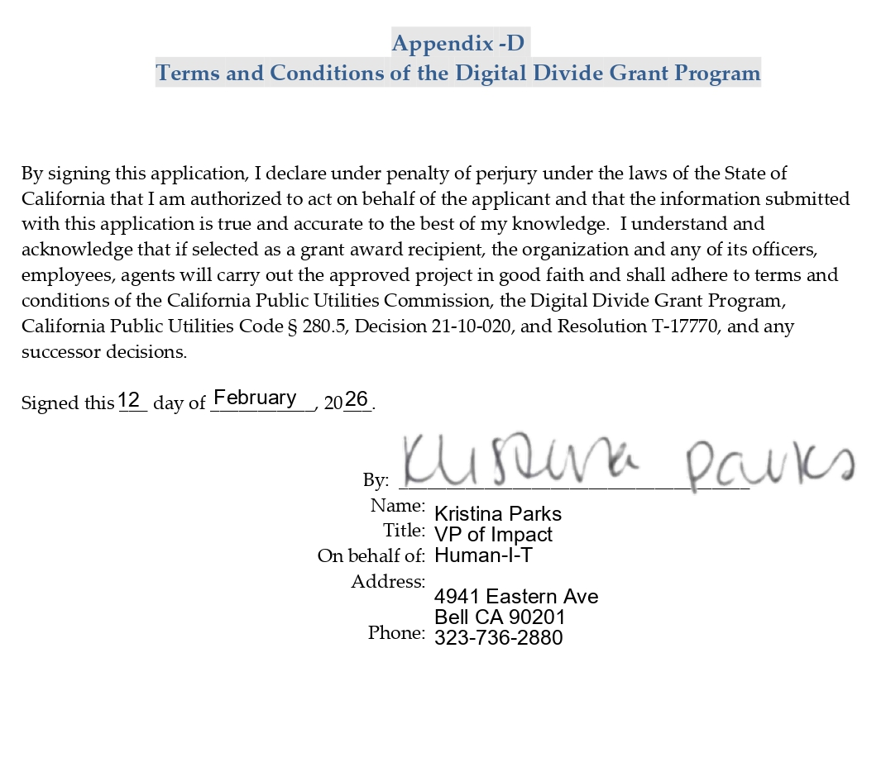

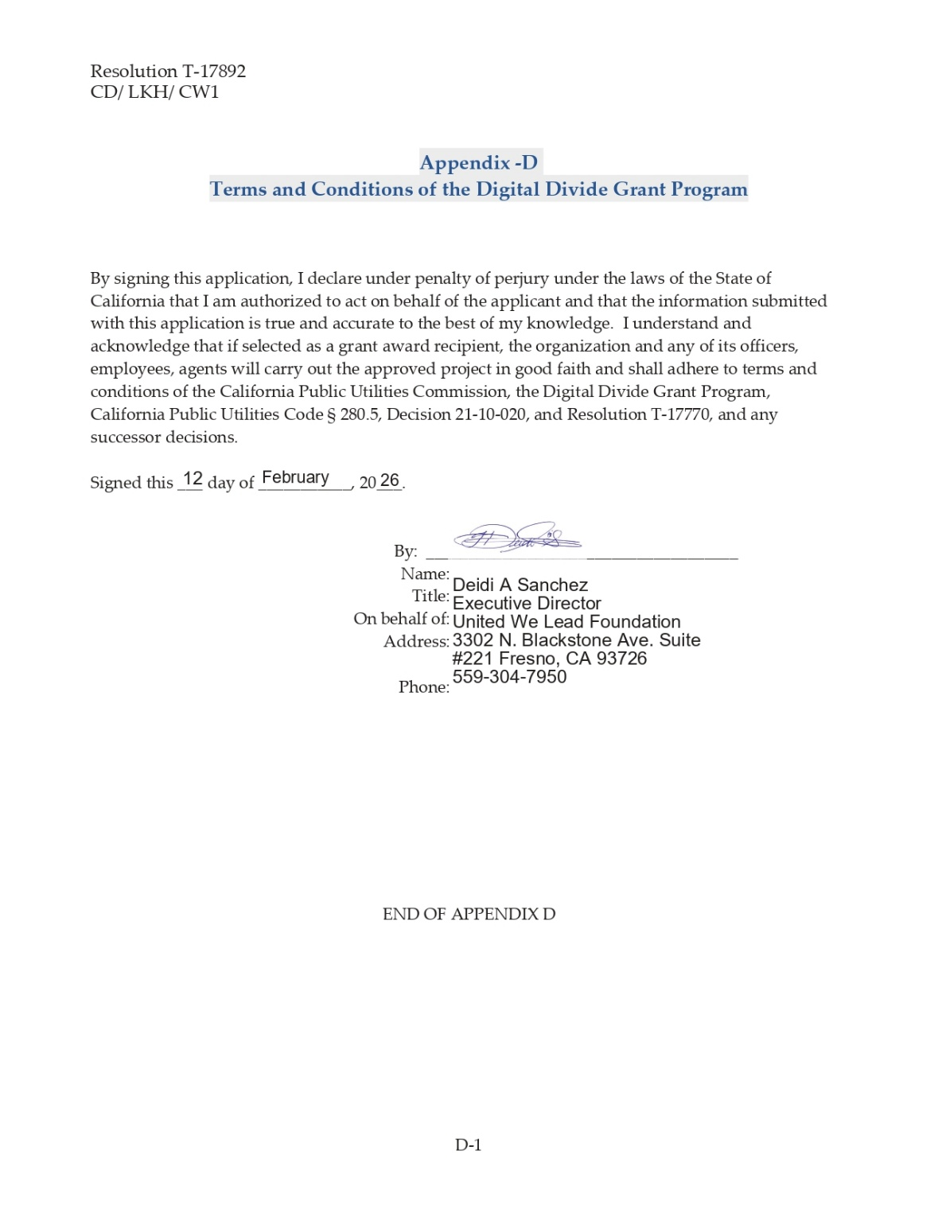
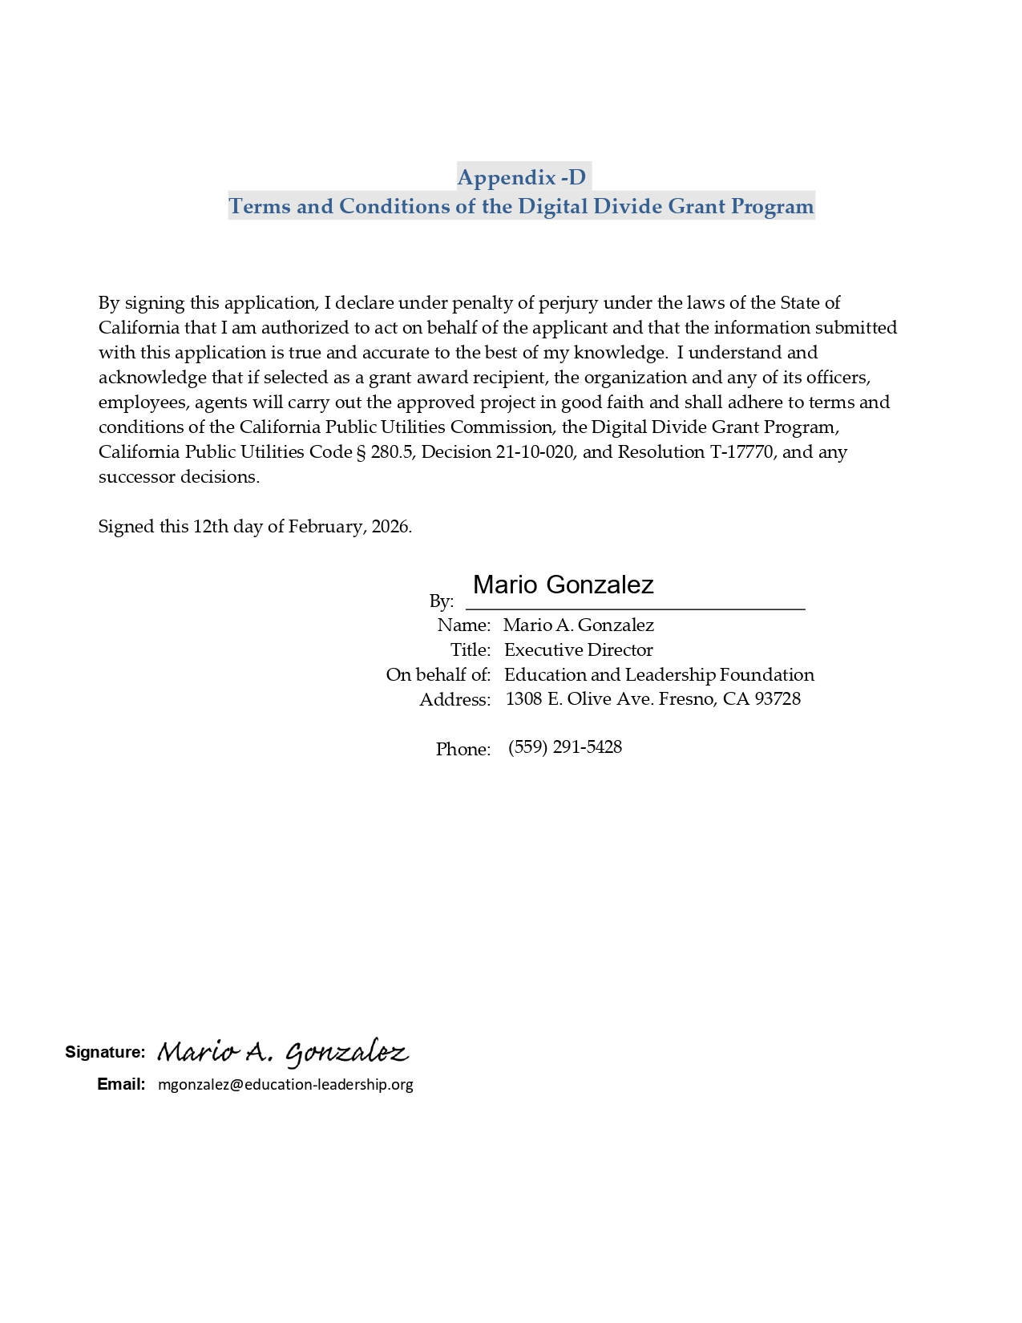

All statutory references refer to the Public Utilities Code, unless otherwise stated.
Pursuant to Pub. Util. Code § 280.5(b), the Digital Divide Account, established in the California Teleconnect Fund Administrative Committee Fund, must be used only for digital divide pilot projects.
Department Report
Grant recipients must be exempt from taxation under Section 501(c)(3) of the Internal Revenue Code. Pub. Util. Code § 280.5(c)(2).
Pub. Util. Code § 280.5(e).
D.21-10-020, Ordering Paragraph (OP) 7, 8.
Res. T-17770, p 5.
Department Report; see also Res. T-17842, p. 7.
Res. T-17770, pp. 8-9, states the baseline requirements include: (1) The application must be complete and timely submitted. The information and documents submitted must be sufficiently responsive to the application requirements. (2) The applicant is a tax-exempt organization under section 501(c)(3) of the Internal Revenue Code. (3) The applicant must be active and in good standing with the California Franchise Tax Board. (4) The applicant must submit at least three letters of recommendation. The letters of recommendation must be from entities unrelated to the beneficiary school, and can include state or local government agencies, public schools or school districts, county offices of education, persons holding public office, trade associations or groups, community groups, and/or anchor institutions. (5) The applicant must have a project established/active with a beneficiary school(s), or, at minimum, an agreement with a beneficiary school(s) to execute a proposed project. (6) The applicant must submit at least two letters of endorsement per beneficiary school supporting the digital divide project. One letter is required from each of the following: the beneficiary school’s district office and the beneficiary school’s Parent Teachers Association. (7) The beneficiary school(s) must be located within the boundaries of an urban or rural small school district, as identified by the California Department of Education. (8) The beneficiary school(s) must have a Free or Reduced-Price Meal participation rate of at least 50 percent.
See Appendix A.
Human-I-T Application, p. 12.
See Appendix B.
See Appendix A
United We Lead Foundation Application, Section 2., p. 1.
See Appendix B
See Appendix A.
Education and Leadership Foundation Application, Section 4.1.
See Appendix B.
The signed agreements of the grant finalists are appended to this resolution as Appendix E.
The Project Status Report submission due date is modified to allow grantees time for project implementation.
A user guide containing instructions on how to use Kiteworks is available at https://www.cpuc.ca.gov/-/media/cpuc-website/about-cpuc/employee-information/kiteworksftpexternalusersquickstartguide.pdf.
D.18-06-032, Appendix 1, p. 11-12, revised in D.25-11-003, Appendix B, p. 14-16.
PUC 280.5 (d) For purposes of this section, “community technology programs” means a program that is engaged in diffusing technology in local communities and training local communities in the use of technology, especially local communities that otherwise would have no access or limited access to the Internet and other technologies. PUC 280.5 (e) For purposes of this section, “digital divide projects” means community technology programs involved in activities that include, but are not limited to, the following: (1) Providing open access to and opportunities for training in technology. (2) Developing content relevant to the interests and wants of the local community. (3) Preparing youth for opportunities in the new economy through multimedia training and skills. (4) Harnessing technology for e-government services. https://law.justia.com/codes/california/code-puc/division-1/part-1/chapter-1-5/section-280-5/
A nonprofit organization would have existed more than one year if more than one year has passed from the effective date of exemption as listed on IRS determination letter on the date of the project submission.
A completed digital literacy training project is a project where the applicant planned for, executed, and completed a digital literacy project of at least 192 hours of instruction.
Tables for Approved Project Budgets for each school and CBO were taken from their submitted applications.
Project Status Report submission due date is modified to allow grantees time for project implementation.

