COM/MBK/jds/cg7 PROPOSED DECISION Agenda ID #24193
Quasi-Legislative
Item #15 06/11/2026

Decision PROPOSED DECISION OF COMMISSIONER BAKER (Mailed 05/07/2026)

BEFORE THE PUBLIC UTILITIES COMMISSION OF THE STATE OF CALIFORNIA

Order Instituting Investigation to Establish a Priority List, for the Fiscal Years 2026-2027 and 2027-2028, of Existing At-Grade Rail Crossings, of City Streets, County Roads or State Highways, in need of separation; or Existing Grade-Separated Rail Crossings in need of Alterations or Reconstruction in Accordance with Section 2452 of the California Streets and Highways Code. | Investigation (I.) 25-06-010

DECISION ESTABLISHING THE CALIFORNIA GRADE-SEPARATION FUND PRIORITY LIST FOR FISCAL YEAR 2026-2027

Summary
This decision establishes and adopts the California Grade-Separation Fund Priority List for Fiscal Year 2026-2027, as required by California Streets and
Highways Code § 2452 et. seq. Consistent with the California Public Utilities Commission’s adopted procedure, this proceeding will remain open until the Commission issues a final decision establishing the California Grade-Separation Priority List for Fiscal Year 2027-2028 and opens a new investigation for the next cycle proceeding to establish future Grade-Separation Priority Lists.

Background

Factual Background
California Streets and Highways (S&H) Code § 2452 requires the California Public Utilities Commission (Commission) to establish annual California Grade-Separation Program Priority Lists (Priority List(s)) for certain rail crossing projects, including projects to construct new grade-separations to replace existing at-grade crossings and projects to alter or reconstruct existing grade-separations. The Commission initiated this proceeding by issuing Order Instituting Investigation (I.) 25-06-010 on June 12, 2025, to evaluate and establish the California Grade-Separation Program Priority List for Fiscal Year (FY) 2026-2027 and FY 2027-2028.
The Commission’s adoption of Priority Lists establishes the
priorities for allocating funds to qualified projects that eliminate or otherwise
improve hazardous railroad crossings under S&H Code § 2450 et seq.
By July 1st of each year, the Commission provides the adopted Priority List to the California Transportation Commission (CTC) for use in the FY beginning on that date to fund qualified projects consistent with the Priority List. The CTC has delegated this authority to the California Department of Transportation (Caltrans).
Every two years, the Commission issues a new Order Instituting
Investigation (OII), to establish the Priority Lists for the next two FYs.
The Commission adopts the Priority List for the first FY by interim decision issued before that FY commences.
For the second year in the cycle, the Commission updates and revises the Priority List for the second FY by deleting projects for which funds were allocated in the first FY. The Commission then adopts a revised Priority List by final decision before the second FY begins and issues a new OII to start the next two-year funding cycle.
Commission procedure requires local agencies to file planned
grade-separation project nominations in response to an announcement made a
year prior to the cycle. The Commission reviews each nominated project to
ensure that it is eligible for the California Grade-Separation Program and holds
hearing(s), as needed, so that nominating agencies may present each proposal,
answer questions about its proposal details, and confirm the accuracy of each
proposal, as appropriate. Attendance and participation in these hearing(s) is
mandatory for any nominated project proponent. For each FY, the
Commission’s Rail Safety Division (RSD), using currently adopted formulas,
adjusts and ranks the draft Priority List in accordance with evidence received at
the hearing(s), and presents the list to the Commission as the Priority List for
adoption by interim decision.

Procedural Background
The Commission issued an OII on June 12, 2025. The OII provided notice, as required by S&H Code § 2451, to railroads, light rail transit agencies, cities, counties and others of the opportunity to file nominations for separation of existing railroad at-grade crossings, or alteration or reconstruction of existing grade-separations. The Commission provided this notice to the service list compiled at the conclusion of the previous Priority List proceeding. The notice included an October 24, 2025 deadline to file nominations for grade-separation projects proposed to be included in the FY 2026-2027 Priority List.
On July 29, 2025, the assigned Administrative Law Judge (ALJ) issued a ruling setting a remote Prehearing Conference, which was held on August 18, 2025. Commissioner Baker issued a Scoping Memo and Ruling on August 29, 2025, which among other things established a schedule for the proceeding.
Project proponents filed their project nominations with RSD on October 24, 2025. Included in the timely submitted project nominations was one from the City of Hanford. While the City of Hanford had been on the service list in past Priority List cycles, it inadvertently was not on the list for this OII. After discovering this discrepancy, the City of Hanford made a motion for party status on November 19, 2025. The assigned ALJ issued a ruling on November 21, 2025, granting the City of Hanford’s motion.
On February 11, 2026, RSD provided a draft Priority List with initial priority designations for each project being considered for FY 2026-2027 and FY 2027-2028 for review and comment. Party comments were due on February 25, 2026, and a final RSD Priority List was released on March 11, 2026.
On March 20, 2026, the assigned ALJ held a remote evidentiary hearing in which all project proponents introduced and discussed their nominated projects. The assigned ALJ, RSD, and Caltrans had the opportunity to ask questions about the nominated projects.

Submission Date
This matter was submitted on March 20, 2026, upon holding the evidentiary hearing.

Establishment of the FY 2026-2027 Priority List
RSD prepared the preliminary draft of the Priority List on February 11, 2026, using the existing formulas and evaluating each nominated project.
In the March 20, 2026 evidentiary hearing, each party introduced its projects and answered questions about the nominated projects. Subsequent to the evidentiary hearing, on April 24, 2026, the assigned ALJ issued a ruling receiving and admitting each nominated project filing into evidence.
RSD finalized the FY 2026-2027 Priority List to include 29 nominated projects on the Priority List. One project nominated by the City of Redding was found to be ineligible because it was submitted on October 31, 2025, a full week following the deadline for project nominations.
The 2026-2027 Priority List prepared and endorsed by RSD is included as Appendix A to this decision. We find that the statutory procedure for creating the FY 2026-2027 Priority List was properly followed. This interim decision finds that RSD’s recommended FY 2026-2027 Priority List is reasonable, and thus adopts the Priority List in Appendix A to this decision for the purpose of allocating funds in the California Grade-Separation Fund.

Categorization and Need for Hearing
This proceeding was categorized as quasi-legislative. A hearing was held in accordance with the Commission’s adopted procedure for establishing the biennial Priority List.

Procedural Matters
This decision affirms all rulings made by the assigned ALJ and the assigned Commissioner in this proceeding. All motions not ruled on are deemed denied.

Comments on Proposed Decision
The proposed decision of Commissioner Matthew Baker in this matter was mailed to the parties on May 7, 2026, in accordance with Section 311 of the Public Utilities Code, and comments were allowed under Rule 14.3. The parties filed no comments in this proceeding.

Assignment of Proceeding
Matthew Baker is the assigned Commissioner and Leah Goldberg is the assigned Administrative Law Judge in this proceeding.

Findings of Fact
- Written notification of the opportunity to file nominations for separation of
existing railroad grade crossings, or alteration or reconstruction of existing grade-separations, under S&H Code § 2451, was provided to railroads, light rail
transit agencies, cities, counties, and others on the service list compiled at the
conclusion of the previous Priority List proceeding. The notice advised them
of the deadline to file a nomination for each grade-separation project they sought
to include in the FY 2026-2027 Priority List.
- RSD received a total of 29 timely nominations for proposed projects to be
included in the current FY 2026-2027 Priority List.
- One nominated project was found to be ineligible because it was not submitted by the project nomination deadline of October 24, 2025.
- RSD evaluated and ranked all eligible nominated projects accepted in this proceeding in priority, and the methodology utilized by RSD to rank the nominations in priority order is that which we have adopted in I.25-06-010.
- The final FY 2026-2027 Priority List prepared by RSD includes 29 nominated projects.
- The FY 2026-2027 Priority List attached as Appendix A consists of nominated projects ranked in priority order by RSD in accordance with the Commission’s adopted methodology in the proceeding.
- The Commission’s adopted procedure requires that, upon adoption of the California Grade-Separation Priority List for FY 2026-2027, the proceeding must remain open for a subsequent phase of the proceeding to adopt the subsequent decision establishing a Grade-Separation Priority List for FY 2027-2028 and opening a new investigation for the next proceeding cycle to establish future Grade-Separation Priority Lists.

Conclusions of Law
- Appendix A should be adopted as the FY 2026-2027 Priority List in this proceeding as the interim decision.
- The effective date of this interim decision must be no later than
June 30, 2026, to comply with S&H code § 2452.
- This proceeding should remain open.

ORDER
IT IS ORDERED that:
- This interim decision adopts the California Grade-Separation Priority List attached as Appendix A and establishes the Fiscal Year 2026-2027 Priority List of projects that the Commission determines to be the most urgently in need of separation, alteration or reconstruction.
- The Commission's Rail Safety Division shall provide copies of this interim decision to the California Department of Transportation and the California Transportation Commission no later than July 1, 2026.
- The Commission's Rail Safety Division shall take all necessary actions to establish the California Grade-Separation Priority List for fiscal year 2027-2028 in a timely manner, as required by law.
- Investigation 25-06-010 shall remain open until the Commission issues the final decision in this proceeding.
This order is effective today.
Dated June __, 2026, at Sacramento, California.
APPENDIX A
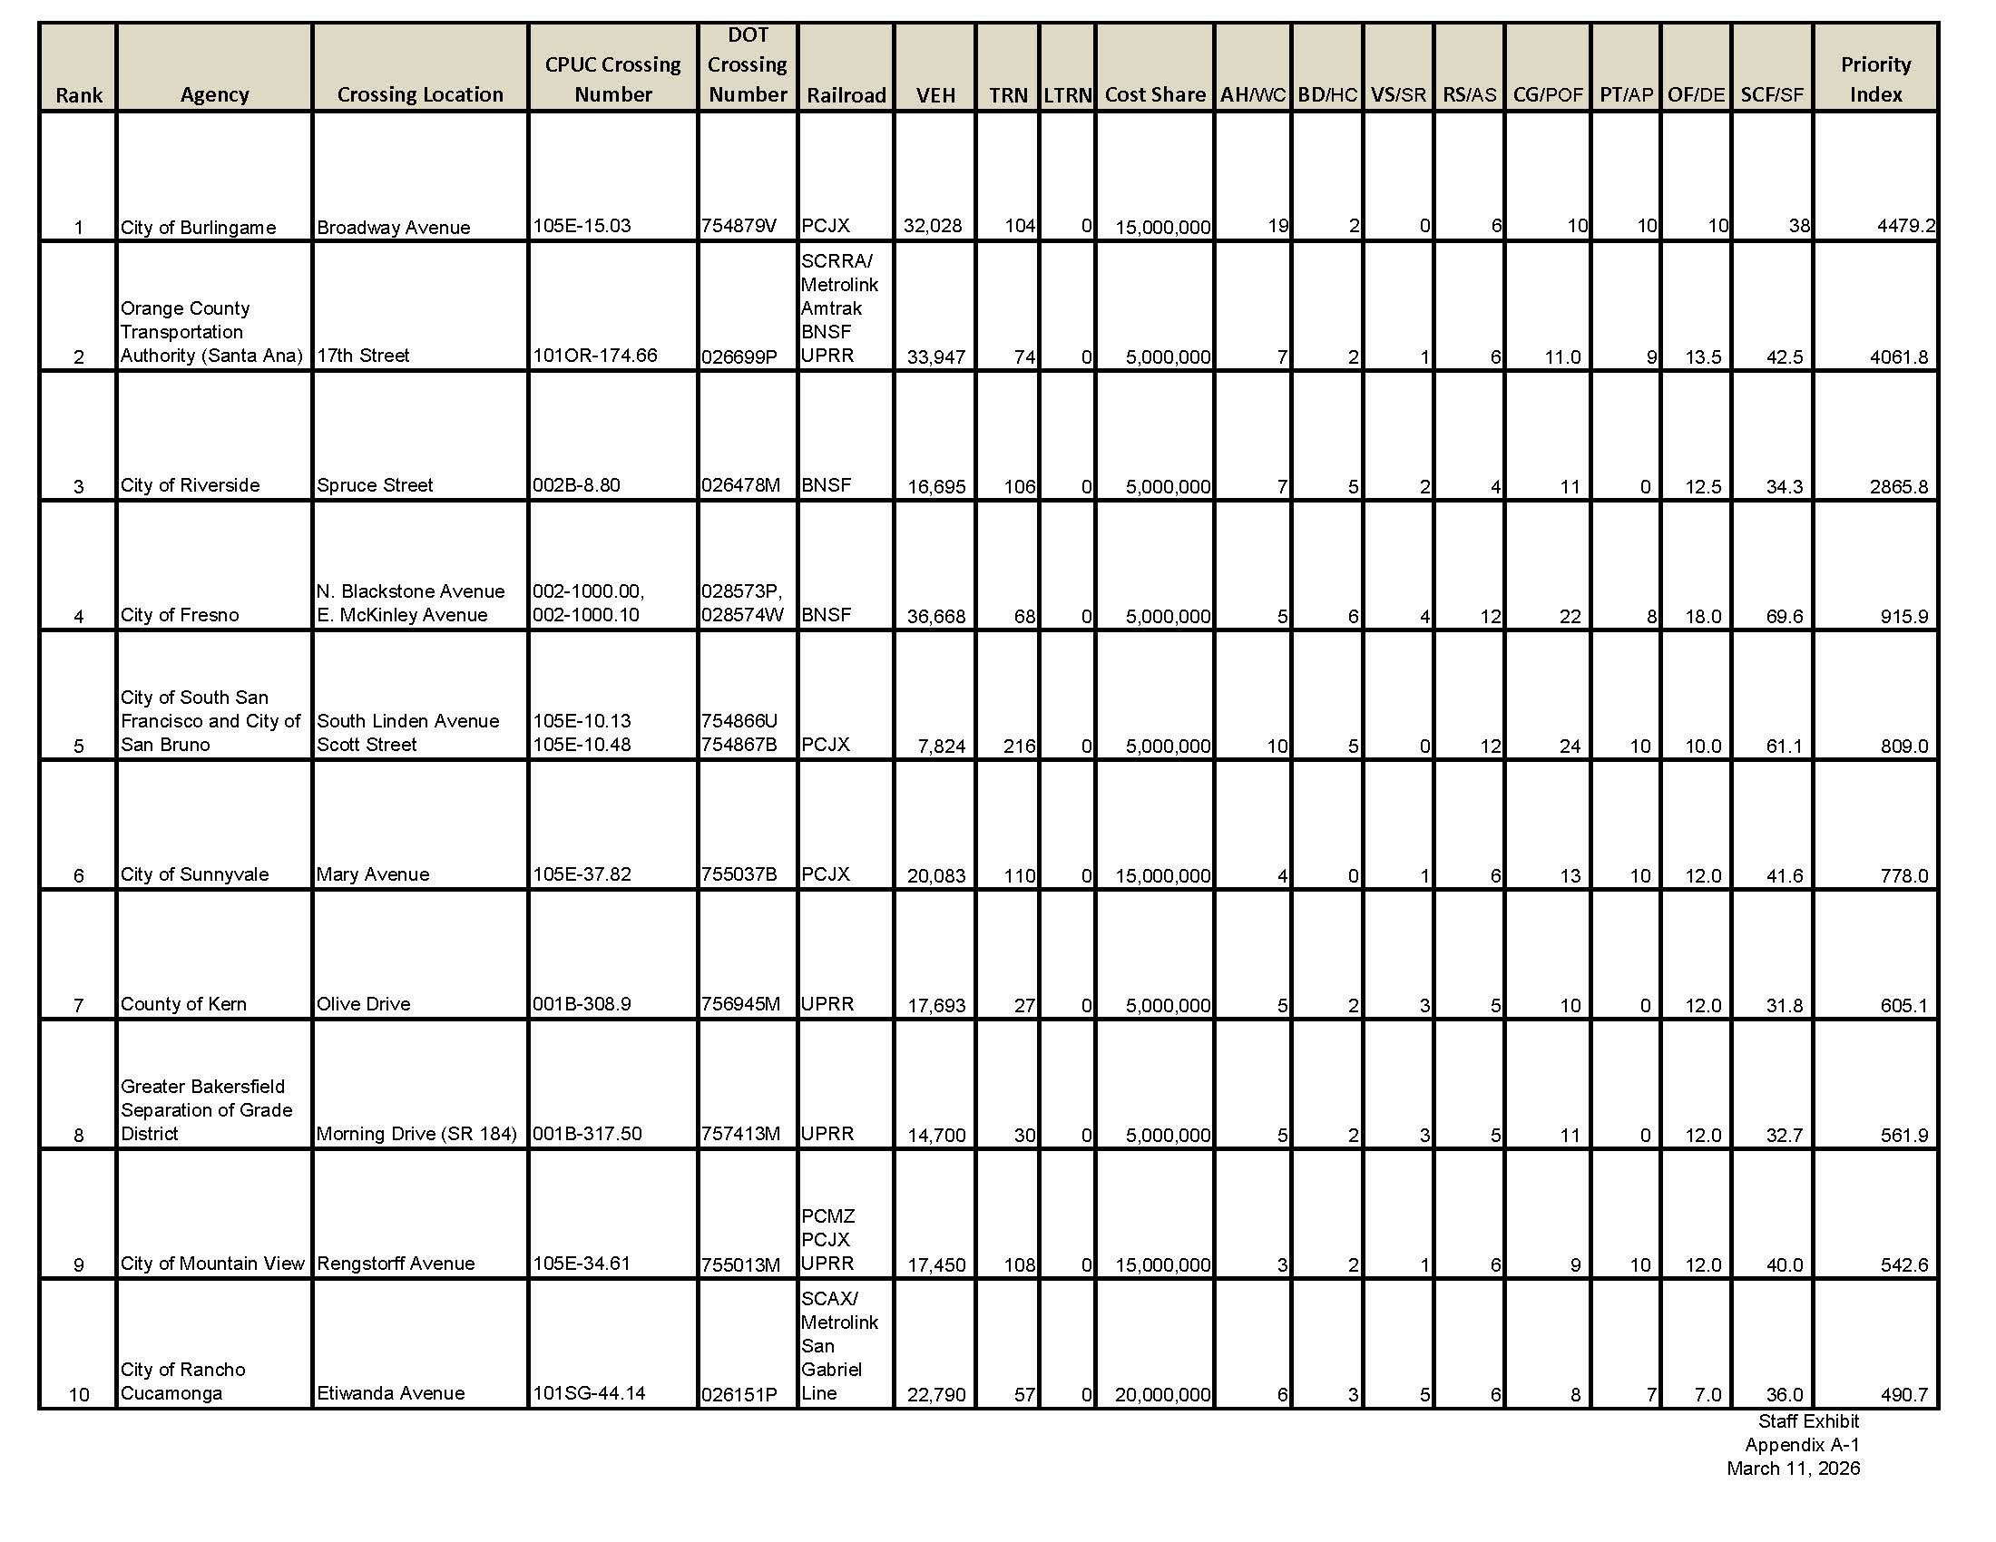

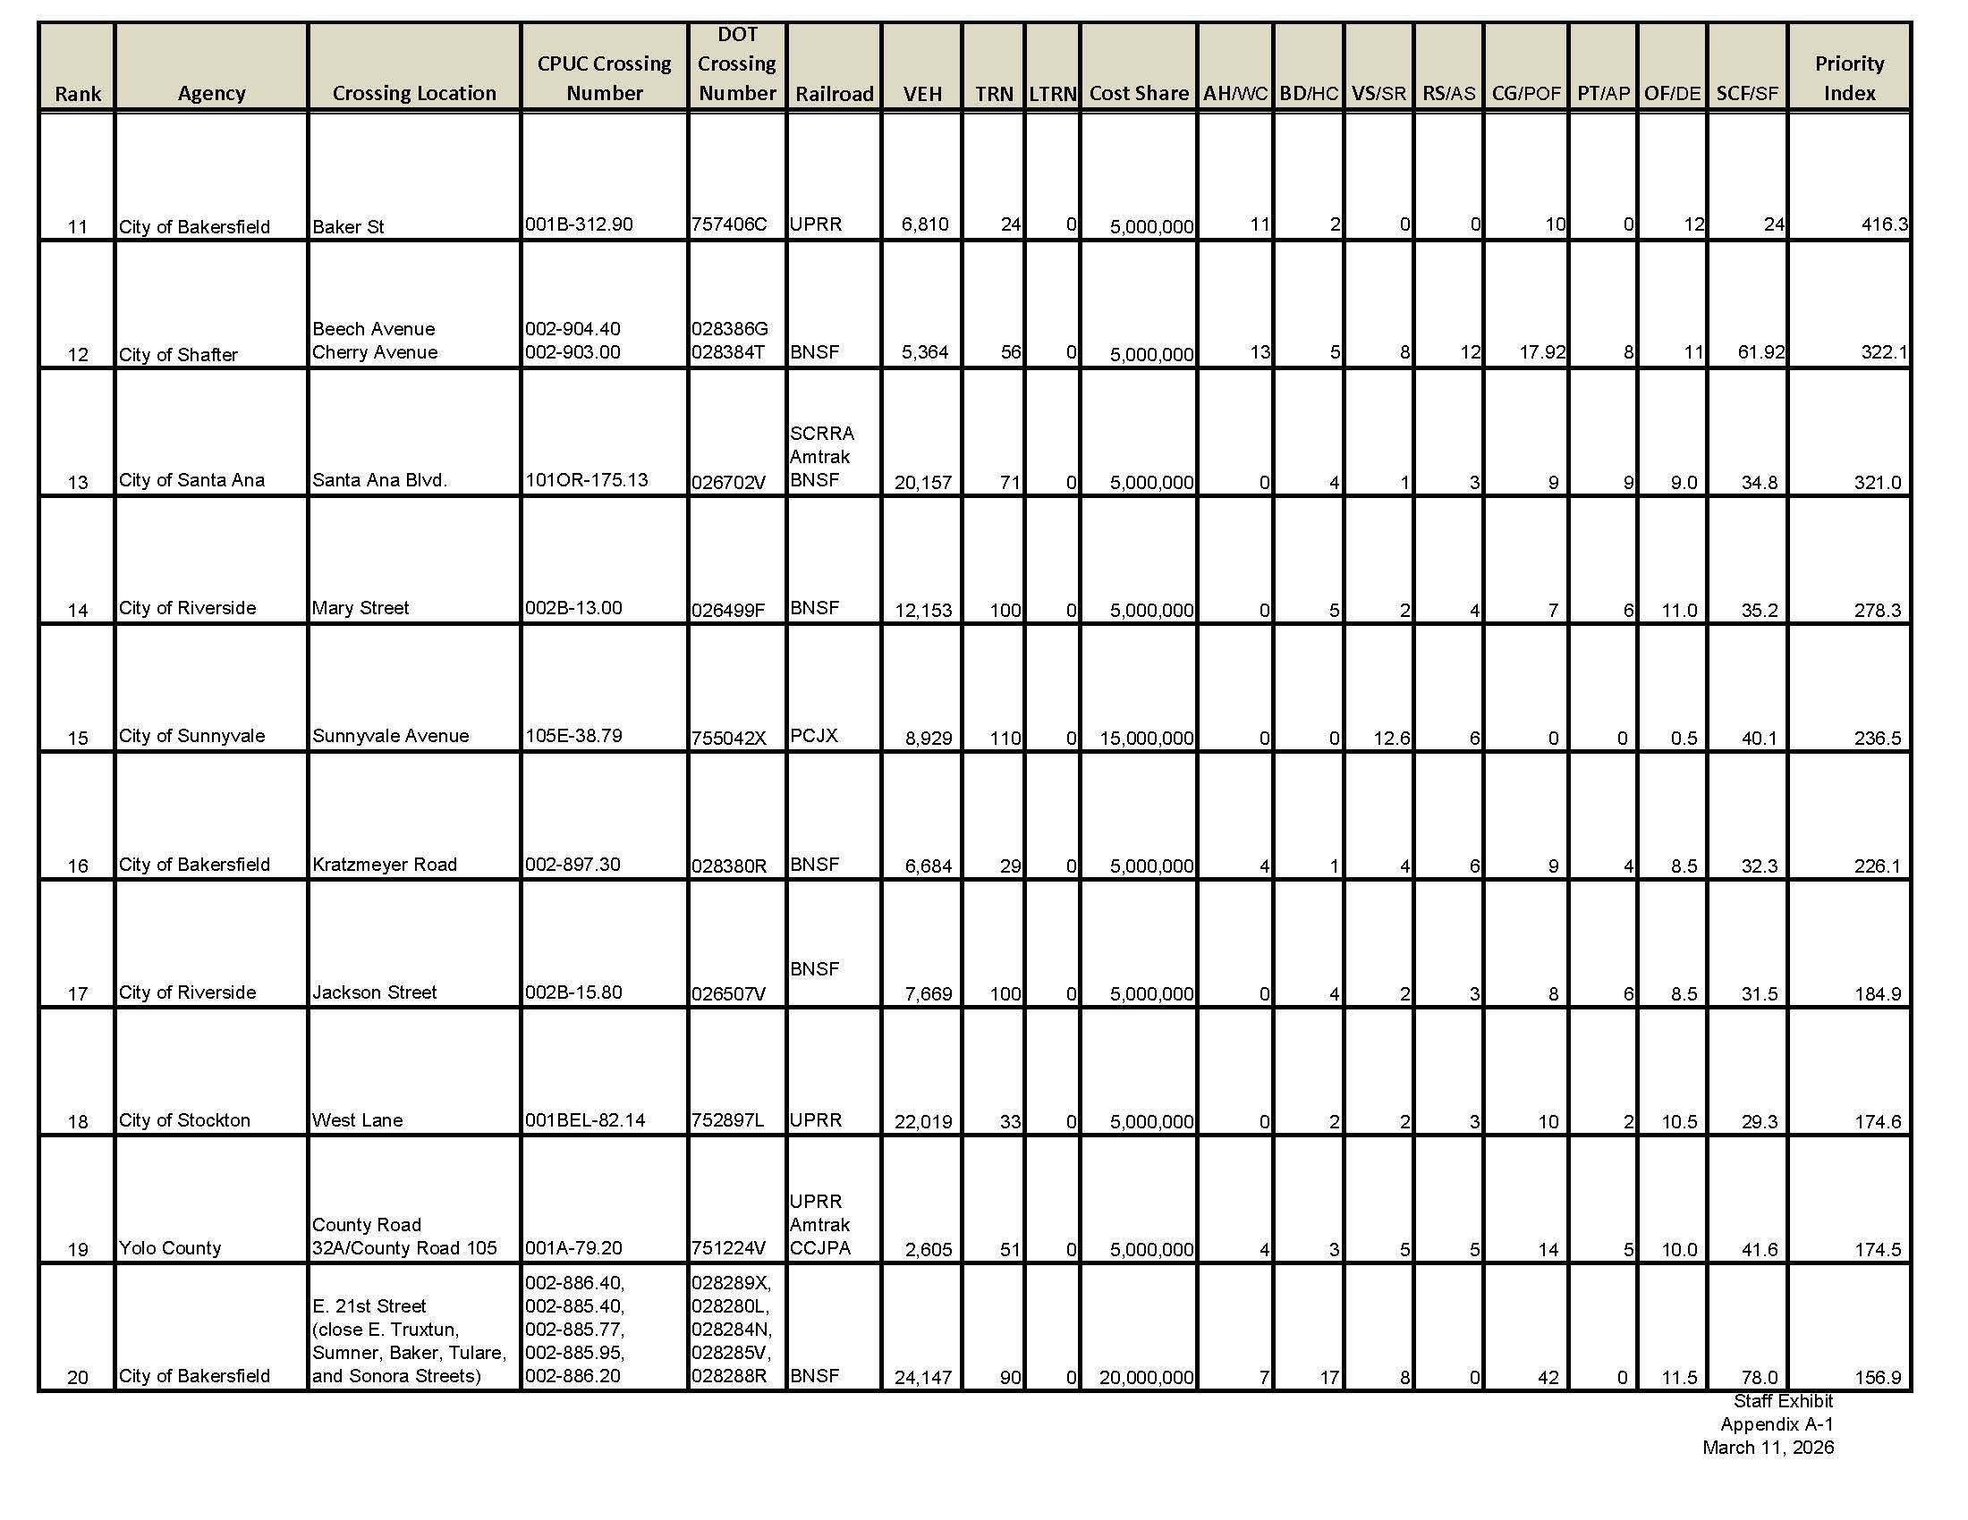

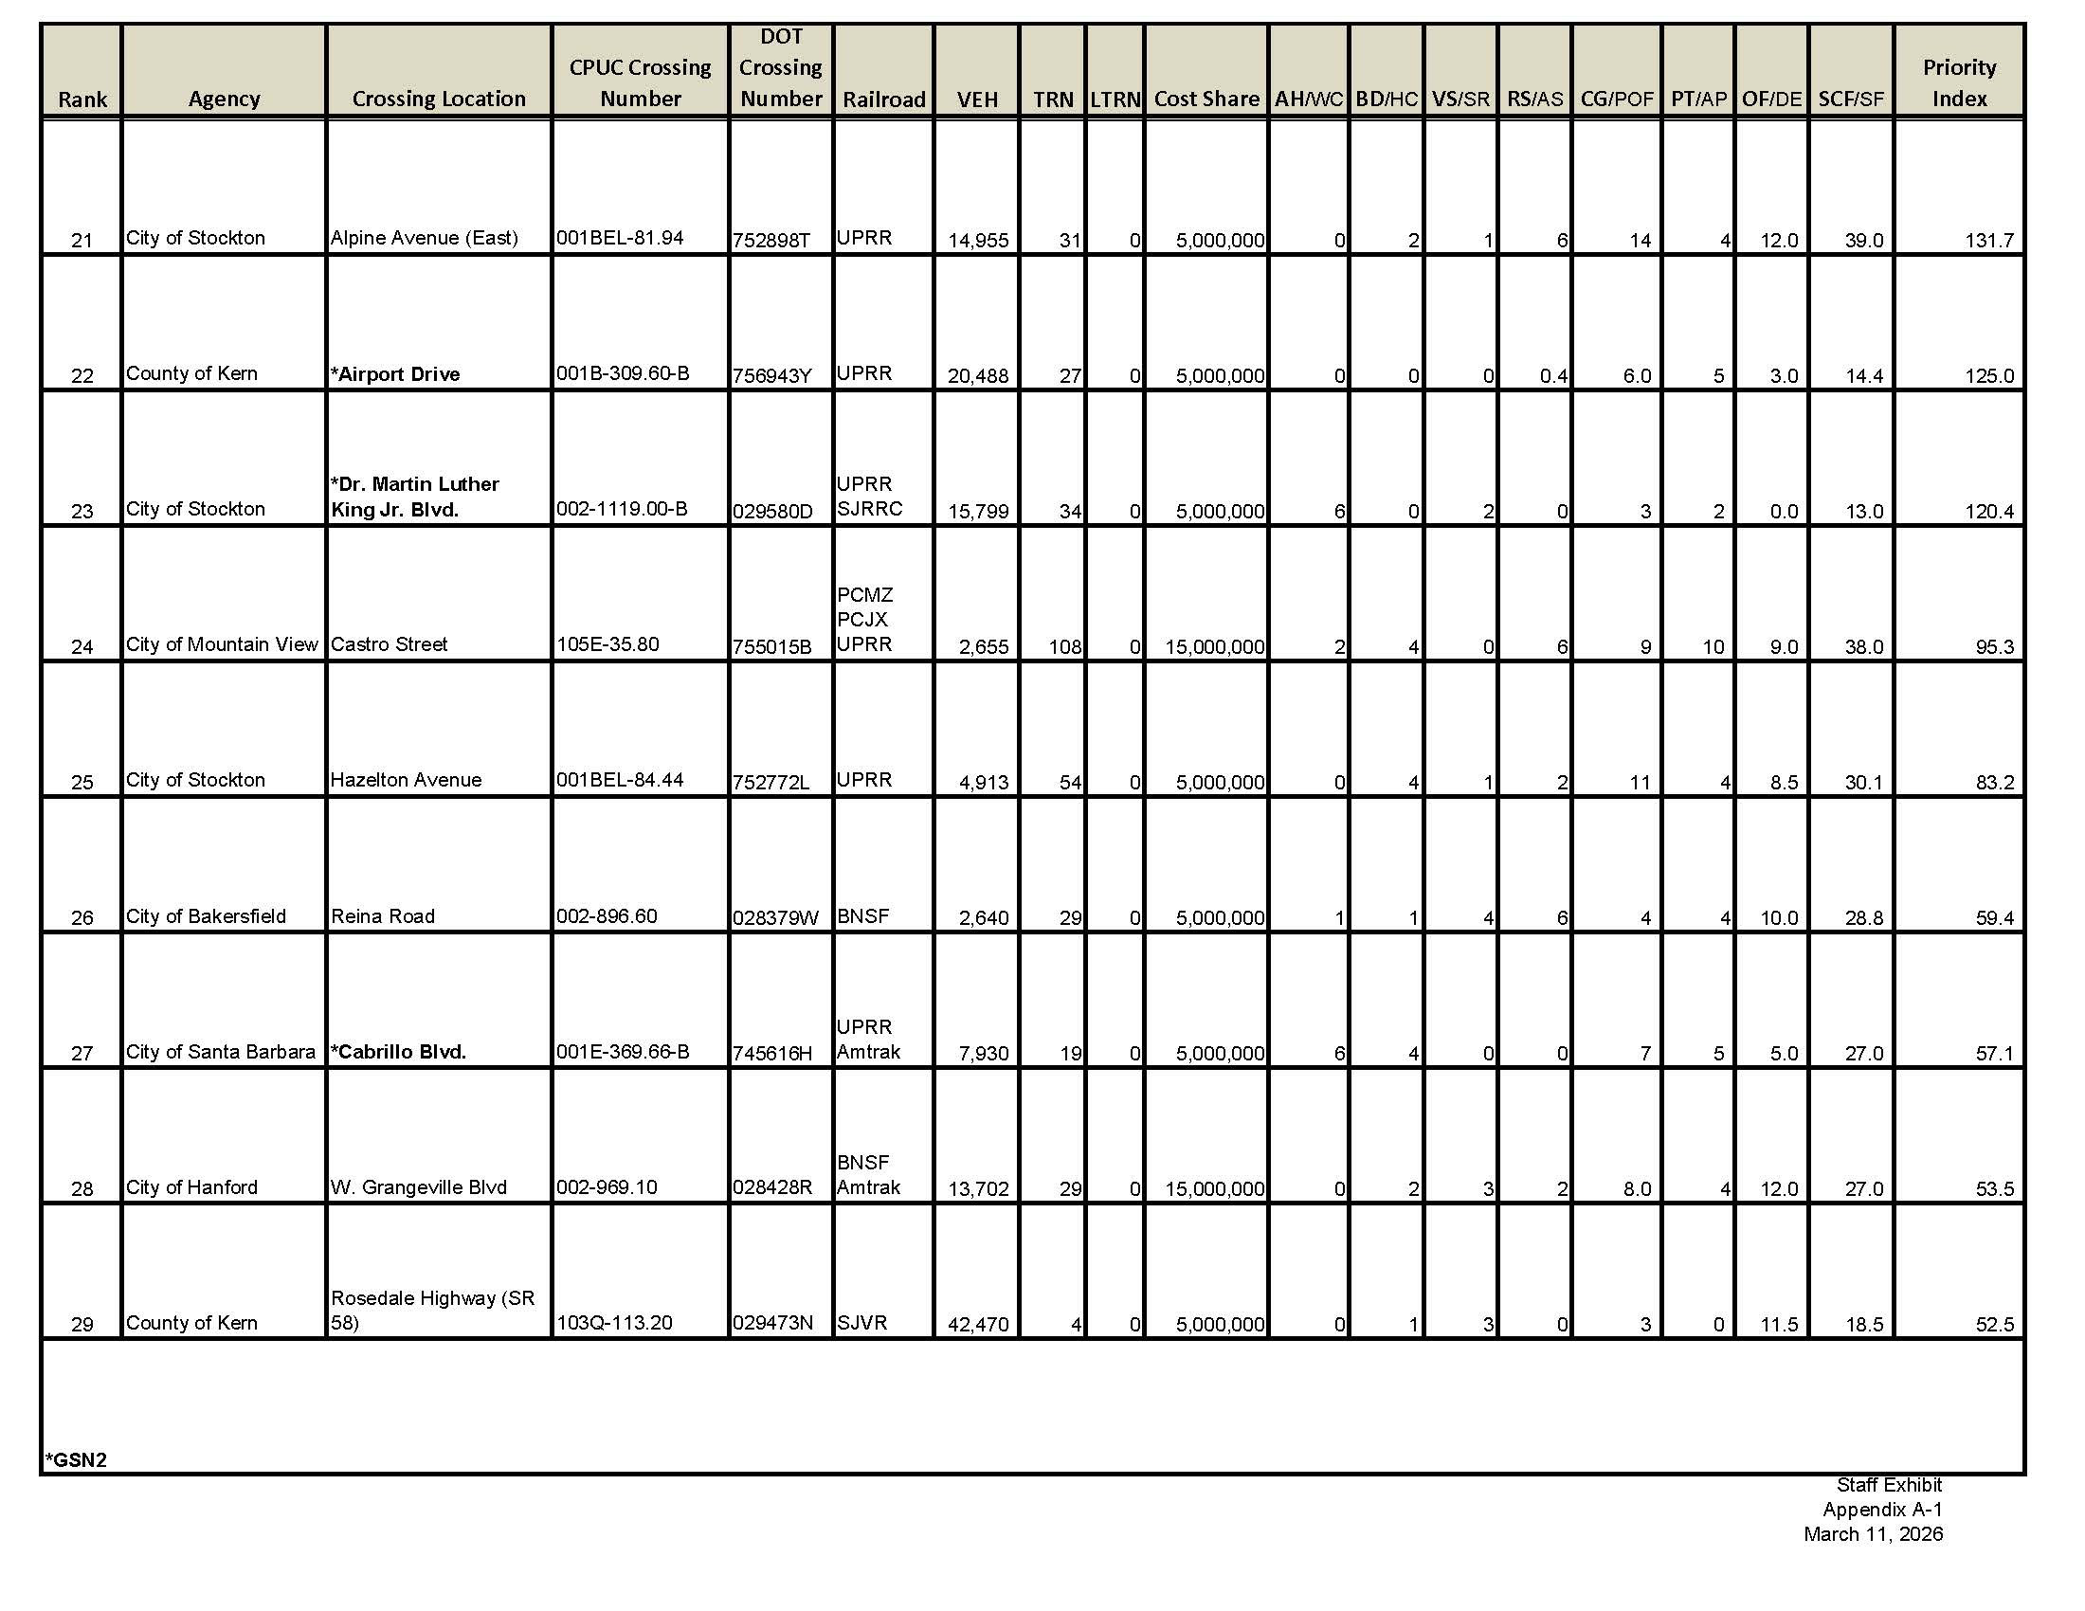

Definitions and Abbreviations used in the Priority List Table:

DOT – Department of Transportation
VEH – Vehicle TRN – Train
LTRN - Light Rail Trains COST Share - Project Cost Share (a cost of more than $5 million is permitted for qualified projects per S&H Code Section 2454 (h) for multi-year funding)

Crossings Nominated for Separation or Elimination:
AH - Accident History BD - Crossing Blocking Delay
VS - Vehicular Speed Limit RS - Rail Speed Limit
CG - Crossing Geometrics PT - Passenger trains
SCF - Special Conditions Factor OF - Other Factors (Passenger Buses, School Buses, Hazmat Trucks, Community Impact)

*Existing Grade Separations Nominated for Alteration or Reconstruction (GSN2):
WC - Width Clearance HC - Height Clearance
SR - Speed Reduction AS - Accidents near Structure
POF - Probability of Failure AP - Accident Potential
DE - Delay Effects SF - Separation Factor

Railroad Abbreviations:
AMTRAK: National Railroad Passenger Corporation
CCJPA: Capital Corridor Joint Powers Authority
BNSF: The Burlington Northern Santa Fe Railway Company PCJX: Peninsula Corridor Joint Powers Board (Caltrain/PCMZ) SCRRA: Southern California Regional Rail Authority (Metrolink) SJRRC: San Joaquin Regional Rail Commission (ACE)
SJVR: San Joaquin Valley Railroad
UPRR: Union Pacific Railroad Company
PCMZ: Caltrain Commuter Railroad Company
(END OF APPENDIX A)

S&H Code § 190 requires the State’s annual budget to include $15 million for funding grade-separation projects. According to Caltrans, approximately $15 million will carry over to this application cycle. This means that approximately $30 million in funding should be available for the FY 2026-2027 program cycle.
The Priority List is a comparative evaluation of all qualified projects nominated and accepted for inclusion in this investigation, with the priority index value based on one of the two formulas that RSD uses to rank projects, as published in Appendix A to the call for nominations: one formula for crossings nominated for separation or elimination, and the other for existing grade-separations in need of alteration or renovation. The formulas incorporate crossing inventory and accident data submitted in the nomination forms and verified by RSD. RSD reviews each application for qualification and creates the proposed Priority List from the nomination data entered into a Microsoft Excel spreadsheet that calculates the priority index value for each project.
The OII forestalled inclusion of projects nominated after the deadline. “Local agencies in California desiring to have a crossing separation project considered for inclusion in the Grade-Separation Priority List for FYs 2026-2027 and 2027-2028, to be established under S&H Code § 2452, and pursuant to the Commission’s Rules of Practice and Procedure (Rules) 13.7(f) shall submit the Grade-Separation Nomination Form GSN-1 or GSN-2 (GSN-1 Form and GSN-Form) as “supporting documents” using the Electronic Filing System on the Commission’s website at www.cpuc.ca.gov/PUC/efiling no later than Friday, October 24, 2025. Instructions on how to upload project applications is attached as Appendix 6 to this OII. Applications received after the deadline will not be processed.” Order Instituting Investigation to Establish the California Grade-Separation Fund Priority List for the Fiscal Years 2026-2027 and 2027-2028 at 6-7.

