June 12, 2026 Agenda ID: 24289
RESOLUTION T-17916

TO: Parties on the CASF Distribution (Service) List

This is Draft Resolution T-17916 of the ​Communications​ Division. This Draft Resolution will appear on the agenda at the next Commission meeting to be held July 16, 2026, which is at least 30 days after the date of this letter. The Commission may vote on this Resolution at that time, or it may postpone a vote until a later meeting. To confirm when the item will be heard, please see the Business Meeting agenda, which is posted on the Commission’s website 10 days before each Business Meeting. When the Commission votes on a Draft Resolution, it may adopt all or part of it as written, amend, modify, or set it aside and prepare a different Resolution. Only when the Commission acts does the Resolution become binding on the parties.

Any member of the public may serve comments on the Draft Resolution as provided in Public Utilities Code § 311(g) and Rule 14.5 of the Commission’s Rules of Practice and Procedure (Rules).

Comments along with a certificate of service (COS) shall be sent via email to: the CASF Service List, Brandon.Coyle@cpuc.ca.gov and casf_infrastructure_grant_administrator@cpuc.ca.gov by July 2, 2026, at 5:00 PM.

Those submitting comments on the Draft Resolution must serve their comments on the entire service list the Draft Resolution was served to on the same date that the comments are submitted to the ​Communications​ Division.

Comments shall focus on factual, legal, or technical errors in the proposed Draft Resolution. Comments should list the recommended changes to the Draft Resolution. Comments shall be limited to three pages in length and shall include a subject index listing the recommendations to the draft resolution, a table of authorities, and an appendix setting forth the proposed revised findings and ordering paragraphs.

Replies to comments must be submitted no later than July 7, 2026. Replies shall be submitted and served in the same manner as opening comments. Replies shall be submitted and served in the same manner as opening comments.

Sincerely,

/s/
Maria Ellis, Director
​​Communications​ Division
California Public Utilities Commission

PUBLIC UTILITIES COMMISSION OF THE STATE OF CALIFORNIA

Communications Division | RESOLUTION T-17916
Broadband Video and Marketing Branch | July 16, 2026

R E S O L U T I O N

RESOLUTION T-17916: Approves up to $32,398,849 from the California Advanced Services Fund (CASF) for the Broadband Infrastructure Grant Account application of co-applicants WiConduit and GigabitNow, (U-7387-C) for the Forestville Connect Ext., Graton Connect, and Sonoma Coast Connect Ext. projects in Sonoma County.

PROPOSED OUTCOME:

- Awards three grants for up to $32,398,849 from the CASF Infrastructure Funding Account to co-applicants WiConduit and GigabitNow in Sonoma County.

SAFETY CONSIDERATIONS:

- There are no adverse safety considerations identified by the Communications Division. The projects to be funded by this award have the potential to improve communications resiliency and redundancy

ESTIMATED COST:

- There are no costs associated with this Resolution.

SUMMARY

This Resolution approves grant funding for three grants in the amount of up to $32,398,849 from the California Advanced Services Fund (CASF) Broadband Infrastructure Grant Account (Infrastructure Account) for the grant applications of co-applicants WiConduit and GigabitNow, (U-7387-C) for the Forestville Connect Ext., Graton Connect, and Sonoma Coast Connect Ext. projects. The projects will provide funding to 341 unserved locations in
Sonoma County.

This Resolution recommends three grant awards to co-grantees: WiConduit and GigabitNow. The following grant applications listed below in Table 1 are recommended for approval by the Commission. Associated maps and project information summaries are included in the appendices.

Table 1: Summary of Grant Funding
Co-Applicants | Project Name | Unserved Locations | Initial Requested Amount | Revised Amount | CASF Approved Amount
WiConduit & GigabitNow | Forestville Connect Ext. | 130 | $12,121,354 | $12,121,354 | $12,121,354
WiConduit & GigabitNow | Graton Connect | 110 | $12,254,650 | $9,758,595 | $9,758,595
WiConduit & GigabitNow | Sonoma Coast Connect Ext. | 101 | $9,085,007 | $10,518,900 | $10,518,900

- BACKGROUND

The CASF Infrastructure Account provides grant funding to Internet service providers (ISPs)/eligible entities to build or upgrade broadband infrastructure in areas that are unserved by existing broadband providers. The CASF program was initiated in 2008, after the program was first adopted by the California Public Utilities Commission (Commission) in Decision (D.) 07-12-054 and enacted into statute pursuant to Senate Bill (SB) 1193.

On July 20, 2021, Governor Newsom signed historic broadband legislation to help bridge the digital divide; SB 156 changed the definition of “unserved area,” allowing, but not requiring, funding for “an area for which there is no facility-based broadband provider offering at least one tier of broadband service at speeds of at least 25 Mbps downstream, 3 Mbps upstream.” Additionally, SB 156 requires grantees to “deploy infrastructure capable of providing broadband access at speeds of a minimum of 100 Mbps downstream and 20 Mbps upstream” and that any grantees receiving CASF funding must report subcontracted work in excess of $25,000; this information must be posted by the Commission on a monthly basis.
On November 17, 2022, the Commission issued D.22-11-023, adopting programmatic changes to the CASF Infrastructure Account. Attachment 1 of D.22-11-023 (“CASF Guidelines”) set forth the rules, application requirements, and guidelines for the CASF Infrastructure Account.

- APPLICATION REVIEW AND EVALUATION

WiConduit and GigabitNow Background

On October 31, 2026, WiConduit submitted six CASF Infrastructure applications. Of the six applications, Communications Division (CD) Staff is recommending approval of three applications requesting 100 percent funding for a total of up to $32,398,849 to deploy last-mile Fiber to the Home (FTTH) broadband access to 341 unserved households in Sonoma County. On April 10, 2026, WiConduit and GigabitNow decreased their funding request for Graton Connect to $10,518,900 after reducing the proposed project from 192 to 110 due to overlap with the 82 FTTH locations to be funded by the California Broadband Equity, Access, and Deployment (BEAD) program.

For the 2025 CASF Infrastructure Grant application cycle, applicants determined eligibility for funding based on the California Interactive Broadband Map, which relied on 2023 mapping data. Because the evaluation and review period occurred while the Commission was collecting 2024 broadband location data, Staff verified eligibility using the current 2024 dataset to ensure the eligibility of all locations was based on the most recent available data and to prevent the awarding of program funds in areas already served.

WiConduit is a 501(c)(3) non-profit organization working on broadband access and digital equity by delivering fast, affordable, and reliable broadband infrastructure and services in underserved communities. They help communities organize around their connectivity needs, deploy resilient broadband networks (including underground fiber and emergency radio systems), advocate for digital equity, and provide training and support that promotes digital literacy and technology adoption.

GigabitNow, the co-applicant with WiConduit, is an independent telecommunications company and Certificate of Public Convenience and Necessity (CPCN) holder. Founded in 1991, GigabitNow, a division of IsoFusion, is a broadband provider specializing in the design, deployment, and operation of community-focused fiber networks across the United States. GigabitNow has served as a network designer, builder, and long-term operator on the Sea Ranch fiber network, a community owned FTTH system, in Sonoma County. GigabitNow provides internet services, maintenance, and customer support, while the infrastructure remains under community ownership.

On January 30, 2025, WiConduit, in partnership with GigabitNow, was awarded $17,010,997 through the Last Mile Federal Funding Account (FFA) to support the construction of a broadband network in rural West Sonoma County to serve an estimated 800 unserved locations. The three CASF projects in this Resolution propose to serve rural pockets of Sonoma County where the limited existing broadband options of legacy DSL and low-bandwidth fixed wireless access (FWA) are not providing served speeds. The three projects will build upon the FFA award and leverage existing network infrastructure to benefit communities that have historically been underserved due to low population density, challenging terrain, and lack of investment from incumbent providers. The projects will integrate with existing and planned backbone infrastructure, creating a contiguous, scalable broadband network across the region.

Staff’s review and evaluation of the applications is summarized below.

- Forestville Connect Extension (Ext.)

Project Summary
In compliance with D.22-11-023, Staff determined that WiConduit and GigabitNow’s Forestville Connect Ext. Project is eligible to receive up to $12,121,354 in CASF Infrastructure Account grant funding.

WiConduit and GigabitNow propose to serve 130 unserved locations by constructing a FTTH network with up to 1,000 Megabits per second (Mbps) download and 1,000 Mbps upload in Sonoma County.

Challenges
Pursuant to Pub. Util. Code Section 281(f)(8) and as required by D.22-11-023, the Commission provided an opportunity for entities to challenge the application. Challenges were due on December 5, 2025. The Forestville Connect Ext. Project received no challenges.

Revisions
Staff determined that the Forestville Connect Ext. project does not overlap with other grant-funded terrestrial broadband projects.

Technology Deployment
WiConduit and GigabitNow will deploy approximately 42 miles of last-mile fiber. The network infrastructure will be approximately 80% aerial and 20% underground. They plan to connect to the State Middle Mile Broadband Network where available.

Median Household Income and Low-Income Service
The median household income (MHI) for the project area is approximately $115,453. This MHI meets the definition of low-income as set forth in D.22-11-023, as it falls at or below the low-income threshold of $120,900 for a family of four in Sonoma County, set by the Department of Housing and Community Development’s (HCD) list of state income limits.

The project will provide a FTTH low-income plan of $14.99 at 100 Mbps download and 100 Mbps upload. Installation and connection charges will be waived for five years from completion of the project. To further reduce the burden on low-income residents, WiConduit and GigabitNow intends to participate in the California Lifeline Home Broadband Pilot program upon completion of the Sonoma Coast Connect Ext. project.

Safety Considerations
The proposed project enables the public to access the public safety benefits of reliable broadband infrastructure. The project is located in a Commission-designated Tier 2 and 3 High-Fire Threat District.

Funding Determination
WiConduit and GigabitNow project the proposed Forestville Connect Ext. to cost up to $12,121,354. The CASF Infrastructure account will fund 100 percent of expenditures.

Viability
Staff determined that the applicant and the project are financially viable, and the applicant’s engineering design meets the program standards. The applicant demonstrated the administrative, technical, and operational capacity to provide broadband service at the scale of this project.

WiConduit and GigabitNow received 19 letters of support from federal government, state government, local government, and local community representatives. For more details, see Appendix F.

California Environmental Quality Act
Based on the information received, the Commission’s Energy Division has determined that this project has not yet met the requirements of California Environmental Quality Act (CEQA) categorical exemption at this time. WiConduit and GigabitNow must comply with the CEQA requirements discussed in the appendices. If WiConduit and GigabitNow provide additional documentation demonstrating that the project qualifies for a CEQA exemption, then the project can be exempted by letter from the Communications Division Director or the director’s delegate or designee.

- Graton Connect

Project Summary
In compliance with D.22-11-023, Staff determined that WiConduit and GigabitNow’s Graton Connect Project is eligible to receive up to $9,758,595 in CASF Infrastructure Account grant funding.

WiConduit and GigabitNow propose to serve 110 unserved locations by constructing a FTTH network with up to 1,000 Megabits per second (Mbps) download and 1,000 Mbps upload in Sonoma County.

Challenges
Pursuant to Pub. Util. Code Section 281(f)(8) and as required by D.22-11-023, the Commission provided an opportunity for entities to challenge the application. Challenges were due on December 5, 2025. The Graton Connect Project received no challenges.

Revisions
Staff determined that Graton Connect has 82 locations that overlap with FTTH proposed projects under the federal Broadband Equity, Access, and Deployment (BEAD) program. As a result, Staff directed WiConduit and GigabitNow to reduce the number of locations to be funded by CASF from 192 to 110 and to reduce funding from $12,254,650 to $9,758,595. Staff determined that the Graton Connect project does not overlap with other grant funded terrestrial broadband projects. Staff posted the revised Graton Connect project summary on the Commission’s webpage on May 29th, 2026.

Technology Deployment
WiConduit and GigabitNow’s will deploy approximately 40 miles of last mile fiber. The network infrastructure will be approximately 80% aerial and 20% underground. They plan to connect to the State Middle Mile Broadband Network where available.

Median Household Income and Low-Income Service
The median household income (MHI) for the project area is approximately $137,929, which does not meet the low-income standard (by county) as set forth in D.22-11-023. The low-income threshold for a family of four in Sonoma County as designated by the Department of Housing and Community Development’s (HCD) is $120,900. While the project area does not directly meet the low-income threshold, the Graton Connect project is a unique area in which MHI data, collected at the Census Block Group (CBG) level, is skewed in a way that does not represent the economic disparities in the disadvantaged low-income communities. Staff analyzed the communities and locations this project will serve, such as Graton and Occidental and found the MHI is $91,429 and $108,307 respectively, far below the low-income threshold of $120,900. Furthermore, Graton’s poverty rate of 24.3% is significantly higher than California’s poverty rate of 11.8%. This suggests WiConduit and GigabitNow are targeting underserved areas within CBG’s that contain high income communities outside the boundaries of the project area and the planned infrastructure deployments. For this reason, Staff recommends approval of this project to mitigate the economic disparities that obfuscate the low-income communities of the wine and agricultural economy within Graton Connect.

The project will provide a FTTH low-income plan of $14.99 at 100 Mbps download and 100 Mbps upload. Installation and connection charges will be waived for five years from completion of the project. To further reduce the burden on low-income residents, WiConduit and GigabitNow intends to participate in the California Lifeline Home Broadband Pilot program upon completion of the Sonoma Coast Connect Ext. project.

Safety Considerations
The proposed project enables the public to access the public safety benefits of reliable broadband infrastructure. The project is located in a Commission-designated Tier 2 and 3 High Fire-Threat District.

Funding Determination
The proposed project will cost up to $9,758,595, of which the CASF account will fund 100% of expenditures.

Viability
Staff determined that the applicant and the project are financially viable, and the applicant’s engineering design meets the program standards. The applicant demonstrated the administrative, technical, and operational capacity to provide broadband service at the scale of this project.

WiConduit and GigabitNow received 19 letters of support from federal government, state government, local government, and local community representatives. For more details, see Appendix I.

California Environmental Quality Act
Based on the information received, the Commission’s Energy Division has determined that this project has not met the requirements of California Environmental Quality Act (CEQA) categorical exemption at this time. WiConduit and GigabitNow must comply with the CEQA requirements discussed in the appendices. If WiConduit and GigabitNow provides additional documentation demonstrating that the project qualifies for a CEQA exemption, then the project can be exempted by letter from the Communications Division Director or the director’s delegate or designee.

- Sonoma Coast Connect Extension (Ext.)

Project Summary
In compliance with D.22-11-023, Staff determined that WiConduit and GigabitNow’s Sonoma Coast Connect Ext. Project is eligible to receive up to $10,518,900 in CASF Infrastructure Account grant funding.

WiConduit and GigabitNow propose to serve 101 unserved locations by constructing a FTTH network with up to 1,000 Megabits per second (Mbps) download and 1,000 Mbps upload in Sonoma County.

Challenges
Pursuant to Pub. Util. Code Section 281(f)(8) and as required by D.22-11-023, the Commission provided an opportunity for entities to challenge the application. Challenges were due on December 5, 2025. WiConduit and GigabitNow’s Project received no challenges.

Revisions
Staff determined that the Sonoma Coast Connect Ext. project does not overlap with other grant funded terrestrial broadband projects.

On May 21st, 2026, WiConduit and GigabitNow updated their application to request an increase to the original funding amount from $9,085,007 to $10,518,900. Original cost estimates for underground deployment were based on installation of infrastructure under soft ground and sandy terrain, but further research by the applicant revealed a higher percentage of rocky terrain in the project area resulting in increased cost. Staff reviewed the new cost estimate and recommended approval of the increased cost of up to $10,518,900.

Technology Deployment
WiConduit and GigabitNow will deploy approximately 43 miles of last mile fiber. The network infrastructure will be approximately 80% aerial and 20% underground. They plan to connect to the State Middle Mile Broadband Network where available.

Median Household Income and Low-Income Service
The median household income (MHI) for the project area is approximately $77,607. This MHI meets the definition of low-income as set forth in D.22-11-023, as it falls at or below 80 percent of the statewide median income designated by the Department of Housing and Community Development’s (HCD).

The project will provide a FTTH low-income plan of $14.99 at 100 Mbps download and 100 Mbps upload. Installation and connection charges will be waived for five years from completion of the project. To further reduce the burden on low-income residents, WiConduit and GigabitNow intends to participate in the California Lifeline Home Broadband Pilot program upon completion of the Sonoma Coast Connect Ext. project.

Safety Considerations
The proposed project enables the public to access the public safety benefits of reliable broadband infrastructure. The project is located in a Commission-designated Tier 2 and 3 High Fire-Threat District.

Funding Determination
The proposed Sonoma Coast Connect Ext. Project will cost up to $10,518,900. The CASF Infrastructure account will fund 100 percent of expenditures.

Viability
Staff determined that the applicant and the project are financially viable, and the applicant’s engineering design meets the program standards. The applicant demonstrated the administrative, technical, and operational capacity to provide broadband service at the scale of this project.

WiConduit and GigabitNow received 19 letters of support from federal government, state government, local government, and local community representatives. For more details, see Appendix L.

California Environmental Quality Act
Based on the information received, the Commission’s Energy Division has determined that the project meets the criteria for CEQA categorical exemption under 14 California Code of Regulation (C.C.R.) Section 15301 (Existing Facilities), 15302 (Replacement or Reconstruction), Section 15303 (New Construction or Conversion of Small Structures), and Section 15304 (Minor Alternations to Land). Thus, the WiConduit - Sonoma Coast Connect Extension project is categorically exempt from CEQA review and the Commission may authorize funds for the construction activities.

- NOTICE

On October 31, 2025, CD received 41 grant applications for CASF Infrastructure Account funding. On November 14, 2025, Staff posted all the proposed project area maps and project summaries for the Forestville Connect Ext., Graton Connect, and Sonoma Coast Connect Ext. projects on the Commission’s CASF Infrastructure Project Summaries webpage and sent notice regarding the project to the CASF Distribution and Service Lists.

Pursuant to Pub. Util. Code Section 281(f)(8) and as required by D.22-11-023, the Commission provided an opportunity for entities to challenge the application. Challenges were due on December 5, 2025.

- COMMENTS

In compliance with Public Utilities Code Section 311(g), a notice letter was emailed on June 12, 2026, informing all parties on the CASF Distribution List of the availability of the draft of this Resolution and of the opportunity for public comments at the Commission’s documents website at http://www.cpuc.ca.gov/documents/. This letter also informed parties that the final conformed Resolution adopted by the Commission will be posted and available on the same website.

- FINDINGS

- On October 31, 2025, WiConduit and GigabitNow submitted six grant applications for CASF funding, including the Forestville Connect Ext., Graton Connect, and Sonoma Coast Connect Ext. projects, to deploy last-mile broadband infrastructure to enable Fiber-to-the-Home service at speeds of up to 1,000 megabits per second (Mbps) download and 1,000 Mbps upload to a total of 341 CASF Eligible locations in Sonoma County.

- On November 14, 2025, Staff posted all the proposed project area maps and project summaries for the Forestville Connect Ext., Graton Connect, and Sonoma Coast Connect Ext. projects on the Commission’s CASF Infrastructure Project Summaries webpage.

- Staff received no challenges to the Forestville Connect Ext., Graton Connect, and Sonoma Coast Connect Ext. projects.

- The Commission has determined that WiConduit and GigabitNow’s Sonoma Coast Connect Ext. project meets the criteria for California Environmental Quality Act (CEQA) categorical exemption under 14 California Code of Regulation (C.C.R.) Section 15301 (Existing Facilities), 15302 (Replacement or Reconstruction), Section 15303 (New Construction or Conversion of Small Structures), and Section 15304 (Minor Alternations to Land).

- WiConduit and GigabitNow’s Forestville Connect Ext. and Graton Connect are not exempt at this time and are still under review for CEQA exemption.

- Based on its review, Staff determined that all three WiConduit and GigabitNow projects qualify for Infrastructure Account grants pursuant to D.22-11-023 and its Attachment 1 and recommends Commission approval of total CASF funding of up to $32,398,849.

- A notice letter was emailed on June 12, 2026, informing all parties on the CASF Distribution List of the availability of the draft of this Resolution and of the opportunity for public comments at the Commission’s documents website at http://www.cpuc.ca.gov/documents/.

THEREFORE, IT IS ORDERED that:

- The Commission shall award up to $12,121,354 in CASF Broadband Infrastructure Grant Account funds to WiConduit & GigabitNow for the Forestville Connect Ext. Project as described herein and summarized in the appendices of this Resolution.

- The Commission shall award up to $9,758,595 in CASF Broadband Infrastructure Grant Account funds to WiConduit & GigabitNow for the Graton Connect Project as described herein and summarized in the appendices of this Resolution.

- The Commission shall award up to $10,518,900 in CASF Broadband Infrastructure Grant Account funds to WiConduit & GigabitNow for the Sonoma Coast Connect Ext. Project as described herein and summarized in the appendices of this Resolution.

- Awardees shall comply with all guidelines, requirements and conditions associated with a CASF award, as specified in D.22-11-032 and its Attachment 1, and all requirements for this project included in this Resolution including Appendices A through C.

- If an awardee fails to complete the project in accordance with the CASF guidelines and requirements outlined in D.22-11-023 and its Attachment 1, and the terms outlined in this Resolution, awardee must reimburse some or all the CASF funds that it has received.

- The Commission has determined that WiConduit and GigabitNow’s Sonoma Coast Connect Ext. Project is exempt from California Environmental Quality Act (CEQA) review pursuant to 14 California Code of Regulation (C.C.R.) Section 15301 (Existing Facilities), 15302 (Replacement or Reconstruction), Section 15303 (New Construction or Conversion of Small Structures), and Section 15304 (Minor Alternations to Land). The Commission may authorize funds for the construction activities.

- The Commission cannot release funds for construction activities for WiConduit and GigabitNow’s Forestville Connect Ext. and Graton Connect Ext. projects, until CEQA review is complete. Funds for preconstruction activities such as permitting and CEQA compliance may be awarded prior to commencement of construction. WiConduit and GigabitNow must comply with the requirements set forth in the CEQA Section of the Resolution. WiConduit and GigabitNow must provide their Proponent’s Environmental Assessment for the Forestville Connect Ext. and Graton Connect Ext. projects prior to the first payment. If Staff evaluation finds either project can be exempt from CEQA, then the project can be exempted by letter from the Communications Division Director or the director’s delegate or designee.

- Awardees must complete and execute the consent forms (to be sent to the grantee after this Resolution is adopted) agreeing to the conditions set forth in this Resolution and return to Staff within 30 calendar days from the date of the adoption of this Resolution. Failure to submit the consent form within 30 calendar days from the adoption date of this Resolution may result in the Commission voiding the grant award.

This resolution is effective today.

Commissioner Signature blocks to be added
upon adoption of the resolution

The foregoing resolution was duly introduced, passed and adopted at a conference of the California Public Utilities Commission of the State of California held on July 16, 2026, the following Commissioners voting favorably thereon:

Dated , at ______________, California

APPENDIX A

Compliance Requirements

- Deployment Schedule
All CEQA-exempt projects must be completed within 18 months, and all other projects shall be completed within 24 months after receiving authorization to construct. If the grantee is unable to complete the proposed project within the 18-month or 24-month timeframe requirements, the grantee must notify the Director of the Communications Division as soon as the grantee becomes aware of this possibility. If such notice is not provided, the Commission may reduce payment for failure to satisfy this requirement of timely notification to the Director.

- Execution and Performance
Staff and awardee shall determine a project start date after the CASF grant recipient has obtained all approvals, including permits. Should the grantee or any contractor it retains fail to commence work by the designated date, upon five days’ written notice the Commission may terminate the grant. If the grantee fails to complete the project in accordance with the terms of Commission approval as set forth in this resolution, the awardee shall reimburse some or all of the CASF funds that it has received. The grantee must complete all construction covered by the grant on or before the grant’s termination date.

- Minimum Performance Criteria
 | CASF Performance Criteria | Proposed Project
Project Completion | CEQA-exempt projects must be completed within 18 months, and all other projects shall be completed within 24 months after receiving authorization to construct | within 18 months of permitting approval (CEQA Exempt)
Pricing | Prices committed for five years after completion of the project | 5-year commitment
Speed | At least 100/20 Mbps | 1,000 Mbps / 1,000 Mbps
Latency | Maximum of 100 ms of latency | < 100 ms
Data Caps | Minimum of 190 GBs per month | No data cap
Affordability | Must offer low-income plan | $14.99 / month

- Letter of Credit
The Commission exempts Certificate of Public Convenience and Necessity (CPCN) holders from providing a letter of credit, on the basis that the company submitted a performance bond to the Commission to maintain its CPCN and that the Commission has other means to enforce compliance. In its application, WiConduit, which operates as a non-profit company, does not currently have a CPCN. However, co-applicant GigabitNow provided proof of CPCN registration and thus is exempt from the requirement of providing a letter of credit.

- Project Audit
The Commission has the right to conduct any necessary audit, verification, and discovery during project implementation/construction to ensure that CASF funds are spent in accordance with Commission approval.

Grantee invoices may be subject to a financial audit by the Commission at any time within three years of completion of the work.

- Providing Voice Service
WiConduit has attested that it will offer Voice Over Internet Protocol (VoIP) service through its partnership with Alianza, a cloud-based VoIP solutions provider.

- Reporting
All grantees must submit biannual progress reports on the status of the project, irrespective of whether grantees request reimbursement or payment. These reports are due semi-annually, in March and September, until the project is completely built and operational. Progress reports shall describe the schedule for deployment, major construction milestones and costs submitted in the proposal; indicate the actual date of completion of each task/milestone as well as problems and issues encountered, and the actions taken to resolve these problems and issues during project implementation and construction; and identify future risks to the project.

Before full payment of the project is made, grantees must submit a project completion report. Grantees shall also include test results on the download and upload speeds at a representative sample of locations in the final completion report, per CASF Guidelines, Section 13: Reporting Requirements. Grantees must certify that each progress report is true and correct under penalty of perjury.

- Prevailing Wage
Section 1720 of the California Labor Code specifies that CASF-subsidized projects are subject to prevailing wage requirements. Grantees committed to following state prevailing wage requirements with regards to these projects.
- Contractor Reporting
Grantees must comply with the contractor reporting requirements of Section 281(l)(1) of the California Public Utilities Code, which requires reporting of certain information for all contractors and subcontractors undertaking a contract or subcontract in excess of twenty-five thousand dollars on CASF-subsidized projects.

APPENDIX B

Payments to CASF Recipients

Pub. Util. Code Section 281(f)(10) defines the costs the Commission may reimburse as follows:
- Costs directly related to the deployment of infrastructure;
- Costs to lease access to property or for Internet backhaul services for a period not to exceed five years; and
- Costs incurred by an existing facility-based broadband provider to upgrade its existing facilities to provide for interconnection.

Additionally, D.22-11-023, Attachment 1, Section 7 caps administrative expenses directly related to the project at 10 percent of the grant amount.

The grantee may submit reimbursement requests at the following intervals:
- 10 percent completion;
- 35 percent completion;
- 60 percent completion;
- 85 percent completion; and
- 100 percent completion.

The final 15 percent payment request (from 85 to 100 percent) will not be paid without an approved completion report. Payments are based on submitted receipts, invoices and other supporting documentation showing expenditures incurred for the project in accordance with the approved CASF funding budget included in the CASF grantee’s application.

Payment to grantees shall follow the process adopted for funds created under Public Utilities Code Section 270. The Commission generally processes payments within 20-25 business days, including Communications Division and Administrative Services review time. The State Controller’s Office (SCO) requires an additional 14-21 days to issue payment from the day that requests are received by SCO from Administrative Services. The project is funded at 100%, CASF will not accept invoices that include a handling fee.

APPENDIX C

California Environmental Quality Act Requirements

The following two projects are subject to California Environmental Quality Act (CEQA) review:

- Forestville Connect Ext.
- Graton Connect

The Commission must complete CEQA review prior to disbursing CASF funds for construction activities. The initial funding granted in this Resolution may be used for project development and other WiConduit & GigabitNow activities that do not involve construction or any activities that would have any direct or indirect effect on the physical environment. Prior to any construction activity for the project, WiConduit & GigabitNow are required to seek further authority from the Commission for such activity by filing a Proponent’s Environmental Assessment (PEA) pursuant to Commission Rule of Practice and Procedure 2.4; and must undergo an environmental review pursuant to CEQA (California Public Resources Code § 21000 et seq.).

WiConduit & GigabitNow should contact the Supervisor of the Commission’s Energy Division Infrastructure Planning and CEQA Section well in advance of a contemplated filing to (a) consult with Staff regarding the process of developing and filing a PEA ; (b) provide for cost recovery per Rule of Practice and Procedure 2.5; and (c) enter into a Memorandum of Understanding to allow the Energy Division to initiate the retention of an environmental contractor to perform the environmental review. WiConduit & GigabitNow must provide a PEA prior to the first payment. The Commission cannot release funds for the construction phase of this project until the Commission has completed CEQA review.

The following WiConduit project is subject to California Environmental Quality Act (CEQA) review and was determined to be categorically exempt:

- Sonoma Coast Connect Ext.

The project is located in Sonoma County, serving the unincorporated community between Seaview and Cazadero. WiConduit provided the Commission with its project plans to install 53 miles of fiber optic cable. All project infrastructure will be installed on existing distribution poles or built under or along city streets within existing rights-of-way. There will be no placement of project infrastructure in new right-of-way or previously undisturbed ground. Following the completion of construction activities, WiConduit will return the site to its original condition.

Based on the information that WiConduit provided, the Commission’s Energy Division has confirmed that the project meets the criteria for the CEQA categorical exemptions under 14 California Code of Regulation (C.C.R.), Section 15031 (Existing Facilities), Section 15302 (Replacement or Reconstruction), Section 15303 (New Construction or Conversion of Small Structures), and Section 15304 (Minor Alterations to Land). Thus, the WiConduit – Sonoma Coast Connect Extension project is categorically exempt from CEQA review and the Commission may authorize funds for construction activities.

APPENDIX D

WiConduit and GigabitNow – Forestville Connect Ext. CASF Application

Key Information
Project Name | Forestville Connect Ext.
Project Plan | The project proposes to deploy FTTH across Sonoma County to 130 unserved locations.
County | Sonoma
Communities | Jenner, Timber Cove
Project Size | 4.65 square miles
Download / Upload speed | 1,000 Mbps / 1,000 Mbps
Median Household Income | $115,453
Pricing Plan (Monthly) | Plan A (Residential): 100 / 100 Mbps - $49.99  Plan B (Residential): 500 / 500 Mbps - $74.99  Plan C (Residential): 1,000 / 1,000 Mbps - $99.99  Plan D (Low-Income): 100 / 100 Mbps - $14.99  Plan E (Business): 100 / 100 Mbps - $149.99  Plan F (Business): 1,000 / 1,000 Mbps - $199.99
Affordability (Low Income Plan) | Plan D (Low-Income): 100 / 100 Mbps - $14.99  WiConduit and GigabitNow intends to participate in the California Lifeline Home Broadband Pilot program.
Unserved Locations | 130
Subscriber Take Rate | 60%
High Fire Threat Districts | Yes
Deployment Schedule (from permit approval date) | 18 Months (CEQA-exempt)  24 Months (non-CEQA exempt)
Proposed Project Budget | $12,121,354
Original Grant Request | $12,121,354
CASF Grant Amount | $12,121,354
Cost per Household | $93,241
Census Blocks | 060971537052000 | 060971537052001 | 060971537052003
Census Blocks | 060971537052006 | 060971537053002 | 060971537053005
Census Blocks | 060971537054005 | 060971537054019 | 060971537113001

APPENDIX E
WiConduit and GigabitNow – Forestville Connect Ext.
Project Location Map
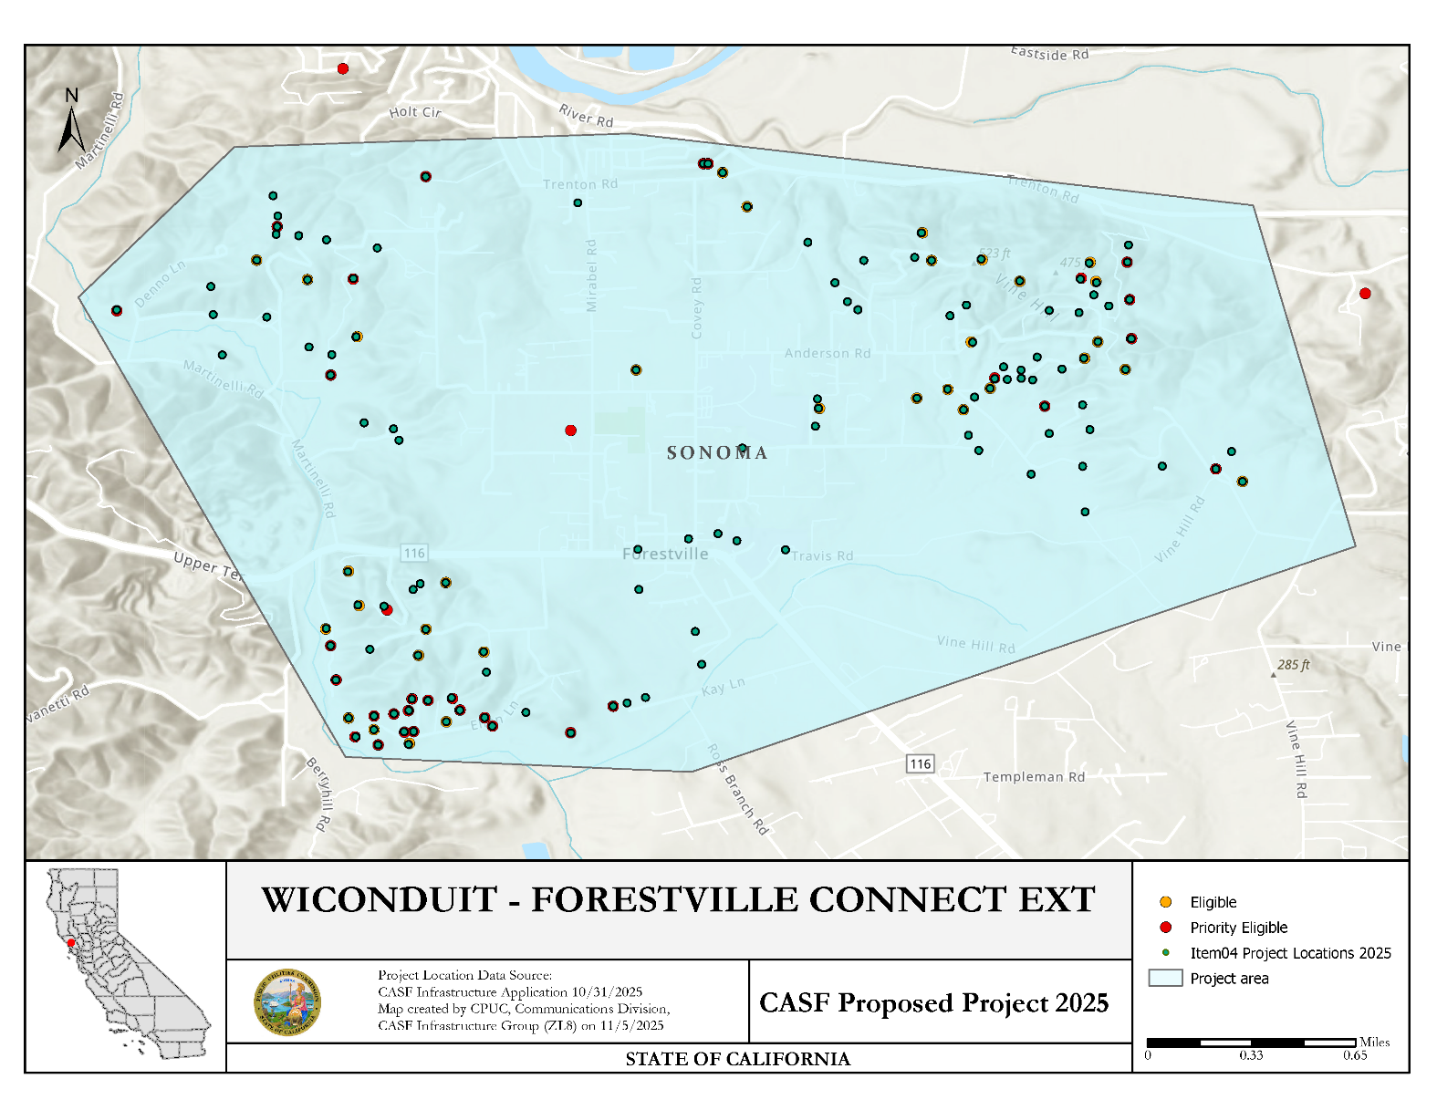

APPENDIX F
WiConduit and GigabitNow – Forestville Connect Ext.

Community Supporters
- Mike Thompson, Member, United States Congress
- Mike McGuire, Senator, California Senate
- Chris Rogers, California Assemblymember, Second District
- Lynda Hopkins, Supervisor, Fifth District
- Rebecca Hermosillo, Supervisor, Sonoma First District
- James Gore, Supervisor, Sonoma Fourth District
- Geof Syphers, CEO, Sonoma Clean Power
- Johannes J. Hoevertsz, Director, Sonoma County Department of Public Infrastructure
- Tony Goodwin, Chief Radio Officer, North Bay Communication Cooperative
- Amie R. Carter, Superintendent, Sonoma County
- Roberta MacIntyre, President / CEO, FireSAFE Sonoma
- Amy Beilharz, President, Safer West County
- Carolyn Sell, Leader Coordinator, FireSafe Occidental
- Dr. Keith Taylor, Professor, University of California Davis
- Indigo Perry, Cofounder and Program Director, Emergency Prep Help
- Robert Dozor, Assistant Chief Radio Officer, North Bay Communication Cooperative
- Thomas Andrew Hilldale, Training and Programming Manager, North Bay Communication Cooperative
- Nathan Gilfenbaum, Vice Chairperson, North Bay Communications Cooperative
- Michael Nicholls

APPENDIX G

WiConduit and GigabitNow – Graton Connect CASF Application

Key Information
Project Name | Graton Connect
Project Plan | The project proposes to deploy FTTH across Sonoma County to 110 unserved locations.
County | Sonoma
Communities | Graton
Project Size | 11.76 square miles
Download / Upload speed | 1,000 Mbps / 1,000 Mbps
Median Household Income | $137,929
Pricing Plan (Monthly) | Plan A (Residential): 100 / 100 Mbps - $49.99  Plan B (Residential): 500 / 500 Mbps - $74.99  Plan C (Residential): 1,000 / 1,000 Mbps - $99.99  Plan D (Low-Income): 100 / 100 Mbps - $14.99  Plan E (Business): 100 / 100 Mbps - $149.99  Plan F (Business): 1,000 / 1,000 Mbps - $199.99
Affordability (Low Income Plan) | Plan D (Low-Income): 100 / 100 Mbps - $14.99  WiConduit and GigabitNow intends to participate in the California Lifeline Home Broadband Pilot program.
Unserved Locations | 110
Subscriber Take Rate | 60%
High Fire Threat Districts | Yes
Deployment Schedule (from permit approval date) | 18 Months (CEQA-exempt)  24 Months (non-CEQA exempt)
Proposed Project Budget | $9,758,595
Original Grant Request | $12,254,650
CASF Grant Amount | $9,758,595
Cost per Household | $88,715
Census Blocks | 060971536012014 | 060971536012015 | 060971536021000
Census Blocks | 060971536021007 | 060971536021008 | 060971536021009
Census Blocks | 060971536022000 | 060971536022002 | 060971536022003
Census Blocks | 060971536022006 | 060971536022007 | 060971536022008
Census Blocks | 060971536022012 | 060971536022014 | 060971536022015
Census Blocks | 060971537082010 | 060971537082011 | 060971537113007
Census Blocks | 060971537113008 | 060971537113009 | 060971543061000
Census Blocks | 060971543061001 | 060971543061002 | 060971543061004
Census Blocks | 060971543062001 | 060971543062012 | 060971543062013

APPENDIX H
WiConduit and GigabitNow – Graton Connect
Revised Project Location Map
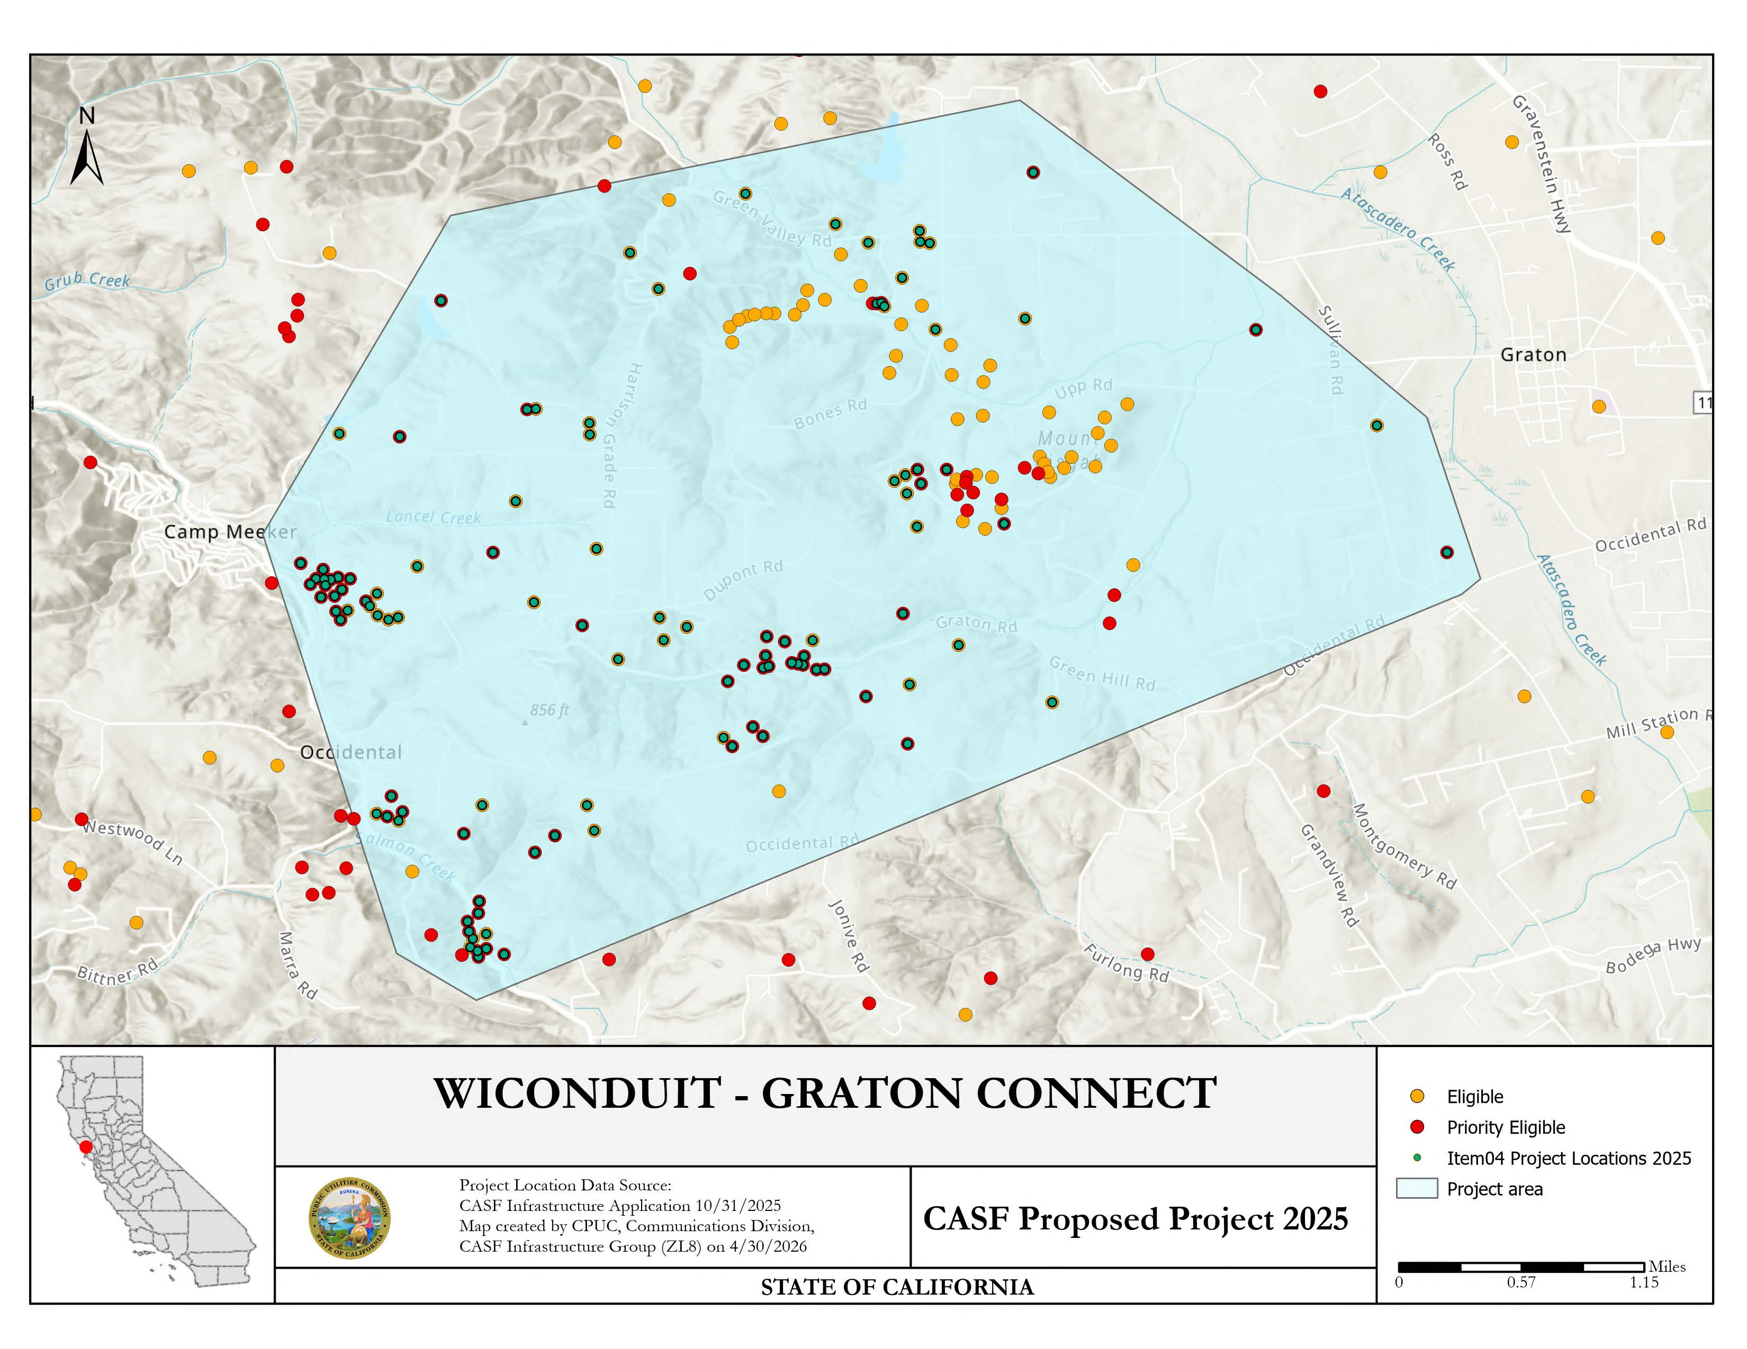

Original Project Location Map
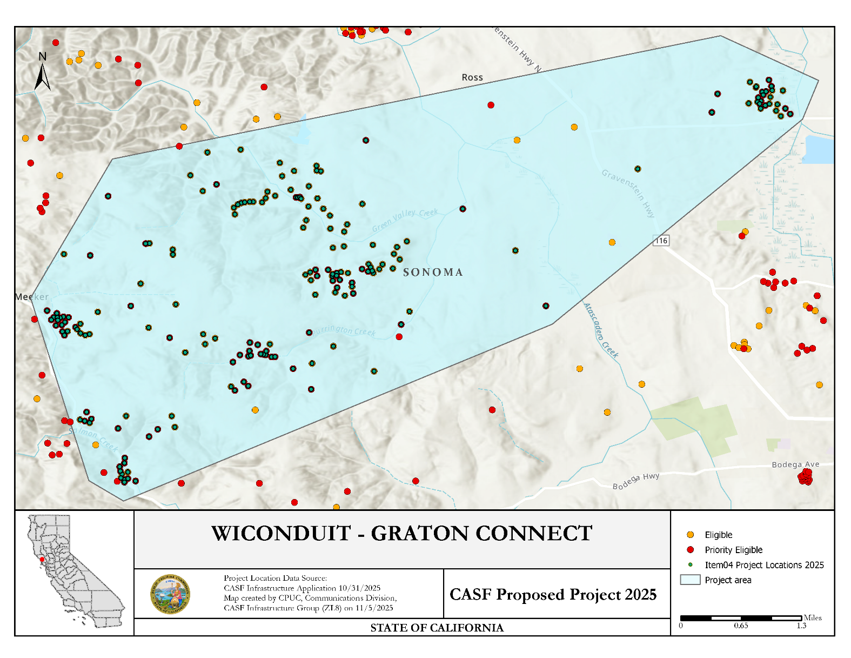

APPENDIX I
WiConduit and GigabitNow – Graton Connect

Community Supporters
- Mike Thompson, Member, United States Congress
- Mike McGuire, Senator, California Senate
- Chris Rogers, California Assemblymember, Second District
- Lynda Hopkins, Supervisor, Fifth District
- Rebecca Hermosillo, Supervisor, Sonoma First District
- James Gore, Supervisor, Sonoma Fourth District
- Geof Syphers, CEO, Sonoma Clean Power
- Johannes J. Hoevertsz, Director, Sonoma County Department of Public Infrastructure
- Tony Goodwin, Chief Radio Officer, North Bay Communication Cooperative
- Amie R. Carter, Superintendent, Sonoma County
- Roberta MacIntyre, President / CEO, FireSAFE Sonoma
- Amy Beilharz, President, Safer West County
- Carolyn Sell, Leader Coordinator, FireSafe Occidental
- Dr. Keith Taylor, Professor, University of California Davis
- Indigo Perry, Cofounder and Program Director, Emergency Prep Help
- Robert Dozor, Assistant Chief Radio Officer, North Bay Communication Cooperative
- Thomas Andrew Hilldale, Training and Programming Manager, North Bay Communication Cooperative
- Nathan Gilfenbaum, Vice Chairperson, North Bay Communications Cooperative
- Michael Nicholls

APPENDIX J

WiConduit and GigabitNow – Sonoma Coast Connect Ext. CASF Application

Key Information
Project Name | Sonoma Coast Connect Ext.
Project Plan | The project proposes to deploy FTTH across Sonoma County to 101 unserved locations.
County | Sonoma
Communities | Inland Hills between Jenner and Timber Cove
Project Size | 15.77 square miles
Download / Upload speed | 1,000 Mbps / 1,000 Mbps
Median Household Income | $77,607
Pricing Plan (Monthly) | Plan A (Residential): 100 / 100 Mbps - $49.99  Plan B (Residential): 500 / 500 Mbps - $74.99  Plan C (Residential): 1,000 / 1,000 Mbps - $99.99  Plan D (Low-Income): 100 / 100 Mbps - $14.99  Plan E (Business): 100 / 100 Mbps - $149.99  Plan F (Business): 1,000 / 1,000 Mbps - $199.99
Affordability (Low Income Plan) | Plan D (Low-Income): 100 / 100 Mbps - $14.99  WiConduit and GigabitNow intends to participate in the California Lifeline Home Broadband Pilot program.
Unserved Locations | 101
Subscriber Take Rate | 60%
High Fire Threat Districts | Yes
Deployment Schedule (from permit approval date) | 18 Months
Proposed Project Budget | $10,518,900
Original Grant Request | $9,085,007
CASF Grant Amount | $10,518,900
Cost per Household | $89,951  $104,148
Census Block | 060971543041121 | 060971543041128 | 060971543041129
Census Block | 060971543041130 | 060971543041133 | 060971543041140
Census Block | 060971543041141 | 060971543041144 | 060971543041147
Census Block | 060971543041148 | 060971543041149 | 060971543041150
Census Block | 060971543041151 | 060971543041167 | 060971543042000
Census Block | 060971543042005 | 060971543042009 | 060971543042013
Census Block | 060971543042014 | 060971543042015

APPENDIX K
WiConduit and GigabitNow – Sonoma Coast Connect Ext.
Project Location Map
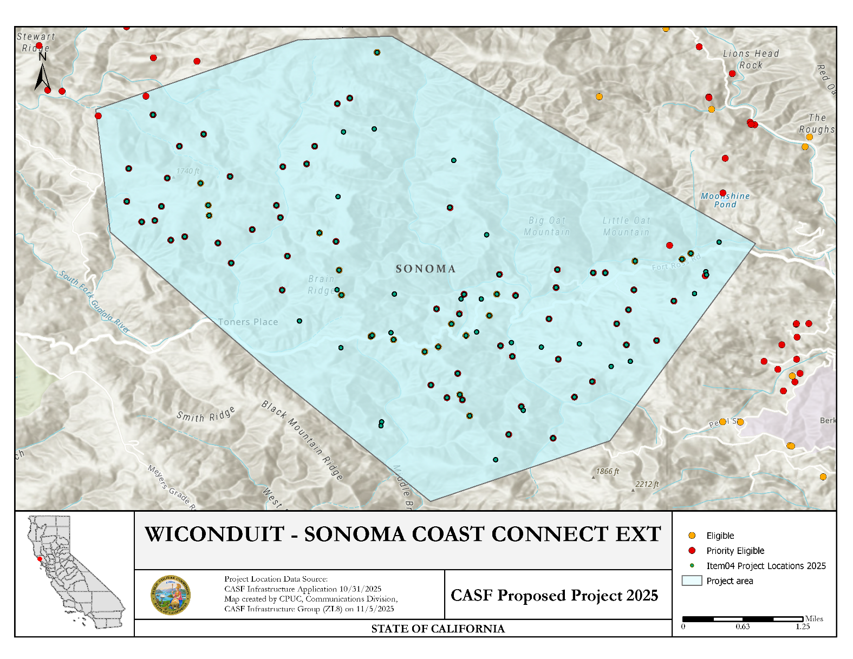

APPENDIX L
WiConduit and GigabitNow – Sonoma Coast Connect Ext.

Community Supporters
- Mike Thompson, Member, United States Congress
- Mike McGuire, Senator, California Senate
- Chris Rogers, California Assemblymember, Second District
- Lynda Hopkins, Supervisor, Fifth District
- Rebecca Hermosillo, Supervisor, Sonoma First District
- James Gore, Supervisor, Sonoma Fourth District
- Geof Syphers, CEO, Sonoma Clean Power
- Johannes J. Hoevertsz, Director, Sonoma County Department of Public Infrastructure
- Tony Goodwin, Chief Radio Officer, North Bay Communication Cooperative
- Amie R. Carter, Superintendent, Sonoma County
- Roberta MacIntyre, President / CEO, FireSAFE Sonoma
- Amy Beilharz, President, Safer West County
- Carolyn Sell, Leader Coordinator, FireSafe Occidental
- Dr. Keith Taylor, Professor, University of California Davis
- Indigo Perry, Cofounder and Program Director, Emergency Prep Help
- Robert Dozor, Assistant Chief Radio Officer, North Bay Communication Cooperative
- Thomas Andrew Hilldale, Training and Programming Manager, North Bay Communication Cooperative
- Nathan Gilfenbaum, Vice Chairperson, North Bay Communications Cooperative
- Michael Nicholls

Public Utilities (Pub. Util.) Code § 281(f)(4)
See Public Utilities (Pub. Util.) Code § 281(b)(1)(B)(ii)(I).
See Pub. Util. Code § 281(f)(5)
See Pub. Util. Code § 281(l).
California Interactive Broadband Map available at https://www.broadbandmap.ca.gov/
See https://www.hcd.ca.gov/sites/default/files/docs/grants-and-funding/income-limits-2025.pdf
See D. 22-11-023, Attachment 1, § 8.11, Pricing Commitment
See https://docs.cpuc.ca.gov/PublishedDocs/Published/G000/M577/K860/577860183.PDF
See U.S ACS Census income data for Graton, CA and Occidental, CA
See U.S ACS Census poverty data for Graton, CA
See U.S. ACS Census poverty data for California
See D. 22-11-023, Attachment 1, § 8.11, Pricing Commitment
See https://docs.cpuc.ca.gov/PublishedDocs/Published/G000/M577/K860/577860183.PDF
80 percent of the 2025 Statewide Median Income of 118,100 is $94,480. See: https://www.hcd.ca.gov/sites/default/files/docs/grants-and-funding/income-limits-2025.pdf
See D. 22-11-023, Attachment 1, § 8.11, Pricing Commitment
See https://docs.cpuc.ca.gov/PublishedDocs/Published/G000/M577/K860/577860183.PDF
See https://www.cpuc.ca.gov/industries-and-topics/internet-and-phone/california-advanced-services-fund/casf-infrastructure-project-summaries for project summaries and https://www.cpuc.ca.gov/industries-and-topics/internet-and-phone/california-advanced-services-fund/casf-infrastructure-grant/casf-infrastructure-approved-projects for approved projects.
The Commission extended the CASF Infrastructure application deadline from April 1 to October, 2025, and all subsequent deadlines were moved back by six months.
See CASF Infrastructure Project Summaries at https://www.cpuc.ca.gov/industries-and-topics/internet-and-phone/california-advanced-services-fund/casf-infrastructure-project-summaries
SB 156, enacted on July 20, 2021, and effective immediately, requires the Commission to fund projects that “deploy infrastructure capable of providing broadband access at a minimum of 100 Mbps downstream and 20 Mbps upstream.” See Pub. Util. Code § 281(f)(5).
See D. 22-11-023, Attachment 1.
Administrative costs are defined as “indirect overhead costs attributable to a project, per generally accepted accounting principles (GAAP), and the direct cost of complying with Commission administrative and regulatory requirements related to the grant itself.” Applicants seeking additional funds will require a Commission exemption included in a draft resolution.

