PUBLIC UTILITIES COMMISSION OF THE STATE OF CALIFORNIA

ENERGY DIVISION RESOLUTION E-5460
June 11, 2026

RESOLUTION

Resolution E-5460. Confirmation of candidates for appointment to the Diablo Canyon Independent Safety Committee (DCISC) for a three-year term beginning July 1, 2026.

PROPOSED OUTCOME:
- The California Public Utilities Commission (CPUC) ratifies the CPUC President’s selection of candidates for consideration by the Governor of California for appointment to the DCISC.

SAFETY CONSIDERATIONS:
- The DCISC reviews operations at Pacific Gas and Electric Company’s (PG&E) Diablo Canyon Power Plant (DCPP) for the purpose of assessing the safety of current operations and suggesting recommendations for continued safe operations. The appointed candidate will serve a three-year term on the DCISC.

ESTIMATED COST:
- All ongoing DCISC costs were funded previously. Ratification of the CPUC President’s selection of candidates for appointment to the DCISC will not result in any additional costs.

As required by D.23-08-004, dated August 10, 2023.
__________________________________________________________

Summary
The Diablo Canyon Independent Safety Committee (DCISC) consists of three members, each appointed in turn by the California Governor, the California Attorney General (AG), and the Chair of the California Energy Commission, serving staggered three-year terms. Section 1.B of the Third Restated Charter for the DCISC describes the process for appointment of DCISC members: it requires the California Public Utilities Commission (CPUC or Commission) to select and forward to the appointing authority no more than three new candidates plus the incumbent for DCISC membership. The appointing authority for the current cycle is the Governor of California. This Resolution ratifies the CPUC President’s selection of Dr. Per F. Peterson (incumbent), and Dr. Michael Quinn as candidates for appointment to the DCISC, for a three-year term commencing on
July 1, 2026.

Background
Establishment of the DCISC and Member Selection Process:
The CPUC created the DCISC in Decision (D.) 88-12-083 as part of the overall settlement of ratemaking issues for the Diablo Canyon Power Plant (DCPP), which is owned and operated by Pacific Gas and Electric Company (PG&E). Senate Bill (SB) 846 (Dodd, 2022), signed into law by Governor Newsom on September 2, 2022, primarily requires the CPUC to consider the potential extension of operations at the DCPP, but also calls for the DCISC to continue operations through such time as all spent nuclear fuel has been moved to dry storage at the DCPP Independent Spent Fuel Storage Installation, and that the DCISC continue to make findings and recommendations appropriate to enhance the safety of the operation of the DCPP.
The DCISC is an independent, three-member committee responsible for monitoring the safety of PG&E’s operation of DCPP. The DCISC conducts site visits at the DCPP, holds public meetings, and issues an annual report summarizing its activities and reviews of DCPP operations and provides findings and recommendations regarding DCPP operational safety. The DCISC’s budget for 2026-2027 is primarily paid out of the
SB 846 Non-Bypassable Charge by ratepayers from all Load Serving Entities.
D.88-12-083 established the qualifications and procedures for appointment of members to the DCISC and defined the scope of the Committee’s operations and responsibilities. Membership on the DCISC is a compensated position.

On October 24, 2006, the DCISC submitted Application (A.) 06-10-024 proposing a restated charter. The CPUC adopted the Restated Charter in D.07-01-028 on
January 25, 2007. Submission of a Second Restated Charter was authorized in Ordering Paragraph 3 of D.21-09-003 on September 9, 2021, and approved in Advice Letter 6361-E on December 9, 2021. Submission of the Third Restated Charter was authorized in Ordering Paragraph 4 of D.23-08-004 on August 10, 2023, and approved in Advice
Letter 7034-E on September 25, 2023.

Section 1.B of the Third Restated Charter describes the process for appointment of DCISC members. It requires the CPUC to select no more than three candidates for DCISC membership from among those applicants responding to an open request by the CPUC for applications. The incumbent member whose term is about to expire is to be deemed an additional candidate if they consent. The CPUC is charged with the responsibility to provide for public comment on the applicants’ qualifications and potential conflicts of interest. The President of the CPUC is to review the applicants’ qualifications, experience, and background, including any conflicts of interest, together with any public comments, and propose as candidates to the appointing authority only persons with knowledge, background, and experience in the field of nuclear power plants and nuclear safety issues. The Energy Division prepares a draft resolution ratifying the CPUC President’s selection of candidates for the Commission.

Current Applicants:
On January 09, 2026, an open request for applications to fill the July 1, 2026, vacancy on the DCISC was posted on the CPUC’s website. An application was timely received from Dr. Michael Quinn. In addition, Dr. Per F. Peterson, the incumbent member of the DCISC whose term is set to expire, sent a letter to the Energy Division confirming his willingness to continue serving as a member of the DCISC.

Dr. Peterson provided a synopsis of his technical experience and professional activities relating to applied and fundamental topics related to nuclear technology. Dr. Peterson’s work has covered topics in nuclear fusion energy, fission reactor design and safety analysis, nuclear waste management, and fundamental topics in heat transfer and fluid mechanics. Dr. Peterson was originally appointed to the DCISC in 2004, by then Attorney General Bill Lockyer. Dr. Peterson’s seventh term on the DCISC is set to expire on June 30, 2026.

In Dr. Michael Quinn’s application, he describes his experience working in the nuclear power industry, and consulting on nuclear operations and safety for industry clients as well as the U.S. and Canadian governments. Dr. Michael Quinn was previously selected by the Commission as one of the qualified candidates considered for appointment.

Public Comments on Applicants:
On February 19, 2026, an announcement was posted on the CPUC’s website and emailed to the relevant service lists inviting comments on the candidates. Summaries of their qualifications were included with the announcement. All public comments received for the candidates are included in their entirety in Appendix B of this Resolution. In the paragraphs below, where a commenter submitted comments as the representative of an organization or group, that organization or group is identified in parentheses.

Comments in support of Per F. Peterson’s reappointment were submitted by Dr. Robert Budnitz. The supporting comments emphasize Dr. Peterson’s extensive and quality experience serving on the DCISC, his outstanding qualifications, reputation as an expert in nuclear power plant safety, and engineering honors.

Comments in support of Dr. Michael Quinn’s appointment were submitted by
Steven Crowe, Michael Fecht, Matthew Sunseri, Richard Swanson (Performance Management Initiatives), Rochelle Becker (Alliance for Nuclear Responsibility), and Lucy J Swanson (San Luis Obispo Mothers for Peace). The supporting comments highlight Dr. Michael Quinn’s breadth of experience including his work in plant operations, nuclear safety, and decommissioning, and with the Nuclear Regulatory Commission (NRC); his integrity; and his independence.

Notice
Notice of this Resolution was made by publication in the CPUC’s Daily Calendar. A copy of the Draft Resolution was sent to all of the applicants and to those submitting comments on their behalf. A copy of the Draft Resolution was also sent to the Governor and to the service lists of PG&E’s 2021 Nuclear Decommissioning Cost Triennial proceeding (A.21-12-007), A.24-03-018, and R.23-01-007, the Commission’s Rulemaking implementing SB 846.

Discussion
The third restated charter adopted in D.23-08-004 and Advice Letter 7034-E requires that candidates for appointment to the DCISC be persons with knowledge, background, and experience in the field of nuclear power facilities and nuclear safety issues who demonstrate they have no conflicts of interest. The discussion below details CPUC President John Reynolds’ determinations as to the qualifications of each candidate.

Summaries of the qualifications of each applicant are included in Appendix A of this Resolution.

Dr. Per F. Peterson is qualified to continue to serve on the Diablo Canyon Independent Safety Committee (DCISC).
Dr. Per F. Peterson is an incumbent member of the DCISC, having been appointed to his initial term from 2004 through 2007 by then-Attorney General Bill Lockyer. Following his first term, Dr. Peterson was appointed by the Governor of the State of California for six subsequent three-year terms beginning in 2008. In addition to his service on the DCISC, Dr. Peterson is a Distinguished Professor in the Department of Nuclear Engineering at UC Berkeley and holds the William and Jean McCallum Floyd Endowed Chair. He also serves as the part-time Chief Nuclear Officer for Kairos Power, where he advises on the development of fluoride-salt-cooled high-temperature reactor technology.
Previously, Dr. Peterson served as the Executive Associate Dean of the College of Engineering at UC Berkeley from 2015 to 2017, and has also chaired both the Department of Nuclear Engineering and the Energy and Resources Group. Earlier in his career, he worked for Bechtel National, Inc., designing systems for processing high-level nuclear waste. His extensive advisory background includes serving as a member of the Blue Ribbon Commission on America’s Nuclear Future and the National Academies Nuclear and Radiation Studies Board. Dr. Peterson is a member of the National Academy of Engineering and a Fellow of the American Nuclear Society. He earned his Ph.D. in nuclear engineering from the University of California, Berkeley, in 1988.
Dr. Peterson has no conflicts of interest, having received no income, gifts, or investments from PG&E or its affiliates. His qualifications demonstrate the requisite knowledge, background, and experience in the field of nuclear power plants and reactor safety to continue his service on the committee.
Dr. Michael Quinn is qualified to serve on the Diablo Canyon Independent Safety Committee.

Dr. Michael Quinn has been continuously engaged in the nuclear industry for over
45 years: currently, he leads evaluations on nuclear operations reliability and conduct of operations, and since 2006 teaches U.S. NRC inspectors and technical staff on evaluating elements of nuclear licensee performance and safety culture. Since 1999 he has engaged as an operations evaluator and consultant to the U.S., Canadian commercial nuclear power industry, and the U.S. Department of Energy (DOE), evaluating significant nuclear events, regulatory compliance, program rigor, and facilitating performance improvement; during the 24 years prior he held director-level positions in the power block of a nuclear unit within a large nuclear utility. His experience includes developing and delivering root cause evaluation training to NRC staff; leading significant issue evaluations at four ISFSI sites; refueling operations events at five nuclear plant sites; Dr. Michael Quinn has also led teams that developed and implemented corrective actions to address significant operational events at over
30 nuclear facilities/units – including the nuclear fuel melt at the National Institute of Standards and Technology – and has performed evaluations for three regulators in the U.S. and Canada. He has led teams in evaluating, developing, and implementing programs to establish a safety culture at commercial nuclear power facilities and the U.S. DOE. Dr. Michael Quinn has experience facilitating the transition of nuclear plant staff to permanent shutdown: focusing on operational compliance and reliability, staff retention, addressing concerns, and facilitating a healthy nuclear safety culture and safety conscious work environment. Dr. Michael Quinn has taught nuclear safety event causal analysis to the U.S. NRC, Canadian Nuclear Safety Commission, and the Japan Nuclear Regulation Authority. Dr. Michael Quinn earned a Doctorate of Science in Organizational Management Systems and an Executive Master of Business Administration degree, both from the University of New Haven, and a B.S. in Chemistry from Charter Oak College. He previously held a U.S. NRC Senior Reactor Operator License on a Westinghouse pressurized water reactor, and is a Certified Root Cause Investigator and Radiation Safety Officer.

Dr. Michael Quinn has no conflicts of interest that would preclude his serving on the DCISC. His qualifications show that he has knowledge, background, and experience in the field of nuclear power plants and nuclear safety issues.

As required by D.23-08-004 and Advice Letter 7034-E, President Reynolds has reviewed the qualifications, experience, and backgrounds of Dr. Per F. Peterson, and Dr. Michael Quinn and, finding them qualified to serve on the DCISC, chooses to provide their names to the Governor of California as candidates for appointment to the DCISC for the three-year term beginning July 1, 2026.

Comments
Public Utilities Code section 311(g)(1) provides that this Resolution must be served on all parties and subject to at least 30 days public review. Any comments are due within 20 days of the date of its mailing and publication on the Commission’s website and in accordance with any instructions accompanying the notice. Section 311(g)(2) provides that this 30-day review period and 20-day comment period may be reduced or waived upon the stipulation of all parties in the proceeding.

The 30-day review and 20-day comment period for the draft of this resolution was neither waived nor reduced. Accordingly, this draft resolution was mailed to parties for comments on May 1, 2026 for comment by May 21, 2026. No comments were received.

Findings AND CONCLUSIONS
- Decision (D.) 88-12-083 created the Diablo Canyon Independent Safety Committee (DCISC).
- Senate Bill (SB) 846 continued the DCISC requiring that the DCISC continue operations through such time as all spent nuclear fuel has been moved to dry storage at the DCPP Independent Spent Fuel Storage Installation and that it continues to make findings and recommendations appropriate to enhance the safety of the operation of the DCPP.
- The DCISC is an independent, three-member committee responsible for monitoring the safety of PG&E’s operation of the Diablo Canyon Power Plant.
- D.07-01-028 adopted a restated charter for the DCISC including revised procedures for appointments of DCISC members.
- D.21-09-003 ordered the submission of a second restated charter in an advice letter. The second restated charter for the DCISC was submitted in Advice Letter 6361-E and approved on December 9, 2021.
- D.23-08-004 ordered the submission of a third restated charter in an advice letter. The third restated charter for the DCISC was submitted in Advice Letter 7034-E and approved on September 25, 2023.
- On January 09, 2026, in accordance with D.23-08-004 and Advice Letter 7034-E, an announcement was posted on the CPUC’s website seeking applications for the
July 1, 2026, vacancy on the DCISC.
- The Governor of California is the appointing authority for the July 1, 2026, vacancy on the DCISC.
- Dr. Per F. Peterson, the incumbent member of the DCISC whose term expires on June 30, 2026, responded to the CPUC’s January 09, 2026, announcement and consents to being a candidate for reappointment to the DCISC.
- Dr. Michael Quinn, a professional nuclear energy consultant, responded to the CPUC’s January 09, 2026, announcement, and submitted an application to be considered as a candidate for appointment to the DCISC.
- The CPUC invited comments on Dr. Peterson’s, and Dr. Michael Quinn’s qualifications in an announcement posted on the CPUC’s website on
February 18, 2026.
- Comments supporting the appointment of Dr. Peterson’s, and Dr. Michael Quinn, to the DCISC were received in response to the CPUC’s February 18, 2026, announcement inviting comments.
- The CPUC’s President, John Reynolds, has reviewed the qualifications, experience, and backgrounds of Dr. Per F. Peterson, and Dr. Michael Quinn.
- Dr. Per F. Peterson, and Dr. Michael Quinn have knowledge, background, and experience in the field of nuclear power plants and nuclear safety issues and are qualified candidates for appointment to the DCISC.
- President John Reynolds has chosen to provide the names of Dr. Per F. Peterson, and Dr. Michael Quinn as candidates for appointment to the DCISC for a three-year term beginning July 1, 2026.
- President John Reynolds’ selection of Dr. Per F. Peterson, and Dr. Michael Quinn, as the candidates for appointment to the DCISC for a three-year term beginning
July 1, 2026, should be ratified and provided to the Governor of California.

Therefore it is ordered that:
- President John Reynolds’ selection of Dr. Per F. Peterson, and Dr. Michael Quinn as qualified candidates for consideration by the Governor of California for appointment to the Diablo Canyon Independent Safety Committee for a three-year term beginning July 1, 2026, is hereby ratified.

This Resolution is effective today.

The foregoing resolution was duly introduced, passed and adopted at a conference of the Public Utilities Commission of the State of California held on June 11, 2026; the following Commissioners voting favorably thereon:

/s/ LEUWAM TESFAI
Leuwam Tesfai
Executive Director

JOHN REYNOLDS
President

DARCIE L. HOUCK
KAREN DOUGLAS
MATTHEW BAKER
CHRISTINE HARADA
Commissioners

Dated June 11, 2026, at Sacramento, California.

APPENDIX A

The following statements were supplied by the applicants as part of the application process and were available for public review and comment starting on
February 18, 2026. The assertions of fact contained within these statements have not been disputed. These statements are provided verbatim.

Dr. Per F Peterson (Incumbent)
I am a professor in the Department of Nuclear Engineering at U.C. Berkeley, and serve
part time as Chief Nuclear Officer at Kairos Power. My attached CV provides a detailed
summary of positions I have held. Prior to beginning graduate studies, I worked in
industry on the design of nuclear facilities.
I am a member of the National Academy of Engineering. My research and publications
cover both applied and fundamental topics related to nuclear technology. My work and over 300 research publications have covered topics in nuclear fusion energy, fission
reactor design and safety analysis, nuclear waste management, and fundamental topics in heat transfer and fluid mechanics that are relevant to these applications. I am frequently called upon to serve on advisory panels for the federal government, the national laboratories and the National Academies on topics related to nuclear technologies, as well as expert panels at academic conferences and workshops. I am currently a member of the National Academies Nuclear and Radiation Studies Board.
Since 2003 I have been active in research and development for a novel high temperature reactor technology now called fluoride salt cooled high temperature reactors (FHRs).
Initial work with universities and national laboratories showed the technology has
promise to have high intrinsic safety, precluding accidents that can have off-site
consequences as can and have occurred with existing water cooled reactors. In 2012 the
Department of Energy funded a large research project with UC Berkeley, MIT and UW
Madison, which was successful in establishing the scientific and technical basis for
design and licensing of this new class of high temperature reactors. In 2017 I joined, on a part-time basis, the start up company Kairos Power formed to further develop this FHR technology. I currently continue to teach and supervise research at UC Berkeley while working part time at Kairos, and remain active also as a member of the Diablo Canyon Independent Safety Committee.
I have taught extensively in courses related to reactor design and safety. This includes
the undergraduate courses NE-161, Nuclear Power Engineering, and NE-170, Nuclear
Design, as well as the graduate courses NE-260, Thermal Aspects of Nuclear Reactors
NE-267, Nuclear Reactor Safety, and NE-275, Risk Assessment. The NE-161, NE-260,
NE-267, and NE-275 courses cover all theoretical and practical aspects of nuclear reactor safety.
In 2017 I stepped down from my position as Executive Associate Dean of the College of
Engineering, and am also a former chair the Department of Nuclear Engineering and of
the Energy and Resources Group, at U.C. Berkeley. I am a Fellow of the American
Nuclear Society and a former chair of its Thermal Hydraulics Division. I previously
chaired the Radiation Safety Committee for the University of California, Berkeley, which is regulated by the California Department of Public Health and is responsible for
reviewing all authorizations for radioactive materials and radiation producing machines used in research on the Berkeley campus, and chaired of the Reactor Safeguards Committee for the Aerotest Research Reactor in Pleasanton, California until 2017.

Dr. Michael Quinn
Dr. Michael Quinn has several decades of comprehensive commercial nuclear power experience that entail independently evaluating, overseeing, and/or operating at commercial nuclear power and/or government nuclear reactor sites. His hands-on experience includes:
- Currently: Chair of the Connecticut Nuclear Energy Advisory Council (NEAC), which is responsible for independent oversight of the two-unit Millstone Nuclear Power Station and the Connecticut Yankee (Haddam Neck Site) Independent Spent Fuel Storage Installation (ISFSI). NEAC reports to the Governor of the State of Connecticut and the Connecticut General Assembly. Dr. Michael Quinn was appointed by the President Pro Tempore of the Connecticut Senate
- Currently: Nuclear Evaluator. During the past 20 years Dr. Michael Quinn has been, and is currently, an independent nuclear power operations evaluator; during which time his experience has included on-site evaluation of nuclear operational and organizational performance at over 40 nuclear generating units in the US and Canada, as well as on research reactors and US Department of Energy nuclear facilities
- Currently: Instructor to the US NRC. Since 2006 (four successive five-year contracts), Dr. Michael Quinn and his Team has taught over 600 US NRC inspectors and technical staff how to evaluate nuclear plant licensee event evaluation performance, engaging the USNRC Reactor Oversight Program’s Inspection Procedures 95001, 95002, and 95003; seven cornerstones; and three cross-cutting areas of human performance, safety culture, and Problem Identification & Resolution (contracted into 2029)
- Previously: 25 years in operating and senior site management roles at two nuclear power stations, earning a Senior Reactor Operator’s License (SRO) on a Westinghouse PWR (Diablo Canyon is a Westinghouse PWR). While at Millstone Nuclear Station, Michael was a member of the station recovery team that developed and commissioned nuclear safety & safety conscious work environment (SCWE) programs to support restart after a several year USNRC-directed shutdown
Dr. Michael Quinn has a demonstrated history to prescriptively and effectively communicate his independent evaluations, reports, and recommendations in objective, balanced, empirically-based, plain language to a broad spectrum of stakeholders. His recommendations and corrective actions address the 1) substantive problems, 2) the causal factors that enabled the problems, and 3), the processes that should have identified and addressed the causal factors at an earlier, safer, more risk-compliant time.
Michael has delivered his independent assessments to federal and state agencies, state and federal regulators, utility commissions, Boards of Directors, nuclear utility executives, nuclear plant staff, external interest groups, and the public. He has presented findings in closed and open settings, as well as in public forums with regulators, town hall attendees, and public stakeholders.

EDUCATION:
Doctor of Science (Sc.D.) Organizational System Dynamics - University of New Haven
Master of Business Administration - University of New Haven
BSc. Chemistry - Charter Oak College
BA General Studies Biology - University of Connecticut

LICENSURE and CERTIFICATIONS
- U.S. NRC Senior Reactor Operator License #10071 Westinghouse Pressurized Water Reactor (PWR)
- Certified Event Causal Analysis Investigator by:
- Nuclear Safety Review Concepts Event Evaluation (Phoenix Method) and,
- FPI/ PII Prevention and Reduction of Nuclear Organizational and Programmatic Failures
- Certified Radiation Safety Officer

On a Personal Note:
Dr. Michael Quinn is a four-decade American Red Cross blood donor, during this time donating 16 gallons.
LinkedIn: https://www.linkedin.com/in/quinnmd/
Google Scholar Link: https://scholar.google.com/citations?hl=en&user=lFjU6ncAAAAJ

END OF APPENDIX A

APPENDIX B

The following are all of the public comments submitted regarding the applicants for the Diablo Canyon Independent Safety Committee. The comments are grouped by candidate and are provided verbatim. Four respondents who provided support letters for Dr. Michael Quinn in 2025 used the same letter the Commission had on file to again provide support to Dr. Michael Quinn in 2026. Those letters contain references to the 2025 vacancy but are in support of Dr. Michael Quinn’s 2026 candidacy.

Comments on the Qualifications of Dr. Per F Peterson

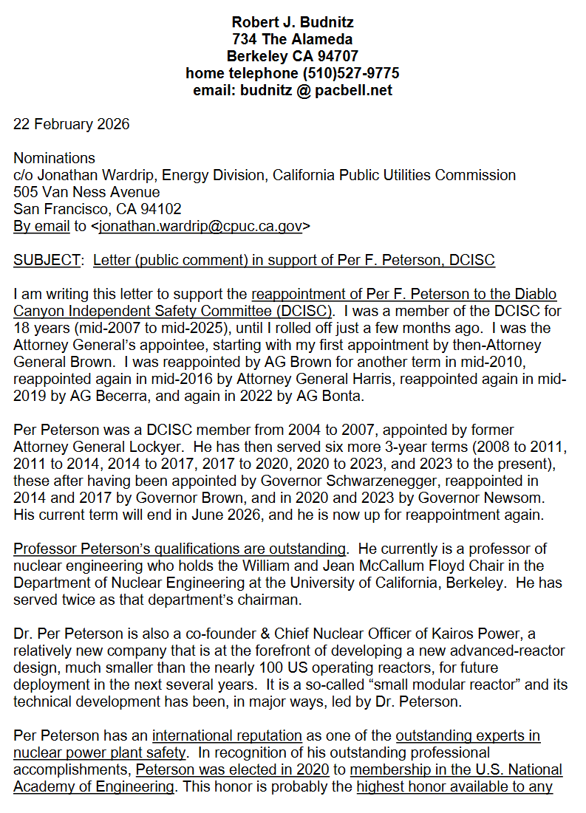
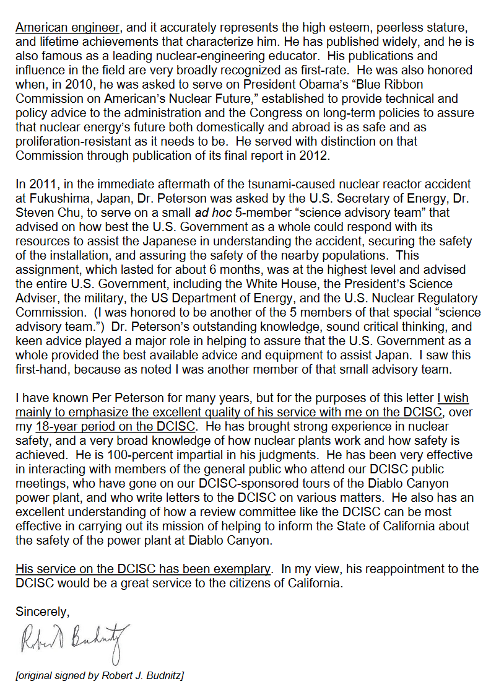
Comments on the Qualifications of Dr. Michael Quinn
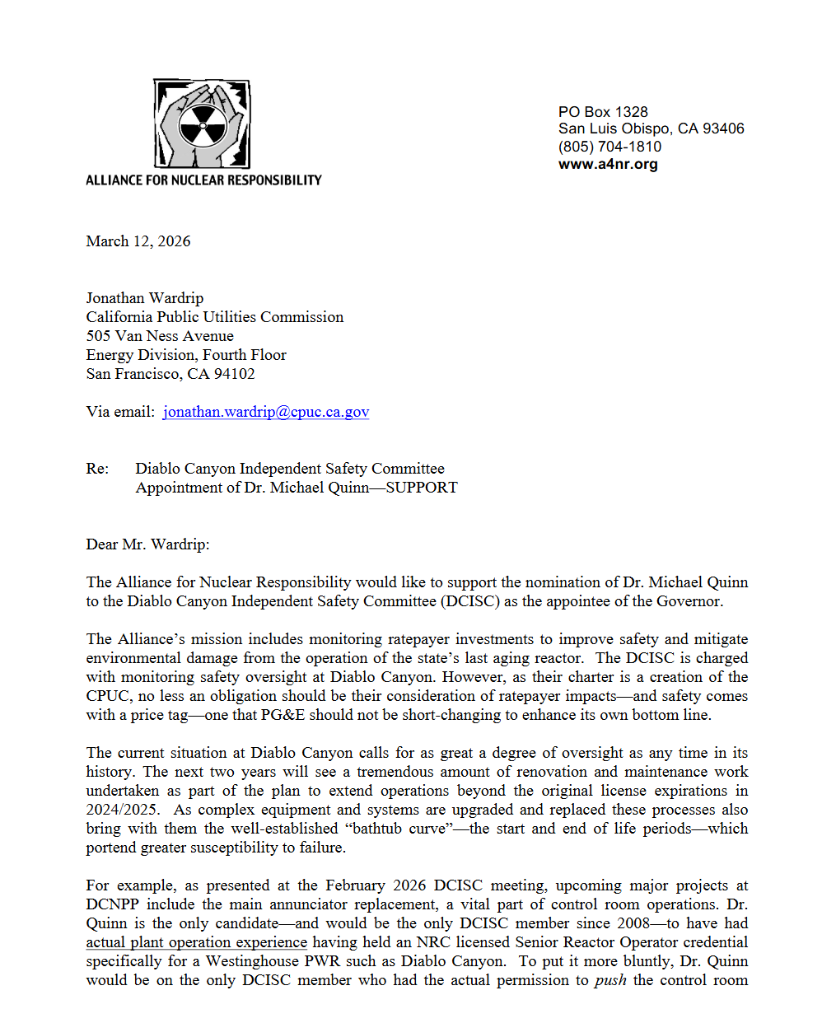

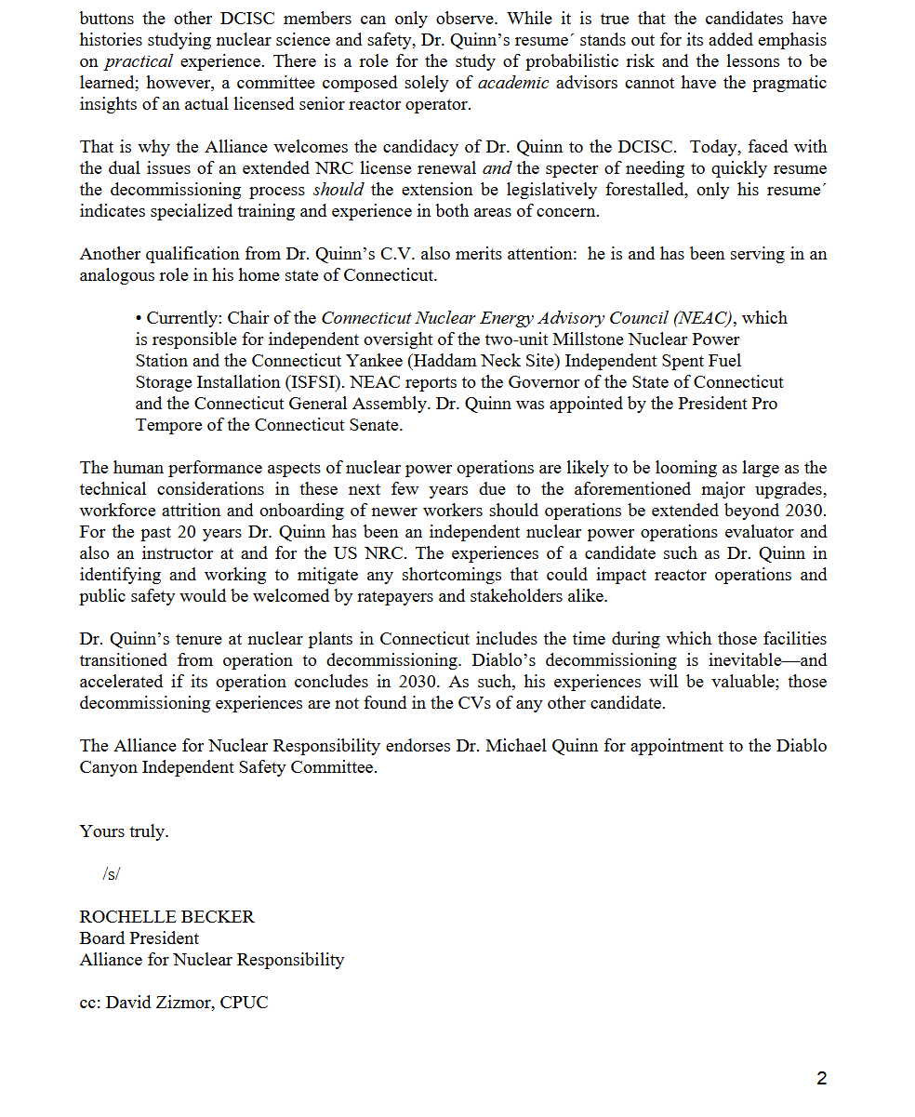

Dear Sir,
I am honored to have the opportunity to provide comments on the qualifications of Dr. Michael Quinn. I have worked in the nuclear industry for over 48 years with experience in reactor operations, training, maintenance, start-up, troubled plant recovery, and coordination of oversight for TVA’s nuclear plants. I am a graduate of the United States Naval Academy who qualified as a Nuclear Engineer in the Naval Reactors Program.
For the past 8 years, I have had the honor to work with Dr. Michael Quinn on multiple projects involving recovery of troubled plants and organizations. Dr. Michael Quinn is the ideal candidate for appointment to the Diablo Canyon Independent Safety Committee. His far-ranging knowledge of nuclear operations and management of nuclear safety issues is evident based on his continuing professional successes. He has an SRO license and years of experience in identification and correction of safety issues. He is a recognized expert in root cause analysis as well as nuclear safety culture assessment and implementation. His recent experience includes leading teams to identify performance issues at the Waste Isolation Pilot Project (nuclear facility storing transuranic waste) and to evaluate the state of the nuclear safety culture at the NIST NCNR reactor facility (NRC licensed facility).
As TVA’s Nuclear Safety Review Board coordinator during the restart of Sequoyah and Browns Ferry Nuclear Plants, I had the opportunity to interact with each member of our off-site review committees. Dr. Michael Quinn would have been a welcome addition.
Most recently, I have had the opportunity to observe Dr. Michael Quinn’s ability to assess complicated organizational and technical issues at high hazard nuclear facilities. He has the unique ability to be able to identify issues, capture their significance, and develop recommendations to correct the issues. His knowledge of NRC regulations is unsurpassed. He has an excellent relationship with NRC personnel and management having instructed many of them in the NRC root cause analysis course. Specifically, he and his team are the exclusive instructors teaching NRC personnel how to assess and review the adequacy of root cause submittals to the NRC. Dr. Michael Quinn is well spoken and is sensitive to the importance of his reports and how they impact public perceptions. I have witnessed his outstanding ability to effectively communicate to all levels of management and external stakeholders.
Dr. Michael Quinn’s ability to lead teams is unparalleled. He functions at a high level, is energetic, and ensures all team members are heard. He has demonstrated mastery of capturing the data inputs, processing the information and communicating all critical items to the customers and regulators in a manner that promotes understanding of important issues. He is excellent at identifying issues that could potentially lead to future problems and has a history of developing corrective actions to resolve the potential issues. He is candid, personable, and has the unique ability to see and understand the “big picture” issues and needs. I am honored to have worked with him.
In short, I cannot think of a better person than Dr. Michael Quinn for the Diablo Canyon Independent Safety Committee. He will make an immediate positive impact if chosen for the position.

Steven K. Crowe, Captain, USNR (ret)

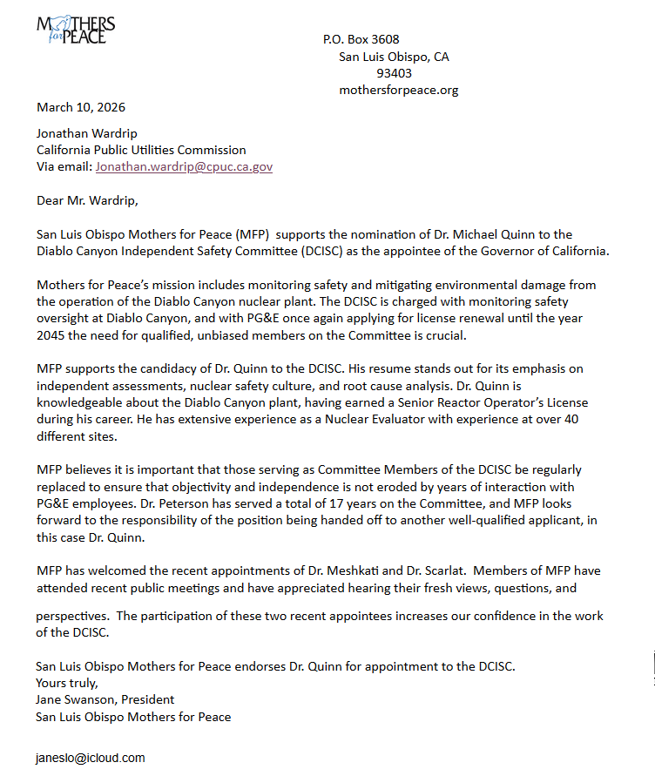

END OF APPENDIX B

Pub. Util. Code Section 712.1.
PG&E Advice Letter 6870-E/6870-E-A as approved by Resolution E-5299; Pub. Util. Code Section 712.8(l)(1).
D.88-12-083, Appendix C, Attachment A; See also Pub. Util. Code Sections 712.1(c) and (e).
In Resolution E-3152, the Commission established that DCISC member compensation be set at levels commensurate with fees paid by PG&E for comparable services. The compensation levels set in E-3152 have since been revised several times, most recently in D.23-08-004. The current compensation levels were affirmed on April 1, 2025, in PG&E Advice Letter (AL) 7553-E as follows: annual retainer of $10,800; $270/hour fee for attendance at DCISC meetings; $270/hour fee for DCISC work performed outside of committee meetings in excess of 40 hours/year; and reimbursement of expenses incurred in performance of DCISC work.
The approval of Advice Letter 7034-E and the text of the Third Restatement of the Charter for the Diablo Canyon Independent Safety Committee (in Attachment 2) are available at: https://www.pge.com/tariffs/assets/pdf/adviceletter/ELEC_7034-E.pdf.
As conflicts of interest are a legal question, their review was conducted by the CPUC’s legal department which the President then approved.
A link to the announcement posted on the CPUC’s website was sent to the service lists of A.21-12-007, R.23-01-007, and A.24-03-018 to ensure that parties interested in issues relating to the DCPP were aware of the announcement. A.21-12-007 is PG&E’s 2021 Nuclear Decommissioning Cost Triennial Proceeding; R.23-01-007 is the Rulemaking implementing SB 846; A.24-03-018 is PG&E’s 2025 DCPP Extended Operations Forecast.
See CPUC Resolution E-5329 (June 20, 2024) and CPUC Resolution E-5399 (June 12, 2025).
A link to the announcement was also sent to the service lists of A.21-12-007, R.23-01-007, and A.24-03-018. See footnote 7 above.
Conflicts of interest guidelines are set forth in Section I.C of the second restated charter. They establish limits for DCISC members on income and gifts from PG&E or an affiliated company, and investments in PG&E or an affiliate. They also prohibit members of the DCISC from attempting to use their position to influence an action of the Committee about which they have a financial interest. DCISC members are required to file a Statement of Economic Interest in the same manner as designated CPUC employees. No person shall serve on the DCISC who has a prior history of supporting or opposing PG&E as a witness or intervenor in nuclear licensing or CPUC proceedings associated with the DCPP.

