State of California
M E M O R A N D U M
Date: |  | July 16, 2026
To: |  | President John Reynolds  Commissioner Matthew Baker  Commissioner Christine Harada
From: | Commissioner Darcie L. Houck  Commissioner Karen Douglas
Subject: | Reappointments and New Appointments to the Disadvantaged Communities Advisory Group (DACAG)

Recommended Reappointments and Appointments
We recommend that the Commission vote to reappoint Sarah Sharpe to the Disadvantaged Communities Advisory Group (DACAG).
Additionally, we recommend that the Commission vote to appoint four new DACAG members:
- Travis Gibrael
- Jacob Norte
- Ryan O’Neill
- Melanie Peck
Background
Senate Bill 350 (de León, Chapter 547, Statutes of 2015), as codified in Public Utilities Code section 400(g), requires the California Public Utilities Commission (CPUC) and the California Energy Commission (CEC) to establish a disadvantaged communities advisory group (DACAG) consisting of representatives from disadvantaged communities. The purpose of the DACAG is to review and provide advice on proposed clean energy and pollution reduction programs and determine whether those proposed programs will be effective and useful in disadvantaged communities. The DACAG is subject to a Charter approved by the CPUC and CEC.
The DACAG is comprised of 11 members who serve two-year staggered terms. Five members shall serve in two-year terms running from April 1 to March 31 of even years. Five members, plus the Governor’s Tribal representative, serve two-year terms running from April 1 to March 31 of odd years. A member may be reappointed, but no member may serve for more than three consecutive full terms. Of the four DACAG members currently eligible for reappointment, one member (Sarah Sharpe) has sought reappointment. One other member, Fred Beihn, has reached his term limit. This memo discusses our appointment recommendations.
Recommended DACAG Member Reappointments
Sarah Sharpe, DACAG Secretary, completed her first term on March 31, 2026, and has requested reappointment. We recommend Ms. Sharpe for reappointment based on her demonstrated commitment to and participation in the DACAG and her work on the DACAG to uplift the perspectives of vulnerable California communities. The following is a summary of her qualifications:
Sarah Sharpe: Based in Fresno, Sarah Sharpe is the Deputy Executive Director for the Central California Asthma Collaborative. As Deputy Executive Director, Ms. Sharpe provides administrative, financial, and programmatic oversight and direction in support of the organization’s mission to address inequities and improve health by reducing environmental impacts and emphasizing the prevention and management of chronic disease. Ms. Sharpe has more than twenty years of experience working with and for the benefit of disadvantaged communities in the San Joaquin Valley. She has experience with California and federal energy policy having worked at the CPUC as an advisor to CPUC Commissioner Martha Guzman Aceves and as Administrator Guzman’s chief of staff at the Environmental Protection Agency (EPA) Region 9. While at the CPUC, Ms. Sharpe was involved in developing the CPUC’s Environmental and Social Justice Action Plan. Ms. Sharpe holds a Master of Education from City University of New York, Brooklyn College.

Recommended New DACAG Member Appointments
On December 20, 2025, the Commissions issued a solicitation for application to membership in the DACAG to fill member vacancies. The application deadline was January 30, 2026.
CPUC and CEC staff interviewed 17 applicants and CPUC and CEC DACAG commissioners jointly recommend candidates Travis Gibrael, Jacob Norte, Ryan O’Neill, and Melanie Peck based on strong qualifications including clean energy experience and disadvantaged community representation.
The following is a summary of the applicants’ qualifications:
Travis Gibrael: Based in Oakland, Mr. Gibrael works as the Co-Director and Research and Education Organizer for Reclaim Our Power Utility Justice Campaign, a coalition of frontline communities organizing to intervene in the energy decision-making process in California and promote visions of a transformative energy system. He conducts and oversees research efforts, develops popular education materials, and engages with legislative, regulatory and statutory administration processes relating to utility regulation. Mr. Gibrael is also a Solar Technician and Project Lead at Sunwork Renewable Energy Projects, a non-profit solar and heat pump installer operating in the Bay Area and Central Coast. Prior to these roles, Mr. Gibrael was Co-Founder of EnerWealth Solutions, LLC, a solar project developer in the Southeast United States, and a Rural Capacity Strategist at The Conservation Fund. Mr. Gibrael received a Bachelor of Arts from New York University and a Master of Social Work from University of North Carolina, Chapel Hill.

Jacob Norte: Based in Warner Springs, Mr. Norte works as the Environmental Director at the Los Coyotes Band of Cahuilla and Cupeño Indians. He designs and implements Tribal environmental programs, coordinates emergency response, and leads communication with electric investor-owned utilities, including coordinating new distribution infrastructure. Mr. Norte served seven years as an Executive Member of the Tribal Council for Los Coyotes and is the Policy and Regulatory Advocacy Chair on the Executive Board of the Tribal Energy and Climate Collaborative and an Executive Board Member of the Native American Environmental Protection Coalition. Mr. Norte has a Bachelor of Arts from Pepperdine University.

Ryan O’Neill: Based in Ukiah, Mr. O’Neill works as an Energy Program Specialist at the Northen Rural Energy Network (NREN), which provides energy efficiency program services to PG&E, Pioneer Community Energy, Sonoma Clean Power, and Redwood Coast Energy Authority customers in 17 counties in Northern California. He designs and administers energy efficiency programs across residential, commercial, and public sectors in Lake County and conducts stakeholder engagement with local governments and rural communities. Mr. O’Neill is a member of the Lake Area Planning Council Prior to joining NREN, he worked at Naver, a social mobile app as a Content Creator and Marketing Specialist. Mr. O’Neill has a Master of Science in Sustainability (Energy, Environment, and Society) from University of Stavanger, Norway, and Bachelor of Arts in Psychology and a Bachelor of Arts in Philosophy from University of California, Santa Barbara.

Melanie Peck: Based in Los Angeles, Ms. Peck is the Chief Program Officer at the United States Green Building Council of California, a member-based non-profit advocating for a sustainable, resilient, and equitable built environment. She leads statewide community outreach and engagement, and workforce, energy and training strategy development, including program design and implementation. Prior to her role at USGBC-CA, she was Director of People, Culture and Workforce Excellence at the municipal utility Seattle City Light, where she led talent acquisition, workforce development, apprenticeship, race and social justice and equity initiatives. She has a Bachelor of Arts from California State University, Fullerton and a Master of Public Administration from Brandman University (now University of Massachusetts Global).

The CEC is expected to recommend the approval of four DACAG member nominees (Sarah Sharpe, Travis Gibrael, Ryan O’Neill and Melanie Peck) at its business meeting on July 8, 2026, and the approval of the final DACAG member nominee (Jacob Norte) at its August 12, 2026 business meeting. The reappointment and new appointments to the DACAG will be confirmed once the CPUC and CEC both vote to approve them.
Conclusion
Sarah Sharpe has made significant contributions to the Disadvantaged Community Advisory Group as DACAG Secretary and we recommend her reappointment. Travis Gibrael, Jacob Norte, Ryan O'Neill, and Melanie Peck are highly qualified professionals and will make valuable contributions to the Disadvantaged Communities Advisory Group in advising the CPUC and CEC, and we recommend their appointments.
Sincerely,
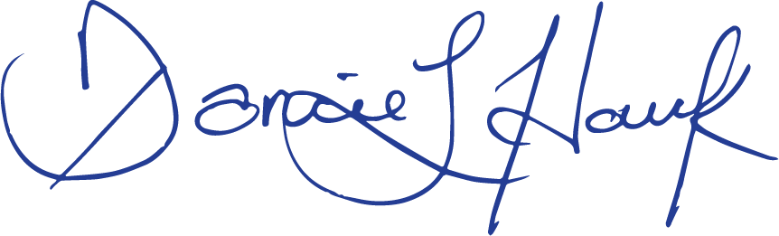
Darcie L. Houck, Commissioner
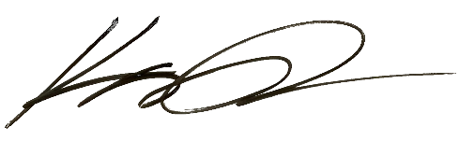
Karen Douglas, Commissioner

