July 13, 2026 Agenda ID: 24385
RESOLUTION T-17926

TO: Parties on the CASF Distribution (Service) List

This is Draft Resolution T-17926 of the ​Communications​ Division. This Draft Resolution will appear on the agenda at the next Commission meeting to be held August 13, 2026, which is at least 30 days after the date of this letter. The Commission may vote on this Resolution at that time, or it may postpone a vote until a later meeting. To confirm when the item will be heard, please see the Business Meeting agenda, which is posted on the Commission’s website 10 days before each Business Meeting. When the Commission votes on a Draft Resolution, it may adopt all or part of it as written, amend, modify, or set it aside and prepare a different Resolution. Only when the Commission acts does the Resolution become binding on the parties.

Any member of the public may serve comments on the Draft Resolution as provided in Public Utilities Code § 311(g) and Rule 14.5 of the Commission’s Rules of Practice and Procedure (Rules).

Comments along with a certificate of service (COS) shall be sent via email to: Benjamin.Swearingen@cpuc.ca.gov and casf_infrastructure_grant_administrator@cpuc.ca.gov by August 3, 2026, at 5:00 PM.

Those submitting comments on the Draft Resolution must serve their comments on the entire service list the Draft Resolution was served to on the same date that the comments are submitted to the ​Communications​ Division.

Comments shall focus on factual, legal, or technical errors in the proposed Draft Resolution. Comments should list the recommended changes to the Draft Resolution. Comments shall be limited to three pages in length and shall include a subject index listing the recommendations to the draft resolution, a table of authorities, and an appendix setting forth the proposed revised findings and ordering paragraphs.

Replies to comments must be submitted no later than August 10, 2026. Replies shall be submitted and served in the same manner as opening comments.

Sincerely,

/s/
Maria I. Ellis
Director for Broadband Initiatives
​​Communications​ Division
California Public Utilities Commission

PUBLIC UTILITIES COMMISSION OF THE STATE OF CALIFORNIA

Communications Division | RESOLUTION T-17926
Broadband Video and Marketing Branch | August 13, 2026

R E S O L U T I O N

RESOLUTION T-17926: Approves up to $24,040,291 from the California Advanced Services Fund (CASF) for the Broadband Infrastructure Grant Account application of Frontier California Inc., (U-1002-C) for the Merced Dos Palos, Plumas Greenville, and Tulare Central Projects.

PROPOSED OUTCOME:

- Awards three (3) grants for up to $24,040,291 from the CASF Infrastructure Funding Account to Frontier California Inc. in Fresno, Merced, Plumas, and Tulare Counties.

SAFETY CONSIDERATIONS:

- There are no adverse safety considerations identified by the Communications Division. The projects to be funded by this award have the potential to improve communications resiliency and redundancy.

ESTIMATED COST:

- There are no costs associated with this Resolution.

SUMMARY

This Resolution approves grant funding for three projects to Frontier California Inc. (Frontier) in the amount of up to $24,040,291 from the California Advanced Services Fund (CASF) Broadband Infrastructure Grant Account (Infrastructure Account). The projects will provide broadband connectivity to a total of 590 unserved locations in Fresno, Merced, Plumas, and Tulare Counties.

The recommended grants are listed below in Table 1. Associated maps and project information summaries are included in the appendices.
Table 1: Summary of Grant Funding
Applicant | Project Name | Unserved Locations | Requested Amount | CASF Approved Amount
Frontier | Merced Dos Palos | 289 | $14,838,903 | $14,838,903
Frontier | Plumas Greenville | 187 | $3,451,686 | $3,451,686
Frontier | Tulare Central | 114 | $5,749,702 | $5,749,702
TOTAL: | Three Projects | 590 | $24,040,291 | $24,040,291

- BACKGROUND

The CASF Infrastructure Account provides grant funding to Internet Service Providers (ISPs)/eligible entities to build or upgrade broadband infrastructure in areas that are unserved by existing broadband providers. The CASF program was initiated in 2008, after the program was first adopted by the California Public Utilities Commission (Commission) in Decision (D.) 07-12-054 and enacted into statute pursuant to Senate Bill (SB) 1193.

On July 20, 2021, Governor Newsom signed historic broadband legislation to help bridge the digital divide; Senate Bill (SB) 156 changed the definition of “unserved area,” allowing, but not requiring, funding for “an area for which there is no facility-based broadband provider offering at least one tier of broadband service at speeds of at least 25 Mbps downstream, 3 Mbps upstream.” Additionally, SB 156 requires grantees to “deploy infrastructure capable of providing broadband access at speeds of a minimum of 100 Mbps downstream and 20 Mbps upstream” and that any grantees receiving CASF funding must report subcontracted work in excess of $25,000; this information must be posted by Commission on a monthly basis.

On November 17, 2022, the Commission issued D.22-11-023, adopting programmatic changes to the CASF Infrastructure Account. Attachment 1 of D.22-11-023 (CASF Guidelines) set forth the rules, application requirements, and guidelines for the CASF Infrastructure Account.

- APPLICATION REVIEW AND EVALUATION

Frontier Background

On October 31, 2025, Frontier submitted three applications for CASF Infrastructure Account grants requesting approximately 90 percent funding of each project’s projected cost, for a total of up to $24,040,291. The three projects will deliver fiber-to-the-home (FTTH) broadband access to 590 unserved households in the counties of Fresno, Merced, Plumas, and Tulare.

The applicant determined eligibility for funding based on the California Interactive Broadband Map, which during the 2025 application cycle was based on 2023 mapping data. Because the evaluation and review period occurred while the Commission was collecting 2024 broadband location data, Staff verified eligibility using the 2024 dataset to ensure the eligibility of all locations was based on the most recent available data and to prevent the awarding of program funds in areas already served.

Frontier, which operates in California as Frontier California Inc., began in 1929 as part of General Telephone & Electronics (GTE). It later became Verizon California after GTE’s merger with Bell Atlantic in 2000 and was ultimately acquired by Frontier Communications in 2016. Frontier operates as a major incumbent local exchange carrier in California, providing telephone and broadband services across former Verizon territories. Frontier has maintained active status with the California Secretary of State since March 18, 1929, and is currently registered with the CPUC under utility number U-1002-C. On January 15, 2026, the Commission approved Verizon Communications Inc.’s acquisition of Frontier Communications, including Frontier’s California operations and obligations.

Staff’s review and evaluation of the three applications are summarized below.

- Merced Dos Palos

Project Summary
In compliance with D.22-11-023, Staff determined that Merced Dos Palos Project is eligible to receive up to $14,838,903 in CASF Infrastructure Account grant funding.

Frontier proposes to serve 289 unserved locations by constructing an FTTH network with up to 7 Gigabits per second (Gbps) download and upload in Fresno and Merced Counties.

Challenges
Pursuant to Pub. Util. Code Section 281(f)(8) and as required by D.22-11-023, the Commission provided an opportunity for entities to challenge the application. Challenges were due on December 5, 2025.

The Merced Dos Palos Project received no challenges.

Revisions
Staff determined that the Merced Dos Palos Project does not overlap with other grant-funded terrestrial broadband projects.

Technology Deployment
Frontier will deploy approximately 80 miles of last-mile fiber for the Merced Dos Palos Project. The network infrastructure will be approximately 48 percent aerial and 52 percent underground.

Median Household Income and Low-Income Service
The median household income (MHI) for the Merced Dos Palos Project area is approximately $51,080. This MHI meets the definition of low-income as set forth in D.22-11-023 as it falls at or below the low-income threshold of $75,100 for a family of four living in either Merced or Fresno Counties as designated by the Department of Housing and Community Development (HCD).

Frontier agrees to change the Verizon Forward (VZ FWD) income eligibility threshold for customers in the Merced Dos Palos Project area to match the CASF low-income threshold, which is based on the HCD Low Median Household Income (MHI) for the respective counties. Per Frontier, this is an expansion of eligibility, as the CASF HCD MHI thresholds are higher than the previously stated VZ FWD threshold of 200 percent Federal Poverty Guideline. After applying the VZ FWD $19.99 discount, Frontier will provide a low-income plan at $20.00 for speeds of 200 Mbps download and 200 Mbps upload to eligible low-income customers served by the Merced Dos Palos Project. To further reduce the burden on low-income households, on May 29, 2026, Frontier submitted a Tier 2 Advice Letter requesting authorization to participate in the Home Broadband Pilot. Customers who qualify both for Frontier’s low-income plan and for the Home Broadband Pilot discount will pay $0.00 monthly charges. Installation and connection charges will be waived for five years from completion of the project.

Safety Considerations
The Merced Dos Palos Project enables the public to access the public safety benefits of reliable broadband infrastructure. Many households in the project area are within or fewer than two miles from Federal Emergency Management Agency (FEMA) Special Flood Hazard Area (SFHA) High-risk Zone A. The Merced Dos Palos Project will provide critical communications resiliency and redundancy in the area.

The project is not located in a Commission-designated High Fire-Threat District.

Funding Determination
Frontier requested $14,838,903 in CASF Infrastructure Account funding for the Merced Dos Palos Project, which is approximately 92 percent of the total project cost of $16,129,242. Based on its review, Staff considers it appropriate to recommend funding the amount requested by Frontier ($14,838,903), as the Merced Dos Palos Project will serve a low-income area and use existing outside plant infrastructure. Frontier will cover the remaining eight percent of proposed project expenditures.

Viability
Staff determined that the applicant and project are financially viable, and the applicant’s engineering design meets the program standards. The applicant demonstrated the administrative, technical, and operational capacity to provide broadband service at the scale of this project.

Frontier received one letter of support for the Merced Dos Palos Project from California State Senator, 14th District Anna M. Caballero.

California Environmental Quality Act
Based on the information received, the Commission’s Energy Division has determined that the Merced Dos Palos Project has not yet met the requirements of California Environmental Quality Act (CEQA) categorical exemption at this time. Frontier must comply with the CEQA requirements discussed in the appendices.

If Frontier provides additional documentation demonstrating that the Merced Dos Palos Project qualifies for a CEQA exemption, then the project can be exempted by letter from the Communications Division Director or the director’s delegate or designee.

- Plumas Greenville

Project Summary
This resolution recommends that the Commission award Frontier a grant of up to $3,451,686 for the Plumas Greenville Project. In compliance with D.22-11-023, Staff determined that Plumas Greenville Project is eligible to receive up to $3,451,686 in CASF Infrastructure Account grant funding.

Frontier proposes to serve 187 unserved locations by constructing an FTTH network with up to 7 Gbps download and 7 Gbps upload in Plumas County.

Challenges
Pursuant to Pub. Util. Code Section 281(f)(8) and as required by D.22-11-023, the Commission provided an opportunity for entities to challenge the application. Challenges were due on December 5, 2025.

The Plumas Greenville Project received no challenges.

Revisions
Staff determined that the Plumas Greenville Project does not overlap with other grant-funded terrestrial broadband projects.

Technology Deployment
Frontier will deploy approximately 33 miles of last-mile fiber for the Plumas Greenville Project. The network infrastructure will be approximately 94 percent aerial and 6 percent underground.

Median Household Income and Low-Income Service
The MHI for the Plumas Greenville Project area is approximately $59,240. This MHI meets the definition of low-income as set forth in D.22-11-023 as it falls at or below the low-income threshold of $76,250 for a family of four living in Plumas County as designated by the HCD.

Frontier agrees to change the Verizon Forward (VZ FWD) income eligibility threshold for customers in the Plumas Greenville Project area to match the CASF low-income threshold, which is based on the HCD Low Median Household Income (MHI) for the respective counties. Per Frontier, this is an expansion of eligibility, as the CASF HCD MHI thresholds are higher than the previously stated VZ FWD threshold of 200 percent Federal Poverty Guideline. After applying the VZ FWD $19.99 discount, Frontier will provide one low-income plan at $20.00 for speeds of 200 Mbps download and 200 Mbps upload to eligible low-income customers served by the Plumas Greenville Project. To further reduce the burden on low-income households, on May 29, 2026, Frontier submitted a Tier 2 Advice Letter requesting authorization to participate in the Home Broadband Pilot. Customers who qualify both for Frontier’s low-income plan and for the Home Broadband Pilot discount will pay $0.00 monthly. Installation and connection charges will be waived for five years from completion of the project.

Safety Considerations
The Plumas Greenville Project will enable the public to access public safety benefits of reliable broadband infrastructure. The project is located in rural census blocks with rocky and mountainous terrain in Plumas County. A significant portion of the project is in a Commission-designated Tier 2 High Fire-Threat District; the town of Greenville was largely destroyed by the Dixie Fire in 2021. The installation of high-speed broadband internet service will improve communications resiliency and redundancy in the area.

Additional Considerations
On August 4, 2021, the Dixie Fire, the largest single-source fire in California history, destroyed 75 percent of the town of Greenville. The Dixie Fire’s economic impact on the community is ongoing, and Greenville continues to experience population loss since the fire. The Plumas Greenville Project will provide high-speed internet access to facilitate Greenville’s economic recovery.

Funding Determination
Frontier requested $3,451,686 in CASF Infrastructure Account funding for the Plumas Greenville Project, which is approximately 87 percent of the total project cost of $3,962,900. Based on its review, Staff consider it appropriate to recommend funding the amount requested by Frontier ($3,451,686), as the Plumas Greenville Project will serve a low-income area and use existing outside plant infrastructure. Frontier will cover the remaining 13 percent of proposed project expenditures.

Viability
Staff determined the project to be financially viable, and the applicant’s engineering design meets program standards. The applicant demonstrated the administrative, technical, and operational capacity to provide broadband service at the scale of this project.

Frontier received one letter of support for the Plumas Greenville Project from California Assemblymember, 1st District, Heather Hadwick.

California Environmental Quality Act
Based on the information received, the Commission’s Energy Division has determined that the Plumas Greenville Project has not yet met the requirements of California Environmental Quality Act (CEQA) categorical exemption at this time. Frontier must comply with the CEQA requirements discussed in the appendices.

If Frontier provides additional documentation demonstrating that the Plumas Greenville Project qualifies for a CEQA exemption, then the project can be exempted by letter from the Communications Division Director or the director’s delegate or designee.

- Tulare Central

Project Summary
This resolution recommends that the Commission award Frontier a grant of up to $5,749,702 for the Tulare Central Project. In compliance with D.22-11-023, Staff determined that the Tulare Central Project is eligible to receive up to $5,749,702 in CASF Infrastructure Account grant funding.

Frontier proposes to serve 114 unserved locations by constructing an FTTH network with up to 7 Gbps download and 7 Gbps upload in Tulare County.

Challenges
Pursuant to Pub. Util. Code Section 281(f)(8) and as required by D.22-11-023, the Commission provided an opportunity for entities to challenge the application. Challenges were due on December 5, 2025.

Charter Communications, Inc. (Charter), doing business as Spectrum Pacific West, LLC, submitted timely challenges to the Tulare Central Project. Staff upheld one of Charter’s challenged locations and removed it from the project. Remaining challenges were either not substantiated or found to be outside the area to be served by the Tulare Central Project.

Revisions
Staff determined that the Tulare Central Project does not overlap with other grant-funded terrestrial broadband projects.

Technology Deployment
Frontier will deploy approximately 39 miles of last-mile fiber for the Tulare Central Project. The network infrastructure will be approximately 72 percent aerial and 28 percent underground.

Median Household Income and Low-Income Service
The median household income (MHI) for the Tulare Central Project area is approximately $72,169. This MHI meets the definition of low-income as set forth in D.22-11-023 as it falls at or below the low-income threshold of $75,100 for a family of four living in Tulare County as designated by the Department of Housing and Community Development (HCD).

Frontier agrees to change the Verizon Forward (VZ FWD) income eligibility threshold for customers in the Tulare Central Project area to match the CASF low-income threshold, which is based on the HCD Low Median Household Income (MHI) for the respective counties. Per Frontier, this is an expansion of eligibility, as the CASF HCD MHI thresholds are higher than the previously stated VZ FWD threshold of 200 percent Federal Poverty Guideline. After applying for the VZ FWD $19.99 discount, Frontier will provide a low-income plan at $20.00 for speeds of 200 Mbps download and 200 Mbps upload to eligible low-income customers served by the Tulare Central Project. To further reduce the burden on low-income households, on May 29, 2026, Frontier submitted a Tier 2 Advice Letter requesting authorization to participate in the Home Broadband Pilot. Customers who qualify both for Frontier’s low-income plan and for the Home Broadband Pilot discount will pay $0.00 monthly. Installation and connection charges will be waived for five years from completion of the project.

Safety Considerations
The Tulare Central Project will enable the public to access the public safety benefits of reliable broadband infrastructure. A significant portion of the households in the project area are located in a Federal Emergency Management Agency (FEMA) Zone A Special Flood Hazard Area (SFHA) on FEMA’s National Flood Hazard Layer (NFHL) indicating a high‑risk flood area. The Tulare Central Project’s deployment of a high-speed, fiber-based broadband network will strengthen existing emergency communication systems.

Funding Determination
Frontier requested $5,749,702 in CASF Infrastructure Account funding for the Tulare Central Project, which is approximately 91 percent of the total project cost of $6,325,305. Based on its review, Staff considers it appropriate to recommend funding the amount requested by Frontier ($5,749,702), as the Tulare Central Project will serve a low-income area and use existing outside plant infrastructure. Frontier will cover the remaining nine percent of proposed project expenditures.

Viability
Staff determined the Tulare Central Project to be financially viable, and the applicant’s engineering design meets the program standards. The applicant demonstrated the administrative, technical, and operational capacity to provide broadband service at the scale of this project.

Frontier received a letter of support for the Tulare Central Project from California Assemblywoman, 33rd District, Alexandra M. Macedo.

California Environmental Quality Act
Based on the information received, the Commission’s Energy Division has determined that the Tulare Central Project has not yet met the requirements of California Environmental Quality Act (CEQA) categorical exemption at this time. Frontier must comply with the CEQA requirements discussed in the appendices.

If Frontier provides additional documentation demonstrating that the Tulare Central Project qualifies for a CEQA exemption, then the project can be exempted by letter from the Communications Division Director or the director’s delegate or designee.

- NOTICE

On October 31, 2025, the Communications Division (CD) received 41 grant applications for CASF Infrastructure Account funding. On November 14, 2025, Staff posted all the proposed project area maps and project summaries for the Merced Dos Palos, Plumas Greenville, and Tulare Central Projects on the Commission’s CASF Infrastructure Project Summaries webpage and sent notice regarding the project to the CASF Distribution and Service Lists.

- COMMENTS

In compliance with Public Utilities Code Section 311(g), a notice letter was emailed on July 13, 2026, informing all parties on the CASF Distribution List of the availability of the draft of this Resolution for public comments at the Commission’s documents website at http://www.cpuc.ca.gov/documents/. This letter also informed parties that the final conformed Resolution adopted by the Commission will be posted and available on the same website.

- FINDINGS

- On October 31, 2025, Frontier California Inc. submitted three grant applications for CASF funding for its Merced Dos Palos, Plumas Greenville, and Tulare Central Projects to deploy last-mile broadband infrastructure to enable fiber-to-the-home service at speeds of up to 7 Gigabits per second (Gbps) download and 7 Gbps upload to a total of 590 CASF Eligible locations in Fresno, Merced, Plumas, and Tulare Counties.

- On November 14, 2025, Staff posted all the proposed project area maps and project summaries for the Merced Dos Palos, Plumas Greenville, and Tulare Central Projects on the Commission’s CASF Infrastructure Project Summaries webpage.

- Staff received one challenge from Charter Communications, Inc. to the Tulare Central Project and directed Frontier California Inc. to remove one challenged location from the project.

- Staff received no challenges to the Merced Dos Palos and Plumas Greenville Projects.

- Based on its review, Staff determined that all three Frontier California Inc. projects qualify for Infrastructure Account grants pursuant to D.22-11-023 and its Attachment 1 and recommends Commission approval of total CASF funding of up to $24,040,291.

- Frontier California Inc. proposes offering broadband-speed internet, using fiber-to-the-home technology at speeds up to 7 Gbps download and 7 Gbps upload to last-mile consumers.

- The Commission has determined that Frontier’s Merced Dos Palos, Plumas Greenville, and Tulare Central projects are not exempt from California Environmental Quality Act at this time.

- A notice letter was emailed on July 13, 2026, informing all parties on the CASF Distribution List of the availability of the draft of this Resolution for public comments at the Commission’s documents website at http://www.cpuc.ca.gov/documents/.

THEREFORE, IT IS ORDERED that:

- The Commission shall award up to $14,838,903 in CASF Broadband Infrastructure Grant Account funds to Frontier California Inc. for the Merced Dos Palos Project as described herein and summarized in the appendices of this Resolution.

- The Commission shall award up to $3,451,686 in CASF Broadband Infrastructure Grant Account funds to Frontier California Inc. for the Plumas Greenville Project as described herein and summarized in the appendices of this Resolution.

- The Commission shall award up to $5,749,702 in CASF Broadband Infrastructure Grant Account funds to Frontier California Inc. for the Tulare Central Project as described herein and summarized in the appendices of this Resolution.

- Frontier California Inc. shall comply with all guidelines, requirements and conditions associated with a CASF award, as specified in D.22-11-032 and its Attachment 1, and all requirements for this project included in this Resolution including Appendices A through C.

- If Frontier California Inc. fails to complete the project in accordance with the CASF guidelines and requirements outlined in D.22-11-023 and its Attachment 1, and the terms outlined in this Resolution, it must reimburse some or all the CASF funds that it has received.

- If Staff evaluation finds any of the projects can be exempt from the California Environmental Quality Act (CEQA), then the project can be exempted by letter from the Communications Division Director or the director’s delegate or designee.

- For those projects not determined to be categorically exempt, the Commission cannot release funds for construction activities until CEQA review is complete. Funds for preconstruction activities such as permitting and CEQA compliance may be awarded prior to commencement of construction. The awardees must comply with the requirements set forth in the CEQA Sections of the Resolution. The awardees must provide their Proponent’s Environmental Assessment for each project prior to the first payment.

- Awardees must complete and execute the consent forms (to be sent to the grantee after this Resolution is adopted) agreeing to the conditions set forth in this Resolution and return to CASF Staff within 30 calendar days from the date of the adoption of this Resolution. Failure to submit the consent form within 30 calendar days from the adoption date of this Resolution may result in the Commission voiding the grant award.

This Resolution is effective today.

I hereby certify that this Resolution was adopted by the Public Utilities Commission at its regular meeting on August 13, 2026. The following Commissioners approved it:

Leuwam Tesfai Executive Director

APPENDIX A

Compliance Requirements

- Deployment Schedule
The Commission requires a grantee to complete their projects within 24 months of California Environmental Quality Act (CEQA) approval or within 18 months if CEQA-exempt. If the grantee is unable to complete the proposed project within the timeframe requirements, the grantee must notify the Director of the Communications Division as soon as the grantee becomes aware of this possibility. If such notice is not provided, the Commission may reduce payment for failure to satisfy this requirement of timely notification to the Director.

- Execution and Performance
Staff and awardee shall determine a project start date after the CASF grant recipient has obtained all approvals, including permits. Should the grantee or any contractor it retains fail to commence work by the designated date, upon five days’ written notice the Commission may terminate the grant. If the grantee fails to complete the project in accordance with the terms of Commission approval as set forth in this resolution, the awardee shall reimburse some or all of the CASF funds that it has received. The grantee must complete all construction covered by the grant on or before the grant’s termination date.

- Minimum Performance Criteria
 | CASF Performance Criteria | Proposed Project
Project Completion | CEQA-exempt projects must be completed within 18 months, and all other projects shall be completed within 24 months after receiving authorization to construct | within 18 months of permitting approval (if CEQA Exempt)
Pricing | Prices committed for five years after completion of the project | 5-year commitment
Speed | At least 100/20 Mbps | 7 Gbps/ 7 Gbps
Latency | Maximum of 100 ms of latency | < 100 ms
Data Caps | Minimum of 190 GBs per month | None
Affordability | Must offer low-income plan | 200/200 Mbps for $20.00 monthly

- Letter of Credit
The Commission exempts Certificate of Public Convenience and Necessity (CPCN) holders from providing a letter of credit, on the basis that the company submitted a performance bond to the Commission to maintain its CPCN and that the Commission has other means to enforce compliance. In its application, Frontier California Inc. provided proof of CPCN registration and thus is exempt from the requirement of providing a letter of credit.

- Project Audit
The Commission has the right to conduct any necessary audit, verification, and discovery during project implementation/construction to ensure that CASF funds are spent in accordance with Commission approval.

Grantee invoices may be subject to a financial audit by the Commission at any time within three years of completion of the work.

- Providing Voice Service
Frontier will provide tariffed voice service that meets FCC standards for E-911 service and battery back-up, list the types of voice services offered, and a timeframe for providing any voice service offerings.

- Reporting
All grantees must submit biannual progress reports on the status of the project, irrespective of whether grantees request reimbursement or payment. These reports are due semi-annually, in March and September, until the project is completely built and operational. Progress reports shall describe the schedule for deployment, major construction milestones and costs submitted in the proposal; indicate the actual date of completion of each task/milestone as well as problems and issues encountered, and the actions taken to resolve these problems and issues during project implementation and construction; and identify future risks to the project.

Before full payment of the project is made, grantees must submit a project completion report. Grantees shall also include test results on the download and upload speeds at a representative sample of locations in the final completion report, per CASF Guidelines, Section 13: Reporting Requirements. Grantees must certify that each progress report is true and correct under penalty of perjury.

- Prevailing Wage
Section 1720 of the California Labor Code specifies that CASF-subsidized projects are subject to prevailing wage requirements. Grantees committed to following state prevailing wage requirements with regards to these projects.
- Contractor Reporting
Grantees must comply with the contractor reporting requirements of Section 281(l)(1) of the California Public Utilities Code, which requires reporting of certain information for all contractors and subcontractors undertaking a contract or subcontract in excess of twenty-five thousand dollars on CASF-subsidized projects.

APPENDIX B

Payments to CASF Recipients

Pub. Util. Code Section 281(f)(10) defines the costs the Commission may reimburse as follows:
- Costs directly related to the deployment of infrastructure;
- Costs to lease access to property or for Internet backhaul services for a period not to exceed five years; and
- Costs incurred by an existing facility-based broadband provider to upgrade its existing facilities to provide for interconnection.

Additionally, D.22-11-023, Attachment 1, Section 7 caps administrative expenses directly related to the project at 10 percent of the grant amount.

The grantee may submit reimbursement requests at the following intervals:
- 10 percent completion;
- 35 percent completion;
- 60 percent completion;
- 85 percent completion; and
- 100 percent completion.

The final 15 percent payment request (from 85 to 100 percent) will not be paid without an approved completion report. Payments are based on submitted receipts, invoices and other supporting documentation showing expenditures incurred for the project in accordance with the approved CASF funding budget included in the CASF grantee’s application.

Payment to grantees shall follow the process adopted for funds created under Public Utilities Code Section 270. The Commission generally processes payments within 20-25 business days, including Communications Division and Administrative Services review time. The State Controller’s Office (SCO) requires an additional 14-21 days to issue payment from the day that requests are received by SCO from Administrative Services. The project is funded at 100%, CASF will not accept invoices that include a handling fee.

APPENDIX C

California Environmental Quality Act Requirements

The following three projects are subject to California Environmental Quality Act (CEQA) review:

- Merced Dos Palos Project
- Plumas Greenville Project
- Tulare Central Project

The Commission must complete CEQA review prior to disbursing CASF funds for construction activities. The initial funding granted in this Resolution may be used for project development and other Frontier California Inc. activities that do not involve construction or any activities that would have any direct or indirect effect on the physical environment. Prior to any construction activity for the project, Frontier California Inc. is required to seek further authority from the Commission for such activity by filing a Proponent’s Environmental Assessment (PEA) pursuant to Commission Rule of Practice and Procedure 2.4; and must undergo an environmental review pursuant to CEQA (California Public Resources Code § 21000 et seq.).

Frontier California Inc. should contact the Supervisor of the Commission’s Energy Division Infrastructure Planning and CEQA Section well in advance of a contemplated filing to (a) consult with Staff regarding the process of developing and filing a PEA; (b) provide for cost recovery per Rule of Practice and Procedure 2.5; and (c) enter into a Memorandum of Understanding to allow the Energy Division to initiate the retention of an environmental contractor to perform the environmental review. Frontier California Inc. must provide a PEA prior to the first payment. The Commission cannot release funds for the construction phase of this project until the Commission has completed CEQA review.

APPENDIX D

Frontier California Inc. – Merced Dos Palos

Key Information
Project Name | Merced Dos Palos
Project Plan | The project proposes to deploy Fiber-to-the-Home in two counties to 289 unserved locations.
County | Merced and Fresno
Communities | Dos Palos, South Dos Palos
Project Size | 73.65 square miles
Download / Upload speed | 7000 Mbps / 7000 Mbps
Median Household Income | $51,080
Pricing Plan (Monthly) Residential | 200/200 Mbps: $39.99  500/500 Mbps: $49.99  1000/1000 Mbp: $74.99  2000/2000 Mbps: $89.99  5000/5000 Mbps: $114.99  7000/7000 Mbps: $134.99
Affordability  (Monthly Low-Income Plan) | 200/200 Mbps: $20.00  Frontier has submitted a Tier 2 Advice Letter requesting authorization to participate in the California Lifeline Home Broadband Pilot program. Low-income customers who also participate in this program will pay $0.00.
Unserved Locations | 289
Subscriber take rate | 49%
High Fire Threat Districts | No
Deployment Schedule (from permit approval date) | 18 Months if CEQA-exempt  24 Months if not CEQA-exempt
Proposed Project Budget (Total) | $16,129,242
Grant Requested Amount | $14,838,903
CASF Grant Amount (100 percent) | $14,838,903
Cost per household | $51,345
Census Blocks | 060190084021001 | 060470024011044 | 060470024011127
Census Blocks | 060190084021003 | 060470024011052 | 060470024011128
Census Blocks | 060190084021006 | 060470024011054 | 060470024011129
Census Blocks | 060190084021007 | 060470024011056 | 060470024011130
Census Blocks | 060190084021008 | 060470024011057 | 060470024011133
Census Blocks | 060190084021009 | 060470024011060 | 060470024011136
Census Blocks | 060190084021010 | 060470024011065 | 060470024011138
Census Blocks | 060190084021011 | 060470024011069 | 060470024011139
Census Blocks | 060190084021012 | 060470024011072 | 060470024011140
Census Blocks | 060190084021013 | 060470024011080 | 060470024011141
Census Blocks | 060190084021014 | 060470024011086 | 060470024011142
Census Blocks | 060190084021015 | 060470024011088 | 060470024011148
Census Blocks | 060190084021016 | 060470024011089 | 060470024011153
Census Blocks | 060190084021017 | 060470024011092 | 060470024011170
Census Blocks | 060190084021018 | 060470024011093 | 060470024011171
Census Blocks | 060190084021024 | 060470024011094 | 060470024011173
Census Blocks | 060190084021026 | 060470024011095 | 060470024031000
Census Blocks | 060190084021027 | 060470024011096 | 060470024032000
Census Blocks | 060190084021028 | 060470024011097 | 060470024032019
Census Blocks | 060190084021029 | 060470024011100 | 060470024032049
Census Blocks | 060190084021034 | 060470024011103 | 060470024032050
Census Blocks | 060190084021035 | 060470024011105 | 060470024032050
Census Blocks | 060190084021037 | 060470024011106 | 060470024032051
Census Blocks | 060470021002016 | 060470024011114 | 060470024032052
Census Blocks | 060470024011003 | 060470024011115 | 060470024032053
Census Blocks | 060470024011022 | 060470024011118 | 060470024032054
Census Blocks | 060470024011032 | 060470024011124 | 060470024042010
Census Blocks | 060470024011033 | 060470024011125

APPENDIX E

Frontier California Inc. – Merced Dos Palos Project

Project Location Map
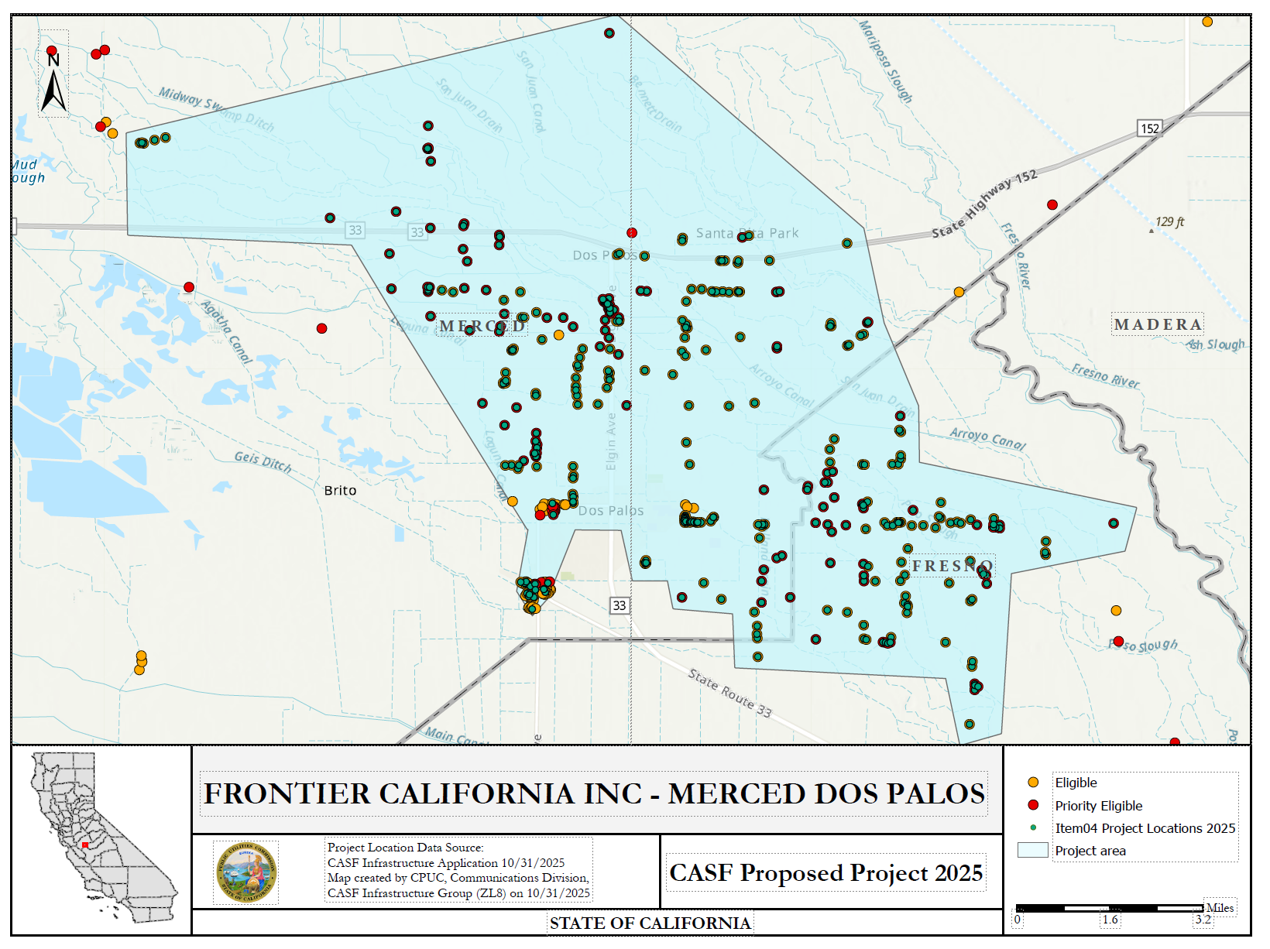

APPENDIX F

Frontier California Inc. – Plumas Greenville

Key Information

Project Name | Plumas Greenville
Project Plan | The project proposes to deploy Fiber-to-the-Home across one county to 187 unserved locations.
County | Plumas
Communities | Crescent Mills, Greenville and Taylorsville
Project Size | 53.32 square miles
Download / Upload speed | 7000 Mbps / 7000 Mbps
Median Household Income | $59,240
Pricing Plan (Monthly) Residential | 200/200 Mbps: $39.99  500/500 Mbps: $49.99  1000/1000 Mbps: $74.99  2000/2000 Mbps: $89.99  5000/5000 Mbps: $114.99  7000/7000 Mbps: $134.99
Affordability  (Monthly Low-Income Plan) | 200/200 Mbps: $20.00  Frontier has submitted a Tier 2 Advice Letter requesting authorization to participate in the California Lifeline Home Broadband Pilot program. Low-income customers who also participate in this program will pay $0.00.
Unserved Locations | 187
Subscriber take rate | 68%
High Fire Threat Districts | Yes
Deployment Schedule (from permit approval date) | 18 Months if CEQA-exempt  24 Months if not CEQA-exempt
Proposed Project Budget (Total) | $3,962,900
Grant Requested Amount | $3,451,686
CASF Grant Amount (100 percent) | $3,451,686
Cost per household | $18,458
Census Blocks | 060630004001019  060630004001051  060630004001054  060630004001055  060630004001058  060630004001060  060630004001165  060630004001168  060630004001169  060630004001172  060630004001174 | 060630004001175  060630004001189  060630004001203  060630004001204  060630004001207  060630004002000  060630004002001  060630004002002  060630004002003  060630004002004 | 060630004002014  060630004002019  060630004002020  060630004002026  060630004002029  060630004002030  060630004002179  060630004002181  060630004002184  060630004002185

APPENDIX G
Frontier California Inc. – Plumas Greenville Project
Project Location Map
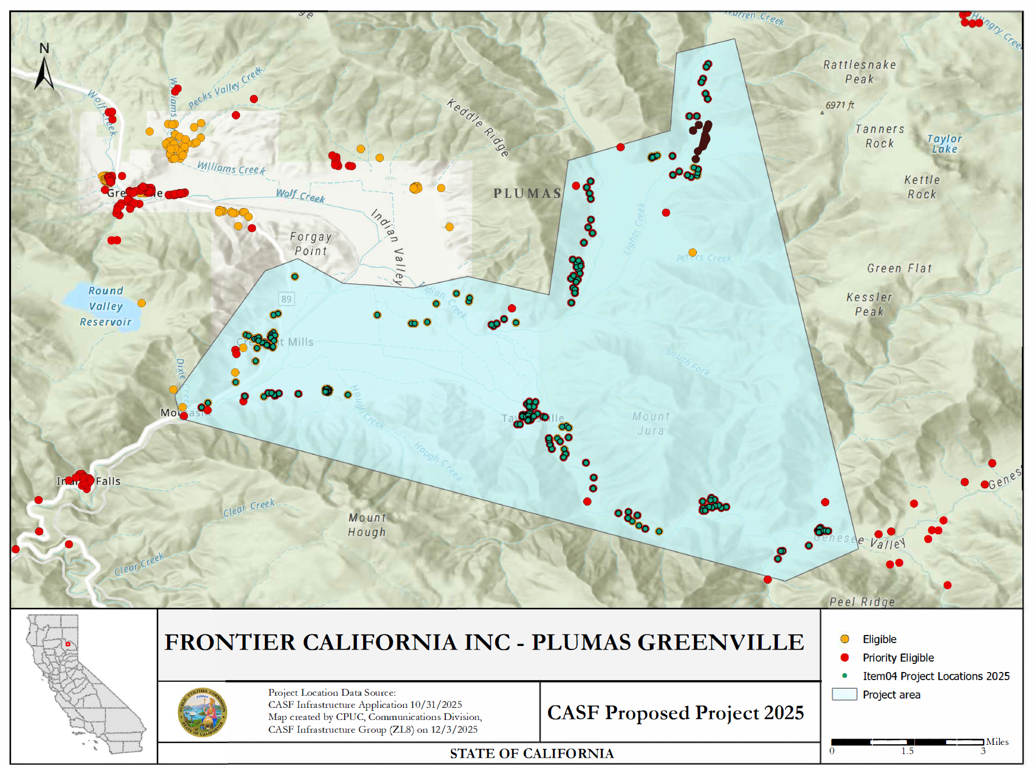

Project Name | Tulare Central
Project Plan | The project proposes to deploy Fiber-to-the-Home across one county to 114 unserved locations.
County | Tulare
Communities | Strathmore, Lindsay, Porterville, Visalia, and Exeter
Project Size | 65.29 square miles
Download / Upload speed | 7000 Mbps / 7000 Mbps
Median Household Income | $72,169
Pricing Plan (Monthly) Residential | 200/200 Mbps: $39.99  500/500 Mbps: $49.99  1000/1000 Mbp: $74.99  2000/2000 Mbps: $89.99  5000/5000 Mbps: $114.99  7000/7000 Mbps: $134.99
Affordability  (Monthly Low-Income Plan) | 200/200 Mbps: $20.00  Frontier has submitted a Tier 2 Advice Letter requesting authorization to participate in the California Lifeline Home Broadband Pilot. Low-income customers who also participate in this program will pay $0.00.
Unserved Locations | 114
Subscriber take rate | 50%
High Fire Threat Districts | No
Deployment Schedule (from permit approval date) | 18 Months if CEQA-exempt  24 Months if not CEQA-exempt
Proposed Project Budget (Total) | $6,325,305
Grant Requested Amount | $5,749,702
CASF Grant Amount (100 percent) | $5,749,702
Cost per household | $50,435
Census Blocks | 061070008022065  061070008022077  061070008022079  061070008022089  061070014001005  061070014001009  061070014001013  061070014001014  061070014001024  061070016023004  061070025002026  061070025002027  061070025002036  061070025002071  061070033011001  061070033011019 | 061070033011031  061070033011035  061070033011050  061070033011061  061070033011063  061070033011073  061070033011080  061070033013028  061070033013029  061070033021012  061070033021014  061070033021022  061070033021030  061070033022006  061070033022012  061070033011007 | 061070033022022  061070033022023  061070033022026  061070033022027  061070033022031  061070033022034  061070033022036  061070033022040  061070033022041  061070033023011  061070033023017  061070033023026  061070033023027  061070033023028  061070033023029

APPENDIX I

Frontier California Inc. – Tulare Central Project

Project Location Map
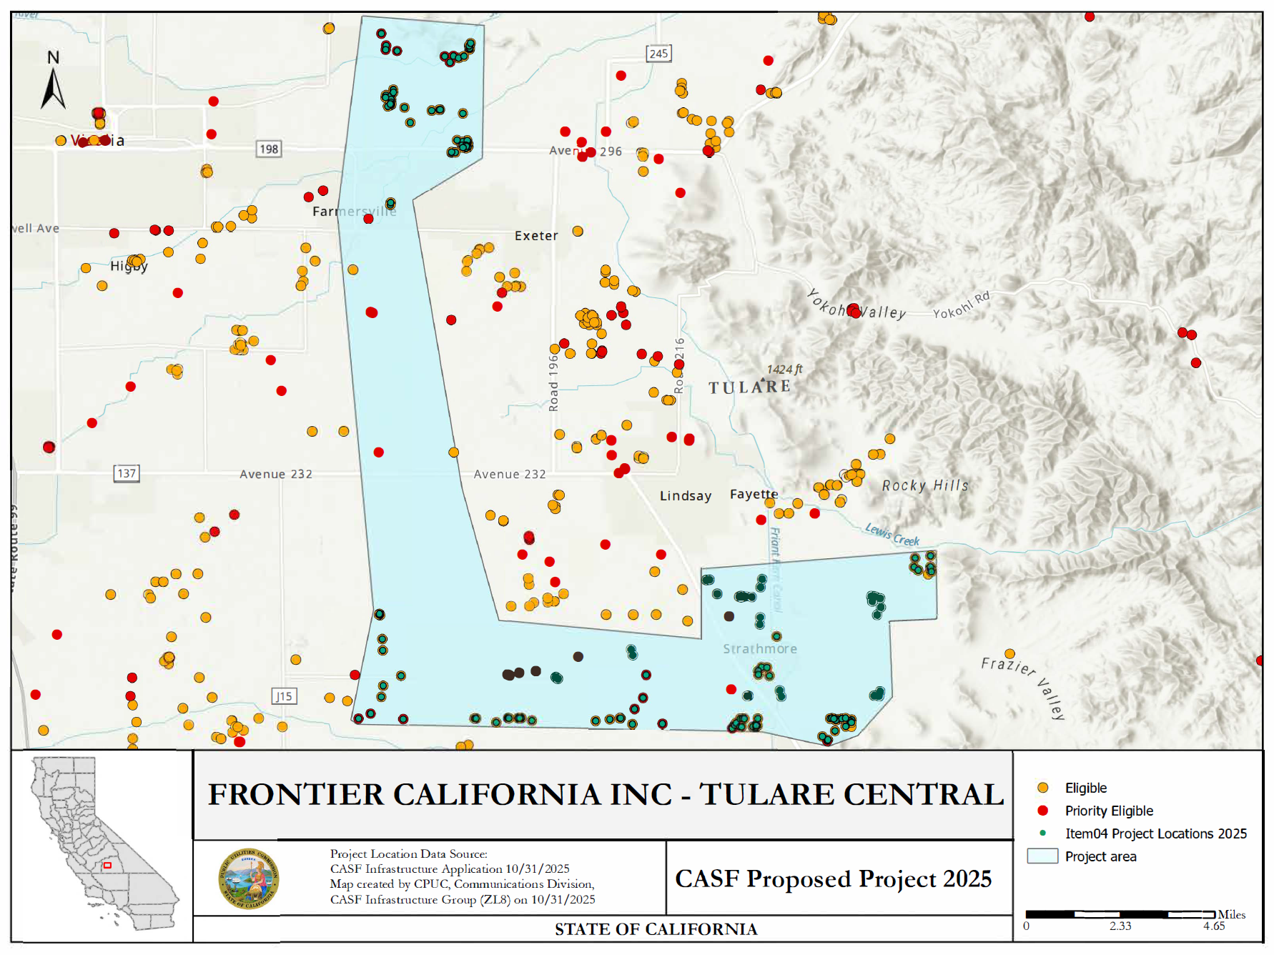

Public Utilities (Pub. Util.) Code § 281(f)(4).
See Bill Text - SB-1193 Telecommunications: universal service: California Advanced Services Fund.
See Bill Text - SB-156 Communications: broadband.
See Public Utilities (Pub. Util.) Code § 281(b)(1)(B)(ii)(I).
See Pub. Util. Code § 281(f)(5).
See Pub. Util. Code § 281(l).
See CASF Grantee Monthly Contractor Reporting.
See California Interactive Broadband Map.
See https://www.hcd.ca.gov/sites/default/files/docs/grants-and-funding/income-limits-2025.pdf. The project area also meets the definition of low-income as set forth in D.22-11-023 because the MHI is below 80 percent of the 2025 Statewide Median Income of $118,100, which is $94,480.
See D. 22-11-023, Attachment 1, § 8.11, Pricing Commitment.
See Special Flood Hazard Area (SFHA) | FEMA.gov and FEMA's National Flood Hazard Layer (NFHL) Viewer.
See https://www.hcd.ca.gov/sites/default/files/docs/grants-and-funding/income-limits-2025.pdf. The project area also meets the definition of low-income as set forth in D.22-11-023 because the MHI is below 80 percent of the 2025 Statewide Median Income of $118,100, which is $94,480.
See https://www.hcd.ca.gov/sites/default/files/docs/grants-and-funding/income-limits-2025.pdf. The project area also meets the definition of low-income as set forth in D.22-11-023 because the MHI is below 80 percent of the 2025 Statewide Median Income of $118,100, which is $94,480.
See https://www.cpuc.ca.gov/industries-and-topics/internet-and-phone/california-advanced-services-fund/casf-infrastructure-project-summaries for project summaries and https://www.cpuc.ca.gov/industries-and-topics/internet-and-phone/california-advanced-services-fund/casf-infrastructure-grant/casf-infrastructure-approved-projects for approved projects.
The Commission extended the CASF Infrastructure application deadline from April 1 to October 31, 2025, and all subsequent deadlines were moved back by six months.
See CASF Infrastructure Project Summaries at https://www.cpuc.ca.gov/industries-and-topics/internet-and-phone/california-advanced-services-fund/casf-infrastructure-project-summaries.
SB 156, enacted on July 20, 2021, and effective immediately, requires the Commission to fund projects that “deploy infrastructure capable of providing broadband access at a minimum of 100 Mbps downstream and 20 Mbps upstream.” See Pub. Util. Code § 281(f)(5).
Frontier agrees to change the Verizon Forward (VZ FWD) income eligibility threshold for customers in the Merced Dos Palos, Plumas Greenville, and Tulare Central project areas to match the CASF low-income threshold, which is based on the HCD Low Median Household Income (MHI) for the respective counties.
See D. 22-11-023, Attachment 1.
Administrative costs are defined as “indirect overhead costs attributable to a project, per generally accepted accounting principles (GAAP), and the direct cost of complying with Commission administrative and regulatory requirements related to the grant itself.” Applicants seeking additional funds will require a Commission exemption included in a draft resolution.
Frontier agrees to change the Verizon Forward (VZ FWD) income eligibility threshold for customers in the Merced Dos Palos, Plumas Greenville, and Tulare Central project areas to match the CASF low-income threshold, which is based on the HCD Low Median Household Income (MHI) for the respective counties.

