PUBLIC UTILITIES COMMISSION OF THE STATE OF CALIFORNIA

Date of Issuance: July 17, 2026  Communications Division | RESOLUTION T-17915  July 16, 2026
Broadband Video and Market Branch

R E S O L U T I O N

RESOLUTION T-17915: Approves up to $33,197,090 from the California Advanced Services Fund (CASF) for the Broadband Infrastructure Grant Account applications of Surfnet Communications, Inc., (U-7265-C) for the Santa Barbara Fiber and Central Coast Fiber Broadband projects in Santa Barbara, Monterey, Santa Clara, Santa Cruz, and San Luis Obispo Counties.

PROPOSED OUTCOME:

- Awards two grants for up to $33,197,090 from the CASF Infrastructure Funding Account to Surfnet Communications, Inc. in Santa Barbara, Monterey, Santa Clara, Santa Cruz, and San Luis Obispo counties.

SAFETY CONSIDERATIONS:

- There are no adverse safety considerations identified by the Communications Division. The projects to be funded by this award have the potential to improve communications resiliency and redundancy.

ESTIMATED COST:

- There are no costs associated with this Resolution.

- SUMMARY

This Resolution approves grant funding for two grants in the amount of up to $33,197,090 from the California Advanced Services Fund (CASF) Broadband Infrastructure Grant Account (Infrastructure Account) for the grant applications of Surfnet Communications, Inc. (Surfnet) for the Santa Barbara Fiber and Central Coast Fiber Broadband projects. The projects will provide broadband connectivity to a total of 1,293 unserved locations in Santa Barbara, Monterey, Santa Clara, Santa Cruz, and San Luis Obispo Counties.
This Resolution recommends two grant awards to one grantee: Surfnet. The following grant applications listed below in Table 1 are recommended for approval by the California Public Utilities Commission (Commission). Associated maps and project information summaries are included in the appendices.

Table 1: Summary of Grant Funding
Applicant | Project Name | Unserved Locations | Initial Requested Amount | Revised  Amount | CASF Approved Amount
Surfnet Communications, Inc. | Santa Barbara Fiber | 366 | $9,792,000 | $9,190,327 | $9,190,327
Surfnet Communications, Inc. | Central Coast Fiber Broadband | 927 | $24,976,000 | $24,006,763 | $24,006,763

- BACKGROUND

The CASF Infrastructure Account provides grant funding to Internet service providers (ISPs)/eligible entities to build or upgrade broadband infrastructure in areas that are unserved by existing broadband providers. The CASF program was initiated in 2008, after the program was first adopted by the Commission in Decision (D.) 07-12-054 and enacted into statute pursuant to Senate Bill (SB) 1193.

On July 20, 2021, Governor Newsom signed historic broadband legislation to help bridge the digital divide; Senate Bill (SB) 156 changed the definition of “unserved area,” allowing, but not requiring, funding for “an area for which there is no facility-based broadband provider offering at least one tier of broadband service at speeds of at least 25 Mbps downstream, 3 Mbps upstream.” Additionally, SB 156 requires grantees to “deploy infrastructure capable of providing broadband access at speeds of a minimum of 100 Mbps downstream and 20 Mbps upstream” and that any grantees receiving CASF funding must report subcontracted work in excess of $25,000; this information must be posted by the Commission on a monthly basis.

On November 17, 2022, the Commission issued D.22-11-023, adopting programmatic changes to the CASF Infrastructure Account. Attachment 1 of D.22-11-023 (CASF Guidelines) set forth the rules, application requirements, and guidelines for the CASF Infrastructure Account.

- APPLICATION REVIEW AND EVALUATION

Surfnet Communications, Inc. Background
On October 31, 2025, Surfnet submitted two CASF Infrastructure applications, requesting 100 percent funding for a total of $34,768,000, to deploy last-mile fiber-to-the-home (FTTH) broadband access to 1,459 unserved households in the counties of Santa Barbara, Monterey, Santa Clara, Santa Cruz, and San Luis Obispo.

The Surfnet Santa Barbara Fiber Project originally proposed 408 locations. Staff deemed 30 locations ineligible (served by Frontier) and upheld 12 challenged locations submitted by Frontier, resulting in a total reduction of 42 locations. On March 18, 2026, Surfnet revised its request, lowering the funding request to $9,190,327 and reducing the proposed locations to 366.

Surfnet’s Central Coast Fiber Broadband Project, originally called Four County Fiber, initially proposed 1,051 locations. Staff determined 2 locations were invalid because they were not within the project area. Staff deemed an additional 3 locations were previously funded by the Federal Funding Account (FFA) Grant Program previously awarded to Surfnet. In response to challenges by Ranch WiFi and Charter Communications, Staff upheld 119 of the challenged locations resulting in a total reduction of 124 locations. In light of the reduction in the number of locations, on May 14, 2026, Surfnet revised its application, changing the project name and lowering the funding request to $24,006,763 for a total of 927 project locations.

The total revised grant funding for the two projects is $33,197,090 to serve 1,293 locations. The CASF grant funding request will cover the complete project deployment costs of the two projects. The applicant determined eligibility for funding based on the California Interactive Broadband Map, which during the 2025 application cycle was based on 2023 mapping data. Because the evaluation and review period occurred while the Commission was collecting 2024 broadband location data, Staff verified eligibility using the more current 2024 dataset to ensure the eligibility of all locations are based on the most recent available data and to prevent the awarding of program funds in areas already served.

Surfnet, established in 2004, following the acquisition of SurfnetUSA, is a broadband Internet Service Provider (ISP) that connects California's Central Coast communities. Per Surfnet, the company’s emphasis is on providing broadband access to mountain and coastal communities that are unserved by major broadband carriers. Surfnet’s mission is to work directly with local residents in the Santa Barbara, Santa Cruz Mountains, North Monterey County, San Luis Obispo and Santa Clara areas. Surfnet benefits from over 70 years of cumulative experience in the ISP industry. The company is locally owned and operated and is committed to hiring from within the community and supporting local businesses.

Staff’s review and evaluation of the applications is summarized below.

- Santa Barbara Fiber

Project Summary
In compliance with D.22-11-023, Staff determined that the Santa Barbara Fiber Project is eligible to receive up to $9,190,327 in CASF Infrastructure Account grant funding.

Surfnet proposes to serve 366 unserved locations by constructing a FTTH network with up to 1,000 Megabits per second (Mbps) download and 1,000 Mbps upload in Santa Barbara County.

Challenges
Pursuant to Pub. Util. Code Section 281(f)(8) and as required by D.22-11-023, the Commission provided an opportunity for entities to challenge the application. Challenges were due on December 5, 2025.

Frontier submitted timely challenges to Surfnet’s Santa Barbara Fiber Infrastructure Account grant application. CASF Staff upheld 12 of Frontier’s challenged locations.

Revisions
Staff determined that the Santa Barbara Fiber Project does not overlap with other grant funded terrestrial broadband projects. Surfnet revised its application, reducing the number of project locations by 42 to account for ineligible locations and challenges upheld by Staff. Staff posted the revised Santa Barbara Fiber Project Summary on the Commission’s webpage on April 14, 2026.

Technology Deployment
Surfnet will deploy approximately 44.72 miles of last-mile fiber. The network infrastructure will be 97.4% aerial and 2.6% underground.
Median Household Income and Low-Income Service
The median household income (MHI) for the project area is approximately $162,200 which exceeds the Department of Housing and Community Development’s (HCD) low-income threshold by county. This data is calculated from the American Community Survey (ACS) and reflects the MHI at the census block group (CBG) level which results in an incomplete picture of the economic conditions. Despite the overall affluence of Santa Barbara County (where lower and higher income households are averaged together within the same CBG), localized analysis and data reveal substantial income and connectivity disparities within the project area. Rural valleys and agricultural communities across the Santa Ynez region continue to face limited or unreliable broadband options.

School district data further illustrates this disparity. Approximately 21% of students in
the Los Olivos Elementary School District and 31% of students in the College Elementary School District qualify for the National School Lunch Program, a commonly used indicator of low-income households. English Language Learner populations represent roughly 5% of students in Los Olivos Elementary School District and approximately 8% in the College Elementary School District. The Santa Ynez Valley is a designated AG-I (agricultural) zone; many working families in the agriculture industry earn substantially less than the county’s median household income. This project will serve a community with demonstrable income disparity and identifiable low-income populations within a high-cost region, supporting its alignment with CASF criteria for a “low-income area.”

This project will provide a low-income plan of $15 for speeds of 100 Mbps download and 20 Mbps upload. Connection charges will be waived for five years from completion of the project. To further reduce the burden on low-income residents, Surfnet intends to participate in the California Lifeline Home Broadband Pilot program upon completion of the Santa Barbara Fiber Project.

Safety Considerations
The proposed project enables the public to access the public safety benefits of reliable broadband infrastructure. The project is located in a Tier 2 Fire Zone.

Funding Determination
The proposed project will cost up to $9,190,327, of which the CASF account will fund 100% of costs.

Viability
CASF Staff determined that the applicant and the project are financially viable, and the applicant’s engineering design meets the program standards. The applicant, a recipient of multiple grants from both the CASF Infrastructure and Last Mile FFA programs, has demonstrated the administrative, technical, and operational capacity to provide broadband service at the scale of this project.

Surfnet received ten letters of support for the Santa Barbara Project from local government and community representatives, including the Santa Barbara County Association of Governments, EconAlliance, Santa Barbara County Board of Supervisors and Los Olivos Elementary School District. For more details, see Appendix F.

California Environmental Quality Act
Based on the information received, the Commission’s Energy Division has determined that the project meets the criteria for California Environmental Quality Act (CEQA) categorical exemption under 14 California Code of Regulation (C.C.R.) Section 15301 (Existing Facilities), Section 15303 (New Construction or Conversion of Small Structures), and Section 15304 (Minor Alterations to Land). Thus, the Santa Barbara Fiber project is categorically exempt from CEQA review, and the Commission may authorize funds for the construction activities.

- Central Coast Fiber Broadband

Project Summary
In compliance with D.22-11-023, Staff determined that Central Coast Fiber Broadband Project is eligible to receive up to $24,006,763 in CASF Infrastructure Account grant funding.

Surfnet proposes to serve 927 unserved locations by constructing a FTTH network with up to 1,000 Megabits per second (Mbps) download and 1,000 Mbps upload in Monterey, Santa Clara, Santa Cruz, and San Luis Obispo Counties.

Challenges
Pursuant to Pub. Util. Code Section 281(f)(8) and as required by D.22-11-023, the Commission provided an opportunity for entities to challenge the application. Challenges were due on December 5, 2025.

Ranch WiFi and Charter Communications submitted timely challenges to Surfnet’s Central Coast Fiber Broadband Infrastructure Account grant application. CASF Staff upheld 118 of Ranch WiFi’s challenged locations and one of Charter Communications’ challenged locations and directed Surfnet to reduce the number of proposed locations to reflect these upheld challenges.

Revisions
Staff determined that the Central Coast Fiber Project does not overlap with other grant- funded terrestrial broadband projects. However, Surfnet did revise the original application and removed the following: two locations outside of project area, 3 locations previously funded by the FFA, and 119 challenged locations for a total of 122. Staff posted the revised Central Coast Fiber Broadband Project summary on the Commission’s webpage on May 15, 2026.

Technology Deployment
Surfnet will deploy approximately 118 miles of last-mile fiber. The network infrastructure will be approximately 98% aerial and 2% underground.

Median Household Income and Low-Income Service
The Surfnet Central Coast Fiber Broadband Project MHI data, calculated by CBG, obfuscates significant intra-region disparities. The calculated MHI for the project area in Monterey County ($88,333) Santa Clara County ($123,312) and Santa Cruz County ($148,015) meets the low-income standard for a family of four as designated by the HCD list of state income limits by county. The MHI for San Luis Obispo County ($120,459) exceeds HCD’s low-income threshold for the area to be served by the project. See Table 2 for MHI calculation by CBG for each county.

Table 2: Central Coast Broadband Fiber Median Household Income by County
County | MHI Calculation by CBG (Project Areas) | HCD 2025 State Income Limits by County
Monterey | $88,333 | $115,700
Santa Clara | $123,312 | $159,550
Santa Cruz | $148,015 | $158,700
San Luis Obispo | $120,459 | $111,300

However, analysis by Staff revealed economic disparities within San Luis Obispo County including in several school districts within the county. According to 2025-2026 Unified School District data, 72.6% of students in the Paso Robles Joint Unified School District, 37.4% in the Templeton Unified School District, 69.7% in the Shandon Joint Unified School District, and 69.4% in the San Miguel Joint Union School District are eligible for free or reduced-price meals, a commonly used indicator of economic hardship. Overall, the four counties included in Surfnet’s Central Coast Fiber Broadband project contain both affluent and low-income households, where historically underserved communities continue to face significant barriers to affordable and reliable broadband access.

This project will provide a low-income plan of $15 for speeds of 100 Mbps download and 20 Mbps upload. Connection charges will be waived for five years from completion of the project. To further reduce the burden on low-income residents, Surfnet intends to participate in the California Lifeline Home Broadband Pilot program upon completion of the Central Coast Fiber Broadband Project.

Safety Considerations
The proposed project enables the public to access the public safety benefits of reliable broadband infrastructure.

Funding Determination
The proposed project will cost up to $24,006,763, of which the CASF account will fund 100% of costs.

Viability
CASF Staff determined that the applicant and the project are financially viable, and the applicant’s engineering design meets the program standards. Surfnet, a recipient of both CASF and FFA grants, demonstrated the administrative, technical, and operational capacity to provide broadband service at the scale of this project.

Surfnet received 23 letters of support: one letter of support for the Central Coast Fiber Broadband Project from the Member of Congress, 24th District, California, one letter from the County of Santa Cruz, Information Services Dept., one from the First District Supervisor, County of Santa Cruz Board of Supervisors, two from Assemblymember’s, Assembly California Legislature, 28th and 30th Districts, one from President and CEO of the California Emerging Technology Fund, one from United States House of Representatives, 19th Congressional District, and 12 from local residents. For more details, see Appendix I.

California Environmental Quality Act
Based on the information received, the Commission’s Energy Division has determined that this project has not met the requirements of CEQA categorical exemption at this time. Surfnet must comply with the CEQA requirements discussed in the appendices. If Surfnet provides additional documentation demonstrating that the project qualifies for a CEQA exemption, then the project can be exempted by letter from the Communications Division Director or the director’s delegate or designee.

- NOTICE

On October 31, 2025, the Communications Division (CD) received 41 grant applications for CASF Infrastructure Account funding. On November 14, 2025 Staff posted all the proposed project area maps and project summaries for the Santa Barbara Fiber and Central Coast Fiber Broadband projects on the Commission’s CASF Infrastructure Project Summaries webpage and sent notice regarding the project to the CASF Distribution and Service Lists.

Pursuant to Public Utilities Code Section 281(f)(8) and as required by D.22-11-023, the Commission provided an opportunity for entities to challenge the application. Challenges were due on December 5, 2025.

- COMMENTS

In compliance with Public Utilities Code Section 311(g), a notice letter was emailed on June 12, 2026 informing all parties on the CASF Distribution List of the availability of the draft of this Resolution for public comments at the Commission’s documents website at http://www.cpuc.ca.gov/documents/. This letter also informed parties that the final conformed Resolution adopted by the Commission will be posted and available on the same website. The Commission received no comments.

- FINDINGS

- On October 31, 2025, Surfnet Communications, Inc. (Surfnet) submitted two grant applications for California Advanced Services Fund (CASF) funding for its Santa Barbara Fiber and Central Coast Fiber Broadband projects to deploy last-mile broadband infrastructure to enable Fiber-to-the-Home service at speeds of up to 1 gigabit per second (Gbps) symmetrical to a total of 1,459 eligible locations in Santa Barbara, Monterey, Santa Clara, Santa Cruz, and San Luis Obispo Counties.

- On November 14, 2025, Staff posted all the proposed project area maps and project summaries for the Santa Barbara Fiber and Central Coast Fiber Broadband projects on the Commission’s CASF Infrastructure Project Summaries webpage. On April 14, 2026, Staff posted the revised Santa Barbara Fiber Project and on May 15, 2026, Staff posted Central Coast Fiber summaries on the Commission’s webpage.

- Staff received challenges from Frontier, Ranch WiFi and Charter Communications to the Santa Barbara Fiber and Central Coast Fiber Broadband projects. CASF Staff upheld 12 of Frontier’s challenged locations to the Santa Barbara Fiber project, 118 of Ranch WiFi’s challenged locations, and one of Charter Communications challenged locations to the Central Coast Fiber Project.

- Based on its review, Staff determined that the two Surfnet projects qualify for Infrastructure Account grants pursuant to D.22-11-023 and its Attachment 1 and recommends Commission approval of total CASF funding of up to $33,197,090.

- Surfnet proposes offering broadband-speed internet, using Fiber-to-the-Home (FTTH) technology at speeds up to 1 Gbps download and 1 Gbps upload to last-mile consumers.

- Surfnet will secure joint-pole agreements with utility pole owners where needed to deploy broadband infrastructure on existing utility poles for both Surfnet projects.

- The Commission has determined that the Surfnet Communications, Inc. Santa Barbara Fiber project is exempt from California Environmental Quality Act (CEQA) review pursuant to 14 California Code of Regulation (C.C.R.) Section 15301 (Existing Facilities), Section 15303 (New Construction or Conversion of Small Structures), and Section 15304 (Minor Alterations to Land). Surfnet’s Central Coast Fiber Broadband project is not exempt from California Environmental Quality Act at this time and is still under review.

- A notice letter was emailed on June 12, 2026, informing all parties on the CASF Distribution List of the availability of the draft of this Resolution for public comments at the Commission’s documents website at http://www.cpuc.ca.gov/documents/.

- The Commission received no comments.

THEREFORE, IT IS ORDERED that:

- The Commission shall award up to $9,190,327 in CASF Broadband Infrastructure Grant Account funds to Surfnet for the Santa Barbara Project as described herein and summarized in the appendices of this Resolution.

- The Commission shall award up to $24,006,763 in CASF Broadband Infrastructure Grant Account funds to Surfnet for the Central Coast Fiber Broadband Project as described herein and summarized in the appendices of this Resolution.

- Surfnet shall comply with all guidelines, requirements and conditions associated with a CASF award, as specified in D.22-11-023 and its Attachment 1, and all requirements for this project included in this Resolution, including Appendices A through I.

- If Surfnet fails to complete the project in accordance with the CASF guidelines and requirements outlined in D.22-11-023 and its Attachment 1, and the terms outlined in this Resolution, Surfnet must reimburse some or all the CASF funds that it has received.

- If Staff evaluation finds the Surfnet Central Coast Project exempt from the California Environmental Quality Act (CEQA), the project can be exempted by letter from the Communications Division Director or the director’s delegate or designee.

- The Commission cannot release funds for construction activities for the Surfnet Central Coast Project until CEQA review is complete. Funds for preconstruction activities such as permitting and CEQA compliance may be awarded prior to commencement of construction. The awardee must comply with the requirements set forth in the CEQA Section of the Resolution. The awardee must provide their Proponent’s Environmental Assessment for each project prior to the first payment.
- Surfnet must complete and execute the consent forms (to be sent to the grantee after this Resolution is adopted) agreeing to the conditions set forth in this Resolution and return to CASF Staff within 30 calendar days from the date of the adoption of this Resolution. Failure to submit the consent form within 30 calendar days from the adoption date of this Resolution may result in the Commission voiding the grant award.

This resolution is effective today.

The foregoing resolution was duly introduced, passed and adopted at a conference of the California Public Utilities Commission of the State of California held on July 16, 2026, the following Commissioners voting favorably thereon:
/s/LEUWAM TESFAI
Leuwam Tesfai
Executive Director
JOHN REYNOLDS
President
DARCIE L. HOUCK
CHRISTINE HARADA
KAREN DOUGLAS
MATTHEW BAKER
Commissioners

Dated July 16, 2026, at San Francisco, California

APPENDIX A

Compliance Requirements

- Deployment Schedule
All CEQA-exempt projects must be completed within 18 months, and all other projects shall be completed within 24 months after receiving authorization to construct. If the grantee is unable to complete the proposed project within the 18-month or 24-month timeframe requirements, the grantee must notify the Director of the Communications Division as soon as the grantee becomes aware of this possibility. If such notice is not provided, the Commission may reduce payment for failure to satisfy this requirement of timely notification to the Director.

- Execution and Performance
Staff and awardee shall determine a project start date after the CASF grant recipient has obtained all approvals, including permits. Should the grantee or any contractor it retains fail to commence work by the designated date, upon five days’ written notice the Commission may terminate the grant. If the grantee fails to complete the project in accordance with the terms of Commission approval as set forth in this resolution, the awardee shall reimburse some or all of the CASF funds that it has received. The grantee must complete all construction covered by the grant on or before the grant’s termination date.

C. Minimum Performance Criteria

 | CASF Performance Criteria | Proposed Projects
Project Completion | CEQA-exempt projects must be completed within 18 months, and all other projects shall be completed within 24 months after receiving authorization to construct | Within 18 months of permitting approval (CEQA Exempt)
Pricing | Prices committed for five years after completion of the project | 5-year commitment
Speed | At least 100/20 Mbps | 100 Mbps / 20 Mbps
Latency | Maximum of 100 ms of latency | < 100 ms
Data Caps | Minimum of 190 GBs per month | No data cap
Affordability | Must offer low-income plan | $15.00/month

D. Letter of Credit
The Commission exempts Certificate of Public Convenience and Necessity (CPCN) holders from providing a letter of credit, on the basis that the company submitted a performance bond to the Commission to maintain its CPCN and that the Commission has other means to enforce compliance. In its application, Surfnet provided proof of CPCN registration and thus is exempt from the requirement of providing a letter of credit.

E. Project Audit
The Commission has the right to conduct any necessary audit, verification, and discovery during project implementation/construction to ensure that CASF funds are spent in accordance with Commission approval.

Grantee invoices may be subject to a financial audit by the Commission at any time within three years of completion of the work.

F. Providing Voice Service
Surfnet established a strategic partnership with RingCentral, a leading provider of cloud-based voice solutions. This partnership enables Surfnet to offer voice services to its customers indirectly, ensuring access to communication methods that meet stringent safety standards. RingCentral's voice services meet and often exceed FCC standards, providing E-911 service to all customers. In addition, RingCentral's voice over internet protocol (VoIP) services features battery back-up capabilities.

G. Reporting
All grantees must submit biannual progress reports on the status of the project, irrespective of whether grantees request reimbursement or payment. These reports are due semi-annually, in March and September, until the project is completely built and operational. Progress reports shall describe the schedule for deployment, major construction milestones and costs submitted in the proposal; indicate the actual date of completion of each task/milestone as well as problems and issues encountered, and the actions taken to resolve these problems and issues during project implementation and construction; and identify future risks to the project.

Before full payment of the project is made, grantees must submit a project completion report. Grantees shall also include test results on the download and upload speeds at a representative sample of locations in the final completion report, per CASF Guidelines, Section 13: Reporting Requirements. Grantees must certify that each progress report is true and correct under penalty of perjury.
H. Prevailing Wage
Section 1720 of the California Labor Code specifies that CASF-subsidized projects are subject to prevailing wage requirements. Grantees committed to following state prevailing wage requirements with regards to these projects.

I. Contractor Reporting
Grantees must comply with the contractor reporting requirements of Section 281(l)(1) of the California Public Utilities Code, which requires reporting of certain information for all contractors and subcontractors undertaking a contract or subcontract in excess of twenty-five thousand dollars on CASF-subsidized projects.

APPENDIX B

Payments to CASF Recipients

Pub. Util. Code Section 281(f)(10) defines the costs the Commission may reimburse as follows:

- Costs directly related to the deployment of infrastructure;
- Costs to lease access to property or for Internet backhaul services for a period not to exceed five years; and
- Costs incurred by an existing facility-based broadband provider to upgrade its existing facilities to provide for interconnection.

Additionally, D.22-11-023, Attachment 1, Section 7 caps administrative expenses directly related to the project at 10 percent of the grant amount.

The grantee may submit reimbursement requests at the following intervals:
- 10 percent completion;
- 35 percent completion;
- 60 percent completion;
- 85 percent completion; and
- 100 percent completion.

The final 15 percent payment request (from 85 to 100 percent) will not be paid without an approved completion report. Payments are based on submitted receipts, invoices and other supporting documentation showing expenditures incurred for the project in accordance with the approved CASF funding budget included in the CASF grantee’s application.

Payment to grantees shall follow the process adopted for funds created under Public Utilities Code Section 270. The Commission generally processes payments within 20-25 business days, including Communications Division and Administrative Services review time. The State Controller’s Office (SCO) requires an additional 14-21 days to issue payment from the day that requests are received by SCO from Administrative Services. The project is funded at 100%, CASF will not accept invoices that include a handling fee.

APPENDIX C

California Environmental Quality Act Requirements

Santa Barbara Fiber project

The Santa Barbara Fiber Project was subject to California Environmental Quality Act (CEQA) review and determined to be Categorically exempt.

The project is located in Santa Barbara County, near the unincorporated communities of Los Olivos and Santa Ynez. Surfnet Communications, Inc. provided the Commission with its project plans to place 230,000 feet of aerial fiber on existing SoCal Edison and Frontier utility poles under joint-use agreements. Where aerial placement is not feasible, approximately 6,104 feet of underground conduit will be installed through directional boring or trenching. Power equipment and passive optical networking devices will be housed in newly installed equipment cabinets. No project infrastructure will be placed in new rights-of-way or previously undisturbed ground. Following the completion of construction activities, Surfnet Communications, Inc. will return the site to its original condition.

Based on the information that Surfnet provided, the Commission’s Energy Division has confirmed that the project meets the criteria for the CEQA categorical exemptions under 14 California Code of Regulation (C.C.R.) Section 15301 (Existing Facilities), Section 15303 (New Construction or Conversion of Small Structures) and Section 15304 (Minor Alterations to Land). Thus, Surfnet’s Santa Barbara Fiber Project is categorically exempt from CEQA review, and the Commission may authorize funds for construction activities.

Central Coast Fiber Broadband project

The Central Coast Fiber Project is subject to California Environmental Quality Act (CEQA) review:

The Commission must complete CEQA review prior to disbursing CASF funds for construction activities. The initial funding granted in this Resolution may be used for project development and other Surfnet activities that do not involve construction or any activities that would have any direct or indirect effect on the physical environment. Prior to any construction activity for the project, Surfnet is required to seek further authority from the Commission for such activity by filing a Proponent’s Environmental Assessment (PEA), pursuant to Commission Rule of Practice and Procedure 2.4; and must undergo an environmental review pursuant to CEQA (California Public Resources Code § 21000 et seq.).

Surfnet should contact the Supervisor of the Commission’s Energy Division Infrastructure Planning and CEQA Section well in advance of a contemplated filing to (a) consult with Staff regarding the process of developing and filing a PEA; (b) provide for cost recovery per Rule of Practice and Procedure 2.5; and (c) enter into a Memorandum of Understanding to allow the Energy Division to initiate the retention of an environmental contractor to perform the environmental review. Surfnet must provide a PEA prior to the first payment. The Commission cannot release funds for the construction phase of this project until the Commission has completed CEQA review.

APPENDIX D

Surfnet Communications, Inc. – Santa Barbara Fiber

Key Information
Project Name | Santa Barbara Fiber
Project Plan | The project proposes to deploy FTTH across Santa Barbara County to 366 unserved locations.
County | Santa Barbara
Communities | Santa Ynez
Project Size | 13.24 square miles
Download / Upload speed | 1,000 Mbps / 1,000 Mbps
Median Household Income | $162,200
Pricing Plan (Monthly) Residential | 100 Mbps Symmetrical Standard Plan (100/100 Mbps): $50  300 Mbps Symmetrical Standard Plan (300/300 Mbps): $80  1000 Mbps Symmetrical Standard Plan (1000/1000 Mbps): $130
Affordability  (Low Income Plan) | 100/20 Mbps: $15  Surfnet intends to participate in the California Lifeline Home Broadband Pilot program
Unserved Locations | 366
Subscriber take rate | 54%
High Fire Threat Districts | Yes
Deployment Schedule (from permit approval date) | 18 Months
Proposed Project Budget (Total) | $9,190,327
Original Grant Request | $9,792,000
CASF Grant Amount (100 percent) | $9,190,327
Cost per household | $25,110
Census Blocks | 060830018001228  060830019051008  060830019051010  060830019051011  060830019051014  060830019051013  060830019051024  060830019051025  060830019051026  060830019051027 | 060830019051042  060830019051043  060830019051047  060830019051050  060830019051053  060830019051055  060830019051058  060830019051059  060830019051060  060830019051062 | 060830019051067  060830019051068  060830019051069  060830019051071  060830019051072  060830019051073  060830019053000  060830019051035  060830019051028  060830019051030 | 060830019053001  060830019053002  060830019053003  060830019053004  060830019053010  060830019053011  060830019053013

APPENDIX E

Surfnet Communications, Inc. – Santa Barbara Fiber
Project Location Map
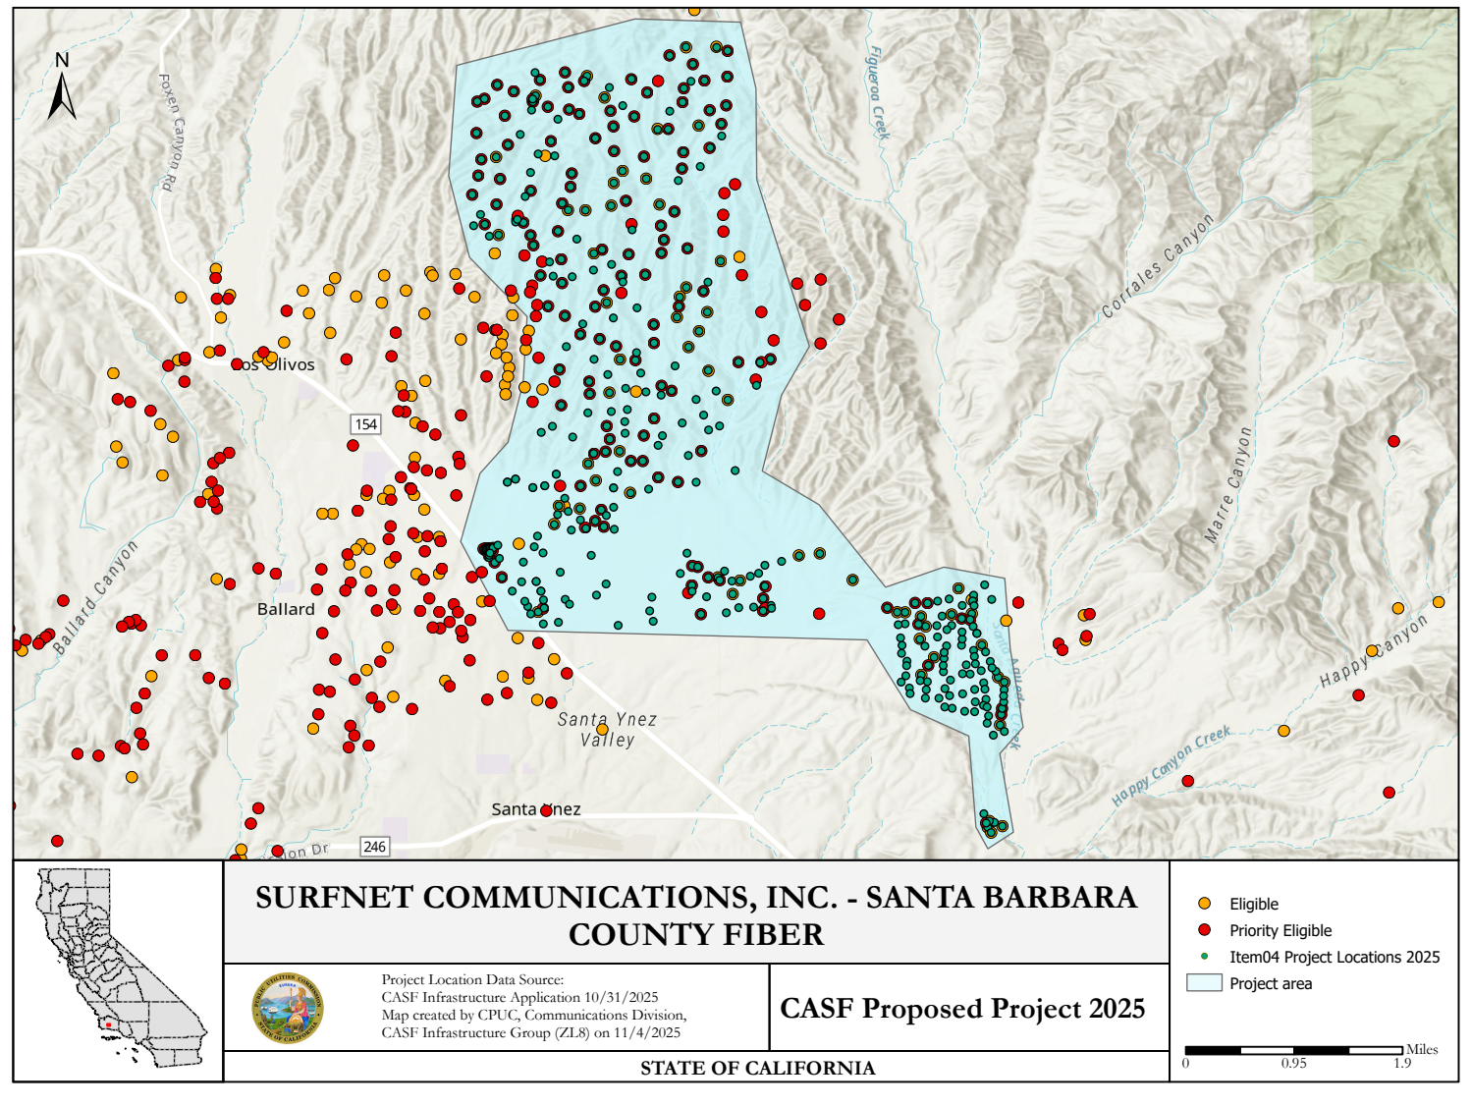
APPENDIX F

Surfnet Communications, Inc. – Santa Barbara Fiber

Community Supporters

- Marjie Kirn, Santa Barbara County Association of Governments
- Laurie Tamura, Board President, EconAlliance
- Laura Capps, Chair, Santa Barbara County Board of Supervisors
- Sunne Wright McPeak, President and CEO, CETF
- Ray Vazquez, Superintendent/Principal, Los Olivos Elementary School District
- Joan Hartmann, Third District Supervisor, County of Santa Barbara
- Shelby Arthur, Tri-County Lead, Broadband Consortium Pacific Coast
- Dr. Kimberly Sheehan, Santa Ynez Valley Union High School District
- Michael Foote, Director of Economics Development, REACH
- Salud Carbajal, Member of Congress

APPENDIX G

Surfnet Communications, Inc. – Central Coast Fiber Broadband

Key Information
Project Name | Central Coast Fiber Broadband
Project Plan | The project proposes to deploy FTTH across Monterey, Santa Clara, Santa Cruz, and San Luis Obispo Counties to 927 unserved locations.
County | Monterey, Santa Clara, Santa Cruz, and San Luis Obispo
Communities | Creston, Los Gatos, Paso Robles, San Miguel, Scotts Valley, Templeton, and surrounding communities
Project Size | 111.71 square miles
Download / Upload speed | 1,000 Mbps / 1,000 Mbps (FTTH)
Median Household Income | Monterey $88,333  Santa Clara $123,312  Santa Cruz $148,015  San Luis Obispo $120,459
Pricing Plan (Monthly) Residential | 100 Mbps Symmetrical Standard Plan (100/100 Mbps): $50  300 Mbps Symmetrical Standard Plan (300/300 Mbps): $80  1000 Mbps Symmetrical Standard Plan (1000/1000 Mbps): $130
Affordability  (Low Income Plan) | 100/20 Mbps: $15  Surfnet intends to participate in the California Lifeline Home Broadband Pilot program
Unserved Locations | 927
Subscriber take rate | 86%
High Fire Threat Districts | No
Deployment Schedule (from permit approval date) | 18 Months
Proposed Project Budget (Total) | $24,006,763
Original Grant Request | $24,976,000
CASF Grant Amount (100 percent) | $24,006,763
Cost per household | $25,897
Census Blocks | 060290045002522  060530114001404  060530114001433  060530114001434  060530114001435  060530114001436  060530114001437  060530114001459  060790102022000  060790103012036  060790103012037  060790103012039  060790103012059  060790103012060  060790103012160  060790103012161  060790103012162  060790103012163  060790103012164  060790103012165  060790103012174  060790103012178  060790103012179  060790103012184  060790103012188  060790103012191  060790103012193  060790103012200  060790103012218  060790103012219  060790103012220 | 060790103012223  060790103013024  060790103021000  060790103021012  060790103021013  060790103021015  060790103021018  060790103021019  060790103021020  060790103021021  060790103021023  060790103021025  060790103021042  060790103021056  060790103021058  060790103021059  060790103021060  060790103021061  060790103021062  060790103021068  060790103021069  060790103021070  060790103022019  060790103022041  060790103022042  060790103022044  060790103022048  060790103022050  060790103022051  060790103022052  060790103022053  060790103022054 | 060790103031000  060790103031016  060790103032044  060790103032045  060790103032048  060790103032051  060790103032053  060790103032054  060790103032055  060790103032056  060790103032057  060790103032062  060790103032065  060790103032075  060790103032083  060790103032084  060790103032085  060790103032099  060790103032100  060790103032101  060790103032102  060790103032103  060790103032104  060790103032105  060790103032106  060790103032115  060790103032126  060790103032132  060790123051015  060790131001000  060790131001002 | 060790131001003  060790131001011  060790131001012  060790131001013  060790131001014  060790131001024  060790131001025  060790131001026  060790131001027  060790131001028  060790131002000  060790131002001  060790131002002  060790131002003  060790131002004  060790131002005  060790131002015  060790131002016  060790131002027  060855118003046  060871205001007  060871205002025  060871205002032  060871205003003  060871205003004  060871205003006  060871205003009  060871205003014  060871205003021  060871205003064  060871210001001  060871210001010  060871210001012  060871210002011

APPENDIX H

Surfnet Communications, Inc. – Central Coast Fiber Broadband
Project Location Map

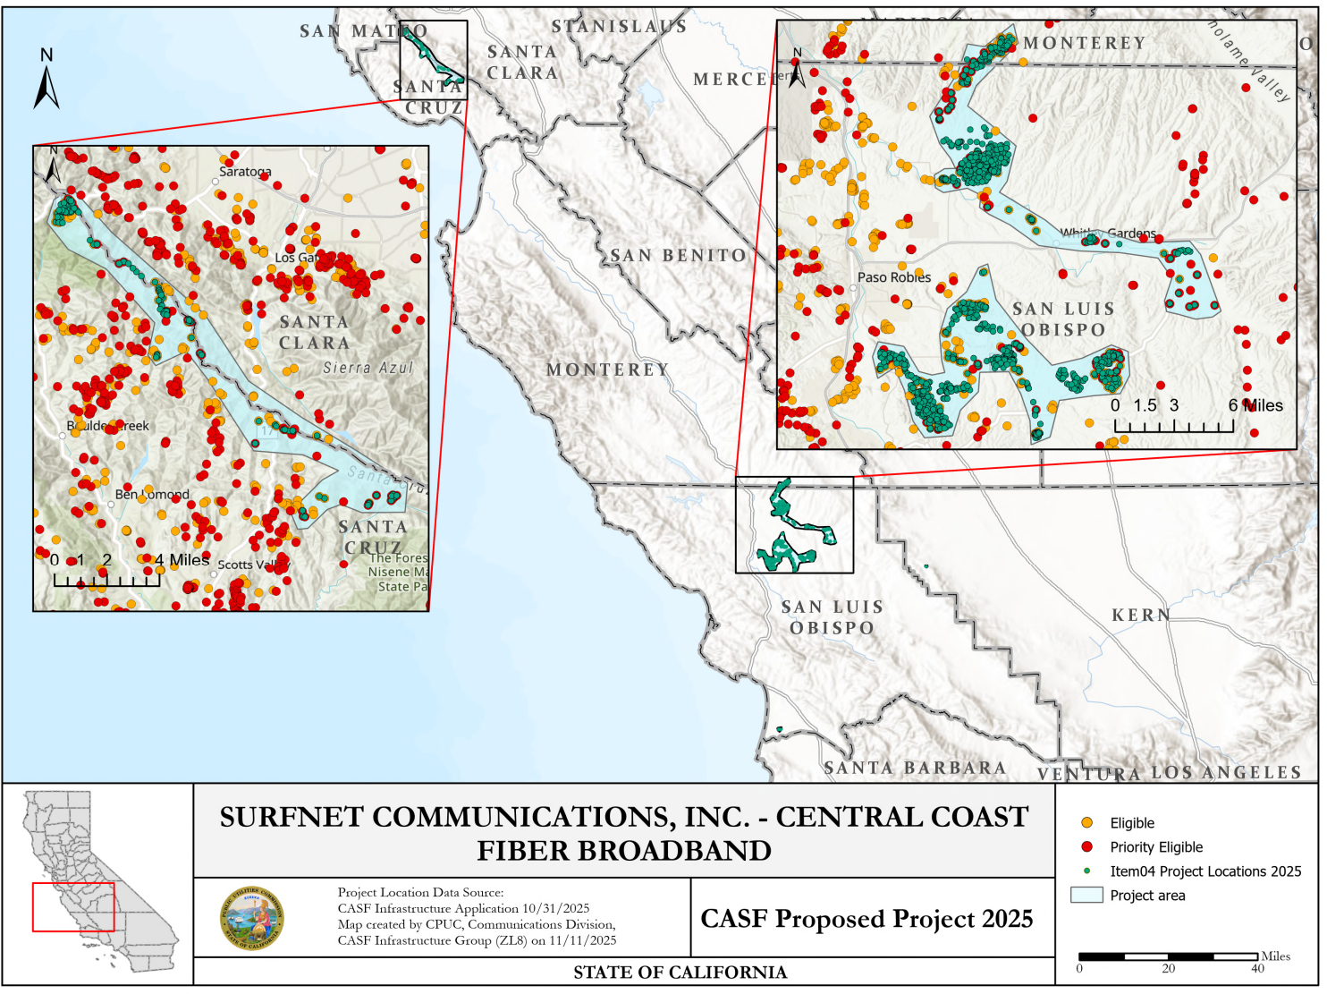

APPENDIX I

Surfnet Communications, Inc. - Central Coast Fiber Broadband

Community Supporters

- Salud O. Carbajal, Member of Congress, 24th District, California Congressional Representative of Santa Barbara, San Luis Obispo and Ventura Counties
- Jimmy Panetta, U.S. Representative, 19th Congressional District, United States House of Representatives
- Gail Pellerin, Assemblymember, 28th District, Assembly California Legislature
- Dawn Addis, Assemblymember, 30th District, Assembly California Legislature
- Tammie Weigl, IT Director, County of Santa Cruz, Information Services Dept.
- Sanjay Khandelwal, Board President, California Broadband Alliance
- Tahar Goraya, MA, MPA, President and CEO, Central Coast Broadband Consortium, Monterey Bay Economic Partnership
- Shelby Arthur, Broadband Consortium Pacific Coast
- Manu Koenig, First Director Supervisor, Santa Cruz County Board of Supervisors
- James Hackett, Chief Operating Officer, Cruzio Internet
- Sunne Wright McPeak, President and CEO, California Emerging Technology Fund
- An additional 12 letters of support from local residents throughout the Monterey, Santa Clara, Santa Cruz and San Luis Obispo Counties

Public Utilities (Pub. Util.) Code § 281(b)(1)(B)(ii)(I).
Pub. Util. Code § 281(f)(5)
Pub. Util. Code § 281(l).
California Interactive Broadband Map available at https://www.broadbandmap.ca.gov/
https://www.hcd.ca.gov/sites/default/files/docs/grants-and-funding/income-limits-2025.pdf
These school districts serve the project area but are not Surfnet’s Santa Barbara Fiber Project polygon.
Data derived from: https://www.cde.ca.gov/ds/ad/documents/frpm2526.xlsx
https://www.cde.ca.gov/sdprofile/details.aspx?cds=42692450000000
https://www.cde.ca.gov/sdprofile/details.aspx?cds=42691790000000
https://www.countyofsb.org/944/Santa-Ynez-Valley-Planning-Area
Lowest Earning Industry Cluster according to Santa Barbara State of the Workforce Report dated September, 2024.
See D. 22-11-023, Attachment 1, §8.11, Pricing Commitment
California Department of Housing and Community Development | California Department of Housing and Community Development
EdData - District Profile - Paso Robles Joint Unified
EdData - District Profile - Templeton Unified
EdData - District Profile - Shandon Joint Unified
EdData - District Profile - San Miguel Joint Union
See D. 22-11-023, Attachment 1, §8.11, Pricing Commitment
See https://www.cpuc.ca.gov/industries-and-topics/internet-and-phone/california-advanced-services-fund/casf-infrastructure-project-summaries for project summaries and https://www.cpuc.ca.gov/industries-and-topics/internet-and-phone/california-advanced-services-fund/casf-infrastructure-grant/casf-infrastructure-approved-projects for approved projects.
The Commission extended the CASF Infrastructure application deadline from April 1 to October 31, 2025, and all subsequent deadlines were moved back by six months.
See CASF Infrastructure Project Summaries at https://www.cpuc.ca.gov/industries-and-topics/internet-and-phone/california-advanced-services-fund/casf-infrastructure-project-summaries
SB 156, enacted on July 20, 2021, and effective immediately, requires the Commission to fund projects that “deploy infrastructure capable of providing broadband access at a minimum of 100 Mbps downstream and 20 Mbps upstream.” See Pub. Util. Code § 281(f)(5).
See D. 22-11-023, Attachment 1.
Administrative costs are defined as “indirect overhead costs attributable to a project, per generally accepted accounting principles (GAAP), and the direct cost of complying with Commission administrative and regulatory requirements related to the grant itself.” Applicants seeking additional funds will require a Commission exemption included in a resolution.

