ALJ/ABT/nd3 Date of Issuance 8/20/2026

Decision 26-08-011 August 13, 2026

BEFORE THE PUBLIC UTILITIES COMMISSION OF THE STATE OF CALIFORNIA

Application of San Diego Gas & Electric Company (U-902M) and Southern California Gas Company (U-904G) for an Exemption Pursuant to Section 853 of the Public Utilities Code with Respect to the Creation of an Intermediate Holding Company, or Alternatively, for an Order Finding that the Proposed Transaction Does Not Constitute an Activity Subject to Section 854. | Application 25-05-020

DECISION GRANTING PROPOSED TRANSACTION WITH RESPECT
TO THE CREATION OF AN INTERMEDIATE HOLDING COMPANY

TABLE OF CONTENTS
Title Page
DECISION GRANTING PROPOSED TRANSACTION WITH RESPECT TO THE CREATION OF AN INTERMEDIATE HOLDING COMPANY 1
Summary 2
1. Background 2
2. Jurisdiction 6
3. Issues Before the Commission 6
4. Discussion of Proposed Transaction with Respect to the Creation of an Intermediate Holding Company 7
4.1. Applicability of Section 854 7
4.2. Consideration of Public Interest Factors in Section 854 11
4.2.1. No Adverse Impact on Rates, Service, or Operations 11
4.2.2. Financial Structure and Risk to Ratepayers 13
4.2.3. Regulatory Oversight and Affiliate Transactions 15
4.2.4. Workforce Impacts 16
4.2.5. Balancing Benefits and Risks 17
4.2.6. Conclusion 18
4.3. Impacts on Environmental and Social Justice Communities 18
5. Summary of Public Comment 21
6. Conclusion 21
7. Procedural Matters 23
8. Waiver of Comment Period 23
9. Assignment of Proceeding 23
Findings of Fact 23
Conclusions of Law 24
ORDER 25

DECISION GRANTING PROPOSED TRANSACTION WITH RESPECT
TO THE CREATION OF AN INTERMEDIATE HOLDING COMPANY

Summary
This decision addresses Application 25-05-020, filed by San Diego Gas & Electric Company (SDG&E) and Southern California Gas Company (SoCalGas) (jointly, Applicants), seeking approval of a proposed internal corporate reorganization involving the creation of Sempra California, LLC as an intermediate holding company. Based on the record developed in this proceeding, we find that the proposed transaction is a limited internal corporate reorganization that does not transfer ownership or control of SDG&E or SoCalGas to a third party, does not affect utility rates, service, operations, workforce, or management, and does not impair the Commission’s ability to regulate the utilities.
We find that application of the review requirements of Section 854 is not necessary in the public interest under the circumstances presented, and we grant Applicants’ request for an exemption pursuant to Section 853(b), subject to the conditions adopted in this decision.
This proceeding is closed.

Background
On May 30, 2025, San Diego Gas & Electric Company (SDG&E) and Southern California Gas Company (SoCalGas) (jointly, Applicants) filed Application (A.) 25-05-020 seeking an exemption pursuant to Public Utilities Code Section 853 with respect to the creation of an intermediate holding company, Sempra California, LLC, or, alternatively, an order finding that the proposed transaction does not constitute an activity subject to Section 854. Applicants describe the proposed transaction as an internal corporate reorganization that would insert Sempra California, LLC between the utilities and their current parent entities, without changing ultimate ownership or control.
Specifically, the proposed transaction would insert Sempra California, LLC, as an intermediate holding company above Enova Corporation and Pacific Enterprises, the direct corporate parents of Applicants, and below Sempra, the ultimate corporate parent of Applicants (Proposed Transaction), as illustrated in these pre- and post-organization charts:
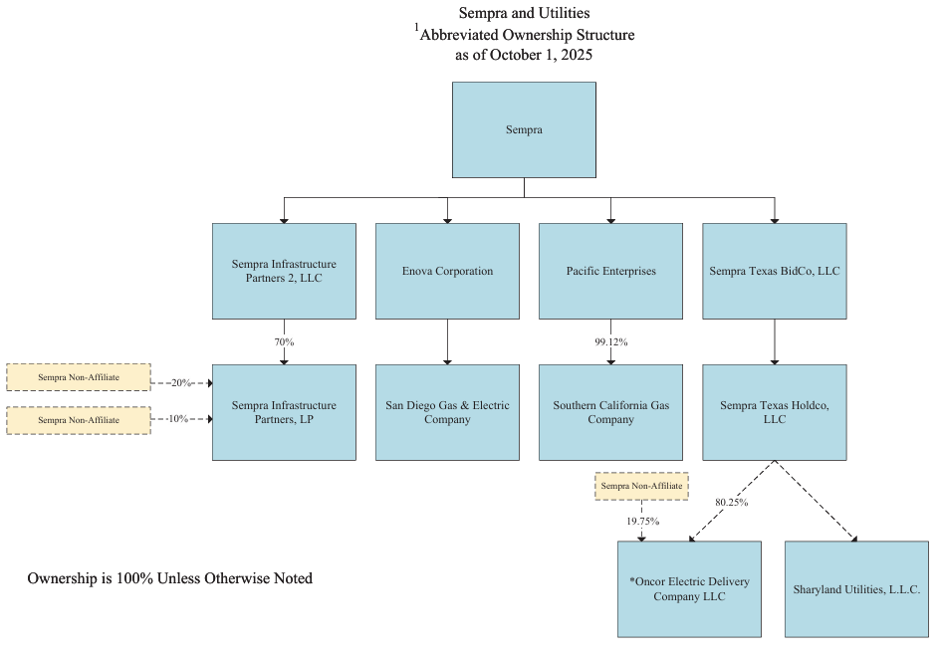
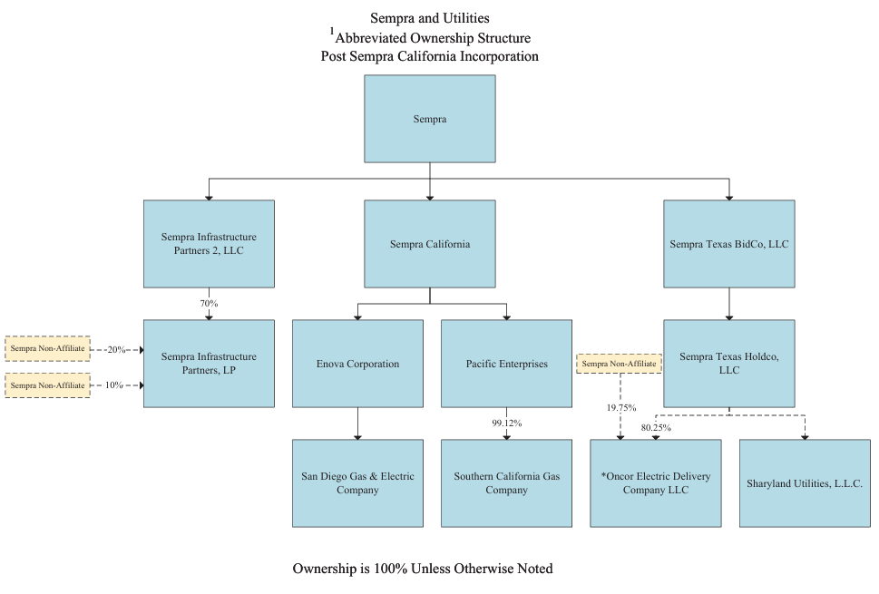
Applicants assert that the Proposed Transaction will not affect utility operations, rates, or services, and is intended to facilitate corporate and financial management.
On June 13, 2025, Utility Workers Union of America, AFL-CIO, Local 483 (UWUA) filed a response to the Application. UWUA did not oppose the requested relief but raised concerns regarding potential workforce impacts, including whether the Proposed Transaction could lead to workforce consolidation or the reallocation of work between utilities.
On July 14, 2025, Applicants filed a reply to UWUA’s response, stating that the Proposed Transaction would not result in workforce changes and would not affect employees, operations, rates, or services. Applicants maintained that the transaction is a ministerial internal reorganization and requested that the California Public Utilities Commission (Commission) approve the Application without further proceedings.
A prehearing conference was held on August 20, 2025, at which time the assigned Administrative Law Judge (ALJ) and the Applicants discussed the scope and schedule for the proceeding. The assigned ALJ indicated that additional information would be requested to ensure that the record was sufficiently developed, particularly with respect to public interest considerations and regulatory safeguards.
On September 18, 2025, the assigned ALJ issued a ruling requesting additional information from Applicants. The ruling directed Applicants to provide further detail regarding, among other things, workforce impacts, ratepayer protections, regulatory safeguards, and the applicability of Sections 853 and 854. Applicants timely filed their response on October 3, 2025.
On January 6, 2026, the assigned Commissioner issued a Scoping Memo and Ruling, which defined the issues in this proceeding and determined that evidentiary hearings were not required. The Scoping Memo identified issues related to the applicability of Section 854, whether an exemption under Section 853(b) is appropriate, whether the Proposed Transaction is in the public interest, including the sufficiency of existing regulatory safeguards, and whether the transaction has any impact on Environmental and Social Justice (ESJ) communities.
On January 7, 2026, the assigned ALJ issued a further ruling requesting additional information, directing Applicants to address the newly scoped issues concerning public interest, regulatory safeguards, and ESJ impacts. Applicants timely filed their response on February 6, 2026, addressing these issues and asserting that the Proposed Transaction will have no adverse impacts on the public interest, will not affect Commission oversight, and will not result in environmental or social justice impacts.
On April 14, 2026, the assigned ALJ issued a ruling determining that the record in this proceeding is complete, that the Commission has no further questions, and that no additional information is required. The ruling closed the evidentiary record and deemed this matter submitted as of April 14, 2026.

Jurisdiction
The Commission has jurisdiction over Applicants pursuant to Sections 451, 454, 701, 853, and 854.

Issues Before the Commission
The issues to be determined or otherwise considered in this proceeding are as follows:
- Does Section 854 apply to the creation of Sempra California, LLC, as an intermediate holding company above Enova Corporation and Pacific Enterprises, the direct corporate parents of Applicants, and below Sempra, the ultimate corporate parent of Applicants?
- If Section 854 applies to the Proposed Transaction, should the Commission exempt the transaction pursuant to Section 853(b)?
- Is the Proposed Transaction in the public interest, including whether existing regulatory safeguards and holding company conditions remain sufficient to protect ratepayers and ensure effective Commission oversight?
- Are there any impacts on ESJ communities, including the extent to which the Proposed Transaction impacts the achievement of any of the nine goals of the Commission’s ESJ Action Plan?

Discussion of Proposed Transaction with Respect to the Creation of an Intermediate Holding Company

Applicability of Section 854
The first issue before the Commission is whether the Proposed Transaction requires approval pursuant to Section 854(a), or alternatively, whether an exemption is warranted pursuant to Section 853(b).
Section 854(a) generally requires Commission authorization before a person or corporation may merge with, acquire, or control a California public utility. The purpose of Section 854 is to permit the Commission to review transactions affecting public utilities before they occur and to impose such conditions as the public interest may require. The standard generally applied by the Commission to determine if a transaction should be approved under Section 854(a) is whether the transaction will be “adverse to the public interest.” The statute is intended to ensure that changes in ownership or control of public utilities do not adversely affect the public interest, including ratepayers and the Commission’s ability to effectively regulate the utility. “The purpose of this and related sections is to enable the Commission, before any transfer of public utility authority is consummated, to review the situation and to take such action, as a condition of the transfer, as the public interest may require.”
Applicants contend that Section 854 does not apply because the Proposed Transaction is a limited internal corporate reorganization that does not result in a change in ultimate ownership or control of SDG&E or SoCalGas. Under the proposed structure, Sempra will remain the ultimate corporate parent of both utilities, and no third party will acquire any ownership interest in, or control over, either utility. Rather, the transaction inserts a new intermediate holding company (Sempra California) between Sempra and the utilities’ existing parent companies. Applicants assert that prior Commission decisions have recognized that internal holding-company restructurings that do not result in a transfer of ultimate ownership or control may not require approval under Section 854.
The Commission has historically declined to adopt a bright-line definition of “control” for purposes of Section 854. Instead, the Commission has determined the applicability of Section 854 on a case-by-case basis, taking into account the facts and circumstances of the particular transaction.
Commission precedent reflects that internal holding-company transactions do not fit neatly into categorical rules. Some decisions have found that transactions involving only changes in legal ownership and not actual control did not require full Section 854 review, while other decisions have applied Section 854 to upstream holding-company transactions.
The instant Proposed Transaction presents such a close question. On the one hand, the transaction inserts a new intermediate holding company into the corporate structure above Applicants. On the other hand, Sempra will remain the ultimate parent company, no third party will acquire ownership or control of either utility, and the record demonstrates that utility operations, management, workforce, rates, and service will remain unchanged.
We find that an exemption is warranted pursuant to Section 853(b). Section 853(b) authorizes the Commission to exempt a transaction from the requirements of Section 854 where application of those provisions is not necessary in the public interest. Section 853(b) reflects the Legislature’s recognition that not every transaction potentially falling within Article 5 warrants the review otherwise required under Section 854. Rather, Section 853(b) affords the Commission flexibility to tailor its review to the circumstances of a particular transaction and to exempt transactions where the full application of Article 5 is not necessary to protect the public interest.
The Commission has repeatedly recognized that we have broad discretion to grant an exemption, that there is no hard-and-fast test for granting an exemption, and that exemption determinations are made on a case-by-case basis.
Here, the record demonstrates that:
(1) Sempra will remain the ultimate parent company;
(2) no third party will acquire ownership or control of SDG&E or SoCalGas;
(3) utility operations and management will remain unchanged;
(4) utility rates and service obligations will remain unchanged;
(5) workforce levels and collective bargaining agreements will remain unchanged; and
(6) the Commission’s regulatory authority would not be diminished by the Proposed Transaction.
These facts closely resemble the types of internal corporate reorganizations that the Commission has previously found appropriate for exemption treatment.
In granting an exemption pursuant to Section 853(b), we will also consider the public-interest factors in Section 854(c) as guidance. In doing so, we recognize that the Commission has exercised its discretion to exempt under Section 853(b) in limited circumstances.
We turn to those public-interest considerations below.

Consideration of Public Interest
Factors in Section 854
We next consider the public-interest factors reflected in Section 854(c) as guidance in evaluating this exemption.
We evaluate the Proposed Transaction by considering its potential effects on utility rates, service quality, operations, financial condition, workforce, regulatory oversight, and other matters relevant to the public interest. This review is not a formal determination under Sections 854(b) or 854(c), but rather an evaluation of potential impacts on the public-interest in connection with the Commission’s exercise of its exemption authority under Section 853(b). We also consider whether existing regulatory safeguards, affiliate transaction rules, and holding company conditions remain sufficient to protect ratepayers and preserve the Commission’s ability to regulate Applicants effectively.
We evaluate these assertions below.

No Adverse Impact on Rates,
Service, or Operations
Applicants have represented, and no party has disputed, that the transaction will not affect utility rates, services, or day-to-day operations. Nor is there evidence that the transaction will impair the Commission’s regulatory authority or the applicability of existing affiliate transaction rules and holding company conditions. Applicants will continue to operate as regulated public utilities subject to Commission jurisdiction, and there will be no changes to tariffs, customer rates, or service obligations as a result of the transaction.
The Commission has previously found that transactions involving internal holding-company reorganizations may be appropriate for exemption treatment where utility rates, service, operations, management, and regulatory oversight remain unchanged. The record here reflects those same characteristics. The Proposed Transaction does not involve the transfer of utility assets, changes to utility management, modifications to utility rates or tariffs, or any reduction in the Commission’s jurisdiction over SDG&E or SoCalGas.
The record supports these representations. No party has presented evidence indicating that the transaction will directly or indirectly increase rates or degrade service quality. Nor does the transaction involve any transfer of assets, liabilities, or operational control that would affect the utilities’ ability to provide safe and reliable service.
However, the absence of immediate impacts does not end the inquiry. The Commission must also consider whether the transaction could create structural conditions that may affect rates or service in the future, including through financial arrangements, affiliate transactions, or changes in corporate incentives. As discussed below, we address these potential risks through the continued application of existing safeguards and the imposition of targeted conditions.

Financial Structure and
Risk to Ratepayers
Applicants assert that the Proposed Transaction will not adversely affect the financial condition of SDG&E or SoCalGas and will not result in increased financial risk to ratepayers. According to Applicants, the transaction does not involve new debt at the utility level, does not alter the utilities’ capital structures, and does not result in the transfer of utility assets.
The Commission sought additional information on these issues through assigned-ALJ rulings, reflecting the importance of ensuring that holding company restructurings do not facilitate financial practices that could harm ratepayers. In response, Applicants explained that existing regulatory safeguards would remain in effect following the Proposed Transaction, including Commission access to books and records, the continued applicability of affiliate transaction rules, and holding-company conditions designed to protect ratepayers from adverse financial effects associated with nonutility activities. Applicants further asserted that the Commission would retain full regulatory authority over Applicants following consummation of the transaction.
Maintaining separate books and records is an important safeguard because it promotes transparency, facilitates regulatory review, and helps ensure that utility assets and expenses remain distinct from those of affiliated entities. Separate accounting records also assist the Commission in monitoring compliance with affiliate transaction requirements and help prevent inappropriate cost shifting between regulated and nonregulated operations. To preserve these protections, we condition approval of the Proposed Transaction on Applicants continuing to maintain separate books and records and refraining from commingling utility assets with those of any affiliate, including Sempra California.
The Commission also finds it appropriate to require continued ring-fencing protections. Ring-fencing generally refers to structural and financial protections designed to separate regulated utility operations from the risks of affiliated nonutility businesses and to preserve utility assets for utility purposes. Such safeguards help ensure that utility assets remain available to serve utility customers and are not exposed to liabilities arising from nonutility businesses. Consistent with existing Commission safeguards designed to protect utility assets and ratepayers from nonutility risks, Applicants shall remain ring-fenced from the financial obligations of their parent and affiliate entities, and utility assets shall not be pledged or otherwise encumbered to support nonutility affiliate obligations without prior Commission authorization.
Based on the record, we find that the transaction, as described, does not introduce material financial risk to ratepayers. However, the creation of an additional holding company layer can create opportunities for upstreaming of capital, increased leverage at non-utility affiliates, or other financial arrangements that may indirectly affect the utilities. Accordingly, continued vigilance is required to ensure that ratepayers are insulated from such risks.

Regulatory Oversight
and Affiliate Transactions
A central concern in evaluating holding company structures is whether the Commission’s ability to regulate the utilities and monitor affiliate transactions remains intact. Applicants assert that the Proposed Transaction will not impair regulatory oversight and that existing affiliate transaction rules, reporting obligations, and other Commission regulatory requirements will continue to apply following consummation of the transaction.
We agree that the Commission retains jurisdiction over Applicants regardless of the insertion of an intermediate holding company. The utilities remain public utilities subject to Commission regulation, and existing rules governing affiliate transactions, cost allocation, and reporting remain applicable.
Nevertheless, the addition of a new corporate layer introduces additional complexity into the corporate structure. This can make it more difficult to trace financial flows, monitor affiliate transactions, and ensure that utility resources are not used to subsidize non-utility affiliates.
The Commission has long imposed safeguards designed to protect utility customers from risks associated with holding-company structures and affiliate relationships. These safeguards include affiliate transaction rules, reporting and disclosure requirements, restrictions designed to prevent inappropriate cost shifting between regulated and nonregulated entities, requirements that transactions between utilities and affiliates occur on an arm’s-length basis, Commission access to books and records, and other conditions adopted in prior Commission decisions governing the Sempra holding-company structure. These protections remain applicable following the creation of Sempra California and provide important assurances that utility resources will not be used to subsidize nonutility activities and that the Commission will continue to have access to information necessary to carry out its regulatory responsibilities.
To ensure that these protections remain effective following consummation of the Proposed Transaction, we find it appropriate to impose additional conditions reaffirming that all transactions between SDG&E or SoCalGas and Sempra California, LLC, or any affiliate, shall be conducted on an arm’s-length basis and in compliance with applicable affiliate transaction rules. We further require that the creation of Sempra California not diminish the Commission’s access to books, records, personnel, or other information necessary to regulate Applicants effectively.

Workforce Impacts
UWUA ultimately did not oppose the application. UWUA initially raised concerns regarding potential workforce impacts, including whether the transaction could result in workforce consolidation or reallocation of work between affiliates. Applicants responded that the transaction is not expected to result in layoffs, workforce reductions, workforce consolidation, reallocation of work, or changes to existing collective bargaining agreements.
The record does not contain evidence contradicting Applicants’ representations. However, the Commission takes workforce impacts seriously, particularly in transactions involving corporate restructuring.
We find that the transaction, as described, does not present a risk of adverse workforce impacts. Nevertheless, post-consummation reporting requirements are appropriate. Applicants shall notify the Commission, through the Energy Division, within 30 days following consummation of the transaction, confirming that the transaction has been completed in accordance with the representations made in the Application. In addition, Applicants shall notify the Commission of any material workforce changes or labor-related impacts attributable to the transaction within 12 months following consummation. These reporting requirements will assist the Commission in verifying compliance with the representations made in this proceeding and monitoring implementation of the Proposed Transaction.

Balancing Benefits and Risks
Applicants assert that the Proposed Transaction will provide administrative and organizational benefits by placing Applicants under a common intermediate holding company and simplifying the corporate structure through which Sempra manages its California utility holdings.
Although these benefits are not quantified, they are consistent with the nature of internal corporate reorganizations and are plausible on this record.
The potential risks identified in this proceeding relate primarily to financial arrangements, affiliate transactions, and regulatory transparency. However, the record demonstrates that utility operations, management, workforce, rates, and service will remain unchanged. Moreover, existing affiliate transaction rules, holding company safeguards, reporting obligations, and the conditions adopted in this decision substantially mitigate the potential risks associated with the addition of an intermediate holding company.
Considering the record as a whole, we find that the anticipated benefits of the Proposed Transaction outweigh any potential risks.

Conclusion
Based on the record, we grant an exemption under Section 853(b) subject to the terms and conditions herein. Existing affiliate transaction rules, holding company safeguards, reporting requirements, and the conditions adopted in this decision provide adequate protection for ratepayers and preserve the Commission’s regulatory oversight. We are also persuaded by the public interest factors in Section 854 which we used as guidance in informing our decision to grant this exemption. The Proposed Transaction does not transfer ownership or control of SDG&E or SoCalGas to a third party, does not affect utility rates, service, operations, workforce, or management, and does not impair the Commission’s ability to regulate the utilities.

Impacts on Environmental and
Social Justice Communities
As part of our public-interest review, we consider whether the Proposed Transaction has any impacts on ESJ communities and whether it affects the achievement of the goals set forth in the Commission’s ESJ Action Plan.
The Commission’s ESJ Action Plan recognizes that many communities throughout California experience disproportionate environmental burdens and barriers to accessing safe, reliable, and affordable utility services. Consistent with that framework, the Commission considers whether the Proposed Transaction would adversely affect disadvantaged communities, impair access to utility services, undermine affordability, or otherwise interfere with the Commission’s ability to advance ESJ-related policies and programs.
Applicants assert that the Proposed Transaction will have no direct or indirect impacts on ESJ communities. According to Applicants, the transaction does not involve any changes to utility operations, infrastructure, service territories, or customer rates, and therefore does not affect how utility services are delivered to any community, including those identified as ESJ communities.
The record supports the conclusion that the Proposed Transaction will not result in direct environmental impacts. The transaction does not involve construction, physical modifications to utility systems, or operational changes that would affect emissions, land use, or environmental quality. As such, there is no evidence that the transaction will increase pollution burdens or otherwise adversely affect environmental conditions in any community.
The absence of direct environmental impacts is not, by itself, dispositive. The Commission also considers whether a corporate restructuring could indirectly affect ESJ communities through changes in utility decision-making, resource allocation, affordability, service quality, customer programs, or implementation of Commission-directed initiatives. For that reason, the Commission sought additional information from Applicants regarding potential ESJ implications of the Proposed Transaction and the continued administration of programs serving disadvantaged communities.
We also consider whether the transaction may have indirect impacts on ESJ communities, particularly with respect to affordability, service quality, and access to utility services. These considerations are central to several of the ESJ Action Plan goals, including ensuring equitable access to safe and reliable utility services, enhancing consumer protections, and improving outreach and engagement with underserved communities.
The record does not demonstrate that the transaction will affect rates, service quality, or utility operations. Applicants will continue to be regulated public utilities subject to the Commission’s jurisdiction and existing consumer protection requirements. There is no evidence that the proposed corporate restructuring will impair the utilities’ ability to provide safe, reliable, and affordable service to ESJ communities.
We also consider whether the Proposed Transaction could impair the Commission’s ability to implement ESJ-related policies or hold the utilities accountable for achieving Commission-directed ESJ objectives. The record demonstrates that the creation of Sempra California will not alter the Commission’s jurisdiction over SDG&E or SoCalGas, will not affect the applicability of Commission decisions, rules, reporting requirements, or program obligations, and will not reduce the utilities’ responsibility to implement Commission-directed ESJ initiatives. Applicants will remain subject to all existing requirements relating to affordability programs, customer protections, outreach efforts, and service to disadvantaged communities. Applicants confirmed that the transaction will not change how ESJ programs are administered, funded, or implemented, and will not reduce resources dedicated to such efforts.
Based on the record, we find that the Proposed Transaction will not have material adverse impacts on ESJ communities. The transaction does not alter utility operations, infrastructure, service quality, affordability, customer protections, or access to utility services. Nor does it impair the Commission’s ability to implement, monitor, or enforce ESJ-related programs and policies.
We further find that the Proposed Transaction is operationally neutral with respect to the goals of the Commission’s ESJ Action Plan. While the transaction does not itself advance specific ESJ initiatives, it does not hinder progress toward those goals, diminish existing ESJ programs, or reduce the utilities’ obligations to comply with Commission-directed ESJ requirements.
Accordingly, we conclude that the Proposed Transaction does not adversely affect ESJ communities and is consistent with the Commission’s ESJ Action Plan.

Summary of Public Comment
Rule 1.18 of the Commission’s Rules of Practice and Procedure (Rules) allows any member of the public to submit written comment in any Commission proceeding using the “Public Comment” tab of the online Docket Card for that proceeding on the Commission’s website. Rule 1.18(b) requires that relevant written comment submitted in a proceeding be summarized in the final decision issued in that proceeding.
As of June 1, 2026, no public comments appeared on the Docket Card for the proceeding.

Conclusion
Based on the record in this proceeding, we conclude that the Proposed Transaction presents a close question regarding the applicability of Section 854(a). The transaction inserts a new intermediate holding company into the corporate structure above Applicants but does not change the utilities’ ultimate ownership, management, operations, workforce, rates, service obligations, or regulatory responsibilities.
We find that Applicants have demonstrated that application of the review requirements of Section 854 are not necessary in the public interest within the meaning of Section 853(b).
The record demonstrates that Sempra will remain the ultimate parent company, no third party will acquire ownership or control of SDG&E or SoCalGas, utility operations and management will remain unchanged, and the Commission’s jurisdiction and regulatory oversight will remain intact. Existing affiliate transaction rules, reporting requirements, holding company safeguards, and the conditions adopted in this decision provide additional protections for ratepayers and preserve the Commission’s ability to regulate the utilities effectively.
Consistent with Commission precedent, we have also considered the public-interest factors reflected in Section 854(c) as guidance in evaluating this exemption request. Based on that review, we find that the transaction does not adversely affect utility rates, service, operations, workforce, or regulatory oversight; does not introduce material financial risk to ratepayers; and does not impair the Commission’s ability to regulate SDG&E or SoCalGas. We further find that the transaction will not have material adverse impacts on ESJ communities and is operationally neutral with respect to the goals of the Commission’s ESJ Action Plan.
Accordingly, we grant Applicants’ request for an exemption pursuant to Section 853(b) subject to the conditions adopted in this decision.

Procedural Matters
This decision affirms all rulings made by the ALJ and assigned Commissioner in this proceeding. All motions not ruled on are deemed denied.

Waiver of Comment Period
This is an uncontested matter in which the decision grants the relief requested. Accordingly, as provided in Rule 14.6(c)(2), the otherwise applicable 30-day public review and comment period for this decision is waived.

Assignment of Proceeding
Commissioner Karen Douglas is the assigned Commissioner and Alberto T. Rosas is the assigned Administrative Law Judge in this proceeding.

Findings of Fact
- Under the Proposed Transaction, Sempra will remain the ultimate parent of Applicants both before and after the reorganization.
- The Proposed Transaction does not involve the transfer of ownership or control of SDG&E or SoCalGas to a third party.
- The Proposed Transaction is a corporate restructuring that does not involve construction, changes to utility operations, or modification of service territories.
- The Proposed Transaction does not result in any changes to utility rates, tariffs, or customer service obligations.
- The Proposed Transaction does not alter the day-to-day operations or management of SDG&E or SoCalGas.
- The Proposed Transaction does not involve the transfer of utility assets or liabilities.
- The record does not demonstrate that the Proposed Transaction will adversely affect the financial condition of SDG&E or SoCalGas or materially increase financial risk to ratepayers.
- The Proposed Transaction introduces an additional intermediate holding company layer into the corporate structure above Applicants but does not change the ultimate ownership of SDG&E or SoCalGas and does not result in any substantive change to utility operations, management, workforce, or regulatory oversight.
- The record does not contain evidence demonstrating that the Proposed Transaction will adversely affect rates, service quality, or utility operations.
- The Proposed Transaction does not impair the Commission’s jurisdiction, regulatory authority, or ability to enforce applicable statutes, Commission decisions, affiliate transaction rules, reporting requirements, and existing? holding company conditions.
- Existing affiliate transaction rules, reporting requirements, and holding company safeguards applicable to Applicants will remain in effect following consummation of the Proposed Transaction.
- The Proposed Transaction does not involve physical changes to infrastructure or operations that would result in direct environmental impacts.
- The record does not demonstrate that the Proposed Transaction will have adverse impacts on ESJ communities.
- The Proposed Transaction is neutral with respect to the achievement of the Commission’s ESJ Action Plan goals.

Conclusions of Law
- The Commission has jurisdiction over Applicants pursuant to Sections 451, 454, 701, 853, and 854.
- Section 853(b) authorizes the Commission to exempt a transaction from the requirements of Article 5 where application of those provisions is not necessary in the public interest.
- Based on the record developed in this proceeding, Applicants have demonstrated that application of the review requirements of Section 854 is not necessary in the public interest.
- It is reasonable to consider the public-interest factors in Section 854(c) as guidance in evaluating an exemption under Section 853(b).
- The Proposed Transaction does not adversely affect utility rates, service, operations, management, workforce, or regulatory oversight.
- The Proposed Transaction does not materially increase financial risk to ratepayers based on the record before the Commission.
- The Proposed Transaction does not impair the Commission’s jurisdiction, regulatory authority, or ability to enforce applicable statutes, Commission decisions, affiliate transaction rules, reporting requirements, and existing holding company conditions.
- The Proposed Transaction does not have material adverse impacts on ESJ communities and is consistent with the Commission’s ESJ Action Plan.
- It is reasonable to adopt the conditions set forth in this decision.
- Subject to the conditions adopted in this decision, the proposed transaction should be exempted from the review requirements in Sections 854(a)-(d) pursuant to Section 853(b).
- This proceeding should be closed.

ORDER
IT IS ORDERED that:
- Application 25-05-020, filed by San Diego Gas & Electric Company (SDG&E) and Southern California Gas Company (SoCalGas) (jointly, Applicants), is granted, subject to the conditions set forth in this decision. Applicants are authorized to complete the proposed corporate reorganization, including the creation of Sempra California, LLC as an intermediate holding company above Enova Corporation and Pacific Enterprises, the direct corporate parents of Applicants, and below Sempra, the ultimate corporate parent of Applicants. For illustrative purposes only, the authorized corporate reorganization will look as follows once completed:
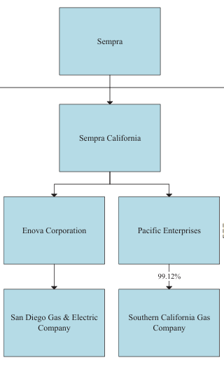
- San Diego Gas & Electric Company and Southern California Gas Company’s request for an exemption pursuant to Public Utilities Code Section 853(b) is granted.
- San Diego Gas & Electric Company and Southern California Gas Company (jointly, Applicants) shall continue to comply with all applicable statutes, Commission decisions, General Orders, affiliate transaction rules, reporting requirements, holding company conditions, and other requirements applicable to Applicants.
- The authorization granted in this decision is conditioned on the following:
  - San Diego Gas & Electric Company (SDG&E) and Southern California Gas Company (SoCalGas) (jointly, Applicants) shall maintain separate books and records and shall not commingle utility assets with those of any affiliate, including Sempra California, LLC.
  - All transactions between SDG&E or SoCalGas and Sempra California, LLC, or any affiliate, shall be conducted on an arm’s-length basis and in compliance with applicable affiliate transaction rules.
  - The creation of Sempra California, LLC shall not diminish the Commission’s access to books, records, personnel, or information necessary to regulate SDG&E or SoCalGas.
  - Applicants shall continue to be ring-fenced from the financial obligations of their parent and affiliate entities, and no utility assets shall be pledged or encumbered to support non-utility affiliate obligations without prior Commission authorization.
  - Applicants shall notify the Commission, through the Energy Division, within 30 days following consummation of the transaction, confirming that the transaction has been completed in accordance with the representations made in the Application.
  - Applicants shall notify the Commission of any material changes to workforce levels or labor arrangements attributable to the transaction within 12 months following consummation.
- Within 60 days following consummation of the proposed transaction, San Diego Gas & Electric Company and Southern California Gas Company shall submit a Tier 2 Advice Letter containing the following:
  - Narrative Description: A detailed explanation of the final corporate structure, describing how the proposed transaction reconfigures the network of relationships established through holding companies and affiliates;
  - Organizational Chart: A visual diagram depicting how the proposed transaction reconfigures the network of relationships established through holding companies and affiliates; and
  - Certificate of Compliance: A statement signed under penalty of perjury certifying that (i) the narrative description and diagram are true and accurate representations of the reconfigured corporate network, and (ii) the utilities are in compliance with all conditions adopted in this decision.
- The preliminary determination in the Scoping Memo that evidentiary hearings were not required is affirmed.
- All rulings issued by the assigned Commissioner and Administrative Law Judge in this proceeding are affirmed. All motions not otherwise addressed in this decision are denied.
- Application 25-05-020 is closed.
This order is effective today.
Dated August 13, 2026, at San Francisco, California.

JOHN REYNOLDS
President
DARCIE L. HOUCK
KAREN DOUGLAS
MATTHEW BAKER
CHRISTINE HARADA
Commissioners

All statutory references are to the Public Utilities Code unless otherwise noted.
Response to ALJ’s Ruling Requesting Additional Information, filed October 3, 2025, at Attachment 3.
Decision (D.) 03-06-069 at 5.
D.07-03-047 (In Re Wild Goose Storage Inc., No. 06-05-033, 2007 WL 846540 (Mar. 15, 2007) (Order Modifying Decision 06-11-019 and Denying Rehearing of Decision as Modified) (clarifying that application of the “not adverse to the public interest” test is not a separate standard, but rather the same as demonstrating that the transaction was in the public interest under Section 854(a))).
San Jose Water Co. (1916) 10 CRC 56; D.03-06-069 at 4; D.03-02-071 at 10.
A.25-05-020 filed May 30, 2025 (Application) at 1-3, 11-12.
Application at 1, 8-10, 12.
Application at 1, 3-4, 8-10.
Application at 8-9, citing D.16-01-037 [internal holding-company restructuring did not constitute a change of control under Section 854].)
See control discussion in D.08-12-021 at 11; D.07-06-061 at 47; D.03-06-069 at 8-10.
See D.03-06-069 at 6-10; D.12-04-035.
Application at 1, 3-4, 8-10, and Exhibit A.
Application at 1; Response to ALJ Ruling Requesting Additional Information (Response to Ruling), filed October 3, 2025, at 2, 12-13.
Prior Commission decisions involving telecommunications companies recognize our broad power to exempt mergers from review under §§ 854(b) and (c). See D.06-04-074 at 8; D.06-04-075 at 8. The Commission has used the Section 854(c) public interest factors to guide our analysis outside mergers, including for transactions not subject to Section 854. See D.24-05-004 at 13.
Application at 1 [“the ultimate parent would continue to be Sempra”]; Application at 11-12.
Application at 1 [“SDG&E and SoCalGas... would continue to be owned by Enova Corporation... and Pacific Enterprises”] and stating that the Proposed Transaction will result in “no change in the immediate or ultimate legal ownership” of the utilities; Application at 8-10, charts at Exhibit A.
Application at 1; Response to Ruling, filed October 3, 2025, at 2 and 16 [“Sempra California... will play no role in the day-to-day operations or management of the California Utilities”].
Application at 1 [no change in rates or services]; Response to Ruling, filed October 3, 2025, at 13 [“customers will experience the same level of service” and “ratepayers will continue to pay the same Commission-authorized rates”].
Response to Ruling, filed October 3, 2025, at 2 [“The creation of an intermediate holding company is not expected to result in workforce consolidation or reallocation at this time”].
Response to Ruling, filed October 3, 2025, at 18-19.
See D.12-04-035.
D.06-04-074 at 16; D.06-04-075 at 15.
D.04-07-023 (In Re Pac. Gas & Elec. Co., No. 00-06-010, 2004 WL 1686978 (July 8, 2004) (Denying PG&E’s request to use our authority under Section 853(b) to exempt lease and license agreements from Section 851)).
D.06-04-074 at 16; D.06-04-075 at 15.
Application at 1; Response to Ruling, filed October 3, 2025, at 17.
See D.12-04-035.
Response to Ruling, filed October 3, 2025, at 8-10; Application at 14-15.
Response to Ruling, filed October 3, 2025, at 8-10; Application at 1-3.
Response to Ruling, filed October 3, 2025, at 3-5, 22-25.
See D.86-03-090, 1986 Cal. PUC LEXIS 198, at 90-95 (finding that a holding-company structure may provide greater separation between the utility and nonregulated affiliates and may insulate ratepayers from diversification risks); Response to Ruling, filed October 3, 2025, at 4-5 (stating that existing holding-company conditions and affiliate transaction rules preserve the status quo regarding insulation of ratepayers from adverse financial effects associated with nonutility activities).
Response to Ruling, filed October 3, 2025, at 4-5, 22-25 (stating that existing holding-company conditions, affiliate transaction rules, and reporting obligations will remain applicable and that the Commission will retain its authority to regulate Applicants following the Proposed Transaction); Application at 1-3 (stating that the transaction will not alter the regulatory status of the utilities).
See D.86-03-090, D.97-12-088, D.98-03-073.
Response of UWUA, Local 132, filed June 30, 2025, at 2-4.
Response to Ruling, filed October 3, 2025, at 2 (stating that workforce consolidation or reallocation is not expected); Application at 1 (stating that the transaction will result in no change in employees).
Application at 2-4.
Response to Ruling, filed February 6, 2026, at 2-5 (stating that the Proposed Transaction will not adversely affect ESJ communities and will not alter utility operations, infrastructure, service territories, rates, service delivery, or ESJ-related programs); Application at 1 (stating that the Proposed Transaction will result in no change in operations, rates, or services).

