PUBLIC UTILITIES COMMISSION OF THE STATE OF CALIFORNIA

Agenda ID# 24510
ENERGY DIVISION RESOLUTION E-5476
October 8, 2026

RESOLUTION

Resolution E-5476. Adopts updates to the Avoided Cost Calculator for use in demand-side distributed energy resource cost-effectiveness analysis.

PROPOSED OUTCOME:
- Adopts certain data input updates and minor modeling adjustments for the Avoided Cost Calculator for use in Distributed Energy Resource (DER) cost-effectiveness analyses.

SAFETY CONSIDERATIONS:
- There are no safety considerations associated with this resolution.

ESTIMATED COST:
- No incremental cost. Funds necessary for updates to the Avoided Cost Calculator were authorized in Decision (D.) 16-06-007, D.23-11-087, and D.25-11-005.

Authorized by D.16-06-007, issued on June 15, 2016, D.19-05-019, issued on May 21, 2019, D.22-05-002, issued on May 5, 2022, D.24-07-015, issued on July 15, 2024, and D.24-08-007, issued on August 7, 2024.
__________________________________________________________

Summary
The Avoided Cost Calculator (ACC) is used in cost-effectiveness analysis of distributed energy resource (DERs) programs and policies. This Resolution provides a link to the final 2026 ACC and related documentation and data files, consistent with policies adopted in D.16-06-007, D.19-05-019, D.22-05-002, D.24-07-015, D.24-08-007, and
D.25-11-005. The documentation provides additional detail about this update, including a comparison of the 2026 and 2024 ACC outputs. This Resolution describes the data and major modeling updates to the 2026 ACC.

Background
The ACC, first adopted in D.05-04-024, was originally used to only measure Energy Efficiency (EE) cost-effectiveness. The assumptions, data, and models used in the ACC require periodic updates to stay current with market conditions, prices, and trends. Thus, semi-regular improvements to the ACC modeling software and data input updates were adopted in decisions from several EE proceedings (e.g., D.06-06-063,
D.09-09-047, and D.12-05-015).

The Commission subsequently expanded the use of the ACC to customer generation programs (in D.09-08-026) and to demand response programs (in D.10-12-024).

In 2014, the California Public Utilities Commission (CPUC) opened the Integrated Distributed Energy Resources (IDER) proceeding (Rulemaking (R.) 14-10-003), with a focus on developing policy to facilitate the use of Distributed Energy Resources (DERs). Among the goals of R.14-10-003 was to establish a unified cost-effectiveness framework that would apply to all DER programs, technologies, and proceedings. The IDER proceeding established a four-phase plan to accomplish this, in which the first phase was to update the ACC regularly.

In 2022, the Commission opened proceeding R.22-11-013 as a successor proceeding to R.14-10-003. The focus of the successor proceeding is on considering DER program cost-effectiveness issues, data access and use, and equipment performance standards. Updates to the ACC were moved to this proceeding.

D.24-07-015 adopted the Societal Cost Test (SCT) as an additional informational test for the Commission to consider when evaluating the cost-effectiveness of DERs. Prior to the issuance of D.24.07-015, the Commission had adopted four cost effectiveness tests to evaluate demand-side resources programs’ cost-effectiveness, which examine costs and benefits from various perspectives, including ratepayers, the grid, program administrators and program participants. D.24-07-015 introduced the SCT – a fifth test – which considers the benefits and costs experienced by society (e.g. the impact of particulate air pollution on human health) in its evaluation of cost-effectiveness.
D.24-07-015 affirmed that the Total Resource Cost Test (TRC) remains the primary cost-effectiveness test for evaluating DER cost-effectiveness and that the SCT will be information-only. Ultimately, the SCT will inform and supplement a broader framework of tests used for assessing the cost-effectiveness of DERs.

D.24-08-007 ordered minor modeling adjustments and data input updates to the ACC, which included:
- The ACC will use IRP’s latest adopted system plan as the baseline portfolio of the ACC, replacing the “No New DER” scenario.
- The ACC will use an “Integrated Calculation” methodology to model the generation capacity avoided costs and GHG avoided costs using utility solar and lithium-ion energy storage. Additional resources in the Integrated Calculation may be considered in future ACC update cycles.
- A minimum level of avoided generation capacity costs for the ACC model is set at the fixed operations and maintenance costs of existing gas generation.
- The ACC will use an alternative storage dispatch logic in SERVM to calculate the hourly generation capacity allocation.
- The ACC will calibrate and benchmark SERVM model outcomes for the Preferred System Plan (PSP) to actual CAISO market outcomes prior to producing the energy and ancillary service price forecasts that are used in the ACC.
- Consideration of the Refrigerant Avoided Cost Calculator (RACC) is moved to the Energy Efficiency (EE) Proceeding, R.13-11-005.
- A minimum level of avoided GHG costs for the ACC model is set at the cap-and-trade (now known as cap-and-invest) price forecasts.
- Continues using the current methodology for calculating avoided transmission and distribution costs in the ACC but with the most current transmission and distribution cost data.

D.25-11-005 made further modifications to the biennial update process for the ACC. In that decision, the Commission directed that either the IRP PSP or IRP TPP Base Case portfolio be used for the purpose of updating the ACC, among other things.

D.26-09-007 ordered the following changes to the ACC, beginning with the 2026 update:
- Use a single electric-sector based value to represent both electric and natural gas greenhouse gas (GHG) reductions in the ACC.
  - Previously, the natural gas ACC model used a GHG value based on a limited 2021 study and escalated over time, which the Commission found to be increasingly outdated and inaccurate and instead directed that a single electric-sector based value be used for both natural gas and electric ACC models.
- Remove the GHG rebalancing component.
  - In previous iterations of the ACC, the GHG rebalancing component represented the effect on sectoral emissions goals due to the migration of load from natural gas to electric over time. Adopting the single avoided GHG value linked to the IRP, as described above, does not require a GHG rebalancing component because there is no longer a need for a separate adjustment to reflect cross-sector (gas to electric) value transfers. This uniformly allows the ACC to represent marginal cost signals thus capturing the full GHG impacts of electrification and fuel-substitution measures without an additional adjustment step.
- Use a simplified implementation of the Integrated Calculation to address transparency issues and sensitivity to minor inconsistencies between RESOLVE and the Strategic Energy & Risk Valuation Model (SERVM).
  - The decision adopts an updated integrated calculation that considers a hybrid solar+storage resource as a single resource rather than two separate resources.
- Use Loss of Load Hours (LOLH) rather than Expected Unserved Energy (EUE) for capacity allocation factors.
  - EUE puts more weight on large shortfall events and understates the value of resources that reduce loss of load across many hours. Using the frequency of loss of load aligns capacity avoided costs with the consistent value of avoiding loss of load in any given hour.
- Use energy prices (rather than temperature) to assign days with high generation capacity value.
  - Assigning month-hour averages of generation capacity values to individual days from a method that uses days with the highest temperatures to days with highest energy prices more accurately identifies days with greatest grid constraints, reflecting higher building electrification uptake and growing renewable generation.
- Represent the difference in reliability risk of weekdays versus weekends in capacity value allocation.
  - Reflects the results of reliability modeling that show weekdays have significantly higher reliability risk than weekends.
- Update the peak capacity allocation factors (PCAFs) calculations for transmission avoided costs.
  - Use the Integrated Energy Policy Report load forecast for future years, as used in SERVM modeling for calculating energy avoided costs, instead of historical loads.
- Align Transmission Avoided Costs across utilities.
  - Use the Discounted Total Investment Method approach to calculate marginal transmission costs for all electric utilities.

Discussion
The adoption of these changes in D.26-09-007 produces higher avoided costs in all hours than in the 2024 ACC, as shown in Figure 1:

Figure 1
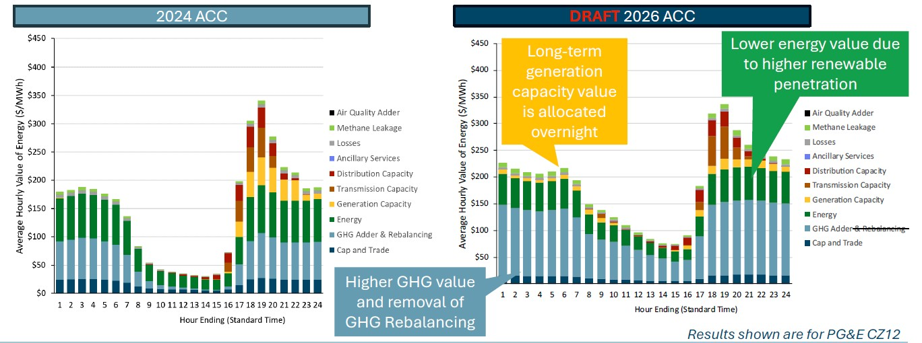

As shown in Figure 1, as more renewables have been built since 2024, the 2026 ACC produces a lower energy value due to higher renewable penetration. The Generation Capacity value in the 2026 ACC differs from 2024 as the value is spread overnight to cover storage dispatch hours rather than concentrated just during the peak nighttime. In addition, the generation capacity value in the 2026 ACC is lower in the near-term and higher in the long-term. This is because while avoided capacity drops per year, because the value is spread out, it increases avoided capacity costs in early morning hours compared to the 2024 calculator. The expected increase and shift from 2024 are shown in Figure 2 on the right.

Figure 2
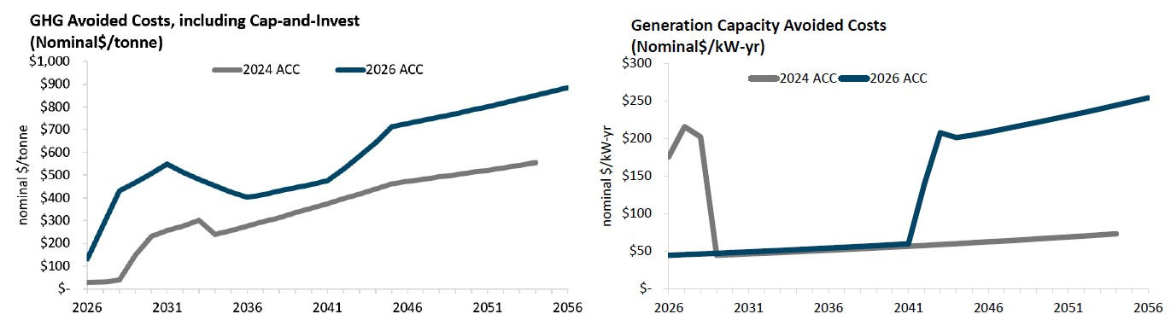

The GHG Value is significantly higher in 2026 than 2024 due to the expiration of federal tax credits for developing more renewable energy and new tariff costs on the imported solar and storage components, which causes GHG avoided costs to increase substantially. The expected increase and shift from 2024 are shown in Figure 2 on the left.

Ultimately, the updates to GHG values in the Electric and Gas ACC produce increases relative to the 2024 ACC, while the Generation Capacity value is set to decrease in the short term as it is spread out across all hours. These two changes account for most of the substantial shift in avoided costs relative to 2024.

Other ACC methodology updates produce no significant effect on avoided costs relative to 2024. Using LOLH rather than EUE for capacity allocation factors, using energy prices to assign days with generation capacity value, and separating weekdays versus weekends in generation capacity value allocation will better reflect real-world results in the ACC. In addition, updating the peak capacity allocation factors calculations for transmission avoided costs to use the Integrated Energy Policy Report load forecast for future years, and aligning the calculation of transmission avoided costs across utilities with the DTIM method results in only a minor shift in the calculation of transmission costs.

Table 1 lays out the combined effect of the expected changes relative to 2024:

Table 1
Direction of Change Driven by all Avoided Cost Calculator Updates relative to 2024 ACC
Gas GHG Value | Increase
GHG Rebalancing Removal | Increase
Electric GHG Value | Increase
Refined Integrated Calculation of Generation Capacity Value | Decrease
Use LOLH rather than EUE | No significant change
Use energy prices (rather than temperature) to assign days with high generation capacity value. | No significant change
Separate weekdays versus weekends in generation capacity value allocation | No significant change
Update the peak capacity allocation factors (PCAFs) calculations for transmission avoided costs. | No significant change
Alignment of Transmission Avoided Costs across utilities (DTIM method) | No significant change

Comments
Public Utilities Code section 311(g)(1) provides that this Resolution must be served on all parties and subject to at least 30 days public review. Any comments are due within 20 days of the date of its mailing and publication on the CPUC’s website and in accordance with any instructions accompanying the notice. Section 311(g)(2) provides that this 30-day review period and 20-day comment period may be reduced or waived upon the stipulation of all parties in the proceeding.

The 30-day review and 20-day comment period for the draft of this resolution was neither waived nor reduced. Accordingly, this draft resolution was mailed to parties for comments, and will be placed on the CPUC's agenda no earlier than 30 days from today.

Findings
- D.22-05-002 OP 1 directs Energy Division Staff to make major changes to the Avoided Cost Calculator, as specified in that Decision, during even-numbered years.
- D.22-05-022 provided additional time for review of the draft Avoided Cost Calculator.
- D.24-08-007 directed Energy Division Staff to hold a workshop to review the current procedural framework for the ACC biennial update process, facilitate discussion of the ACC Guiding Principles, and how to consider equity in the evaluation of DER cost-effectiveness.
- Energy Division Staff held the workshop, as directed in D.24-08-007, on April 10, 2025, and gave stakeholders the opportunity to present and comment on proposed Guiding Principles for the ACC, equity considerations in the evaluation of DER cost-effectiveness, and changes to the biennial update process.
- D.25-11-005 replaced the biennial ACC update process in D.22-05-002 with a revised process to avoid delays in ACC updates.
- D.26-09-007 adopts minor modeling adjustments and data input updates to the ACC.
- The updates to the Avoided Cost Calculator, as referenced in Appendix A, are reasonable for use in DER cost-effectiveness. It is reasonable to adopt this 2026 Avoided Cost Calculator, specifically referred to as 2026 ACC v1a.

Therefore it is ordered that:
- The updates to the Avoided Cost Calculator, as specified herein and further enumerated in documents made available through Appendix A of this Resolution, are adopted for use in demand-side distributed energy resource cost-effectiveness analyses.

This Resolution is effective today.

I certify that the foregoing resolution was duly introduced, passed, and adopted at a conference of the Public Utilities Commission of the State of California held on
October 8, 2026, the following Commissioners voting favorably thereon:

Commissioner Signature blocks to be added
upon adoption of the resolution

Dated , at <Voting meeting location>, California

Appendix A

Avoided Cost Calculator 2026 Update documents are available online.

The 2026 ACC Gas Model, the 2026 ACC Electric Model, the 2026 ACC Integrated Calculation Inputs, the 2026 ACC Documentation, and related data files are all available for download on the CPUC website: DER Cost-Effectiveness (ca.gov)

Alternatively, the ACC Documentation and files will also be shared on the R.22-11-013 Service List.

The Commission opened R.04-04-025 to develop avoided costs in a “consistent and coordinated manner across Commission proceedings.” D.05-04-024 adopted the report, Methodology and Forecast of Long-Term Avoided Cost(s) for the Evaluation of California Energy Efficiency Programs, and associated spreadsheet models developed by the consulting firm E3, to use in determining the cost-effectiveness of EE programs.
Order Instituting Rulemaking to Consider Distributed Energy Resource Program Cost-Effectiveness Issues, Data Use and Access, and Equipment Performance Standards, pp.2-3.
D.24-07-015, p.23-24.
D.24-08-007, p.10-15.
D.24-08-007, p.15-20.
D.25-11-005, p.13-15.

