PUBLIC UTILITIES COMMISSION OF THE STATE OF CALIFORNIA

Agenda ID# 24517
ENERGY DIVISION RESOLUTION E-5422
October 8, 2026

RESOLUTION

Resolution E-5422. San Diego Gas & Electric Company (SDG&E) requests approval for a new Navy Master Utility Services Contract (Contract) with the Navy's Naval Facilities Engineering Command, Southwest (NAVFAC Southwest)

PROPOSED OUTCOME:
- This Resolution grants the request to create a new Navy Master Utility Services Contract with NAVFAC Southwest.

SAFETY CONSIDERATIONS:
- Utilities are expected to comply with all federal and state safety regulations, including Public Utilities Code Section 451.

ESTIMATED COST:
- SDG&E is expected to recover all costs through rates.

By Advice Letter (AL) 4508-E/3338-G (Tier 3) submitted on
September 13, 2024 and supplemental documents 4508-E-A/3338-G-A submitted on September 24, 2025

__________________________________________________________

Summary
California Public Utilities Commission (CPUC) approves the new Contract of SDG&E with NAVFAC Southwest (attached as Exhibit A) because this Contract fulfills SDG&E’s obligation to serve, is consistent with federal and state laws, and meets the interests of the parties.

On September 13, 2024, SDG&E requested authorization to create a new Navy Master Utility Services Contract with NAVFAC Southwest.

On September 24, 2025, SDG&E submitted supplemental documents requesting approval for a slightly revised version of the original Contract, although the Contract fundamentals remained the same.

No protests were received.

This Resolution approves SDG&E’s request to create a new Navy Master Utility Services Contract with NAVFAC Southwest (attached as Exhibit A) because the Contract fulfills SDG&E’s obligation to serve, is consistent with federal and state laws, and meets the interests of the parties.

Background
The Navy's Naval Facilities Engineering Command, Southwest (NAVFAC Southwest) provides facilities acquisition, installation engineering/support, and Construction Battalion/contingency engineering services to the Navy, Marine Corps, and other Department of Defense and federal agencies.

NAVFAC Southwest has the authority to enter into a service contract with SDG&E as granted by the General Services Administration (GSA), Federal Acquisition Regulation (FAR) part 41.

SDG&E and the Navy executed a Master Utility Services Contract N62473-24-C-4401 on October 1, 2024, to supersede contract N62473-14-C-0201.

FAR Title 48, part 41.103(b), states that these types of contracts shall have a maximum term of 10 years.

Decision 01-01-046 states that “under Public Utilities Code sections 451, 761, 762, 768 and 770, [utilities] have an obligation to provide full and adequate service to all their customers.” This requirement, known as the “obligation to serve,” is mandated by state law.

SDG&E submitted AL 4508-E/3338-G under Section 8.2.3 of General Order (GO) 96-B, which allows a utility to provide service to a government agency that deviates from its tariff, but requires notification to the CPUC via prompt Advice Letter submittal.

Energy Industry Rule 5.3 of GO 96-B categorizes advice letters requesting services to a government agency pursuant to General Rule 8.2.3 as Tier 3.

SDG&E then submitted a supplemental AL for a newer supplement version of the Contract which includes updated contract number, pricing, effective dates, and a batch of federal regulatory clauses. Exhibit B contains four tables detailing these updates.

Notice
Notice of AL 4508-E/3338-G and the supplemental documents was made by publication in the Commission’s Daily Calendar. SDG&E states that a copy of the Advice Letter and supplemental documents were mailed and distributed in accordance with Section 4 of General Order 96-B.

Protests
Advice Letters AL 4508-E/3338-G and the supplemental documents were not protested.

Discussion
This updated Contract fulfills SDG&E’s obligation to serve, consistent with federal and state laws, and meets the interests of the parties.

Energy Division has reviewed the updated Contract between SDG&E and NAVFAC Southwest. This updated Contract fulfills SDG&E’s obligation to serve, meets the interests of both parties, and complies with federal and state laws. It addresses rates, payments, services, equipment and facilities, land rights, liabilities, and energy conservation in accordance with SDG&E’s tariffs and Commission rules and regulations. Therefore, Energy Division staff recommends approving this updated Contract.

Comments
This is an uncontested matter in which the resolution grants the relief requested. Accordingly, pursuant to Pub. Util. Code § 311(g)(2), the otherwise applicable 30-day period for public review and comment is waived.

Findings

- SDG&E requests to create a new Navy Master Utility Services Contract with NAVFAC Southwest.
- Decision 01-01-046 states that “under Public Utilities Code sections 451, 761, 762, 768 and 770, [utilities] have an obligation to provide full and adequate service to all their customers.”
- SDG&E served all required parties in accordance with General Order 96-B, Section IV.
- Protests to Advice Letters (AL) 4508-E/3338-G and the supplemental documents were due no later than October 3, 2024 and October 14, 2025, respectively. No protests were received.
- Pursuant to Pub. Util. Code § 311(g)(2) and Rule 14.6(c)(2), the 30-day comment period for Draft Resolutions is waived.
- NAVFAC Southwest has the authority to enter into a service contract with SDG&E as granted by the General Services Administration (GSA), Federal Acquisition Regulation (FAR) part 41.
- SDG&E and the Navy executed a Master Utility Services Contract
N62473-24-C-4401 on October 1, 2024, to supersede contract N62473-14-C-0201.
- FAR Title 48, part 41.103(b), states that these types of contracts shall have a maximum term of 10 years.
- The Contract serves the interests of both parties and complies with federal and state regulations.

THEREFORE, it is ordered that:

- The request of San Diego Gas & Electric Company (SDG&E) to create a new Navy Master Utility Services Contract as requested in Advice Letter AL
4508-E-A/3338-G-A is approved.

This Resolution is effective today.

Commissioner Signature blocks to be added upon adoption of the resolution

The foregoing resolution was duly introduced, passed and adopted at a conference of the Public Utilities Commission of the State of California held on October 8, 2026; the following Commissioners voting favorably thereon:

Dated October 8, 2026, at Sacramento, California

Exhibit A

(Contract)

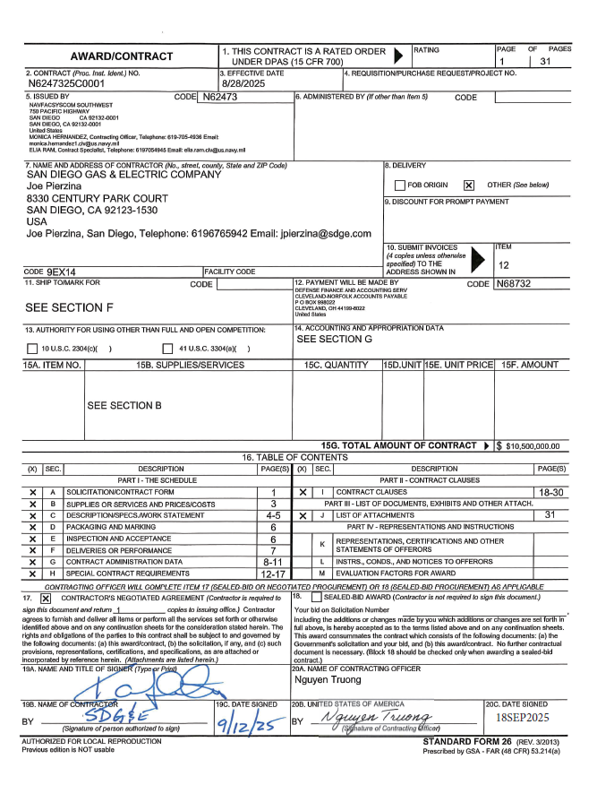
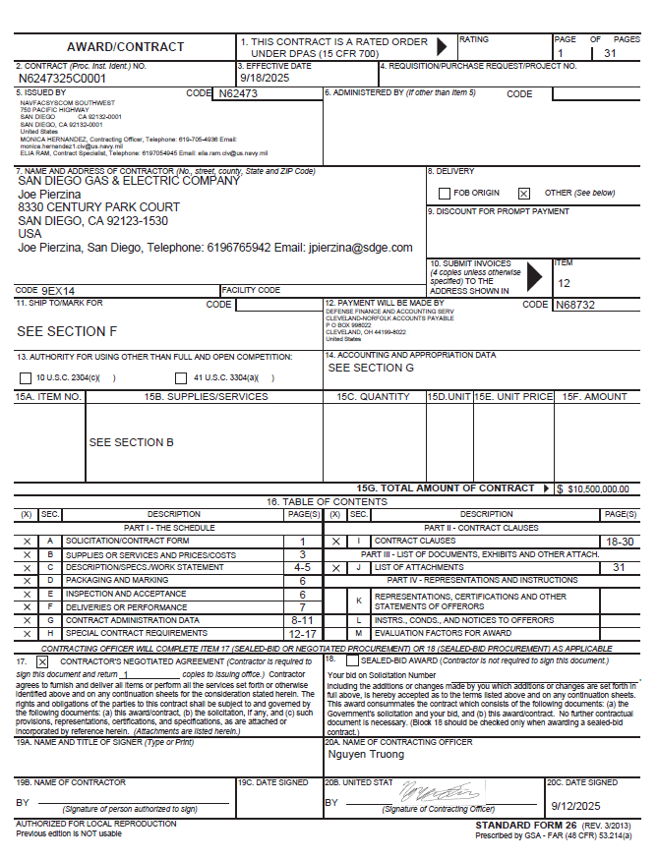
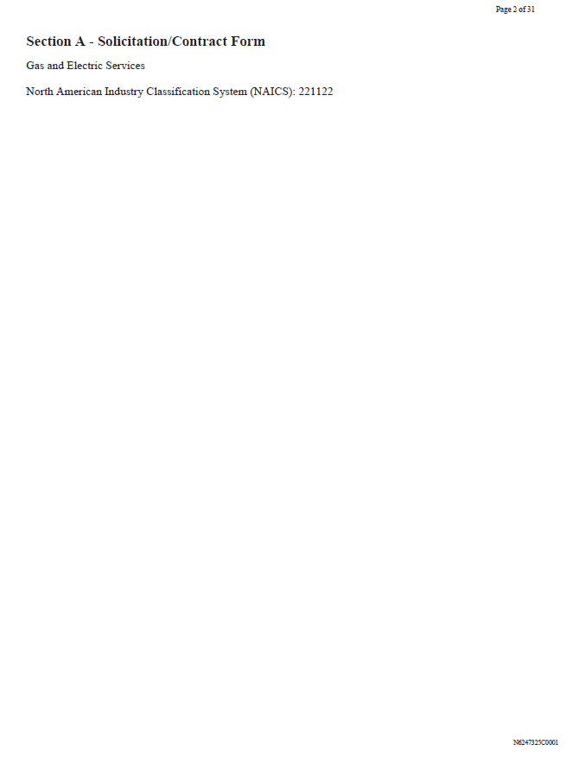
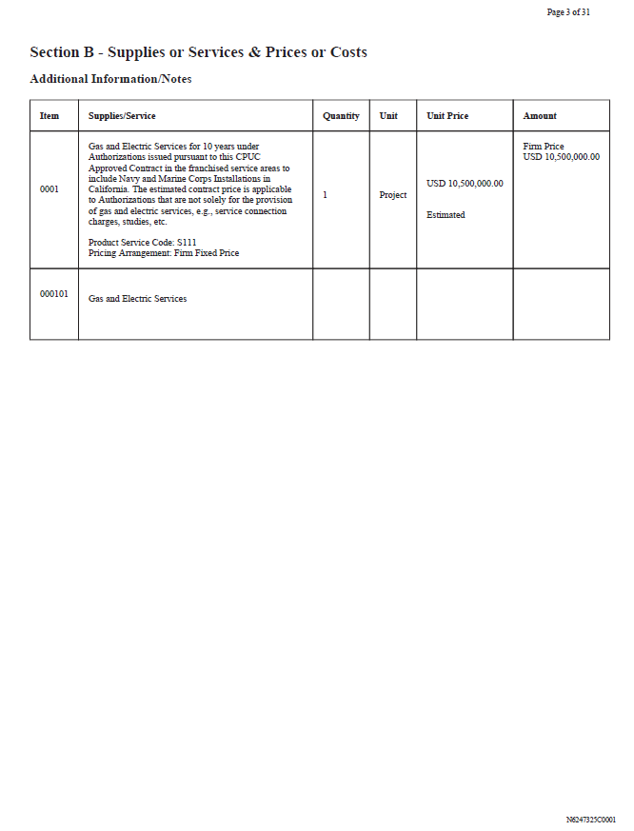
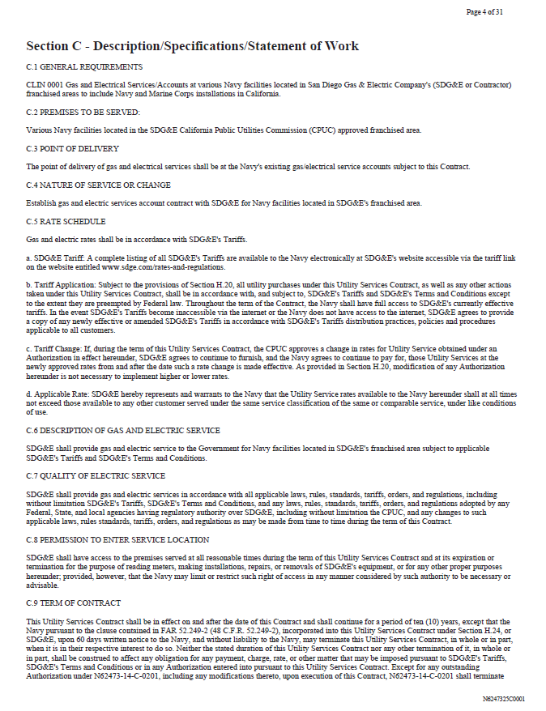
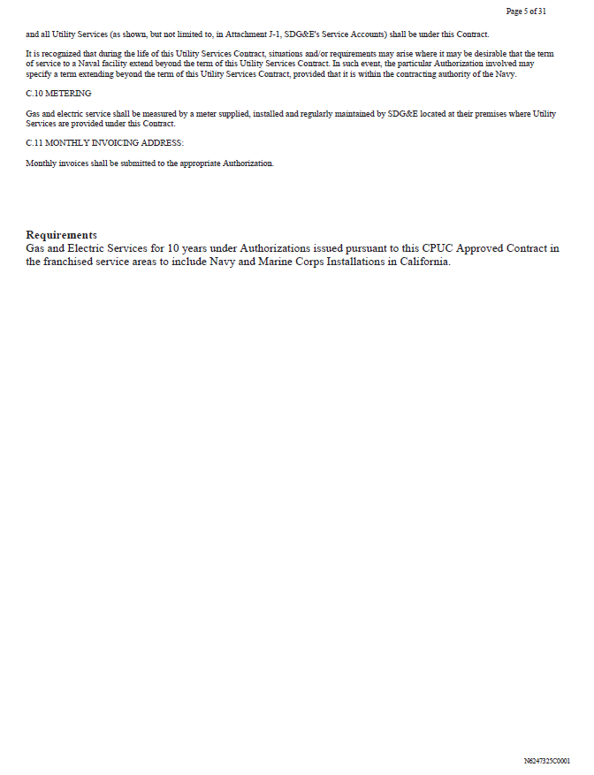
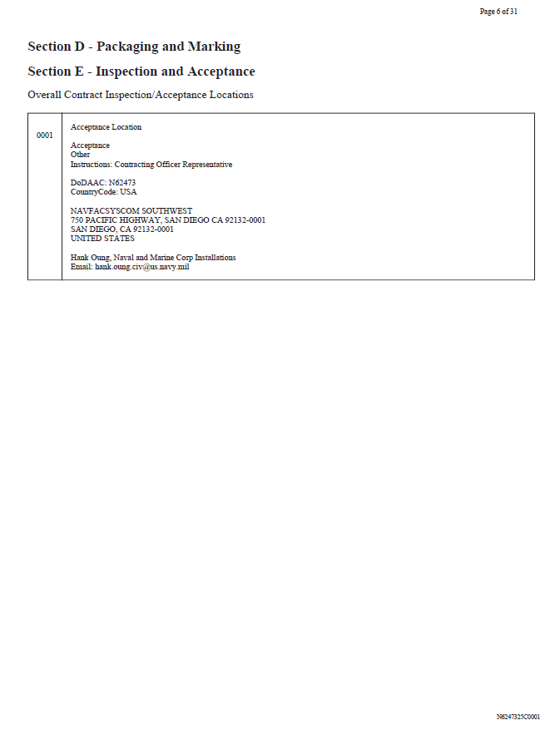
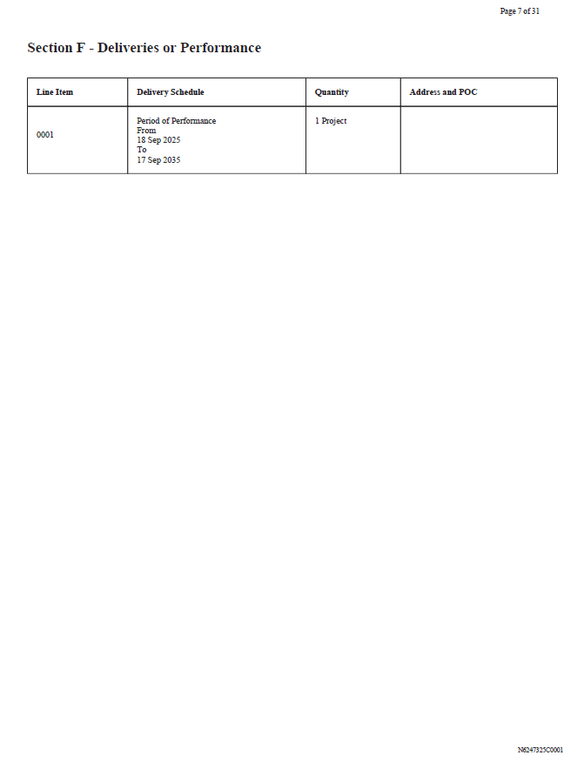
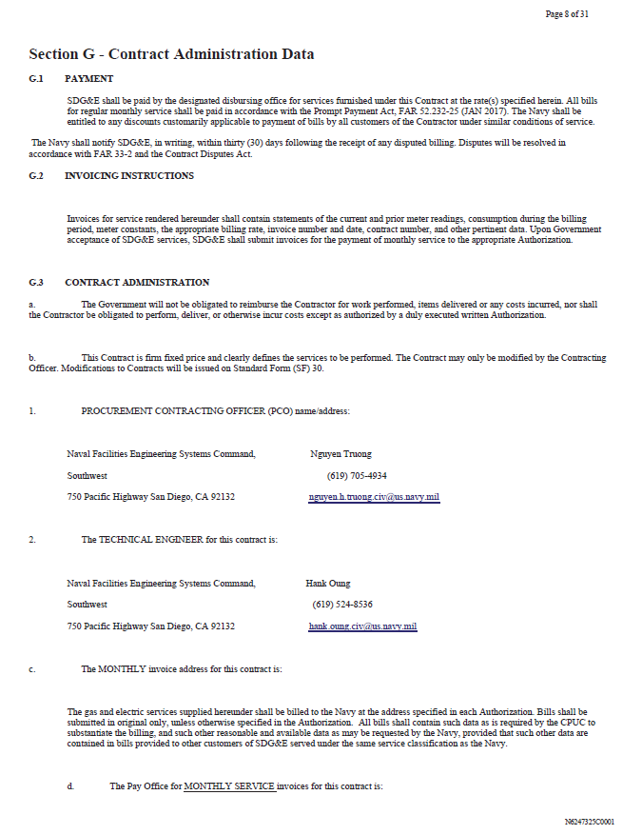
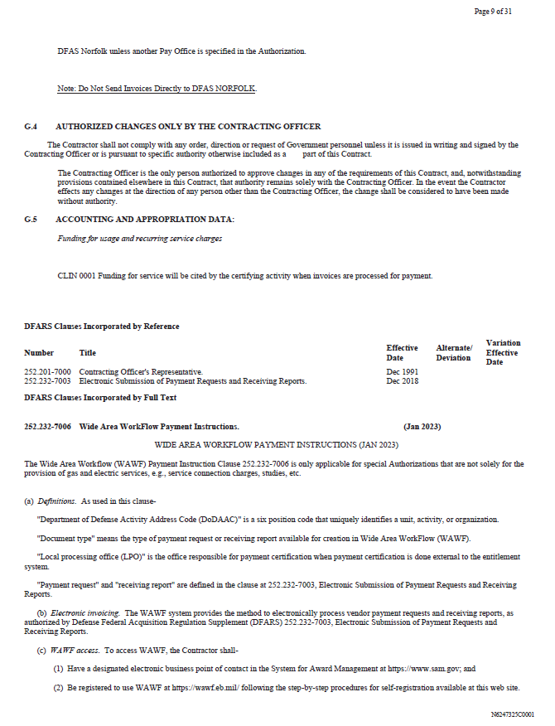
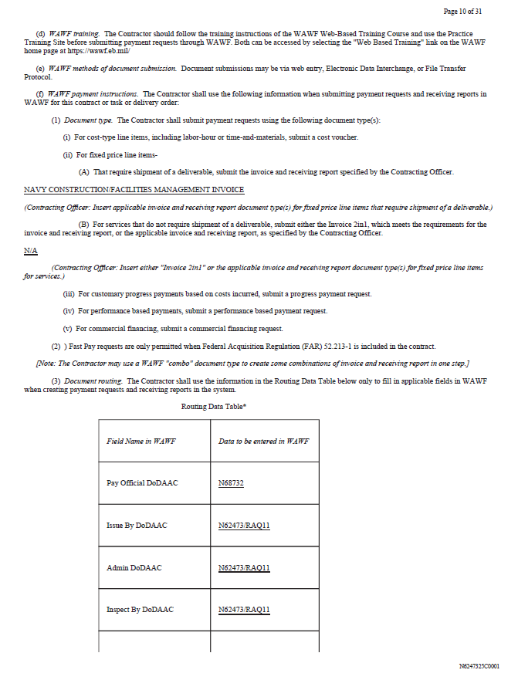
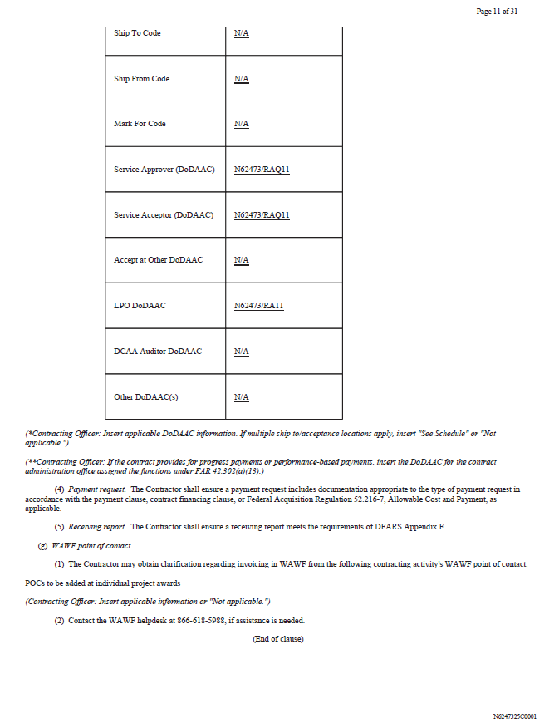
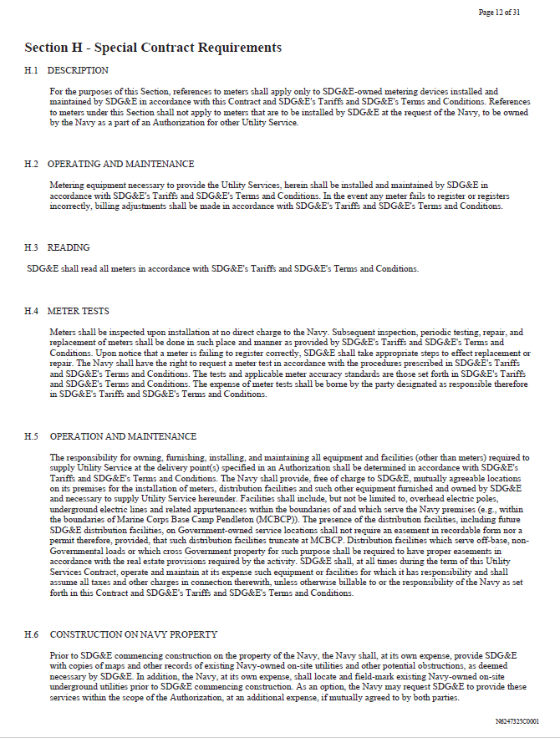
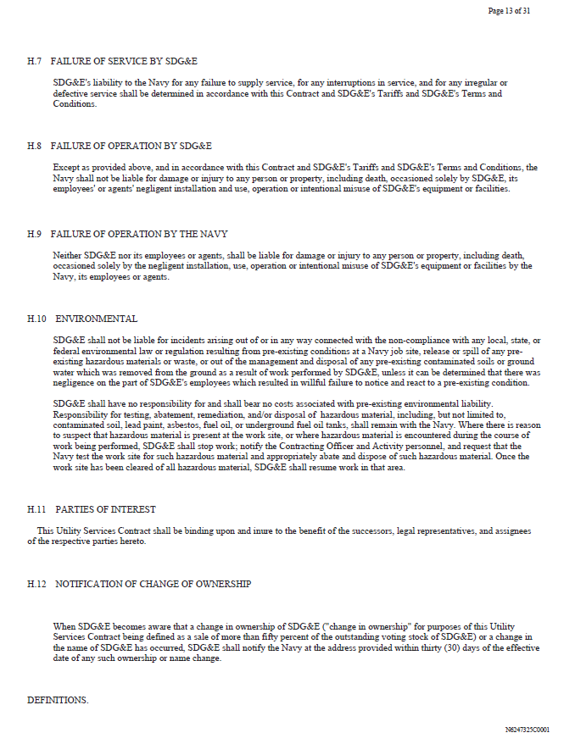
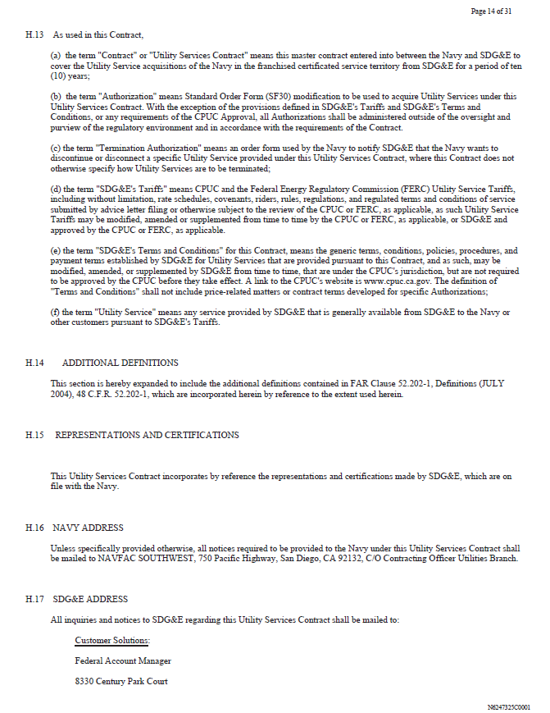
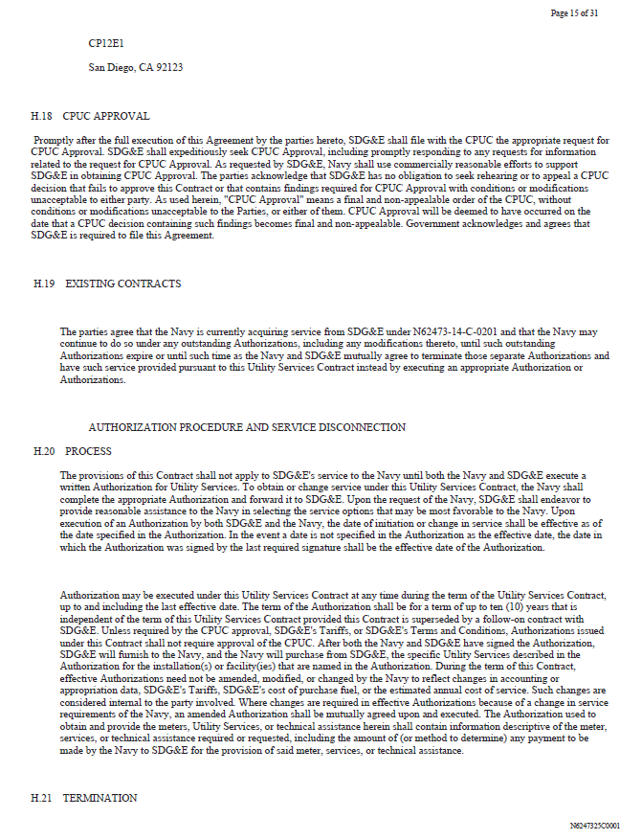
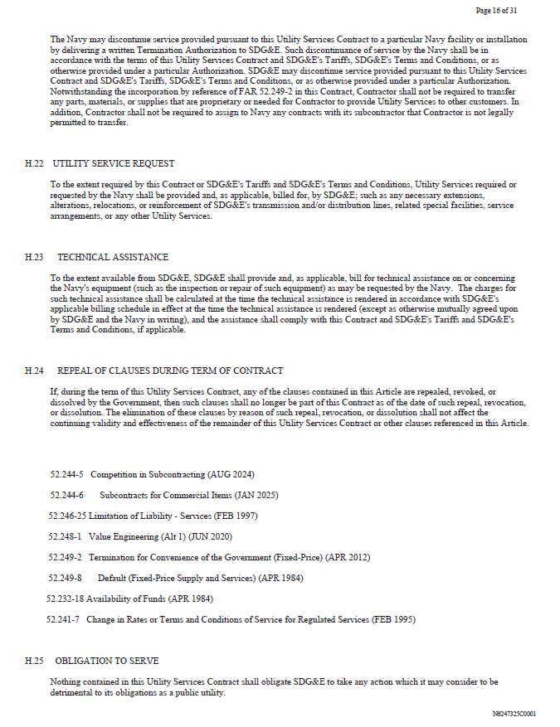
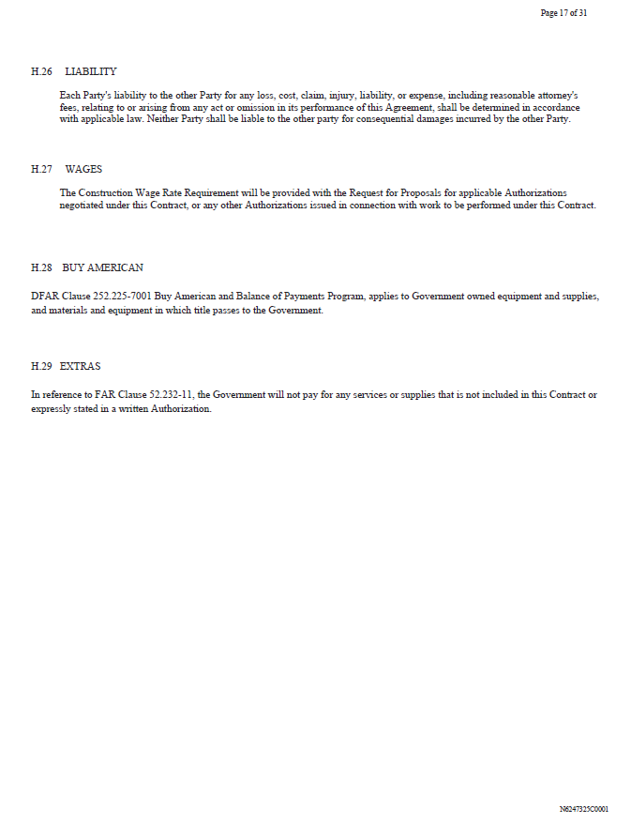
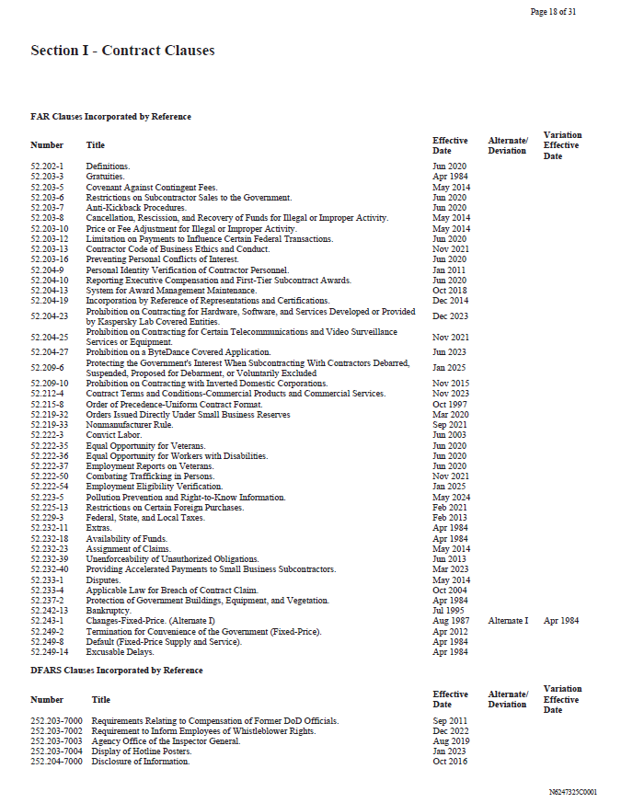
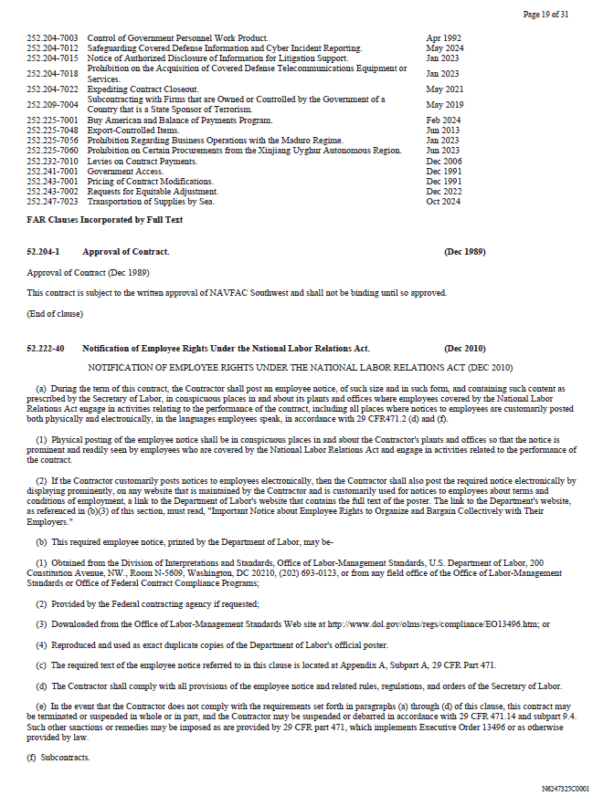
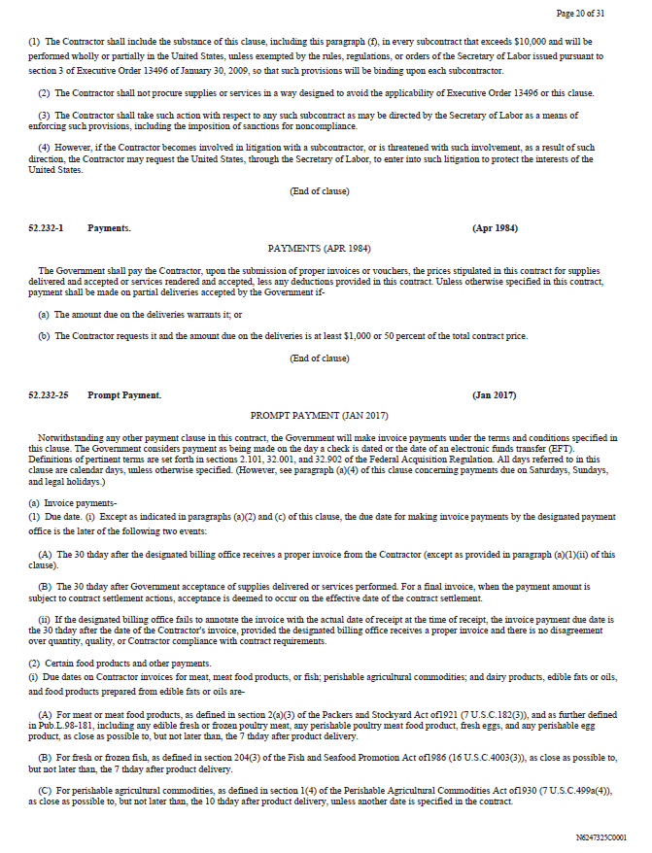
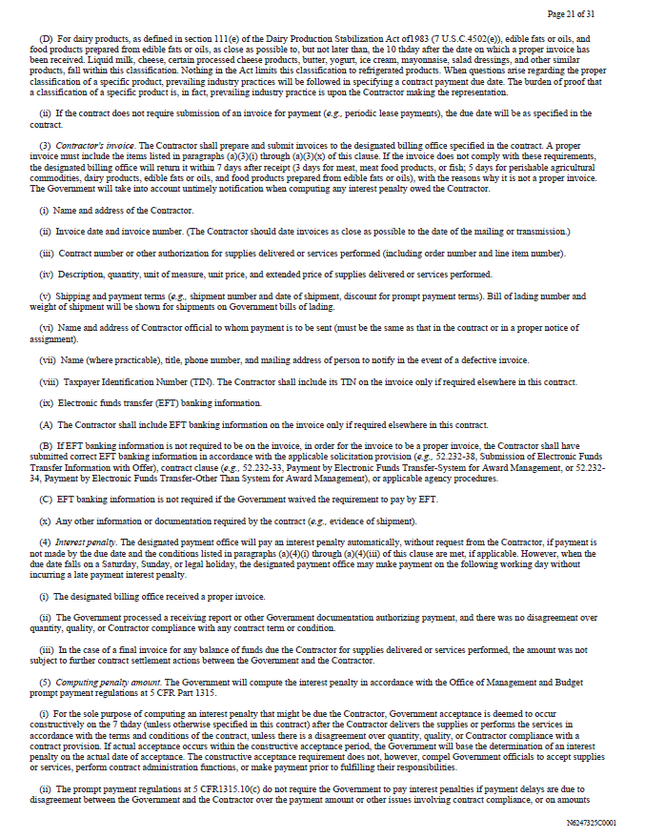
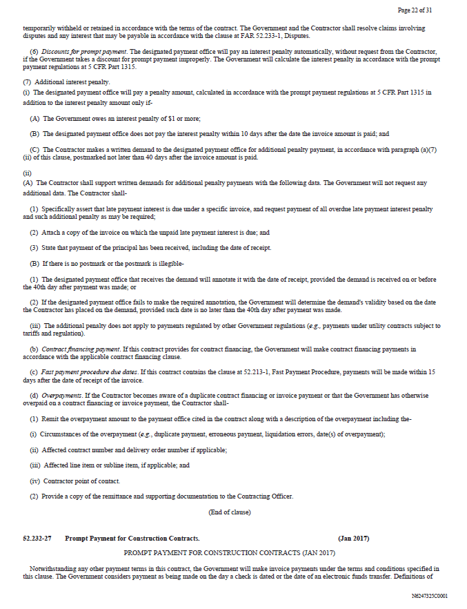
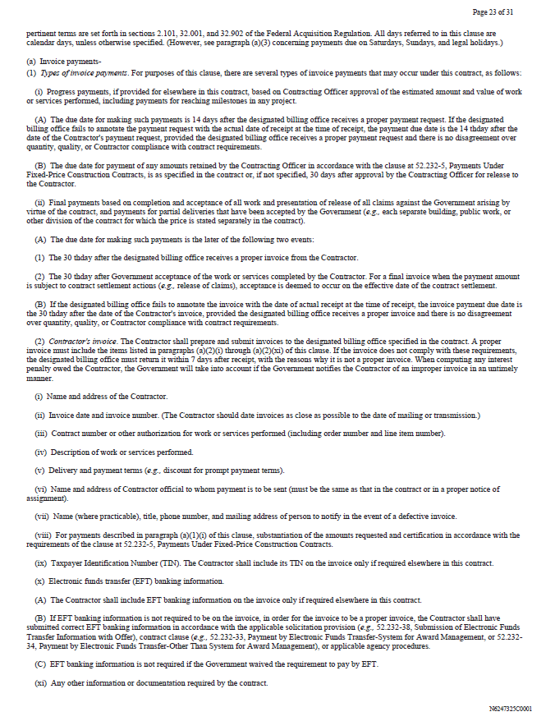
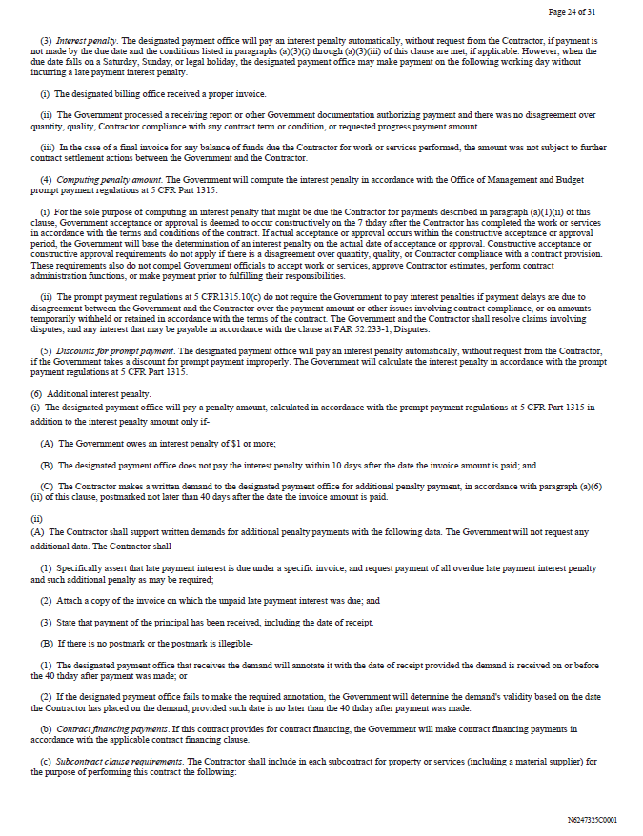
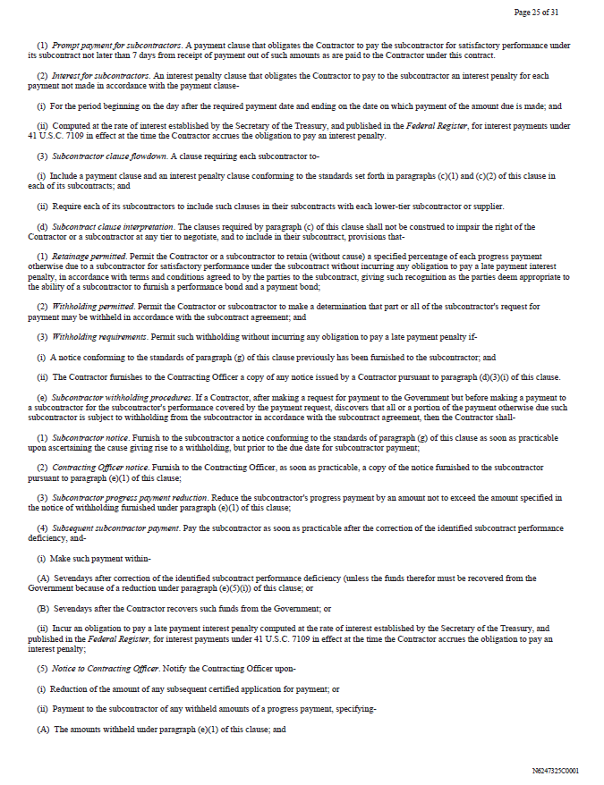
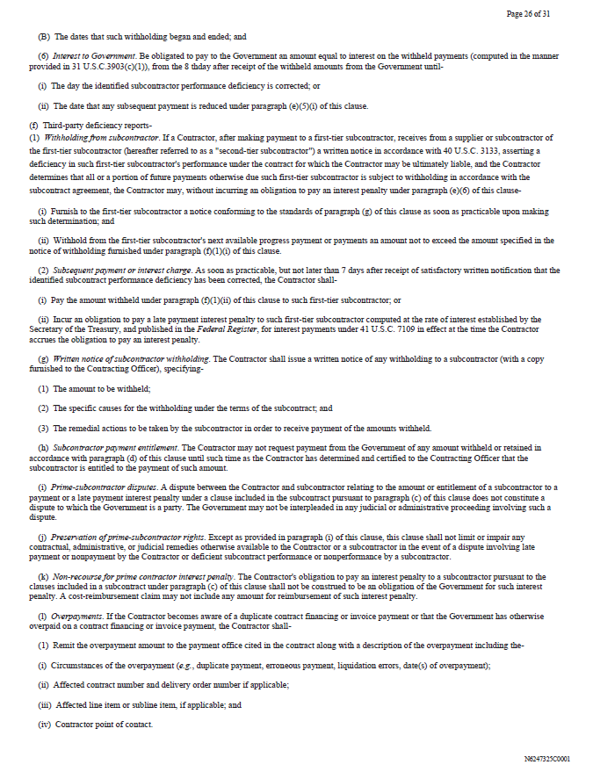
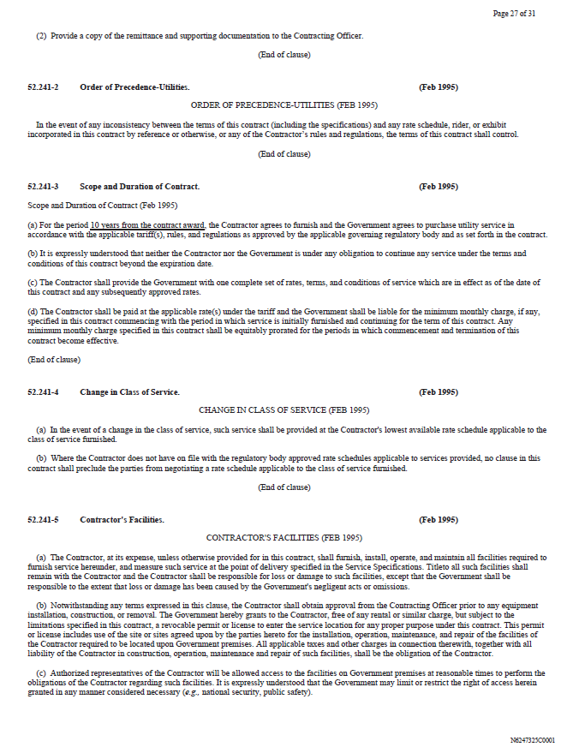
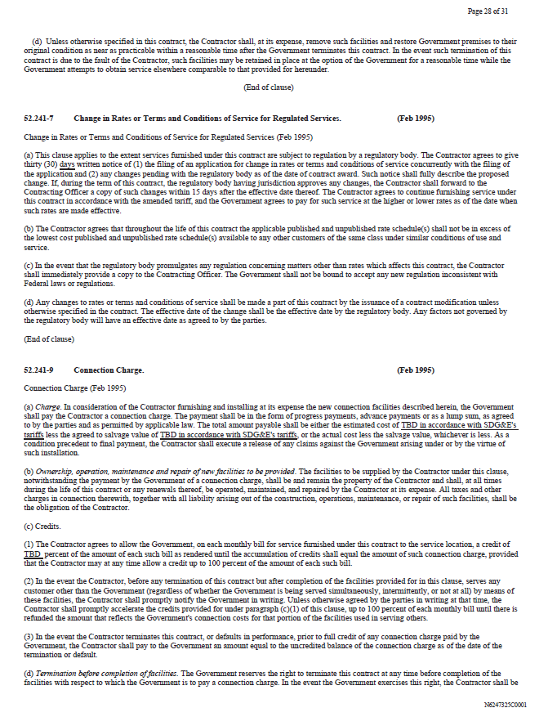

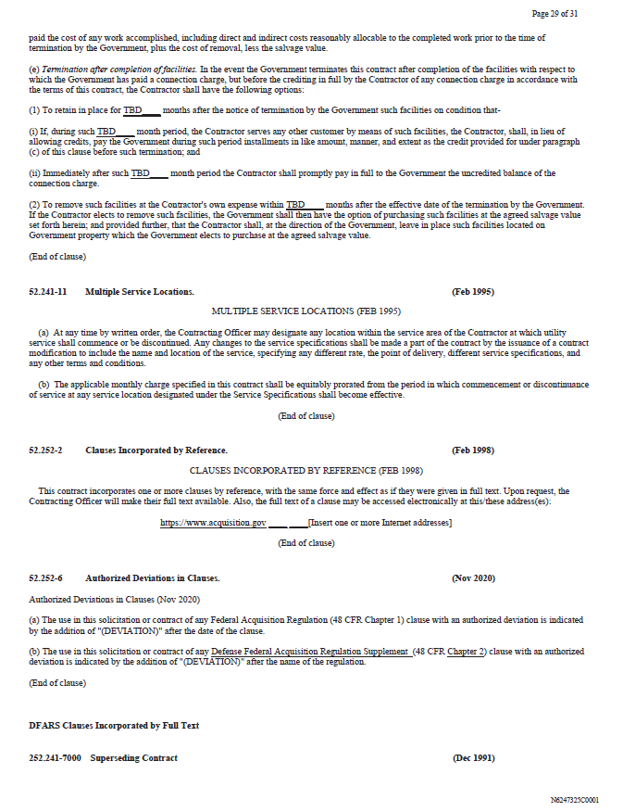
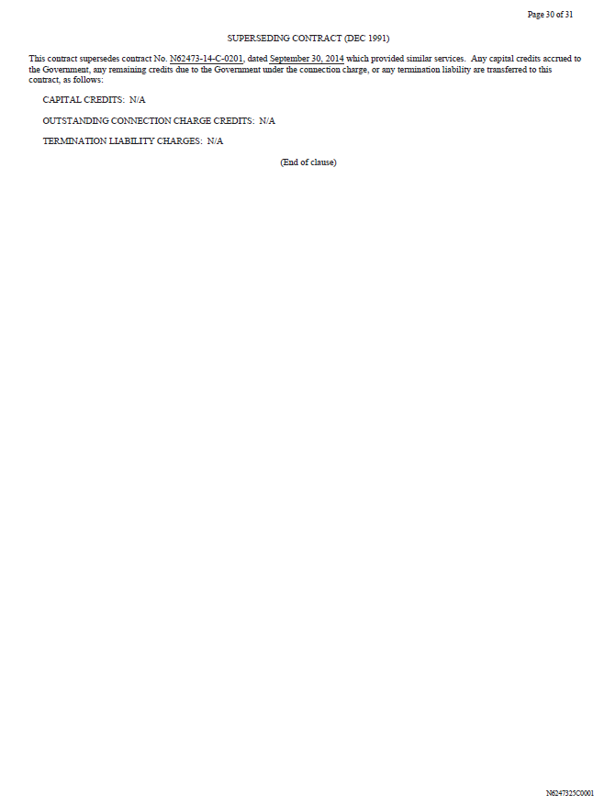
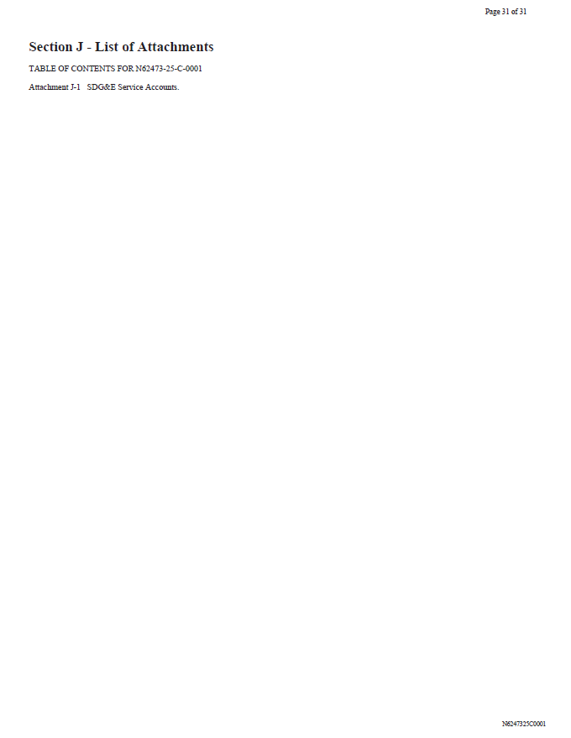

Exhibit B

Table Summary of Revisions to Navy Master Utility Services Contract with San Diego Gas & Electric Company
Table Summary of Revisions to
Navy Master Utility Services Contract with San Diego Gas & Electric Company

Comments | Page Number/Box #/Section Original AL (AL)/  Supplement (NV) | Original AL Version | Change in Supplement (New Version)
Contract Number | Page 1, Box 2 | Contract Number N6247324C4401 | Contract Number N6247325C0001
Effective Date | Page 1, Box 3 | Effective date is October 1, 2024 | Effective Date is August 28, 2025 (NOTE: Parties will use September 18, 2025 (Full contract execution date)); Period of Performance (Section F) is 9/18/25-  9/17/35
Navy Information | Page 1, Box 5 | Lists "PWContracts Core - Utility & Energy, Code RAQ11-UTIL" | Missing and new contact information added
Contract Price | Page 1, Box  15(G)/Page 2, Section B (AL)/Page 3,  Section B (NV) | $0.01 | $10.5MM (applicable to Authorizations that are not solely for provision of gas and electric services, e.g., service  connection charges, studies, etc.)
Section D | Page 1, Box 16 | Sec D not checked and not included | Sec D is now checked but there is no  content in that section
Requirements | Section C - Page 4(AL)/5 (NV) | Blank | New "Requirements" note is added to the end of the section (repeat of language in  Section B)
Section E | Section E - Page 5 (AL)/6 (NV) | Inspection And Acceptance Terms  listed as “N/A”, except for Accept by  Government. | Government Acceptance Location added

Comments | Page Number/Box #/Section Original AL (AL)/  Supplement (NV) | Original AL Version | Change in Supplement (New Version)
Section F | Section F - Page 7  (NV)/ 6 (AL) | Delivery Date: 9/30/34 | Period of Performance is 9/18/25-9/17/35
Fix Typo | Section H.26 –  Page 13 (AL)/17  (NV) | The end of the second sentence says  “that Party” | The end of the second sentence says  “the other Party”.
FAR Addition – Contractor’s Officer’s  Representative | After Section G.5, Page 8 (AL)/9 (NV) | Only includes 252.232-7003 | Adds Section 252.201-7000 (Contractor’s Officer’s Representative)
WAWF Invoicing | After Section G.5, Page 8 (AL)/ 9 (NV) | Only includes 252.232-7003 | Adds Section 252.232-7006 (Wide Area WorkFlow Payment Instructions); contract adds following: “The Wide Area Workflow (WAWF) Payment Instruction Clause 252.232-7006 is only applicable for special Authorizations that are not solely for the provision of gas and electric services, e.g., service connection charges, studies, etc.”

 | Deleted FARs/DFARs
52.203-11 |  | Certification and Disclosure Regarding Payments to Influence Certain Federal Transactions
52.204-4 |  | Reserved
52.204-24 |  | Representation Regarding Certain Telecommunications and Video Surveillance Services or Equipment
52.222-21 |  | Prohibition of Segregated Facilities
52.222-26 |  | Equal Opportunity
52.212-5 |  | Contract Terms and Conditions Required to Implement Statutes or Executive Orders – Commercial Products and Commercial Services
52.223-6 |  | Reserved
52.223-18 |  | Reserved
252.225-7059 |  | Prohibition on Certain Procurements from the Xinjiang Uyghur Autonomous Region-Represenation
52.204-26 |  | Covered Telecommunications Equipment or Services-Representation
52.232-34 |  | Payment by Electronic Funds Transfer – Other than System for Award Management
52.241-6 |  | Service Provisions
252.204-7008 |  | Compliance with Safeguarding Covered Defense Information Controls
252.225-7059 |  | Prohibition on Certain Procurements from the Xinjiang Uyghur Autonomous Region -Representation
New FARs/DFARs
52.232-11 |  | Extras. Also, language was inserted into the contract that provides that “Government will not pay for any services or  supplies that is not included in this Contract or expressly stated in a written Authorization.” (Page 17)
252.225-7001 |  | Buy American and Balance of Payments Program. Also, language was inserted into the contract that provides that  “applies to Government owned equipment and supplies, and materials and equipment in which title passes to the  Government.” (Page 17)
52.204-1 |  | Approval of Contract. Inserted to confirm that contract is subject to written approval of NAVFAC Southwest and is not  binding until so approved. (Page 19)
52.241-9 |  | Connection Charge (Previously only incorporated by reference) – TBDs were inserted indicating blanks would be filled  pursuant to SDG&E’s tariffs (Pages 28-29)
252.241-7000 |  | Superseding Contract. Required by Navy; inserts indicate that there are no credits due to Government or transfer of  termination liability. (Pages 29-30)

Updated FARs/DFARs
Number | AL Version | New Version | Title
52.204-23 | 11/21 | 12/23 | Prohibition on Contracting for Hardware, Software, and Services  Developed or Provided by Kaspersky Lab Covered Entities
52.209-6 | 11/21 | 1/25 | Protecting the Government’s Interest When Subcontracting With Contractors Debarred, Suspended, Proposed for Debarment, or  Voluntarily Excluded
52.212-4 | 12/22 | 11/23 | Contract Terms and Conditions – Commercial Products and  Commercial Services
52.222-54 | 5/22 | 1/25 | Employment Eligibility Verification
52.223-5 | 5/11 | 5/24 | Pollution Prevention and Right-to-Know Information
252.204-7012 | 1/23 | 5/24 | Safeguarding Covered Defense Information and Cyber Incident  Reporting
252.247-7023 | 1/23 | 10/24 | Transportation of Supplies by Sea
52.244-5 | 12/96 | 8/24 | Competition in Subcontracting
52.244-6 | 2/24 | 1/25 | Subcontracts for Commercial Products and Commercial  Services
52.248-1 | 4/84 | 6/20 | Value Engineering

8.2.3 Emergency Service; Service to Government Agencies At all times, a utility other than a telephone corporation may provide service (other than resale service) to a government agency for free, or at reduced rates and charges, or under terms and conditions otherwise deviating from its tariffs then in effect. The utility may begin such service without prior Commission approval, but the utility shall promptly submit an advice letter to the appropriate Industry Division to notify the Commission of the utility's provision of such service and of the rates, charges, terms and conditions under which the service is provided. Although the advice letter may be effective pending disposition under General Rule 7.5.3, the Commission may determine, in an appropriate proceeding, the reasonableness of such service. For purposes of this General Rule 8.2.3, "government agency" means the United States and its departments, Indian tribes recognized by the United States or the State of California, the State of California and its political subdivisions and municipal corporations, including the departments thereof, and public fairs and celebrations.

