ALJ/KWZ/jds Date of Issuance 09/09/2026

Decision 26-09-043 September 8, 2026

BEFORE THE PUBLIC UTILITIES COMMISSION OF THE STATE OF CALIFORNIA
Order Instituting Rulemaking to Establish a Framework and Processes for Assessing the Affordability of Utility Service. | Rulemaking 18-07-006

ORDER CORRECTING ERROR
The Commission has been informed of an error in Decision (D.) 26-08-023. Therefore, pursuant to Resolution A-4661, IT IS ORDERED that D.26-08-023 is corrected as follows:
- On page 2, Part I.B.15 of D.26-08-023, under CPUC Verification, the entry is corrected from “Verified” to “Not verified, corrected to February 19, 2026.”
Dated September 8, 2026, at San Francisco, California.

/s/ 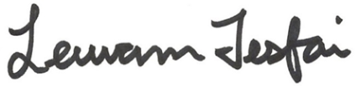
Leuwam Tesfai
Executive Director

