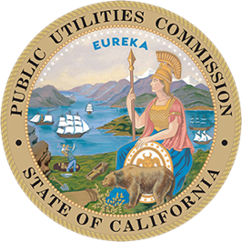
California Public Utilities Commission
505 Van Ness Ave., San Francisco

_________________________________________________________________________________
FOR IMMEDIATE RELEASE PRESS RELEASE
Media Contact: Terrie Prosper, 415.703.1366, news@cpuc.ca.gov

CPUC Staff Issue Proposal Penalizing Liberty Utilities $16 Million
for Involvement in 2020 Mono County Fire

SAN FRANCISCO, Sept. 25, 2026 – The California Public Utilities Commission’s (CPUC) Safety and Enforcement Division today issued a proposed Administrative Enforcement Order that would penalize Liberty Utilities $16 million for violations related to the 2020 Mountain View Fire in Mono County.

Today’s action, part of the CPUC’s ongoing efforts to hold utilities accountable for causing catastrophic wildfires, is called an Administrative Enforcement Order. It is issued under the CPUC’s Enforcement Policy, which was adopted in November 2020 to better serve Californians through expeditious and efficient enforcement actions initiated and performed by CPUC staff.

Under the Administrative Enforcement Order, Liberty has 30 days either to agree to pay the required penalty to the state’s General Fund upon the CPUC’s adoption of a Final Order, or to request a hearing.

The Mountain View Fire ignited in a field adjacent to 106834 US-395 in Coleville on Nov. 17, 2020, and burned approximately 20,835 acres of land, resulted in the death of one person and injured at least one other, and destroyed or damaged 97 homes and structures.

Cal Fire and CPUC investigators determined that a power line owned by Liberty that failed and made contact with the ground, igniting cured annual grasses, is the most likely cause of the Mountain View fire.

The CPUC’s Safety and Enforcement Division investigation into the Mountain View Fire and of Liberty’s infrastructure found multiple violations of General Order 95, a CPUC regulation that sets forth the design, construction, and maintenance of overhead electrical lines and communications facilities.
More Information
- Today’s Administrative Enforcement Order (under the Administrative Enforcement Order sub-headline)
###
About the California Public Utilities Commission
The CPUC regulates services and utilities, protects consumers, safeguards the environment, and assures
Californians access to safe and reliable utility infrastructure and services. Visit www.cpuc.ca.gov for
more information.

