RSCD/TAH/RRT/JAE/u13/vdl DRAFT CA-20
2/7/02

Decision

BEFORE THE PUBLIC UTILITIES COMMISSION OF THE STATE OF CALIFORNIA

Application of the Santa Clara Valley Transportation Authority for an order authorizing construction of at-grade crossings of Race Street (82D-4.5) and Parkmoor Avenue (82D-4.6), and an at-grade pedestrian crossing at Race Station (82D-4.4) by the light rail transit line of the Vasona Light Rail Project in the City of San Jose, County of Santa Clara. | Application 01-05-063  (Filed May 29, 2001)

O P I N I O N

Summary
Santa Clara Valley Transportation Authority (VTA) requests authority to construct at-grade crossings of Race Street and Parkmoor Avenue, and an at-grade pedestrian crossing at Race Station by the light rail transit line (LRT) of the Vasona Light Rail Project in the City of San Jose, Santa Clara County.

Discussion
VTA was created as a County department by the Santa Clara County Board of Supervisors on June 6, 1972 to oversee the region's transportation system. VTA's primary responsibility since its creation has been the development, operation and maintenance of the bus and light rail system within the County. VTA separated from the County of Santa Clara and merged with the region's Congestion Management Agency in January 1995; it thereby gained the additional responsibility of managing the County's blueprint to reduce congestion and improve air quality.
The Vasona Light Rail Project will be an extension to the existing 28.6-mile VTA light rail system (see Appendix A). The alignment of the proposed Vasona Corridor extends from downtown San Jose to the Vasona Junction in City of Los Gatos. The northerly terminus of the alignment is at the intersection of West San Carlos Street and Woz Way in downtown San Jose, where the Vasona line connects to the existing Guadalupe Corridor line. From this point, the alignment extends to the west San Carlos Street to Delmas Avenue, passing under State Route 7. The line extends north along the east side of Delmas Avenue to San Fernando Street, at which point the alignment turns west again. The line continues to the San Jose/Diridon Station on an alignment to the north of San Fernando Street, crossing Los Gatos Creek on a proposed new bridge. The segment west of Autumn Street, including the location where the line crosses the existing Union Pacific Railroad Company’s (UP) and Peninsula Corridor Joint Powers Board’s (Caltrain) Diridon Yard tracks, is underground. After crossing under the yard tracks at the San Jose/Diridon Station, the alignment returns to the surface and heads in a southerly direction along the west side of the Diridon Yard tracks. From a point just south of Park Avenue, the proposed alignment utilizes the existing Vasona railroad corridor. The project remains within the railroad corridor all the way to the Vasona Junction in City of Los Gatos. Existing freight rail service in this corridor will continue unchanged, although the existing single track will be relocated in many areas to allow for construction of the light rail tracks.
The proposed project is expected to be funded in three phases. Phase 1 constructs the portion of the project from downtown San Jose to the Downtown Campbell Station. Phase 2 extends the LRT line from the Downtown Campbell Station to the Winchester Station. Phase 3 extends the LRT line from the Winchester Station to the Vasona Junction Station in Los Gatos.
The LRT facility tracks will cross Race Street, Parkmoor Avenue and the Race Station pedestrian crossing at-grade. The at-grade crossings proposed here are the most financially and environmentally acceptable choice and are in keeping with the open access concept of LRT. Alternatives to at-grade crossings are: depressing the streets below the tracks, depressing the tracks below street level, elevating the streets above track level and elevating the tracks above street level. Each of these alternatives may be physically impossible at this site. Other problems would also be created with a grade-separated crossing, such as conflicts with existing developments and utilities, noise generation, aesthetic impacts and the creation of possible hazards due to flooding caused by depressing rail or street facilities. Construction of this project serves the public by providing efficient transportation in a growing area of the Santa Clara Valley.
VTA is the lead agency for this project under the California Environmental Quality Act of 1970 (CEQA), as amended, Public Resources Code Section 21000 et seq. A Draft Environmental Impact Report (EIR) for the Vasona Corridor Light Rail Transit Project was released to the public in October 1999, beginning the formal review period. VTA prepared a Final EIR/Final Environmental Impact Statement (EIS) in March 2000 in accordance with CEQA and the National Environmental Policy Act (NEPA). The EIS/EIR evaluated the proposed rail transit project and several alternatives. Public scoping meetings were held on April 14-15, 1999, at which meetings, the light rail project was discussed at length with local citizens in the surrounding communities. In addition, there had been previously a period of public comment wherein local citizens were asked to write in their comments and concerns regarding impact on their properties or other pertinent matters. Comments by the public, where feasible, were incorporated into the environmental documents and considered in the preparation of the EIS/EIR of the Light Rail Corridor.
On May 8, 2000, a Notice of Determination was filed with the State Secretary of Resources - Office of Planning and Research, Sacramento and the County Clerk Recorder's Office - Santa Clara County, City of San Jose. The Notice of Determination, which is included in Appendix C, advised all interested parties that the VTA was in compliance with Section 21108 of the California Public Resources Code.
VTA has approved the proposed project, as the environmentally superior alternative, and further stated that:
- The project will not have a significant effect on the environment.
- A Final EIR was prepared for this project pursuant to the provisions of CEQA.
- Mitigation measures were made a condition of the approval of the project.
- A Statement of Overriding Considerations was not adopted for this project.
- Findings were made pursuant to the provisions of CEQA.
A certification was made that the Final EIR with comments, responses and record of the project approval was made available to the general public at the Environmental Analysis, Building B in the City of San Jose on May 5, 2000.
The Commission is a responsible agency for this project under CEQA (Public Resources Code Section 21000 et seq.). CEQA requires that the Commission consider the environmental consequences of a project that is subject to its discretionary approval. In particular, to comply with CEQA, a responsible agency must consider the lead agency's EIR or Negative Declaration prior to acting upon or approving the project (CEQA Guideline Section 15050 (b)). The specific activities that must be conducted by a responsible agency are contained in CEQA Guideline Section 15096. The site of the proposed project has been inspected by the Commission's Rail Safety and Carriers Division — Rail Crossings Engineering Section staff. Staff examined the need to construct the proposed crossings, as indicated in the exhibits attached to the application, and recommends that the application be approved.
The Commission has reviewed the lead agency environmental documents. The EIS/EIR included an analysis of potential environmental effects, including impacts related to transportation and traffic, air quality, noise and vibration, energy, land use, socio-economics and environmental justice, vegetation and wildlife, water quality, floodplains, geology, hazardous materials, magnetic fields and interference, cultural resources, aesthetic considerations, safety and security, construction and growth-inducing impacts.
The EIS analyzed 35 potential environmental impacts. Of that number, 17 were found to have no effect, be not substantial, potentially beneficial or beneficial; 18 were found to have potentially substantial or substantial effects. However, mitigation measures were adopted and will be implemented as specified by the lead agency to either eliminate or substantially lessen those environmental impacts. Safety, security, transportation and noise are within the scope of the Commission’s permitting process. Accordingly, we considered the following relevant information.
The proposed project will reduce overall vehicle-miles-traveled (VMT) and vehicle-hours-traveled (VHT) in Santa Clara County. Reducing traffic congestion will also reduce auto emissions that degrade air quality. This is a beneficial impact because a decrease in VMT and VHT reduces congestion, air pollution and energy consumption.
The lead agency environmental review did not identify any impacts from the project related to safety and security. One significant transportation impact was identified at an existing railroad crossing located between Sunnyoaks and Hacienda Avenues. This will be mitigated to a less-than-significant level by pavement modifications or lane stripping, and signs on northbound Winchester Blvd.
Noise impacts were identified as exceeding Federal Transit Administration (FTA) thresholds at various residences located along the alignment as well as vibration levels, which may exceed FTA thresholds at those locations. These impacts would be mitigated to less-than-significant levels by mitigation measures including the construction of soundwalls, building modifications, if required, and the use of vibration-dampening track construction materials and/or trenches, if required. In addition, special track design and lubrication will be employed to reduce wheel squeal.
Although not within the Commission’s direct permitting authority for this project, we also noted the following impacts and mitigations. Socio-economic impacts will be less than significant, as the project will not result in disproportionate impacts to minority or low-income populations. No neighborhoods will be divided and no cultural or religious facilities will be impacted by the project.
The proposed project will not result in significant air quality impacts. In fact, the project is anticipated to result in a beneficial impact on regional air quality. Furthermore, the proposed project conforms to the requirements of the federal Clean Air Act.
The project will provide opportunities for joint development at various locations. Joint development, sometimes referred to as Transit-Oriented Development, has overall beneficial land use impacts because it allows for high-density infill with easy transit access.
The proposed project will not result in significant long-term water quality impacts. However, the proposed project could result in significant short-term water quality impacts during construction. The short-term impacts would be reduced to a less-than-significant level by the mitigation measures being implemented.
As to each of the potentially substantial or substantial impacts identified in the EIS/EIR within the scope of the Commission's permitting authority and discussed above, the Commission finds the lead agency adopted feasible mitigation measures to either eliminate or substantially lessen the impacts to less-than-significant levels.
Protection at the crossings shall be as indicated by text, plans attached to the application and as further described by Appendices A and B of this order.
The application is in compliance with the Commission's filing requirements, including Rules 38 to 41 of the Rules of Practice and Procedure. A site map of the grade crossing is as shown on plans attached to the application as Appendix A.
In Resolution ALJ 176-3065, dated June 14, 2001 and published in the Commission Daily Calendar on June 15, 2001, the Commission preliminarily categorized this application as ratesetting, and preliminarily determined that hearings were not necessary. Since no protests were filed and no hearings were held, this preliminary determination remains accurate. The Commission’s Rail Safety and Carriers Division recommends that this application be granted. Given these developments a public hearing is not necessary, and it is not necessary to disturb the preliminary determinations made in Resolution ALJ 176-3065.
This is an uncontested matter in which the decision grants the relief requested. Accordingly, pursuant to Public Utilities Code Section 311 (g)(2), the otherwise applicable 30-day period for public review and comment is being waived.
Findings of Fact
- Notice of the application was published first in the Commission Daily Calendar on June 1, 2001. There are no unresolved matters or protests; a public hearing is not necessary.
- VTA requests authority to construct at-grade crossings at Race Street and Parkmoor Avenue, and an at-grade pedestrian crossing at Race Station by the LRT line of the Vasona Light Rail Project in San Jose, Santa Clara County, as more fully described by text and as indicated by plans attached to the instant application and Appendices A, B, C and D of this order.
- Construction of the proposed project is an essential element in the construction of the Vasona Light Rail Extension Project. The project is required in order to provide quality and accessible public transportation system in the Vasona/Highway 17 Corridor area within the Cities of San Jose, Campbell and Los Gatos. The goal is to construct a system that is convenient, is integrated with other rail and bus service, and which minimizes environmental effects on existing land uses to the extent practical. The benefits of the project include a reduction in automobile trips, improvements in air quality and a reduction in energy usage.
- Santa Clara County, referred to as Silicon Valley, contains many high-tech companies from other nations. The growth of that industry has resulted in substantial increases in jobs and population in the County, and such growth is projected to continue.
- The substantial growth and development that has taken place in Santa Clara County during the last decades has caused transportation system deficiencies in the Vasona Corridor, as well as throughout the County. To address the resulting increase in traffic demand on the County's transportation system, a comprehensive transportation plan was established. The plan identified the future deficiencies in the County's transportation system by identifying the planned transportation system improvements in relation to the existing need and anticipated population growth. One of the conclusions of the plan was that the Vasona Corridor was an important corridor to be considered for future transit improvements.
- Public convenience and necessity require the construction of the at-grade crossings.
- Public safety requires that the at-grade crossings be protected as indicated in the application and as more fully described in Appendices A and B of this order.
- VTA is the lead agency for this project under the CEQA, as amended, and the NEPA.
- VTA prepared a Final EIR and a Final EIS in March 2000, State Clearinghouse Document #99032027, as shown in Appendix D.
- The Final EIS/EIR was approved by U.S. Department of Transportation, Federal Transit Administration, pursuant to (State) Division 13, Public Resources Code (Federal) 42 U.S.C 4332 (2) (c) on May 15, 2000.
- A Notice of Determination was filed on May 8, 2000, with the State Secretary of Resources - Office of Planning and Research, which stated that "the project will not have a significant effect on the environment."
- The EIS/EIR analyzed 35 potential environmental impacts. Of that number, 18 were found to have potentially substantial or substantial effects. However, mitigation measures were adopted and will be implemented as specified by the lead agency to either eliminate or substantially lessen those environmental impacts.
- Safety, security, transportation and noise are within the scope of the Commission's permitting authority.
- The Commission is a responsible agency for this project, and has reviewed and considered the lead agency's Final EIS/EIR for the Vasona Corridor Light Rail Transit Project, prepared for and approved by the FTA and the VTA.
- The EIS/EIR did not identify any impacts from the project related to safety and security.
- The Commission finds that for each potentially substantial environmental impact identified in the EIS/EIR within the scope of the Commission's permitting authority and as discussed in this decision, the lead agency adopted feasible mitigation measures to eliminate or substantially lessen the impacts to less than significant levels.
Conclusion of Law
The application should be granted as set forth in the following order.

ORDER

IT IS ORDERED that:
- Santa Clara Valley Transportation Authority (VTA) is authorized to construct at-grade crossings to be identified as Race Street Crossing 82D-4.5, Parkmoor Avenue Crossing 82D-4.6, and an at-grade pedestrian crossing at Race Station, to be identified as 82D-4.4, by the LRT line of the Vasona Light Rail Project in City of San Jose, Santa Clara County, as set forth in Appendix A, and as more fully described in the application.
- Clearances and walkways shall be in accordance with General Order 143-B.
- Protection at the crossing shall be as indicated by text, plans attached to the application and as further described by Appendices A and B of this order.
- Construction and maintenance costs shall be borne in accordance with an agreement, which has been entered into between the parties. A copy of the agreement shall be filed with the Commission prior to starting construction.
- Within 30 days after completion of the work under this order, VTA shall notify the Commission in writing that the authorized work was completed.
- This authorization shall expire if not exercised within two years unless time is extended or if the above conditions are not complied with. Authorization may be revoked or modified if public convenience, necessity, or safety so require.
- The application is granted as set forth above.
- Application 01-05-063 is closed.
This order becomes effective 30 days from today.
Dated , at San Francisco, California

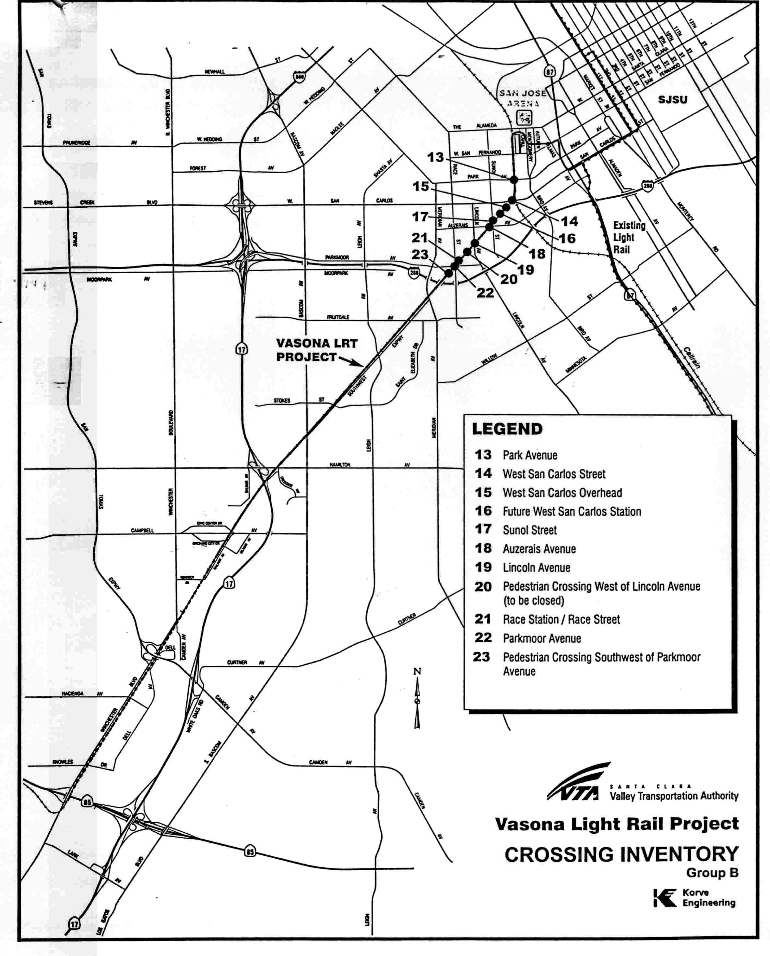

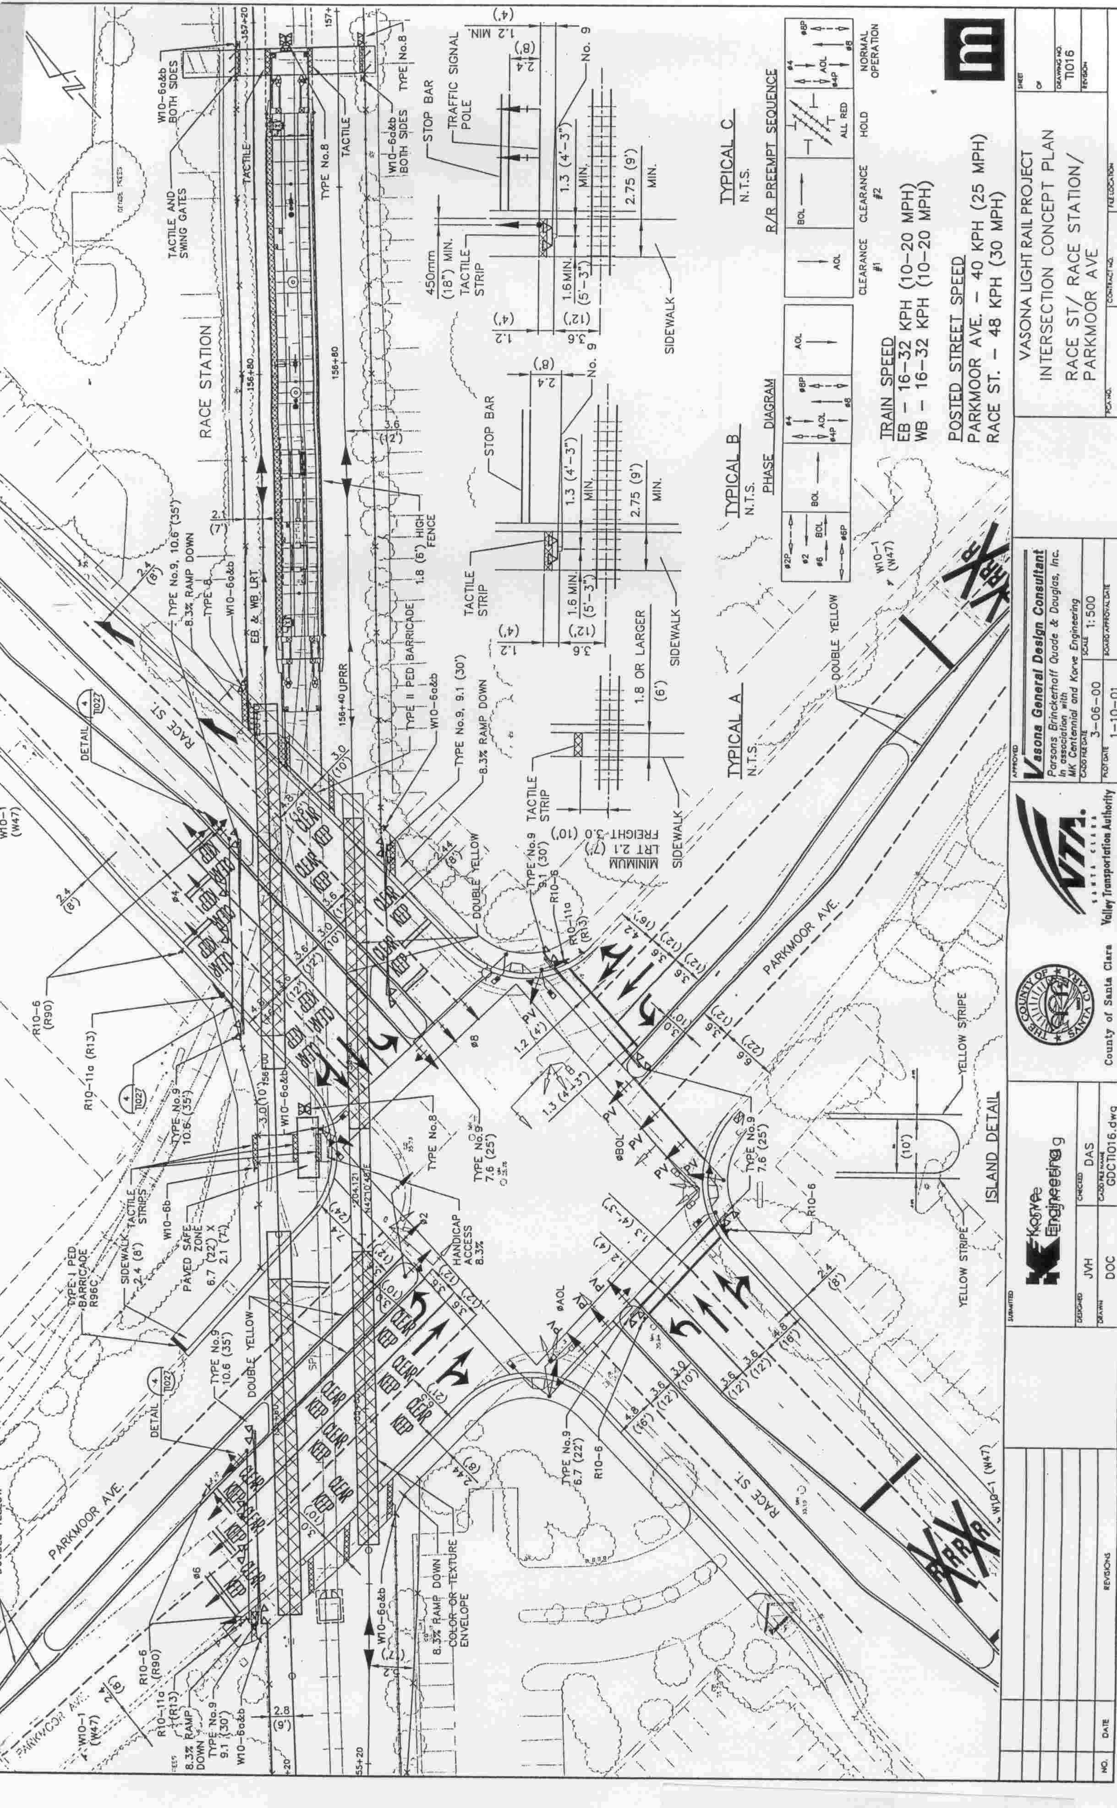
(End of Appendix A)
APPENDIX B

As part of the project to construct a LRT system, the Santa Clara Valley Transportation Authority (VTA) proposes to construct at-grade crossings of Race Street and Parkmoor Avenue, and an at-grade pedestrian crossing at Race Station. Public safety requires that the crossings be protected, as stated on the application and more particularly as set forth below:
- Race Street and Parkmoor Avenue:
All traffic will be stopped when the light rail crosses the intersection, with the exception of the westbound Parkmoor Avenue left turn and the northbound Race Street right-turn movements. Sets of traffic pre-signals will be installed on southbound Race Street and Eastbound Parkmoor Avenue in advance of the grade crossings. Programmed Visibility (PV) signal heads will be installed on the far side of the intersection for southbound Race Street and the eastbound Parkmoor Avenue to control traffic which may be on the tracks when light rail approaches.
Raised medians (10 feet wide) will be constructed on all intersection approach legs to prevent gate drive-arounds. Roadway widening will occur on all approach legs except the east Parkmoor Avenue approach. Additional traffic lanes will be striped so that all approaches will have a left, through and shared through right lane configuration at the intersection. Existing railroad gates will be relocated and placed parallel to the tracks, with additional gates in the raised medians.
Pedestrian warning signs "LOOK BOTH WAYS" will be located at the crossings. Pedestrian ADA tactile strips will be placed on all sidewalks crossing the tracks and a paved safe zone along with a PUC Standard No. 8 pedestrian flashing signal, as specified in General Order (GO) 75-C, will be installed between the tracks on the northwest quadrant.
- Race Street:
Further protection at this crossing shall be as shown in Exhibit D of the application, and as described below:
1) Two PUC Standard No. 9 automatic gates with flashing light signals as specified in General Order (GO) 75-C shall be relocated and placed on Race Street facing northbound traffic just south of the intersection.
2) Two PUC Standard No. 9 automatic gates with flashing light signals as specified in GO 75-C shall be relocated and placed on Race Street facing northbound traffic just north of the intersection.
3) Two PUC Standard No. 9-A automatic gates with flashing light signals on cantilever arms as specified in GO 75-C shall be relocated and placed on Race Street facing southbound traffic.
- Parkmoor Avenue:
Further protection at this crossing shall be as shown in Exhibit D of the application, and as described below:
1) Two PUC Standard No. 9 automatic gates with flashing light signals as specified in GO 75-C shall be relocated and placed on Parkmoor Avenue facing westbound traffic.
2) Two PUC Standard No. 9 automatic gates with flashing light signals as specified in GO 75-C shall be relocated and placed on Parkmoor Avenue facing eastbound traffic.
- Race Station Pedestrian Crossing:
This crossing shall be protected by swing gates on each end of the crossing, and two PUC Standard No. 8 pedestrian flashing light signals with bells, one at the center of the crossing and another on the east side entrance of the pedestrian crossing as specified in GO 75-C. The flashing lights are placed so that pedestrians may see a flashing light when entering the pedestrian crossing from either side, and when entering or leaving the station platform. A pedestrian warning sign "LOOK BOTH WAYS" will be placed at the swing gates A. Type II pedestrian barricade shall also be installed near the station between the tracks to
discourage unsafe pedestrian movements as specified in GO 75-C.
(End of Appendix B)
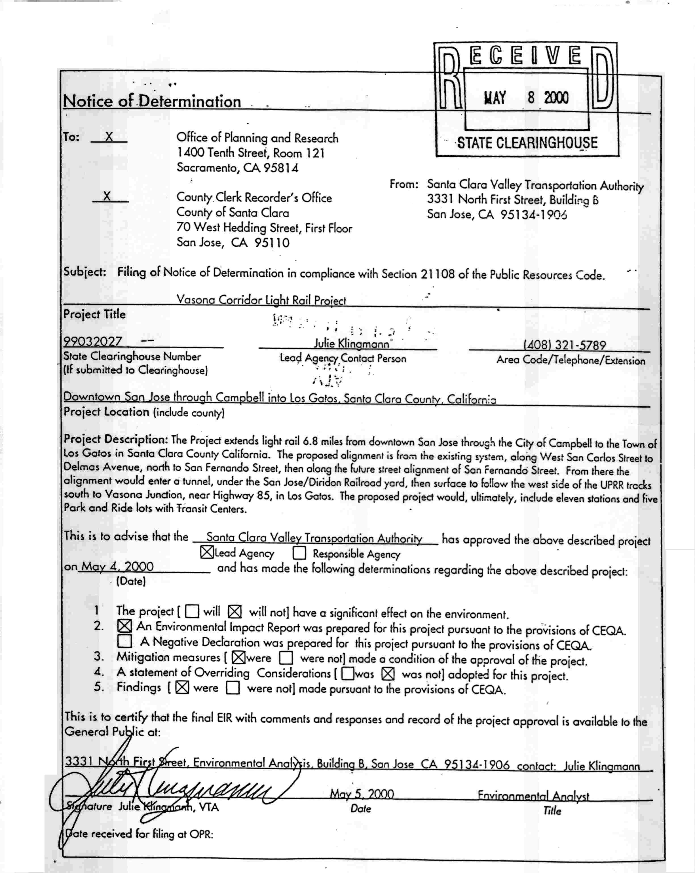
(End of Appendix C)

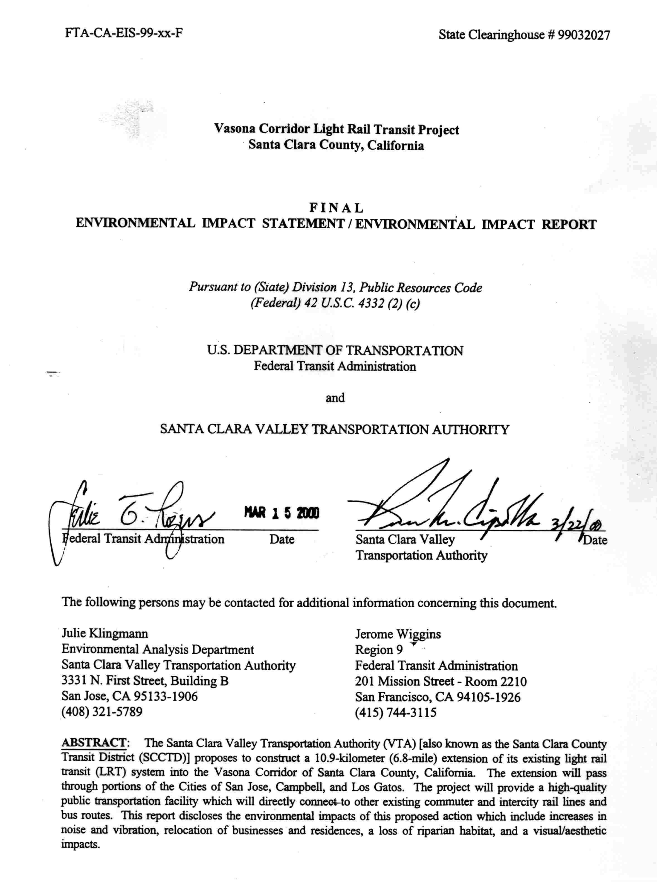
(End of Appendix D)

