RSCD/TAH/RRT/SH DRAFT CA-16
3/21/02

Decision

BEFORE THE PUBLIC UTILITIES COMMISSION OF THE STATE OF CALIFORNIA

Application of the State of California, Department of Transportation, for an order authorizing the Department to replace existing crossing at separated grade known as Tehachapi Creek Bridge and Overhead and to realign State Route 202. The concerned tracks are the property of the Union Pacific Railroad Company located in the City of Tehachapi, Kern County, State of California. | Application 01-09-010  (Filed September 4, 2001)

O P I N I O N

Summary
State of California, Department of Transportation (Caltrans) requests authority to replace the existing crossing at separated grades of Tehachapi Creek Bridge and Overhead (existing State Route (SR) 202) with a new bridge and overhead crossing at separated grades on the proposed realignment of SR 202 over the tracks of Union Pacific Railroad Company’s (UP) El Paso Main Line in the City of Tehachapi, Kern County.

Discussion
Caltrans proposes to replace the existing crossing at separated grades of Tehachapi Creek Bridge and Overhead (existing SR 202) with a new bridge and overhead crossing at separated grades on the proposed realignment of SR 202. The proposed bridge and overhead is necessary to accommodate the anticipated increased traffic flow (from an average daily traffic count (ADT) currently at 14,600 vehicles to an expected ADT of 18,300 vehicles by the year 2020) on the existing SR 202. SR 202, located in the eastern portion of Kern County, provides the only access to the Tehachapi-California Correctional Institution (CCI) from the major east-west artery, SR 58. SR 58 is the major State highway which connects United States Highway (U.S.) 101 (in San Luis Obispo County) with Interstate (I) 5, SR 99, and SR 14 (in Kern County) and U.S. 395 and I-15 (in San Bernardino County). The proposed new bridge and overhead is necessary, because the existing bridge deck is approximately 26 feet wide, the current Caltrans standards require a bridge deck of approximately 40 feet wide, and Caltrans cannot widen the existing bridge deck on its present structure. Commuter traffic to CCI and the increase in population to Tehachapi Valley, Cummings Valley, Stallion Springs and Bear Valley Springs have added to the traffic congestion along SR 202 and Tucker Road.
The proposed bridge and overhead structure will carry SR 202 over UP’s El Paso Main Line tracks by means of cast-in-place/pre-stressed concrete box girder bridge. The proposed bridge is to be 482.3 feet long and will provide a traveled way width of 23.6 feet. Upon completion of the new bridge and overhead crossing at separated grades and the Tucker Road connection, vehicular traffic will be rerouted from the existing Tehachapi Creek Bridge and Overhead to the new bridge and overhead on the new alignment of SR 202. Falsework opening required over UP’s tracks is 21 feet (vertical clearance) and 45 feet (horizontal clear width).
Caltrans is the lead agency for this project under California Environmental Quality Act of 1970 (CEQA), as stated in Public Resources Code Section 21000 et. seq. Caltrans prepared an Initial Study/ Environmental Assessment (in cooperation with the United States Department of Transportation – Federal Highway Administration (FHWA)) for the project of which the new bridge and overhead crossing at separated grades are a part. On October 14, 1998, Caltrans issued a Negative Declaration (as shown in Appendix A) pursuant to CEQA, as stated in Division 13 (Environmental Protection) of the Public Resources Code, and approved the project. Caltrans determined “The proposed action would not have a significant effect upon the environment for the following reasons:
‘The project would have no significant effect on land use, parklands, recreational facilities, community growth, neighborhoods, residences or educational facilities. No archaeological, historic or cultural resources are found in the area. No wetlands, unique vegetation, fish and wildlife, floodplains or timber resources are involved.
‘The project would have no significant effect upon business, industry, the economy, employment, agricultural resources, sensitive receptors, water quality, air quality, energy use or seismic exposure.
‘Up to 14 parcels could be affected by acquisition.’”
The Initial Study/Environmental Assessment stated that the proposed project would require the acquisition of approximately 14 parcels. The acquisitions would be partial. The 14 parcels are zoned as commercial (11 parcels), high density (2 parcels), and general agricultural (1 parcel). Caltrans “would implement the Federal Uniform Relocation Assistance and Real Property Acquisition Policies Act of Policies Act of 1970.” Concerning “Environmental Justice, “ Caltrans stated that “1994 Federal Executive Order 12898 (Federal Actions to Address Environmental Justice in Minority Populations and Low-income populations) requires that each federal agency to take the appropriate and necessary steps to identify and avoid disproportionately high and adverse effects of federal projects on minority and low-income populations. The project would not adversely impact minority and low-income populations disproportionately because no housing units will be acquired therefore, no residences would be displaced.”
On November 3, 1998, (as shown in Appendix A) FHWA “determined that this project will not have any significant impact on the human environment.”
The Commission is a responsible agency for this project under CEQA. Under CEQA, a responsible agency must consider the environmental consequences of a project that is subject to its discretionary approval. In particular, to comply with CEQA, a responsible agency must consider the lead agency’s EIR or Negative Declaration prior to acting upon or approving the project (CEQA Guideline Section 15050(b)). The specific activities which must be conducted by a responsible agency are contained in CEQA Guideline Section 15096.
The Commission has reviewed the lead agency’s Initial Study/ Environmental Assessment and Negative Declaration adopted by the lead agency in approving the project. We are aware of no information to indicate that the lead agency’s finding of no significant impact was not reasonable. Accordingly, we adopt the lead agency Negative Declaration for purposes of our permitting approval of the project.
The existing Tehachapi Creek Bridge and Overhead at separated grades and the site of the proposed new bridge and overhead have been inspected by the Commission’s Rail Safety and Carriers Division – Rail Crossings Engineering Section staff. After reviewing the need for and the safety of the proposed new bridge and overhead at separated grades, staff recommends that Caltrans’ request be granted.
The Application was found to be in compliance under the Commission’s filing requirements, including Rule 38 of Rules of Practice and Procedure, which relates to the construction of public highway crossings and separations over a railroad. A site map and detailed drawings of the proposed new bridge and overhead grade separation structure are shown in Appendix B attached to the order.
In Resolution ALJ 176-3071, dated September 20, 2001 and published on the Commission Daily Calendar on September 21, 2001, the Commission preliminarily categorized this application as ratesetting, and preliminarily determined that hearings were not necessary. Since no hearings were held, this preliminary determination remains accurate. The Commission’s Rail Safety and Carriers Division recommends that this application be granted. Given these developments, a public hearing is not necessary, and it is not necessary to disturb the preliminary determinations made in Resolution ALJ 176-3071.
This is an uncontested matter in which the decision grants the relief requested. Accordingly, pursuant to Public Utilities Code Section 311(g)(2), the otherwise applicable 30-day period for public review and comment is being waived.
Findings of Fact
- Notice of the application was published in the Commission Daily Calendar on September 14, 2001. There are no unresolved matters or protests; a public hearing is not necessary.
- Caltrans requests authority, under Public Utilities Code Sections 1201-1205, to replace the existing crossing at separated grades of Tehachapi Creek Bridge and Overhead (SR 202) with a new bridge and overhead at separated grades on the proposed realignment of SR 202 over the tracks of UP’s El Paso Main Line in Tehachapi, Kern County.
- The replacement of the existing Tehachapi Creek Bridge and Overhead with a new bridge and overhead at separated grades is required to accommodate the anticipated increased traffic flow (from the current ADT of 14,600 vehicles to the expected ADT of 18,300 vehicles by the year 2020) on the existing SR 202 due to increased commuter traffic to CCI and the increase in population in Tehachapi Valley, Cummings Valley, Stallion Springs and Bear Valley Springs.
- Public convenience, necessity and safety require replacement of the existing Tehachapi Creek Bridge and Overhead with a new bridge and overhead at separated grades.
- Caltrans is the lead agency for this project under CEQA, as amended.
- Caltrans issued a Negative Declaration and determined that the project will not have a significant effect upon the environment.
- The Commission is a responsible agency for this project, and has reviewed and considered the lead agency's Initial Study/Environmental Assessment and Negative Declaration.
Conclusions of Law
- As stated herein, we adopt the lead agency’s Negative Declaration finding no significant impact from the project for purposes of our permitting approval of the project.
- The application should be granted as set forth in the following order.

ORDER

IT IS ORDERED that:
- State of California, Department of Transportation (Caltrans) is authorized to replace the existing crossing at separated grades of Tehachapi Creek Bridge and Overhead with a new bridge and overhead crossing at separated grades over Union Pacific Railroad Company’s (UP) El Paso Main Line tracks in Tehachapi, Kern County, at the location and substantially as shown by plans attached to the Application and Appendix B of this order, identified as Crossing B-359.4-A.
- Clearances shall be in accordance with General Order (GO) 26-D, except that during the period of construction a temporary impaired vertical clearance of not less than 21 feet, 0 inches above top of rail and temporary impaired horizontal (clear width) clearance of 45 feet, 0 inches during construction of the new bridge and overhead shall be authorized. UP shall be authorized to operate with such reduced overhead clearance provided that instructions are issued by the railroad and filed with the Commission forbidding employees to ride on tops of cars beneath the structure.
- Caltrans shall notify the Commission and UP at least 15, but not more than 30, days in advance of the date when the temporary impaired clearances will be created.
- Walkways shall conform to GO 118. Walkways adjacent to any trackage subject to rail operations shall be maintained free of obstructions and shall be promptly restored to their original condition in the event of damage during construction.
- Construction and maintenance costs shall be borne in accordance with an agreement to be entered into between the parties. A copy of the agreement, together with plans approved by UP, shall be filed with the Commission prior to commencing construction. Should the parties fail to agree, the Commission will apportion the costs of construction and maintenance by further order.
- Within 30 days after completion of the work under this order, Caltrans shall notify the Commission in writing that the authorized work has been completed.
- This authorization shall expire if not exercised within three years unless time is extended or if the above conditions are not complied with. Authorization may be revoked or modified if public convenience, necessity or safety so require.
- The application is granted as set forth above.
- Application 01-09-010 is closed.
This order becomes effective 30 days from today.
Dated , at San Francisco, California.

APPENDIX A
ENVIRONMENTAL DOCUMENTS

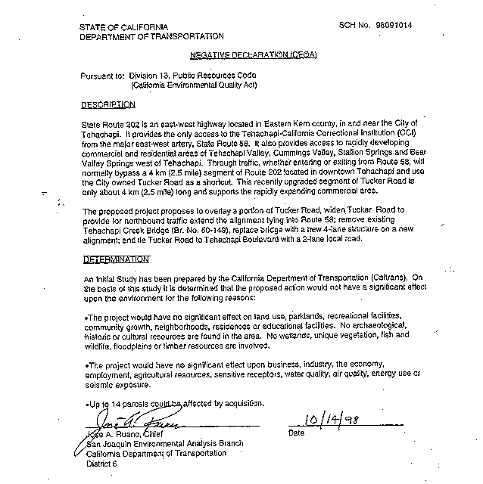
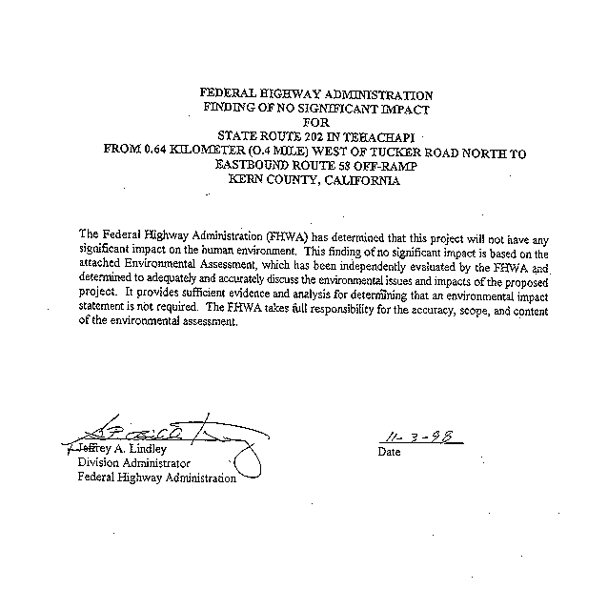

APPENDIX B
PLANS

