RSCD/RWC/BPA DRAFT
5/16/02
Agenda ID #563

Decision

BEFORE THE PUBLIC UTILITIES COMMISSION OF THE STATE OF CALIFORNIA

Application of Sacramento Regional Transit District for an order authorizing District to construct, modify, maintain, and operate a light rail passenger system and Union Pacific Railroad tracks across Jackson Road, Florin-Perkins Road, Mather Field Road, Mills Park Drive, Zinfandel Drive, Olson Drive, Kilgore Road and Sunrise Boulevard in the County of Sacramento, State of California. | Application 01-05-034  (Filed May 15, 2001)

O P I N I O N

Summary
The Sacramento Regional Transit District (District) requests the authority to construct, modify, maintain, and operate a light rail passenger system and modify the Union Pacific Railroad’s (Railroad) track across eight public crossings in the County of Sacramento. At two crossings the District will relocate the Railroad track, and install one additional light rail track. At five crossings the District will install two new light rail tracks, and relocate the Railroad track. At the Sunrise Boulevard crossing the District will relocate the Railroad track in preparation for a future light rail grade separation.

Discussion
The proposed project covers approximately 5.3 miles, and involves the modification of eight at-grade crossings. The proposed project will add a second light rail track for the segments along the E-line, which is currently a single track, and further extend the double track alignment east, as part of the Folsom Corridor Project. This will require the relocation of existing Railroad facilities, construction of new light rail facilities, and testing of those facilities. A sketch of the project area is set forth in Appendix A of this decision. Appendix B of this decision summarizes the crossing modifications. At present the Railroad operates one train per day on its AH line. Upon the project completion, the District will have 266 daily light rail movements.
The purpose of this project is to:
- Improve public transit service in this rapidly growing corridor by providing increased transit capacity and faster, convenient access between downtown Folsom and downtown Sacramento.
- Enhance regional connectivity through expanded, interconnected light rail transit services, along the primary travel corridors in Sacramento County.
- Accommodate future travel demand in the corridor by expanding model options.
- Alleviate growing traffic congestion on the US 50 freeway between downtown Sacramento, the community of Rancho Cordova, and the City of Folsom, and on major parallel arterials in the corridor, such as Folsom Boulevard.
- Alleviate growing parking demand in downtown Sacramento and corridor employment centers and the congestion and circulation impacts resulting from increased peak hour traffic.
- Improve regional air quality by reducing auto emissions.
- Improve mobility options to employment, education, medical, and retail centers for corridor residents in particular low income, youth, elderly, disabled, and ethnic minority populations.
- Support local economic and land development goals.
Through the application, the District requested the authority, pursuant to Section 12.2 of Commission General Order (GO) 75-C, to deviate from Section 7.1 of GO 75-C at the Jackson Road crossing. The District proposes to install one Commission Standard No. 9-A highway crossing signal as described in GO 75-C, augmented by traffic signal head assemblies for the westbound approach. Due to the street geometrics at this location, the installation of standard railroad warning devices and traffic signals on separate structures would result in conflicting lines of sight. Combining the two systems onto a single structure will lessen the potential driver confusion by providing a clear line of sight to all signals, thereby increasing public safety. Installed at the eastbound approach will be one Commission Standard No. 9-A.
The project will be financed by State and Federal funds. The project is scheduled for completion in 2003.
The District is the lead agency for this project under the California Environmental Quality Act of 1970 (CEQA), as amended, Public Resources Code 21000 et. seq. On March 15, 2000, in compliance with CEQA, the District filed its Notice of Determination (NOD) approving this project stating that the project will have a significant effect on the environment. Mitigation measures were made a condition of approval of the project.
The Commission is a responsible agency for this project under CEQA (Public Resources Code Section 21000 et seq.). CEQA requires that the Commission consider the environmental consequences of a project that is subject to its discretionary approval. In particular, to comply with CEQA, a responsible agency must consider the lead agency’s Environmental Impact Report or Negative Declaration prior to acting upon or approving the project (CEQA Guideline Section 15050(b)). The specific activities that must be conducted by a responsible agency are contained in CEQA Guideline Section 15096.
The Commission has reviewed the District’s environmental documentation. The environmental documentation consists of a Final Environmental Impact Statement/Environmental Impact Report (FEIS/EIR), and the NOD. Analysis of potential environmental impacts included: air quality, noise and vibration, visual changes, safety and security, cultural resources, neighborhoods/businesses, geology and soils, hazardous wastes/materials, water resources/quality, utilities, job creation, vegetation and wildlife, land use, seismicity, and transportation and traffic.
Safety and security, transportation and noise are within the scope of the Commission’s permitting process.
Safety and security impacts were identified in the FEIS/EIR. The impacts are related to the addition of the District’s facilities, where safety and security will be required. The adopted mitigation measures include the District extending contract security services to include coverage of park-and-ride lots, stations, and maintenance facilities, and an increase to the existing District law enforcement staff. The District will monitor impacts at major arterial grade crossings and implement operation and signal timing improvements as necessary to minimize vehicle queues that may disrupt other cross street traffic.
Noise impacts were identified in the FEIS/EIR. The impacts identified related to light rail vehicle, power substation, and grade crossing noise. The mitigation measures adopted to address these impacts involve installing sound attenuation barriers, sound-insulating affected residences, modifying train operating procedures, and reducing, to the extent possible, the noise emissions of light rail vehicles through shielding, reprofiling of wheels and other measures.
Transportation and traffic impacts were identified in the FEIS/EIR. The impacts involve the relocation of a bikepath in the City of Folsom, and reduced level of service at several intersections. The adopted mitigation measures include the City of Folsom relocating its bike path, and use of near-side grade crossing indicators where at-grade crossings are adjacent to light rail stations. This will minimize the amount of time the gates are down when trains must stop to load and unload passengers before crossing the roadway. For all but one of the intersections affected, it was determined that the intersections are at their ultimate configuration and no improvements are proposed. For the remaining intersection, mitigation measures include striping to provide a left-turn lane, and a shared right-turn lane.
The Commission’s Rail Safety and Carriers Division (RSCD), Rail Crossings Engineering Section staff inspected the site of the proposed project. After reviewing the need for and safety of the proposed crossing, the staff recommends that the requested authority sought by the District be granted for a period of four years.
With respect to the potentially significant safety and security, noise and transportation impacts identified above, the Commission finds that the District adopted feasible mitigation measures to either eliminate or substantially lessen those impacts. We will adopt the District’s environmental findings and mitigations for purposes of our approval.
Application 01-05-034 meets the filing requirements of the Commission’s Rules of Practice and Procedure, including Rule 39 and 40, which relates to the widening or relocation of an existing crossing and the construction of a railroad track across a public highway.
In Resolution ALJ 176-3064 dated May 24, 2001, the Commission preliminarily categorized this application as ratesetting, and preliminarily determined that hearings were not necessary. No protests have been received. The Commission’s RSCD recommends that this application be granted. Given these developments, a public hearing is not necessary, and it is not necessary to disturb the preliminary determinations made in Resolution ALJ 176-3064.
This is an uncontested matter in which the decision grants the relief requested. Accordingly, pursuant to Public Utilities Code Section 311(g)(2), the otherwise applicable 30-day period for public review and comment is being waived.
Findings of Fact
- Notice of the application was published in the Commission Daily Calendar on May 18, 2001. No protests have been filed.
- The District requests authority, under Public Utilities Code Sections 1201-1205, to construct, modify, maintain, and operate across eight at-grade crossings.
- The District crossings to be modified are at Jackson Road (083E-6.20), and Florin-Perkins Road (083E-6.55).
- The District crossings to be constructed for the E-Line are at Mather Field Road (milepost 11.76), Mills Park Drive (milepost 12.60), Zinfandel Drive (milepost 13.10), Olson Drive (milepost 13.54), and Kilgore Road (milepost 13.94).
- The Railroad crossings to be modified are at Jackson Road (1AH-96.0), Florin-Perkins Road (1AH-96.3), Mather Field Road (1AH-101.5), Mills Park Drive (1AH-102.4), Zinfandel Drive (1AH-102.9), Olson Drive (1AH-103.3), Kilgore Road (1AH-103.7), and Sunrise Boulevard (1AH-104.1).
- Public convenience, safety, and necessity require the modification of subject crossings.
- Public safety requires that the crossings be equipped with warning devices as summarized in Appendix B of this decision, and in accordance with GO 75-C, except at Jackson Road (083E-6.20) where the District is requesting the authority to deviate from GO 75-C, Section 7.1 by constructing a Commission Standard No. 9-A modified with traffic signal head assemblies to be located on the westbound approach.
- The District is the lead agency for this project under the CEQA, as amended.
- The Commission is a responsible agency for this project, and has reviewed and considered the District’s environmental documentation upon which the District relied in adopting mitigation measures for the project.
- On March 15, 2000, the District filed its NOD approving the project and found that the Downtown Sacramento - Folsom Corridor Project would have a significant effect on the environment.
- Safety, security, transportation and noise are within the scope of the Commission’s permitting process.
- The Commission finds that for each potentially significant impact related to safety and security, transportation, or noise, the District adopted feasible mitigation measures to either eliminate or substantially lessen those impacts.
Conclusions of Law
- The application is uncontested and a public hearing is not necessary.
- The application should be granted as set forth in the following order.

ORDER

IT IS ORDERED that:
- The Sacramento Regional Transit District (District) is authorized to construct, modify, maintain, and operate across eight crossings, at the locations and as shown on the plans attached to the application, and delineated in Appendix B of this decision.
- The crossings shall be identified as described in Appendix B of this decision.
- The crossings shall be fitted with warning devices as described in Appendix B of this decision and as shown on the plans attached to the application, in accordance with General Order (GO) 75-C.
- At Jackson Road (083E-6.20) the District is granted the authority to deviate from GO 75-C, Section 7.1 by constructing a Commission Standard No. 9-A modified with traffic signal head assemblies to be located on the westbound approach.
- Clearances shall be in accordance with GO 26-D.
- Walkways shall conform to GO 118. Walkways adjacent to any trackage subject to rail operations shall be maintained free of obstructions and shall be promptly restored to their original condition in the event of damage during construction.
- Construction and maintenance costs shall be borne in accordance with an agreement that has been entered into between the parties. A copy of the agreement shall be filed by the District with Rail Safety and Carriers Division (RSCD) prior to construction. Should the parties fail to agree, the Commission will apportion the costs of construction and maintenance by further order.
- Prior to construction, the District shall file with RSCD final construction plans.
- The District will inform the Rail Crossings Engineering Section of RSCD in writing within 30 days of the date of completion of this project.
- This authorization shall expire if not exercised within four years unless time is extended or if the above conditions are not complied with. Authorization may be revoked or modified if public convenience, necessity, or safety so require.
- This application is granted as set forth above.
- Application 01-05-034 is closed.
This order is effective today.
Dated , at San Francisco, California.

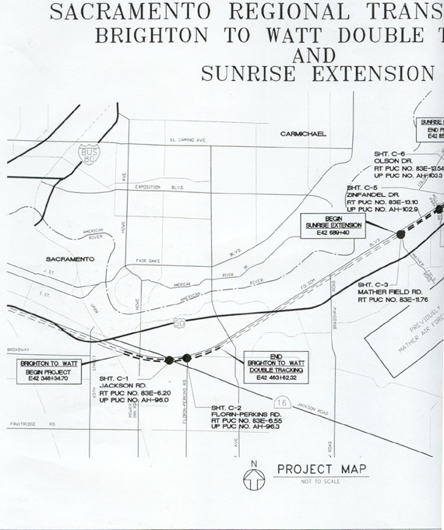
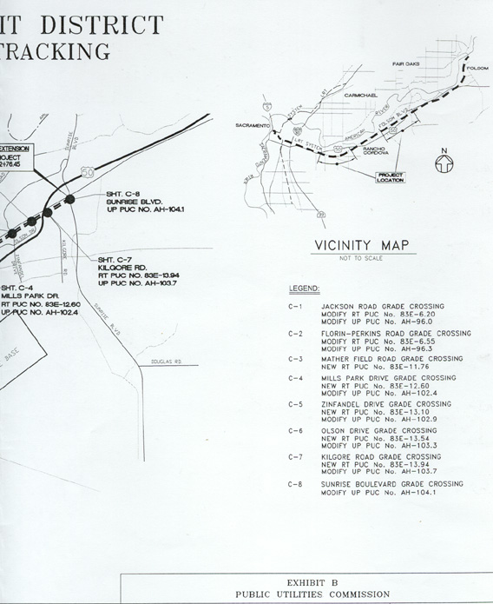
Street Name and  PUC Crossing No. | Existing Warning  Devices | Proposed Warning  Devices | Existing Track(s) | Proposed Track(s) | Work Summary
Jackson Road  1AH-96.0  083E-6.20 | 2 x Std 9  1 x AAWS | 2 x Std 9A  2 x AAWS | 1 LRT  1 FREIGHT | 2 LRT  1 FREIGHT | Shift freight track, install one LRT track. Install new devices and surfacing.
Florin-Perkins Road  1AH-96.3  083E-6.55 | 4 x Std 9 | 1 x Std 9A  3 x Std 9  2 x Std 8  1 x AAWS | 1 LRT  1 FREIGHT | 2 LRT  1 FREIGHT | Shift freight track, install one LRT track. Install new devices and surfacing.
Mather Field Road  1AH-101.5  083E-11.76 | 1 x Std 9A  3 x Std 9 | 2 x Std 9A  2 x Std 9  2 x Std 8  1 x AAWS | 1 FREIGHT | 2 LRT  1 FREIGHT | Shift freight track, install two LRT tracks. Install new devices and surfacing.
Mills Park Drive  1AH-102.4  083E-12.60 | 2 x Std 9 | 2 x Std 9A  2 x Std 8  1 x AAWS | 1 FREIGHT | 2 LRT  1 FREIGHT | Shift freight track, install two LRT tracks. Install new devices and surfacing.

Zinfandel Drive  1AH-102.9  083E-13.10 | 4 x Std 9 | 1 x Std 9A  3 x Std 9  2 x Std 8  1 x AAWS | 1 FREIGHT | 2 LRT  1 FREIGHT | Shift freight track, install two LRT tracks. Install new devices and surfacing.
Olson Drive  1AH-103.3  083E-13.54 | 4 x Std 9 | 1 x Std 9A  3 x Std 9  2 x Std 8  1 x AAWS | 1 FREIGHT | 2 LRT  1 FREIGHT | Shift freight track, install two LRT tracks. Install new devices and surfacing.
Kilgore Road  1AH-103.7  083E-13.94 | 2 x Std 9 | 1 x Std 9A  1 x Std 9  2 x Std 8  1 x AAWS | 1 FREIGHT | 2 LRT  1 FREIGHT | Shift freight track, install two LRT tracks. Install new devices and surfacing.
Sunrise Boulevard  1AH-104.1 | 3 x Std 9A  1 x Std 9 | 3 x Std 9A  2 x Std 9  2 x Std 8  1 x AAWS | 1 FREIGHT | 1 FREIGHT | Shift freight track.

Unless otherwise noted, all Standards (Std) refer to the Commission’s General Order No. 75-C.
Advanced Automatic Warning Sign (AAWS) as specified in the engineering drawings. A W10 sign with flashers.
The District is granted the authority to deviate from Commission General Order 75-C, Section 7.1 by constructing one Commission Standard No. 9-A modified with traffic signal head assemblies to be located on the westbound approach. The eastbound approach will be one Commission Standard No. 9-A.
Light Rail Transit (LRT).

