CPSD/RWC/HMJ/JFP/SH/vdl DRAFT Agenda ID # 2198
Ratesetting

Decision

BEFORE THE PUBLIC UTILITIES COMMISSION OF THE STATE OF CALIFORNIA

In the Matter of the Application of the SAN DIEGO METROPOLITAN TRANSIT DEVELOPMENT BOARD for an order authorizing construction at four at-grade crossings on two light rail vehicle (LRV) tracks and closure of one existing at-grade crossing at the San Ysidro Intermodal Transportation Center (SYITC) development, in the City of San Diego, San Diego County, California. | Application 01-03-011  (Filed March 9, 2001)

O P I N I O N

Summary
San Diego Metropolitan Transit Development Board (MTDB) requests authority to construct four at-grade highway-rail crossings (crossings). MTDB also requests to close one existing crossing which crosses the two light rail transit (LRT) tracks on both the MTDB’s right-of-way (ROW) and City of San Diego’s (City) ROW at the San Ysidro Intermodal Transportation Center (SYITC) in San Diego, San Diego County. Finally, MTDB also requests a deviation from Section 7.8 of General Order (GO) 75-C, to modify the warning devices so that the bells sound only during the initial warning and descent stages until the automatic gates are within 10 degrees of the horizontal position.

Discussion
MTDB requests authority to construct four proposed crossings at Rail Court Drive, San Ysidro Boulevard/Jack in the Box Drive-Thru Restaurant, San Ysidro Boulevard/Gateway Inn Motel, and Beyer Boulevard/Gateway Inn Motel parking lot of MTDB’s San Diego Trolley, Inc. (SDTI) LRT tracks. MTDB also requests authority to physically remove the existing crossing of San Ysidro Boulevard at Beyer Boulevard by the northerly realignment of the existing LRT tracks.
MTDB is a transit development board existing under Chapter 294, Statute of 1975, Section 120050 et seq. of the Public Utilities Code. MTDB is charged with construction and operation of public transit systems within its area of jurisdiction.
SDTI currently makes 241 LRT movements each weekday through the SYITC corridor between the proposed Rail Court Drive and Beyer Boulevard crossings. The last departure from the SDTI San Ysidro/Tijuana Station is at 1:02 a.m., except Saturdays on which day SDTI provides all-night hourly service.
The SDTI LRT system presently operates within an exclusive MTDB ROW and City ROW. In addition to eliminating the existing San Ysidro Boulevard at Beyer Boulevard crossing, the northerly realignment of the existing LRT tracks will eliminate the existing condition that all northbound vehicular traffic along San Ysidro Boulevard must cross the LRT tracks when exiting the area south of the crossing and when exiting the Interstate (I) 5 off-ramp at San Ysidro Boulevard.
MTDB performed a study of alternative alignments. SDTI’s Blue Line trolley terminates a few yards from the entrance of the United States Border Station in San Ysidro. The last two blocks of the Blue Line cross into the median of San Ysidro Boulevard and result in several conflict points, described as follows:
- All trains must cross the northbound lanes of San Ysidro Boulevard, just south of the Beyer Boulevard intersection. Motor vehicles queued at the traffic signal can block the tracks.
- Pedestrians also cross the tracks at the above location. The existing pedestrian crossing has no warning devices or signals.
- An off-ramp from northbound I-5 terminates on San Ysidro Boulevard, immediately north of the existing trolley station and the proposed trolley station. All traffic entering the San Ysidro community from Mexico and I-5 must cross the LRT rails. Passengers must cross traffic lanes to access the Border Station. The arrival of an LRT train often results in hundreds of pedestrians attempting to cross the street at one time, thereby bringing vehicular traffic to a standstill.
In addition to the above problems, other modes of transportation also are impacted by the congestion in the San Ysidro community. The Border Station area is a major departure point for intercity buses carrying workers to their jobs in the interior of California. Approximately 12 bus companies serve San Ysidro, but many bus companies must board passengers in parking lots, alleyways, or on street corners due to the lack of an organized transportation facility. Jitney services, taxis, Tijuana shuttle buses, and Metropolitan Transit System transit buses all board and discharge passengers in and around the existing trolley station, adding to the local congestion. All of these services are subject to delays when trains heavily loaded with passengers arrive at the existing trolley station.
MTDB developed the SYITC project to address the above-referenced conflict, to create a safer and more orderly movement of pedestrians and vehicles in the area, and to reduce greatly the number of vehicles required to cross the LRT tracks. To achieve this goal, MTDB proposed to relocate the LRT tracks to the east side of the San Ysidro Boulevard ROW. MTDB, however, proposes to keep trolley operations at grade for the following reasons:
- The existing San Ysidro trolley station, when relocated, must remain at grade due to several constraints related to the proximity of the existing trolley station and the proposed trolley station to the Border Station. The Border Station entry serves a large number of pedestrians. Over 21,000 passengers walk between the Border Station and the existing trolley station each day. The large volume of pedestrians associated with each train movement makes it infeasible to use elevators to move passengers to street level.
- Security is an extreme concern in the vicinity of the Border Station due to the sensitive and hazardous nature of the activities performed there. It is essential to maintain clear lines of sight for security personnel. It would be difficult for United States Immigration and Naturalization Service and Border Patrol personnel to maintain proper surveillance with an elevated or underground trolley station. The existing trolley station is completely surrounded by existing land uses that the users cannot move feasibly. These land uses include a large-scale commercial development immediately adjacent to the existing trolley station, the Border Station to the south and east, and an interchange on I-5, which terminates at the north end of the existing trolley station.
MTDB considered grade separation for the LRT tracks extending north from the existing trolley station. However, MTDB found grade separation infeasible, due to the following constraints:
- City cannot substantially relocate San Ysidro Boulevard, because San Ysidro Boulevard is completely surrounded by developed properties that have no other means of access. The roadway must remain open to vehicular traffic at all times, because the roadway is the only access to the Border Station entrances from the United States. Consequently, only limited reconstruction of San Ysidro Boulevard is feasible.
- The I-5 entrance and exit ramps terminate on San Ysidro Boulevard immediately north of the existing trolley station and the proposed trolley station. Only a slight adjustment of the ramp locations can occur, because the ramp locations are contiguous with the pavement of the international inspection station, located less than 300 feet away from the intersection of San Ysidro Boulevard and the I-5 ramps. Consequently, City cannot substantially change the elevation of the intersection. This constraint contributes to the infeasibility of changing the grade of San Ysidro Boulevard.
- The LRT tracks are immediately adjacent to the intersection of San Ysidro Boulevard and the I-5 ramps. Since the elevation of the existing trolley station, the proposed trolley station, and San Ysidro Boulevard are constrained as described above, an at-grade crossing at Rail Court Drive is unavoidable.
- MTDB proposes three other at-grade crossings, each serving private commercial properties (Jack in the Box Drive-Thru Restaurant, Gateway Inn Motel, and Gateway Inn Motel parking lot) off of San Ysidro and Beyer Boulevards, in the project area. Exhibits B and C in the Application and plans included in Appendix B attached to the order illustrate the necessity for these proposed crossings.
- MTDB indicated the elevation of the proposed trolley station on the right side of the profile in Exhibit C in the Application. MTDB established the elevation of the proposed trolley station to match the floor elevation of the adjacent businesses, whose entries open directly onto the trolley platform. The grade of the rails leaving the proposed station is limited to a maximum of 2 percent to comply with the United States Americans with Disabilities Act requirements for disabled persons using the proposed trolley station. Proceeding northward, as shown on the left side of Exhibit C, MTDB showed two theoretical profiles based on the maximum gradient, 4.3 percent, on which the LRT vehicles can operate. Exhibit C shows hypothetical grade separation structures spanning the two publicly used private roadways at the Gateway Inn Motel and the Jack in the Box Drive-Thru Restaurant. An LRT vehicle cannot achieve the required elevations for either an overpass or an underpass based on the 4.3 percent limitation.
- Further north, an analogous limitation occurs at the entrance to a private parking lot. Exhibit B in the Application showed that the 4.3 percent grade limitation prevents the LRT vehicles from passing above the private parking lot roadway. MTDB ruled out an underpass not only due to the grade constraint, but also due to the presence of a major box culvert storm drain that would have conflicted with a below-grade trolley alignment.
- Although four crossings will exist after construction of the project, the number of vehicles and pedestrians using those crossings will be far lower than the number forced to cross the LRT tracks in its existing alignment. Currently, all vehicles and many of the pedestrians leaving the Border Station area must cross the LRT tracks at least one time when heading north on San Ysidro Boulevard. Vehicles and pedestrians include city buses, intercity buses, Border Station personnel, taxis, and other vehicles dropping off passengers at the international border. Vehicles entering from I-5 northbound on San Ysidro Boulevard currently must cross the tracks twice. After project construction completion, only patrons of the Gateway Inn Motel and the Jack in the Box Drive-Thru Restaurant and the small number of vehicles traveling to the southernmost block of San Ysidro Boulevard, accessed by way of Rail Court Drive, will use the proposed crossings. In addition, intercity buses will continue to cross at the signalized intersection at Rail Court Drive.
The final result of the SYITC project will be an organized transportation facility adjacent to the Border Station. Arriving travelers will be able to access all modes of public transportation without crossing a street. There will be a reduction in the number of vehicles crossing the LRT tracks and of congestion in the community.
The proposed crossings of Beyer Boulevard/Gateway Inn Motel parking lot, San Ysidro Boulevard/Gateway Inn Motel, San Ysidro Boulevard/Jack in the Box Drive-Thru Restaurant, and Rail Court Drive and the physical removal of the existing San Ysidro Boulevard at Beyer Boulevard crossing are necessary to enhance safety and mobility of pedestrians and motorists on SDTI’s LRT system at the SYITC development near the San Ysidro international border crossing between the United States and Mexico. The San Ysidro border crossing has over 10 million northbound pedestrians and 12 million northbound vehicles crossing each year. These volumes are equivalent to over 28,000 pedestrians and 33,000 vehicles entering the United States each day. The SYITC development will alleviate traffic congestion and centralize the different modes of transportation within the proposed trolley station area. In addition, the proposed closure of the San Ysidro Boulevard at Beyer Boulevard crossing and the four proposed new crossings will minimize the amount of vehicular traffic crossing the LRT tracks. A raised center median throughout MTDB’s and City’s ROW will preclude vehicular left-turn movements over the LRT tracks.
The proposed Beyer Boulevard/Gateway Inn Motel parking lot crossing will be a bi-directional crossing over MTDB’s and City’s ROW between the motel’s parking lot and Beyer Boulevard. The roadway geometrics will allow only right-turn movements into and out of the private roadway. This crossing will consist of two Standard No. 9 (flashing light signals with automatic gates, as described in GO 75-C warning devices as further described in Appendix A attached to the order.
The proposed San Ysidro Boulevard/Gateway Inn Motel crossing will be a bi-directional crossing over MTDB’s and City’s ROW between the motel and San Ysidro Boulevard. The roadway geometrics will allow only right-turn movements into and out of the private roadway. This crossing will consist of two Standard No. 9 warning devices as further described in Appendix A attached to the order.
The proposed San Ysidro Boulevard/Jack in the Box Drive-Thru Restaurant crossing will be a one-way crossing over MTDB’s and City’s ROW from the restaurant to San Ysidro Boulevard. The roadway geometrics will allow only right-turn movements out of the private driveway. This crossing will consist of one Standard No. 9 warning device as further described in Appendix A attached to the order.
The proposed Rail Court Drive crossing will cross over MTDB’s and City’s ROW to San Ysidro Boulevard and the I-5 on-ramp. The roadway will consist of one lane in each direction and is designed as a conventional four-legged intersection. This crossing will consist of two Standard No. 9 warning devices as further described in Appendix A attached to the order.
At each of the proposed crossings, MTDB requests a deviation from Section 7.8 of GO 75-C, which requires the constant ringing of bells at at-grade highway-rail crossings when passing trains activate the warning devices. To reduce noise at each of the proposed crossings, MTDB requests to modify the warning devices so that bells sound only during the initial warning and descent stages until the automatic gates are within 10 degrees of the horizontal position. However, the flashing red lights will continue to provide the necessary warning aspects until completion of the entire gate activation cycle and until the train has subsequently cleared each proposed crossing.
MTDB is the lead agency for this project under the California Environmental Quality Act of 1970 (CEQA, as amended in 1982), as stated in Public Resources Code Section 21000 et seq. On May 29, 1998, MTDB filed with the San Diego County Clerk a “NOTICE OF AVAILABILITY OF AN ENVIRONMENTAL ASSESSMENT AND NOTICE OF INTENT TO ADOPT A MITIGATED NEGATIVE DECLARATION FOR THE SAN YSIDRO INTERMODAL TRANSPORTATION CENTER, SAN DIEGO, CALIFORNIA” (NOA). On August 11, 2000, MTDB filed a Notice of Determination (NOD) with the San Diego County Clerk. The NOD found that “the project will not have a significant effect on the environment.” MTDB issued a Mitigated Negative Declaration for this project pursuant to the provisions of CEQA. Copies of the NOA, NOD, and Mitigated Negative Declaration are included in Appendix C attached to the order.
The Commission is a responsible agency for this project under CEQA. CEQA requires that the Commission consider the environmental consequences of a project subject to its discretionary approval. In particular, to comply with CEQA, a responsible agency must consider the lead agency’s Environmental Impact Report or Negative Declaration prior to acting upon or approving the project (CEQA Guideline Section 15050(b)). The specific activities that a responsible agency must conduct are contained in CEQA Guideline Section 15096.
The Commission has reviewed and considered the lead agency’s environmental documents and finds them adequate for our decision-making purposes. Safety, security, transportation, and noise are within the scope of the Commission’s permitting process. The Mitigated Negative Declaration did not identify environmental impacts related to safety, security, transportation, and noise.
As there were no identified environmental impacts related to noise, we find that there is no need to grant MTDB’s request for a deviation from Section 7.8 of GO 75-C, allowing them to silence the bells on the automatic warning devices until the gates are within 10 degrees of the horizontal position. Due to the surrounding commercial establishments and the pedestrian mall surrounding the nearby trolley station and the subject crossings, the proximity to the international border crossing, and the large number of pedestrians identified by MTDB as using these facilities, we believe that the continuous sounding of the bells on the automatic warning devices is essential for public safety and will provide an audible warning to pedestrians in the area.
MTDB may resubmit their request for a deviation from Section 7.8 of GO 75-C once the at-grade crossings are placed into operation, and if they can document a need for such a variance. Commission staff would consider granting such a variance after evaluating MTDB’s request and supporting data.
We find that MTDB’s environmental documents are adequate for our decision-making purposes, and we find that MTDB reasonably concluded that with the adopted mitigations, the proposed crossings would not have a significant effect on the environment. Accordingly, we adopt the NOD and Mitigated Negative Declaration for purposes of our project approval.
The Commission’s Consumer Protection and Safety Division – Rail Crossings Engineering Section (RCES) staff has inspected the sites of the proposed crossings of Beyer Boulevard/Gateway Inn Motel parking lot, San Ysidro Boulevard/Gateway Inn Motel, San Ysidro Boulevard/Jack in the Box Drive-Thru Restaurant, and Rail Court Drive and the site of the proposed physical removal of San Ysidro Boulevard/Beyer Boulevard crossing. After reviewing the need for and the safety of the proposed crossings and the proposed physical removal of the San Ysidro Boulevard/Beyer Boulevard crossing, RCES recommends that the Commission grant MTDB’s request.
The Application is in compliance with the Commission’s filing requirements, including Rule 40 of Rules of Practice and Procedure, which relates to the construction of railroad tracks across a public highway. A site map and detailed drawings of the proposed crossings are shown in Appendix B attached to the order.
MTDB wishes to commence construction of this project as soon as possible in order to ensure that the project is completed to improve safety at the LRT tracks. MTDB therefore requests that the Commission waive the usual 30-day effective date of an order. Therefore, we will make our order effective immediately.
In Resolution ALJ 176-3059, dated March 15, 2001, and published in the Commission Daily Calendar on March 16, 2001, the Commission preliminarily categorized this application as ratesetting, and preliminarily determined that hearings were not necessary. Since no protests were filed, this preliminary determination remains accurate. The Commission’s Consumer Protection and Safety Division recommends that this application be granted. Given these developments, a public hearing is not necessary, and it is not necessary to disturb the preliminary determinations made in Resolution ALJ 176-3059.
This is an uncontested matter in which the decision grants the relief requested. Accordingly, pursuant to Public Utilities Code Section 311(g)(2), the otherwise applicable 30-day period for public review and comment is being waived.
Assignment of Proceeding
Richard Clark is the assigned Examiner in this proceeding.
Findings of Fact
- Notice of the Application was published in the Commission Daily Calendar on March 13, 2001. There are no unresolved matters or protests; a public hearing is not necessary.
- MTDB requests authority, under Public Utilities Code Sections 1201-1205, to construct four proposed crossings at Rail Court Drive, San Ysidro Boulevard/ Jack in the Box Drive-Thru Restaurant, San Ysidro Boulevard/Gateway Inn Motel, and Beyer Boulevard/Gateway Inn Motel parking lot of MTDB’s SDTI LRT tracks. MTDB also requests authority to physically remove the existing crossing of San Ysidro Boulevard at Beyer Boulevard by the northerly realignment of the existing LRT tracks.
- Construction of the proposed crossings and the physical removal of the San Ysidro Boulevard at Beyer Boulevard crossing are necessary to enhance safety and mobility of pedestrians and motorists on SDTI’s LRT system at the SYITC development near the San Ysidro border crossing between the United States and Mexico, by minimizing the amount of vehicular traffic crossing the LRT tracks. A raised center median through MTDB’s and City’s ROW will preclude vehicular left-turn movements over the SDTI tracks.
- Public convenience, necessity, and safety require construction of the four proposed crossings and the physical removal of the existing San Ysidro Boulevard at Beyer Boulevard crossing by the northerly realignment of the existing LRT tracks.
- Public safety requires installation at each proposed crossing of Standard No. 9 warning devices as further described in GO 75-C and Appendix A attached to the order.
- MTDB is the lead agency for this project under CEQA, as amended.
- MTDB filed with the San Diego County Clerk an NOA and an NOD, prepared a Mitigated Negative Declaration, and found that “the project will not have a significant effect on the environment.”
- The Commission is a responsible agency for this project, and has reviewed and considered the lead agency’s NOA, NOD, and Mitigated Negative Declaration.
- Safety, security, transportation, and noise are within the scope of the Commission’s permitting process.
- The lead agency did not identify environmental impacts related to safety, security, transportation, and noise.
- As there were no identified environmental impacts related to noise, there is no need to grant MTDB’s request for a deviation from Section 7.8 of GO 75-C. Due to the existing commercial establishments and the pedestrian mall surrounding the nearby trolley station and subject crossings, the proximity to the international border crossing, and the large number of pedestrians identified by MTDB as using these facilities, the continuous sounding of the bells on the automatic warning devices is essential for public safety in providing an audible warning to pedestrians.
Conclusions of Law
- We waive the usual 30-day effective date of an order as MTDB wishes to commence construction of the project at the earliest possible date.
- We find that the MTDB reasonably concluded that with the adopted mitigation measures the project will have no significant effect on the environment.
- The Application should be granted as set forth in the following order.

ORDER

IT IS ORDERED that:
- San Diego Metropolitan Transit Development Board (MTDB) is authorized to construct four at-grade highway-rail crossings (crossings) at Rail Court Drive, San Ysidro Boulevard/Jack in the Box Drive-Thru Restaurant, San Ysidro Boulevard/Gateway Inn Motel, and Beyer Boulevard/Gateway Inn Motel parking lot over MTDB’s San Diego Trolley, Inc. light rail transit (LRT) tracks in the City of San Diego (City), San Diego County, at the locations and substantially as described in and as shown by plans attached to the Application, as described and identified in Appendix A attached to this order, and as shown by plans in Appendix B attached to this order.
- MTDB, in cooperation with City, shall physically remove and vacate the existing crossing of San Ysidro Boulevard at Beyer Boulevard, CPUC Crossing No. 36-15.20, by the northerly realignment of the LRT tracks.
- MTDB shall ensure the installation of Standard No. 9 (flashing light signals with automatic gates, as described in Commission General Order (GO) 75-C) warning devices at each of the authorized crossings, as described in Appendix A attached to this order.
- MTDB’s request for a deviation from Section 7.8 of GO 75-C is denied. MTDB must ensure that the bells sound continuously during each activation of the Standard No. 9 automatic warning devices.
- Clearances and walkways shall conform to GO 143-B.
- MTDB and City shall borne construction and maintenance costs in accordance with an agreement between MTDB and City (parties). MTDB shall file a copy of the agreement, together with plans approved by City, with the Commission’s Rail Crossings Engineering Section (RCES) prior to commencing construction. Should the parties fail to agree, the Commission will apportion the costs of construction and maintenance by further order.
- Within 30 days after completion of the work under this order, MTDB shall notify RCES in writing, by submitting a completed standard Commission Form G (Report of Changes at Highway Grade Crossings and Separations), of the completion of the authorized work.
- This authorization shall expire if not exercised within two years unless time is extended or if the above conditions are not complied with. The Commission may revoke or modify authorization if public convenience, necessity or safety so require.
- The Application is granted as set forth above.
- Application 01-03-011 is closed.
This order is effective today.
Dated , at San Francisco, California.

A P P E N D I X A
SUMMARY OF AT-GRADE HIGHWAY RAIL CROSSINGS
CPUC
Crossing No. Roadway Name Required Warning Devices
36-15.14 Beyer Blvd./ Two Standard No. 9 warning devices each
Gateway Inn with two flashing lights, a gate arm, and an
Motel parking audible device.
lot

36-15.24 San Ysidro Two Standard No. 9 warning devices each
Blvd./Gateway with two flashing red lights, a gate arm,
Inn Motel and an audible low tone device.

36-15.25 San Ysidro One Standard No. 9 warning device with
Blvd./Jack in two flashing red lamps, a gate arm, and
the Box Drive- an audible low tone device.
Thru Restaurant

36-15.28 Rail Court Two Standard No. 9 warning devices each
Drive with two flashing red lights, a gate arm,
and an audible device. One California Department of Transportation Standard Type 17-3-70 traffic signal with a 20-foot mast arm, pedestrian heads, a pedestrian pushbutton, and a railroad crossbuck.

A P P E N D I X B
PLANS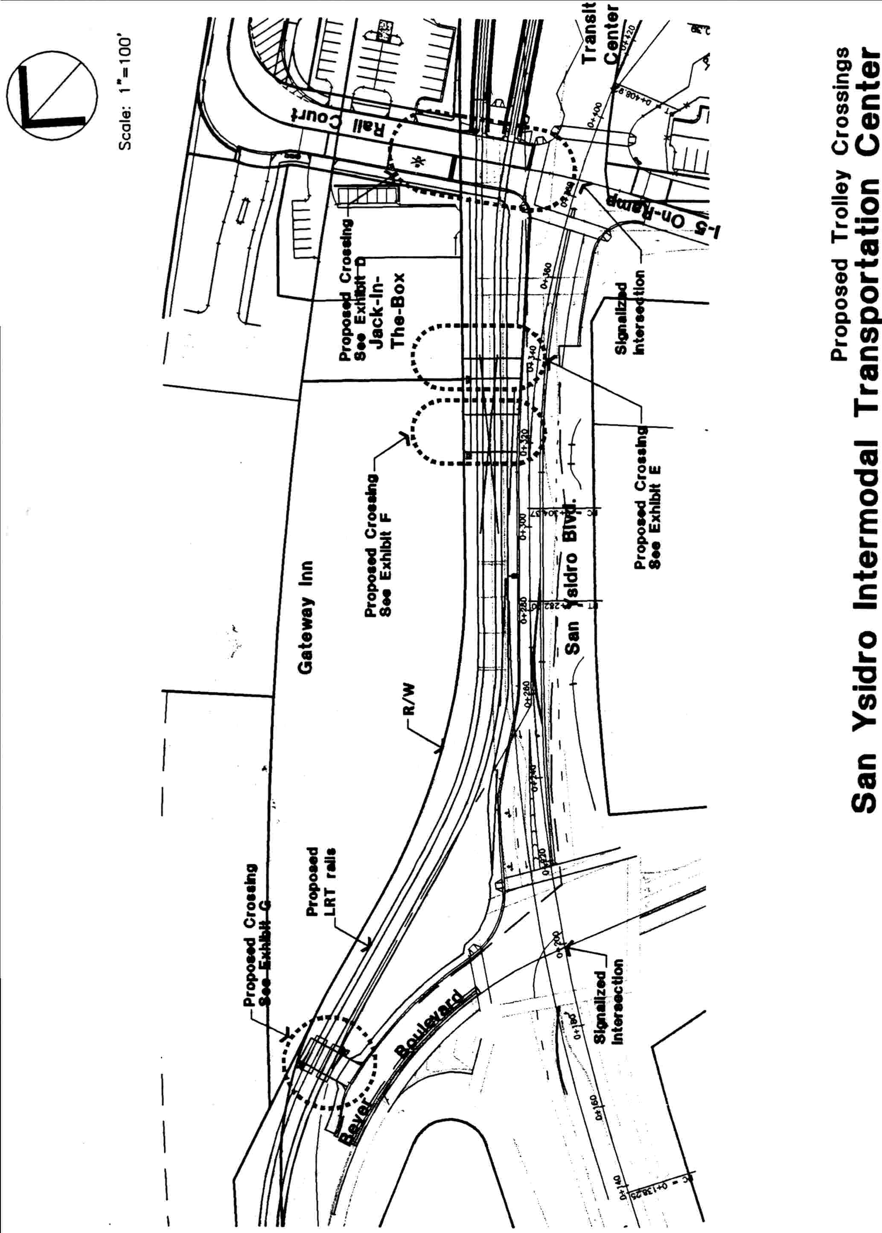

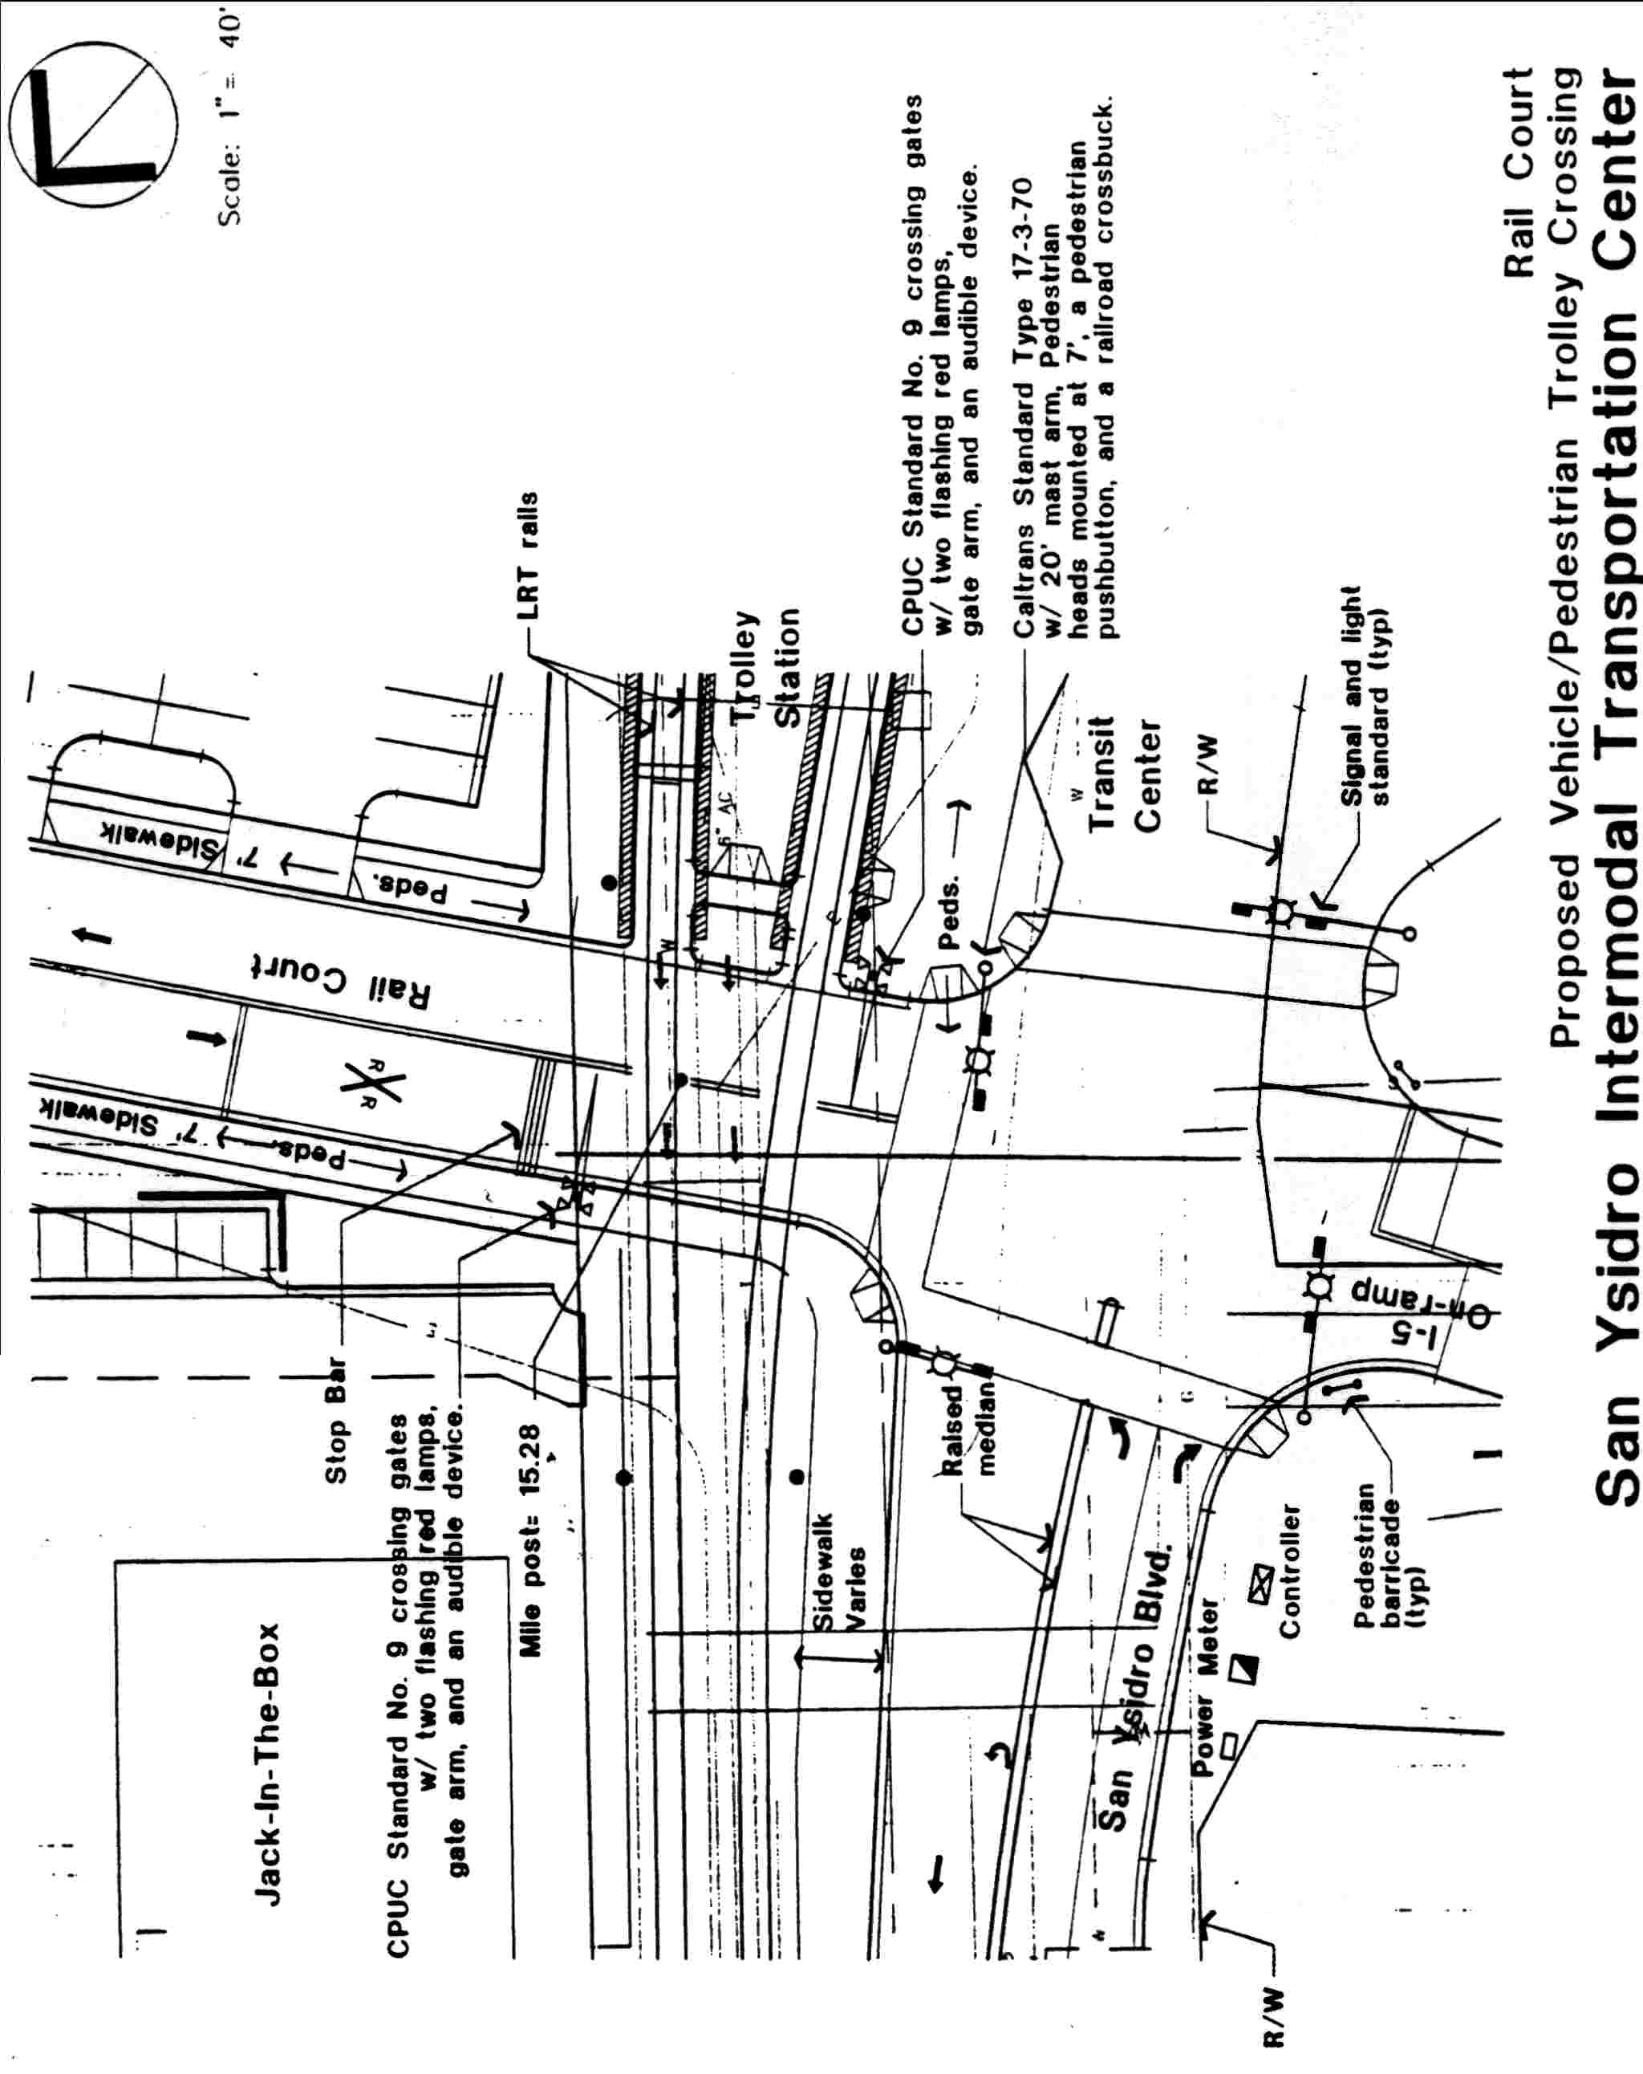

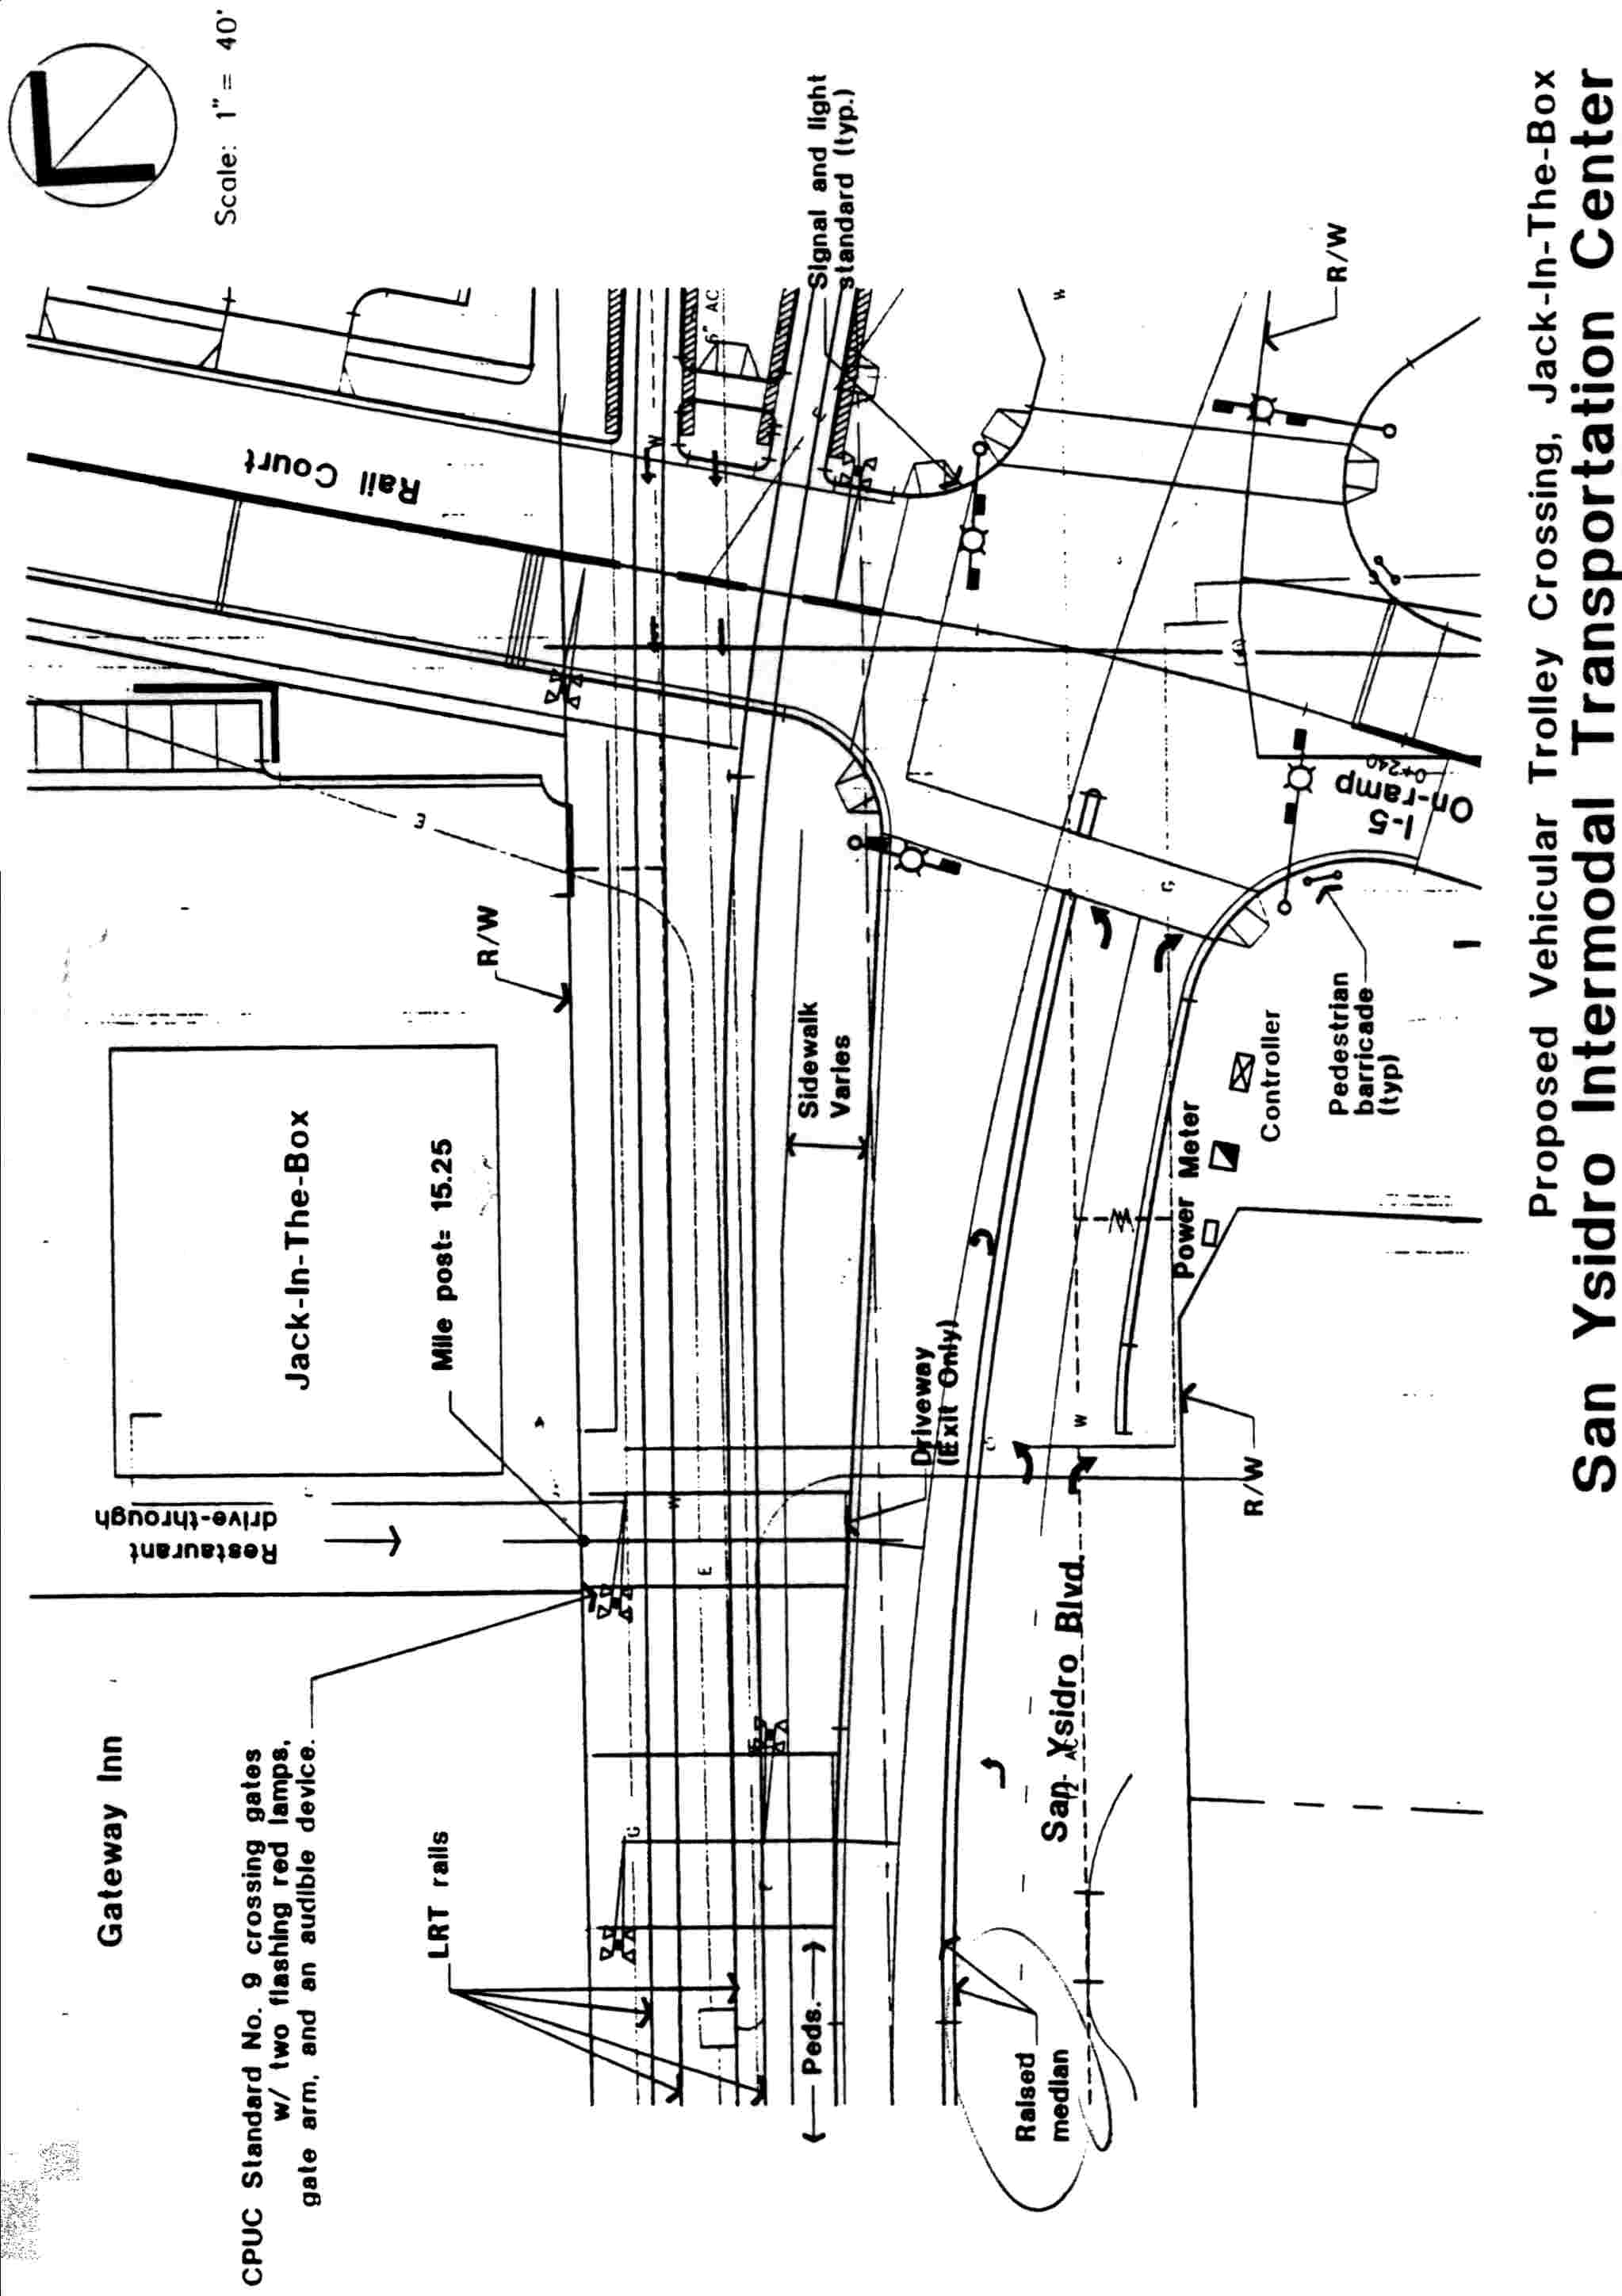
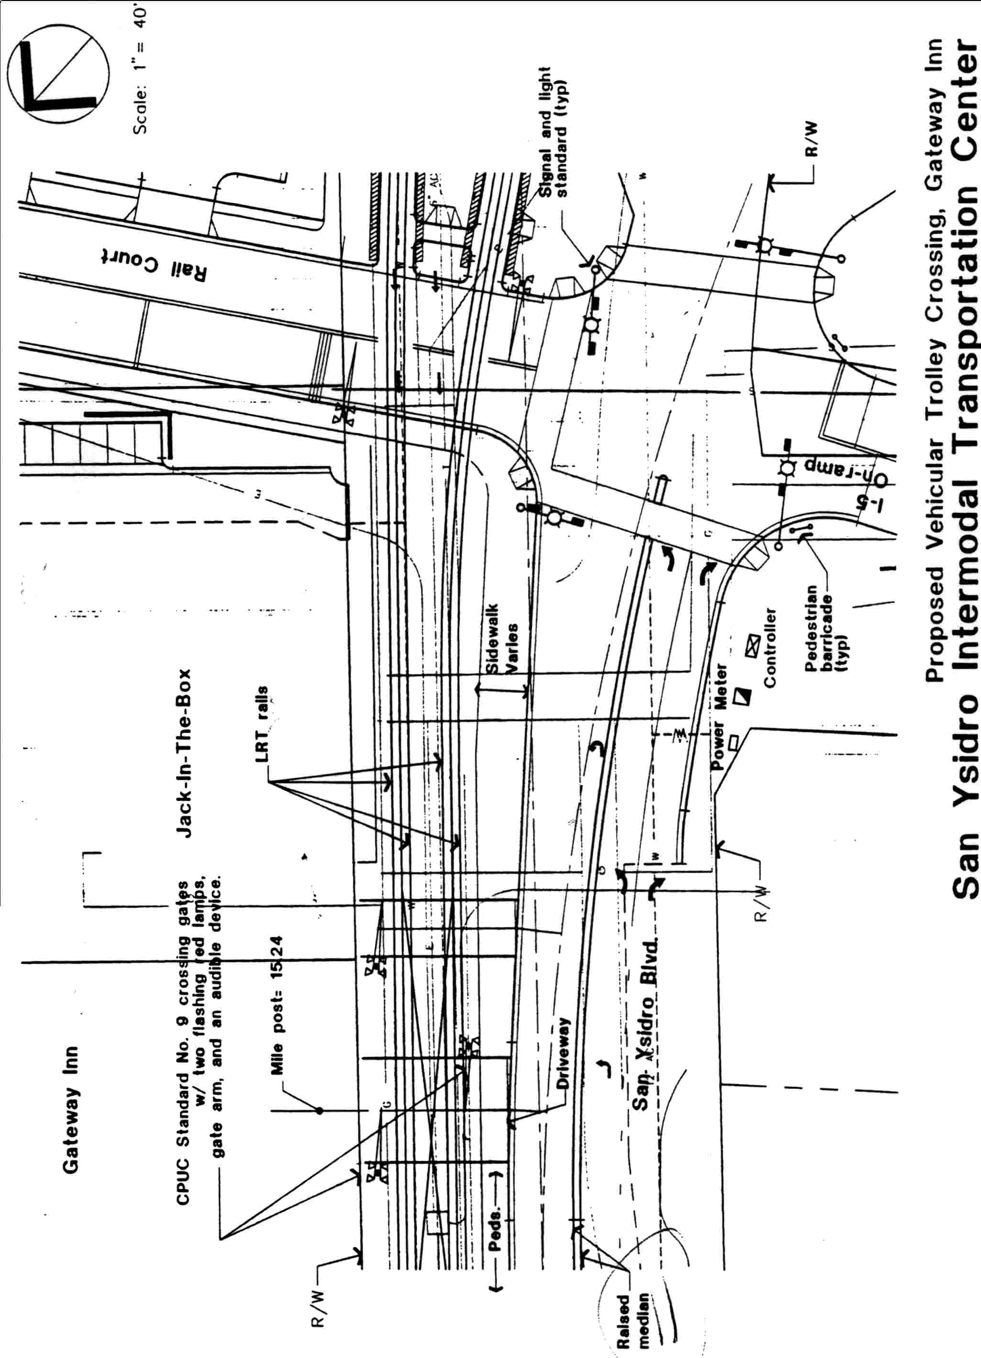

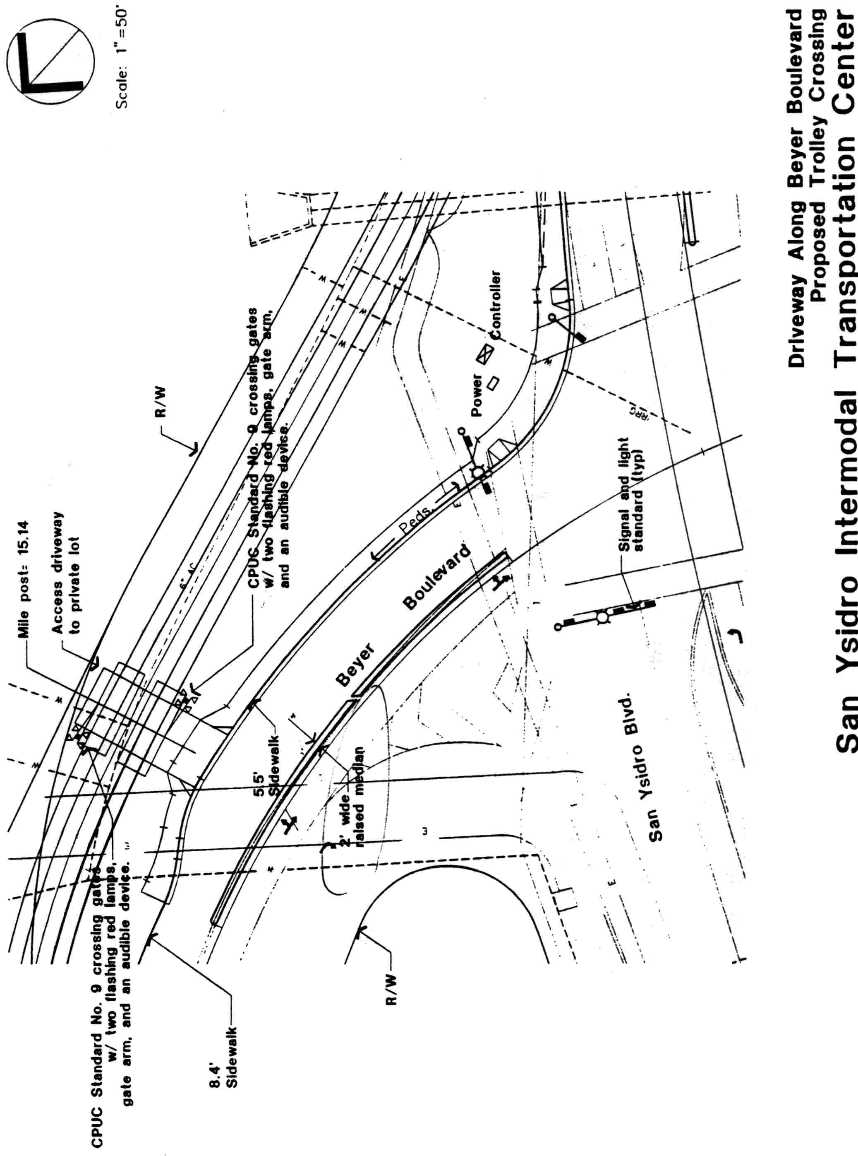
A P P E N D I X C
ENVIRONMENTAL DOCUMENTS
