ALJ/DJE/hl2 DRAFT Agenda ID #2717
Ratesetting
10/2/2003 Item #11

Decision PROPOSED DECISION OF ALJ EVANS (Mailed 9/11/2003)

BEFORE THE PUBLIC UTILITIES COMMISSION OF THE STATE OF CALIFORNIA

In the Matter of the Application of KERMAN TELEPHONE COMPANY (U 1012 C) to restructure intrastate rates and charges for telephone services furnished within the State of California. | Application 02-01-004  (Filed January 4, 2002)

(See Appendix A for List of Appearances)

OPINION APPROVING SETTLEMENT BETWEEN KERMAN TELEPHONE COMPANY AND OFFICE OF RATEPAYER ADVOCATES

Summary
This decision approves a stipulation between Kerman Telephone Company (Kerman) and the Commission’s Office of Ratepayer Advocates (ORA). This decision establishes final rates for Kerman, following the authorization in Decision (D.) 03-03-009 of interim rates subject to “true up.”

Background

Kerman Telephone Company
Kerman owns and operates a telephone system that provides local exchange telephone service to approximately 6,800 customers in the City of Kerman and in surrounding unincorporated areas of Fresno County. Kerman is located approximately 15 miles west of the City of Fresno on State Route 180.

Interim Rate Relief
In D.03-03-009, dated March 13, 2003, the Commission granted Kerman’s Motion for Interim Rate Relief and provided the interim relief through payment of an additional $1,937,350 in California High Cost
Fund-A (CHCF-A) revenues to Kerman based on Test Year 2002. Kerman originally filed for a General Rate Case (GRC) via Advice Letter (AL) 291 with the Commission’s Telecommunications Division (TD) on June 1, 2001. Kerman asked for a revenue increase based on a 2002 Test Year of $2.255 million, which would have produced a 12.25% rate of return on an intrastate rate base of approximately $4,079,125.
Kerman provided notice to its customers by bill insert as well as by an advertisement in the Kerman Newspaper in June of 2001. There were no customer complaints pertaining to Kerman’s AL filing, but the Office of Ratepayer Advocates (ORA) filed a protest to AL 291 on July 5, 2001.
In Resolution T-16597, the Commission denied Kerman’s request and ordered Kerman to file a GRC application. The Commission provided a list of items or issues that Kerman must address or comply with in its application. In addition, the Commission ordered ORA to conduct an audit of the affiliated transactions and jurisdictional separation practices of Kerman. Kerman was also ordered by the Commission to fund the audit. Kerman complied with these orders in its Application 02-01-004, which it filed on January 4, 2002.
Kerman noted in its application that the primary factors driving the request for rate relief were additional plant investment and increased operating expenses. In D.03-03-009, we found that Kerman was facing a financial emergency and authorized it an interim increase of $1,937,350 based on a 10% intrastate rate of return. We granted this interim increase subject to “true-up,” that is, Kerman would reflect any adjustments to its 2003 Test Year final revenue rate award. That “true-up” adjustment is a payment back to the CHCF-A by Kerman of $515,022, based on the Settlement Agreement between Kerman and ORA, which we are asked to approve.

Settlement Agreement
At the first day of hearings on February 19, 2003, Kerman and ORA announced that they had reached a full settlement of all the issues in the case and that a written stipulation would be forthcoming. On March 4, 2003, Kerman and ORA, the only parties to this proceeding, filed a joint motion requesting approval of an All-Party Settlement Agreement. (see Appendix B of this order.) This matter stood as submitted with the tendering of this motion.
Included in Appendix B to this decision are the joint exhibits reflecting the terms of the settlement, including (1) a comparison exhibit showing the unseparated 2003 Test Year Company Results of Operation, (2) an exhibit showing the separated, or intrastate, results of operation for the Test Year 2003 “base case,” and (3) an exhibit showing separated results of operation reflecting the “adopted Test Year at New Rates.” Additional attachments in Appendix B support the rate design calculations and propose a finding on service quality. The highlights of the settlement are as follows:
- A reduction of total company Test Year expenses (excluding depreciation) of $447,780 from the expense amount filed by Kerman in its original rate case filing.
- A reduction of total company test year depreciation expense of $813,618 from the level filed by Kerman in its original rate case filing. This reduction is attributable to an adjustment to depreciation rates on four accounts beginning with Test Year 2003, consistent with ORA’s recommendation in its direct testimony as originally served on December 16, 2002.
- A reduction of total company Test Year rate base from $12,760,448 to $10,000,000 prior to adjusting rate base to reflect changes in depreciation. (After taking into account impacts associated with changes in depreciation rates, the test year total company rate base is $10,406,810).
- Use of total company test year revenues as projected by Kerman in its original rate case filing.
- The rate design as proposed by Kerman in its original rate case filing, including the elimination of mileage bands.
- The use of a 10% intrastate rate of return on which to determine Kerman’s revenue requirement.

Discussion and Public Interest
This is an All-Party Settlement Agreement. We approve all-party settlements provided the following criteria are present in addition to criteria applicable to all settlements, which we discuss below. All-party settlements must meet the following requirements:
- The Settlement must command the unanimous sponsorship of all active parties to the proceeding. Because Kerman and ORA are the only parties to this proceeding, this criterion plainly is met.
- The sponsoring parties must be fairly representative of the affected interests. The increase in rates Kerman proposes will affect its customers. ORA represents the interests of those customers and advocates for all customers.
- No term of the settlement may contravene statutory provisions or prior Commission decisions. Nothing in the Settlement Agreement we approve contravenes statutory provisions or prior Commission decisions, and thus the settlement meets this criterion.
- The settlement must convey to the Commission sufficient information to permit it to discharge its future regulatory obligations with respect to the parties and their interests. The Settlement Agreement we approve sufficiently states the amount of the proposed revenues, revenue requirement, and rate design, as well as a stipulated rate of return so as to enable the Commission to fulfill its future regulatory obligations with respect to the parties and their interests.
In addition to meeting the all-party settlement criteria, the parties must demonstrate that the settlement is reasonable in light of the whole record, is consistent with the law, and is in the public interest. In evaluating settlements, the Commission has recognized a strong public policy in California favoring settlement and avoiding litigation. We find that this Settlement Agreement satisfies all three requirements of Rule 51.1(e).
First, as ORA and Kerman note, the terms of the Settlement Agreement are reasonable in light of the whole record. The Settlement Agreement reduces test year expenses and rate base to levels within the ranges established by ORA and Kerman testimony. The reduction in depreciation rates for the four specified accounts also falls within the ranges of depreciation rates proposed by ORA and Kerman. A 10% intrastate rate of return is consistent with recent Commission Resolutions in Small Local Exchange Carrier (LEC) rate proceedings under General Order (GO) 96-A and also falls between the 9.12% rate recommended by ORA and the 12.25% rate recommended by Kerman. With the exception of measured rate business service, the record reflects no dispute with Kerman’s proposed rate design. In fact, at the Public Participation Meeting held in Kerman on January 13, 2003, the customers in attendance supported Kerman’s rate design proposal. ORA and Kerman stipulated that service complies with all of
GO 133-B service quality measurement standards that are applicable to companies Kerman’s size. ORA confirmed that for the last five years only four informal minor service complaints were filed with the Commission and that all of these were resolved. Kerman and ORA believe that the Commission should find that Kerman’s service quality is reasonable. We agree and will do so.
Second, the Settlement Agreement is consistent with the law. Consistent with Pub. Util. Code § 451, the Settlement Agreement will lead to rates that are just and reasonable. In addition, consistent with Duquesne Light Co. v. Barasch, 488 U.S. 299, 109 S.Ct 609, 102 L.Ed.#d 646 (1989), the rate design and the 10% intrastate rate of return established by the Settlement Agreement allow Kerman the opportunity to earn a reasonable rate of return.
Finally, the public interest supports adoption of the Settlement Agreement since the Settlement Agreement eliminates the uncertainty inherent in continuing to litigate contested issues while also providing for the resolution of those issues in a manner acceptable to all parties to the proceeding. The Settlement Agreement also eliminates the need for time-consuming litigation. Further, all terms of the underlying settlement lie within the range of proposals supported by the sworn testimony, which constitutes the evidentiary record of this proceeding.

Conclusion
The Settlement Agreement between ORA and Kerman is reasonable and should be adopted.

Categorization
In Resolution ALJ 176-3080, dated January 4, 2002, the Commission preliminarily categorized this proceeding as ratesetting. The Scoping Memo issued on November 8, 2002 affirmed this categorization and found that hearings will be required.

Comments on Proposed Decision
The proposed decision of the ALJ in this matter was mailed to the parties in accordance with Section 311(d) of the Public Utilities Code and Rule 77.1 of the Rules of Practice and Procedure. The parties have stipulated to reduce the comment period to seven calendar days from date of mailing of the proposed decision for opening comments and three calendar days thereafter for reply comments. On September 17, 2002, ORA advised us that it would not be filing either opening or reply comments. On September 18, 2003, Kerman filed opening comments requesting that Finding of Fact 5 be revised to reflect the overcollection was in 2002, not Test Year 2003, and representing that ORA concurred with this request. That correction is appropriate and has been made.

Assignment of Proceeding
Susan P. Kennedy is the Assigned Commissioner and Dean J. Evans is the assigned ALJ in this proceeding.
Findings of Fact
- Kerman and ORA have entered into a Settlement Agreement that resolves every issue in the proceeding.
- No term of the Settlement Agreement contravenes statutory provisions or prior Commission decisions.
- The Settlement Agreement, together with the record in this proceeding, conveys sufficient information to permit the Commission to discharge its future regulatory obligation with respect to the parties and their interests.
- There is no known opposition to approving the Settlement Agreement.
- Kerman over collected $515,022 from the CHCF-A for 2002.
- Kerman’s service quality is reasonable because service complies with the requirements of GO 133-B service quality measurement standards.
- The summaries of earnings presented and the quantities and calculations included in Appendix B which underlie them, are reasonable for ratemaking purposes.
Conclusions of Law
- The Settlement Agreement is an “uncontested settlement” as defined in Rule 51(f).
- The Settlement Agreement is reasonable in light of the whole record, consistent with the law, and in the public interest.
- The Settlement Agreement also meets the criteria of an all-party settlement: it commands the unanimous sponsorship of all active parties to the proceeding; these parties are fairly representative of the affected interests; no terms of the settlement contravene statutory provisions or prior Commission decisions; and the settlement conveys to the Commission sufficient information to permit it to discharge its future regulatory obligations.
- Kerman should refund to the CHCF-A $515,022, plus interest, within 45 days from the effective date of this order. Interest should be calculated using the three-month commercial paper rate from the date of the payment of the interim rate amount to the date of the refund.
- The Settlement Agreement should be adopted.
- Based on the record, the revised rates proposed in the Settlement Agreement are reasonable and justified, considering the test year expenses, rate base, depreciation levels and rate of return.
- This decision should be made effective immediately to enable Kerman to implement its new rates and charges without delay.

ORDER

IT IS ORDERED that:
- The motion for adoption of the Settlement Agreement by Kerman Telephone Company (Kerman) and the Commission’s Office of Ratepayer Advocates (ORA) is granted.
- Kerman is authorized to file in accordance with General Order (GO) 96-A and make effective on not less than five days’ notice tariffs containing the rate revisions as proposed by Kerman. The revised rates shall apply to service rendered on and after the tariffs’ effective date.
- The lump sum refund of $515,022, including interest, shall be paid or credited by Kerman to the California High Cost Fund-A within 45 days from the effective date of the final order in this application.
- This proceeding is closed.
This order is effective today.
Dated _____________, at San Francisco, California.
LIST OF APPEARANCES

JEFFREY F. BECK
Attorney at Law
E. Garth Black; Mark P. Schreiber and Sean P. Beatty
COOPER, WHITE & COOPER, L.L.P.
201 California Street, 17th Floor
San Francisco, CA 94111
(415) 433-1900
Fax # - (415) 433-5530
Appearing for Kerman Telephone Co. (U 1012 C)
Applicant
smalllecs@cwclaw.com
jbeck@cwclaw.com
NATALIE WALES
CALIFORNIA PUBLIC UTILITIES COMMISSION
Legal Division
505 Van Ness Avenue, Room 5000
San Francisco, CA 94102
(415) 355-5490
Appearing for ORA
Protestant
ndw@cpuc.ca.gov

(END OF APPENDIX A)

BEFORE THE PUBLIC UTILITIES COMMISSION

OF THE STATE OF CALIFORNIA

In the Matter of the Application of KERMAN TELEPHONE COMPANY (U 1012 C) to restructure intrastate rates and charges for telephone services furnished within the State of California. | Application 02-01-004  (Filed January 4, 2002)

JOINT MOTION OF KERMAN TELEPHONE CO. (U 1012 C) AND THE OFFICE OF RATEPAYER ADVOCATES FOR ADOPTION OF ALL-PARTY SETTLEMENT AGREEMENT PURSUANT TO ARTICLE 13.5
OF THE COMMISSION'S RULES OF PRACTICE AND PROCEDURE

Pursuant to Rule 51.1(c) of the Commission's Rules of Practice and Procedure, Kerman Telephone Co. ("Kerman") and the Office of Ratepayer Advocates ("ORA") request that the Commission approve and adopt the Settlement Agreement entered into between Kerman and ORA that resolves Kerman's general rate case in its entirety ("Settlement Agreement"). A copy of the Settlement Agreement is attached to this motion.
The attached Settlement Agreement reflects an agreed-upon resolution of Kerman's rate case supported by all parties to this proceeding. Consistent with the requirements of Rule 51.1(e) of the Commission's Rules of Practice and Procedure , the Settlement Agreement is reasonable in light of the whole record, is consistent with law, and is in the public interest.
I. BACKGROUND
On January 4, 2002, Kerman filed its general rate case application seeking an increase of intrastate revenues and the modification of certain of its rates. At the same time, Kerman also filed a motion for interim rate relief seeking an interim revenue increase of $1,937,350 for 2002 consistent with its currently-authorized rate of return of 10%.
ORA protested Kerman's general rate case application and opposed Kerman's motion for interim rate relief. ORA also retained the services of outside consultants as authorized by the Commission in Resolution T-16597 dated November 29, 2001. In support of its review of Kerman's rate case filing, ORA engaged in extensive discovery in the form of written and oral data requests. ORA also visited Kerman's offices as part of its review. On December 16, 2002, ORA served its direct testimony in support of its case.
On January 30, 2003, Kerman served its written reply testimony responding to the issues raised in ORA's testimony.
Hearings on Kerman's rate case application were scheduled to begin on Tuesday, February 18, 2003. On Thursday, February 13, 2003, Kerman and the ORA, which are the only parties to this general rate case proceeding, participated in a conference call to discuss possible areas of settlement. Based on the results of the conference call, the parties agreed that additional time to discuss settlement in person would be worthwhile and received permission from the assigned Administrative Law Judge (ALJ) to delay the beginning of hearings until the afternoon of February 18th so that the parties could meet in the morning. Based on developments during the morning of February 18th, the parties sought and received from the ALJ an additional extension of the hearings until 10:00 a.m. on Wednesday, February 19th. The parties continued meeting during the afternoon of February 18th and early on February 19th. At approximately 10:00 a.m. on February 19th, the parties appeared in the hearing room before the assigned ALJ to announce that they had reached settlement of all outstanding issues in the general rate case. Kerman's counsel provided a summary of the details of the settlement on the record, and ORA's counsel concurred in this summary. The parties also stipulated to the introduction of pre-served testimony into the record while reserving their rights to object to such testimony or cross-examine the witnesses sponsoring such testimony in the event the Commission rejects or modifies the settlement.
The parties have reduced the terms of their settlement to writing, and their written Settlement Agreement is attached to this Joint Motion. By this Joint Motion, the parties request that the Commission approve and adopt the Settlement Agreement as the basis of the Commission's final decision in this proceeding.
II. SUMMARY OF SETTLEMENT AGREEMENT
As a result of their negotiations, Kerman and ORA have reached a settlement of all outstanding issues raised by their testimony in this proceeding. Attached to the Settlement Agreement are exhibits reflecting the terms of the settlement, including (1) a comparison exhibit showing unseparated 2003 Test Year Total Company results of operation, (2) an exhibit showing separated results of operation for the Test Year 2003 “base case,” and (3) an exhibit showing separated results of operations reflecting the “Adopted Test Year at New Rates.” Additional attachments to the Settlement Agreement support the rate design calculations and propose finding on service quality issues. Components of the settlement that produce the results reflected in these attachments include the following:
● A reduction of total company test year expenses (not including depreciation) of $447,780 from the expense amount filed by Kerman in its original rate case filing.
● A reduction of total company test year depreciation expense of $813,618 from the level filed by Kerman in its original rate case filing. This reduction is attributable to an adjustment to depreciation rates for four particular accounts beginning with test year 2003, consistent with ORA's recommendation in its direct testimony as originally served on December 16, 2002. A further discussion of this change to depreciation rates occurs later in this motion.
● A reduction of total company test year rate base from $12,760,448 to $10,000,000 prior to adjusting rate base to reflect changes in depreciation (after taking into account impacts associated with changes in depreciation rates, test year total company rate base is $10,406,810).
● Total company test year revenues as projected by Kerman in its original rate case filing.
● Rate design as proposed by Kerman in its original rate case filing, including the elimination of mileage bands.
● A 10% intrastate rate of return.
As part of the settlement, Kerman agreed to reduce depreciation rates beginning in 2003 for four accounts: 1) General Purpose Computers; 2) Digital Switching; 3) Circuit Switching; and 4) Buried Cable. The agreed-upon depreciation rates for those accounts beginning in 2003 are as follows:
Account Previous Rate 2003 Settlement Rate
General Purpose Computers 31.10% 9.99%
Digital Switching 14.29% 9.62%
Circuit Equipment 12.03% 8.31%
Buried Cable 9.22% 4.23%
As discussed above, these changes in depreciation rates reduce Kerman's total company test year depreciation expense by $813,618.
- THE SETTLEMENT AGREEMENT IS REASONABLE AND IS IN THE PUBLIC INTEREST
To obtain Commission approval of a settlement, the parties must demonstrate that the settlement is reasonable in light of the whole record, is consistent with law, and is in the public interest. Rule 51.1(e), Commission's Rules of Practice and Procedure. In evaluating settlements, the Commission has recognized a strong public policy in California favoring settlements and avoiding litigation. Re Pacific Bell, 45 C.P.U.C.2d 158, 169, D.92-07-076 (July 22, 1992). The Settlement Agreement satisfies all three requirements of Rule 51.1(e) and should be adopted by the Commission.
First, the terms of the Settlement Agreement are reasonable in light of the whole record. The Settlement Agreement reduces test year expenses and rate base to levels within the ranges established by the parties' testimony. The reduction in depreciation rates for four specified accounts also falls within the ranges of depreciation rates proposed by the parties. A 10% intrastate rate of return is consistent with recent Commission Resolutions in Small LEC rate proceedings under G.O. 96-A and also falls between the 9.12% rate recommended by ORA and the 12.25% rate recommended by Kerman. With the exception of measured rate business service, the record reflects no disputes with Kerman's proposed rate design. Regarding measured rate business service, the record demonstrated that no other small local exchange carrier in California has adopted such a rate design and that Kerman's small business community did not support the change from flat rate business service. Finally, the record also demonstrates that Kerman has adequate service quality to support adoption of the Settlement Agreement. General Order 133-B sets forth service quality standards with which Kerman must conform. Kerman has satisfied each of those standards. See Ex. 3, Hurley Direct (for Kerman), pp. 11-13; Ex. 10, ORA Direct Testimony, p. 5-2.
Second, the Settlement Agreement is consistent with applicable law. Consistent with Public Utilities Code Section 451, the Agreement will lead to rates that are just and reasonable. In addition, consistent with Duquesne Light Co. v. Barasch, 488 U.S. 299, 109 S.Ct. 609, 102 L.Ed.2d 646 (1989), the rate design and 10% intrastate rate of return established by the Settlement Agreement allow Kerman the opportunity to earn a reasonable rate of return.
Finally, the public interest supports adoption of the Settlement Agreement. The Settlement Agreement eliminates the uncertainty inherent in continuing to litigate contested issues while also providing for the resolution of those issues in a manner acceptable to all parties to the proceeding. The Settlement Agreement also eliminates the need for time consuming litigation, reducing the strain on the Commission's limited resources. Further, all terms of the underlying settlement lie within the range of proposals supported by the sworn testimony which constitutes the evidentiary record of this proceeding. For these reasons, adopting the Settlement Agreement is in the public interest.
IV. CONCLUSION
Based on the foregoing, the Commission should adopt the Settlement Agreement as its resolution of Kerman's rate case filing.
Dated this 3rd day of March, 2003, at San Francisco, California.

Jeffrey F. Beck
Sean P. Beatty
COOPER, WHITE & COOPER LLP
201 California Street
Seventeenth Floor
San Francisco, CA 94111
Telephone: (415) 433-1900
Telecopier: (415) 433-5530

By:___________________________________
Jeffrey F. Beck
Attorneys for Kerman Telephone Co.

Natalie D. Wales
OFFICE OF RATEPAYER ADVOCATES
California Public Utilities Commission
505 Van Ness Avenue
San Francisco, CA 94102
Telephone: (415) 355-5490
Telecopier: (415) 703-2262

By:___________________________________
Natalie D. Wales
BEFORE THE PUBLIC UTILITIES COMMISSION

OF THE STATE OF CALIFORNIA

In the matter of the Application of Kerman
Telephone Co. (U 1012 C) to restructure intrastate Application No. 02-01-004
rates and charges for telephone services furnished
within the State of California.
_________________________________________

SETTLEMENT AGREEMENT
This Settlement Agreement is entered into as of February 19, 2003, by and between Kerman Telephone Co. ("Kerman") and the Office of Ratepayer Advocates ("ORA"), these being all of the parties to the captioned proceeding. This Settlement Agreement is intended to resolve all issues presented in this general rate application of Kerman Telephone Co. (U 1012 C).
RECITALS
- On January 4, 2002, Kerman initiated this proceeding with the filing of its general rate case application seeking an increase of intrastate revenues and the modification of certain of its rates.
- On January 4, 2002, contemporaneously with the filing of its application in this proceeding, Kerman filed a motion for interim rate relief seeking an interim revenue increase of $1,937,350 for 2002 consistent with its currently-authorized rate of return.
- Thereafter, ORA protested Kerman's general rate case application and opposed Kerman's motion for interim rate relief.
- Following investigation and the propounding of discovery and the service by both sides of the prepared testimony of their respective witnesses, Kerman and ORA have arrived at an agreement that provides for the settlement of all issues presented in the within general rate case proceeding.
- The within settlement is supported by the testimony received in evidence in this proceeding. The settlement is reasonable in light of the whole record, is consistent with the laws of the State of California, and is in the public interest.
AGREEMENT
NOW, THEREFORE, based upon the mutual agreement reflected in this Settlement Agreement, Kerman and ORA agree to resolution of Kerman's general rate case application on the following terms:
- In support of this settlement, the parties have offered into evidence the pre-served testimonies of each of their witnesses, and the same have been received into the record by ruling of the assigned Administrative Law Judge, Dean Evans. Judge Evans has further ruled that this proceeding shall be considered submitted upon the receipt of this written Settlement Agreement. Each party has, for the purposes of settlement, waived cross-examination of the opposing witnesses, but the parties have reserved their rights of objections, motions, and cross-examination with respect to the testimony of the other party in the event the settlement by the pates is rejected by the Commission. The testimonies have been received into the record in accordance with the terms expressed in this paragraph.
- The parties have agreed to adoption by the Commission of the unseparated Total Company results of operation for the 2003 Test Year set forth on Attachment 1 to this Settlement Agreement. In accordance with Rule 51.1 (c), Attachment 1 is in the form of a comparison exhibit. This exhibit reflects a stipulated reduction in Kerman's depreciation rates to the levels specified for the following four accounts: General Purpose Computers, 9.99%; Digital Switching, 9.62%; Circuit Equipment, 8.31%; and Buried Cable, 4.23%. The parties have further stipulated that these depreciation rate changes shall become effective in 2003 and that they shall not be applied to prior years or to the calculation of any true-up for Kerman's motion for interim rate relief.
- The adopted terms of settlement for the 2003 Test Year “base case” are set forth on a jurisdictionally-separated basis in Attachment 2 to this Settlement Agreement.
- The parties further stipulate to:
(a) Adoption by the Commission of a 10% overall rate of return on intrastate operations, which is the rate of return currently authorized for
Kerman. Based on Kerman's actual capital structure, the 10% stipulated rate of return would be produced by the following factors:
Item | Cost | Weight | Weighted Cost
Debt | 5.00 | 0.211 | 1.06
Equity | 11.34 | 0.789 | 8.94
ROR |  |  | 10.00
(b) Adoption of the rate design proposed by Kerman in its filing, which is set forth in Attachment D to Exhibit 1, the Direct Testimony of Rhonda Armstrong. This rate design provides for (1) the elimination of grandfathered two-party service and the related elimination of mileage charges on one-party service, (2) establishment of charges for local area directory assistance, (3) establishment of a 1.5% late payment charge, and (4) establishment of a change charge at one-half the amount of a new service order charge. The tariff changes required to implement these rate design changes are contained in Attachment E to Exhibit 1. The aggregate Test Year revenue impact of these local exchange rate design proposals is a reduction of $240,979.
- Application of the stipulated 10% overall rate of return and the stipulated local rate design changes to the “base case” test year set forth in Attachment 2 produces the “Adopted Test Year at New Rates” set forth on Attachment 3 to this Settlement Agreement. This exhibit reflects an increase in Kerman's local exchange revenue requirement of $912,304, in comparison to the base case exhibit in Attachment 2 ($5,798,750 less $4,886,446 = $912,304). Details of this calculation are set forth in Attachment 4 to this Settlement Agreement.
- Attachment 5 to this Settlement Agreement reflects the details of the stipulated net $912,304 revenue requirement increase. This exhibit shows that an increase in Kerman's test year CHCF-A revenues of $1,153,283, offset by the $240,979 local rate reduction, is necessary to produce the $912,304 increase in the Test Year revenue requirement. Accordingly, Kerman's current $1,949,058 level of 2003 CHCF-A funding provided in Resolution T-16712 should be increased by $1,153,283, to a total 2003 CHCF-A funding level of $3,102,341.
- Kerman shall pay in full all invoices issued by outside consultants retained by ORA for audits prepared in connection with Kerman's general rate case application. Kerman shall be authorized to recover all amounts paid to the ORA-retained outside consultants in its next CHCF-A filing as a nonrecurring item.
- ORA agrees that it will not oppose adoption by the Commission of the draft decision of ALJ Evans mailed on February 11, 2003, granting Kerman's motion for interim rate relief. Following issuance of a Commission decision authorizing interim rate relief, Kerman will submit a compliance filing to adjust the authorized level of interim rate relief to reflect the revenue requirement impacts of this Settlement Agreement. ORA reserves the right to review and comment on Kerman's compliance filing.
- By entering into this Settlement Agreement, Kerman affirms that it shall comply with the provisions of the Commission's Decision Number 93-02-019 establishing reporting requirements pertaining to affiliate transactions and that it shall further comply with rules of the Federal Communications Commission pertaining to affiliate transaction as those rules apply to Kerman and as those rules may be modified in the future.
- The parties stipulate that the Commission should base its findings on service quality issues on the facts summarized in Attachment 6 to this Settlement Agreement.
- The provisions of this Settlement Agreement are not severable and shall only become effective after the Commission has entered an order approving this Settlement Agreement without modification. In the event this Settlement Agreement is not accepted in its entirety by the Commission, it shall be deemed to be withdrawn, without prejudice to any claims, positions, or contentions which may have been made or are made in this proceeding by any party and shall not be admissible in evidence or in any way described in any proceedings hereinafter. The provisions of this Settlement Agreement shall not be construed as or deemed to be a precedent by any party or the Commission with respect to any issue, principle, or interpretation or application of law and regulations, for any purpose or in connection with any proceeding before a court of law or any state or federal government regulatory body.
OFFICE OF RATEPAYER ADVOCATES

Dated:______________ By:_______________________________
Natalie D. Wales
Counsel to the Office of Ratepayer Advocates

KERMAN TELEPHONE CO.

Dated:______________ By:_______________________________
Jeffrey F. Beck
COOPER, WHITE & COOPER LLP
Counsel to Kerman Telephone Co.
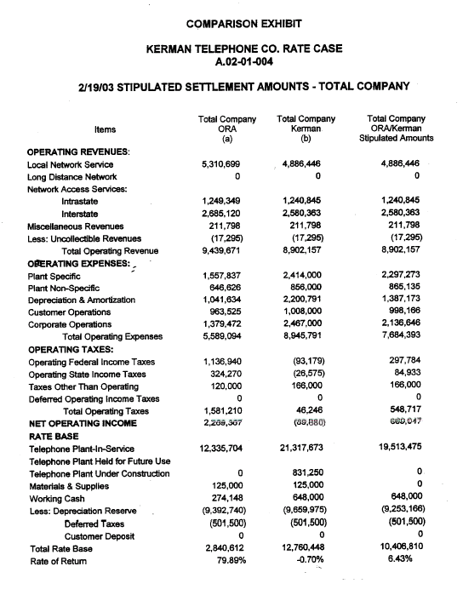
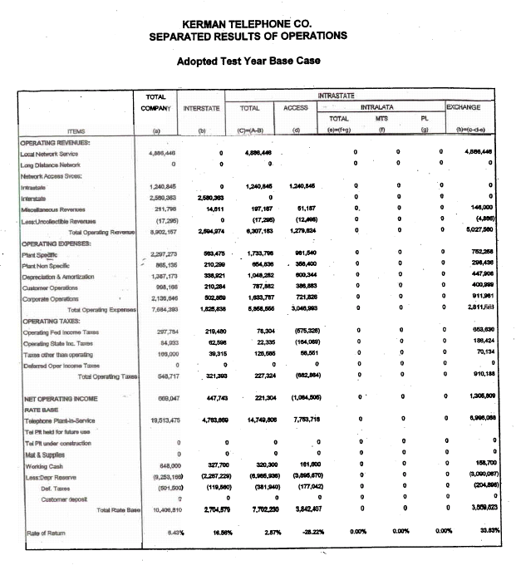
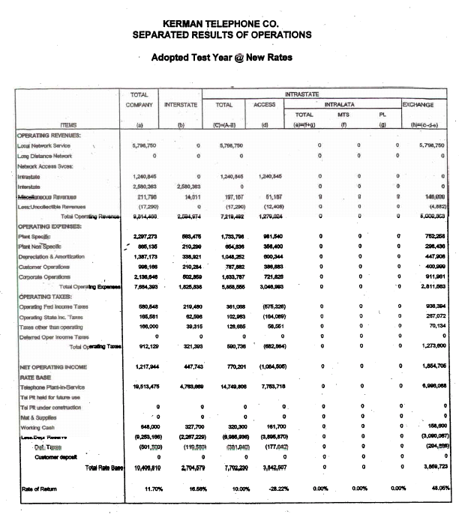

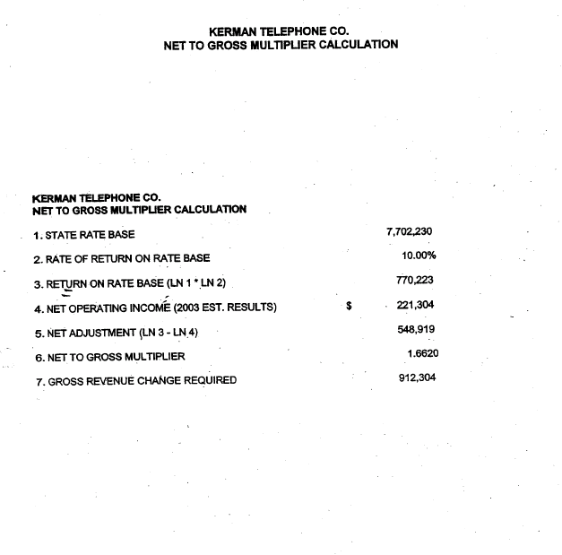
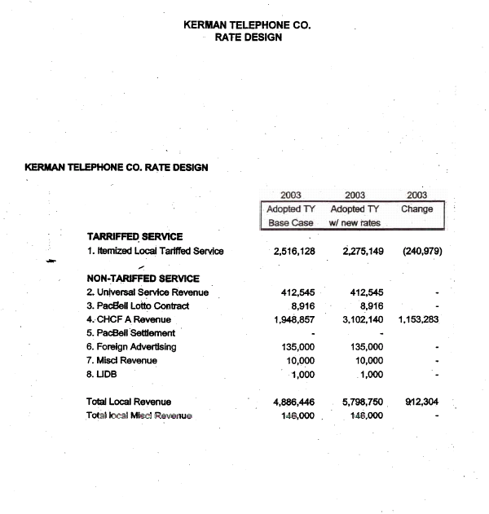
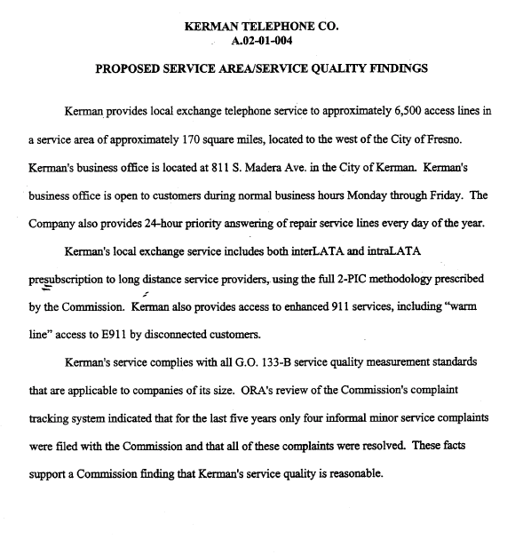
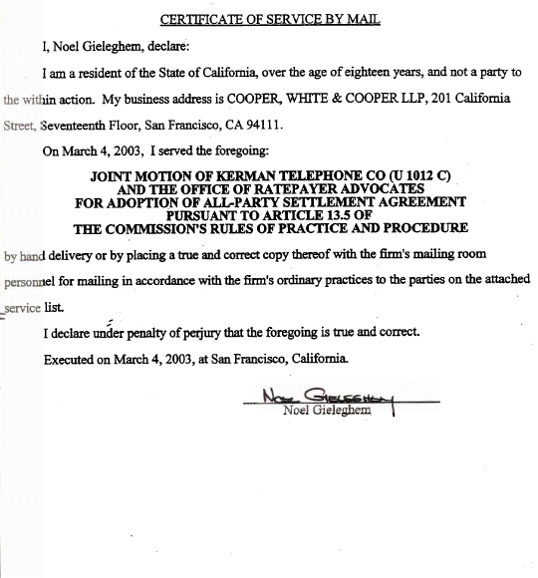

The plant accounts affected are General Purpose Computers, Digital Switching, Circuit Equipment and Buried Cable.
Cal. Pub. Util. Code § 309.5.
D.92-12-019, 46 CPUC 2d 538, 550-551 (1992).
Pacific Bell, 45 CPUC 2d 158, 169, D.92-07-076 (July 22, 1992).
Resolutions T-16697, 16707 and 16711.
See Resolution T-16697, Resolution T-16707, and Resolution T-16711.

