CPSD/RWC/DAR/JFP/mvm/vdl D R A F T Agenda ID #5926
Ratesetting

Decision _______

BEFORE THE PUBLIC UTILITIES COMMISSION OF THE STATE OF CALIFORNIA

Application of the City of San Diego for authority to construct new Harbor Drive Pedestrian Overpass Grade Separation Bridge Structure, CPUC No. 002-268.82-AD and DOT No. 924617J over three light rail vehicle tracks of the Metropolitan Transit Development Board and two heavy rail tracks of the BNSF Railway Company in the City of San Diego, County of San Diego, California. | Application 06-04-003  (Filed April 5, 2006)

O P I N I O N

Summary
This decision grants the City of San Diego’s (City) request to construct a new pedestrian overpass grade-separation bridge (Pedestrian Bridge), referred to as the Harbor Drive Pedestrian Bridge, over three light rail vehicle tracks of the Metropolitan Transit Development Board (MTDB), two heavy rail tracks of the BNSF Railway Company (BNSF), and Harbor Drive in the City of San Diego, County of San Diego.

Discussion
Proposed Project
The proposed construction of the Pedestrian Bridge is part of a larger project involving construction of a new at-grade crossing of Park Boulevard that was authorized by Decision (D.) 03-12-018. The Park Boulevard crossing is located approximately 70 feet southeast of the former Eighth Avenue crossing.
The City’s application satisfies the compliance filing requirement ordered by D.03-12-018, which was rendered and made effective on December 4, 2003.
The Park Boulevard at-grade vehicular crossing requires a Pedestrian Bridge in order to separate pedestrians from the at-grade vehicular crossing and the rail tracks, thereby providing safe and efficient access to the ball park for pedestrians. The Pedestrian Bridge will span above and across Harbor Drive, three light rail vehicle tracks (MTDB), and two heavy rail tracks (BNSF). The southern end of the Pedestrian Bridge will be connected to the third story of the Convention Center hotel parking structure.
The proposed Pedestrian Bridge will be designed as a self-anchored suspension bridge. According to the plans contained within the application, the total length of the proposed bridge structure is approximately 466 feet from abutment to abutment. The minimum vertical clearance from the top of the rail to the permanent bridge structure is 29 feet 6 inches. The horizontal clearance from the centerline of track to its nearest bridge abutment is 11 feet. The deck of the bridge will be elevated to provide vertical clearances of approximately 17.5 feet over Harbor Drive and approximately 26 feet over the railway tracks.
Environmental Review
The California Environmental Quality Act of 1970 (CEQA, as amended, Public Resources Code Section 21000 et seq.) applies to discretionary projects to be carried out or approved by public agencies. A basic purpose of CEQA is to inform governmental decision-makers and the public about potential, significant environmental effects of the proposed activities. The Commission must issue a discretionary decision in order for the project to proceed (i.e., the Commission must approve the project pursuant to Section 1202 of the Public Utilities Code) and consider the environmental consequences of the project by acting as either a lead or responsible agency under CEQA.
The lead agency is the public agency with the greatest responsibility for supervising or approving the project as a whole. Here, City is the lead agency for this project and the Commission is a responsible agency. As a responsible agency under CEQA, the Commission must consider the lead agency’s environmental documents and findings before acting on or approving this project.
City filed, with the State Clearinghouse and San Diego County Clerk, a Notice of Determination (NOD) and a Final Mitigated Negative Declaration (FMND) for this project on February 16, 2005. The FMND finds that this project will not have a significant effect on the environment with implementation of the mitigation measures identified. The identified mitigation measures in the FMND do not address environmental impacts falling within the scope of the Commission’s permitting process (safety, transportation and noise). A copy of the NOD is included in Appendix A attached to the order.
The Commission reviewed and considered the City’s FMND and NOD, and finds them adequate for our decision-making purposes.
The Commission’s Consumer Protection and Safety Division – Rail Crossings Engineering Section (RCES) has inspected the site of the proposed Pedestrian Bridge. After reviewing the need for and safety of the proposed crossing, RCES recommends that the Commission grant City’s request.
The application is in compliance with the Commission's filing requirements, including Rule 38 of Rules of Practice and Procedure, which relates to the construction of a public highway across a railroad. A plan of the proposed crossing is shown in Appendix B attached to this order.

Categorization and Need for Hearings
In Resolution ALJ 176-3170, dated April 13, 2006, and published in the Commission Daily Calendar on April 14, 2006, the Commission preliminarily categorized this application as ratesetting, and preliminarily determined that hearings were not necessary. No protests were filed, and it is not necessary to disturb the preliminary determinations made in Resolution ALJ 176-3170.

Waiver of Comment Period
This is an uncontested matter in which the decision grants the relief requested. Accordingly, pursuant to Public Utilities Code Section 311(g)(2), the otherwise applicable 30-day period for public review and comment is being waived..
Assignment of Proceeding
Richard Clark is the assigned Examiner in this proceeding.
Findings of Fact
- Notice of the application was published in the Commission’s Daily Calendar on April 7, 2006. There are no unresolved matters or protests; a public hearing is not necessary.
- City requests authority, under Public Utilities Code Sections 1201-1205, to construct the Harbor Drive Pedestrian Bridge over three light rail vehicle tracks of MTDB, two heavy rail tracks of the BNSF, and Harbor Drive in the City of San Diego, County of San Diego.
- The proposed crossing is part of a larger project involving construction of a new at-grade crossing of Park Boulevard authorized by D.03-12-018. The proposed crossing, located east of the Harbor Drive and Park Boulevard intersection, will separate pedestrians from the at-grade vehicular crossing and the rail tracks to provide safe and efficient access to the ball park for pedestrians.
- Public convenience, safety and necessity require the construction of the proposed crossing.
- City is the lead agency for this project under CEQA, as amended.
- The City adopted an FMND and NOD for this project pursuant to CEQA.
- The Commission is a responsible agency for this project, and has reviewed and considered the lead agency’s FMND and NOD.
Conclusions of Law
- The FMND and NOD adopted by the City as the documentation required by CEQA for the crossing project are adequate for our decision-making purposes.
- We adopt the City’s FMND and NOD for purposes of our approval.
- The application should be granted as set forth in the following order.
ORDER
IT IS ORDERED that:
- City of San Diego (City), is authorized to construct a pedestrian bridge over three light rail vehicle tracks of the Metropolitan Transit Development Board (MTDB) and two heavy rail tracks of the BNSF Railway Company (BNSF) and Harbor Drive, southeast of the former Eighth Avenue crossing and east of the Harbor Drive and Park Boulevard intersection, in the City of San Diego, San Diego County, at the location and substantially as shown by plans attached to the Application and Appendix B of this order, identified as CPUC Crossing No. 002-268.82-AD.
- City, MTDB, and BNSF shall comply with all applicable rules, including Commission General Orders and the Manual on Uniform Traffic Control Devices (MUTCD), as amended by the MUTCD California Supplement.
- Construction and maintenance costs shall be borne in accordance with an agreement that has been entered into between City, MTDB, and BNSF (parties). Should the parties fail to agree, the Commission will apportion the costs of construction and maintenance by further order.
- Within 30 days after completion of the work under this order, BNSF and MTDB shall notify the Rail Crossing Engineering Section (RCES) in writing, by submitting a completed standard Commission Form G (Report of Changes at Highway Grade Crossings and Separations), of the completion of the authorized work.
- This authorization shall expire if not exercised within three years unless time is extended or if the above conditions are not complied with. Authorization may be revoked or modified if public convenience, necessity, or safety so require.
- A request for extension of the three-year authorization period must be submitted to RCES at least 30 days before the expiration of that period. A copy of the request must be sent to all interested parties.
- This application is granted as set forth above.
- Application 06-04-003 is closed.
This order becomes effective 30 days from today.
Dated ____________, at San Francisco, California.
NOTICE OF DETERMINATION
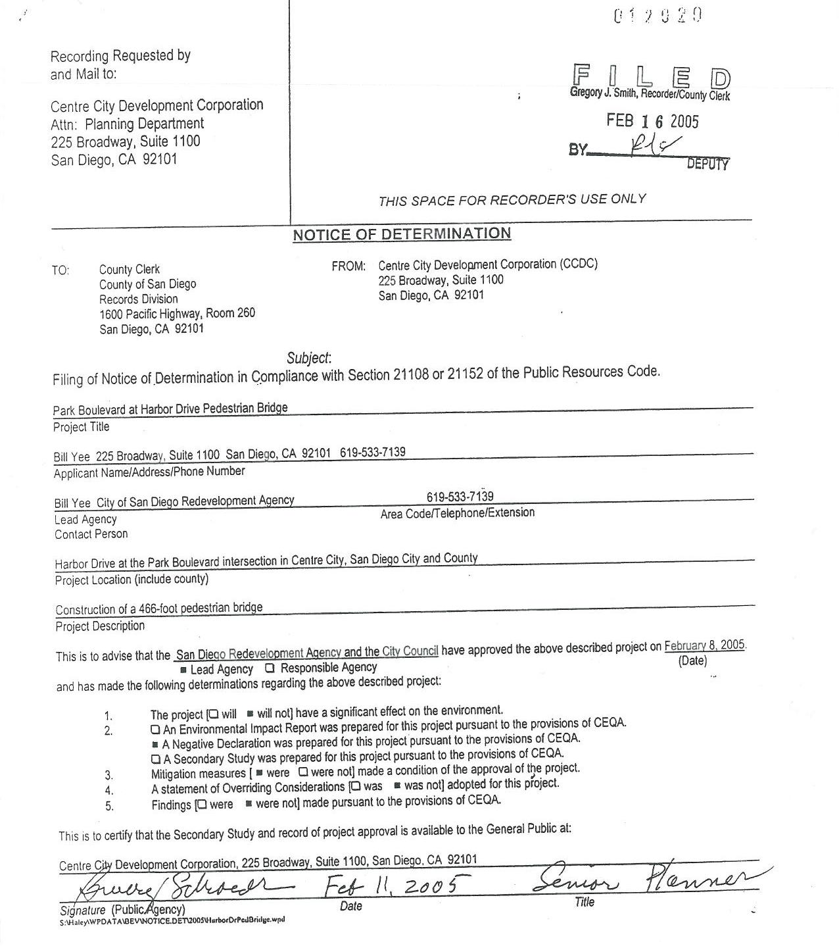
BRIDGE PLAN & ELEVATION
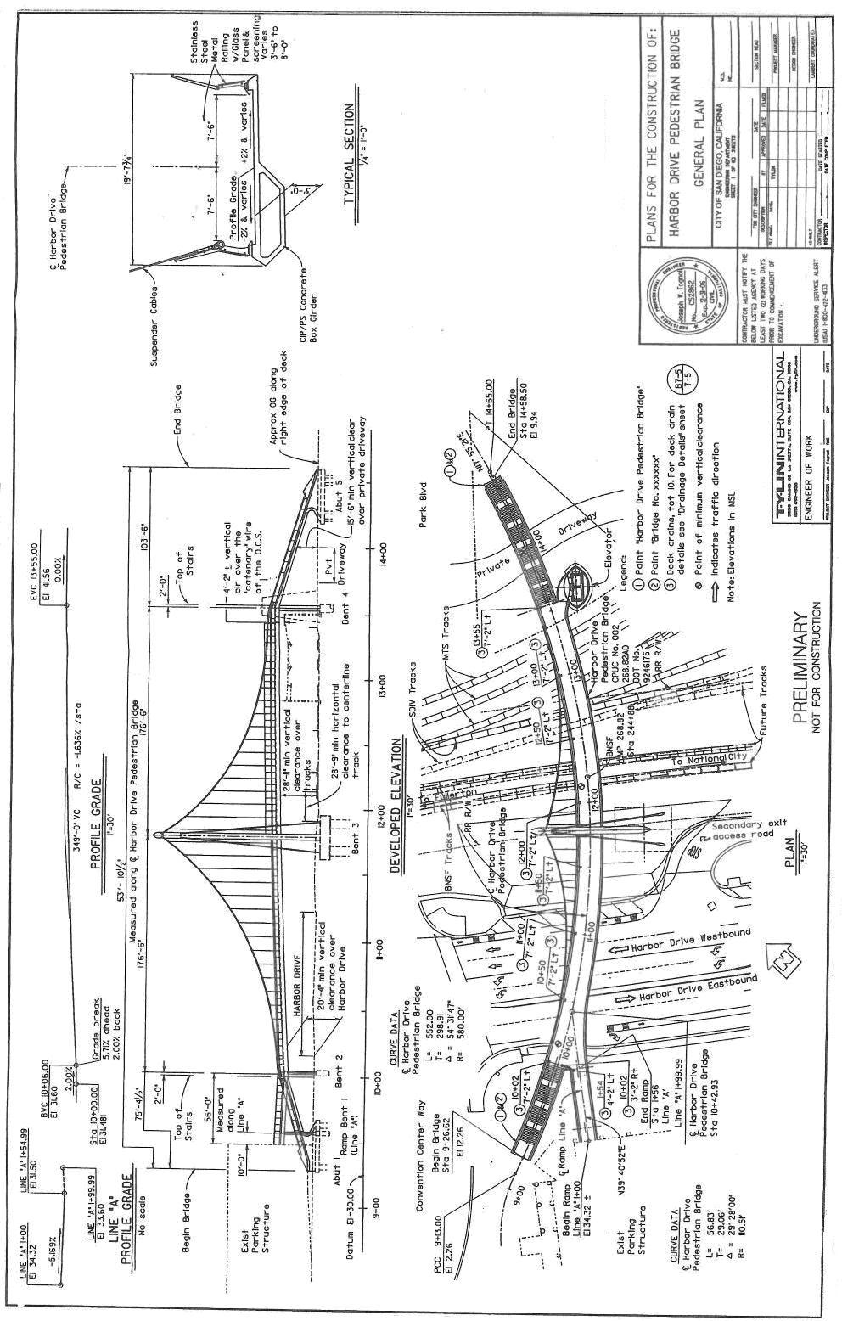

CEQA Guidelines (Title 14 of the California Code of Regulations), Section 15051(b).
CEQA Guidelines, Sections 15050(b) and 15096.

