CPSD/RWC/DAR/JFP/mc1 DRAFT Agenda ID #6336
Ratesetting

Decision ____________

BEFORE THE PUBLIC UTILITIES COMMISSION OF THE STATE OF CALIFORNIA

Application of the City of Torrance to construct a grade-separated crossing of Del Amo Boulevard over the Harbor Subdivision tracks of the Burlington Northern Santa Fe-LACMTA in the City of Torrance, California. | Application 06-08-032  (Filed August 30, 2006)

O P I N I O N

Summary
This decision authorizes the City of Torrance (City) to construct a grade-separated highway-rail crossing (grade separation) of Del Amo Boulevard over the jointly owned BNSF Railway Company (BNSF) - Los Angeles County Metropolitan Transportation Authority’s (LACMTA) Harbor Branch Line tracks, in Torrance, Los Angeles County.

Discussion
The City proposes to construct the Del Amo Boulevard Extension project over the Harbor Branch Line tracks jointly owned at this location by the BNSF and LACMTA. The BNSF operates an average of 17 freight trains daily on the Harbor Branch Line. LACMTA does not currently operate any type of light rail service on the Harbor Branch Line. Del Amo Boulevard functions as a major east/west roadway that extends from Crenshaw Boulevard to the west and Prairie Avenue to the east.
The Del Amo Boulevard Extension project is an integral part of the master plan of development in the City of Torrance. Public interest, safety, and necessity require a grade separation of Del Amo Boulevard over the Harbor Branch Line tracks. This grade separation project also is essential to provide continuous access and to reduce conflicts for public safety and emergency vehicles south and north of the project.
The eastern segment of Del Amo Boulevard currently terminates just west of Crenshaw Boulevard near the entrance to the Dow Chemical manufacturing plant; the western segment terminates at Maple Avenue. The project entails a 0.7-mile extension of Del Amo Boulevard between Crenshaw Boulevard and Maple Avenue on an elevated bridge structure to provide a continuous road through an industrial right-of-way.
The proposed bridge structure will vary from approximately 59 feet, 6 inches to 76 feet, 8 inches in width. The structure will maintain a minimum vertical clearance of 24 feet from top of rail to the lowest part of the bridge structure. Del Amo Boulevard will carry four vehicular through lanes, two shoulders, and a median with a barrier on the proposed overhead grade separation structure. The CPUC crossing number for the proposed grade separation will be CPUC Crossing No. 002H-20.16-A.

Environmental Review
The California Environmental Quality Act of 1970 (CEQA, as amended, Public Resources Code Section 21000 et seq.) applies to discretionary projects to be carried out or approved by public agencies. A basic purpose of CEQA is to inform governmental decision-makers and the public about potential, significant environmental effects of the proposed activities. Since the project is subject to CEQA and the Commission must issue a discretionary decision in order for the project to proceed (i.e., the Commission must approve the project pursuant to Section 1202 of the Public Utilities Code), the Commission must consider the environmental consequences of the project by acting as either a lead or responsible agency under CEQA.
The lead agency is the public agency with the greatest responsibility for supervising or approving the project as a whole. Here, the City is the lead agency for this project and the Commission is a responsible agency. As a responsible agency under CEQA, the Commission must consider the lead agency’s environmental documents and findings before acting on or approving this project.
The City prepared a Recirculated Draft Environmental Impact Report/Environmental Assessment (EIR/EA) for the Del Amo Boulevard Extension Project, which includes the proposed grade separation, (State Clearinghouse No. 2001121087), and Findings of Fact and Statement of Overriding Considerations (FFSOC).
The EIR/EA included an analysis of potential environmental impacts related to, among other items, transportation and circulation, and noise. Safety, transportation, and noise as they relate to the proposed grade separation are within the scope of the Commission’s permitting process.
The City, in its EIR/EA identified significant impacts related to transportation and circulation. The significant impacts relate to increased traffic congestion at street intersections. Fifteen intersections in the project area are projected to operate at highly congested levels during one or both of the peak traffic hours. Ten arterial street segments also would be significantly impacted by the traffic diversion resulting from the proposed extension.
Specific mitigation measures are proposed for 7 of the 15 significantly impacted intersections and are discussed in the EIR/EA. No mitigation measures were proposed for significantly impacted residential street segments. Consequently, significant and unavoidable impacts exist at 8 intersections and on 10 arterial street segments.
The FFSOC contains statements pertaining to impacts, mitigation measures, and findings for each impact. Included in the FFSOC is the Statement of Overriding Considerations (SOC). The lead agency adopted the SOC to approve the project despite significant and unavoidable adverse environmental impacts related to transportation and circulation. Specifically, the lead agency determined that changes or alterations have been required in, or been incorporated into, the project which avoid or substantially lessen the significant environmental effect identified in the EIR/EA. Further mitigation measures to fully mitigate impacts to a less-than-significant level at these intersections are infeasible, because of the built-out nature of the project area and the infeasibility of acquiring right-of-way to widen the roadways to provide additional turn lanes.
The City found that the benefits of the proposed project outweigh the significant unavoidable adverse environmental impacts. The City determined that each of the separate benefits identified in the SOC, in itself and independent of other project benefits, is a basis for overriding all unavoidable impacts identified in the environmental documents and in the City’s findings.
The Commission reviewed and considered the EIR/EA. We find that with respect to issues within the scope of our permitting process, the City did not identify any significant environmental impacts. We adopt the City’s findings and mitigations for purposes of our approval.
With respect to the SOC, we find that the City enumerated several significant benefits associated with the proposed extension project despite certain significant and unavoidable impacts. Therefore, we accept and adopt the findings of the SOC for purposes of our approval.

Filing Requirements and Staff Recommendations
The application is in compliance with the Commission’s filing requirements, including Rule 3.7 of Rules of Practice and Procedure, which relates to the construction of a public highway across a railroad. A vicinity map indicating the location of the proposed grade separation is shown in Appendix A attached to the order.
The Commission’s Consumer Protection and Safety Division – Rail Crossings Engineering Section (RCES) reviewed and analyzed the plans submitted with the application, and recommends that the Commission grant the City’s request.

Categorization and Need for Hearings
In Resolution ALJ 176-3178, dated September 7, 2006, and published in the Commission Daily Calendar on September 8, 2006, the Commission preliminarily categorized this application as Ratesetting and preliminarily determined that hearings were not necessary. No protests have been received. Given these developments, it is not necessary to disturb the preliminary determinations made in Resolution ALJ 176-3178.

Waiver of Comment Period
This is an uncontested matter in which the decision grants the relief requested. Accordingly, pursuant to Section 311(g)(2) of the Public Utilities Code and Rule 14.6(c)(2) of the Commission’s Rules of Practice and Procedure, the otherwise applicable 30-day period for public review and comment is waived.

Assignment of Proceeding
Richard Clark is the assigned Examiner in this proceeding.
Findings of Fact
- Notice of the application was published in the Commission’s Daily Calendar on September 7, 2006. There are no unresolved matters or protests; a public hearing is not necessary.
- The City requests authority, under Public Utilities Code Sections 1201-1205, to construct the proposed Del Amo Boulevard grade separation over the Harbor Branch Line tracks in Torrance, Los Angeles County.
- Public necessity and safety require construction of the proposed Del Amo Boulevard grade separation.
- The City is the lead agency for this project under CEQA, as amended.
- The City approved the project and adopted the EIR/EA and SOC for the expansion project pursuant to CEQA. No environmental impacts related to the proposed crossing were identified. Mitigation measures for other impacts were made a condition of the approval of the project.
- The Commission is a responsible agency for this project and has reviewed and considered the lead agency’s EIR/EA and FFSOC.
Conclusions of Law
- The EIR/EA and FFSOC adopted by the City as the documentation required by CEQA for the grade separation project are adequate for our decision-making purposes.
- The application is uncontested and a public hearing is not necessary.
- The application should be granted as set forth in the following order.
ORDER

IT IS ORDERED that:
- The City of Torrance is authorized to construct the Del Amo Boulevard grade-separated highway-rail crossing, identified as CPUC Crossing No. 002H-20.16-A, over the BNSF Railway Company-Los Angeles County Metropolitan Transportation Authority’s (BNSF-LACMTA) Harbor Branch Line, in Torrance, Los Angeles County, at the location and substantially as described in the application and Appendix A attached to this order.
- Within 30 days after completion of the work under this order, BNSF shall notify the Commission’s Consumer Protection and Safety Division – Rail Crossings Engineering Section (RCES) in writing, by submitting a completed standard Commission Form G (Report of Changes at Highway Grade Crossings and Separations), of the completion of the authorized work.
- This authorization shall expire if not exercised within three years unless time is extended or if the above conditions are not complied with. The Commission may revoke or modify authorization if public convenience, necessity or safety so require.
- A request for extension of the three-year authorization period must be submitted to RCES at least 30 days before the expiration of that period. A copy of the request must be sent to all interested parties.
- The application is granted as set forth above.
- Application 06-08-032 is closed.
This order becomes effective 30 days from today.
Dated _________________________________, at San Francisco, California.

VICINITY MAP
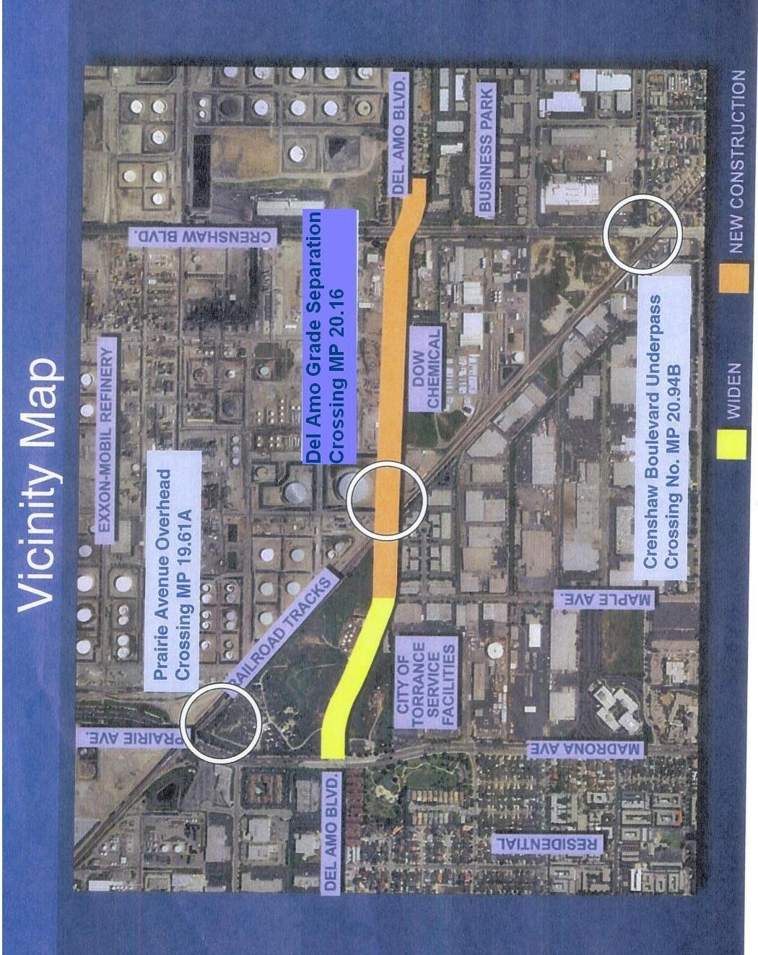

CEQA Guidelines (Title 14 of the California Code of Regulations), Section 15051(b).
CEQA Guidelines, Sections 15050(b) and 15096.

