CPSD/RWC/DAR/MLK/vdl DRAFT Agenda ID #8416
Ratesetting

Decision _________

BEFORE THE PUBLIC UTILITIES COMMISSION OF THE STATE OF CALIFORNIA

In the Matter of the Application of the City of Madera for the construction of an overcrossing to cross Ellis Street across the Right of Way of the Union Pacific Railroad Company. | Application 08-09-004  (Filed September 2, 2008)

DECISION GRANTING THE CITY OF MADERA AUTHORITY
TO CONSTRUCT A GRADE SEPERATED CROSSING OVER THE
RAILROAD TRACKS AND RIGHT-OF-WAY OF THE UNION
PACIFIC RAILROAD COMPANY IN THE CITY OF MADERA

Summary
This decision grants the request of the City of Madera (City) for authority to construct a grade separated crossing over one set of railroad tracks owned by the Union Pacific Railroad (UPRR) at Ellis Street in the City, County of Madera. In addition to crossing the UPRR track, the grade separated crossing will also cross over State Route (SR) 99, Golden State Boulevard, and Sharon Avenue in the City. The new grade separated crossing will be identified as CPUC Crossing No. 001B-181.60-A.

Discussion
The proposed grade separated crossing will cross over the UPRR railroad tracks, and is part of a proposed new roadway project connecting Ellis Street and Avenue 16. This project will enhance the City’s circulation network and serve to reclassify Ellis Street as an arterial street. Further, currently there are no grade separated crossings over the UPRR between Cleveland Avenue and Avenue 17 to connect with SR 99. The existing intersection at Avenue 16/SR 99 provides access on and off SR 99 only to the west side of the freeway. The lack of a roadway over the UPRR track at Avenue 16 increases travel time for east-west travelers in the City, and limits access to SR 99 for residents living on the east side of the track and the freeway. Currently, traffic east of the freeway and tracks must use the circuitous route along Country Club Drive, Cleveland Avenue, and Gateway Drive for an east-west route over SR 99 and the tracks. The construction of the proposed grade separated crossing will shift some of the existing traffic off of the at-grade highway-rail crossing on Cleveland Avenue, adjacent to the congested Cleveland Avenue/Gateway Drive intersection. Appendix A, attached to this order, is a vicinity map of the project.
The proposed Ellis Street grade separated crossing will be a concrete box girder bridge approximately 606 feet in length, and 57 feet in travel-way width (including bike lanes) that will cross the UPRR railroad track, Golden State Boulevard, SR 99, and Sharon Avenue in the City.
Environmental Review and CEQA Compliance
The California Environmental Quality Act of 1970 (CEQA, as amended, Public Resources Code Section 21000 et seq.) applies to discretionary projects to be carried out or approved by public agencies. A basic purpose of CEQA is to inform governmental decision-makers and the public about potential significant environmental effects of the proposed activities. The Commission must issue a discretionary decision in order for the project to proceed (i.e., the Commission must approve the project pursuant to Section 1202 of the Public Utilities Code), therefore, the Commission must consider the environmental consequences of the project by acting as either a lead or responsible agency under CEQA.
The lead agency is the public agency with the greatest responsibility for supervising or approving the project as a whole. Here, the City is the lead agency for this project and the Commission is a responsible agency. As a responsible agency under CEQA, the Commission must consider the lead agency’s environmental documents and findings before acting on or approving this project.
Pursuant to CEQA and the National Environmental Policy Act (NEPA), the City and Caltrans prepared environmental documentation consisting of an Initial Study/Environmental Assessment and a Mitigated Negative Declaration/Finding of No Significant Impact for the Ellis Street Overcrossing on State Route 99 in the City of Madera, dated June 2008, which identifies environmental impacts related to the Ellis Street grade separated crossing project.
Environmental impacts related to safety, traffic (transportation), and noise is within the scope of the Commission’s permitting process. In this Initial Study/Environmental Assessment and Mitigated Negative Declaration/Finding of No Significant Impact, no significant impacts related to safety and traffic issues are identified. However, the project would have a positive impact on traffic and transportation by enhancing local circulation. Moreover, there is a potential for temporary disruption of traffic during construction of the project, which would be mitigated by developing a Traffic Management Plan. Also, there will be some noise impacts due to construction activities that will be mitigated by compliance with Caltrans Standard Specifications, Section 7-1.011, “Sound Control Requirements.”
Caltrans reviewed this project to determine its compliance with NEPA requirements and on September, 29, 2008 signed a final Finding of No Significant Impact based on its determination that the project will not have a significant impact on the human environment.
Mitigation measures were made a condition for the approval of this project. We will adopt the City’s and Caltrans’ environmental findings and mitigations for purposes of our approval.
Filing Requirements and Staff Recommendations
This application is in compliance with the Commission’s filing requirements, including Rule 3.7 of Rules of Practice and Procedure, which relates to the construction of a public highway across a railroad.
The Commission’s Consumer Protection and Safety Division – Rail Crossings Engineering Section has inspected the site of the proposed crossing, has reviewed and analyzed the plans submitted with the application, and recommends that the Commission grant the City’s request.
Categorization and Need for Hearings
In Resolution ALJ 176-3221 dated September 18, 2008, and published in the Commission’s Daily Calendar on September 19, 2008, the Commission preliminarily categorized this application as ratesetting, and preliminarily determined that hearings were not necessary. No protests have been received. Given these developments, a public hearing is not necessary, and it is not necessary to disturb the preliminary determinations made in Resolution ALJ 176-3221.
Waiver of Comment Period
This is an uncontested matter in which the decision grants the relief requested. Accordingly, pursuant to Section 311(g)(2) of the Public Utilities Code and Rule 14.6(c)(2) of the Commission’s Rules of Practice and Procedure, the otherwise applicable 30-day period for public review and comment is being waived.
Assignment of Proceeding
Richard Clark is the assigned Examiner in this proceeding.
Findings of Fact
- Notice of the application was published in the Commission’s Daily Calendar on September 10, 2008. There are no unresolved matters or protests. A public hearing is not necessary.
- City requests authority, under Public Utilities Code Sections 1201-1205, to construct the Ellis Street grade separated crossing over the railroad track and right-of-way of UPRR in the City of Madera, Madera County. This crossing will be identified as CPUC Crossing No. 001B-181.60-A.
- The City is the lead agency for this project under CEQA, as amended. The City and Caltrans, acting pursuant to CEQA and NEPA, prepared an Initial Study/Environmental Assessment and Mitigated Negative Declaration/Finding of No Significant Impact.
- Safety, traffic (transportation), and noise are within the scope of the Commission’s permitting process. The City’s and Caltrans’ Initial Study/Environmental Assessment and Mitigated Negative Declaration for the Ellis Street Overcrossing project identified no significant impacts related to safety and traffic. There will be some noise impacts due to construction activities that will be mitigated by compliance with Caltrans Standard Specifications, Section 7-1.011, “Sound Control Requirements.”
- Pursuant to NEPA, Caltrans signed the Finding of No Significant Impact for the project on September 29, 2008.
- Pursuant to CEQA, the City signed the Mitigated Negative Declaration on September 30, 2008 regarding the Ellis Street grade separated crossing project. In this environmental document, the City states that the Ellis Street grade separation project, with the adoption of certain mitigations, will not have a significant effect on the environment.
- The Commission is a responsible agency for this project and has reviewed and considered the Initial Study/Environmental Assessment and Mitigated Negative Declaration/Finding of No Significant Impact of these lead agencies.
Conclusions of Law
- The Initial Study/Environmental Assessment and Mitigated Negative Declaration/Finding of No Significant Impact, prepared pursuant to CEQA and NEPA, are adequate for our decision-making purposes.
- We adopt the City’s and Caltrans’ Mitigated Negative Declaration finding that the Ellis Street grade separation project will not have a significant effect on the environment.
- The application is uncontested and a public hearing is not necessary.
- The application should be granted as set forth in the following order.
ORDER
IT IS ORDERED that:
- The City of Madera (City) is authorized to construct the Ellis Street grade separated crossing over the railroad tracks and right-of-way of the Union Pacific Railroad Company (UPRR) in the City of Madera, Madera County, at the location and substantially as described in the application. The new crossing will be identified as CPUC Crossing No. 001B-181.60-A.
- Within 30 days after completion of the work under this order, the City shall notify the Commission’s Rail Crossings Engineering Section (RCES) that the authorized work is completed by submitting a completed Standard Commission Form G titled Report of Changes at Highway Grade Crossings and Separations.
- This authorization shall expire if not exercised within three years unless time is extended or if the above conditions are not satisfied. The Commission may revoke or modify this authorization if public convenience, necessity, or safety so require.
- A request for extension of the three-year authorization period must be submitted to RCES at least 30 days before the expiration of that period. A copy of the request must be sent to all interested parties.
- This application is granted as set forth above.
- Application 08-09-004 is closed.
This order becomes effective 30 days from today.
Dated _____________ , at San Francisco, California.

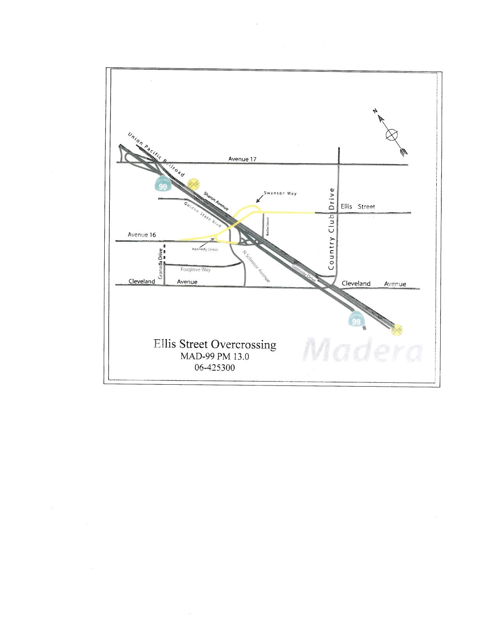
Vicinity Map of Project

CEQA Guidelines (Title 14 of the California Code of Regulations), Section 15051(b).
CEQA Guidelines, Sections 15050(b) and 15096.
42 USC 4332 (2)(c) of 1969 as amended. Projects undertaken in California that utilize federal funds, require discretionary federal approval, or are undertaken by federal agencies are subject to both NEPA and CEQA.
Pursuant to 23 U.S.C. §327, Caltrans may assume federal responsibilities to perform environmental review of highway projects under NEPA.

