PUBLIC UTILITIES COMMISSION OF THE STATE OF CALIFORNIA

Communications Division RESOLUTION -17316
Carrier Oversight & Programs Branch November 10, 2011

R E S O L U T I O N

RESOLUTION T-17316. Rural Telecommunications Infrastructure Grant Program Funding of the Godfrey Ranch Line Extension Grant Project.
________________

SUMMARY

This resolution authorizes construction of the Godfrey Ranch Line Extension Grant Project (Godfrey Ranch Project) located in the service area of Siskiyou Telephone Company (Siskiyou Telephone). Specifically, this resolution (1) authorizes grant funding from the Rural Telecommunications Infrastructure Grant Program in the amount of $1,444,100 for construction of the Godfrey Ranch Project, (2) authorizes the Executive Director to enter into a contract with the Town of Fort Jones, California for Fiscal Agent services associated with the Godfrey Ranch Project and (3) authorizes the revisions to Siskiyou Telephone’s existing line extension tariffs for the Godfrey Ranch Project.

BACKGROUND

Legislation and Rulemaking

The Rural Telecommunications Infrastructure Grant Program (RTIGP) provisions are set forth in Section 276.5 of the Public Utilities Code. The RTIGP provides grants of up to $5 million per project, with total grant funding of $10 million per year, for construction of telecommunications infrastructure to low-income, rural communities currently without telephone service. The RTIGP was established by Assembly Bill 140
in 2001, was amended by AB 2758 to extend the program, effective January 1, 2005 until January 1, 2009, and amended again under SB 1149 until January 1, 2013.

The legislation required the Commission to develop eligibility criteria for community-based groups to apply for grants and to establish a government-industry working group to review the technical criteria of the grant application. On February 27, 2003, the Commission issued an Order Instituting Rulemaking R.03-02-034 to develop application eligibility criteria. After consideration of comments, the Commission issued an Interim Decision D.03-09-071 adopting an application process and eligibility criteria for the grant program on September 18, 2003. On March 17, 2005, the Commission subsequently issued D.05-03-005 which adopted the interim grant program administration rules from D.03-09-071 as final rules.

Application Process

The RTIGP application process is divided into two phases: Phase 1 is the qualifying phase, in which applicants must provide information required by the legislation (information about the community to be served, its residents, financial information, letters of support from the local government and other affected governmental agencies, letters of support from 75% of the identified residential community and identity of the fiscal agent). Upon successful completion of Phase 1, an applicant may submit a Phase 2 Application, detailing the feasibility study and the construction cost study. In the event an applicant has been approved for Phase 1, but is denied Phase 2 approval, the applicant may recover the cost of the application process from grant funds.

Godfrey Ranch Project Description

This RTIGP application proposes to provide 7 line extensions to Godfrey Ranch, an unserved area located within Siskiyou Telephone’s Sawyers Bar Exchange Area. The cost per household is $206,300. The total length of the line extension is 31,404 ft,
trenched to a depth of 3 feet. The construction will occur in heavily forested and steep canyons within the Trinity Alps.

The Godfrey Ranch Project will provide telephone service to private residences in the Sawyers Bar Exchange. Due to the topographical constraints of the terrain, cellular and satellite technologies are not feasible, therefore Siskiyou Telephone proposes to utilize conventional landline telecommunications construction consisting of copper and fiber facilities, and will utilize Rural Utilities Service (RUS) standards and specifications to be compatible with Siskiyou Telephone’s existing telecommunications network.

The facilities to be constructed will provide Plain Old Telephone Service and Digital Subscriber Line service. The Godfrey Ranch Project is projected to take twelve weeks to complete (weather permitting) once the grant funds have approved. Total cost for construction, labor, and materials, and Fiscal Agent services will be $1,444,100.

DISCUSSION

Review of Phase 1 and 2 Applications

On August 17, 2007 the Communications Division (CD) received a Phase 1 Application from Siskiyou Telephone for the Godfrey Ranch Project. After review of the Phase 1 Application, CD found the application compliant with all necessary requirements. The applicant was notified in writing of the approval on July 31, 2008, and their eligibility to submit a Phase 2 Application, the feasibility study detailing the engineering and cost aspects of the Godfrey Ranch Project. The Phase 2 Application was submitted on October 10, 2008. Copies of the Phase 2 Application were provided to the Government Industry Working Group for review. One of the criteria of the Phase 2 Application is completion of a California Environmental Quality Act (CEQA) review. Resolution T-17205 was adopted by the Commission on June 25, 2009 and authorized the Executive Director to enter into a contract for CEQA review. An environmental Initial Study (IS) was prepared to identify the potential effects on the environment from the installation and construction of an underground telecommunications line in the right-of-way of Salmon River Road in Siskiyou County, and to evaluate the significance of these effects. The Final Initial Study and Mitigated Negative Declaration can be found at:

http://www.cpuc.ca.gov/NR/rdonlyres/F7DC3272-A20C-46F5-AE0B-4900014EEA7A/0/GodfreyRanchFinalMND.pdf.

The Community Representative for the Godfrey Ranch Project and Siskiyou Telephone were notified of the Phase 2 Application approval in the amount of $1,429,781 by mail on March 14, 2011. On July 12, 2011, Siskiyou Telephone notified CD that due to increases in the world market prices for copper, it was requesting an additional $48,473 for the Godfrey Ranch Project. After conducting an analysis of copper prices, CD Staff allowed an additional $8,319 for a total of $1,438,100 to fund construction of the Godfrey Ranch Project. With an additional $6,000 budgeted for the services of the Fiscal Agent; the total grant amount requested is $1,444,100.

The Government Industry Working Group Evaluation

The Government Industry Working Group (GIWG) is comprised of six members, and includes a former state legislator, a consumer advocate, an attorney specializing in telecommunications issues and representatives of three telecommunications companies operating in California. Copies of the Phase 2 Application for the Godfrey Ranch Project were sent out to the GIWG on March 9, 2009 requesting response by March 23, 2009. At a meeting of the GIWC on April 2, 2009 the technology chosen by Siskiyou Telephone for the Godfrey Ranch Project was reviewed and found to be feasible by all members of the GIWG.

Fiscal Agent Review

Section 276.5 of the California Public Utilities Code states:

The criteria shall include a requirement that a local agency, as defined by Section 50001 of the Government Code, or a town as defined by Section 21 of the Government Code, shall act as the community based group’s fiscal agent for the receipt and distribution of funds.

R.03-02-034 further specifies Grant Program Administration Rules. The Fiscal Agent is required in R.03-02-034 to provide an accounting, of expenditures and account balances, until no funds remain in the account. Upon completion of the infrastructure work, records shall be reviewed by an independent Certified Public Accountant and an Attestation Report shall be submitted to the Commission to ensure that the work is completed and paid for as represented.

The Phase 2 Application for the Godfrey Ranch Project designates the Town of Fort Jones, California, as the Fiscal Agent. The Town of Fort Jones is a local agency as
defined by Section 50001 of the Government Code. CD received a letter from the Town of Fort Jones, dated March 22, 2011, stating its willingness to act as the Fiscal Agent for the administration of the Godfrey Ranch Project.

The Executive Director of the CPUC shall enter into an agreement with the Town of Fort Jones, California as Fiscal Agent to receive the grant funds for the Godfrey Ranch Project.

California High Cost Fund-A

The funding source for RTIGP projects is the California High Cost Fund-A (CHCF-A). There are sufficient funds in the CHCF-A to cover the cost of the Godfrey Ranch Project.

California Environmental Quality Act Review

The issuances of grants pursuant to the RTIGP are discretionary actions subject to the requirements of California Environmental Quality Act (CEQA). CEQA reviews for RTIGP grants are conducted consistent with the two phase application process for RTIGP funding established in D.03-09-071. The CPUC is the lead agency for utility projects under CEQA.

Approval of a Phase 1 Application means that the Commission has determined that a proposed project is eligible to receive funds under the RTIGP. Phase 1 determinations do not approve a “project” under CEQA and do not trigger environmental review. Phase 2 Applications seek funds that are necessary for the construction of rural telecommunications infrastructure and are projects under CEQA. Phase 2 Applications are subject to a case-by-case factual analysis of environmental impacts.

Funding for CEQA review was approved by the Commission in T-17205. An environmental Initial Study was prepared to identify the potential effects on the environment from the installation and construction of an underground telecommunications line in the right-of-way of Salmon River Road in Siskiyou County, and to evaluate the significance of these effects. The Initial Study was based on site visits, analysis of the environmental settings, and the studies of cultural resources, biological resources, and site geology.

Based on the Initial Study, the Godfrey Ranch Project as proposed by Siskiyou Telephone, including the mitigation measures proposed, would have no significant impacts in the areas of: aesthetics, agricultural resources, air quality, biological resources, cultural resources, geology and soils, hazards and hazardous materials, hydrology and water quality, land use planning, mineral resources, noise, population and housing, recreation, transportation and traffic, and utilities and service systems.

The complete Initial Study and Mitigated Negative Declaration can be found at:

http://www.cpuc.ca.gov/NR/rdonlyres/F7DC3272-A20C-46F5-AE0B-4900014EEA7A/0/GodfreyRanchFinalMND.pdf

The Energy Division review found the Phase 2 Application complete and in compliance with General Order 131-D and adopted the final Mitigated Negative Declaration (which incorporates the draft Initial Study and Mitigated Negative Declaration), subject to the conclusions therein, and authorizes work on the line extension to begin.

Siskiyou Telephone submitted comments informing the Commission of a determination by the United States Forest Service that, due to recent forest fires, there is no longer Spotted Owl habitat within 0.25 miles of the Godfrey Ranch project. This determination is applicable to a Spotted Owl mitigation measure currently contained in the Mitigated Negative Declaration for the Godfrey Ranch project, which restricts the start date for construction activities. Revisions are proposed to Sections 2.1 and 2.2 of the Mitigated Negative Declaration, which are contained in Appendix B of this Resolution, consistent with this determination. These revisions would allow for an earlier construction start date.

Godfrey Ranch Project Tariff

In addressing Incumbent Local Exchange Carriers (ILEC’s) cost recovery, the Commission found that existing line extension tariffs should not apply to the RTIGP. In D.03-09-071 (page 13) the Commission stated: “The line extension tariffs were not designed to address a state-administered program such as this one, where funds collected through a surcharge on telecommunications customers, are provided to pay for infrastructure costs. We find that existing line extension tariffs should not apply to this program. Instead ILEC’s shall file advice letters setting forth line extension rates, charges and other terms and conditions applicable to each RTIGP. Such charges shall be reasonable and cost-based. Such terms shall be consistent with this decision. These tariffs shall supplement, not replace existing line extension tariffs. Where we find that a grant application should be approved, we will permit ILEC’s to recover from the fund infrastructure costs contained in the Commissioner-approved tariff”.

Based on a review of the project, Siskiyou Telephone has complied with the Commission’s tariffing requirements and filed a compliance tariff as shown in Appendix A.

COMMENTS

Public Utilities Code Section 311(g)(1) requires that a draft resolution be served on all parties, and be subject to a public review and comment period of 30 days or more, prior to a vote of the Commission on the resolution. A draft of today’s resolution was distributed for comment to Siskiyou Telephone, AT&T, Verizon, the Small LEC’s, the Community Representative Godfrey Ranch Project, Board of Supervisors Siskiyou County, the Town of Fort Jones, USFS, and other interested parties.

Late comments were submitted by Siskiyou Telephone on Oct. 13. The comments request a modification of the Mitigated Negative Declaration. The reason stated for the requested modification is that the United States Forest Service has determined that there is no longer Northern Spotted Owl habitat within 0.25 miles of the proposed Godfrey Ranch project. The modifications would allow Siskiyou Telephone to begin construction as soon as weather permits, instead of July, 2012, as proposed in the initial Mitigated Negative Declaration. CD Staff accepts the comments, and will include the revised mitigation measure Section 2.1 and 2.2 as Appendix B in this Resolution.

FINDINGS

1. The Siskiyou Telephone Company, in concert with the Godfrey Ranch Line Extension Grant Project customers requesting telephone service, did submit a Rural Telecommunications Infrastructure Grant Application Phase 1 and Phase 2 for the Godfrey Ranch Project.

2. The Siskiyou Telephone Company is requesting Rural Telecommunications Infrastructure Grant funds in the amount of $1,444,100 for the construction of the Godfrey Ranch Project.

3. The Phase 1 Application was approved on July 31, 2008, and the Phase 2 Application was approved on March 14, 2011 in the amount of $1,429,781 pending California Environmental Quality Act review. Due to increases in the costs for materials after the Phase 2 Application was approved, the revised final amount for construction including the services of the Fiscal Agent is $1,444,100.

4. The Government Industry Working Group has reviewed the Phase 2 Application and found the proposed project to be technically feasible.

5. The California Public Utilities Commission is the lead agency for California Environmental Quality Act review of the Godfrey Ranch Project.

6. The Energy Division (ED) reviewed the Phase 2 Application for the Godfrey Ranch Project and completed an Initial Study and Negative Mitigation Declaration.

7. Approval of this Resolution is in the public interest and the grant funds for the Godfrey Ranch Project should be approved. The Commission has considered the final Mitigated Negative Declaration (which incorporates the draft Initial Study/ Mitigated Negative Declaration) and finds it sufficient for its decision making purposed.

8. Comments submitted by Siskiyou Telephone provide information that the United States Forest Service has determined there is no longer Spotted Owl habitat within 0.25 miles of the Godfrey Ranch Project. Consistent with this determination, revisions are proposed to Sections 2.1 and 2.2 of the Mitigated Negative Declaration, as contained in Appendix B of this Resolution.

9. The Town of Fort Jones, California, will act as the Fiscal Agent for the Godfrey Ranch Project.

10. The source of the grant funds for the Godfrey Ranch Project is the California High Cost Fund-A.

11. There are sufficient funds in the California High Cost Fund-A to cover the cost of this project.

12. The Siskiyou Telephone Company has filed a compliance Advice Letter tariff and map delineating the Godfrey Ranch Project (See Appendix A).

14. The Commission finds that approval be based on the specifics of this Resolution and the Resolution should not establish a precedent for the contents of future filings or for Commission approval of similar requests.

THERFORE, IT IS ORDERED that:

- Funds shall be granted in the amount of $1,444,100 from the California High Cost Fund-A for funding the construction of the Godfrey Ranch Line Extension Grant Project located in the Sawyers Bar Exchange of the Siskiyou Telephone Company.

- The Executive Director of the California Public Utilities Commission is authorized to enter into an agreement with the Town of Fort Jones, California for administration and disbursement of California High Cost Fund-A funds for the Godfrey Ranch Project.

- The final Mitigated Negative Declaration, revised consistent with Appendix B, is hereby adopted.

This resolution is effective today.

I certify that the foregoing resolution was duly introduced, passed, and adopted at a conference of the Public Utilities Commission of the State of California held on November 10, 2011, the following Commissioners voting favorable thereon:

______________________________
PAUL CLANON
Executive Director
Appendix A

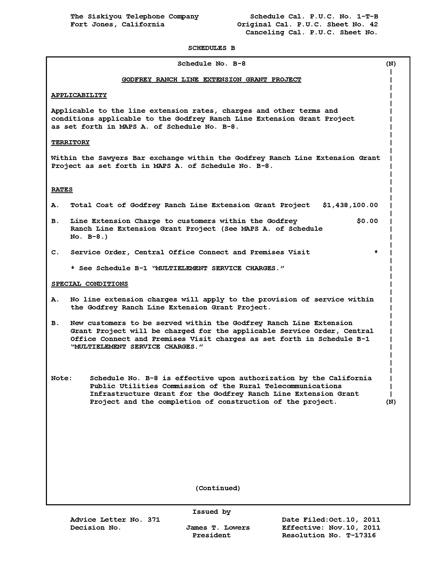
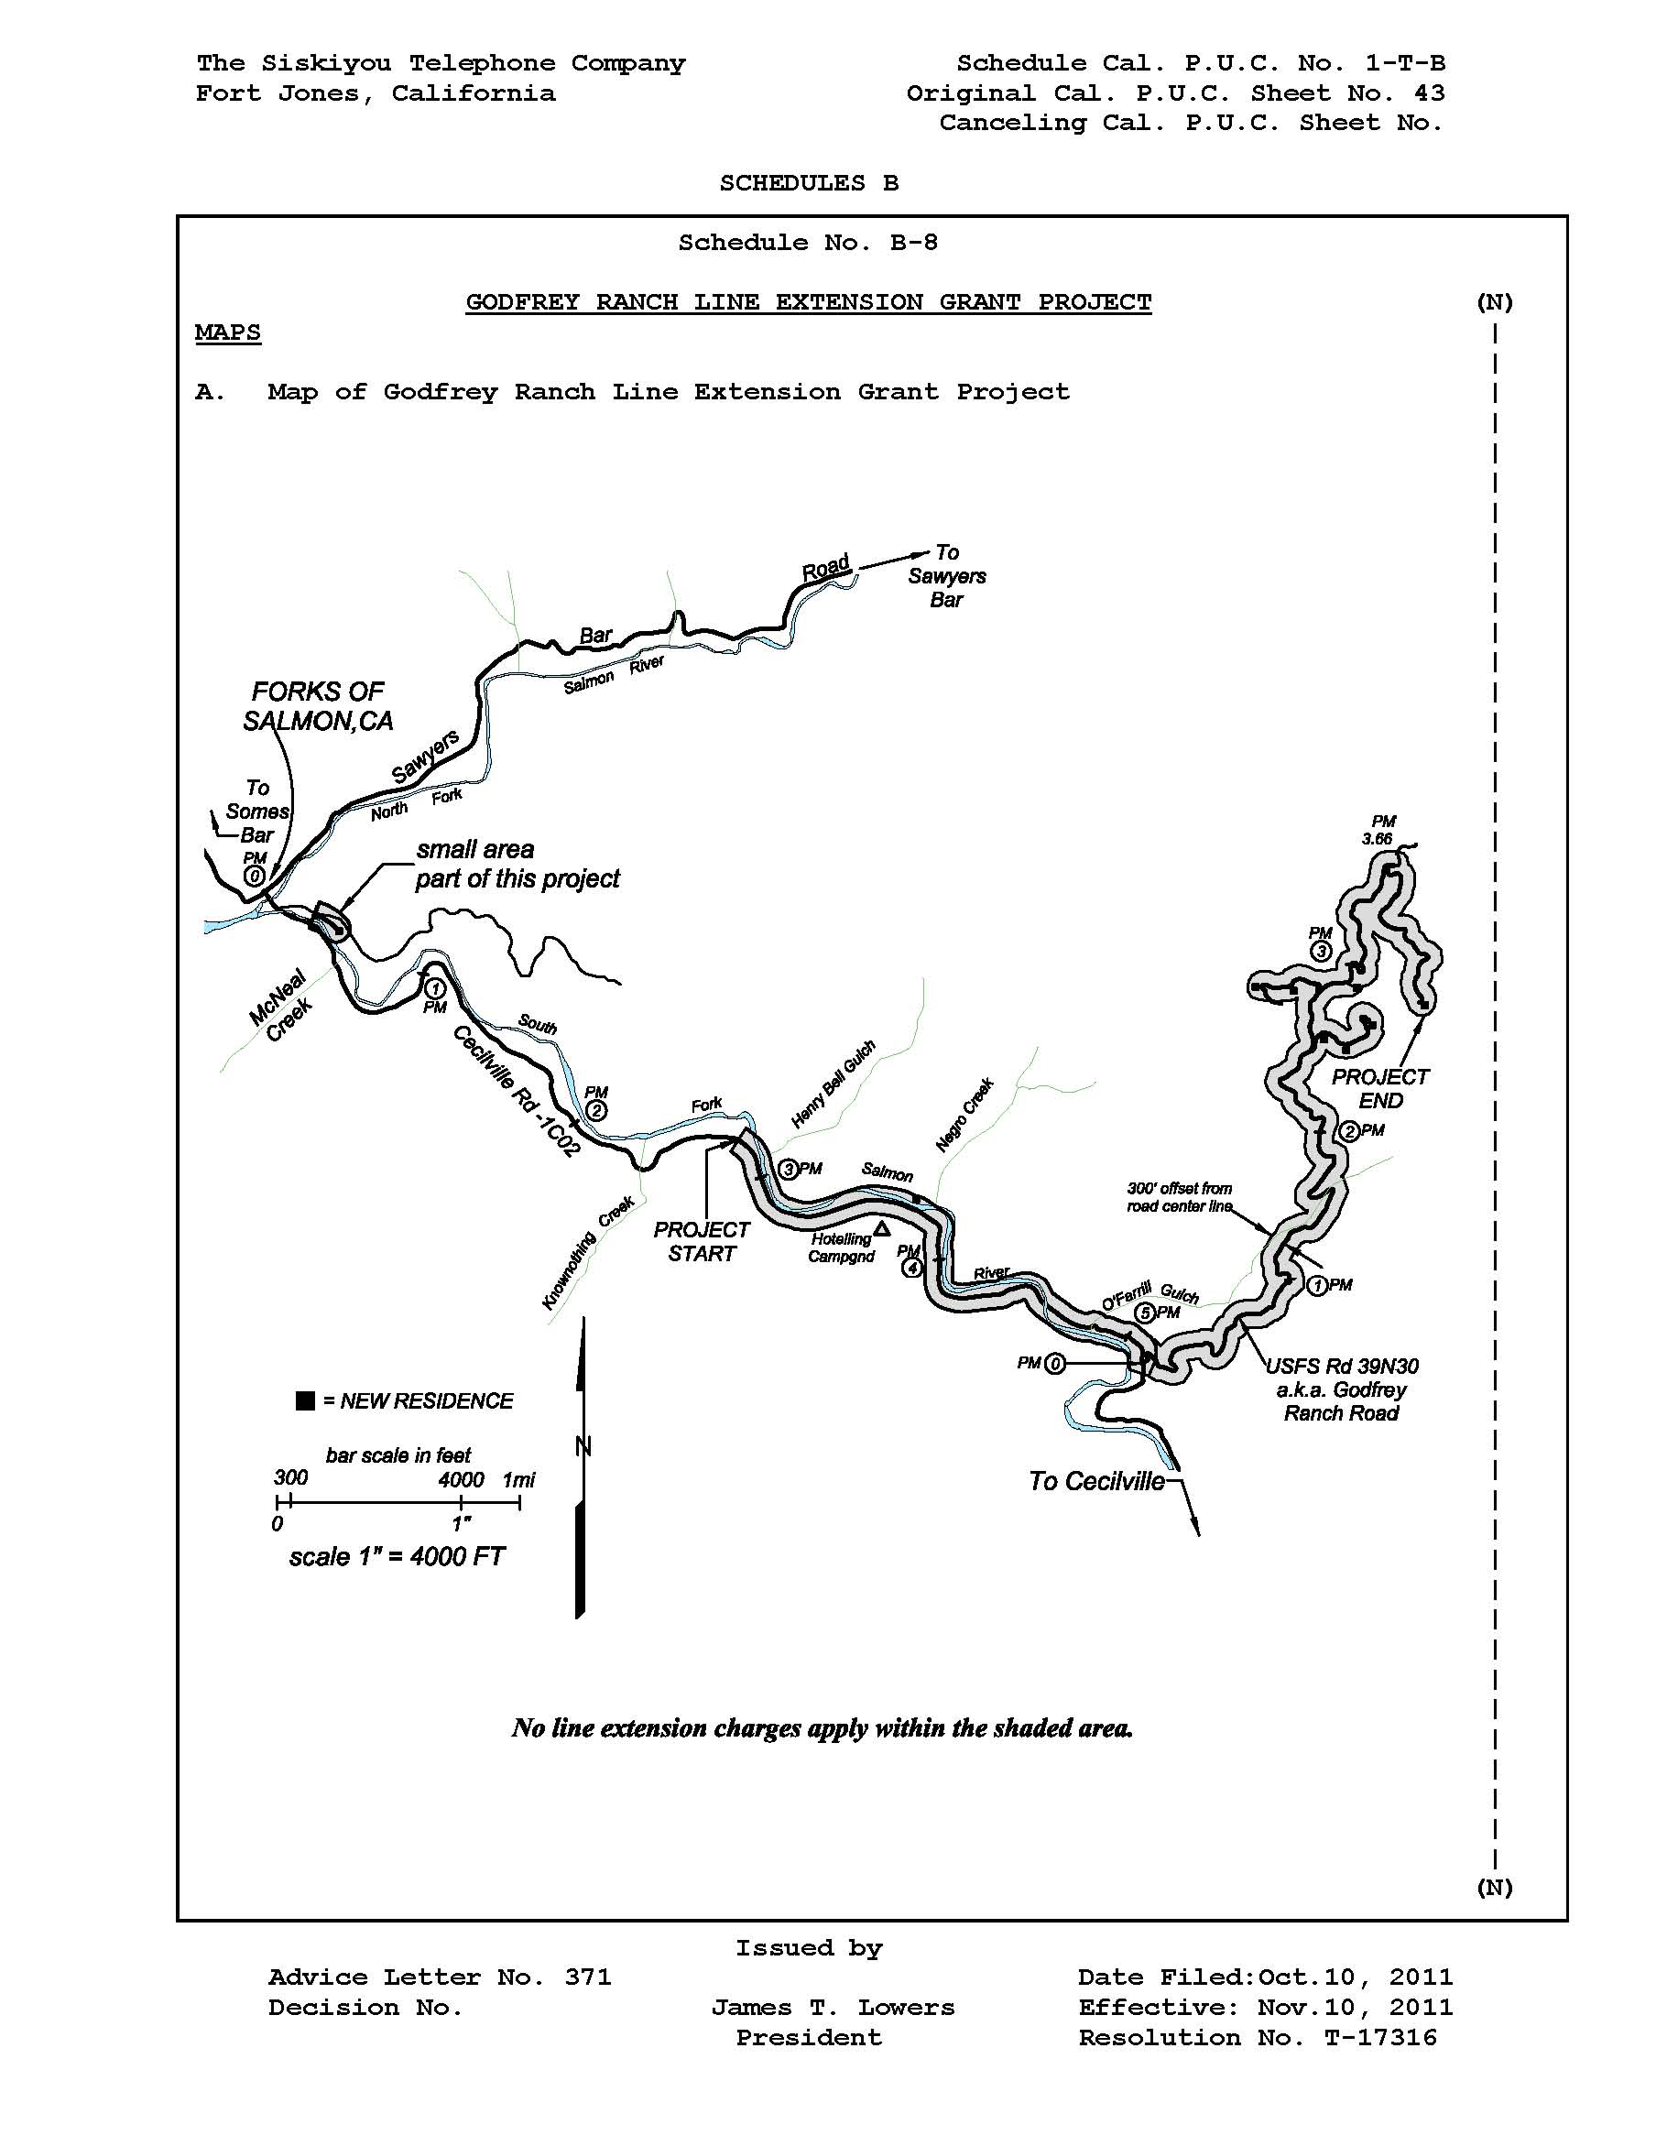

Appendix B

Stats. 2001, Ch.903, AB 140- Strom-Martin Rural Telecommunications Infrastructure Grant
Stats. 2004, Ch.767, AB 2758- Berg.
Stats. 2008, Ch.358. SB 1149-Wiggins.
Order Instituting Rulemaking Into Implementation of AB 140, establishing the Rural Telecommunications Infrastructure Grant Program, Feb. 27, 2003.
Interim Opinion On Implementation Of The Rural Infrastructure Grant Program, Sept. 18, 2003.
Opinion Closing Proceeding, March 17, 2005.
“We will order that all funds disbursed from the grant program be kept and maintained in a separate bank account with the approved fiscal agent as the sole trustee of such funds. The fiscal agent shall provide the account information 60 days prior to the first request for disbursement according to the approved payment schedule. Payments will be made after completion of approved milestones and upon request for payment from the fiscal agent according to the approved payment schedule. Payment requests shall include an itemized accounting of reimbursable amounts. The Commission shall disburse the funds within 60 days of receipt of a complete request for payment that conforms to the approved payment schedule or as soon as is otherwise practicable. Budgetary constraints or other factors may delay release of funds”. September 18, 2003.
“Funds shall be granted in an amount not to exceed $344,000 from the California High Cost Fund-A for funding a California Environmental Quality Act Review of the Godfrey Ranch Line Extension Grant Project located in the Sawyer’s Bar Exchange of The Siskiyou Telephone Company”. June 25, 2009.
Siskiyou Telephone Godfrey Ranch Project Final Initial Study and Mitigated Negative Declaration. Dudek, March 2011.
Rules Relating To The Planning and Construction of Electric Generation and Transmission/Power/Distribution Line Facilities and Substations Located in California. Sept. 10, 1995.

