Item Number 7
Agenda ID # 4231
DRAFT 2/24/05

PUBLIC UTILITIES COMMISSION OF THE STATE OF CALIFORNIA

Telecommunications Division | RESOLUTION T-16878
Public Programs Branch | February 24, 2005

R E S O L U T I O N

Resolution T-16878. Approval of the California Teleconnect Fund (CTF) Administrative Committee Fund Budgets for Revised FY 04-05 and FY 2005-06 to Comply with the Requirements of Public Utilities Code Sections 270-281.
_________________________________________________________________

Summary

This resolution adopts a budget of $20,292,000 for fiscal year (FY) 2005-06 and a revised budget of $17,974,000 for FY 2004-05 for the CTF Administrative Committee Fund.

On July 9, 2004, the California Teleconnect Fund (CTF) Administrative Committee (AC) filed with the Executive Director of the California Public Utilities Commission its proposed budget for July 1, 2005 through June 30, 2006.

Background

The California Teleconnect Fund was implemented under Decision (D.) 96-10-066 on October 25, 1996. In this decision, the Commission reaffirmed its commitment to universal service, and in accordance with state and federal directives, created the CTF to provide discounted rates for a family of telecommunications services for schools and libraries, government-owned health care providers and qualifying community based organizations.

In October 1999, PU Code sections 270-281 were codified as a result of the enactment of Senate Bill (SB) 669 (Stats. 1999, Chapter 677). Section 270(b) requires that the monies in the CTF and five other funds may only be expended pursuant to sections 270-281 and upon appropriation in the annual Budget Act.

On July 9, 2004 the CTF-AC submitted a letter request to the Executive Director seeking the approval of the July 1, 2005 through June 20, 2006 budget of $21.244 million. This budget request was filed in accordance with Paragraph 4.1 of the CTF-AC charter.

On July 31, 2004, the Governor signed the 2004-05 budget. This budget did not include an appropriation for the CTF. On September 28, 2004, SB 1276 was approved by the legislature and signed by the Governor. SB 1276 restored the appropriation for the CTF in the amount of $17,974,000.

Notice/Protests

Notice of the AC’s budget letter request was published in the Commission Daily Calendar of September 13, 2004. The Telecommunications Division received no protest to the letter request.

Discussion

In this Resolution, the Commission adopts the following:

- The CTF program budget for FY 2005-06 in the amount of $20,292,000

- The revised budget for FY 04-05 in the amount of $17,974,000.

Appendix A of this resolution shows the revised FY 2004-05 CTF budget to conform to the appropriation approved by SB 1276.

Appendix B of this resolution shows the FY 2005-06 CTF budget as proposed by TD and by the CTF Administrative Committee in June 2004. The FY 05-06 budget differs from the FY 04-05 budget in that it is a realistic estimate of anticipated program expenses. The FY 04-05 budget was set without consideration of program expenses in addition to claim payments. The FY 05-06 budget includes enough funds to pay for audits, outreach expenses and committee expenses. Of TD’s $20.292 million proposed budget for FY 2005-06, $18.1 million is for claim payments and estimated interest for untimely payments submitted by the carriers providing CTF discounted services, $1.2 million for financial, compliance and surcharge remittance audits, $50,000 for banking fees, $32,000 for Advisory Committee expenses, $610,000 for Administrative/Staff Costs, $50,000 for maintaining the electronic and monitoring systems, and $250,000 is for program outreach. Per advice from the Department of Finance, the pro rata share of interagency costs is set at zero for FY 05-06.

TD’s budget recommendation differs from the CTF-AC’s budget by $950,000. This difference is due to the amount budgeted for the pro-rata share of interagency costs, the amount set aside for audits and staff costs. TD is using estimates that are more current than those available to the CTF-AC, and believes that these estimates are more accurate. Claims projections were developed using data from claims currently on file and estimates based on past claims of what reasonably can be expected to be filed for FY 2005-2006.

TD proposes no change in the surcharge level. Analysis of recent data indicates that proceeds of the current surcharge will be adequate to fund CTF obligations for the remainder of the calendar year. It is anticipated that the surcharge will then be adjusted downward because hold-over obligations from FY 02-03 and FY 03-04 and obligations from FY 04-05 will be paid and the fund will be paying claims on a current basis.

Notice of Availability and Comments

In compliance with PU Code Section 311(g), the Commission had served a hard copy of prior resolutions regarding CTF budgets on all telecommunications carriers and the
parties of record in R. 95-10-020/I95-01-021. To be consistent with the Commission’s commitment to utilize the Internet for distributing Commission orders and information, the Telecommunications Division e-mailed a notice letter informing all carriers licensed in California, telecommunications carriers serving CTF customers and members of the California Teleconnect Fund Administrative Committee on the availability of this draft resolution as well as the conformed resolution, when adopted by the Commission, on the Commission web-site, www.cpuc.ca.gov/static/industry/telco/resolutions/index.htm.

No comments were received by the Telecommunications Division regarding this resolution.

Findings

- In October 1999, Public Utilities Code (PU) Code Sections 270-281 were codified as a result of the enactment of Senate Bill 669.

- PU Code Section 270(b) requires that the monies in California Teleconnect Fund (CTF) Administrative Committee Fund may only be disbursed pursuant to Sections 270-281 and upon appropriation in the annual Budget Act.

- Resolution T-16782 dated December 18, 2003 adopted a Fiscal Year 2004-05 budget of $38.682 million.

- The CTF appropriation for FY 2004-05 was set at $17.974 million.

- The revised FY 2004-05 CTF budget of $17.924 million, as set forth in Appendix A of this resolution, conforms to the FY 2004-05 CTF appropriation and should be adopted.

- On July 9, 2004, the CTF Administrative Committee (AC) submitted a letter request to the Executive Director seeking the approval of the CTF Fiscal Year (FY) 2005-06 budget of $21.242 million.

- The Telecommunications Division’s proposed CTF Fiscal Year 2005-06 budget of $20.292 million is reasonable and should be adopted.

- All telecommunications carriers licensed in California, telecommunications carriers serving CTF customers and members of the California Teleconnect Fund Administrative Committee were informed of the availability of the draft resolution as well as the conformed resolution, when adopted by the Commission, on the Commission web site, www.cpuc.ca.gov.

THEREFORE, IT IS ORDERED that:

- The revised California Teleconnect Fund (CTF) Fiscal Year (FY) 2004-05 budget of $17,974,000, as shown in Appendix A of this resolution, is adopted.

- The CTF FY 2005-06 budget of $20,292,000 as set forth in Appendix B of this resolution is adopted.

This Resolution is effective today.

I hereby certify that this Resolution was adopted by the Public Utilities Commission at its regular meeting on February 24, 2005. The following Commissioners approved it:

STEVE LARSON

Executive Director

Appendix A

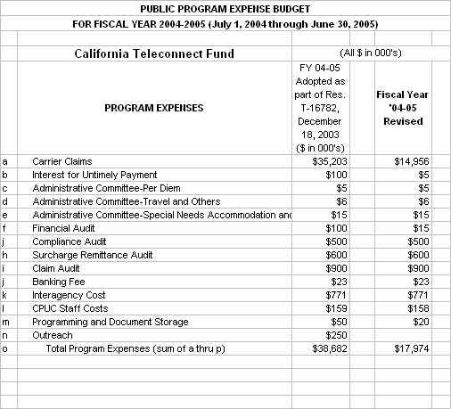

It should be noted that the change in budgeted amounts does not mean that funding for the recipients of the fund is being decreased. The revisions outlined above are due to more recent estimates than were available in September 2003 when the original FY 04-05 budget was developed.
APPENDIX B

