WATER/SMW:jrb

PUBLIC UTILITIES COMMISSION OF THE STATE OF CALIFORNIA

WATER DIVISION RESOLUTION NO. W-4524
March 17, 2005

RESOLUTION

(RES. W-4524), ADOPTION OF REVISION TO WATER DIVISION STANDARD PRACTICE U-3-SM (SP-U-3-SM) REGARDING CALCULATION OF RATE OF RETURN AND RATE OF MARGIN (FORMERLY OPERATING RATIO) FOR CLASS C AND D WATER UTILITIES.

Background
In Phase I of I.90-11-033, the Risk OII proceeding, this Commission addressed concerns regarding the ability of small investor-owned water utilities to earn their authorized return, pay for day to day expenses, and pay for the improvements necessary to comply with water quality regulations. Based on these economic issues, the Commission was concerned about the small water utilities ability to provide safe and clean drinking water to their customers. In an effort to address specific issues, such as the effect of a small staff running these systems in remote areas and the small water utilities view that the rate process was complicated and time-consuming, this Commission developed alternative methods of regulation to simplify and streamline the regulatory process for Class C and D water utilities.

One of the new methods developed in the OII allowed the small water utilities to earn a greater return than had previously been authorized. In the past, the only way to determine a return for a Class C or D water utility was using a rate of return on rate base. Since some of these small utilities had very little rate base, an alternative method, called the Operating Ratio Method, was put forth and authorized for use by this Commission in addition to the traditional rate of return on rate base. The Commission ordered the staff to calculate the return for a particular company based on both the rate of return and the rate of margin, choosing the higher of the two results.
It should be noted that the term “Operating Ratio” which was used in the OII is more properly called the “Rate of Margin” method. The Rate of Margin is applied to Operating Expenses to determine a reasonable return.

Each year since then, the staff has developed a range of rates of return based on current data, while the rate of margin used on each rate case varied from as low as 6% to as high as 20%.

DISCUSSION

In 2004, concerns were raised by this Commission regarding the method for developing a rate of margin for Class C and D water utilities. In particular, the Commission was concerned that no specific method was in place to determine the current Rate of Margin each year.

Responding to this concern, the Water Division has developed a method for determining a current Rate of Margin. This proposed method was distributed to all water utilities for comment in August 2004. Comments were received from the California Water Association (CWA), Garrapata Water, Rio Plaza Water, Nacimiento Water, Peerless Water, and Del Oro Water. The Water Division met with representatives from the water industry to discuss their concerns. After meeting with and considering the comments of the water industry representatives, the Water Division staff revised its proposed Rate of Margin method and provided it to the water industry representatives as well as Commissioners’ Advisors for further comment. These comments, as well as those comments received from CWA (dated March 2, 2005) on the draft of this resolution, have been incorporated into the proposed revisions to Standard Practice SP-U-3-SM attached to this resolution (Attachment A).

The method adopted today to determine the Rate of Margin for Class C and D water utilities is calculated based on a comparison with Class B data. Class B data is used instead of Class A data, because the Class B water operations and financial results are more similar to those of the Class C and D water companies than to the much larger Class A water utilities.

An additional revision to Standard Practice SP-U-3-SM is included in this resolution. It provides a voluntary “sinking fund” type savings account for each Class C and D water utility in order to make funds available in case of emergency as well as provide funds for infrastructure improvement. Many of the smaller water utilities find it difficult to increase their investment in rate base or deal with emergencies. In an effort to alleviate, in part, this lack of sufficient funds, we will give the Class C and Class D companies the opportunity to set aside a portion of the rate of margin return received by the company to be saved as a sort of “sinking fund”. This will provide the company with increased retained earnings which will provide them dollars to invest in infrastructure improvement and have available in case of emergencies. In order to insure that the owner of the company receives both a reasonable return on their investment and that continued investment in the company occurs, the rate of margin return each company receives would be divided between these two components.

Since the return portion represents the owners return on investment, those funds can be disposed of at the discretion of the owner. If the company decides to take advantage of this program, the sinking fund portion must be kept in a bank account and separately tracked by the company so that Commission staff can identify it on the books of the company. Each year in its annual report to the Commission, the company would report the total sinking fund dollars accrued in a given calendar year as well as how much was spent and on what.

Comments

Per statutory requirement, a draft of this resolution was mailed to parties for comments at least 30 days prior to consideration by the Commission.

Public Utilities Code section 311(g)(1) provides that this resolution must be served on all parties and subject to at least 30 days public review and comment prior to a vote of the Commission. Section 311(g)(2) provides that this 30-day period may be reduced or waived upon the stipulation of all parties in the proceeding.

The 30-day comment period for the draft of this resolution was neither waived or reduced. Accordingly, the draft resolution was mailed to parties for comments on February 11, 2005, with comments due on March 2, 2005.

Findings
- Commission D.92-03-093 in I.90-11-033 ordered the CPUC staff to determine returns for Class C and D water utilities based on both the rate of return method and the operating ratio method, choosing the higher of the two resulting returns.

- The Operating Ratio Method is more appropriately titled the Rate of Margin Method.

- The recommended Rate of Return is revised by the Water Division every year to consider more current data. A Rate of Margin of 6% to 20% has been used since D.92-03-093 was issued.

- In 2004, the Commission voiced concern regarding how the Rate of Margin was calculated.

- Based on this concern, the Water Division developed a proposed method for determining a Rate of Margin utilizing on current data and requested comments on this proposed method from the water industry.

- Water Division met with water industry representatives regarding their comments and suggestions.

- Water Division issued a second proposed methodology for comment to the water industry representatives and Commissioners’ Advisors.

- The proposed method for determining Rate of Margin (Attachment A), is reasonable.

Therefore it is ordered that:
  - The revised section of SP-U-3-SM is adopted and shall be used by Commission staff as well as Class C and D water utilities in their determination of a return for Class C and Class D water utilities regulated by the Commission.
  - This resolution is effective today.

I certify that the foregoing resolution was duly introduced, passed, and adopted at a conference of the Public Utilities Commission of the State of California held on March 17, 2005; the following Commissioners voting favorably thereon:

STEVEN LARSON
Executive Director

ATTACHMENT A
(Page 1 of 5)

The following is a revision of the instructions for processing Small Water Utility GRC’s, in particular the discussion of how to calculate the return for Class C and D water utilities, which appears at pages 16 & 17 of Standard Practice U-3-SM:

- Determining a reasonable return for Class C and D Water Utilities: Commission Decision 92-03-093 states in the ordering paragraphs:

“8. Branch is directed to calculate rates using both return-on-ratebase and operating ratio methods of ratemaking for Class C and Class D water companies requesting new rates and to recommend to the Commission that rate method that produces the higher result.”

- Rate of Return: The Audit and Compliance Branch (A&C) of the Water Division (WD) will provide the WD staff analyst with the latest values of allowable Rate of Return (ROR) for Class C and D water companies. A high and low value will be provided which have a range of 50 basis points (one basis point is .01%) such as 13.8% to 14.3%. The WD staff analyst will determine a value from this range based upon his or her best determination of the quality of service the utility is providing. If the utility is doing a better than normal job of meeting the needs of its customers, it should receive a return near the high end of the range. If the utility responds poorly to customer complaints and is not meeting its public utility obligations, it should receive the minimum allowable return. For Class B utilities the Audit and Compliance Branch will determine a utility specific reasonable ROR.

- Rate of Margin: This ratemaking method develops a revenue requirement where little or no rate base exists. The method used to determine an average Rate of Margin is discussed below. The average is then applied to Operating Expenses to determine the estimated dollar return that is then compared with the average dollar ROR on rate base (See paragraph 38 below). The Rate of Margin is determined as follows: Starting in 2005, the A&C Branch of the Water Division will issue a memo in March of each year (at the same time it issues the rate of return memo) that provides recommended average Rates of Margin for Class C and D water utilities to be used by staff. The following is the analysis that the A&C Branch will perform:
ATTACHMENT A
(Page 2 of 5)

  - Since the Rate of Margin for Class C and D water utilities is an unknown figure, WD must estimate it based on the method discussed below.

  - To determine the Rates of Margin for Class C and D water utilities, the A&C Branch assumes that there is a comparable relationship between Class B and C Authorized Rates of Return and Class B and C Authorized Rates of Margin (the same comparison is made between Class B and Class D figures) as follows:

Avg Class C Rate of Margin = Avg Class C Rate of Return
Avg Class B Rate of Margin = Avg Class B Rate of Return

  - The Class C and D Rates of Margin are determined based on a comparison with Class B data, rather than Class A data, because the Class B water operations and financial results are more similar to those of the Class C and D water companies than with the much larger Class A water utilities.

  - The most current average authorized figures are used for the known amounts, which include the average Class C and Class D Rates of Return recommended by Water A&C Branch. The authorized Class B Rates of Return are found in each company’s most recent general rate case decision or resolution.

  - The A&C Branch will then calculate each Class B company’s equivalent authorized Rate of Margin. The individual authorized Class B Rates of Margin are calculated based on the operating expense and revenue figures in each company’s general rate decision or resolution. Operating expenses include operations and maintenance expenses, annual depreciation on non-contributed facilities, amortization of multiyear expenses and applicable taxes (income taxes, property taxes, taxes other than income, payroll taxes).

  - The formula shown below is then solved for the unknown component, in this example the average Class C Rate of Margin for the current year:

Avg Class C Rate of Margin = Avg Class C Rate of Return
Avg Class B Rate of Margin = Avg Class B Rate of Return

Solve for Avg Class C Rate of Margin, so

Avg Class C Rate of Margin = (Avg Class C Rate of Return) * Avg Class B Rate of Margin
(Avg Class B Rate of Return)

The same method is then used to determine the Class D Rates of Margin.
ATTACHMENT A
(Page 3 of 5)

- Determining the recommended return using the Authorized Rate of Return: The calculation is based on the individual Class C or Class D Company’s rate base. The company specific Rate Base is multiplied times the Authorized Rate of Return. The pre-tax rate of return on rate base is then grossed up to provide an after-tax rate of return on rate base.

- Determining the recommended return using the Authorized Rate of Margin: The calculation is based on the individual Class C or Class D Company’s operating expenses. Operating expenses shall include operations and maintenance expenses, annual depreciation on non-contributed facilities, amortization of multi-year expenses and applicable taxes (income taxes are excluded from the calculation). Applicable taxes include property taxes, taxes other than income and payroll taxes. Total operating expenses are then multiplied by the Authorized Rate of Margin to determine the recommended pre-tax return under the Rate of Margin method. The pre-tax rate of margin is then grossed up to provide an after-tax rate of margin.

- Determining the recommended return after comparing the results from the Rate of Return and Rate of Margin calculations: The grossed up dollar amount returns based on the average Rates of Return on Rate Base for Class C and Class D companies and the average dollar amount returns based on the Rates of Margin for Class C and Class D companies are then compared, choosing the higher one (per D.92-03-093). In the resulting Commission resolution there shall be a summary of earnings that shows both the rate of margin and the rate of return on rate base.

- Determining the amount of the Voluntary Profit and Sinking Fund: The Rate of Margin method is normally chosen to determine the recommended return because it more appropriately reflects a utility’s opportunity to earn a reasonable rate of return when the company has minimal rate base. Many of the smaller companies find it difficult to increase their investment in rate base or deal with emergencies. In an effort to alleviate, in part, this lack of sufficient funds, we offer the Class C and Class D companies the opportunity to set aside a portion of the return received by the company to be saved in a type of “sinking fund” or “reserve” in order to provide the company with increased retained earnings which will provide them dollars to invest in infrastructure improvement and have available in case of emergencies. In order to insure that the owner of the company receives both a reasonable return on their investment (profit) and that continued investment in the company occurs (sinking fund/reserve), the following method will be followed by each company on a voluntary basis, to determine the profit and sinking fund/reserve portion of the dollars received.
ATTACHMENT A
(Page 4 of 5)

  - If the Return on Rate Base is greater than the Return on Margin, then the company receives the Return on Rate Base.

  - If the Return on Margin is greater than the Return on Rate Base, the profit and sinking fund/reserve are calculated as follows:

    - Profit Portion = Return on rate base
    - Sinking Fund/Reserve Portion = (Rate of Margin * Operating Expenses) – Return on rate base

  - Since the Profit Portion represents the owners return on investment, those funds can be disposed of at the discretion of the owner.

  - The Sinking Fund/Reserve portion must be kept in a bank account and separately tracked by the company so that Commission staff can identify it on the books of the company.

  - Each year in its annual report to the Commission, the company will report the total sinking fund/reserve dollars accrued in a given calendar year as well as how much was spent and on what.
ATTACHMENT A
(Page 5 of 5)

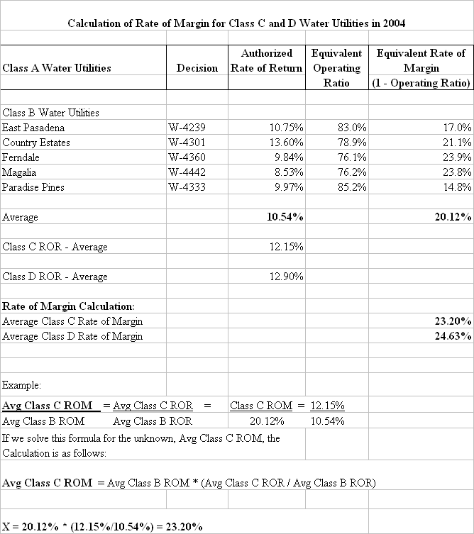

(End of ATTACHMENT A)

D.92-03-093, pg 27-30, 37-38, 54.
D.92-03-093, p.54, Interim Order “8. Branch is directed to calculate rates using both return-on-ratebase and operating ratio methods of ratemaking for Class C and Class D water companies requesting new rates and to recommend to the Commission that rate method that produces the higher result.”
The Rate of Margin can be calculated in two ways: Rate of Margin = Net Operating Revenues/Total Operating Revenues, or Rate of Margin = 1 – Operating Ratio, where the Operating Ratio = Total Operating Expenses/Total Operating Revenue
This number has been used in numerous cases over the years, but staff has been unable to find justification for this figure.
SP-U-3-SM is the latest version of the California Public Utilities Commission, Utilities Division, Hydraulic Branch Standard Practice U-3-W, issued April 6, 1965, updated with new Commission instructions and policies developed since that time.
It should be noted that in D.92-03-093, the term “Operating Ratio” was used to describe a particular methodology, when, in fact, the method the Commission described and ordered the use of is more properly call the “Rate of Margin” method. The Rate of Margin being “1 – Operating Ratio”

