STATE OF CALIFORNIA ARNOLD SCHWARZENEGGER, Governor
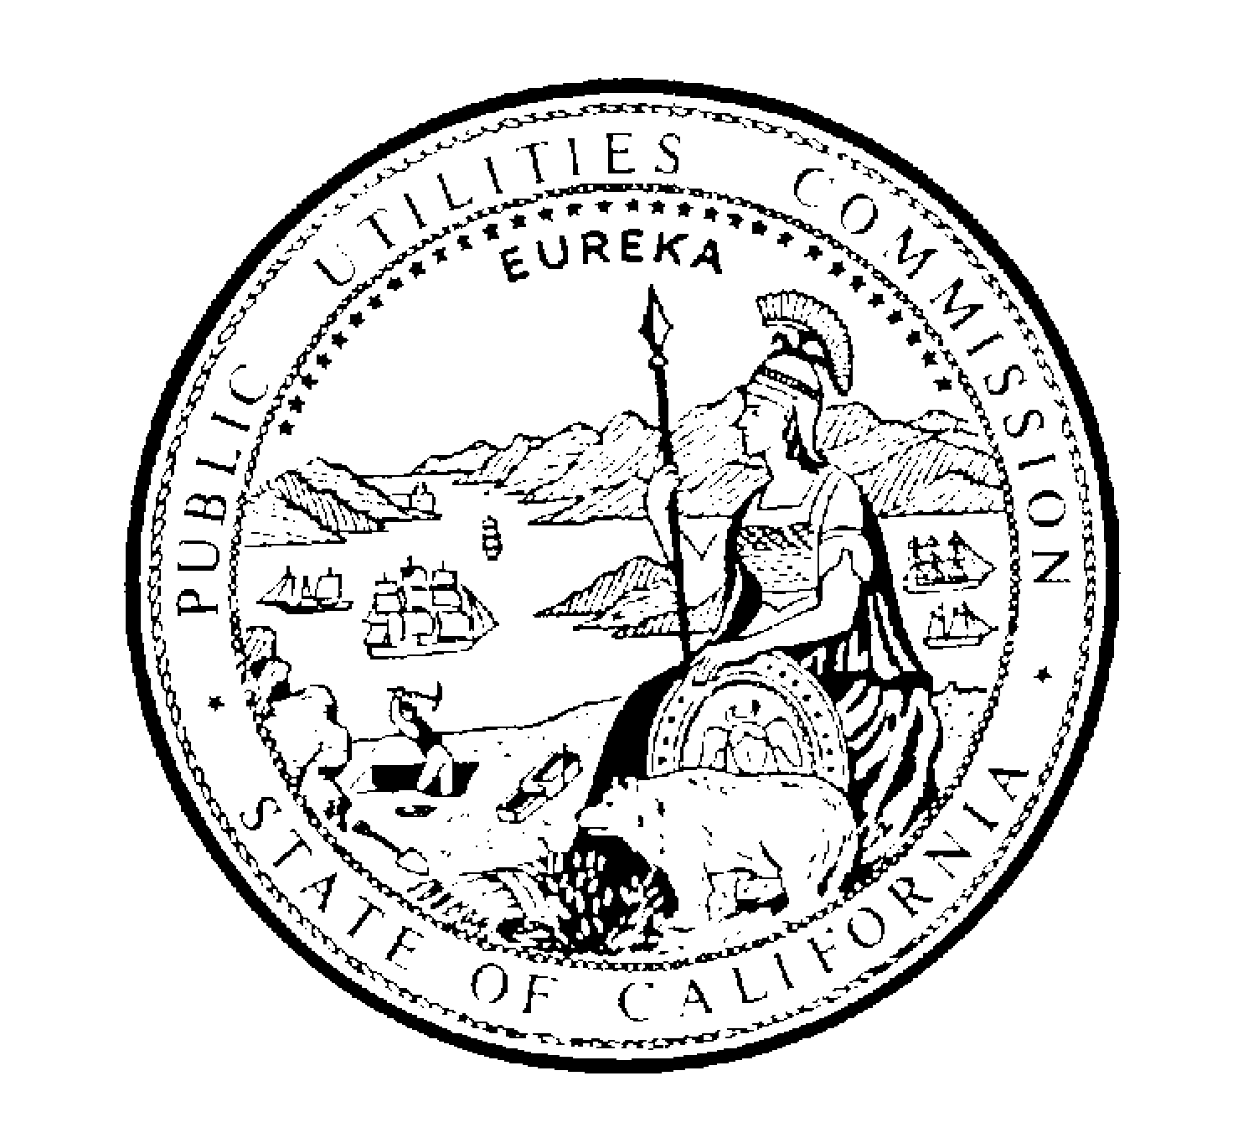PUBLIC UTILITIES COMMISSION
505 VAN NESS AVENUE
SAN FRANCISCO, CA 94102-3298

October 12, 2004 Agenda ID# 3959
Alternate to Agenda ID# 3530
Quasi-Legislative

TO: PARTIES OF RECORD IN APPLICATION 00-12-015.

Enclosed is the Alternate Draft Decision of Commissioner Kennedy to the Draft Decision of Administrative Law Judge (ALJ) Galvin, previously mailed to you.

When the Commission acts on the draft or alternate decision, it may adopt all or part of it as written, amend or modify it, or set aside and prepare its own decision. Only when the Commission acts does the decision become binding on the parties.

Public Utilities Code Section 311(e) requires that an alternate to a draft decision be served on all parties, and be subject to public review and comment prior to a vote of the Commission. Rule 77.6(d) provides that comments on the alternate draft decision be filed at least seven days before the Commission meeting.

Comments the alternate decision must be filed and served October 21, 2004.

Pursuant to Rule 77.3 comments shall not exceed 15 pages. Finally, comments must be served separately on the ALJ and the assigned Commissioner, and for that purpose I suggest hand delivery, overnight mail, or other expeditious method of service. Please also provide an electronic copy of the comments to Ross LaJeunesse at RL2@cpuc.ca.gov.

/s/ Angela K. Minkin
Chief Administrative Law Judge

ANG: cvm

Attachment

