PUBLIC UTILITIES COMMISSION OF THE STATE OF CALIFORNIA

Telecommunications Division | RESOLUTION T-16590
Public Programs Branch | October 25, 2001

R E S O L U T I O N

RESOLUTION NO. T-16590. REVISED FISCAL YEAR 2001-2002 BUDGET FOR THE PERIOD OF JULY 1, 2001 THROUGH JUNE 30, 2002 FOR THE PAYPHONE SERVICE PROVIDERS ENFORCEMENT (PSPE) PROGRAM, THE PUBLIC POLICY PAYPHONE PROGRAM (PPPP) AND THE TELECOMMUNICATIONS DEVICES FOR THE DEAF PLACEMENT INTERIM COMMITTEE PROGRAM (TPIC) TO COMPLY WITH THE REQUIREMENTS OF PUBLIC UTILITIES CODE SECTIONS 270 THROUGH 281.
__________________________________________________________________

SUMMARY

This resolution revises the 2001-2002 fiscal year program budgets for the PSPE, PPPP and TPIC to reflect the amounts included in the adopted State Budget for the three payphone programs as well as the organizational and administrative expenses associated with compliance with Public Utilities (P.U.) Code Sections 270 through 281 (Chapter 1.5 to Part 1, Division 1 of the P.U. Code). These new code sections has been created by the adoption of Senate Bill (SB) 699, as amended by SB 742, which requires the transfer of the funds for TPIC and PSPE into the State Treasury. SB 669 did not address the PPPP. In Resolution T- 16364, dated February 3, 2000, the Commission recommended that the PPPP funds be deposited into the State Treasury and included in the transition plan concerning all of the program funds affected by SB 669.

This resolution adopts the Telecommunication Division (TD) staff’s estimated expenses and revenues for the period July 1, 2001 through June 30, 2002. For PSPE, TD estimates expenses of $1,623,250 and revenues of $458,696. TD recommends an increase in the surcharge rate from $0.10 per payphone line per month to $0.17 per payphone line per month effective November 1, 2001.

For both the TPIC and the PPPP, TD recommends a zero surcharge beginning November 1, 2001. For PPPP, TD estimates expenses of $258,837, revenues of $80,778 and a balance of $681,238 on June 30, 2002. For TPIC, TD estimates expenses of $394,130, revenues of $21,000 and a balance of $2,060,872 on June 30, 2002. APPENDICES A, B and C set forth the original adopted fiscal year 2001-2002 budgets and the revised 2001-2002 budgets to be adopted in this resolution.

BACKGROUND

The following brief summaries describe the development and current activities of the three payphone programs. Discussion on the PSPE and TPIC committees refers to responsibilities before the passage of SB 669 and compliance with related statutes.

- The Payphone Service Providers Enforcement (PSPE) Program. Commission Decision No. 90-06-018, dated June 6, 1990, established as part of an adopted settlement agreement, the Customer Owned Payphone (COPT) Enforcement Program to implement a payphone enforcement program. The COPT Enforcement Subcommittee was subsequently renamed the PSPE Committee (Committee) and was funded by a surcharge, authorized by the Commission, on the COPT lines. The Commission ordered Payphone Service Providers (PSPs) to pay the surcharge on their COPT lines within all service territories of the State of California.

Prior to the implementation of P.U. Code Sections 270-281, the purpose of the Committee was to serve as a Commission advisory body with the responsibility to assist and make recommendations to the Commission regarding administration of the surcharge monies remitted to the PSPE program and to implement the independent administration of the payphone enforcement program. The Committee also made recommendations to the PSPE program for the enforcement of payphone consumer safeguards as set forth in the tariffs filed with the Commission. The purpose of the PSPE Program is to enforce the tariffs, rules and regulations of the Commission, including, but not limited to, signage requirements, rate caps for intraLATA and interLATA calls within the state by inspecting pay telephones and by advising the Local Exchange Carriers (LECs) and Competitive LECs (CLECS) to disconnect pay telephones not in compliance with their respective tariffs. This program has been supported by eight inspectors and a supervisor who inspect payphones throughout the state to ensure compliance with state regulations. A statewide hotline, also administered by the PSPE program, has been available to respond to complaints and other inquiries by payphone users as well as payphone owners.

- The Public Policy Payphone Program (PPPP). In Decision 98-11-029, dated November 5, 1998, the Commission adopted policies and procedures for the PPPP. The PPPP subsidizes payphones for the general public in the interest of public health, safety, and welfare at locations where there would otherwise not be a payphone. Public policy payphones are placed at locations designated as emergency gathering places or locations where residents cannot individually subscribe to telephone service because of unavailability of facilities.
California has had a public policy payphone program in place since 1990, pursuant to Decision 90-06-018 (36 CPUC 2nd 446 at 461 1990). This program existed only in the service territories of Pacific Bell and GTE California Incorporated (GTEC), now Verizon. The Commission by Decision 98-11-029 expanded the public policy program statewide. The PSPE program charter provided for the oversight of the PPPP by the PSPE Committee.

- TDD Placement Interim Committee (TPIC). Pursuant to Decision No. 97-12-104, effective December 16, 1997, the Commission established the TPIC to design and implement a program that provides for publicly available telecommunications devices capable of servicing the needs of the deaf or hearing impaired in existing buildings, structures, facilities, and public accommodations as required by Section 2881.2 of the Public Utilities Code. The TPIC is to be funded by an incremental surcharge of up to 0.0002, or 0.02%, applicable to the billing base to which the Deaf and Disabled Telecommunications Program (DDTP) surcharge is applied. The maximum funding limit for the DDTP surcharge (the aggregate of both the DDTP Program and the TPIC) is capped at 0.50%.

Subject to the direction, control, and approval of the Commission, the TPIC’s mission has been to determine and specify locations within existing buildings, structures, facilities and public accommodations for the placement of program equipment and to ensure consideration for the procurement, installation, and maintenance of the program equipment. The TPIC also advised on meeting the requirements of Section 2881.2 of the Public Utilities Code.

DISCUSSION

Budget Description

This resolution revises the fiscal year 2001-2002 budgets adopted for each of the three payphone programs, as set forth in Appendices A, B and C. In order to accurately reflect the State Budget amounts, expenses are presented in these attachments on a three and nine month basis but revenues are estimated on a four and eight month basis so that surcharge rates can be changed effective November 1, 2001.

The expenses recommended in the revised budgets are generally very close to those adopted in the original budgets. The revenue requirements differ significantly in the revised budgets from the original budgets for the PPPP and the TPIC programs due to the higher carry-over revenue balances. For both of these programs TD recommends that the surcharge rates be reduced to zero effective November 1, 2001.

On January 18, 2001, the Commission in Resolution T-16434 adopted for the PSPE program expenses of $1,240,980, revenues of $371,500 and a revenue balance of $875,301 as of June 30, 2002. For the revised budget TD recommends expenses of $1,623,250, revenues of $458,696 and a revenue balance of $1,069,765 as of June 30, 2002. TD recommends increasing the current surcharge rate of $0.10 per pay telephone line per month to $0.17 effective November 1, 2001. TD estimates that the surcharge rate of $0.17 should provide adequate funding for the PSPE program through June 30, 2003.

On January 18, 2001, the Commission in Resolution T-16444 adopted for the PPPP expenses of $255,348, revenues of $375,196 and a revenue balance of $119,848 as of June 30, 2002. For the revised budget TD recommends expenses of $258,837, revenues of $80,778, a revenue balance of $681,238 on June 30, 2002, and a reduction of the current surcharge rate of $0.08 per pay telephone per month to zero effective November 1, 2001.

On September 7, 2000, the Commission in Resolution T-16429 adopted for the TPIC expenses of $464,179, revenues of $232,800, and a revenue balance of $773,124 as of June 30, 2002. For the revised budget TD recommends expenses of $394,130, revenues of $21,000 and a revenue balance of $2,069,872 on June 30, 2002. TD recommends that the current surcharge of 0.001% be reduced to zero effective November 1,2001.
2. P.U. Code Sections 270, et al

The California Legislature passed SB 669 and the Governor signed SB 669 in October 1999. The provisions of SB 669, as amended by SB 742 in 2001, are codified as Chapter 1.5 (beginning with Section 270) to Part I, Division 1 of the PU Code. PU Code Section 270 provides for the creation of six funds in the State Treasury. The result is that the funds of the public payphone programs and of the other telecommunications public programs, except the Deaf and Disabled Telecommunications Program, will be transferred from existing bank accounts account to the State Treasury on October 1, 2001, consistent with the state budgeting process, which is on a fiscal year basis.

The following are the key requirements of P.U. Code Sections 270-281 for the public payphone programs:

- P.U. Code Section 279(a) creates one committee, the Payphone Service Providers Committee, to function as an advisory board to advise the Commission regarding the development, implementation, and administration of the payphone programs.
- P.U. Code Section 279(b) provides that all revenues collected by the telephone corporations in authorized rates to fund the payphone programs shall be submitted to the Commission pursuant to a schedule established by the Commission. Beginning on October 1, 2001, the Commission shall transfer these moneys to the Controller for deposit in the Payphone Service Providers Committee Fund.
- P.U. Code Section 273 (a) requires all advisory boards to submit: an annual budget to the commission, who shall act on the submitted budget within 90 days after the receipt of the budget, and a report describing the activities of the board on an annual or more frequent basis, as ordered by the commission.
- P.U. Code Section 274 provides that the commission may, whenever it determines necessary (a) conduct financial audits of the revenues required to be collected and submitted to the commission for each of the funds specified in Section 270 and (b) conduct a financial and compliance audit of program-related costs and activities at least once every three years, beginning July 1, 2002.
- P.U. Code Section 271(f) states that each member of the board who is not a public utility employee or who is not reimbursed by an employer for expenses incurred when serving on the board, shall be entitled to make a claim for and to receive expense reimbursement, if authorized by the commission.

COMMENTS ON DRAFT RESOLUTION

In accordance with P.U. Code Section 311 (g) (1), a draft resolution prepared by the TD staff was mailed on September 25, 2001, to the parties of record in I.88-04-029, R.98-05-031 and R.97-10-018-I.97-10-019. A notice of availability was mailed to all telecommunications carriers, including LECs and CLECs, informing them of the availability of the draft resolution, as well as the conformed resolution, on the Commission’s web site, www.cpuc.ca.gov . A hard copy of the conformed copy of the resolution will be provided to all parties on the appropriate service lists. This means of distribution is consistent with the Commission’s commitment to utilize the CPUC Internet for distributing Commission orders and information. Comments received on a timely basis will be addressed by TD in the adopted Resolution.

Advice Letter Filing and Notice to Other Carriers

The adoption of a revised Fiscal Year 2001-2002 budget resulting in a revised surcharge rate for PSPE and a reduction of the surcharge rate to zero for TPIC and PPPP, effective November 1, 2001, would normally require the filing of three advice letters by carriers who collect these charges. For administrative efficiency, we will allow all telecommunications carriers that collect surcharges for these programs, or any other public program, to file one advice letter accompanied by associated tariff sheets, revising the surcharge rates in accordance with the Commission adopted resolutions and/or decisions. This advice letter should be filed on or before November 1, 2001 consistent with the provisions of General Order (G.O.) 96-A. The effective date shall be November 1, 2001.

In filing this advice letter, we will waive the notice requirements of G.O. 96-A, Section III, G.1. to furnish competing utility companies (either public or private) with copies of the related tariff sheets. This is because it does not appear to be in the public interest for each telecommunications carrier to send and receive notices about a regulatory change that each carrier already knows.

FINDINGS

- SB 669, adopted in October 1999, requires the funds of the PSPE program and TPIC to be transferred to the State Treasury.
- It is reasonable to administer the PPPP funds consistent with P.U. Code Sections 270-281.

- P.U. Code Section 279(a) creates the Payphone Service Providers Committee, which will function to advise the Commission on the development, implementation and administration operation of the public payphone programs.

- It is reasonable to adopt a revised budget for PSPE, PPPP and TPIC for the fiscal year 2001-2002 as described in this resolution and set forth in column D in APPENDICES A, B, and C respectively.

- It is reasonable to reduce the surcharge rate for the PPPP and the TPIC to zero effective November 1, 2001.

- It is reasonable to increase the surcharge rate from $0.10 per payphone line per month to $0.17 for the PSPE program effective November 1, 2001.

- For administrative efficiency, it is reasonable to allow all telecommunications carriers that collect the PSPE, PPPP, TPIC and surcharges for any other public program to file one advice letter by November 1, 2001, accompanied by associate tariff sheets, revising the surcharge rates in accordance with Commission resolution and/or decisions.

- The Telecommunications Division recommendations are reasonable and should be adopted.

THEREFORE, IT IS ORDERED that:

- Revised Fiscal Year 2001-2002 budgets for the Payphone Service Providers (PSPE) program, Public Policy Payphone Program (PPPP) and the TDD Placement Interim Committee program (TPIC) set forth in column D of APPENDICES A, B and C of this resolution are adopted consistent with the requirements of Public Utilities Code Sections 270 through 281.
- The surcharge rates for the TPIC and the PPPP shall be reduced to zero effective November 1, 2001.
- The surcharge rate for the PSPE shall be increased to $0.17 per payphone line per month effective November 1, 2001.
- All telecommunications carriers who are required to collect the surcharge rates for the PSPE program, PPPP, the TPIC and any other public program shall file revised tariff sheets by advice letters in accordance with the provisions of General Order No,. 96-A on or before November 1, 2001. The advice letters shall become effective on November 1, 2001. In filing these Advice Letter Filings, the telecommunciations carriers are granted exemption from the noticing requirement of General Order No. 96-A, Section III, G.1.
This Resolution is effective today.

I hereby certify that this Resolution was adopted by the Public Utilities Commission at its regular meeting on October 25, 2001. The following Commissioners approved it:

WESLEY M. FRANKLIN
Executive Director

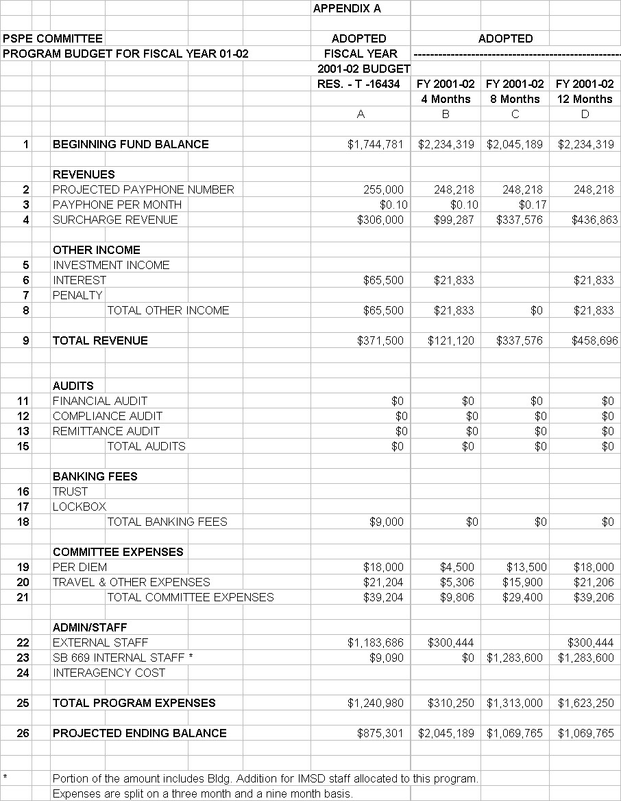
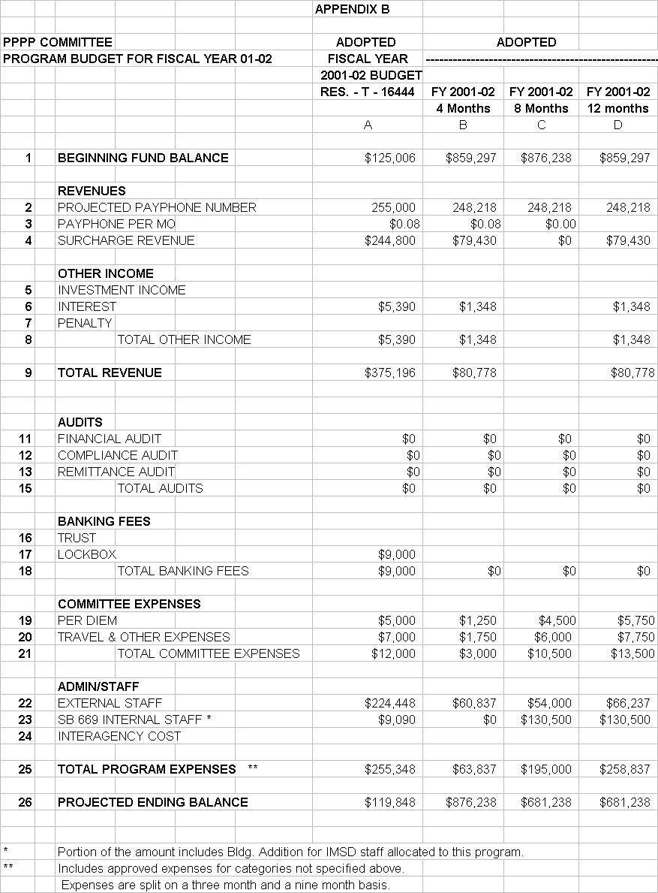
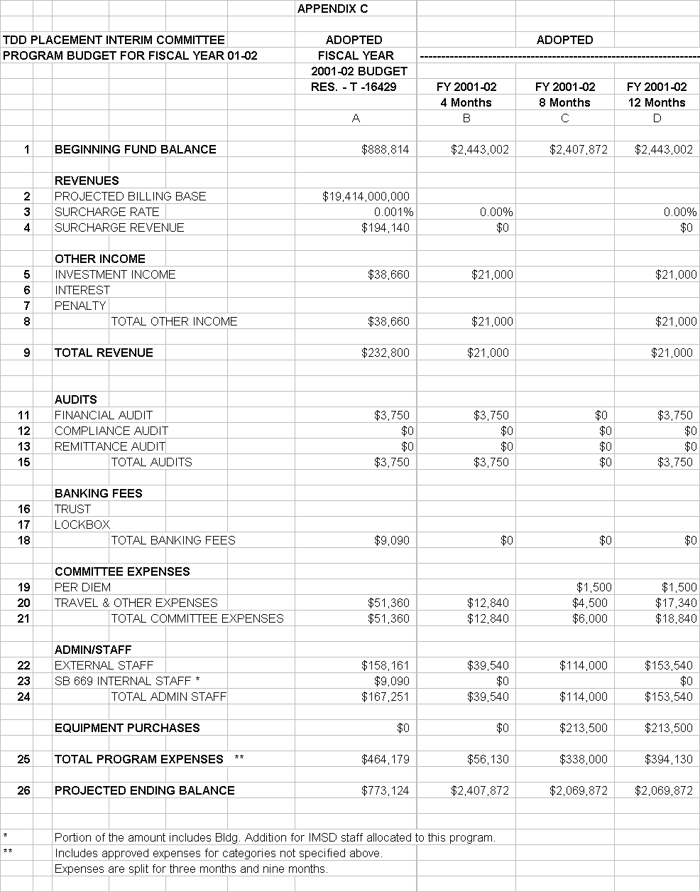

STATE OF CALIFORNIA Gray Davis, Governor
PUBLIC UTILITIES COMMISSION
505 VAN NESS AVENUE
SAN FRANCISCO, CA 94102-3298

September 25, 2001

To: Parties of Record in I. 88-04-029, R. 98-05-031 and R. 97-10-018-I. 97-10-019
Telecommunications Carriers

Draft Resolution T-16590 approves fiscal year 2001- 2002 budgets for (PSPE) program, (PPPP) and (TPIC).
A copy of this draft resolution and the list of all telecommunications carriers are available to the public at the Commission’s web-site at www.cpuc.ca.gov . This Notice of Availability of the draft resolution is being sent to all telecommunications carriers besides the Parties of Record in I. 88-04-029, R. 98-05-031 and R. 97-10-018-I. 97-10-019 and also informs you of the availability of the conformed resolution, when adopted by the Commission, on the Commission website, www.cpuc.ca.gov. If you are not a party to the proceeding, and you do not have Internet access, you may obtain a copy of the draft resolution or conformed resolution by contacting the Telecommunications Division at (415) 703-1989.

Pursuant to Public Utilities (PU) Code 311 (g)(1), this draft resolution is available for public comments. Comments should be focused on factual, legal, and/or technical errors in the draft resolution. Comments must be limited to five pages in length and shall include a subject index listing the recommendations to the draft resolution, a table of authorities, and an appendix setting forth the proposed revised findings and ordering paragraphs.

This draft resolution will be on the agenda of the Commission’s October 25, 2001, meeting which is to be held at least 30 days from the above mailing date. The Commission may vote on the resolution, or it may postpone a vote until later. When the Commission votes on a draft resolution, it may adopt all or part of it as written, amend, or modify it, or set it aside and prepare a different resolution. Only when the Commission acts does the resolution become binding on the parties.

Comments on Resolution T-16590 should be addressed as stated below. The date of submission is the date the comments are received by the Telecommunications Division. Parties must serve a copy of their comments on each party set forth on the appropriate service list attached to the draft resolution, on the same date that the comments are submitted to the Telecommunications Division.

Comments must be received no later than October 10, 2001 (which is 15 days from the date of this mailing). Reply comments may be submitted on or before October 15, 2001, (5 days after opening comments are submitted) and shall be limited to identifying misrepresentations of law, fact, or condition of the record contained in the comments of other parties. Replies shall not exceed three pages in length and shall be submitted and served in the same manner as opening comments. Late-filed opening comments and/or reply comments will ordinarily be rejected.

However, in extraordinary circumstances, a request for leave to submit comments or replies late may be filed together with proposed comments/replies. An accompanying declaration under penalty of perjury shall be submitted setting forth all the reasons for the late submission.

Opening comments and reply comments on Resolution T-16590 should be sent to the
California Public Utilities Commission, Telecommunications Division, 505 Van Ness Avenue, San Francisco, CA 94102, to the attention of Robert Weissman.

Sincerely,

David M. Shantz, Program Manager
Public Programs Branch, Telecommunications Division

Enclosure for the Parties of Record in I. 88-04-029, R. 98-05-031 and R. 97-10-018-I. 97-10-019 (Draft Resolution)

