STATE OF CALIFORNIA ARNOLD SCHWARZENEGGER, Governor
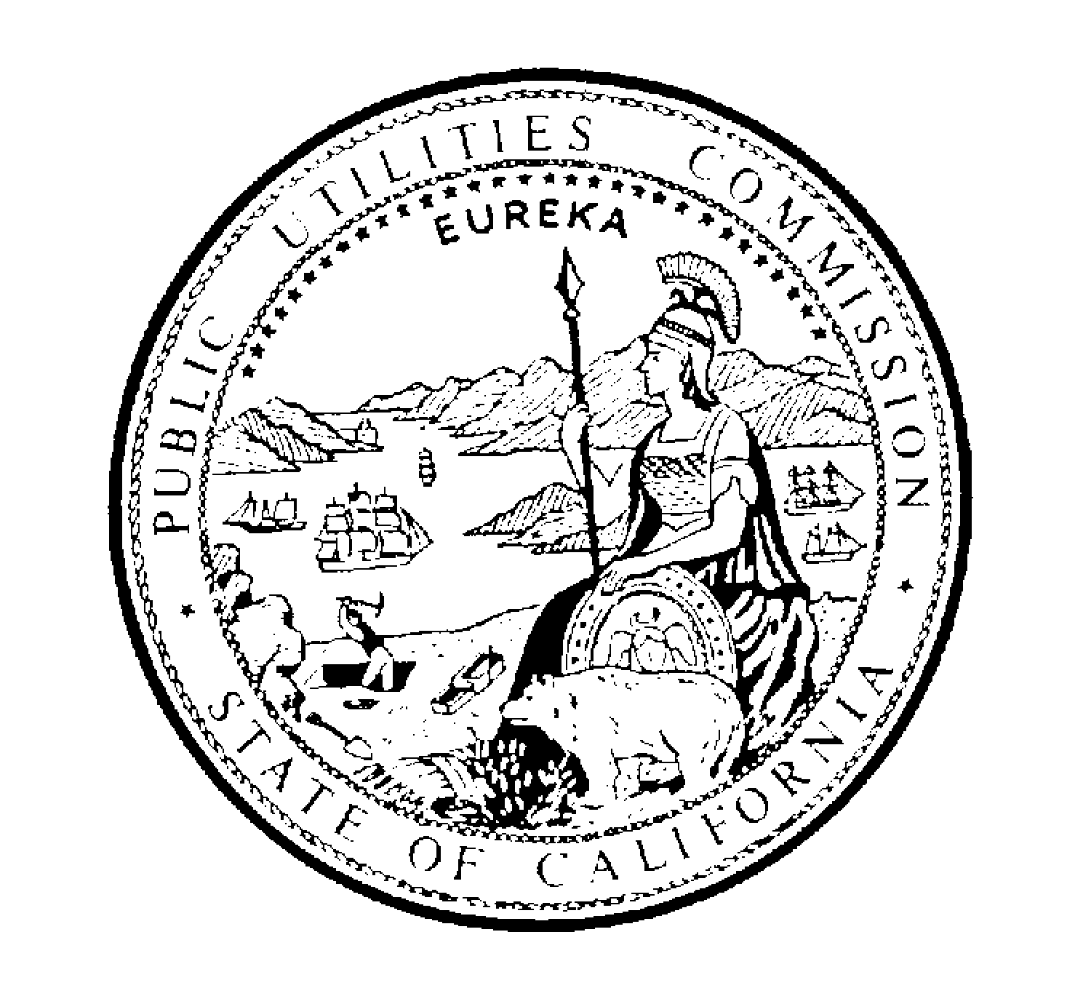PUBLIC UTILITIES COMMISSION
505 VAN NESS AVENUE
SAN FRANCISCO, CA 94102-3298

June 30, 2009 File No.: 602-19

TO: ALL INTERESTED PARTIES

Enclosed is draft Resolution W-4772 of the Division of Water and Audits. It will be on the Commission’s July 30, 2009 agenda. The Commission may then act on this Resolution or it may postpone action until later.

When the Commission acts on the draft resolution, it may adopt all or part of it as written, amend, or modify it, or set it aside and prepare a different resolution. Only when the Commission acts does the resolution become binding on the parties.

Parties to this matter may file comments on this draft resolution. An original and 2 copies of the comments, with a certificate of service, should be submitted to:

Division of Water and Audits, Third Floor
Attention: Tayeb Mogri
California Public Utilities Commission
505 Van Ness Avenue
San Francisco, CA 94102

Parties may submit comments on or before July 20, 2009. The date of submission is the date the comments are received by the Division of Water and Audits. Parties must serve a copy of their comments on Del Oro Water Company, on the same date that the comments are submitted to the Division of Water and Audits.

Comments shall be limited to five pages in length plus a subject index listing the recommended changes to the draft resolution, a table of authorities, and appendix setting forth the proposed findings and ordering paragraphs.

Comments shall focus on factual, legal, or technical errors in the draft resolution, and shall make specific reference to the record or applicable law. Comments which fail to do so will be accorded no weight and are not to be submitted.

Persons interested in comments of parties may write to Tayeb Mogri or telephone him at (415) 703-2146.

/s/ RAMI KAHLON
Rami Kahlon, Director
Division of Water and Audits

Enclosures: Draft Resolution W-4772
Certificate of Service
Service List

DRAFT
WATER/RSK/JB5/TKM/jlj AGENDA ITEM #8655

PUBLIC UTILITIES COMMISSION OF THE STATE OF CALIFORNIA

DIVISION OF WATER AND AUDITS RESOLUTION NO. W-4772
Water and Sewer Advisory Branch July 30, 2009

RESOLUTION

(RES. W-4772), DEL ORO WATER COMPANY, (DOWC). ORDER AUTHORIZING A SURCHARGE TO RECOVER AN INCREASE IN WATER QUALITY EXPENSES PRODUCING AN INCREASE IN ANNUAL REVENUE $728.00 IN FERNDALE DISTRICT, $936.00 IN LIME SADDLE DISTRICT, $364.70 IN PINE FLAT DISTRICT, $156.50 IN PINE MOUNTAIN DISTRICT, $415.00 IN RIVER ISLAND DISTRICT, $521.00 IN STRAWBERRY DISTRICT, AND $415.00 IN WALNUT RANCH DISTRICT.

SUMMARY

By Advice Letter (AL) 225, filed on May 11, 2009 and supplemented on June 4, 2009 (AL 225-A), DOW C requests a one-time surcharge be instituted to each customer’s bill as outlined below to its Schedules 1, General Metered Service, and 2, Flat Rate Service.

Ferndale (DOWCFD) $0.96
Lime Saddle (DOWCLS) $2.64
Pine Flat (DOWCPF) $1.88
Pine Mountain (DOWCPM) $1.68
River Island (DOWCRI) $1.17
Strawberry (DOWCST) $1.38
Walnut Ranch (DOWCWR) $2.70

The increase requested is to recover water compliance costs incurred in 2008 and 2009
over and above the amount allowed in DOWC’s last general rate cases. This increase will not result in a rate of return greater than that last authorized for DOWC‘s various districts.

This resolution hereby grants DOWC the authority to recover in rates the California Department of Public Health (CDPH) fees by adding a one-time surcharge to each customer’s bill.

BACKGROUND

DOWC, a Class B utility, provides water service to customers in the various districts known as Ferndale (DOWCFD), Lime Saddle (DOWCLS), Pine Flat (DOWCPF), Pine Mountain (DOWCPM), River Island (DOWCRI), Strawberry (DOWCST), Walnut Ranch (DOWCWR),. DOWC requests authority under General Order 96-B, Rule 7.6.2 and Water Industry Rule 7.3.3(7) and Section 454 of the Public Utilities Code to recover CDPH fees through a one-time surcharge. The surcharge will recover water quality costs including testing, sampling, and compliance for the years 2008 and 2009. The present rates for DOWCFD became effective on November 13, 2008 pursuant to AL 205; for DOWCLS on May 27, 2008, pursuant to AL 182; for DOWCPF and DOWCPM on October 3, 2008, pursuant to AL 203; for DOWCRI on November 2, 2008, pursuant to AL 206; for DOWCST on May 27, 2008, pursuant to AL 184; and for DOWCWR on
May 7, 2009, pursuant to Res. W-4681.

NOTICE AND PROTESTS

Notice of the proposed rate increase was mailed to the customers. There were four customer contacts complaining that the proposed offset increase should not be allowed because the filings were not readily accessible for customer’s review.

DISCUSSION

Section 116565(a) of the California Health and Safety Code, directs the CDPH to charge the utilities within its jurisdiction for all operating costs. Section 116590(c) of the Health and Safety Code authorizes these costs to be passed on to those utilities’ customers. On March 6, 2002, the Commission approved Res. W-4327, (superseding Res. W-4013) which authorized the establishment of a memorandum account for the CDPH fees that were being billed under Section 116565(a) of the California Health and Safety Code and water testing costs mandated by the CDPH for Water Quality. The resolution authorized Class B, C, and D Water Utilities to establish two memorandum accounts to track water quality expenses, the first – a Water Quality Memorandum Account

(WQMA) and the second – a User Fee Memorandum Account (UFMA) to track CDPH fees not presently included in their rates. The memorandum accounts remained open until January 1, 2008 when they were terminated by provision of Res. W-4327. On July 31, 2008, the Commission approved Res. W-4698 (superseding Res. W-4327) which authorized the establishing of Water Quality and User Fee Balancing Accounts. The change from memorandum accounts to balancing account better reflects the similarity to purchased water, purchased power, and pump tax balancing accounts approved for recovery without an earnings test by D.06-04-037, April 13, 2006.

DOWC established the UFMA as authorized in Res. W-4327, and elected to record therein the water compliance costs with CDPH incurred in 2008 and 2009 and paid to CDPH. These charges are split into several invoices covering the various districts. The invoices covered the period from July 1, 2008 through June 30, 2009 and paid November 25, 2008. A utility is able to seek recovery CDPH fees once it incurs the CDPH charges, i.e., receives an invoice from CDPH authorized by Res. W-4698, effective July 31, 2008.

The issue of recovery of CDPH charges is not a general rate-making matter. Rather, it deals with recovery of a discrete expense item independent of the Commission’s general rate-making responsibilities. The Commission’s policy has been, and continues to be, to allow utilities to recover CDPH charges in rates as authorized in Sections 11656(a) and 116590 (c) of the California Health and Safety Code.

Staff of the Division of Water and Audits (DWA) reviewed the invoices and determined that the charges were reasonable. DOWC proposes to pass on to its customers the operating costs from CDPH, as authorized by Section 116590(c) of the California Health and Safety Code. DWA has reviewed the utility’s request and finds it to be reasonable and recommends that it be authorized.

DOWC’s recorded earnings for the year 2008 show that utility is not over-earning its authorized rate of return. DWA recommends that DOWC be authorized to assess a one-time surcharge for all the districts except for Walnut Ranch which will be over two billing cycles.

COMPLIANCE

DOWC has no outstanding compliance orders. There are no Commission orders requiring system improvements. The utility has been filing annual reports as required.

COMMENTS

This is a contested matter in which the decision grants the relief requested. This proceeding is subject to the public review and comment pursuant to Public Utilities Code 311(g) (1)). The draft resolution was mailed on June 30, 2009. Comments were received on _______________.

FINDINGS

- Del Oro Water Company filed Advice Letter No. 225-A requesting a surcharge in various districts to recover California Department of Public Health fees incurred during 2008 and 2009 pursuant to Section 116565(a) of the Health and Safety Code.

- The undercollections in California Department of Public Health fees represent less than 1% of gross revenues for Del Oro Water Company.

- The surcharge herein would allow Del Oro Water Company to recover in rates the California Department of Public Health fees based on Commission approved Resolution W-4327 dated March 6, 2002 which authorized the establishment of a User Fee Memorandum Account for the fees that were being billed under Section 1116565(a) of the California Health and Safety Code.

- It is proper for Del Oro Water Company to assess a one-time surcharge per customer to recover the California Department of Public Health fees incurred during 2008-2009 in rates pursuant to Section 116590(c) of the California Health and Safety Code.

- The Commission finds, after investigation by the Division of Water and Audits that the request is justified, and the resulting rate is just and reasonable.

- This is a contested matter subject to the public notice and comment provided in the Public Utilities Code Section 311 (g) (1).

THEREFORE IT IS ORDERED THAT:

- Del Oro Water Company is authorized five days after the effective date herein, to make effective revised Schedule 1, General Metered Service and Schedule 2, Flat Rate Service, attached to Advice Letter No. 225-A in its Ferndale District, Lime
Saddle District, Pine Flat District, Pine Mountain District, River Island District, Strawberry District, Walnut Ranch District, and to cancel the corresponding presently effective rate schedules.

- Del Oro Water Company is directed in the future to maintain a User Fee Balancing Account as required by Public Utilities Code Section 792.5.

- This resolution is effective today.

I certify that the foregoing resolution was duly introduced, passed, and adopted at a conference of the Public Utilities Commission of the State of California held on July 30, 2009; the following Commissioners voting favorably thereon:

PAUL CLANON
Executive Director

CERTIFICATE OF SERVICE

I certify that I have by mail this day served a true copy of draft Resolution W-4772 on all parties in these filings or their attorneys as shown on the attached list.

Dated June 30, 2009, at San Francisco, California.

/s/ Josie L. Jones
JOSIE L. JONES

Parties should notify the Division of Water and Audits,
Public Utilities Commission, 505 Van Ness Avenue, Room 3106, San Francisco, CA 94102, of any change of address to insure that they continue to receive documents. You must indicate the Resolution number of the service list on which your name appears.
SERVICE LIST
DRAFT RESOLUTION W-4772

See attached.
Vavrinek, Trine, Day & Co.  Mr. Leonard Danna  26- Sheridan Avenue, Ste. 440  PALO ALTO CA 94306 |  | Kern County Administrator  Mr. Ron Errea  1115 Truxton Avenue  BAKERSFIELD CA 93301 |  | Tuolumne Utilities District  Mr. Peter Kampa  18885 Nugget Blvd.  SONORA CA 95370
California Water Service Co.  Mr. Mike McMasters  3725 South ”H” Street  BAKERSFIELD CA 93304 |  | Tuolumne County Offices  Mr. Craig Pedro, Co. Admin.  2 South Green Street  SONORA CA 95370 |  | McFarland Mutual Water Co.  Mr. Ray Deleon  209 W. Kern Avenue  MCFARLAND CA 93250
Humboldt County Administrator  Loretta A. Nickolaus  825 Fifth Street, Room 111  EUREKA CA 95501-1153 |  | Paradise Irrigation District  Mr. Kevin Phillips  P. O. Box 2409  PARADISE CA 95967 |  | Riverside Comm. Servs. District  Dave Rodrigues  790 Centerville Road  FERNDALE CA 95536
Butte Co. Water & Res. Cons.  Ms. Vickie Newlin  308 Nelson Avenue  OROVILLE CA 95966 |  | Larry Lees  Shasta Co. Admin Officer  1450 Court Street, Ste. 308A  REDDING CA 96001-1673 |  | Butte Co., Chief Admin. Off.  Brian Haddix  24 County Center Drive  OROVILLE CA 95966
Burney Water District  Casey Rodriguez  20222 Hudson Street  BURNEY CA 96013 |  | Kathleen Moran  Colusa County Clerk  546 Jay Street  COLUSA CA 95932 |  | Lassen Pines Water Company  9367 Mountain Meadow Road  SHINGLETOWN CA 96088
City of Colusa, Water & Sewer  Mr. Frank Garofalo  P. O. Box 1063  COLUSA CA 95932 |  | Tulare County Administrator  Jean Rousseau  2800 West Burrel Avenue  VISALIA CA 93291-4582 |  | Springville Pub. Util. District  Attn: Marilyn  P. O. Box 434  SPRINGVILLE CA 93265
James Melching  16581 Coyote Drive  SPRINGVILLE CA 93265 |  | Ralph Guest  334 Main Street  FERNDALE CA 95536 |  | Mr. and Mrs. Gambrell  16497 Wardlaw Drive  SPRINGVI LLE CA 93265
William S. McKinney16521  16521 Mustang Drive  SPRINGVILLE CA 93265  ;;;;;;; |  | Janice Hanna  Del Oro Water Co., Inc.  Drawer 5172  CHICO CA 95927

