STATE OF CALIFORNIA ARNOLD SCHWARZENEGGER, Governor
PUBLIC UTILITIES COMMISSION
505 VAN NESS AVENUE
SAN FRANCISCO, CA 94102-3298

July 21, 2009 File No.: 602-19

TO: All Interested Parties

Enclosed is draft Resolution W-4780 of the Division of Water and Audits. It will be on the Commission’s August 20, 2009 agenda. The Commission may then act on this Resolution or it may postpone action until later.

When the Commission acts on the draft resolution, it may adopt all or part of it as written, amend or modify it, or set it aside and prepare a different resolution. Only when the Commission acts does the resolution become binding on the parties.

Parties to this matter may file comments on this draft resolution. An original and 2 copies of the comments, with a certificate of service, should be submitted to:

Division of Water and Audits, Third Floor
Attention: Moises Chavez
California Public Utilities Commission
505 Van Ness Avenue
San Francisco, CA 94102

Parties may submit comments on or before August 10, 2009. The date of submission is the date the comments are received by the Division of Water and Audits. Parties must serve a copy of their comments on Sereno Del Mar Water Company on the same date that the comments are submitted to the Division of Water and Audits.

Comments shall be limited to five pages in length plus a subject index listing the recommended changes to the draft resolution, a table of authorities and appendix setting forth the proposed findings and ordering paragraphs.

Comments shall focus on factual, legal or technical errors in the draft resolution, and shall make specific reference to the record or applicable law. Comments which fail to do so will be accorded no weight and are not to be submitted.

Persons interested in comments of parties may write to Moises Chavez or telephone him at (415) 703-2805.

/s/ RAMI KAHLON
Rami Kahlon, Director
Division of Water and Audits

Enclosures: Draft Resolution W-4780
Certificate of Service
Service List

DRAFT

WATER/RSK/FLC/PTL/MCV/MDC/jlj AGENDA ITEM #8704

PUBLIC UTILITIES COMMISSION OF THE STATE OF CALIFORNIA

DIVISION OF WATER AND AUDITS RESOLUTION NO. W-4780
Water and Sewer Advisory Branch August 20, 2009

RESOLUTION

(RES. W-4780), SERENO DEL MAR WATER COMPANY (Sereno). ORDER AUTHORIZING A GENERAL RATE INCREASE PRODUCING ADDITIONAL ANNUAL REVENUE OF $7,366 OR 7.30% IN TEST YEAR (TY) 2009 AND $10,732 OR 9.90% FOR ESCALATION YEAR 2010.
__________________________________________________________

Summary
By Draft Advice Letter filed on December 31, 2008, Sereno, a Class D water utility, seeks to increase its rates for water service to recover increased operating expenses and earn an adequate return on its plant investment. The Division of Water and Audits (DWA) accepted this draft advice letter as complete for filing on February 19, 2009.

For Test Year 2009, this resolution grants an increase in gross annual revenues of $7,366 or 7.30% for TY 2009 and additional annual revenue of $10,732 or 9.90% for the escalation year 2010. The gross annual revenues were estimated to provide an Operational Rate of Margin (ROM) of 24%.

Background
Sereno is a solely-owned subsidiary of Russian River Utilities and it serves 126 metered rate residential customers in its service area which is adjacent to Highway 1, approximately 3 ½ miles north of Bodega Bay in Sonoma County.

Sereno has requested authority under Section VI of General Order 96-A and Rule 7.3.3(5), and Section 454 of the Public Utilities Code to increase its revenues by phasing in the revenues over three years and were proposed as follows: $8,100 or 8.73% in 2009; $4,400 or 4.36% in 2010; and $7,400 or 7.03% in 2011. Sereno’s request is based on its estimated ROM of 19.85%.

The present rates were established on March 14, 2008, by approval of Advice Letter 42, which authorized a 4.1% Consumer Price Index for 2007.

The DWA recommends the phased-in increase in revenues over a two-year period instead of Sereno’s three-year period increase in its rates.

DWA estimated present-rate gross revenues for 2008 are $101,094. DWA estimated revenues for TY 2009 are $108,460 and $119,192 for 2010 at the proposed rates.

The last general rate increase was granted on February 11, 2004, pursuant to Res.
W-4459, which authorized a rate increase of $1,633 or 2.17%, resulting in a rate of margin of 20%.

Notice AND PUBLIC MEETING
A notice of the proposed rate increase was mailed to each customer on March 9, 2009. The DWA received three letters in opposition to the rate increase. Sereno responded promptly to the letter and shared its response with the DWA. The Commission’s Consumers Affairs Branch has not received any complaints in the last twelve months.

A public meeting was held on April 13, 2009, at the Bodega Bay Fire Protection District located at 510 Highway One in Bodega Bay, and was attended by twelve customers. The Commission Staff explained the process of the rate increase for Class D water utilities and Sereno’s representatives explained the reasons for the rate increase, and their proposed conservation or tier rate structure. The rest of the meeting consisted of comments and questions by the customers.

DISCUSSION
The DWA made an independent analysis of Sereno’s operations. Appendix A shows Sereno’s and DWA’s estimated summary of earnings at present, requested, and recommended rates for TY 2009 and escalation year 2010. Sereno is in agreement with the summary of earnings at DWA’s recommended rates shown in Appendix A.

The DWA’s general approach for estimating Sereno’s operating expenses, excluding purchased power and water, insurance, taxes other than income, uncollectibles, and salaries, is based on taking the average of the past three years’ (2006 – 2008) recorded expenses and applying the most current monthly escalation factor from the Global

Insight U.S. Economic Outlook. The monthly escalation factor for labor and non-labor is provided by the Division of Ratepayer Advocates from the Global Insight U.S.
Economic Outlook for 2008 through 2012. DWA used the escalation factor published for the month of April, 2009 which was estimated at -0.80% for non-labor expenses and 3.8% for labor expenses.

The DWA reviewed operating revenues and expenses including purchased power and water, materials, contract work, laboratory services (water testing), other plant maintenance, management salaries, office service and rentals, office supplies and expenses, professional services, insurance, regulatory commission expenses, depreciation, and taxes other than income. The major differences between DWA’s and Sereno’s expenses were the following: (1) Materials, (2) Contract Work, (3) Insurance, and (4) Regulatory Commission Expense accounts. Staff verified the operating expenses by reviewing supporting documents for substantiation and accuracy, and included the amounts that were deemed reasonable and prudent.

In Decision (D.) 92-03-093 the Commission adopted the ROM for ratemaking as an alternative to the Rate of Return (ROR) method for Class C and Class D utilities. Therefore, to determine the authorized rate of return and revenues for Sereno, DWA calculated Sereno’s revenues using both the ROR and ROM methods. Under most situations for Class D water utilities with relatively low rate base, the Commission’s policy is to recommend the method that produces the higher revenues.

The DWA annually updates the recommended rates for the ROR and ROM methods for Class D water utilities and for 2009 the recommended rates are as follows:

 | Rates of Return (ROR) | Rates of Margin
Class D | 12.75% to 13.75% | 24%

DWA computed Sereno’s revenues using both methods and the ROM at the recommended rate of 24% produced the higher revenues. The revenues using the ROM at 24% resulted in $119,192 compared to $111,267 using the ROR method with a rate of 13.25%. Appendix A provides a complete breakdown of revenues by category.

Sereno’s current rate structure consists of two schedules: 1, Metered Service; and 3, Construction Service. Given Sereno’s water supply conditions, Sereno proposes to modify its current Metered Service Schedule 1 to a 3-tier water conservation rate structure (also known as block rates) for the quantity charge. Sereno also requests to have their Schedule No. 3 cancelled since they do not anticipate having any further use
for this schedule. DWA recommends granting Sereno’s request to cancel Schedule No. 3 and to implement water conservation rates as discussed below.

In 2008, the Commission approved several water conservation rate design programs with tier rates for several Class A and B water utilities. In adopting the water conservation rates, the Commission did not prescribe specific tier levels or price differentials for the rates; instead it allowed parties in the OII to negotiate the tier levels and rate differentials. The structure of adopted rates, however in general provide a reduce rate for water (per unit cost) in the first tier and/or reduced fixed charge and an increased price in the upper tiers. Sereno’s proposed tier rates follow a similar rate structure as those adopted by the Commission for Class A water companies.

Based on DWA’s analysis of Sereno customers’ 2007 water consumption patterns, approximately 82% of customers have water consumption levels within the first tier 0 to 6.7 Ccf (One Ccf is equal to one hundred cubic feet) and approximately 13% within the 2nd tier 6.71 to 10.7 Ccf and 5% within the 3rd tier more than 10.7 Ccf. Given that the majority of Sereno’s customers’ consumption will fall within the first tier, DWA’s concern about having significant rate impacts for its customers is minimized.

Furthermore, DWA’s concern about the complexity of a 3-tier structure for a Class D water utility is offset by the reduction in the overall rate impact for the majority of the customers, since a portion of the commodity revenue is shifted to the upper tiers. DWA
therefore supports the adoption of Sereno’s proposed rate structure with the following conditions:

- Sereno shall maintain annual customer water consumption data from 2008 through 2011, or through its next General Rate Case (GRC), in order to assess the level of water conservation achieved with implementation of the new rate structure;

- Sereno shall file Tier 1 Advice Letters on or before August 1, 2010 to implement the escalation rates for 2010, and these rates shall become effective on August 1, 2010;

- Sereno shall provide customer education on the new water conservation rates and information on ways customers can reduce their water usage;

- Sereno’s 3-tier rate structure should be re-evaluated in its next GRC filing;
The customer education information shall be filed for review by DWA. Given that Sereno will assume additional risk in its recovery of the authorized revenues and additional costs for the customer education, it shall be granted authority to establish a conservation memorandum account to track revenue shortages and any additional costs associated with its water conservation educational effort. Sereno shall file their request for a conservation memorandum account along with its request to implement their new tariffs.

At the DWA’s recommended rates, shown in Appendix B, the monthly bill for a residential customer with a ¾-inch meter that uses 6.7 Ccf (One Ccf is equal to 100 cubic feet) will increase by $26.91 from $64.84 to $91.75 or 41.5% in 2009 and by $10.02 from $91.75 to $101.77 or 10.9% in 2010. The 2009 increase is due to implementation of the Commission’s prescribed meter size ratios for the rate design, which had not been applied to Sereno’s existing rate structure. A more detailed bill comparison for the present and recommended rates is shown in Appendix C. The adopted quantities and tax calculations are shown in Appendix D.

compliance
There are no outstanding Commission orders requiring system improvements.

Sereno has been filing annual reports as required. However, DWA recommends that Sereno separate out the accounting treatment of the plant information associated with the $190,000 contribution associated with the well collector and 200,000 gallon storage tank, as well as the $250,000 Small Drinking Water Bond Act (SDWBA) loan for improvement of its water treatment plant.

According to the Department of Public Health, the utility currently meets all applicable water quality standards.

The DWA found that Sereno also needs to update the following tariff Rule and Schedule: Rule 3 (Application for Service); and Schedule UF (Surcharge to Fund Public Utilities Commission Reimbursement Fee).

COMMENTS
Public Utilities Code Section 311(g) (1) provides that resolutions generally must be served on all parties and subject to at least 30 days public review and comment prior to a vote of the Commission.

Accordingly, this draft Resolution was mailed to the utility and protesters and made available for public comment on July 21, 2009. Comments were received from ______________________.

Findings
- Sereno should separate the accounting treatment of all plant associated with the $190,000 in contribution and the $250,000 SDWBA loan from Sereno’s plant investments for its 2009 annual report.

- Sereno’s proposed water conservation 3-tier rate structure should be allowed. The water conservation rates should be implemented with the conditions contained herein.

- Sereno should file a Tier 1 Advice Letter on or before August 1, 2010 to implement the escalation rates for 2010, and these rates shall become effective August 1, 2010.

- Sereno should provide customer education information to DWA for review.

- Sereno should be granted authority to establish a memorandum account to track revenue under or over collections associated with implementation of the conservation rates and costs associated with their water conservation education effort.

- Sereno should delete Schedule No. 3, Construction Service.

- Sereno agrees with the DWA’s inflation rates of 3.8% and -0.8% for labor and non labor expenses.

- DWA used annual reports for expenses, where actual bills were not available.

- Except as described in the preceding findings, we find the company’s estimates to be reasonable.

- DWA’s recommended summary of earnings (Appendix A) are reasonable and should be adopted.

- The rates recommended by DWA (Appendix B) are reasonable and should be adopted.

- The quantities (Appendix D) used to develop the DWA’s recommendations are reasonable and should be adopted.

- Sereno should update the following tariff rule and schedule: Rule 3 (Application for Service); and Schedule UF (Surcharge to Fund Public Utilities Commission Reimbursement Fee).

Therefore it is ordered that:
- Authority is granted under Public Utilities Code Section 454 to Sereno Del Mar Water Company to file an advice letter incorporating the summary of earnings and the revised rate schedules attached to this resolution as Appendices A and B, and concurrently cancel its presently effective rate Schedule 1, General Metered Service; and Schedule 3, Construction Service. The effective date of the revised schedules shall be five days after the date of filing.

- Sereno Del Mar Water Company is authorized to increase its annual revenues by $7,366 or 7.30% for Test Year 2009 and $10,732 or 9.9% for escalation year 2010.

- Sereno shall file a Tier 1 Advice Letter on or before August 1, 2010 to implement the escalation rates for 2010, and these rates shall become effective August 1, 2010.

- Sereno Del Mar Water Company’s conservation rates are reasonable and are adopted with the conditions contained herein.

- Sereno Del Mar Water Company shall provide customer education information to the Division of Water and Audits for review.

- Sereno Del Mar Water Company is authorized to establish a memorandum account to track revenue under and over collections associated with the implementation of the conservation rates and costs for their water conservation education efforts.

- Sereno Del Mar Water Company shall separate out the accounting treatment of all plant associated with the $190,000 in contribution and the $250,000 Small Drinking Water Bond Act for its 2009 Annual Report to the Commission.

- The quantities (Appendix D) used to develop the Division of Water and Audits’ recommendations are adopted.

9. Sereno shall update the following tariff rule and schedule: Rule 3 (Application for Service); and Schedule UF (Surcharge to Fund Public Utilities Commission Reimbursement Fee).

10. This resolution is effective today.

I certify that the foregoing resolution was duly introduced, passed, and adopted at a conference of the Public Utilities Commission of the State of California held on August 20, 2009; the following Commissioners voting favorably thereon:

PAUL CLANON
Executive Director

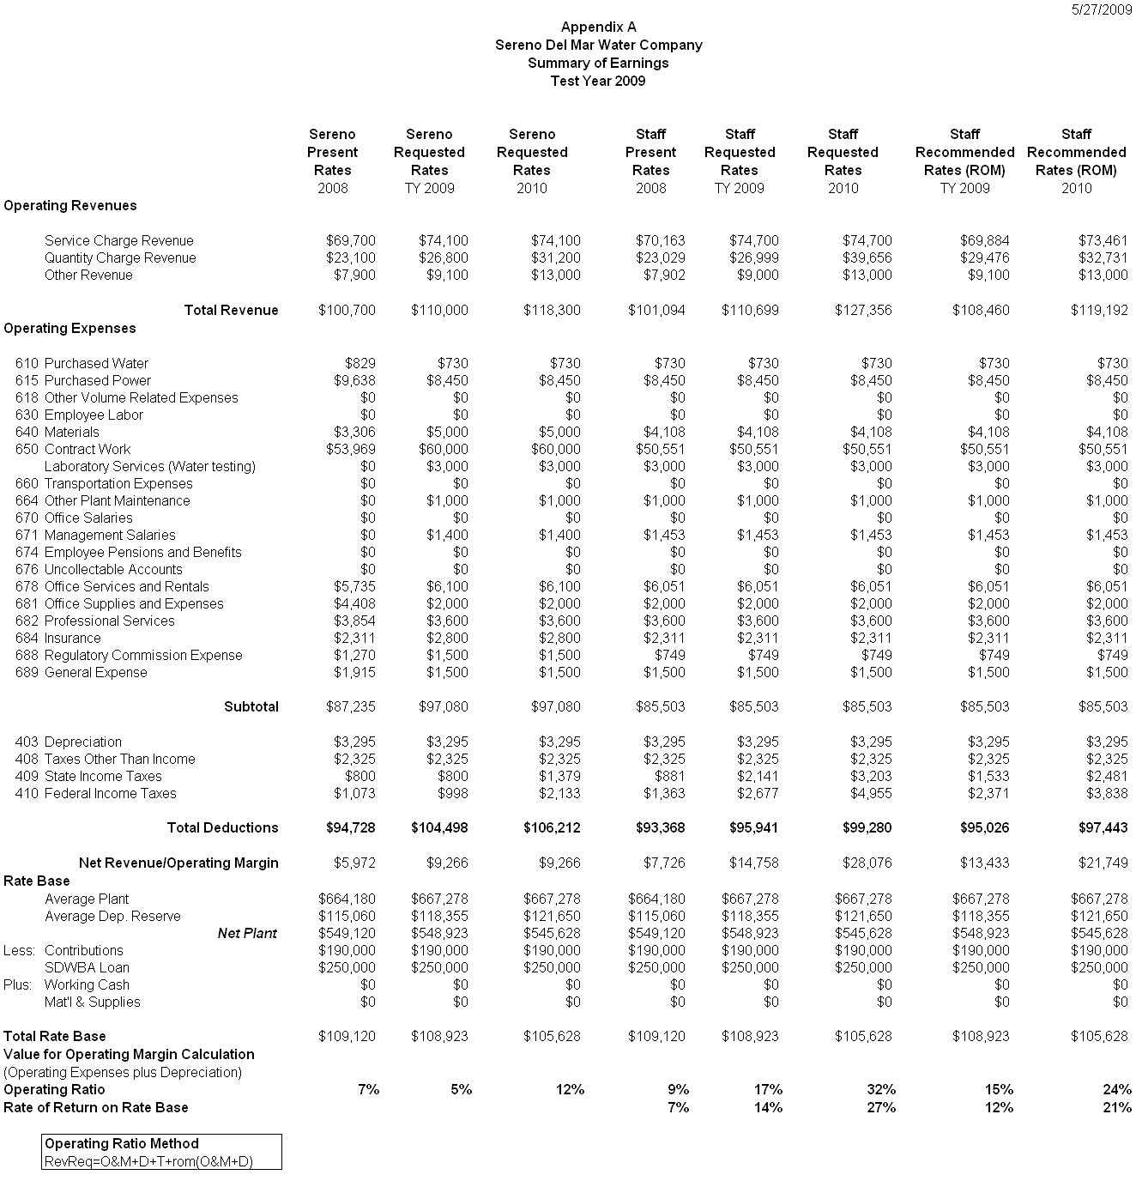

APPENDIX B
Page 1 of 2

Sereno Del Mar Water Company

Schedule No. 1

METERED SERVICE
Test Year 2009

APPLICABILITY

Applicable to all metered water service.

TERRITORY

The subdivision known as Sereno Del Mar and vicinity located 3.5 miles north of Bodega Bay, Sonoma County.

RATES

Quantity Rate |  | 2009
 |  | Per Month
0 to 6.7 | For all water deliver per 100 cu. ft. | $4.00
6.71 to 10.7 | For all water deliver per 100 cu. ft. | $4.50
over 10.7 | For all water deliver per 100 cu. ft. | $5.50

Service Charge |  | 2009
 |  | Per Month
 | Charge per meter size
 | 3/4-inch | $64.95
 | 1-inch | $108.25
 | 1- 1/2 inch | $216.49
 | 2-inch | $346.39

The Service Charge is a readiness-to serve charge which is applicable to all metered service and to which is added the water used computed at the Quantity Rate.

SPECIAL CONDITIONS

  - Any customer prior to resuming service within 12 months after such service was discontinued will be required to pay all service charges which would have been billed if service had not been discontinued.

  - A surcharge of $6.75 in addition to the regular monthly service charge shall be charged to all meter service. The surcharge is specifically for the repayment of the Safe Drinking State Revolving Fund loan as approved by Resolution W-4234. The monthly surcharge rate is subject to periodic adjustment.

  - All bills are subject to the reimbursement fee set forth in Schedule No. UF.
APPENDIX B
Page 2 of 2
Sereno Del Mar Water Company
Schedule No. 1
METERED SERVICE
Escalation Year 2010

APPLICABILITY

Applicable to all metered water service.

TERRITORY

The subdivision known as Sereno Del Mar and vicinity located 3.5 miles north of Bodega Bay, Sonoma County.

RATES
Quantity Rate |  | 2010
 |  | Per Month
0 to 6.7 | For all water deliver per 100 cu. ft. | $4.50
6.7 to 10.7 | For all water deliver per 100 cu. ft. | $5.00
over 10.7 | For all water deliver per 100 cu. ft. | $6.25

Service Charge |  | 2010
 |  | Per Month
 | Charge per meter size
 | 3/4-inch | $68.27
 | 1-inch | $113.79
 | 1- 1/2 inch | $227.57
 | 2-inch | $364.12

The Service Charge is a readiness-to serve charge which is applicable to all metered service and to which is added the water used computed at the Quantity Rate.

SPECIAL CONDITIONS

- Any customer prior to resuming service within 12 months after such service was discontinued will be required to pay all service charges which would have been billed if service had not been discontinued.

- A surcharge of $6.75 in addition to the regular monthly service charge shall be charged to all meter service. The surcharge is specifically for the repayment of the Safe Drinking State Revolving Fund loan as approved by Resolution W-4234. The monthly surcharge rate is subject to periodic adjustment.

- All bills are subject to the reimbursement fee set forth in Schedule No. UF.

(END OF APPENDIX B)

APPENDIX C
Sereno Del Mar Water Company
COMPARISON OF RATES

Test Year 2009
Sereno
 |  |  |  | Per Service Connection Per Month
 |  |  |  | Present | Recommended | Percent
 |  |  |  | Rates | Rates | Increase
Service Charge:
 |  | For 3/4-inch meters |  | $42.26 | $64.95 | 53.7%
 |  | For 1-inch meters |  | $70.49 | $108.25 | 53.6%
 |  | For 1-1/2-inch meters |  | $141.10 | $216.49 | 53.4%
 |  | For 2-inch meters |  |  | $346.39
Quantity Charge:
Metered Water Usage |  | 0 to 6.7 |  | $3.37 | $4.00 | 18.7%
(100 cubic feet) |  | 6.71 to 10.7 |  | $3.37 | $4.50 | 33.5%
 |  | over 10.7 |  | $3.37 | $5.50 | 63.2%

A monthly bill comparison for a customer with a 3/4-inch meter is shown below:
Usage | Present |  | Recommended | Amount | Percent
100 cu. ft. | Rates |  | Rates | Increase | Increase
0 | $42.26 |  | $64.95 | $23 | 53.7%
5 | $59.11 |  | $84.95 | $26 | 43.7%
6.7 | $64.84 |  | $91.75 | $27 | 41.5%
10.7 | $78.32 |  | $109.75 | $31 | 40.1%
17 | $99.55 |  | $144.40 | $45 | 45.1%
20 | $119.77 |  | $160.90 | $41 | 34.3%

APPENDIX C

COMPARISON OF RATES

Sereno Del Mar Water Company

Escalation Year 2010

Sereno
 |  |  | Per Service Connection Per Month
 |  |  | 2009 | Recommended | Percent
 |  |  | Rates | Rates | Increase
Service Charge:
 | For 3/4-inch meters |  | $64.95 | $68.27 | 5.1%
 | For 1-inch meters |  | $108.25 | $113.79 | 5.1%
 | For 1-1/2-inch meters |  | $216.49 | $227.57 | 5.1%
 | For 2-inch meters |  | $346.39 | $364.12 | 5.1%
Quantity Charge:
Metered Water usage | 0 to 6.7 |  | $4.00 | $4.50 | 12.5%
(100 cubic feet) | 6.71 to 10.7 |  | $4.50 | $5.00 | 11.1%
 | over 10.7 |  | $5.50 | $6.25 | 13.6%

A monthly bill comparison for a customer with a 3/4-inch meter is shown below:

Usage | 2009 |  | Recommended | Amount | Percent
100 cu. ft. | Rates |  | Rates | Increase | Increase
0 | $64.95 |  | $68.27 | $3.32 | 5.1%
5 | $84.95 |  | $90.77 | $5.82 | 6.9%
6.7 | $91.75 |  | $101.77 | $10.02 | 10.9%
10.7 | $109.75 |  | $121.77 | $12.02 | 11.0%
17 | $144.40 |  | $161.65 | $17.25 | 11.9%
20 | $160.90 |  | $176.55 | $15.65 | 9.7%

(END OF APPENDIX C)
APPENDIX D
Sereno Del Mar Water Company
ADOPTED QUANTITIES
Test Year 2009

Purchased Power
Pacific Gas and Electric Company
Effective Date May 1, 2006
Schedule A-6 Small General Time-of-Use Service – Polyphase

Total Customer/Meter Charge Rates
Meter Charge (A-6) ($ per meter per day) $0.20107

Total Energy Rates ($ per kWh)
Peak summer $0.41487
Part-Peak summer $0.18872
Off-Peak summer $0.11732
Part-Peak winter $0.14196
Off-Peak winter $0.11603

Total kWh 45,773
Total Cost $8,450

Property Taxes $2,325

Service Connections
¾ - inch 109
1 – inch 17
Total 126

Consumption 6,833 Ccf

Tax Calculations
 |  |  | 2009 | 2010
Operating Revenues |  |  | $108,460 | $119,192
Expenses |  |  | $85,503 | $85,503
Depreciation |  |  | $3,295 | $3,295
Taxes other than Income |  |  | $2,325 | $2,325
Taxable Income for State |  |  | $17,337 | $28,069
State tax |  |  | $1,533 | $2,481
Taxable Income for Federal |  |  | $15,804 | $25,587
Federal tax |  |  | $2,371 | $3,838

(END OF APPENDIX D)
CERTIFICATE OF SERVICE

I certify that I have by mail this day served a true copy of draft Resolution W-4780 on all parties in these filings or their attorneys as shown on the attached list.

Dated July 21, 2009, at San Francisco, California.

/s/ Josie L. Jones
JOSIE L. JONES

Parties should notify the Division of Water and Audits, Public Utilities Commission, 505 Van Ness Avenue, Room 3106, San Francisco, CA 94102, of any change of address to insure that they continue to receive documents. You must indicate the Resolution number of the service list on which your name appears.

SERVICE LIST
DRAFT RESOLUTION W-4780

Rich Panter  1045 Foster Road  NAPA CA 94558 |  | Pat Peterson  5535 Sierra Grande  BODEGA CA 94923 |  | Margaret Briare  P. O. Box 998  BODEGA BAY CA 94923
Patty Ginochio  360 Terra Verde  BODEGA BAY CA 94923 |  | Judy and Cordell Karlstad  P. O. Box 625  BODEGA BAY CA 94923 |  | Jerry Ditto  5378 La Dia Court  BODEGA BAY CA 94923
Gayle Goldstone  5390 El Camino Bella  BODEGA BAY CA 94923 |  | Judith Henderson  492 Los Santos  BODEGA BAY CA 94923 |  | Hal Wood, Administrator  Sereno Del Mar Water Co.  P. O. Box 457  FORESTVILLE CA 95436
Karen Sue & Teresa Foley  5246 Las Flores Drive  BODEGA BAY CA 94923 |  | Joanna Martinelli Strang  281 Calle del Sol  BODEGA BAY CA 94923

- Operating Ratio also known as “Rate of Margin” can be computed in two ways: (1) Rate of Margin= Net Operating Revenues/Total Operating Revenues, or (2) Rate of Margin= 1- Operating Ratio, where the Operating Ratio= Net Operating Revenues/Total Operating Revenues.
- Order Instituting Investigation (OII) 07-01-022.
- Sereno’s billing system has the capability of tracking water consumption information on a monthly basis by customer.

