Item #
Agenda #8964
D R A F T

PUBLIC UTILITIES COMMISSION OF THE STATE OF CALIFORNIA

Communications Division | RESOLUTION T- 17236
Carrier Oversight and Programs Branch | November 20, 2009

R E S O L U T I O N

Resolution T- 17236 Approval of Funding for the Ponderosa Cablevision Auberry project, from the California Advanced Services Fund (CASF), Amounting to $405,613.
__________________________________________________________________

Summary

This Resolution adopts contingent funding for the Ponderosa Cablevision (Ponderosa) Auberry project, amounting to $405,613 from the California Advanced Services Fund (CASF). This amount represents 10% of the project costs to provide broadband service to unserved areas in accordance with Commission Resolution T-17143 and Decision (D.) 09-07-020.

Background

On December 20, 2007, the Commission approved Decision (D.) 07-12-054 which established the two-year CASF program to provide matching funds of up to 40% of the total project costs for the deployment of broadband infrastructure in underserved and underserved areas in California. Resolution T-17143, approved on June 12, 2008, adopts the application requirements, scoring criteria for the award of funds, and a prescribed timeline for other filings and notifications including a projected Commission Meeting date for final approval of award(s). This same Resolution directed interested applicants seeking funding for underserved and underserved projects, to file their project proposals and funding requests beginning July 24, 2008 and August 25, 2008 respectively.

On July 9, 2009, the Commission issued D.09-07-020 establishing new schedules and plans for the filing, review and approval of an additional round of broadband project requests. This decision also provides the potential for the applicants to seek CASF program funding while pursuing funding for broadband deployment grants issued under the American Recovery and Reinvestment Act (ARRA). Because the federal grants under ARRA can fund up to 80% of the project, the Commission provided applicants in D.09-07-020 the opportunity to seek an additional 10% funding coverage from the CASF, leaving only 10% for the applicant to provide.

As of September 24, 2009, CASF funding of $12.6 million has been granted for 28 projects covering 4,318 square miles, benefiting 32,943 potential households as follows:

- Unserved areas: $11.6 million, 16 projects 4,284 square miles, 32,284 households
- Underserved areas: $1 million, 12 projects, 34 square miles, 659 households.

Notice/Protests

The Census Block Group (CBG) list for the Auberry project appeared by county on the Commission’s CASF website page under “(1) UNSERVED areas proposed to be served as of July 17, 2009: Census Block Groups (CBGs).” A challenge was filed on one of the proposed CBGs. Communications Division (CD) proceeded to review and analyze these project areas to verify that they were indeed unserved as of the applicants’ filing date.

Discussion

This Resolution adopts CD’s recommended contingent funding award of $405,613 for the Ponderosa Auberry project in Fresno County. Key project information is on page A-1 of Appendix A. A shapefile of Ponderosa’s proposed Auberry project can be found on page A-2 of Appendix A. Page A-3 of Appendix A locates the project on a map of California.

Ponderosa submitted its Auberry application on July 17, 2009. The total project cost is estimated at $4,056,126, of which 10%, or $405,613, is being requested from CASF as a match to their 80% ARRA fund request.

Ponderosa currently provides DSL service in southern Madera County and northern Fresno County including the communities of Friant, Prather, North Fork, Auberry, and Shaver Lake. Ponderosa Cablevision purchases DSL access service on a wholesale basis from the local telephone company. Currently Ponderosa offers 2 levels of DSL service. Ponderosa’s current service area borders the proposed service area on 2 sides, north and west.

Ponderosa plans to extend its DSL coverage into the proposed area, Township 11 in Fresno County, by utilizing fiber to the home technology, utilizing the ITU-T G 984 standard. Ponderosa will install two OLT terminals, each capable of providing within their coverage area very high speed broadband connections. These terminals will be linked to current Ponderosa facilities in the existing coverage area. There is no electrical power in the system between the OLTs and the ONT. The ONT terminates the fiber at the residence or business and it has backup power to continue to provide service in the event of power outage. The ONT can be equipped with numerous in home distribution options including Ethernet over coax, Ethernet over power line, and traditional wired and wireless Ethernet options.

This project will be able to deliver service to 1,043 households covering an area of about 18.65 square miles in 4 CBGs at average speeds 30 mbps download and 13.33 mbps upload. CD has recommended the Auberry project for approval of CASF funding award and the Commission finds this recommendation to be reasonable and consistent with past Commission orders.

For qualification purposes under the CASF program, unserved areas are defined as areas that are not served by any form of facilities-based broadband, or where Internet connectivity is available only through dial-up service or satellite. CD reviewed this project’s eligibility through analysis of the required submitted data. These data include, but are not limited to: proof of Certificate of Public Convenience and Necessity (CPCN) registration; descriptions of current and proposed broadband infrastructure; Geographic Information System (GIS) formatted Shapefiles mapping the subject areas; assertion that the area is underserved; potential subscriber size and household incomes; project construction schedule; project budget; proposed pricing and commitment period for new subscribers; and, financial qualifications of the applicant. In addition, CD reviewed the Shapefiles submitted which mapped the broadband deployment proposed using United States 2000 Census data, the January, 2008, Broadband Task Force Report (BBTF) including its on-line maps, and the revised August 10, 2009, California Broadband Task Force (CBTF) maps, among others.

CD conducted its independent review and analysis of the Auberry project to verify that the areas proposed to be served by Ponderosa did not coincide with areas shown as being served on the BBTF maps. Of the four CBGs in this proposed project, one was formally challenged. Ponderosa submitted additional information demonstrating that there was not in fact any broadband service in the contested area. CD determined that the CBGs covering the proposed area are qualified as unserved as defined in Resolution T-17143.

The Application Requirements and Guidelines on the awarding of CASF Funds provide that the execution of a Performance Bond is not required if 10% of the total project costs come from the applicant’s capital budget and is not obtained from outside financing sources. Therefore, a performance bond is not required under the CASF.

Ponderosa should comply with all guidelines, requirements, and conditions associated with the granting of CASF funds as specified in Resolution T-17143 including the submission of FCC Form 477 and compliance with the California Environmental Quality Act (CEQA), among others.

The proposed project, however, will be constructed on existing PG&E poles. Therefore, no Proponent’s Environmental Assessments should be required under the California Environmental Quality Act (CEQA). If any special permits are required Ponderosa agreed to notify the CPUC as appropriate and will comply with the conditions associated with the granting of CASF funds as specified in T-17143 including the submission of FCC Form 477.
The receipt of the CASF grant should be contingent on Ponderosa receiving the 80% ARRA grant on its Auberry unserved project. If the applicant is not successful in its request for the ARRA grant or if of the ARRA grant is less than 80%, then Ponderosa may request additional CASF funds in accordance with Ordering Paragraph No. 7 of D.09-07-020. The granting of additional funds will be contingent on the availability of CASF funds.

If Ponderosa is unable to obtain ARRA funding and will not construct the Auberry unserved project, then Ponderosa should notify the Director of the Communications Division promptly so that CASF funds may be reallocated to other grants.

Payments to CASF Recipients

Submission of invoices from and payments to Ponderosa shall be made in accordance with Section IX of Appendix A of Resolution T-17143 and according to the guidelines and supporting documentation required in Resolution T-17143.

Payment to Ponderosa shall essentially follow the process adopted for funds created under Public Utilities Code §270. The following table describes the timeline for processing CASF payments.

Event | Payment Cycle 1  (Day/Month) | Payment Cycle 2  (Day/Month)
Invoices due from Ponderosa to CD | 5th of Month 1 | 20th of Month 1
Payment letters from CD to Information and Management Services Division (IMSD) | On 19th of Month 1 | On 4th of Month 2
Invoices submitted from IMSD to State Controller’s Office (SCO) for payments | 20th through 26th of Month 1 | 5th through 13th of Month 2

Ponderosa may submit invoices under Payment Cycle 1 or 2.

If any date in this payment schedule falls on a weekend or holiday, that date will be advanced to the next business day but the remaining dates in the payment schedule will remain unchanged. The state controller’s office (SCO) requires 14 to 21 days to issue payment from the day that requests are received by SCO.

Comments on Draft Resolution

In compliance with PU Code § 311(g), a notice letter was emailed on October 21, 2009, informing a) all CASF applicants filing under D.09-07-020, and b) parties on the service list of R.06-06-028 of the availability of the draft of this Resolution for public comments at the Commission's website http://www.cpuc.ca.gov/static/documents/index.htm. This letter also informed parties that the final conformed Resolution adopted by the Commission will be posted and will be available at this same website.

Findings

- The CASF was established as a two-year program that will provide matching funds of up to 40% of the total project costs for the deployment of broadband infrastructure in underserved and underserved areas in California.

- Resolution T-17143, approved on June 12, 2008, adopts the application requirements and scoring criteria for the award of funds, a prescribed timeline for other filings, and notifications including a projected Commission Meeting date for final approval of award(s). T-17143 directed interested applicants seeking funding for underserved projects to file their project proposals and funding requests beginning July 24, 2008.

- On July 9, 2009, the Commission issued D.09-07-020 approving a new CASF schedule and plan for an additional round of broadband projects that would complement broadband grants awarded under the federal government’s American Recovery and Reinvestment Act (ARRA). While retaining the 40% matching grant process, the Commission in this Decision authorized providers an option of seeking a 10% grant from the CASF concurrent with efforts to seek an 80% grant from the ARRA fund.

- A list of census block groups (CBGs) appeared by county on the Commission’s CASF website page under “UNSERVED areas proposed to be served as of July 17, 2009: Census Block Groups (CBGs).” The Communications Division (CD) proceeded with its independent review and analysis of this project area to verify that it was underserved as of the applicant’s filing date.

- Unserved areas are defined as areas that are not served by any form of facilities-based broadband, or where Internet connectivity is available only through dial-up service or satellite.

- Ponderosa filed an application on July 17, 2009, under D.09-07-020. CD reviewed the Ponderosa Auberry project eligibility through the analysis of required data submitted. These data include, but are not limited to: proof of Certificate of Public Convenience and Necessity (CPCN) registration; descriptions of current and proposed broadband infrastructure; geographic information system (GIS) formatted Shapefiles mapping the subject areas; assertion that the area is unserved; potential subscriber size and household incomes; project construction schedule; project budget; proposed pricing and commitment period for new subscribers; and, financial qualifications of the applicant.

- Shapefiles, which mapped the broadband deployment, were reviewed by CD using sources including, but not limited to, the United States 2000 Census data, the January, 2008, Broadband Task Force Report, and the revised August 10, 2009, California Broadband Task Force map, among others. These maps helped to verify the existence or non-existence of broadband service areas and broadband speeds, where available.

- Communications Division verified this project and, when necessary, requested additional information and/or meetings with the applicant to clarify its project proposal. Of the 4 CBGs in this proposed project, 1 was formally challenged. Communications Division determined that the CBGs covering the proposed area are qualified as unserved as defined in Resolution T-17143.

- After its review, Communications Division determined the Ponderosa Auberry project application for unserved areas covering 4 CBGs as eligible to receive funding under CASF.

- The Commission finds Communications Division’s recommended contingent California Advanced Services Fund (CASF) award for underserved areas for the Ponderosa Cablevision Auberry project as discussed in this resolution and summarized in Appendix A to be reasonable and consistent with past Commission orders and, therefore, should be adopted. The California Advanced Services Fund (CASF) was implemented by Decision (D.) 07-12-054.

- The posting of a performance bond by Ponderosa is not required as 10% of the total project cost will be financed through their capital budget.

- Ponderosa should comply with all guidelines, requirements, and conditions associated with the granting of CASF funds as specified in Resolution T-17143 including the submission of FCC Form 477 and compliance with the California Environmental Quality Act (CEQA), among others.

- Since Ponderosa’s Auberry project will be constructed on existing PG&E poles, no Proponent’s Environmental Assessments should be required under the California Environmental Quality Act (CEQA). If any special permits are required Ponderosa agreed to notify the CPUC as appropriate and will comply with the conditions associated with the granting of CASF funds as specified in T-17143 including the submission of FCC Form 477.

- The receipt of the CASF grant should be contingent on Ponderosa receiving the 80% ARRA grant on its Auberry unserved project. If the applicant is not successful in its request for the ARRA grant or if of the ARRA grant is less than 80%, then Ponderosa may request additional CASF funds in accordance with Ordering Paragraph No. 7 of D.09-07-020. The granting of additional funds will be contingent on the availability of CASF funds.

- If Ponderosa is unable to obtain ARRA funding and will not construct the Auberry unserved project, then ponderosa should notify the Director of the Communications Division promptly so that CASF funds may be reallocated to other grants.

- A notice letter was emailed on October 21, 2009, informing a) all applicants filing for underserved areas and, b) parties on the service list of R.06-06-028 of the availability of the draft of this Resolution for public comments at the Commission's website http://www.cpuc.ca.gov/static/documents/index.htm. This letter also informed parties that the final conformed Resolution adopted by the Commission will be posted and available at this same website.

THEREFORE, IT IS ORDERED that:

- The California Advanced Services Fund shall award contingent funding of $405,613 from the California Advanced Services Fund to Ponderosa Cablevision (Ponderosa) for the Auberry project to provide service in unserved areas as described in the Discussion section and summarized in Appendix A of this Resolution.

- Ponderosa shall not be required to post a performance bond.

- Ponderosa shall comply with all guidelines, requirements, and conditions associated with the CASF funds award as specified in Resolution T-17143 and D.09-07-020 and the California Environmental Quality Act.

- The receipt of the CASF grant should be contingent on Ponderosa receiving the 80% ARRA grant on its Auberry unserved project. If the applicant is not successful in its request for the ARRA grant or if of the ARRA grant is less than 80%, then Ponderosa may request additional CASF funds in accordance with Ordering Paragraph No. 7 of D.09-07-020. The granting of additional funds will be contingent on the availability of CASF funds.

- Ponderosa shall promptly notify the Director of the Communications Division if Ponderosa is unable to obtain ARRA funding and will not construct the Auberry unserved project, then so that CASF funds may be reallocated to other grants.

- The program fund payment of $405,613 for this Commission-approved unserved project shall be paid out of the CASF fund in accordance with the guidelines adopted in Resolution T-17143 and D.09-07-020.

- Payments to Ponderosa shall be in accordance with Section IX of Appendix A of Resolution T-17143 and in accordance with the process defined in the “Payments to CASF Recipients” section of this resolution.

This Resolution is effective today.

I hereby certify that this Resolution was adopted by the Public Utilities Commission at its regular meeting on November 20, 2009. The following Commissioners approved it:

PAUL CLANON

Executive Director

APPENDIX A
Resolution T- 17236
Ponderosa Cablevision Auberry Project, Key Information

Ponderosa Cablevision
1 | Project ID | 286
2 | Project Name | Ponderosa Cablevision Auberry
3 | Project Plan | Installation of two OLT terminals which will provide customers with FTTH.
4 | Project Size (in square miles) | 18.65
5 | Download speed | 30 Mbps
6 | Upload speed | 13.33 Mbps
7 | Location | Fresno
a) | Community Names | Mount Diablo Base, Meridian
b) | CBGs/Household Income
# |  | CBG | Income
1 |  | 060190064012 | $69,375
2 |  | 060190064013 | $47,727
3 |  | 060190064014 | $44,700
4 |  | 060190064015 | $55,682
c) | ZIP Codes
 |  | 93619
 |  | 93651
 |  | 93626
8 | Estimated Potential Subscriber Size
a) | Households | 1,043
9 | Deployment Schedule (from Commission approval) | 12 Months
10 | Proposed Project Budget | $4,056,126
b) | CASF (10%) | $405,613
c) | CIAC | $0
d) | Amount of CASF Funds Requested | $405,613

APPENDIX A
Resolution T- 17236
Ponderosa Cablevision Auberry Project Shapefiles
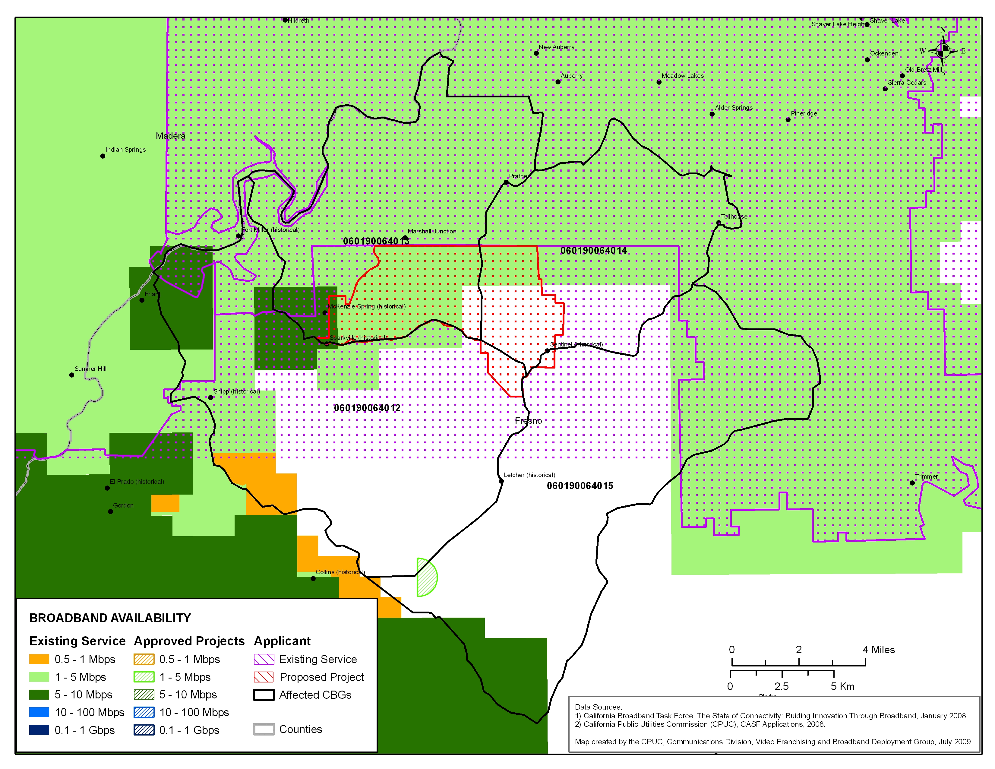

APPENDIX A
Resolution T- 17236
Ponderosa Cablevision Auberry Statewide Map

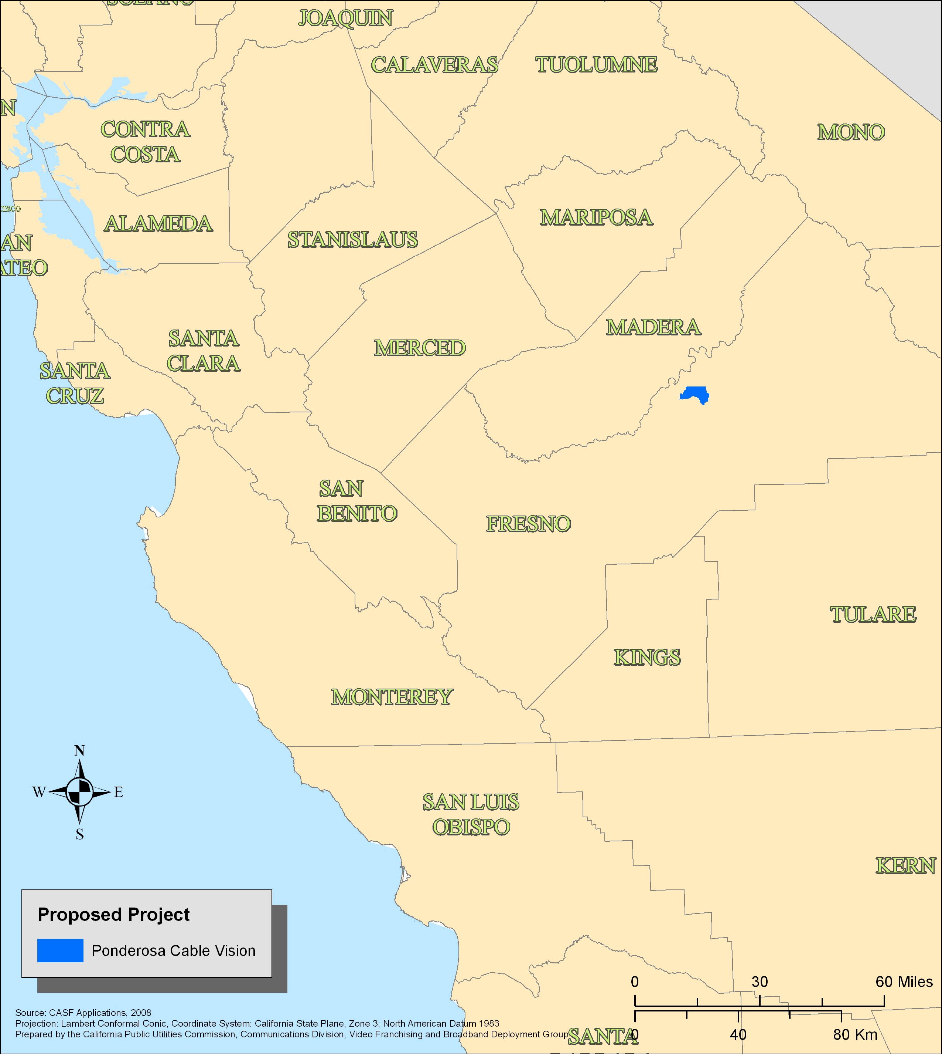

END OF APPENDIX A

SB 1193 (Chapter 393, Stats. of 2008) established the California Advanced Services Fund as a new public purpose program.
The American recovery and Reinvestment Act (ARRA) appropriates $7.2 billion for grants and loans to support broadband deployment on a national level. ARRA offers a unique and ground breaking opportunity for California to partner with the federal government and other state agencies in advancing the goal of bridging the digital divide.
The above schedule is contingent on the CASF recipient submitting clear, complete, and error-free invoices to CD. Additional time to process payments may be necessary if CD finds problems with the submitted invoices.

