Item #
Agenda # 9641
D R A F T

PUBLIC UTILITIES COMMISSION OF THE STATE OF CALIFORNIA

Communications Division | RESOLUTION T- 17288
Carrier Oversight and Programs Branch | August 12, 2010

R E S O L U T I O N

Resolution T- 17288 Approval of Funding for the Redwood Telephone LLC Northern California Open Community Fiber Network Project, from the California Advanced Services Fund, Amounting to $2,169,815.
__________________________________________________________________

Summary

This Resolution adopts contingent funding for the Redwood Telephone LLC Northern California Open Community Fiber Network (Redwood) project, amounting to $2,169,815 from the California Advanced Services Fund (CASF). This amount represents 10% of the project costs to provide broadband service to unserved and underserved areas in accordance with Commission Resolution T-17143 and Decision (D.) 09-07-020.

Background

On December 20, 2007, the Commission approved D.07-12-054 which established the two-year CASF program to provide matching funds of up to 40% of the total project costs for the deployment of broadband infrastructure in unserved and underserved areas in California. Resolution T-17143, approved on June 12, 2008, adopted application requirements, scoring criteria for the award of funds, and a prescribed timeline for other filings and notifications including a projected Commission Meeting date for final approval of award(s).
D.07-12-054 limited the extension of CASF funding to:
- Entities with a Certificate of Public Convenience and Necessity (CPCN) that qualify as “telephone corporations” as defined in § 234 of the Public Utilities Code (PU Code);
- Wireless carriers registered with the Commission that have been granted a Wireless Identification Number (WIR);
- Entities who have pending applications for a CPCN; and
- A consortium with a member holding a CPCN or a WIR who will serve as the fiscal agent of the consortium (D.07-12-054 at pgs. 33-35, mimeo).

On July 9, 2009, the Commission issued D.09-07-020 establishing new schedules and plans for the filing, review and approval of an additional round of broadband project requests. This decision also provides the potential for the applicants to seek CASF program funding while pursuing funding for broadband deployment grants issued under the Recovery Act. Also, because federal grants under Recovery Act can fund up to 80% of the project cost, D.09-07-020 allowed applicants to seek an additional 10% funding coverage from the CASF, leaving only 10% of the project cost for the applicant to provide.

On July 29, 2009, Governor Schwarzenegger signed Assembly Bill (AB) 1555 (Chapter 24, Statutes of 2009), amending Section 281 of the PU Code to expand CASF eligibility to any entity applying for CASF funding in conjunction with their Recovery Act funding request, provided that entity satisfies the eligibility requirement for CASF funding. AB 1555 also provides that the Commission establish requirements and guidelines for non-certificated applicants.

On October 29, 2009, the Commission approved Resolution T-17233 establishing application requirements and guidelines for non-CPUC certificated applicants and broadband providers applying for CASF grant money, in conjunction with an application for Recovery Act funding, to develop and deploy broadband infrastructure.

Notice/Protests

The Census Block Group (CBG) list for the Redwood project appeared by county on the Commission’s CASF website page under “UNDERSERVED areas proposed to be served as of April 1, 2010: Census Block Groups (CBGs).” The Communications Division (CD) proceeded to review and analyze these project areas to verify that they were not served as of the applicants’ filing date.

Discussion

This Resolution adopts contingent funding of $2,169,815 for the Redwood project in Humboldt County. Key project information is on pages A-1 to A-4 of Appendix A. A Shapefile of Redwood’s proposed project can be found on page A-5 of Appendix A.

On April 1, 2009, Redwood submitted its original application with a project cost estimate of $21,698,146 of which 10% or $2,169,815 is being requested from CASF as a match to a Round 2 Recovery Act fund request.

The proposed project stretches along the upper Northern California coastline from Brookings, Oregon border in the north to Benbow, California in the South. An additional segment will run east from Blue Lake to Willow Creek and north to unserved areas including Hoopa, Weitchpec, Orleans, and Somes Bar. The proposed project includes 11 Tribal Lands, 2 Counties, 8 incorporated and over 50 unincorporated cities. The project will pass 62,419 households and 10,362 businesses including local governmental agencies, health care providers, schools, and public safety organizations. These remote areas suffer from rough terrain and inclement weather. Many residents only have dialup available or are completely unserved.

The proposed project would provide up to 1 Gbps secure private transport, carrier-based Ethernet, and wholesale high-speed broadband internet access to its subscribers. There are 164 interconnection points to facilitate broadband adoption and demand aggregation including 28 Incumbent Local Exchange Carrier (ILEC) Central Offices (COs), 73 Tower/Cell Sites, 3 Connections to Service Providers, 41 Last Mile Network Access Points, and a Collocation Facility to the 23 proposed service areas: Arcata, Blue Lake, Brookings, Crescent City, Eureka, Fernbridge, Fieldbrook, Fortuna, Hoopa, Klamath, Korbel, Loleta, Mckinleyville, Orick, Orleans, Redway, Requa, Rio Dell, Samoa/Manilla, Southern Humboldt, Trinidad, Weitchpec, Westhaven, and Willow Creek. Distribution will be over a standard Gigbit Passive Optical Network (GPON) architecture that will allow speeds to any location on the network up to 2.4 Gbps by multiple fibers for additional throughput. Subscribers will receive telephone and internet over a single fiber. This network will use Fiber to the Home (FTTH) technology.

By building a regional middle mile, the Redwood Telephone plan will interconnect anchor community facilities in served, un-served, under-served, rural, and non-rural areas while delivering last mile for unserved and underserved areas. The Redwood project proposes to construct middle mile facilities connecting 538 community anchor facilities including 133 k-12 schools, 15 libraries, 11 community colleges campuses, 5 institutions of higher learning, 77 public safety agencies, 56 medical and health providers, 63 community support organizations, and 177 other government facilities.

Redwood will provide last mile service for seven unserved service areas -- Hoopa, Klamath, Korbel, Orick, Orleans, Requa, and Weitchpec -- representing a population of 3,687 people and 676 businesses across 248 square miles. Underserved broadband services will be enhanced by providing last mile to six communities -- Fieldbrook, Hoopa, Klamath, Kneeland, Loleta, Southern Humboldt, and Westhaven -- representing 10,502 people and 3,541 businesses across 193 square miles.

Redwood will also improve communications for public safety by connecting fire agencies to central communications, state agencies, and to one another. Humboldt and Del Norte County Buildings will be directly connected on a backbone infrastructure for public safety and disaster recovery. All of the regions critical Public Safety Answering Points (PSAP) will be connected on a high-speed, back-bone infrastructure with the State of California for Next Generation 911 services, emergency management, public safety dispatch, and disaster recovery. Secure wireless terminals will be located at 41 locations across Humboldt and Del Norte County. Also, secure backhaul connections to 73 cell sites are available for emergency services on the proposed fiber network.

This project will be able to deliver service to 14,189 households covering an area of about 728 square miles in 119 CBGs at maximum speeds of 25 mbps download / 10 mbps upload retail, and average speeds up to 1 Gbps wholesale.

For qualification purposes under the CASF program, an unserved area is defined as an area that is not served by any form of facilities-based broadband, or where Internet connectivity is available only through dial-up service or satellite. An underserved area is defined as an area in which broadband is available but no facilities-based provider offers service at speeds of at least 3 mbps download and 1 mbps upload. CD reviewed this project’s eligibility through analysis of the required submitted data. These data include, but are not limited to: descriptions of current and proposed broadband infrastructure; Geographic Information System (GIS) formatted Shapefiles mapping the subject areas; assertion that the area is underserved; potential subscriber size and household incomes; project construction schedule; project budget; proposed pricing and commitment period for new subscribers; and financial qualifications of the applicant. In addition, CD reviewed the Shapefiles submitted which mapped the broadband deployment proposed using United States 2000 Census data, the January 2008 California Broadband Task Force (CBTF) Report including its on-line maps, and the revised August 10, 2009 CBTF maps, among others.

CD received no challenges to the project CBGs. However, upon review, CD determined that portions of two of the proposed 119 CBGs, specifically the areas around Loleta and Westhaven overlapped with areas shown as being served with broadband at speeds greater than 3/1 mbps download/upload on the CBTF maps. Redwood clarified that the portions on the map of their proposed area that overlapped with areas shown as served on the CBTF maps were middle mile. No proposed last mile areas overlap served areas. CD determined that the CBGs covering the proposed area are qualified as unserved and underserved as defined in Resolution T-17143. Accordingly, CD recommends that the Commission approve a CASF funding award for the Redwood project.

This project is subject to the California Environmental Quality Act (CEQA). No ground breaking activities may be conducted until the Commission has completed CEQA review. If any special permits are required, Redwood has agreed to notify the Commission, as appropriate.

Redwood is required to comply with all the guidelines, requirements, and terms and conditions associated with the granting of CASF funds for non-licensed broadband providers as specified in the ordering paragraphs of Res. T-17233, including the requirements to 1) post a performance bond equal to the total amount payable under this CASF award, or 10% of the project costs, 2) submit the performance bond within five business days after the completion of the CEQA review, if required and within five business days after Commission approval, if CEQA review is not required; 3) submit the information sheets in Appendices 1 and 2 of Res. T-17233 as part of Redwood’s application; 4) agree in writing to allow the Commission to inspect the applicant’s accounts, books, papers, and documents related to the application and award of CASF funds; and 5) comply with all the guidelines, requirements and conditions associated with the granting of CASF funds as specified in Resolution T-17143, including, but not limited to, the annual submission of Form 477 to the Federal Communications Commission as discussed in Res. T-17143.

The receipt of the CASF grant is contingent on Redwood’s 1) compliance with the requirements in Resolution T-17233 and Resolution T-17143; and 2) receipt of Recovery Act funding on this project. If the applicant is not successful in its request for the Recovery Act grant or if the Recovery Act grant is less than 80%, then Redwood may request additional CASF funds in accordance with Ordering Paragraph No. 7 of D.09-07-020. The granting of additional funds will be contingent on the availability of CASF funds.

If the applicant is not successful in its request for the Recovery Act grant and, as a result will not build its project, Redwood should notify the Director of the Communications Division within thirty (30) days of receiving notification that their Recovery Act application has been rejected so that the Commission may be reallocate CASF funds to other grants.

Payments to CASF Recipients

Submission of invoices from and payments to Redwood shall be made in accordance with Section IX of Appendix A of Resolution T-17143 and according to the guidelines and supporting documentation required in Resolution T-17143.

Payment to Redwood shall essentially follow the process adopted for funds created under Public Utilities Code §270. The following table describes the timeline for processing CASF payments.

Event | Payment Cycle 1  (Day/Month) | Payment Cycle 2  (Day/Month)
Invoices due from Redwood to CD | 5th of Month 1 | 20th of Month 1
Payment letters from CD to Information and Management Services Division (IMSD) | On 19th of Month 1 | On 4th of Month 2
Invoices submitted from IMSD to State Controller’s Office (SCO) for payments | 20th through 26th of Month 1 | 5th through 13th of Month 2

Redwood may submit its invoices under Payment Cycle 1 or 2.

If any date in this payment schedule falls on a weekend or holiday, that date will be advanced to the next business day but the remaining dates in the payment schedule will remain unchanged. The State Controller’s Office (SCO) requires 14 to 21 days to issue payment from the day that requests are received by SCO. Approval and disbursement of the first 25% CASF payment is contingent upon Redwood’s (1) compliance with the requirements in Resolutions T-17233 and T-17143; and (2) receiving Recovery Act funding approval.

Comments on Draft Resolution

In compliance with PU Code § 311(g), a notice letter was emailed on July 13, 2010 informing a) all CASF applicants filing under D.09-07-020, and b) parties on the service list of R.06-06-028 of the availability of the draft of this Resolution for public comments at the Commission's website http://www.cpuc.ca.gov/static/documents/index.htm. This letter also informed parties that the final conformed Resolution adopted by the Commission will be posted and will be available at this same website.

Findings

- The California Advanced Services Fund (CASF) was adopted in Decision (D.) 07-12-054.

- The CASF was established as a two-year program that will provide matching funds of up to 40% of the total project costs for the deployment of broadband infrastructure in underserved and underserved areas in California.

- Resolution T-17143, approved on June 12, 2008, adopts the application requirements and scoring criteria for the award of funds, a prescribed timeline for other filings, and notifications including a projected Commission Meeting date for final approval of award(s). T-17143 directed interested applicants seeking funding for underserved projects to file their project proposals and funding requests beginning July 24, 2008.

- On July 29, 2009, Governor Schwarzenegger signed Assembly Bill (AB) 1555 (Chapter 24, Statutes of 2009), amending Section 281 of the PU Code to expand CASF eligibility to any entity applying for CASF funding in conjunction with their Recovery Act funding request

- On July 9, 2009, the Commission issued D.09-07-020 approving a new CASF schedule and plan for an additional round of broadband projects that would complement broadband grants awarded under the federal government’s American Recovery and Reinvestment Act (Recovery Act). While retaining the 40% matching grant process, the Commission in this Decision authorized providers an option of seeking a 10% grant from the CASF concurrent with efforts to seek an 80% grant from the Recovery Act fund.

- A list of census block groups (CBGs) appeared by county on the Commission’s CASF website page under “UNDERSERVED areas proposed to be served as of April 1, 2010: Census Block Groups (CBGs).” The Communications Division (CD) proceeded with its independent review and analysis of this project area to verify that it was not served as of the applicant’s filing date.

- An unserved area is defined as an area that is not served by any form of facilities-based broadband, or where Internet connectivity is available only through dial-up service or satellite. An underserved area is defined as an area in which broadband is available but no facilities-based provider offers service at speeds of at least 3mbps download and 1 mbps upload.

- Redwood filed its original CASF project application on April 1, 2010, under D.09-07-020. CD reviewed the Redwood project eligibility through the analysis of required data submitted. These data include, but are not limited to: descriptions of current and proposed broadband infrastructure; geographic information system (GIS) formatted Shapefiles mapping the subject areas; assertion that the area is unserved and underserved; potential subscriber size and household incomes; project construction schedule; project budget; proposed pricing and commitment period for new subscribers; and financial qualifications of the applicant.

- Shapefiles, which mapped the broadband deployment, were reviewed by CD using sources including, but not limited to, the United States 2000 Census data, the January 2008 California Broadband Task Force (CBTF) Report, and the revised August 10, 2009 CBTF map, among others. These maps helped to verify the existence or non-existence of broadband service areas and broadband speeds, where available.

- CD verified this project and, when necessary, requested additional information and/or meetings with the applicant to clarify its project proposal.

- Of the 119 CBGs in this proposed project, none were formally challenged. CD determined after its review that portions of 2 of the proposed 119 CBGs, specifically the areas around Loleta and Westhaven overlapped with areas showed as being served with broadband at speeds greater than 3/1 mbps download/upload on the CBTF maps. Redwood clarified that the portions on the map of their proposed area that overlapped areas shown as served on the BBTF were middle mile. No proposed last mile areas overlap served areas.

- CD determined the Redwood project application for underserved areas covering 119 CBGs as eligible to receive funding under CASF.

- The Commission finds CD’s recommendation for conditional CASF award for Redwood’s proposed project for unserved and underserved areas as discussed and summarized in Appendix A, to be reasonable and consistent with Commission orders and, therefore, adopts such award.

- The project is subject to the California Environmental Quality Act (CEQA). No ground breaking activities may be conducted until the Commission has completed CEQA review. If any special permits are required, Redwood has agreed to notify the Commission, as appropriate.

- Pursuant to the ordering paragraphs of Res. T-17233, Redwood is required to 1) post a performance bond equal to the total amount payable under this CASF award, or 10% of the project costs, 2) submit the performance bond within five business days after the completion of the California Environmental Quality Act (CEQA) review, if required and within five business days after Commission approval, if CEQA review is not required.

- The proposed project does not appear to require CEQA review. However, if such review is required, Redwood may not conduct any ground breaking until the Commission has completed this review. If any special permits are required, Redwood has agreed to notify the Commission as appropriate.

- Redwood should comply with all guidelines, requirements, and conditions associated with the granting of CASF funds as specified in Resolution T-17233 and Resolution T-17143, including the submission of FCC Form 477 and compliance with CEQA, among others.

- The receipt of the CASF grant should be contingent on Redwood receiving the 80% Recovery Act grant on its underserved project. If the applicant is not successful in its request for the Recovery Act grant or if of the Recovery Act grant is less than 80%, then Redwood may request additional CASF funds in accordance with Ordering Paragraph No. 7 of D.09-07-020. The granting of additional funds will be contingent on the availability of CASF funds.

- If Redwood is unable to obtain Recovery Act funding and will not construct the project, then Redwood must notify the Director of the Communications Division within thirty (30) days of receiving notification that their Recovery Act application has been rejected so that the Commission may reallocate CASF funds to other grants.

- A notice letter was emailed on July 13, 2010, informing a) all applicants filing for underserved areas and, b) parties on the service list of R.06-06-028 of the availability of the draft of this Resolution for public comments at the Commission's website http://www.cpuc.ca.gov/static/documents/index.htm. This letter also informed parties that the final conformed Resolution adopted by the Commission will be posted and available at this same website.

THEREFORE, IT IS ORDERED that:

- The California Advanced Services Fund shall award contingent funding of $2,169,815 from the California Advanced Services Fund to Redwood Telephone LLC for its Northern California Open Community Fiber Network to provide service in unserved and underserved areas as described in the Discussion section and summarized in Appendix A of this Resolution.

- Redwood shall 1) post a performance bond equal to the total amount payable under this CASF award, or 10% of the project costs, 2) submit the performance bond within five business days after the completion of the California Environmental Quality Act (CEQA) review, if required and within five business days after Commission approval, if CEQA review is not required.

- Redwood shall comply with all guidelines, requirements, and conditions associated with the CASF funds award as specified in Resolution T-17143, Resolution T-17233, and D.09-07-020.

- The receipt of the CASF grant shall be contingent on Redwood receiving the 80% Recovery Act grant on its underserved project. If the applicant is not successful in its request for the Recovery Act grant or if of the Recovery Act grant is less than requested, then Redwood may request additional CASF funds in accordance with Ordering Paragraph No. 7 of D.09-07-020. The granting of additional funds will be contingent on the availability of CASF funds.

- Redwood shall notify the Director of the Communications Division within thirty (30) days of receiving notice that their Recovery Act application has been rejected and as a result, will not construct the underserved project, so that the Commission may reallocate CASF funds to other applicants.

- The program fund payment of $2,169,815 for this Commission-approved project shall be paid out of the CASF fund in accordance with the guidelines adopted in Resolution T-17143 and D.09-07-020.

- Payments to Redwood shall be in accordance with Section IX of Appendix A of Resolution T-17143 and in accordance with the process defined in the “Payments to CASF Recipients” section of this Resolution.

This Resolution is effective today.

I hereby certify that this Resolution was adopted by the Public Utilities Commission at its regular meeting on August 12, 2010. The following Commissioners approved it:

PAUL CLANON

Executive Director

APPENDIX A
Resolution T- 17288
Redwood Project, Key Information

Redwood Telephone LLC
1 | Project Name | Northern California Open Community Fiber Network Project
2 | Project Plan | High capacity microwave systems will be used to provide bandwidth to service providers from Qwest’s backbone fiber optic network.
3 | Project Size (in square miles) | 728
4 | Download speed | 25 mbps
5 | Upload speed | 10 mbps
6 | Location | Humboldt, Del Norte
a) | Community Names | Arcata, Blue Lake, Crescent City, Eureka, Ferndale, Fieldbrook, Fortuna, Hoopa, Klamath, Kneeland, Korbel, Loleta, Mckinleyville, Orick, Orleans, Redway, Requa, Rio Dell, Samoa, Southern Humboldt, Trinidad, Witchpec, Westhaven, Willow Creek
b) | CBGs / Household Income
# |  | CBG | Income
1 |  | 060150001011 | $21,044
2 |  | 060150001012 | $18,833
3 |  | 060150001021 | $32,232
4 |  | 060150001022 | $27,664
5 |  | 060150001031 | $46,776
6 |  | 060150001032 | $28,274
7 |  | 060150001033 | $38,214
8 |  | 060150001034 | $31,148
9 |  | 060150001035 | $20,125
10 |  | 060150002011 | $39,830
11 |  | 060150002012 | $42,386
12 |  | 060150002013 | $39,886
13 |  | 060150002021 | $31,033
14 |  | 060150002022 | $30,875
15 |  | 060150002024 | $36,250
16 |  | 060150002031 | $31,953
17 |  | 060150101022
18 |  | 060230001001 | $16,667
19 |  | 060230001002 | $21,429
20 |  | 060230001003 | $24,167
21 |  | 060230001004 | $19,435
22 |  | 060230002001 | $31,316
23 |  | 060230002002 | $29,188
24 |  | 060230002003 | $29,414
25 |  | 060230002004 | $20,323
26 |  | 060230002005 | $17,155
27 |  | 060230002006 | $21,150
28 |  | 060230002031 | $26,696
29 |  | 060230003001 | $22,344
30 |  | 060230003002 | $30,263
31 |  | 060230003003 | $25,625
32 |  | 060230003004 | $36,583
33 |  | 060230003005 | $32,500
34 |  | 060230004001 | $48,900
35 |  | 060230004002 | $32,000
36 |  | 060230004003 | $23,678
37 |  | 060230005001 | $17,882
38 |  | 060230005002 | $25,333
39 |  | 060230005003 | $22,298
40 |  | 060230005004 | $22,432
41 |  | 060230006001 | $32,370
42 |  | 060230006002 | $34,293
43 |  | 060230006003 | $40,272
44 |  | 060230006004 | $26,037
45 |  | 060230006005 | $37,419
46 |  | 060230007001 | $36,949
47 |  | 060230007002 | $34,063
48 |  | 060230007003 | $40,438
49 |  | 060230007004 | $40,833
50 |  | 060230008001 | $31,061
51 |  | 060230008002 | $39,799
52 |  | 060230008003 | $35,402
53 |  | 060230009001 | $48,036
54 |  | 060230009002 | $49,028
55 |  | 060230009003 | $46,742
56 |  | 060230010005 | $14,620
57 |  | 060230011001 | $29,405
58 |  | 060230011002 | $16,995
59 |  | 060230011003 | $26,974
60 |  | 060230011004 | $32,780
61 |  | 060230011005 | $26,852
62 |  | 060230012001 | $25,313
63 |  | 060230012002 | $48,077
64 |  | 060230012003 | $18,648
65 |  | 060230101011 | $22,132
66 |  | 060230101012 | $26,429
67 |  | 060230101021 | $22,984
68 |  | 060230101022 | $10,000
69 |  | 060230101023 | $26,023
70 |  | 060230101024 | $42,813
71 |  | 060230102001 | $27,760
72 |  | 060230102002 | $34,844
73 |  | 060230102003 | $36,500
74 |  | 060230103001 | $50,417
75 |  | 060230103002 | $37,321
76 |  | 060230103003 | $32,443
77 |  | 060230103004 | $29,583
78 |  | 060230103005 | $44,375
79 |  | 060230104001 | $39,472
80 |  | 060230104002 | $43,929
81 |  | 060230105011 | $40,855
82 |  | 060230105012 | $27,734
83 |  | 060230105013 | $36,406
84 |  | 060230105014 | $33,500
85 |  | 060230105021 | $43,107
86 |  | 060230105022 | $31,186
87 |  | 060230105023 | $47,955
88 |  | 060230106001 | $42,946
89 |  | 060230106002 | $47,850
90 |  | 060230107001 | $36,719
91 |  | 060230107002 | $44,141
92 |  | 060230107003 | $37,125
93 |  | 060230107004 | $23,438
94 |  | 060230107005 | $26,836
95 |  | 060230108001 | $28,833
96 |  | 060230108002 | $34,537
97 |  | 060230108003 | $35,625
98 |  | 060230108004 | $26,731
99 |  | 060230109001 | $22,500
100 |  | 060230109002 | $22,043
101 |  | 060230109003 | $40,227
102 |  | 060230109004 | $40,714
103 |  | 060230110001 | $45,806
104 |  | 060230110002 | $27,279
105 |  | 060230110003 | $34,659
106 |  | 060230111001 | $26,571
107 |  | 060230111002 | $29,336
108 |  | 060230111003 | $31,765
109 |  | 060230111004 | $36,736
110 |  | 060230112001 | $33,571
111 |  | 060230112002 | $43,365
112 |  | 060230112003 | $35,231
113 |  | 060230113001 | $35,102
114 |  | 060230113002 | $25,720
115 |  | 060230113003 | $30,167
116 |  | 060230113004 | $22,027
117 |  | 060230113005 | $27,188
118 |  | 060230113006 | $27,500
119 |  | 060230113007 | $41,528
c) | ZIP Codes
 |  | 95501
 |  | 95503
 |  | 95519
 |  | 95521
 |  | 95524
 |  | 95525
 |  | 95528
 |  | 95531
 |  | 95536
 |  | 95540
 |  | 95542
 |  | 95546
 |  | 95547
 |  | 95548
 |  | 95549
 |  | 95550
 |  | 95551
 |  | 95554
 |  | 95555
 |  | 95556
 |  | 95558
 |  | 95560
 |  | 95562
 |  | 95563
 |  | 95564
 |  | 95565
 |  | 95567
 |  | 95569
 |  | 95570
 |  | 95573
7 | Estimated Potential Subscriber Size
a) | Households | 14,189
8 | Deployment Schedule (from Commission approval date) | 24 Months
9 | Proposed Project Budget | $21,698,146
a) | CASF (10%) | $2,169,815
b) | CIAC | $0
c) | Amount of CASF Funds Requested | $2,169,815

APPENDIX A
Resolution T- 17288
Redwood Project Shapefiles
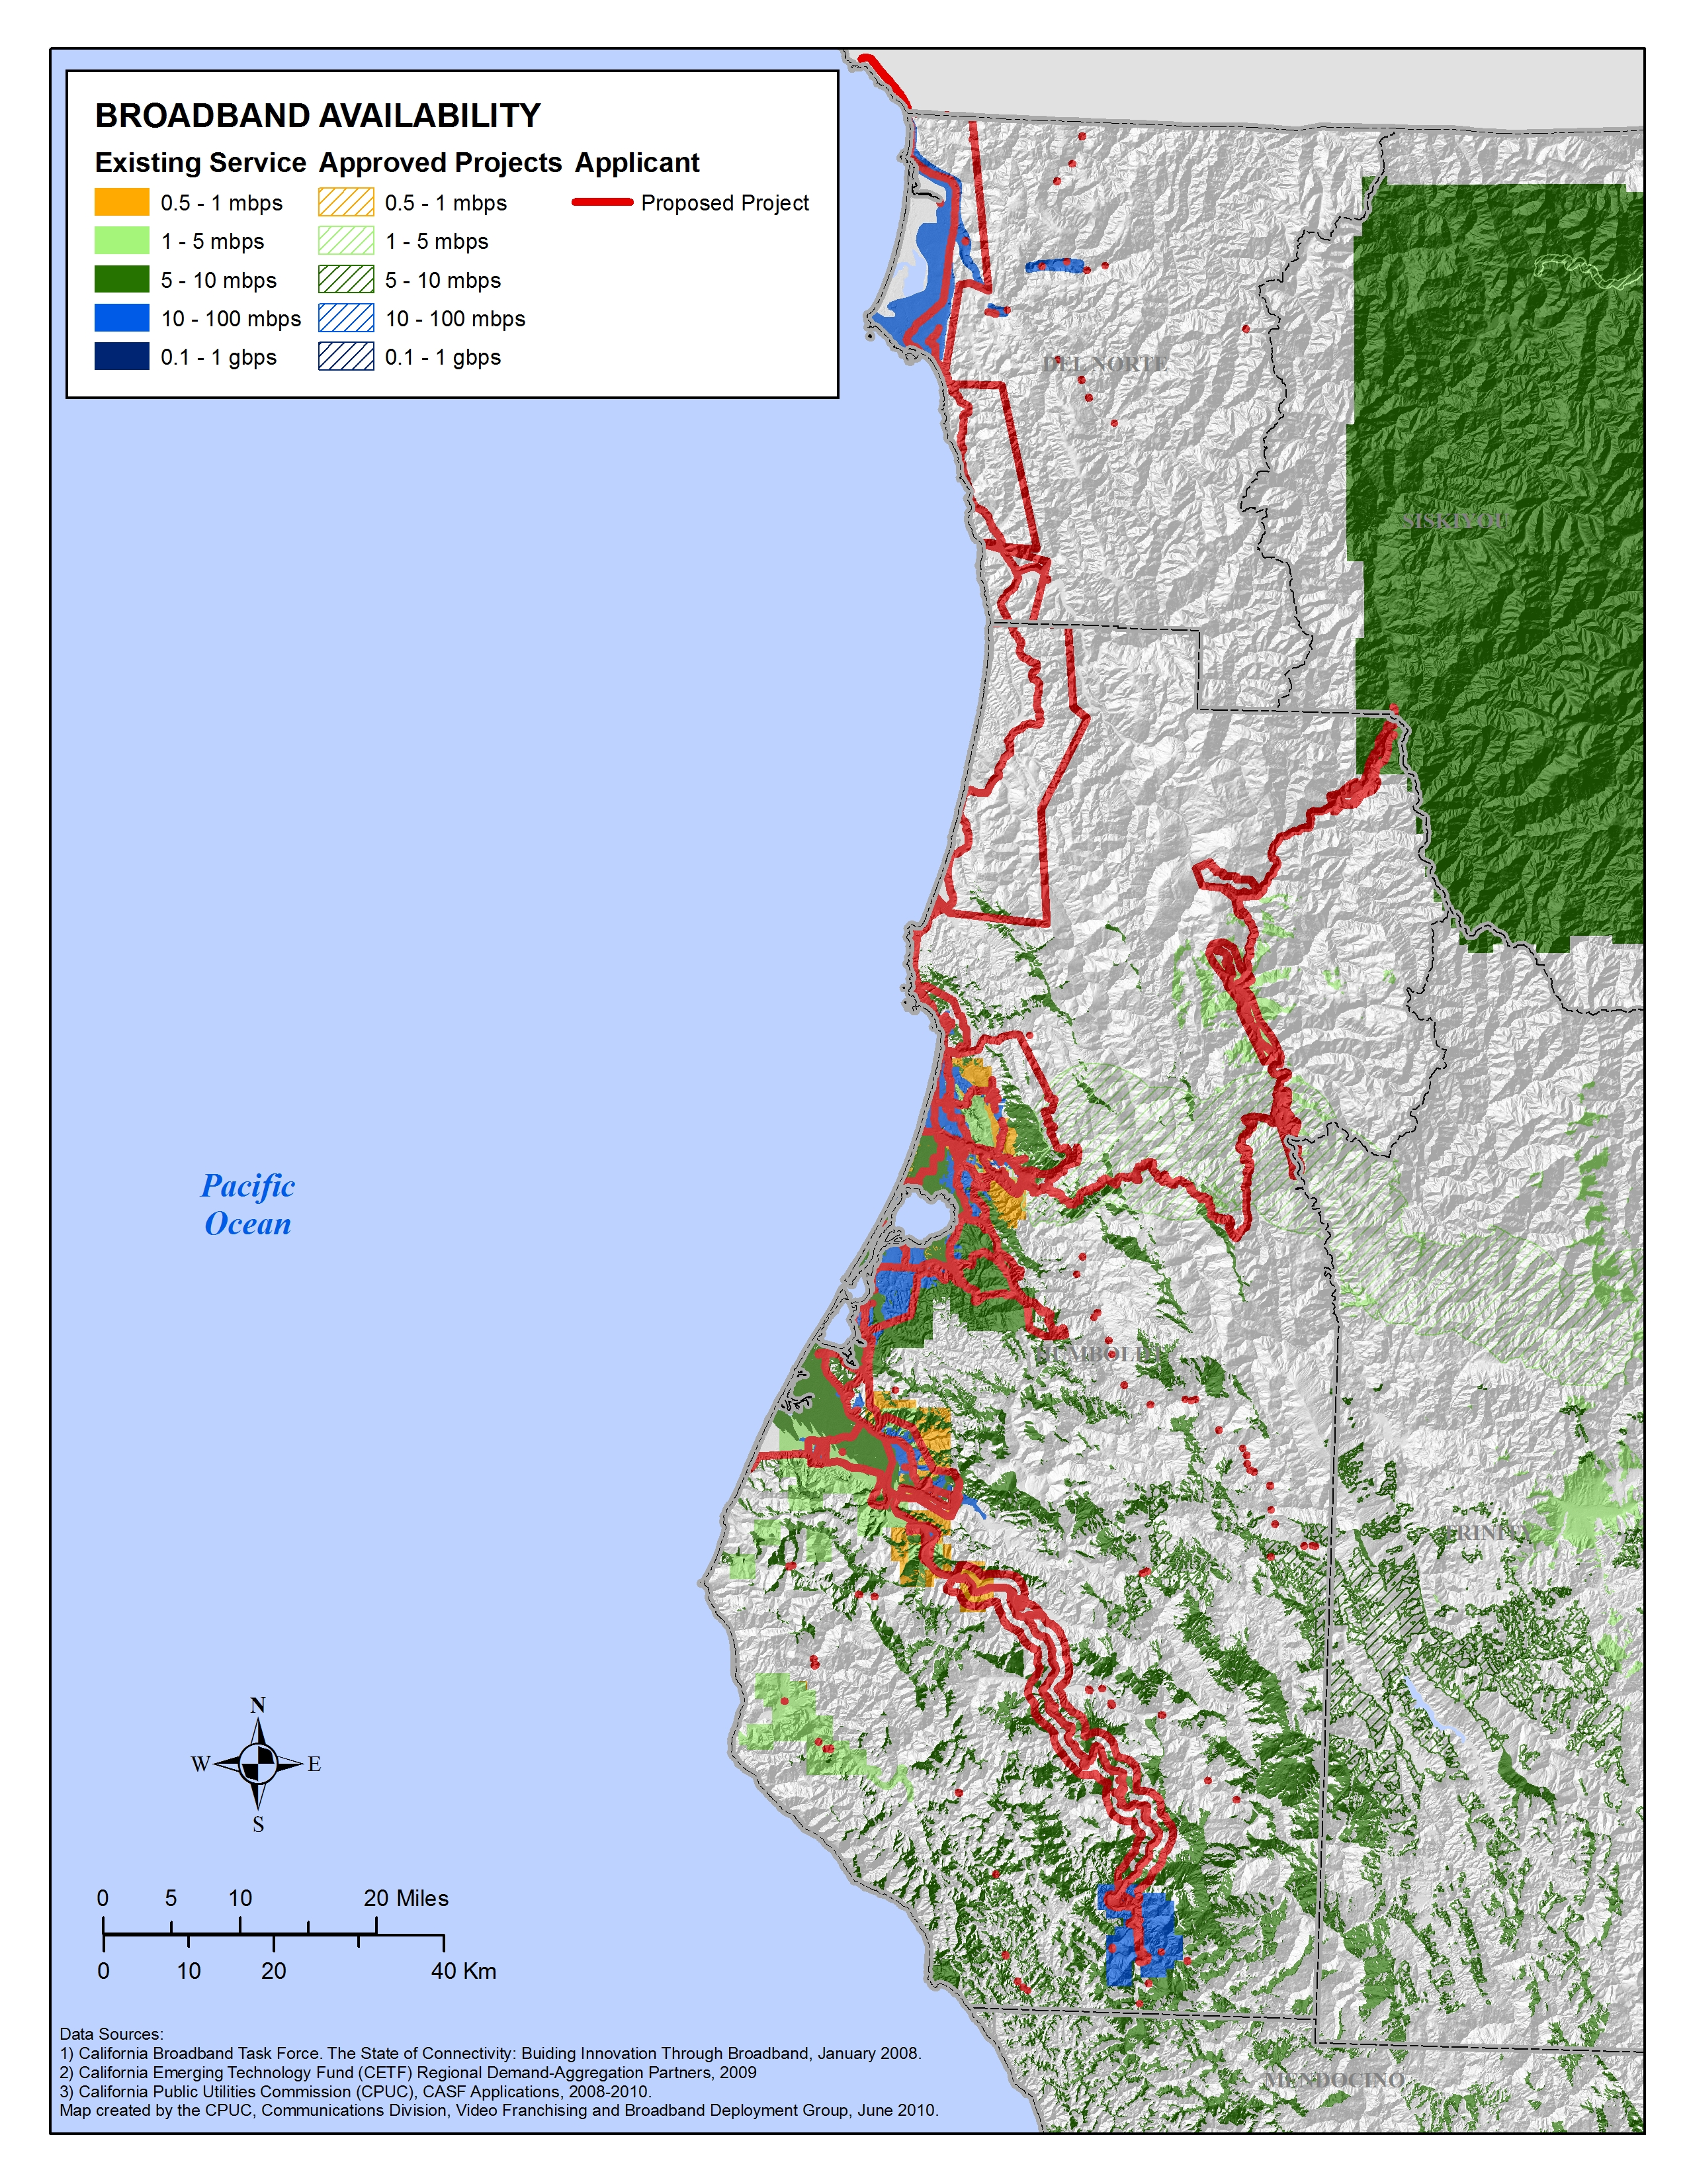
APPENDIX A
Resolution T- 17288
Redwood Statewide Map

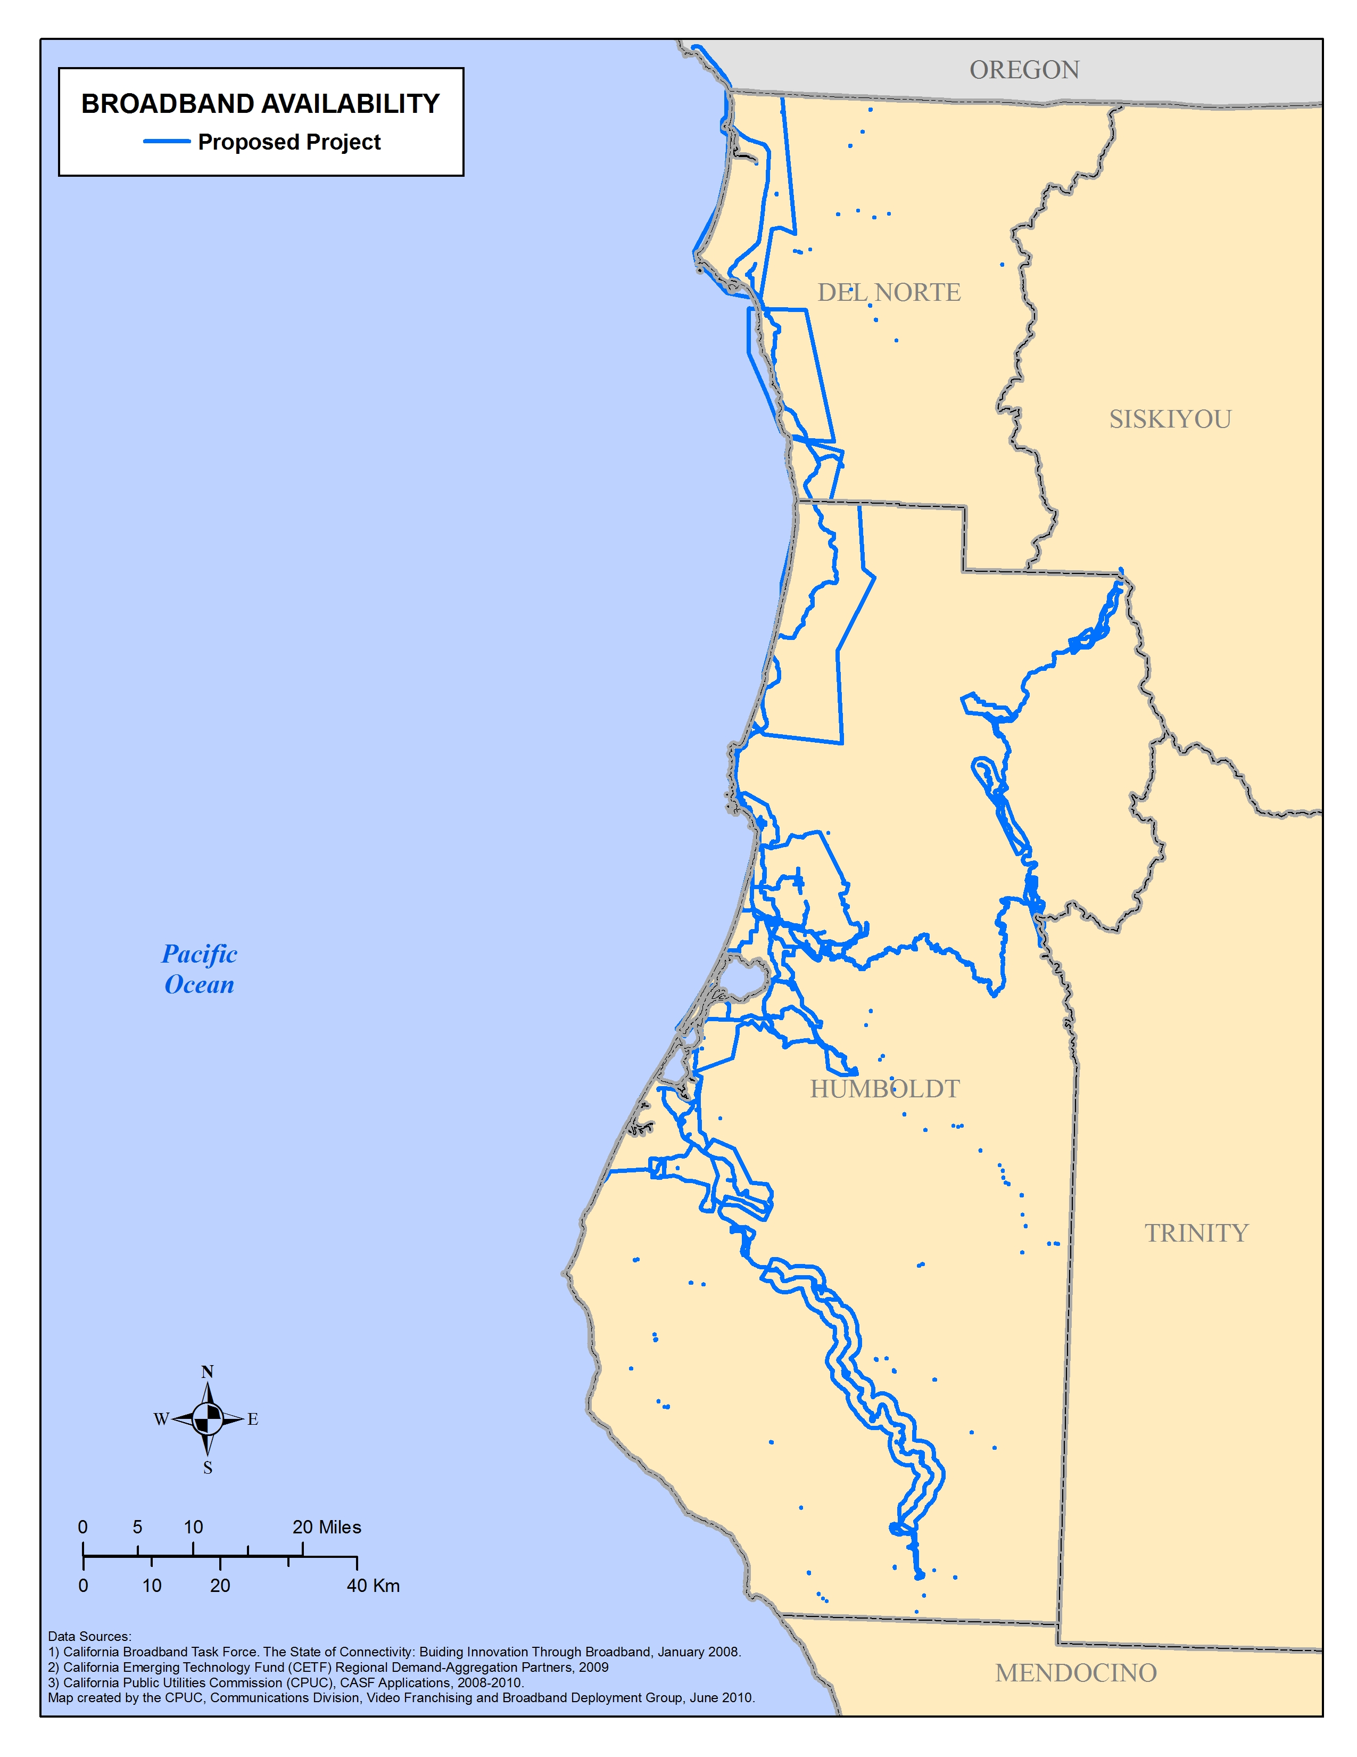

END OF APPENDIX A

SB 1193 (Chapter 393, Stats. of 2008) established the California Advanced Services Fund as a new public purpose program.
The American Recovery and Reinvestment Act (Recovery Act) appropriates $7.2 billion for grants and loans to support national broadband deployment. The Recovery Act offers a unique and ground breaking opportunity for California to partner with the federal government and other state agencies in advancing the goal of bridging the digital divide.
The above schedule is contingent on the CASF recipient submitting clear, complete, and error-free invoices to CD. Additional time to process payments may be necessary if CD finds problems with the submitted invoices.

