PUBLIC UTILITIES COMMISSION OF THE STATE OF CALIFORNIA

ID # 10290
ENERGY DIVISION RESOLUTION E-4403
May 5, 2011

RESOLUTION

Resolution E-4403. Pacific Gas and Electric Company requests approval of the Dam Agreements and Legacy Costs Agreement with the South Feather Water & Power Agency.

PROPOSED OUTCOME: This Resolution approves the Dam Agreements and the Legacy Costs Agreement between Pacific Gas and Electric Company and the South Feather Water & Power Agency. The agreements are approved without modification.

ESTIMATED COST: Terms of the agreements are confidential at this time.

By Advice Letter 3752-E filed on November 5, 2010.
__________________________________________________________

Summary
Pacific Gas and Electric Company’s Lost Creek Dam Agreement, Sly Creek Agreement, and Legacy Costs Agreement, executed with the South Feather Water & Power Agency is approved without modification.
Pacific Gas and Electric Company (PG&E) filed Advice Letter (AL) 3752-E requesting Commission approval of the Lost Creek Dam Agreement, the Sly Creek Dam Agreement, and the Legacy Costs Agreement executed with the South Feather Water & Power Agency (SFWPA).

The Lost Creek Dam Agreement and the Sly Creek Dam Agreement, collectively known as the Dam Agreements, were executed in order to resolve a dispute over cost responsibility between PG&E and SFWPA for certain necessary late-term spillway improvements at the Lost Creek Dam and the Sly Creek Dam in connection with two power purchase agreements that terminated on June 30, 2010.
In addition, PG&E seeks approval of a letter agreement between PG&E and SWFP for legacy costs (Legacy Costs Agreement) arising out of the same power purchase agreements over which PG&E does not dispute its cost responsibility.

This resolution approves the two Dam Agreements and the Legacy Costs Agreement without modification.

PG&E also seeks permission to fully recover net payments made under the three agreements through the Energy Resource Revenue Account (ERRA). This resolution approves recording of the expenditure in ERRA for recovery to the extent that the Commission finds the recovery reasonable in PG&E’s ERRA filing.

Background
By Advice Letter 3752-E filed on November 5, 2010, PG&E requests Commission approval of the Lost Creek Dam Agreement, the Sly Creek Dam Agreement, and the Legacy Costs Agreement between PG&E and SFWPA. The first two agreements, collectively referred to as the Dam Agreements, were executed to resolve disputes over cost responsibility between PG&E and SFWPA on necessary late-term spillway improvements at the Lost Creek Dam and the Sly Creek Dam in connection with two expired power purchase contracts. The Legacy Costs Agreement will affirm PG&E’s sole responsibility on certain repair costs and other late term improvements under the same power purchase contracts. PG&E also seeks permission to fully recover its net payments under the three agreements through the Energy Resource Revenue Account (ERRA).

SFWPA is one of six irrigation districts and water agencies (IDWA) from which PG&E receives/received hydroelectric power under 50-year term power purchase contracts. The two power purchase contracts with SFWPA include the South Fork Project Power Purchase Contract, executed on June 15, 1960, and the Sly Creek Project Power Purchase Contract, executed on March 26, 1981. Both of these contracts expired on June 30, 2010.
Under terms of the SFWPA power purchase contracts, SFWPA was obligated to perform operation and maintenance (O&M) and to make all necessary capital improvements for the reliable and economic performance of service as specified in the contracts, but only to the extent that PG&E made payments to SFWPA sufficient to cover these expenditures. The contracts also contained a provision obligating PG&E to pay additional sums to SFWPA to make up for any deficiencies in payments sufficient to cover such necessary expenditures. The contracts furthermore stipulated that any obligations on either party accrued prior to termination of the contracts would not be affected by the contracts’ termination.

Even as both power purchase contracts expired on June 30, 2010, PG&E and SFWPA continued to disagree on PG&E’s level of remaining liability under the terms of the original contracts, in particular, for spillway improvements at the Lost Creek Dam and the Sly Creek Dam, which were determined by the Federal Energy Regulatory Commission (FERC) and the California Division of Safety of Dams (DSOD) to be necessary for the continued safe operation of the dams. Specifically, the proposed projects consist of modifications to the Lost Creek and Sly Creek dams and spillways to address safety issues associated with the probable maximum flood flow event that would be conveyed through the Lost Creek and Sly Creek reservoirs and the spillways.

Although the determination by the FERC and DSOD was made prior to the contracts’ expiration and construction of the projects has yet to commence, PG&E contended that it was not responsible for the full costs, as benefits of the spillway improvements would extend significantly beyond the terms of the contracts. To resolve this dispute, PG&E and SFWPA entered into a cost-sharing arrangement stipulated in the Dam Agreements. The Dam Agreements would allow PG&E and SFWPA to avoid arbitration, as allowed for under the terms of the original contracts, and also avoid attendant uncertainty over the outcome of any arbitration or protracted legal disputes.

Additionally, PG&E and SFWPA entered into the Legacy Costs Agreement to affirm PG&E’s sole responsibility for costs under the aforementioned expired power purchase contracts for the following late-term projects:

1. Microwave Replacement Project
2. Forbestown Turbine Shutoff Valve (TSV) Replacement Project
3. SCADA installation
4. Sediment Pass-through Study

As with the Dam Agreements, the costs delineated in the Legacy Costs Agreement were deemed necessary and, therefore incurred, prior to the expiration date of the two power purchase contracts.

PG&E requests that it be allowed to recover its share of expenditures under the Dam Agreements and the Legacy Costs Agreement through ERRA.

The Dam Agreements and the Legacy Costs Agreement were submitted to the Energy Division for review. The terms of these agreements are confidential at this time.

Notice
Notice of Advice Letter 3752-E was made by publication in the Commission’s Daily Calendar. PG&E states that copies of the Advice Letter were mailed and distributed in accordance with Section IV of General Order 96-B.

Protests
Advice Letter 3752-E was not protested.

Discussion
Valid arguments can be made by either PG&E or SFWPA to support their respective interpretation of PG&E’s cost responsibility on the two spillway improvement projects. This condition arose largely due to vague language in the original South Fork Project Power Purchase Contract and the Sly Creek Project Power Purchase Contract, which allowed such disputes to arise. On balance, the Dam Agreements can be viewed as beneficial to PG&E ratepayers as they reduce ratepayers’ exposure by injecting certainty into what could be a highly uncertain outcome of arbitration in which PG&E ratepayers might have to absorb all the costs for the spillway improvement projects, plus arbitration and expensive legal fees. The Commission should therefore approve the Dam Agreements.

The Legacy Costs Agreement only serves to affirm PG&E’s cost responsibility and does not increase PG&E’s cost responsibility on the projects.

The expenditures sought by PG&E in the Dam Agreements and the Legacy Costs appear to be reasonable. PG&E should be allowed to record expenditures in relation to the DAM Agreements and the Legacy Costs Agreement for recovery through ERRA but only to the extent that the Commission continues to find the expenditures reasonable in the ERRA filing.

CONFIDENTIAL INFORMATION
Certain portions of the advice letter were filed with the Commission under the confidentiality protections of Sections 583 of the Public Utilities code and G.O. 66-C. A separate declaration seeking confidential treatment of appendices B, C, and D was also filed pursuant to D.06-06-066. The terms of the Dam Agreements and the Legacy Costs Agreement as contained in the confidential appendices B, C, and D of the advice letter should remain confidential at this time.

CommentS
Public Utilities Code section 311(g)(1) provides that this resolution must be served on all parties and subject to at least 30 days public review and comment prior to a vote of the Commission. Section 311(g)(2) provides that this 30-day period may be reduced or waived upon the stipulation of all parties in the proceeding.

The 30-day comment period for the draft of this resolution was neither waived nor reduced. Accordingly, this draft resolution was mailed to parties for comments, and will be placed on the Commission's agenda no earlier than 30 days from today.

Findings AND CONCLUSIONS
- The South Fork Project Power Purchase Contract and the Sly Creek Project Power Purchase Contract govern the operation and maintenance cost responsibility between Pacific Gas and Electric Company and the South Feather Water & Power Agency with respect to the Lost Creek Dam and the Sly Creek Dam.
- The cost responsibility created by the South Fork Project Power Purchase Contract and the Sly Creek Project Power Purchase Contract remains despite the expiration of both power purchase agreements on June 30, 2010.
- The two power purchase agreements contain terms that are imprecise as to the assignment of cost responsibility to either Pacific Gas and Electric or South Feather Water & Power Agency on certain operation and maintenance costs.
- Pacific Gas and Electric and the South Feather Water & Power Agency entered into the Lost Creek Agreement and the Sly Creek Agreement in order to settle the dispute by sharing their cost responsibility.
- Pacific Gas and Electric and the South Feather Water & Power Agency also entered into the Legacy Costs Agreement to affirm Pacific Gas and Electric’s cost responsibility over which there is no dispute.
- The Dam Agreements are in the interest of ratepayers as they dispense with arbitration and reduce ratepayer exposure to cost uncertainty.
- The Legacy Costs Agreement is an affirmation of cost responsibility by Pacific Gas and Electric on certain undisputed legacy operation and maintenance costs and does not create any additional cost responsibility on the ratepayers.
- Pacific Gas and Electric should be allowed to record its share of expenditures in relation to the Dam Agreements and the Legacy Costs Agreement for recovery through the Energy Resource Revenue Account (ERRA), but only to the extent that the Commission finds the expenditures reasonable in the ERRA filing.
- The terms of the Dam Agreements and the Legacy Costs Agreement, as contained in confidential appendixes B, C, and D of the advice letter, should remain confidential at this time.
- Advice Letter 3752-E should be approved effective today without modifications.

Therefore it is ordered that:
- Pacific Gas and Electric Company’s Advice Letter 3752-E, requesting Commission review and approval of the Lost Creek Dam Agreement, the Sly Creek Dam Agreement, and the Legacy Costs Agreement, is approved without modification.
- Pacific Gas and Electric is allowed to record its share of expenditures in relation to the Dam Agreements and the Legacy Costs Agreement for recovery through the Energy Resource Revenue Account (ERRA), but only to the extent that the Commission finds the expenditures reasonable in the ERRA filing.
- Appendices B, C, and D of the advice letter shall remain confidential at this time.

This Resolution is effective today.

I certify that the foregoing resolution was duly introduced, passed and adopted at a conference of the Public Utilities Commission of the State of California held on May 5, 2011; the following Commissioners voting favorably thereon:

_______________
Paul Clanon
Executive Director

STATE OF CALIFORNIA EDMUND G. BROWN JR., Governor
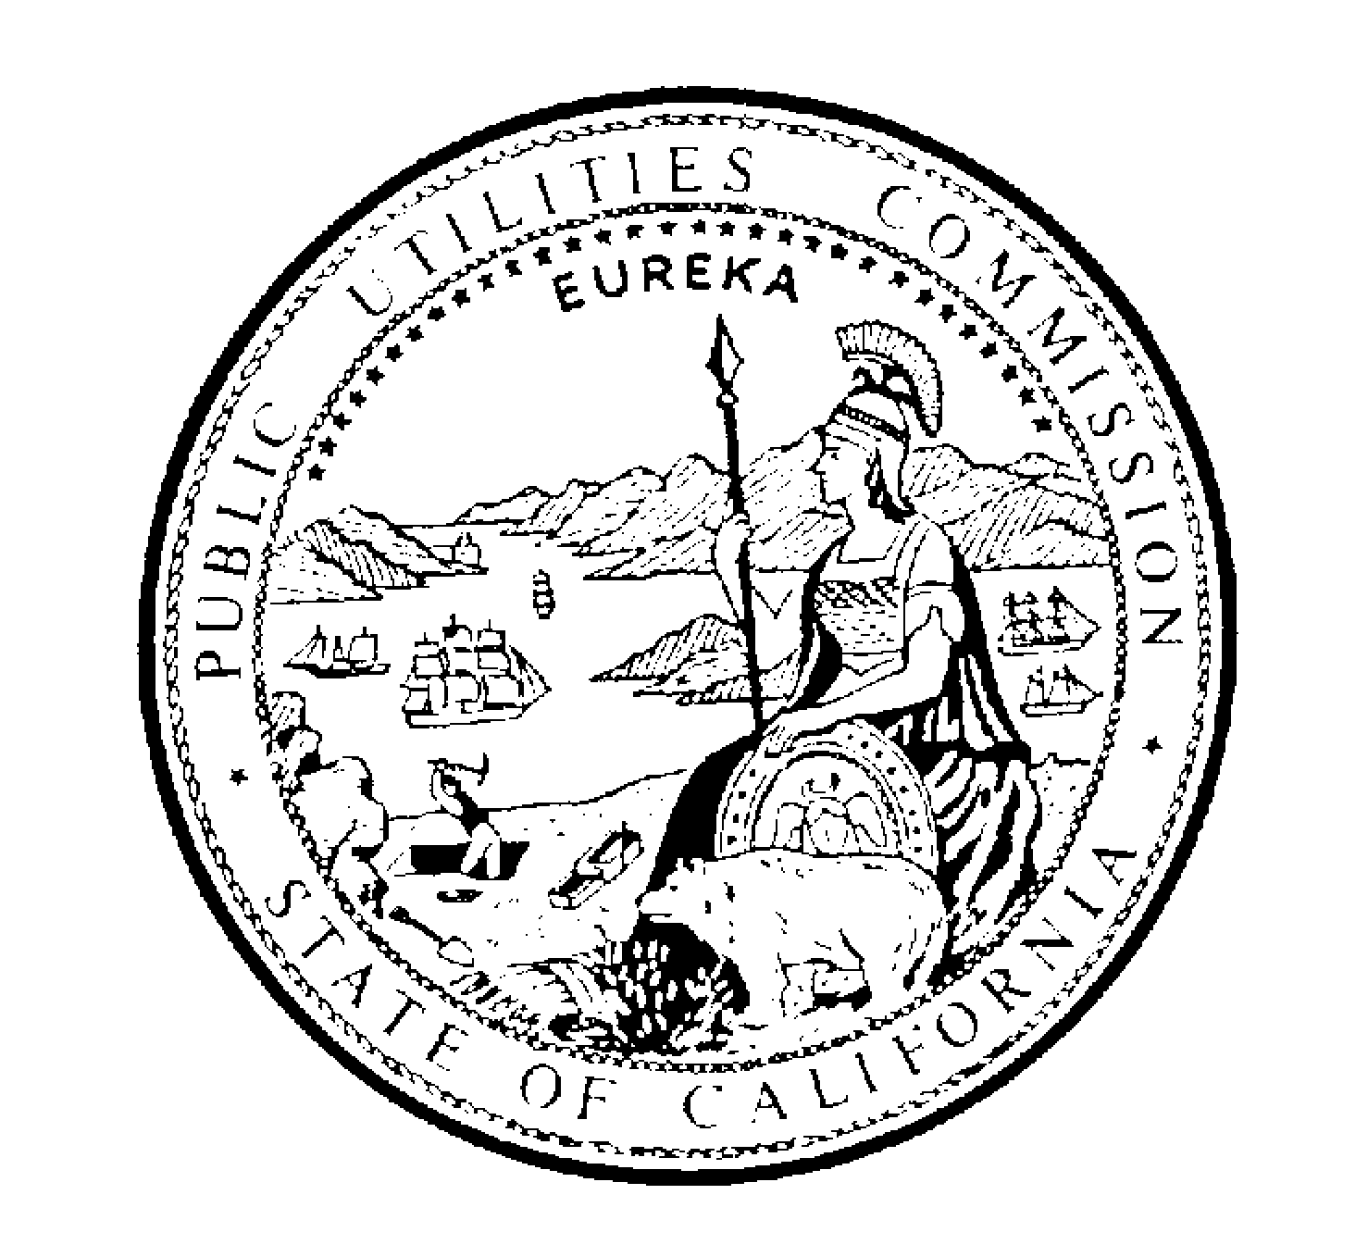PUBLIC UTILITIES COMMISSION
505 VAN NESS AVENUE
SAN FRANCISCO, CA 94102-3298

April 4, 2011 RESOLUTION E-4403

May 5, Commission Meeting

ID # 10290

TO: Parties to Pacific Gas and Electric Company (PG&E) Advice Letter (AL) 3752-E

Enclosed is draft Resolution E-4403 of the Energy Division. It will be on the agenda at the next Commission meeting which is at least 30 days after the mailing date of this letter. The Commission may then vote on this Resolution or it may postpone a vote until later.

The draft resolution approves the Dam Agreements and the Legacy Costs Agreement. The draft resolution also approves PG&E’s request to record expenditures in connection with these agreements in the Energy Resource Revenue Account (ERRA) for future recovery, subject to the condition that the Commission finds the expenditures reasonable in the ERRA filing.

When the Commission votes on a draft Resolution, it may adopt all or part of it as written, amend, modify or set it aside and prepare a different Resolution. Only when the Commission acts does the Resolution become binding on the parties.

Parties may submit comments on the draft Resolution. An original and two copies of the comments, with a certificate of service, should be submitted to:

Honesto Gatchalian
Energy Division
California Public Utilities Commission
505 Van Ness Avenue
San Francisco, CA 94102
Fax: 415-703-2200

A copy of the comments should also be submitted in electronic format to:

Steven Haine and Robert Strauss

Energy Division
California Public Utilities Commission
505 Van Ness Avenue
San Francisco, CA 94102
e-mail: SHI@cpuc.ca.gov and RLS@cpuc.ca.gov

Any comments on the draft Resolution must be received by the Energy Division by April 28, 2011. Those submitting comments must also serve a copy of their comments on the : 1) the entire service list attached to the draft Resolution, 2) all Commissioners, 3) the General Counsel, and 4) the Director of the Energy Division, on the same date that the comments are submitted to the Energy Division.

Comments shall be limited to fifteen pages in length plus a listing of the recommended changes to the draft Resolution and an appendix setting forth the proposed findings and ordering paragraphs.

Comments shall focus on factual, legal or technical errors in the draft Resolution. Comments that merely reargue positions taken in the advice letter or protests will be accorded no weight and are not to be submitted.

Replies to comments on the draft Resolution will not be accepted.

/s/ Robert Strauss
Robert Strauss, Program and Project Supervisor Energy Division

Enclosure: Certificate of Service and Service List

CERTIFICATE OF SERVICE

I certify that I have served a true copy of Draft Resolution E-4403 on the attached service list via electronic mail.

Dated April 4, 2011 at San Francisco, California.

/s/ Honesto Gatchalian

Honesto Gatchalian

NOTICE

Parties should notify the Energy Division, Public Utilities
Commission, 505 Van Ness Avenue, Room 4002
San Francisco, CA 94102, of any change of address to
insure that they continue to receive documents. You
must indicate the Resolution number on the service list
on which your name appears.

RESOLUTION E-4403
SERVICE LIST

Pacific Gas and Electric Company
Attn: Jane K. Yura, Vice President, Regulation and Rates
77 Beale Street, Mail Code B10B
P.O. Box 770000
San Francisco, CA 94177
PGETariffs@pge.com

Chloe Lukins
Supervisor, Electricity Planning & Policy Branch
Division of Ratepayer Advocates
505 Van Ness Avenue
San Francisco, CA 94102
CLU@cpuc.ca.gov

Claire Eustace
Division of Ratepayer Advocates
505 Van Ness Avenue
San Francisco, CA 94102

The other five entities are Merced Irrigation District, Nevada Irrigation District, Placer County Water Agency (PCWA), Solano Irrigation District, and Yuba County Water Agency.

