PUBLIC UTILITIES COMMISSION OF THE STATE OF CALIFORNIA

Communications Division | RESOLUTION T- 17341
Carrier Oversight and Programs Branch | September 22, 2011

R E S O L U T I O N

Resolution T- 17341 Approval of Funding for the Grant Application of Frontier Communications West Coast, Inc. (U-1020-C), from the California Advanced Services Fund (CASF) Amounting to $68,168 for the Del Norte Underserved Broadband Project
____________________________________________________________

Summary

This Resolution adopts funding amounting to $68,168 from the California Advanced Services Fund (CASF) for the CASF grant application of Frontier Communications West Coast, Inc. (Frontier West Coast) for its Del Norte Underserved Broadband Project. The amount granted represents 40% of the total project cost.

Background

On December 20, 2007, the Commission approved Decision (D.) 07-12-054 which established the two-year CASF program to provide matching funds of up to 40% of the total project costs for the deployment of broadband infrastructure in unserved and underserved areas in California. Resolution T-17143, approved on June 12, 2008, adopted the application requirements, scoring criteria for the award of funds, and a prescribed timeline for other filings and notifications including a projected Commission Meeting date for final approval of award(s).

Notice/Protests

Communications Division (CD) staff posted the proposed area project map, census block groups (CBGs) and zip codes lists by county for the Frontier Del Norte project on the Commission’s CASF website page under “Pending New CASF Applications to Offer Broadband as of July 8, 2011.” CD received no challenges to the proposed project areas.

Discussion

This Resolution adopts CD’s recommended CASF funding award of $68,168 for the Del Norte project. This award represents 40% of the total project cost of $170,421. Key information on the project is on page A-1 of Appendix A. Shapefiles and map of the proposed project can be found on pages A-2 and A-3 of Appendix A, respectively.

Project Overview

On January 24, 2011, Frontier West Coast, an incumbent local exchange carrier (ILEC), submitted an application for CASF funding in underserved areas in Del Norte County. Frontier West Coast has been a provider of local exchange service in California for the past 75 years. Aside from local exchange service, it also provides high-speed internet service, long distance and enhanced services.

The proposed Del Norte broadband project is intended to extend high-speed internet service over a 16 square mile area through the expansion of Digital Subscriber Line (DSL) deployment into the more remote area of Frontier West Coast’s rural exchanges. This expansion will involve the addition of DSL capability for 784 households in the Ship Ashore and Fort Dick areas of the Smith River exchange and the Pacific Shores areas of the Crescent City exchange through the addition of a new optical fiber terminal and three Adtran DSLAMs. The CBGs impacted by the project are: 060150002011, 060150002013, 060150002021, and 060150002022.

Frontier West Coast has targeted these areas for broadband deployment because of the existence of customer demand and because it determined the project is economically feasible with the assistance of the 40% CASF grant to match Frontier West Coast’s funding of $68,168.

When completed, the project will reach an estimated 784 households at speeds of 3 megabits per second (mbps) download and 1 mbps upload. Frontier initially estimates the project would yield 313 potential subscribers in the proposed area.

Frontier West Coast has committed to a broadband pricing plan for one-year starting from the beginning date of service under the following terms:

DSL w/Access Line | Non-contract | Customer Contract (1 or 2 year)
Installation (one-time) | $134.99 | $34.99
DSL Service Monthly | 39.99 | 35.99
Modem Fee Monthly | 6.99 | 6.29
Security Software Monthly | 2.99 | 2.69 | optional
Early Termination Penalty | N/A | 200.00

The customer is required to purchase a dial tone line in conjunction with DSL for the above pricing.

Stand-alone DSL | Non-contract | Customer Contract (1 or 2 year)
Installation (one-time) | $134.99 | $34.99
DSL Service Monthly | 49.99 | 47.49
Modem Fee Monthly | 6.99 | 6.64
Security Software Monthly | 2.99 | 2.84 | optional
Early Termination Penalty | N/A | 200.00

The purchase of a modem is required with DSL service. Security software is mandatory with month-to-month pricing and optional with a price protection plan (contract). Several bundled service options are available which may significantly lower the monthly price of the DSL offering and reduce or waive the installation charge. In addition, occasional promotional discounts are offered.

Project Qualification

To qualify under the CASF program, the applicant is required to submit proof that the area is unserved or underserved by submitting shapefiles of the proposed project. CD reviews the submitted shapefiles by comparing them with United States 2010 Census data and the revised June 30, 2010, California Broadband Availability maps. Once the area is found to be eligible either as an unserved or underserved area, CD staff evaluates all other information submitted by the applicant to determine if the project meets the requirements as outlined in Resolution T-17143. Other information reviewed include: proof of a Certificate of Public Convenience and Necessity (CPCN) from the Commission; descriptions of current and proposed broadband infrastructure; potential subscriber size and household incomes; project construction schedule; project budget; proposed pricing and commitment period for new subscribers; and financial qualifications of the applicant.

As an initial step in the review of Frontier West Coast’s application, CD checked the CBGs as submitted in the project application and corrected the CBGs as submitted to conform to the 12-digit format and the 2010 Census. CD also corrected the list of CBGs submitted in the application to include only the CBGs that fall under the CASF program definitions of unserved and underserved areas. Frontier West Coast agreed with these adjustments.

CD then published the CBGs, zip codes, and map of the proposed project on the CASF Commission’s CASF website page under “Pending New CASF Applications to Offer Broadband as of July 8, 2011” to afford interested parties the opportunity to challenge the proposed project areas. CD received no challenges. CD proceeded to evaluate the application with respect to the speed, service area, the applicant’s commitment and ability to fund 60% of the project cost, the price commitment period, and the deployment schedule. CD found that the Del Norte project meets CASF funding requirements with respect to the following factors:
- Speed – the proposed speed offering of 3 mbps download and 1 mbps upload complies with the benchmark set by the Commission
- Service area- is determined to be underserved and covers 16 square miles
- Matching Funds of 60% of project cost – the applicant has certified that the matching funds will come from their capital budget; the submitted balance sheet, income and cash flow statements show that the applicant has the financial capability to do so
- Price commitment period- the applicant has committed to a pricing plan of one year as required
- Deployment schedule – the project will be completed within 5 months, well within the 24 month period construction timeline required

Based on its review, CD determined that Frontier West Coast’s grant application qualifies for funding as an underserved area and meets the requirements of Resolution T-17143. CD recommends Commission approval of CASF funding for Frontier West Coast’s Del Norte project.

Compliance Requirements

The Application Requirements and Guidelines on the awarding of CASF Funds set forth in Resolution T-17143 provide that a Performance Bond is not required if 60% of the total project costs come from the applicant’s capital budget and is not obtained from outside financing sources. In its application, Frontier West Coast certified that 60% of the total project costs will come from its existing capital budget. Therefore, a performance bond is not required for this project.

Frontier West Coast should comply with all guidelines, requirements, and conditions associated with the granting of CASF funds as specified in Resolution T-17143 such as compliance with the California Environmental Quality Act (CEQA) and the submission of FCC Form 477, among others.

For purposes of CEQA review, Frontier West Coast has provided the Commission with construction plans for the Del Norte Underserved project area. Adtran DSLAMs will be either installed in existing buildings or within existing private easements with some minor trenching between the new and existing DSLAM cabinet sites (less than 100 feet total). Accordingly, this project meets the criteria of the CEQA categorical exemption for minor alterations to land (CEQA Guidelines §15304 G.). Thus, the Commission is not required to conduct an environmental review pursuant to CEQA before approving this project.

Payments to CASF Recipients

Submission of invoices from and payments to Frontier West Coast shall be made in accordance with Section IX of Appendix A of Resolution T-17143 and according to the guidelines and supporting documentation required in Resolution T-17143.

Payment to Frontier West Coast shall essentially follow the process adopted for funds created under Public Utilities Code §270. The following table describes the timeline for processing CASF payments.

Event | Payment Cycle 1  (Day/Month) | Payment Cycle 2  (Day/Month)
Invoices due from Frontier West Coast, to CD | 5th of Month 1 | 20th of Month 1
Payment letters from CD to Information and Management Services Division (IMSD) | On 19th of Month 1 | On 4th of Month 2
Invoices submitted from IMSD to State Controller’s Office (SCO) for payments | 20th through 26th of Month 1 | 5th through 13th of Month 2

Frontier West Coast may submit its invoices under Payment Cycle 1 or 2.

If any date in this payment schedule falls on a weekend or holiday, that date will be advanced to the next business day but the remaining dates in the payment schedule will remain unchanged. SCO requires 14 to 21 days to issue payment from the day that requests are received by SCO.

Comments on Draft Resolution

In compliance with PU Code § 311(g), a notice letter was emailed on August 22, 2011, informing all applicants filing for CASF funding and parties on the service list of R.06-06-028 of the availability of the draft of this Resolution for public comments at the Commission's website http://www.cpuc.ca.gov/static/documents/index.htm. This letter also informed parties that the final conformed Resolution adopted by the Commission will be posted and will be available at this same website.

Findings

- The Commission established the California Advanced Services Fund (CASF) in Decision (D.) 07-12-054 as a two-year program that will provide matching funds of up to 40% of the total project costs for the deployment of broadband infrastructure in unserved and underserved areas in California.

- Resolution T-17143, approved on June 12, 2008, adopts the application requirements and scoring criteria for the award of funds, a prescribed timeline for other filings, and notifications including a projected Commission Meeting date for final approval of award(s).

3. Frontier Communications West Coast, Inc. (Frontier West Coast) filed an application for CASF funding for its Del Norte project on January 24, 2011. The Del Norte broadband project is intended to extend high-speed internet service over a 16 square mile area through the expansion of Digital Subscriber Line (DSL) deployment into the more remote area of Frontier West Coast’s rural exchanges. This expansion will involve the addition of DSL capability for 784 customers in the Ship Ashore and Fort Dick areas of the Smith River exchange and the Pacific Shores areas of the Crescent City exchange through the addition of a new optical fiber terminal and three Adtran DSLAMs. The CBGs impacted by the project are: 060150002011, 060150002013, 060150002021, and 060150002022.

- CD staff posted the map, census block groups (CBGs) and zip codes lists by county for the Frontier West Coast Del Norte project on the Commission’s CASF website page under “Pending New CASF Applications to Offer Broadband as of July 8, 2011.” CD received no challenges to the proposed project areas.

- CD reviewed and analyzed data submitted for the Frontier West Coast Del Norte project CASF grant application to determine the project’s eligibility for CASF funding. These data include, but are not limited to: proof of a Certificate of Public Convenience and Necessity (CPCN) from the Commission; descriptions of current and proposed broadband infrastructure; geographic information system (GIS) formatted shapefiles mapping the subject areas; assertion that the area is underserved; potential subscriber size and household incomes; project construction schedule; project budget; proposed pricing and commitment period for new subscribers; and financial qualifications of the applicant.

- CD reviewed the submitted shapefiles which mapped the proposed broadband deployment using United States 2010 Census data and the revised June 30, 2010 California Broadband Availability maps. These maps helped to verify the existence or non-existence of broadband service areas and broadband speeds, where available.

- Based on its review, CD determined that the project qualifies for funding under Resolution T-17143 and recommends Commission approval of CASF funding for Frontier West Coast’s Del Norte project.

- The posting of a performance bond by Frontier West Coast is not required because 60% of the total project cost will be financed through Frontier West Coast’s existing capital budget.

- Frontier West Coast should comply with all guidelines, requirements, and conditions associated with the granting of CASF funds as specified in Resolution T-17143 such as compliance with the California Environmental Quality Act (CEQA) and the submission of FCC Form 477, among others.

- The Commission finds the CD’s recommendation to fund the Del Norte project of Frontier West Coast as summarized in Appendix A to be reasonable and consistent with Commission orders and, therefore, adopts such recommendation.

- A notice letter was emailed on August 22, 2011 informing all applicants filing for CASF funding and parties on the service list of R.06-06-028 of the availability of the draft of this Resolution for public comments at the Commission's website http://www.cpuc.ca.gov/static/documents/index.htm. This letter also informed parties that the final conformed Resolution adopted by the Commission will be posted and available at this same website.

THEREFORE, IT IS ORDERED that:

- The Commission shall award funding of $68,168 from the California Advanced Services Fund to Frontier Communications West Coast, Inc. for the Del Norte underserved area broadband project as described in the Discussion section and summarized in Appendix A of this Resolution.

- The program fund payment of $68,168 for this underserved project shall be paid out of the CASF fund in accordance with the guidelines adopted in Resolution T-17143.

- Payments to the CASF recipient shall be in accordance with Section IX of Appendix A of Resolution T-17143 and in accordance with the process defined in the “Payments to CASF Recipients” section of this Resolution.

- The CASF fund recipient, Frontier Communications West Coast, Inc., shall comply with all guidelines, requirements and conditions associated with the CASF funds award as specified in Resolution T-17143.

This Resolution is effective today.

I hereby certify that this Resolution was adopted by the Public Utilities Commission at its regular meeting on September 22, 2011. The following Commissioners approved it:

PAUL CLANON

Executive Director

APPENDIX A
Resolution T- 17341
Frontier West Coast Del Norte Project
Key Information

Project Name | Frontier West Coast Del Norte Project
Project Plan | Expansion of Digital Subscriber Line (DSL) through the addition of a new optical fiber terminal and three Adtran DSLAMs.
Project Size (in square miles) | 16
Download / upload speed (in Mbps) | 3 Mbps/1 Mbps
Location | Del Norte County
Community Name | Ship Ashore and Fort Dick areas of the Smith River exchange  Pacific Shores area of the Crescent City exchange
CBGs / Household Income | 060150002011 / $39,830
 | 060150002013 / $39,886
 | 060150002021 / $31,033
 | 060150002022 / $30,875
ZIP Codes | 95567
 | 95531
Estimated Potential Subscriber Size  Households / Subscribers | 313
Deployment Schedule (from Commission approval date) | 5 months
Proposed Project Budget
Total | $170,421
Amount of CASF Funds Requested (40%) | $68,168
Internally funded (60%) | $102,253

APPENDIX A
Resolution T- 17341
Frontier West Coast’s Del Norte Project Shapefiles

Wireline Broadband Availability:
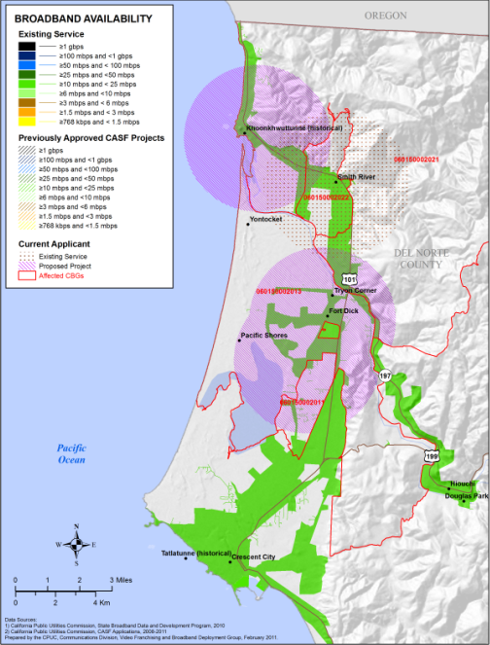

Wireless Broadband Availability:
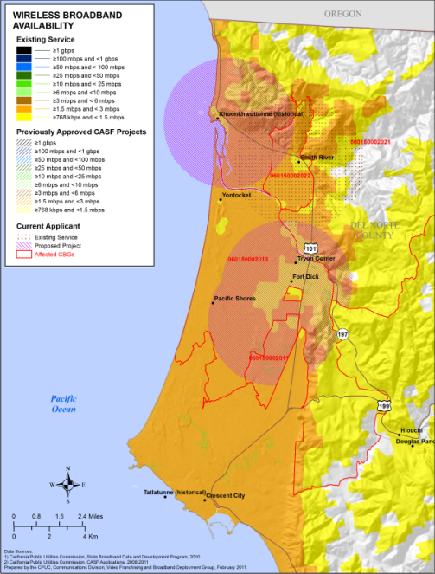

APPENDIX A
Resolution T- 17341
Frontier West Coast’s Del Norte Project Regional Map

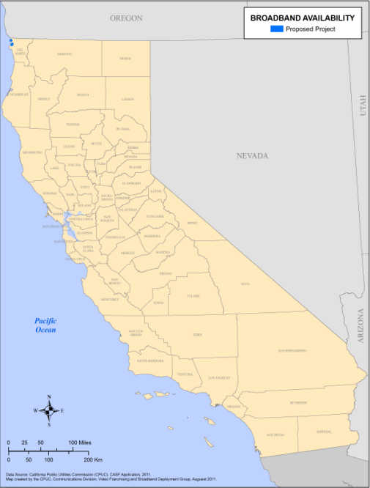

END OF APPENDIX A

An unserved area is defined as an area that is not served by any form of facilities-based broadband, or where internet connectivity is available only through dial-up service or satellite. An underserved area is defined as an area in which broadband is available but no facilities-based provider offers service at speeds of at least 3 mbps download and 1 mbps upload.
The above schedule is contingent on the CASF recipient submitting clear, complete, and error-free invoices to CD. Additional time to process payments may be necessary if CD finds problems with the submitted invoices.

