PUBLIC UTILITIES COMMISSION OF THE STATE OF CALIFORNIA

ID #10805
ENERGY DIVISION RESOLUTION E-4442
December 1, 2011

RESOLUTION

Resolution E-4442.

PROPOSED OUTCOME: This Resolution formally adopts the 2011 Market Price Referent values for use in the 2011 Renewables Portfolio Standard solicitations. This Resolution is made on the Commission’s own motion.

ESTIMATED COST: None
__________________________________________________________

Summary

2011 Market Price Referent values have been calculated for use in the 2011 Renewables Portfolio Standard solicitations.
This resolution formally adopts the 2011 market price referent (MPR) values for use in the 2011 Renewables Portfolio Standard (RPS) solicitations. The 2011 MPR values were calculated using the methodology, model and inputs adopted by this Commission. This resolution also adopts MPR values to serve as the price reasonableness benchmark for RPS contracts with delivery terms of at least four years but less than 10 years. The adopted MPR values will also be used in tariffs and standard contracts for the purchase of RPS-eligible energy from facilities that meet certain conditions. This resolution is made on the Commission’s own motion in conformance with Commission decisions.

Table 1: 2011 MPR values for long-term (10 - 25 year) RPS contracts with start dates through 2016

Adopted 2011 Market Price Referents
(Nominal - dollars/kWh)
Contract Start Date | 10-Year | 15-Year | 20-Year | 25-Year
2012 | 0.07689 | 0.08353 | 0.08956 | 0.09274
2013 | 0.08104 | 0.08776 | 0.09376 | 0.09696
2014 | 0.08454 | 0.09150 | 0.09755 | 0.10081
2015 | 0.08804 | 0.09519 | 0.10132 | 0.10463
2016 | 0.09156 | 0.09883 | 0.10509 | 0.10847

Background
Overview of the Renewables Portfolio Standard (RPS) Program
The California RPS Program was established by Senate Bill (SB) 1078, and has been subsequently modified by SB 107, SB 1036 and SB 2 (1x). The RPS program is codified in Public Utilities Code Sections 399.11-399.20.

Current RPS statute and Commission decisions require that the Commission establish “market prices” after the closing date of the utilities annual RPS solicitations. The market prices established by the Commission, referred to as the market price referent, are used to determine whether a contract selected from a competitive solicitation has above-market costs associated with it.

SB 2 (1x) (Simitian, Chapter 1, Statutes of 2011, First Extraordinary Session) makes significant changes to the RPS program. Most notably, SB 2 requires that each retail seller increase its total procurement of eligible renewable energy resources so that 33 percent of retail sales are served by eligible renewable energy resources no later than December 31, 2020. SB 2 (1X) also removes the market price referent as the basis for cost containment. SB 2 (1x) becomes effective on December 10, 2011.

Additional background information about the Commission’s RPS Program, including links to relevant laws and Commission decisions, is available at http://www.cpuc.ca.gov/PUC/energy/Renewables/overview.htm and http://www.cpuc.ca.gov/PUC/energy/Renewables/decisions.htm.

The purpose and scope of the Market Price Referent (MPR)
RPS program cost containment
Under the current RPS statute, the MPR establishes the basis for the quantity of above-market funds (AMFs) applied towards RPS procurement contracts that are above the MPR and approved by the Commission. Through this function, the MPR sets a limit on the procurement obligations of retail sellers under the RPS program.

If the amount of AMFs available to an electrical corporation is insufficient to support the total costs expended above the MPR, then the Commission shall allow an electrical corporation to limit its annual procurement obligation to the quantity of eligible renewable energy resources that can be procured with available AMFs. However, a utility can voluntarily enter into contracts that exceed the MPR once the cost limitation has been exhausted and the Commission may approve these contracts if they are reasonable. Pacific Gas and Electric, Southern California Edison Company, and San Diego Gas & Electric have each exhausted the allotted AMFs and have not requested a limitation on RPS procurement.

RPS contract cost reasonableness assessment
In D.09-06-050, the Commission established a methodology for calculating a price reasonableness benchmark for short-term RPS contracts, that is, contracts that are less than 10-years. Pursuant to D.09-06-050, the MPR methodology is used to calculate MPR values to be compared with the price of RPS contracts that have duration of at least four years but less than 10 years. (Refer to Appendix A.)

Tariffs for small generators
Pursuant to the current RPS statute and D.07-07-027, the MPR is also used to set the rate in certain tariffs for the purchase of RPS-eligible electricity by a utility from certain sellers.

MPR procedural history
The Commission set the initial parameters for the MPR in D.03-06-071. The method for calculating the MPR was first developed in D.04-06-015. In D.04-06-015, the Commission clarified “what the MPR is not: it does not represent the cost, capacity or output profile of a specific type of renewable generation technology. . . [T]he MPR is to represent the presumptive cost of electricity from a non-renewable energy source, which this Commission, in D.03-06-071, held to be a natural gas-fired baseload or peaker plant.” (D.04-06-015, mimeo., p. 6, n.10.)
The MPR represents what it would cost to own and operate a baseload combined cycle gas turbine (CCGT) power plant over various time periods. The cost of electricity generated by such a power plant, at an assumed technical capacity factor and set of costs, is the proxy for the long-term market price of electricity established by this Commission. To ensure that the MPR represents “the value of different products including baseload, peaking, and as-available output,” the IOUs apply their IOU-specific Time of Delivery (TOD) profiles to the baseload MPR when evaluating RPS renewable facilities. The application of TOD factors to the MPR result in a market price for each product and generating unit.

In D.05-12-042, the methodology for calculating the MPR was expanded and refined. This methodology has been used for the resolutions calculating the MPR for 2005 and 2006. The 2007 MPR was calculated pursuant to D.07-09-024, wherein the Commission adopted an interim method to account for the costs of the emission of greenhouse gases (GHG adder).

D.07-09-024 authorized the use of the GHG adder for the 2007 MPR only. That decision also authorized an examination of the MPR for 2008 and later years, to determine whether any changes should be made to the MPR methodology, including how the compliance costs of State mandates to reduce GHG emissions should be reflected in the MPR.

In 2008, the Commission reevaluated the MPR methodology. This review resulted in a Commission decision that made several notable changes to the MPR methodology. Specifically, D.08-10-026 revised the MPR methodology for determining the cost of natural gas fuel, the capacity factor and the cost of compliance with greenhouse gas regulation for the MPR proxy plant. The decision also revised the methodology for calculating installed capital costs and transmission line losses and it permitted staff to calculate MPR values for a 25-year contract term.

2011 MPRs were calculated using a cash-flow simulation model
Staff calculated the 2011 MPRs using the “MPR model”, which is based on a cash-flow simulation methodology approved by the Commission. The MPR model requires several types of input data, including natural gas prices, capital costs, operating costs, finance costs, taxes, and power delivery assumptions. The primary input drivers for the MPR calculation are the California (CA) gas price forecast, power plant capital costs, and the capacity factor for a proxy baseload plant. (Refer to 2011 MPR model, tabs; CA_Gas_Forecast, Install_Cap, and CF_Inputs.)

Release of 20011 MPR is consistent with prior Commission decisions
Pursuant to D.05-12-042, Staff is required to prepare a draft resolution for the annual MPR, including any relevant supporting materials as attachments to the draft resolution. Consistent with this decision, the 2011 MPR draft resolution was issued after all 2011 utility RPS solicitations closed. For 2011, the draft resolution incorporated the methodological changes adopted in the Commission’s recent decision D.08-10-026 and updated inputs as necessary.

Discussion
2011 MPR Gas Methodology and Inputs
The most significant cost during the life of a new CCGT is the cost of its natural gas fuel. The MPR models the cost of natural gas over the entire life of the proxy plant's long-term contract based on market prices and fundamental forecasts.

D.08-10-026 authorized Staff to use between nine and 12 years (the current maximum) of New York Mercantile Exchange (NYMEX) forward price data. In reviewing the applicable NYMEX data set, Staff determined that there was no evidence of a single outlier that would argue for using less than all available NYMEX forward prices. (Refer to 2011 model, “NYMEX_Futures” and “CA_Gas_Forecast” tabs.)

Comparison of 2011 MPR values to prior year’s
The 2011 MPR values are lower than the 2009 MPRs, primarily due to lower natural gas prices. As discussed above, the most significant cost input during the life a new CCGT is the cost of its natural gas fuel. Fuel costs represent approximately 70 percent of a new CCGT’s all-in costs.

Table 2: Comparison of 2011 and 2009 MPR NYMEX forward price data

NYMEX-year | $/MMBtu  (2011 MPR) | $/MMBtu  (2009 MPR) | Difference (%)
1 | $4.84 | $5.89 | -18%
2 | $5.17 | $6.73 | -23%
3 | $5.44 | $6.91 | -21%
4 | $5.73 | $7.02 | -18%
5 | $6.02 | $7.15 | -16%
6 | $6.29 | $7.30 | -14%
7 | $6.56 | $7.44 | -12%
8 | $6.83 | $7.59 | -10%
9 | $7.10 | $7.74 | -8%
10 | $7.37 | $7.89 | -7%
11 | $7.66 | $8.04 | -5%
12 | $7.96 | $8.19 | -3%

2011 MPR Installed Capital Data Set and Costs
Installed Capital Costs
Pursuant to Commission decisions, the MPR installed capital costs are derived from the publicly available cost data for the folowing CCGTs: Palomar (SDG&E), Cosumnes (SMUD) and Colusa (PG&E). Based on the cost data for these plants, the average installed capital cost, reflecting interconnection costs, environmental permitting costs, additional capacity costs for dry cooling, and contingency costs is $1,136/kw. (Refer to 2011 MPR model “Installed_Cap” tab.)

Installed capital costs for Palomar and Colusa were escalated using Handy-Whitman’s Index of Public Utility Construction Costs, specifically, the “Total Steam Production Plant” index. (Refer to 2011 MPR model “Installed_Cap” tab.)

Capital Cost Inputs
The MPR model requires fixed and variable operational and maintenance (O&M) costs to calculate total installed capital costs for the MPR proxy CCGT. The 2011MPR used CCGT O&M cost inputs from the California Energy Commission’s Comparative Cost of Generation Report. (Refer to 2011 MPR model “CF_Data_Set” tab.)

Explanation of MPR Environmental Inputs
GHG Compliance Cost
In D.08-10-026, the Commission made the cost of compliance with GHG regulation a permanent component of the MPR calculation. The decision adopted criteria for Staff to employ in modeling the GHG compliance costs incurred for the MPR proxy CCGT, until the time when California has a functioning GHG compliance market.
D.08-10-026 directs staff to use market-based costs as the basis for the MPR’s GHG compliance costs. On October 20, 2011, the California Air Resources Board (CARB) adopted cap-and-trade regulation. In anticipation of this, there is a California carbon market today and market behavior and prices reflect this. By contrast, the interim methodology made available by D.08-10-026 to base the MPR GHG compliance costs on market research and meta-analysis is no longer necessary.

In order to implement the fundamental market-based approach of the MPR, as direction by the Commission, the 2011 MPR will utilize market data for the development of the GHG compliance costs associated with the MPR proxy plant. This methodology is an interim market-based methodology until California’s cap-and-trade market is initiated in 2013.

Since 2009, the last time the MPR was calculated, market data have become available that can be used to calculate an implied price for CO2 allowances under the cap-and-trade program. The Intercontinental Exchange and Green Exchange both initiated trading for California CO2 allowances in August 2011. Trading activity on both exchanges is not robust and only the Green Exchange prices are publicly available. However, trading for forward natural gas and electricity contracts through 2015 is more robust. Therefore, the 2011 MPR uses market-based forward natural gas and electricity prices to calculate an implied price for CO2.

This market-based methodology is based on the change of the implied market heat rates over two time periods: the period before and after CARB’s cap-and-trade regulations were adopted. The implied market heat rates are calculated from publicly available forward electricity and natural gas prices using Formula (1), below. The implied market heat rate after the anticipated implementation of the carbon market is higher than it is for the period prior to implementation. The increase in the implied market heat rate reflects the increase in cost of generation expected by the market due to the cost of CO2 allowances under cap-and-trade regulation. The increase in the heat rate times the price of natural gas gives the additional cost in $/MWh due to the cost of CO2 allowances (Formula 2), below. Multiplying the initial or baseline heat rate times the carbon content of natural gas (0.0531 metric tonnes per MMBtu) results in the metric tonnes of CO2 emitted per hour. Dividing the increased cost by the metric tonnes of CO2 emissions yields a $/metric tonne value for CO2 allowances (Formula 3), below. The methodology is illustrated below and the results are shown in Appendix E.

This approach provides the current market assessment of the cost of CO2 allowances for the electricity sector based on market expectations before and after the carbon market was established using a publicly available and transparent method. The resulting MPR GHG compliance costs (in nominal dollars) are $16.27/CO2 metric tonne in 2013, $26.08/ CO2 metric tonne in 2015 and $36.64/ CO2 metric tonne in 2020. (Also, refer to 2011 MPR model “Implied_GHG_cost” tab.)

Three Step Calculation to Estimate Implied CO2 Compliance Costs
The implied market heat rate (btu/kWh) is calculated by dividing electricity price ($/MWh) by the natural gas price ($/MMBtu). Note that the units of MMBtu/MWh are equivalent to the units Btu/kWh.

Formula (1)

Implied heat rate = (Electricity Forwards ($/MWh) – Variable O&M*($/MWh))
Burner Tip Natural Gas Price ($/MMBtu)

Where,
- Electricity forwards are published through 2015 in Megawatt Daily for both NP15 and SP15 delivery points.

- Variable O&M is based on the variable O&M inputs used in the MPR model. The variable O&M is subtracted from the electricity price to calculate a net revenue for the electric generator.

- Natural gas prices are published through 2015 by CSI Unfair Advantage for the same trading period for the electricity forwards. The burner tip natural gas prices are calculated as the Henry Hub price plus the basis differentials between Henry Hub and PG&E City Gate and SoCal prices (for NP15 and SP15, respectively) plus the natural gas distribution rate and municipal surcharge fee calculated for the MPR (escalated annually).

The change in heat rate due to the cost of CO2 allowances is calculated by subtracting a pre-implementation, baseline heat rate from the current, post-implementation heat rate.

Formula (2)

Δ Heat Rate (Btu/kWh) = Heat Rate (Current) –Heat Rate (Baseline) (Btu/kWh))

Where,
- The current heat rate is the implied heat rate calculated after the implementation of the carbon market

- The baseline heat rate is the implied market heat rate prior to the implementation of the carbon market

The change in heat rate times the gas price equals the cost increase due to CO2 allowance costs. The metric tonnes of carbon emission is the baseline heat rate times 0.0530 metric tonnes CO2/MMBtu.

Formula (3)

CO2 Cost ($/metric tonne) = Δ Heat Rate (Btu/kWh) * Gas Price ($/MMBtu)
Heat Rate (Baseline) (Btu/kWh) * CO2 Content (metric tonnes/MMBtu)

The baseline heat rates are based on the forward implied heat rates from December 2010, prior to cap and trade regulations being adopted. The implied heat rate ranges from 7,854 in 2011 to 9,036 in 2014. The increase in heat rate over time is presumably due to factors other than GHG regulation. Next, more recent (September 2011) forward implied heat rates are calculated, which now include anticipated CO2 allowance prices. The recent implied market heat rates for 2013 and beyond are much higher than those calculated using December 2010 data, ranging from 9,275 to 10,948 btu/kWh. To calculate the baseline (without GHG regulation) we increase the September 2011 implied heat rate for 2012 (prior to the implementation of the carbon market) at the same annual rate as the December 2010 data. This baseline is then subtracted from the new implied heat rates calculated using the September 2011 data. The difference in heat rates for each calendar year is presumed to be due to the presence of GHG regulation through 2015. CO2 prices from 2015 through 2030 are escalated using a rate of 5 percent plus inflation. This is the maximum annual increase permitted by CARB for the price ceiling and floor for CO2 allowances. To avoid dramatic geometric price increases in the distant future that result from an annual percentage increase, a linear trend with a fixed annual increase is used from 2030 onward. A comparison of the calculated CO2 allowance prices with the Synapse 2009 and 2011 forecast, the Green Exchange and the CARB ceiling and floor is shown in Figure 1 (in $/metric tonne).

Figure 1

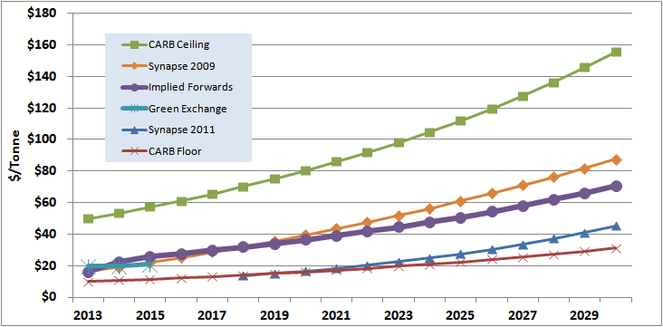

Emissions Reduction Offset Costs
The MPR installed capital costs include the costs for the MPR proxy plant of obtaining emission reduction credits (ERC). Staff’s calculation of ERCs does not impact the MPR average installed capital cost value or the MPR values in any manner.
Staff derived the 2011 MPR ERC costs using the following methodology:
- Obtained criteria pollutant emissions in tons/year from the application for certification (AFC) filing for each plant (Palomar, Cosumnes, Colusa),
  - converted emissions to tons/kW/year based on nameplate rating of each plant, and
  - computed average tons/kw/year for three plants.
- Sourced median ERC costs from "Emission Reduction Offsets Transaction Cost Report for 2008" (California Environmental Protection Agency - Air Resources Board, Table 1, p. 2.)
  - Excluded CO, for which offsets are not required in any district.
  - Applied 1.2:1 offset ratio for all pollutants. Actual offset ratios vary by pollutant and by Air Quality Management District. 1.2 is commonly used as representative offset ratio in journal articles.
- Multiplied ERC costs by tons/kw/year to calculate total $/kW ERC cost of $19/kW or $9.5 million for a 500 MW MPR Proxy Plant.

Comments
Public Utilities Code section 311(g)(1) provides that this resolution must be served on all parties and subject to at least 30 days public review and comment prior to a vote of the Commission. Section 311(g)(2) provides that this 30-day period may be reduced or waived upon the stipulation of all parties in the proceeding.
The 30-day comment period for the draft of this resolution was neither waived nor reduced. Accordingly, this draft resolution was mailed to parties for comments, and will be placed on the Commission's agenda no earlier than 30 days from today.

Findings AND CONCLUSIONS

- The 2011 MPRs were calculated and released consistent with Commission decisions.
- The 2011 MPR values have been finalized for use in the 2011 Renewables Portfolio Standard solicitations and relevant tariffs which employ the MPR.

Therefore it is ordered that:

- The 2011 market price referents in Appendix A are approved for use in the 2011 Renewables Portfolio Standard solicitations and relevant tariffs which employ the Renewables Portfolio Standard market price referent.
- Each electric corporation obligated under Decision 07-07-027, pursuant to Public Utilities Code Section 399.20, shall file a Tier 1 advice letter updating its relevant tariffs and standard contracts with the 2011 market price referents. The advice letter shall be filed and served within 7 days of the effective date of this resolution. The advice letter will have an effective date of January 3, 2011

This Resolution is effective today.

I certify that the foregoing resolution was duly introduced, passed and adopted at a conference of the Public Utilities Commission of the State of California held on December 1, 2011; the following Commissioners voting favorably thereon:

_______________
PAUL CLANON
Executive Director
Appendix A: Adopted 2011 Market Price Referents

Adopted 2011 Market Price Referents - Long-Term Contracts
(Nominal - dollars/kWh)
Contract Start Date | 10-Year | 15-Year | 20-Year | 25-Year
2012 | 0.07689 | 0.08353 | 0.08956 | 0.09274
2013 | 0.08104 | 0.08776 | 0.09376 | 0.09696
2014 | 0.08454 | 0.09150 | 0.09755 | 0.10081
2015 | 0.08804 | 0.09519 | 0.10132 | 0.10463
2016 | 0.09156 | 0.09883 | 0.10509 | 0.10847
2017 | 0.09488 | 0.10222 | 0.10859 | 0.11205
2018 | 0.09831 | 0.10570 | 0.11218 | 0.11572
2019 | 0.10185 | 0.10927 | 0.11586 | 0.11945
2020 | 0.10550 | 0.11296 | 0.11965 | 0.12325
2021 | 0.10916 | 0.11675 | 0.12353 | 0.12712
2022 | 0.11299 | 0.12066 | 0.12752 | 0.13105
2023 | 0.11691 | 0.12468 | 0.13160 | 0.13503

Adopted 2011 Market Price Referents - Short-Term Contracts
(Nominal - dollars/kWh)
Contract Start Date | 5-Year | 6-Year | 7-Year | 8-Year | 9-Year
2012 | 0.06931 | 0.07101 | 0.07259 | 0.07409 | 0.07551
2013 | 0.07406 | 0.07555 | 0.07698 | 0.07837 | 0.07972
2014 | 0.07763 | 0.07907 | 0.08048 | 0.08185 | 0.08321
2015 | 0.08096 | 0.08239 | 0.08381 | 0.08520 | 0.08657
2016 | 0.08414 | 0.08560 | 0.08705 | 0.08847 | 0.09001
2017 | 0.08704 | 0.08853 | 0.09001 | 0.09162 | 0.09325
2018 | 0.09000 | 0.09153 | 0.09323 | 0.09494 | 0.09665
2019 | 0.09304 | 0.09483 | 0.09664 | 0.09844 | 0.10018
2020 | 0.09644 | 0.09835 | 0.10025 | 0.10208 | 0.10382
2021 | 0.10010 | 0.10211 | 0.10402 | 0.10584 | 0.10758
2022 | 0.10404 | 0.10604 | 0.10793 | 0.10972 | 0.11134
2023 | 0.10816 | 0.11011 | 0.11195 | 0.11359 | 0.11528

Appendix B: Utility’s 2011 Time-of-Delivery (TOD) periods and factors

Pacific Gas and Electric

Month | Period | Definition | Factor
June - September | Super-Peak | Hours Ending (HE) 13-20 Monday-Friday (except NERC holidays) | 2.38
June - September | Shoulder | HE 7-12, 21 and 22 Monday-Friday (except NERC holidays); HE 7-22 Saturday, Sunday and all NERC holidays | 1.12
June - September | Night | HE 1-6, 23 and 24 all days (including NERC holidays) | 0.59
October - February | Super-Peak | Defined above | 1.10
October - February | Shoulder | Defined above | 0.94
October - February | Night | Defined above | 0.66
March - May | Super-Peak | Defined above | 1.22
March - May | Shoulder | Defined above | 0.90
March - May | Night | Defined above | 0.61

Southern California Edison Company

Season | Period | Definition | Factor
Summer  June 1 - September 30 | On-Peak | WDxH¹, noon-6 pm | 3.13
Summer  June 1 - September 30 | Mid-Peak | WDxH, 8-noon, 6-11 pm | 1.35
Summer  June 1 - September 30 | Off-Peak | All other times | 0.75
Winter  October 1 - May 31 | Mid-Peak | WDxH, 8 am-9 pm | 1.00
Winter  October 1 - May 31 | Off-Peak | WDxH, 6-8 am, 9 pm-midnight; WE/H² 6 am-midnight | 0.83
Winter  October 1 - May 31 | Super-Off-Peak | Midnight-6 am | 0.61

1/ WDxH is defined as weekdays except holidays
2/ WE/H is defined as weekends and holidays

San Diego Gas &Electric

Season | Period | Definition¹ | Factor
Summer  July 1- October 31 | On-Peak | Weekdays 11am-7pm | 2.50
Summer  July 1- October 31 | Semi-Peak | Weekdays 6am-11am; Weekdays 7pm-10pm | 1.34
Summer  July 1- October 31 | Off-Peak | All other hours | 0.80
Winter  November 1 - June 30 | On -Peak | Weekdays 1pm-9pm | 1.09
Winter  November 1 - June 30 | Semi -Peak | Weekdays 6am-1pm; Weekdays 9pm-10pm | 0.95
Winter  November 1 - June 30 | Off-Peak | All other hours | 0.68

1/ All hours during National Electric Reliability Council (NERC) holidays are Off-Peak.
Appendix C: 2011 MPR California and Henry Hub Gas Forecast (2012 – 2041)

Appendix D: 2011 MPR Natural Gas Fundamental Forecast Methodology

Background
The most significant cost during the life a new CCGT is the cost of its natural gas fuel. The MPR models the cost of gas over the entire life of the proxy plant's long-term contract. As the Commission pointed out in D.05-12-042, no new gas-fired plant in California actually enters into a 20-year fixed price contract for physical gas delivery. Therefore, in order to capture the “fixed-price fuel costs associated with fixed-price electricity from new generating facilities,” the MPR model creates a forecast of long-term gas prices for purposes of the MPR. As explained in D.05-12-042, the MPR model is based on the fact that California market participants; when considering a power purchase agreement (PPA), “use some mixture of market data (NYMEX prices) and fundamentals forecasts for estimating long-term gas prices in a variety of settings, not only new PPAs for electricity produced from CCGTs.”

New York Mercantile Exchange (NYMEX) data
In D.05-12-042, the Commission authorized Staff to use all available NYMEX forward contract data. Under this guidance, the 2005, 2006 and 2007 MPRs were calculated using the full six years of NYMEX. In 2008, NYMEX extended its forward gas contract term offering from six to 12 years. D.08-10-026 authorized Staff to use between nine and 12 years (the current maximum) of NYMEX forward price data.

Transition to Fundamental Forecast
The MPR model’s long-term gas contract requires the use of fundamental gas forecasts to project gas prices when NYMEX forward prices are not available. The MPR fundamental forecast for years 12 – 25 was developed using an average of three out of four private sector natural gas forecasts (Henry Hub) from Cambridge Energy Research Associates, PIRA Energy Group, Global Insight or Wood Mackenzie. Due to contractual obligations requiring the Commission to keep the forecast confidential, Staff can not reveal which of the four firms the forecasts were purchased from.

The use of fundamental forecasts requires a two-step implementation process. First, a methodology must determine how to utilize the fundamental forecast data, and secondly, a methodology is required to transition from NYMEX data to fundamentals data.
D.08-10-026 directed Staff to make the transition from NYMEX forward prices to the first year of the MPR fundamental forecast by using a linear trend of the last three to five years of NYMEX forward prices, which mitigates the impact of any one price in the outer years of NYMEX. The first year of the MPR fundamental forecast is then extended using the annual escalation rate of the averaged private forecasts for the remainder of the MPR fundamental forecast.

California Basis Adjustment
Pursuant to D.08-10-026, Staff uses NYMEX Clearport prices for years when NYMEX data is used and California Basis data from private fundamental forecasts when the MPR Gas Methodology relies on private fundamental forecast data.
Staff continued its use of PG&E Citygate and SoCal Border Clearport prices for the first three years and then fixed the average price in year three through 2023, the last year when the MPR Gas Forecast relies on NYMEX forward prices. The California Basis Adjustment for the remainder of the proxy CCGT’s contract term is based on the average of basis prices from the private fundamental forecasts used to develop the long-term California MPR Gas Forecast. (Refer to 2011 MPR model “CA_Basis_Adj” tab.)

Appendix E: 2011 MPR GHG Compliance Cost Calculation

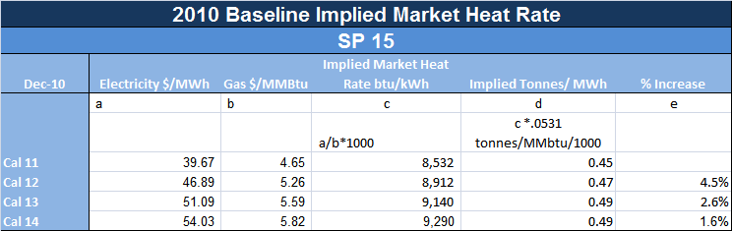

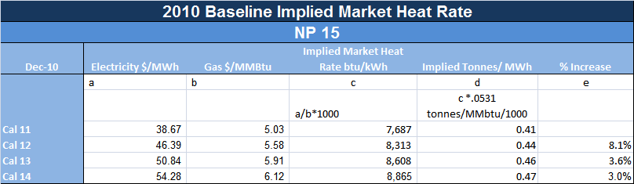

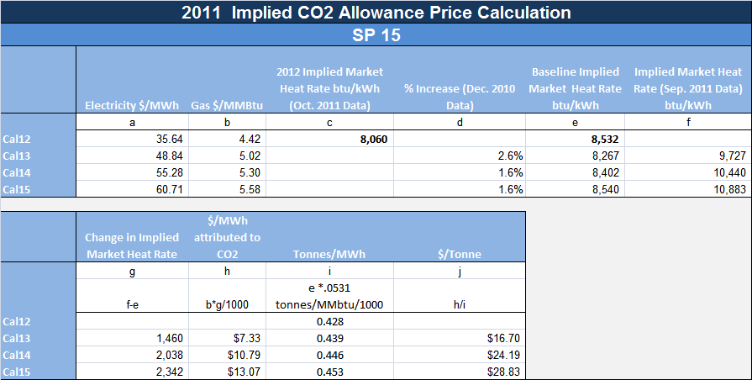

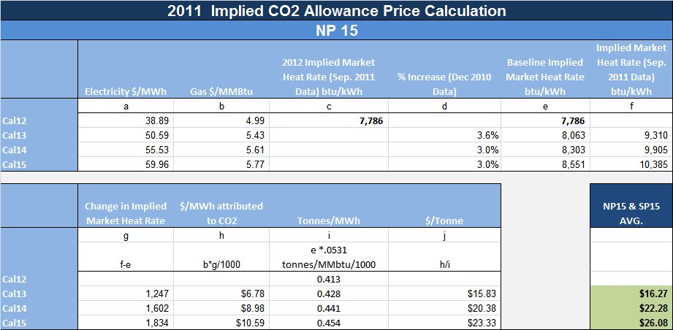

Appendix F: 2011 MPR Gas Forecast Inputs
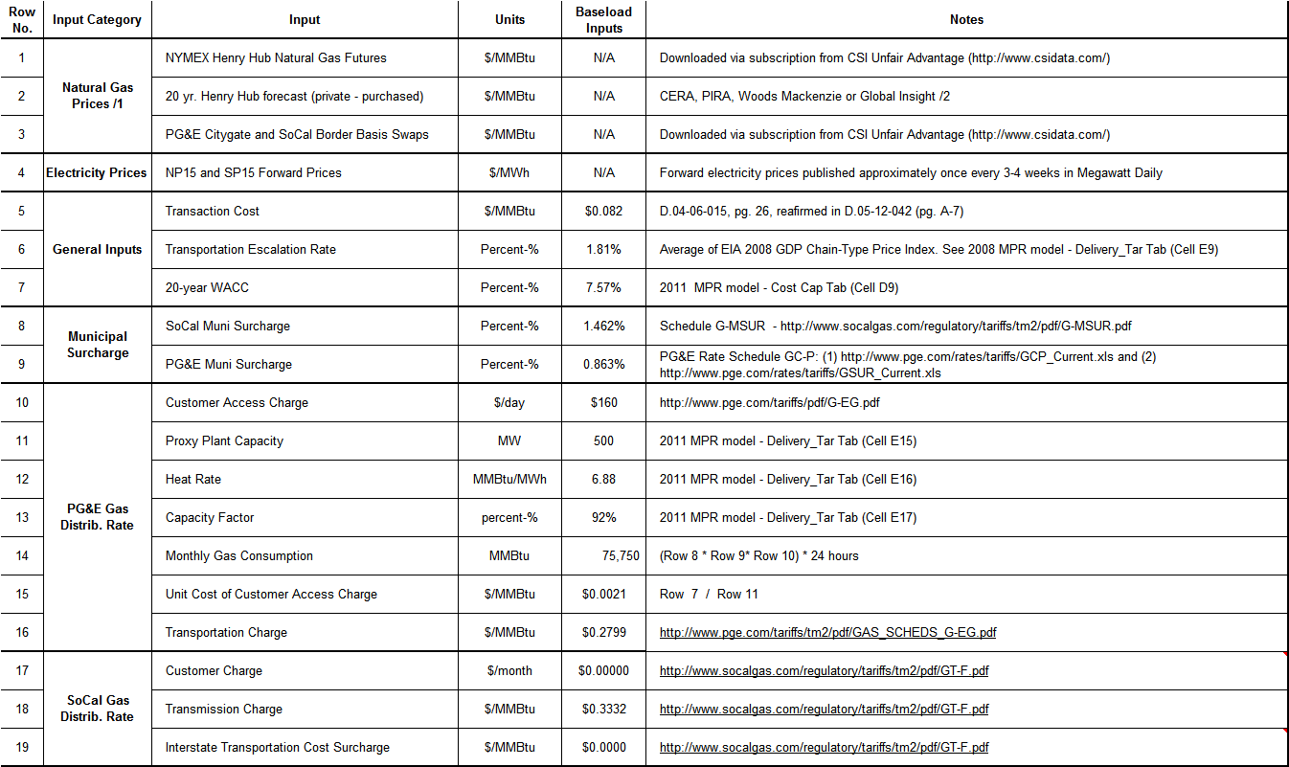
1/ The Henry Hub forecasts are inputs for the MPR - Henry Hub forecast - there are no specific baseload values.
2/ Due to contractual obligations requiring the CPUC to keep the forecast confidential, staff can not reveal which of the firms forecasts were used

Appendix G: 2011 MPR Non-Gas Inputs
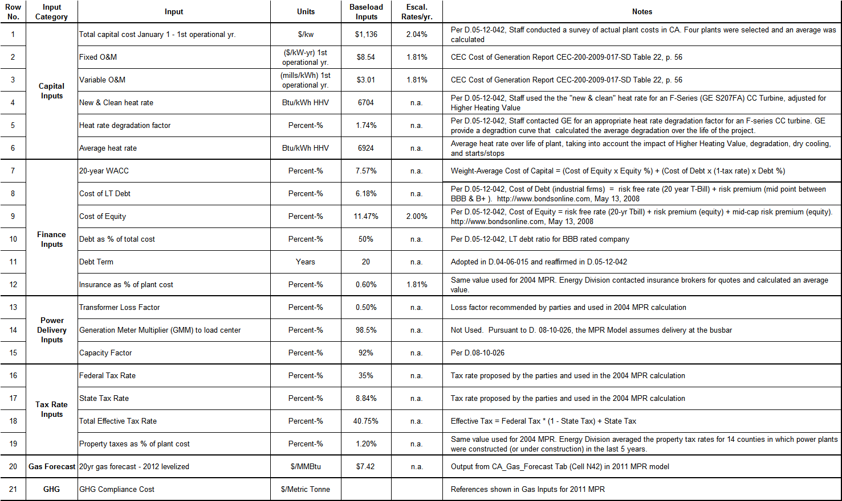

Using 2012 as the base year, Staff calculates MPRs for 2012-2023 that reflect different project online dates. MPRs for long-term contracts though 2023 and for short-term contracts are provided in Appendix A. The 2011 MPR model is available at: http://www.cpuc.ca.gov/PUC/energy/Renewables/mpr
SB 1078 (Sher, Chapter 516, Statutes of 2002); SB 107 (Simitian, Chapter 464, Statutes of 2006); SB 1036 (Perata, Chapter 685, Statutes of 2007); SB 2 (1x) (Simitian, Chapter 1, Statutes of 2011, First Extraordinary Session).
All further references to sections refer to Public Utilities Code unless otherwise specified.
§ 399.14(a)(2)(A) and § 399.15(c)
Decision (D.) 04-06-015 and D.08-10-026.
The new cost containment mechanism will be implemented through the RPS Rulemaking (R.) 11-05-005.
Pursuant to Gov. Code, § 9600(a), Legislation enacted during the Extraordinary Session goes into effect on the 91st day after adjournment of the special session.
§ 399.15(d).
In order to carry out this function, the Commission in D.04-06-015 concluded that the contract price should be compared to the MPR on a net present value basis as calculated over the entire contract term.
§ 399.15(d)(3). The cost limitation applies to Bear Valley Electric Service, Pacific Gas and Electric, Southern California Edison, and San Diego Gas & Electric.
§ 399.15(d)(4).
§ 399.20
The Commission is in the process of implementing new Pub. Util. Code § 399.20 (SB 2 (1X), which expands and modifies the prior feed-in tariff provisions for RPS-eligible generation.
§ 399.15(c)(3).
TOD factors are based on the forward value of electricity during different TOD periods. TOD factors for Pacific Gas and Electric Company, Southern California Electric Company and San Diego Gas & Electric are provided in Appendix B.
A link to the 2011 MPR Model is provided on page 2 of this Resolution.
The 2011 RPS solicitation closed on July 11, 2011.
The MPR Gas Methodology uses a 22-trading day average of NYMEX forward prices ending with the close of the utilities’ solicitations. Accordingly, the 2011 MPR Fundamental Gas forecast is derived from NYMEX forward prices leading up to July 11, 2011.
See D.05-12-042 and D.08-10-026.
There are no new facilities that meet the criteria for the MPR and that have publicly available cost information.
This includes the environmental review and permitting costs incurred for a CCGT, including the purchase of emissions reduction offsets pursuant to California Health and Safety Code §§ 40709 and 40709.5.
Whitman, Requardt & Associates, LLP publishes the Handy-Whitman Index of Public Utility Construction Costs.
The fixed and variable O&M costs for CCGTs in this report are based on a survey of 19 plants built in California, nine of which began operating as recently as 2005 or 2006. Comparative Cost of California Central Station Electricity Generation Technologies, January 2010. The report is available at: http://www.energy.ca.gov/2009publications/CEC-200-2009-017/CEC-200-2009-017-SF.PDF
The resource for modeling GHG compliance costs for the MPR should be: publicly available, based on multiple scenarios and sources of information, based on realistic and public assessments of policy proposals and scenarios, based on the most current reliable information that conforms to the other three criteria. (D.08-10-026, page 31)
A September 28th, 2011 California Supreme Court decision allowed cap and trade to move forward and the California Air Resources Board adopted revised regulations on October 20, 2011. CARB delayed initial implementation from 2012 to 2013. Information about CARB’s cap and trade regulations is available here: http://arb.ca.gov/cc/capandtrade/capandtrade.htm
Furthermore, analysis performed by Synapse Energy Economics (Synapse), the source for the 2008 and 2008 MPR GHG compliance cost inputs, was recently revised. Synapse’s methodology is based on a meta-analysis of federal regulation. In 2011, Synapse updated its carbon price forecast and this latest analysis does not produce carbon prices prior to 2018, significantly later than when California will have a functioning cap-and-trade program.
Daily settlement prices for California carbon allowance futures are accessible here: http://www.thegreenx.com/products/cca/market-data.html
Megawatt Daily publishes forward price curves for each of ~20 trading points at irregular intervals of 1-3 weeks. Prices for SP15 were obtained for 12/1/2010 and 10/20/11. Prices for NP15 were obtained for 11/23/2010 and 9/14/2011.
Information about CSI's Unfair Advantage is available here: www.csidata.com
Because 2015 data is not available from Dec 2010, the annual % increase in 2014 is used again for 2015.
Refer to 2011 MPR model, “Install_Cap” tab
ERC costs vary widely allowing a small number of very high prices to skew average cost upward. In such cases it is common statistical practice to use median rather than average prices. http://www.arb.ca.gov/nsr/erco/ercrpt08.pdf
PG&E 2011 RPS Solicitation pro forma contract. See Attachment H1: Form of Power Purchase Agreement, page 49. http://www.pge.com/b2b/energysupply/wholesaleelectricsuppliersolicitation/renewables2011/index.shtml
SCE 2011RPS Solicitation pro forma contract. See Appendix B-1: 2011 SCE RFP Pro Forma Agreement, Exhibit K, page 1. http://www.sce.com/EnergyProcurement/renewables/2011-request-for-proposal.htm
SDG&E 2011 RPS Solicitation, model PPA, page 41. http://www.sdge.com/rfo/renewable2011/index.shtml
D.05-12-042, p. 17.
NYMEX Clearport provides SoCal basis prices through 2014; however 2013 basis prices were not available for PG&E Citygate. The 2011 MPR model uses the average of the 2012 and 2014 PG&E Citygate basis prices to calculate 2013 basis prices.

