PUBLIC UTILITIES COMMISSION OF THE STATE OF CALIFORNIA
I.D.# 8069
ENERGY DIVISION RESOLUTION E-4180
December 18, 2008

RESOLUTION

Resolution E-4180. American Telephone and Telegraph Company and Pacific Gas and Electric Company. Grants exemption from Undergrounding Requirement of Public Utilities Code (PU Code) Section 320, and resolves related issues regarding a Rule 20/Rule 32 project in Gualala, Mendocino County.
__________________________________________________________

Summary
This Resolution exempts American Telephone and Telegraph Company (AT&T) and Pacific Gas and Electric Company (PG&E) from a ban on installing utility poles needed to transition between existing overhead distribution facilities in Gualala, Mendocino County and a community undergrounding project formed pursuant Electric Rule 20 and Communications Rule 32; and resolves related issues permitting the project to proceed, including project phasing, project boundary revisions, riser poles, and treatment of an area currently having no developed frontage.

Background
Section 320 requires undergrounding along designated Scenic Highways

Public Utilities Code Section 320 (PU Code Section 320) was enacted in 1971, Chapter 1697, and reads in part as follows:

The legislature hereby declares that it is the policy of this state to achieve, whenever feasible and not inconsistent with sound environmental planning, the undergrounding of all future electric and communication distribution facilities which are proposed to be erected in proximity to any highway designated a state scenic highway pursuant to Article 2.5 (commencing with Section 260) of Chapter 2 of Division 1 of the Streets and Highways Code and which would be visible from such scenic highways if erected above ground.

To implement it the Commission conducted Case 9364 and issued Decision (D) 80864 which states that:

…no communications or electric utility shall install overhead distribution facilities "in proximity to" and "visible from" any prescribed corridor on a designated scenic highway in California unless a showing is made before the Commission and a finding made by the Commission that undergrounding would not be feasible or would be inconsistent with sound environmental planning.

The Decision also states
- "in proximity to" as being within 1,000 feet from each edge of the right-of-way of designated State Scenic Highways;
- letter requests for deviations will be accepted, reviewed by the Commission staff and, where appropriate, approved by Commission resolution; and that
- when repairs or replacement of existing overhead facilities in the same location do not significantly alter the visual impact of the Scenic Highway, they should not be considered as new construction and need not be converted to underground.

Tariff Rules 20 of PG&E and 32 of AT&T govern undergrounding conversion programs
The current undergrounding program was instituted by the Commission in 1967 and consists of two parts. The first part, under Tariff Rules 15 and 16, requires new subdivisions to provide underground service for all new connections. The utilities, both electric and telephone, then bear the costs of cables, switches, and transformers, and developers bear other costs. Parties can seek an exemption from these rules by petitioning the Commission.

The second part of the program governs both when and where a utility may remove overhead lines and replace them with new underground service, and who shall bear the cost of the conversion. PG&E’s Tariff, Rule 20, and AT&T’s Rule 32 are the vehicles for the implementation of the underground conversion programs.

Rule 20 sets three levels, A, B, and C, of ratepayer funding for the projects as shown by the gross estimates of TABLE 1.

In summary, under Rule 20C, any electric customer may convert to undergrounding as long as it reimburses the utility for all costs, less the estimated net salvage value and depreciation of the replaced overhead facilities. The customer must make a non-refundable advance to the utility equal to the cost of the underground facilities, less the estimated net salvage value and depreciation of the replaced overhead facilities.

Rule 20B provides limited ratepayer funding for the cost of an equivalent overhead system, and any work on overhead facilities, but the balance of the costs, including cables, conduits, transformers, and structures, must be paid by the customer requesting undergrounding. Rule 20B projects must 1) be agreed to by all property owners served by the overhead lines; 2) include both sides of the street; and 3) extend for a minimum of 600 feet or one block. Additionally, the lines must be along public streets and roads or other locations mutually agreed upon.

Under Rule 20A, however, utility ratepayers bear most of the cost of undergrounding conversions. Rule 20A funds are available only when undergrounding is “in the public interest” for one or more of the following reasons:
- Such undergrounding will avoid or eliminate an unusual heavy concentration of overhead electric facilities;
- The street or road or right-of-way is extensively used by the general public and carries a heavy volume of pedestrian or vehicular traffic ;
- The street or road or right-of-way adjoins or passes through a civic area or public recreation area or an area of unusual scenic interest to the general public; and
- The street or road or right-of-way is considered an arterial street or major collector as defined in the Governor’s Office of Planning and Research General Plan Guidelines.
The determination of “general public interest” under these criteria is made by the local government, after holding public hearings, in consultation with the utilities.

TABLE 1
Contribution by
Ratepayer Contribution Customer Receiving
Rule Through Utility Rates Undergrounding

20A 80% Max: cost from street to meter
Min: zero if use mainline funds
20B 20% 80%
20C De minimus 100%

AT&T incentives to pursue undergrounding projects differ from PG&E’s
Ultimately ratepayers cover all costs incurred by investor-owned utilities (IOUs). For underground conversion projects as for any other capital project PG&E and AT&T must first advance the funds. IOUs budget the activity and then raise the capital and debt to pay for project labor and materials.

PG&E, when the project is complete, adds the total project cost to its ratebase. Periodically rates are re-set to allow PG&E to earn a return of and on investments like this, a positive incentive.

For AT&T however, incentives if anything are the reverse, because the Commission has eliminated traditional cost of service regulation and went further to eliminate all retail price regulation except basic residential services for AT&T and other major incumbent local exchange carriers (ILECs). Instead, to oversimplify, funds for undergrounding compete with other projects and shareholder returns, a negative incentive. Expenditures must be clearly required and justified for management approval.

Under these conditions the Commission must assist IOU management to prioritize projects by interpreting their need and timing. In this case due to the desires of the County and the community of Gualala, and the amount of time elapsed since the project was first authorized in August 2000, the Commission directs AT&T and PG&E to take all action within their control needed to prioritize and design and construction of Phases 1 and 2 as soon as possible.

History

Gualala is an unincorporated community about 100 miles north of San Francisco extending for about a mile along coast Highway 1 in Mendocino County, a state designated Scenic Highway. While AT&T often builds communication lines below PG&E’s on the same pole, in Gualala there are for the most part two separate poles lines along Highway 1, one owned by PG&E and the other by AT&T. Gualala intends to convert all its power and communication facilities along Highway 1 from overhead to underground, largely with utility funding under provisions of Rules 20 and 32.

In August of 2000 the Mendocino County Board of Supervisors passed the first of three Resolutions creating an undergrounding district in Gualala in order to utilize ratepayer funds under Rules 20 and 32. The undergrounding district boundary in Mendocino’s first Resolution includes both sides of Highway One for about a half-mile through a developed area of Gualala.

In 2001 PG&E internally authorized the Gualala Rule 20A project. For the next several years into 2004, parties including PG&E, AT&T, Mendocino County and the Gualala Municipal Advisory Committee (GMAC), Caltrans, and Chevron worked to resolve numerous obstacles to progress on the project, including initial work on street and sidewalk issues. Chevron agreed to dispose of soil contaminated by an abandoned gas station, and Caltrans agreed to AT&T’s request to trench across Highway 1 instead of Caltrans’ more costly initial requirement to bore under the highway. In addition Caltrans verbally committed that it had no plans to increase the width of State Highway 1 through the original downtown developed area adopted by the County’s first Resolution in 2000. This is important because widening the highway could obligate utilities to relocate at their expense any facilities installed in street side franchise areas.

In 2005 the utilities turned their attention to the location of the single joint trench typically shared by all participating utilities in Rule 20/32 conversion projects for efficiency and minimal community disruption. For the most part, the existing AT&T pole line runs on the east side of Highway 1 in a franchised area granted by the County and Caltrans along the street side of properties.

PG&E’s pole line however, runs west of Highway 1 mostly in private yard easements owned by PG&E away from the property frontage on Highway 1. Before developing plans with the County and GMAC and committing to joining AT&T in a joint trench on the east side of the highway PG&E needed Commission permission to give up the existing pole-line easements because they were purchased with ratepayer funds. PG&E’s Advice Letter filing to abandon these easements and move to a street side franchise is discussed below.

In 2006 GMAC asked the County to double the length of the project to approximately one mile (5600 feet) along Highway One. The County held public meetings, approved an expansion, and hired a consultant to survey and define the expansion.

Late in 2006 while developing its Advice Letter for permission to transfer its easements PG&E received from the County an outline of an expanded area of the undergrounding district. PG&E attached the County’s outline without fully assessing it so that the Commission’s permission could also apply to easements in the expanded scope, in order to save the time needed for the Commission to process a second Advice Letter.

Early in 2007 PG&E filed the Advice Letter, 2971-E, and in June 2007 the Commission approved it as filed. The so-called 851 Resolution granted permission under P.U. Code Section 851 to relocate PG&E’s existing overhead facilities from the rear lot easement to the street side underground joint trench with AT&T in a franchise area.

In August 2007, following the survey work for its first boundary expansion, the County passed a third Resolution which was its second boundary expansion. At some point the County “provided the lead design utility, AT&T, with appropriate drawings, mapped in 2006, showing community-owned facilities, such as sewer, water and storm drains.”

In December of 2007 the County and utilities met in Gualala for the first step in implementing the first boundary expansion, which the County had adopted in 2006, which is to physically walk the route.

At the December 2007 Gualala meeting the County also provided the utilities their first view of the second expansion of the district boundary, which the County had adopted in August 2007.

In June 2008 the County wrote to Commission staff requesting it to “reaffirm the expanded undergrounding area, the one-mile along Highway 1 in Gualala, and direct that the project be completed in one stage as soon as practically possible.”9

Please note that within this CPUC Resolution the various County Resolutions, stages, phases, and the sections referred to by the parties as green, red or blue/purple and shown in APPENDIX 1 – Map of ORIGINAL District Boundaries, will generally correspond to Phases 1, 2 or 3 as shown in APPENDIX 2 - Map of PROPOSED District Boundaries.

Notice
Notice of Draft Resolution E-4180 was made by email service to attendees at utility and county meetings and others interested in the matter.

Discussion

PUBLIC UTILITIES CODE SECTION 320

On May 20, 2008 in an email to staff PG&E and AT&T summarized CPUC actions needed including exemption from prohibition on erecting transition poles necessary to connect newly undergrounded facilities with remaining overhead facilities.

New poles will need to be installed as permanent or temporary riser, primary, or service poles at several locations throughout the Gualala project. The location depends on design and construction work yet to be completed in three integrated phases. This Resolution grants authority to the IOUs to place them where needed to construct the project designed in cooperation with local authorities.

EASEMENTS

The Commission granted PG&E’s January 2007 AL request to relocate its distribution line easements in Gualala

Resolution E-4100, June 21, 2007 granted PG&E’s request to abandon the private easements it owned for overhead lines on the west side of Highway 1, and allowed PG&E to join AT&T in its franchise right or way on the east side.⁷

PG&E had attached an outline map to its AL 2971-E encompassing both the original and expanded boundaries adopted in the first two County Resolutions. The Commission’s Resolution E-4100, however, focused on the information required for the Section 851 transfer, and included only a general boundary description without discussing boundaries of the project area:

On p.3: The property is located in the unincorporated community of Gualala, extending from Center Street northerly to Hubert Ave, along Highway One…;
and
On p.4: PG&E requests permission to relocate approximately 4,000 feet of its existing overhead… .

County to provide all easements to IOUs at no cost
After the utilities complete preliminary engineering IOU’s will submit easement requirements to the County who will obtain rights-of-way, as shown in APPENDIX 3.

IOUs require the County to obtain any necessary easements at no cost to the IOUs. Easements required may include trench locations, underground electric wiring and conduits, above ground concrete vaults and pads, equipment cabinets, and transformers adjacent to primary and secondary trench locations.

Rule 20 allocations may be used to offset PG&E’s own costs of identifying easement locations, but the County must provide the funds to pay owners to acquire easements.

IOU final design engineering and estimating begins after the County delivers all required easements to the IOU’s. Final design includes base map design and the overlay of various utility plans, reviews, changes, finalized drawings, and Form B cost agreement.

PROJECT PHASING

Project to be constructed in two or more phases

The utilities were informed at the public meeting in Gualala on Nov 21, 2005 that the County was considering expanding the undergrounding district beyond Phase 1. However, utility attendance at public meetings did not constitute the cooperation required of agencies to work with the utilities to determine the final boundaries of the project. Moreover, IOUs were reluctant to engage and invest in project planning work until the Commission had ruled on Advice Letter, 2971-E.

The County’s Resolution No. 2 in Oct 2006 directed the County DOT to prepare a revised expanded boundary proposal for public hearings and future formal adoption.

The DOT hired an engineer who prepared a revised expanded boundary proposal but the DOT did so without the necessary substantial engineering and technical consultation with the utilities needed to achieve a workable plan for the expanded boundary. See Appendix 3 Sequence of Community and Utility Planning Steps.

After the County adopted the second and third boundary expansions and presented them to AT&T and PG&E, the utilities informed the County that the expanded project might no longer qualify as a single ratepayer-financed undergrounding project. Three phases were discussed as a possible compromise to provide the County with what it originally requested while also permitting compliance with the criteria of Rules 20 and 32 for the funding of the project.

AT&T as lead utility had already prepared a preliminary engineering design for the joint trench along the street side using the original Phase 1 boundary, and together with PG&E the two utilities completed the initial design drawings Easement requirements for the original design have not yet been sent to the County for acquisition pending utility redesign required[continue..?]

The utilities have only committed to construct the original Phase 1 through the developed downtown area, with minor boundary adjustments. In this area the right-of-way (ROW) for the joint trench is clear and no further environmental review is required before construction.

Phase 2 in contrast starts at the edge of the developed downtown area beyond which Highway 1 extends as a rural highway through a wooded area with undisturbed native growth, undeveloped on the east side. To issue a permit here Caltrans may require environmental and archeological studies that can take a year or more to complete. Currently, both PG&E’s and AT&T's lines are behind existing trees. Combining Phase 2 with Phase 1 would delay the project as a whole.

The first step in implementing Phase 2 (the County’s first boundary expansion), which the County had adopted in 2006 as Resolution No. 2, which became the IOUs Red section, was to physically walk the extended route to observe and discuss how the utilities could place in the same new trench their existing separated overhead conductors, while maintaining continuous service to each customer from the new distribution underground, across public and/or private property, to reach each meter or connection point.

Since then an expansion of the original Phase 1 boundary, the IOU’s Green section, has been discussed as a way to resolve technical problems within Phase 1. Expansion would partially absorb and reduce the area of Phase 2 (red), and Phase 3 (purple).

At the August 15, 2008 all-party meeting the County accepted the rationale to proceed with construction of a Phase 1 in advance of settling all issues on remaining Phases.

TWO MAJOR TECHNICAL ISSUES

1. Expansion of the Phase 1 boundary is a solution to converting meters within the Boundary while maintaining service to meters outside of it

County Resolution No. 1 adopted a boundary for the undergrounding district that did not include undergrounding all of the poles needed to serve the meters within the boundary.

Certain properties fronting on the west side of Highway 1 are served electric power from the back (west) side from PG&E poles located on Ocean and Hubert Drives and both sides of those streets are not currently in the Undergrounding (UG) district.

Once the properties fronting on Highway 1 are provided new UG service from the new joint trench along Highway 1 then the existing over head (OH) conductors and poles serving the back side typically would be removed. In this case the OH facilities are still needed to serve other properties remaining on Ocean and Hubert, unless the undergrounding district was expanded to include both sides of Ocean and Hubert.

Residential streets such as Ocean and Hubert normally do not qualify for full ratepayer support under Rule 20A/32a1 due to low residential traffic count but here they do because they meet another criterion; namely, they are in a public area of unusual scenic interest. The overhead facilities obstruct the scenic view toward the ocean, from stretches of Highway 1 and from Ocean and Hubert.

Further, AT&T, PG&E and PUC agree that on the south end of Phase 1 the lot that was originally part of Phase 2 should be included in a Phase 1 expansion.

One solution is to leave existing poles standing outside the undergrounding boundary, and erect more poles as risers where needed to connect with newly undergrounded sections. This approach is simplest and least cost but leaves poles obstructing the view in the seaward direction.

An alternative is for the IOUs to propose expanding the boundary which the County had adopted without consulting the utilities. The County, the IOUs and the Commission could work together to qualify for undergrounding those poles that otherwise mar the scenic view seaward. This approach also would solve the technical problems of maintaining electric and telephone service, and would meet criteria no. 3: “…street passes through a civic area or public recreation area of unusual scenic interest to the general public”. The drawback is higher cost but the accumulated Rule 20 allocations appear sufficient.

PG&E and AT&T should propose that the County expand the Phase 1 boundary to resolve technical obstacles

A practical solution to settling the tariff and technical issues described is to expand the existing boundary of Phase 1 to include both sides of Ocean Drive, Hubert Drive, and Sedalia Drive.

To facilitate this expansion the CPUC confirms that both sides of Ocean, Hubert and Sedalia Drives qualify for Rules 20 and 32 .

The CPUC further confirms that the boundary lines of underground districts may bisect lots. Nothing in existing tariffs or regulations prohibits undergrounding district boundary lines from bisecting lots.

Noncontiguous expansions
The original County Resolution No. 2 (red area) included a small lot at the southern end of County Resolution No. 1 (green) where AT&T lines are visible. It makes sense now to include this lot within the expansion of Phase 1 (green).

An additional separate parcel at the south end was added to the project as part of County Resolution No. 3 (blue/purple). Early conceptual plans for this parcel indicate that it should be treated as new development. The developer is to absorb all construction costs including provision of underground utilities when and as development occurs.

2. An undeveloped area along the east side of Highway 1 that may qualify for future IOU funding lies between two developed areas north and south

Eligibility
County Resolution No.2 included a new section some 600 feet long north of the original boundary of Resolution No. 1 on the east side of Highway 1. This area is now proposed to be a Phase 3, recently referred to by the IOUs as the purple section. One side is undeveloped but both sides have stands of trees shielding wires from view from the highway. Two issues bear on whether this area qualifies for full ratepayer funding at this time.

First, to qualify under criterion 3 of Rules 20A and 32a1 the highway must pass: “…through a civic area or public recreation area of unusual scenic interest to the general public.” Sections to the north and south are already developed, and future highway widening and commercial or other development is expected. On this basis the area could qualify, as did streets in the proposed expanded Phase 1.

Secondly, the facilities must be visible from the Scenic Highway. For the most part they are shielded by trees throughout the year rendering them ineligible at this stage prior to property development.

A third issue of economic efficiency arises as well. If the joint trench in this section were built in a franchise area before development or road widening, whether a California DOT or County franchise, then depending on the trench location, future street/highway or property improvements would likely obligate utilities to pay a second time to relocate them under the usual terms of a franchise.

In this case the unique sloping characteristics of the highway frontage make even less desirable and more expensive to utilities the likely eventual rework of what would be an initially speculative utility investment to underground facilities now through the undeveloped area. Utilities and ratepayers should pay only once, especially when lines in the undeveloped area are largely shielded from view.

Revising the Rule 20A district boundaries for this Phase 3 could create an opportunity to use Rule 20A funds instead of developer funds for the main line trench in the currently undeveloped area. Construction along undeveloped sections, however, would be deferred until development occurs.

Alternative solutions
A first option is to connect the new trenches north and south to the remaining hidden pole lines existing on each side of Highway 1 using new riser poles. While technically simple some oppose any visible poles after Phases 1 and 2, even if temporary.

A second option is for AT&T to extend both joint trenches across the undeveloped section as a 20B/32a2 project. This option eliminates the poles, but the funds are unavailable from the County and landowners, and the buried facilities could need to be relocated at ratepayer expense to develop the frontage.

Under a third option the Commission would qualify the undeveloped section for Rule 20A/32a1 utility and ratepayer funding and AT&T would extend the trench as in the second option but the utility would fund it. AT&T facilities however, will not fit into the existing Caltrans prescriptive franchise right-of-way; therefore the trench in the undeveloped area would have to be located between the Caltrans franchise (generally along the shoulder of Highway 1) and the areas of parcel frontages where development might conflict with buried facilities. Finally, the County in granting its future permits would require developers to avoid the utility lines in the trench or to pay to relocate them. In any case developers would absorb all costs for service laterals and related facilities.

The advantages are eliminating all poles and avoiding funding problems, but it would mean the County having the funds to acquire an easement for the trench paralleling the Caltrans right-of-way. The existing profile and grade of the hillside along the highway would require an adjustment to provide a flat trench path which could create a conflict at the time of final development and street improvements in this area.

Neither IOU for the reasons explained in the preceding paragraph would normally convert facilities from overhead to underground along undeveloped parcels in Gualala where trees shield its lines from view from Highway 1. When the area is developed in the future, Rule 20/32 funds could cover main trench utility installations while developers would pay for all costs to tie to the main trench facilities.

Considering all three phases, the first option above represents an almost complete removal of visible lines, poles and facilities but without risk to the utilities, or the County or property owners of incurring undergrounding expenses twice along any frontage. The Commission further notes that developers normally cover all costs of main line extensions as well as service laterals and facilities, but makes an exception in this case considering the unique location of Phase 3 between two phases that are already eligible, the deferment of actual construction expenditures until such time as the Phase 3 properties are developed, and the desire and choice of the County and community to ultimately spend accumulated allocations for this purpose.

Streetscape status
RMM Design is working under a Caltrans contract to develop sidewalks, streelighting and other streetscape features in downtown Gualala which can conflict with underground utilities. At this time completing a streetscape design would be premature since the utilities first must identify the general location of each service lateral and padmount, and the County must then acquire those easements from property owners and convey them to the utilities for final design. Streetscape construction is likely at least 5 years in the future since there are no County or Caltrans grant funds currently available or expected. In any case the Commission authorizes the use of utility funds for undergrounding one time, either before or after streetscape construction.

Timeline and Schedule for GUALALA UNDERGROUNDING PROJECT

A detailed Table of Events appears in Appendix 3.
Background
Original plan Phase 1 -- Resolution # 00-145 dated 8/2000
First extension Phase 2 -- Resolution # 06-206 dated 10/2006
Second extension Phase 3 -- Resolution # 07-163 dated 8/2007

Phase 1 was reviewed and preliminary design created by AT&T and PG&E together.

Current Plans
The Gualala underground project will be constructed in phases:

Phase 1 (expanded green section): Revised expanded section to be constructed first;
Phase 2 (northernmost portion of original red section): That part of the section north of Phase 1 that is already developed and is 600 ft or greater in length will be designed and constructed in the year following completion of Phase 1 if the County chooses Phase 2 to be its next undergrounding project. One of the two parcels at the south end of Phase 1 is proposed included in the expanded Phase 1 boundary while the second parcel is new construction and is excluded.
Phase 3 (now purple: the blue section and remainder of the original red section): Any developer project greater than 600 ft in trench length would be completed once developer plans are finalized, if the County chooses Phase 3 to be its next undergrounding project.

Comments
Public Utilities Code section 311(g)(1) provides that this resolution must be served on all parties and subject to at least 30 days public review and comment prior to a vote of the Commission. Section 311(g)(2) provides that this 30-day period may be reduced or waived upon the stipulation of all parties in the proceeding.

The 30-day comment period for the draft of this resolution was neither waived nor reduced. Accordingly, this draft resolution was mailed to parties for comments today, Thursday, October 30, 2008 and will be placed on the Commission's agenda no earlier than 30 days from today.

Findings and conclusions
- Section 320 requires undergrounding within 1,000 feet of designated Scenic Highways unless the Commission finds exemption criteria are met.
- New poles will need to be installed as riser, primary, or service poles at locations throughout the Gualala project.
- The project and related areas meet the Commission’s interpretation of permitted exemptions to the undergrounding required by Public Utilities Code Sec. 320
- Tariff Rules 20 of PG&E and 32 of AT&T govern undergrounding conversion programs.
- Utility ratepayer funds under Rules 20A and 32a1 are available only when undergrounding is in the public interest.
- The determination of public interest is made by the local government, after holding public hearings, in consultation with the utilities.
- Gualala is an unincorporated community along a state-designated Scenic Highway, coast Highway 1 in Mendocino County.
- The Mendocino County Board of Supervisors created and twice expanded an undergrounding district in Gualala by passing Resolutions: #00-145 in August 2000, #06-206 in October 2006 and #07-163 in August 2007.
- The Commission signed Resolution E-4100 in June 2007 granting PG&E permission to relocate its existing overhead facilities from private easements to an underground joint trench in AT&T’s existing franchise.
- AT&T and PG&E informed the County that project expansions adopted without consultation might not qualify for utility funding.
- Utility attendance at public meetings did not constitute the cooperation required of agencies to work with the utilities to determine the final boundaries of the project phases.
- The County accepted the rationale to construct Phase 1 before settling all issues on remaining Phases.
- Expansion of the Phase 1 boundary allows IOUs to convert service within the boundary while maintaining overhead service outside of the boundary.
- Both sides of Ocean, Hubert and Sedalia Drives qualify for utility funding under Rules 20 and 32.
- Existing tariffs or regulations do not prohibit undergrounding district boundary lines from bisecting lots.
- Mendocino County is to provide easements to IOUs at no cost.
- California DOT or County franchisers may at any time require utility franchisees to move at utility cost underground facilities previously installed at utility cost in order to accommodate improvements to property or thoroughfares.
- Using new riser poles to connect new trenches in Phases 1 and 2 to the pole lines remaining in the undeveloped area future Phase 3 avoids unnecessary County costs for easements and the future risk of relocation expense to utilities.
- Rule 20/32 funds may cover future main trench utility installations in Phase 3 at the time it is developed but developers will pay all costs to tie to the main trench facilities.
- The Commission authorizes the use of utility funds for undergrounding one time, either before or after streetscape construction.

Therefore it is ordered that:

- AT&T and PG&E are to take all action within their control to complete in 2010 Phase 1 of the Gualala Rule 20/32 project in Mendocino County in accord with the Conclusions herein.

- Phase 2 design is to be started and run concurrently with Phase 1 design and construction in the event that weather or other factors out of utility control delay completion of Phase 1 construction until 2010.

- AT&T and PG&E are to jointly file a quarterly progress report describing unanticipated delays, revisions to the events and responsibilities necessary to complete the project, and forecasting progress expected in the upcoming quarter, and for the remainder of the project.

This Resolution is effective today.

I certify that the foregoing resolution was duly introduced, passed and adopted at a conference of the Public Utilities Commission of the State of California held on December 18, 2008; the following Commissioners voting favorably thereon:

_______________
Paul Clanon
Executive Director
APPENDIX 1
Utility Undergrounding Project, Gualala, Mendocino County
Map of ORIGINAL District Boundaries and County Resolutions
2000 to 2007

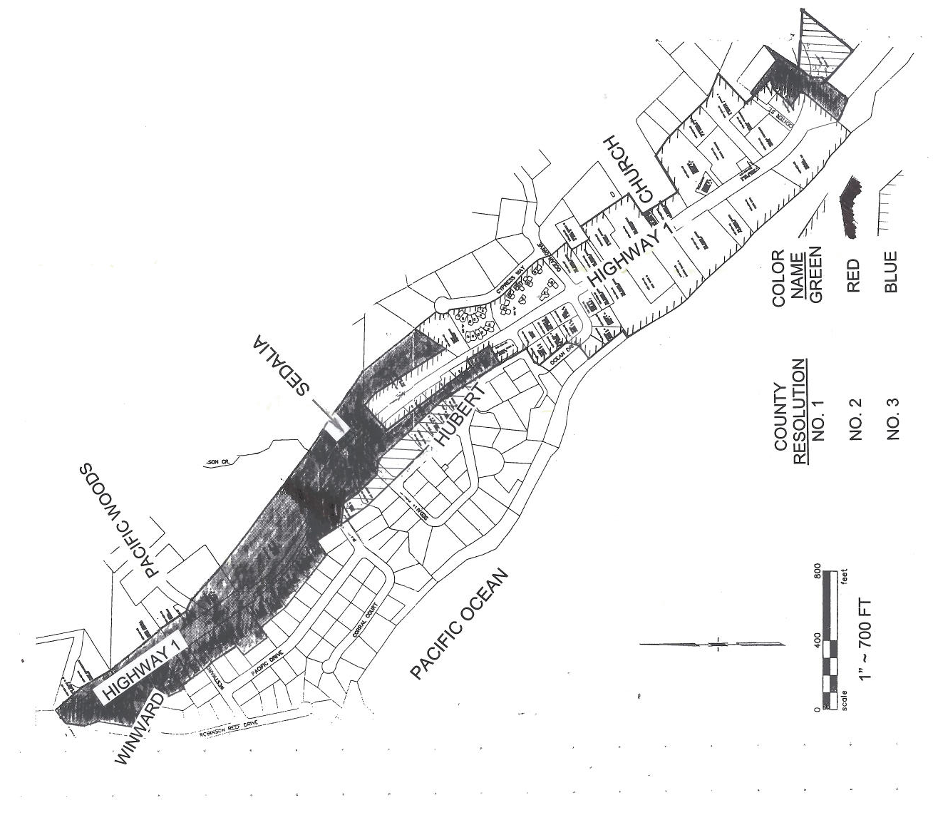
APPENDIX 2
Utility Undergrounding Project, Gualala, Mendocino County
Map of PROPOSED District Boundaries and Phases
2008

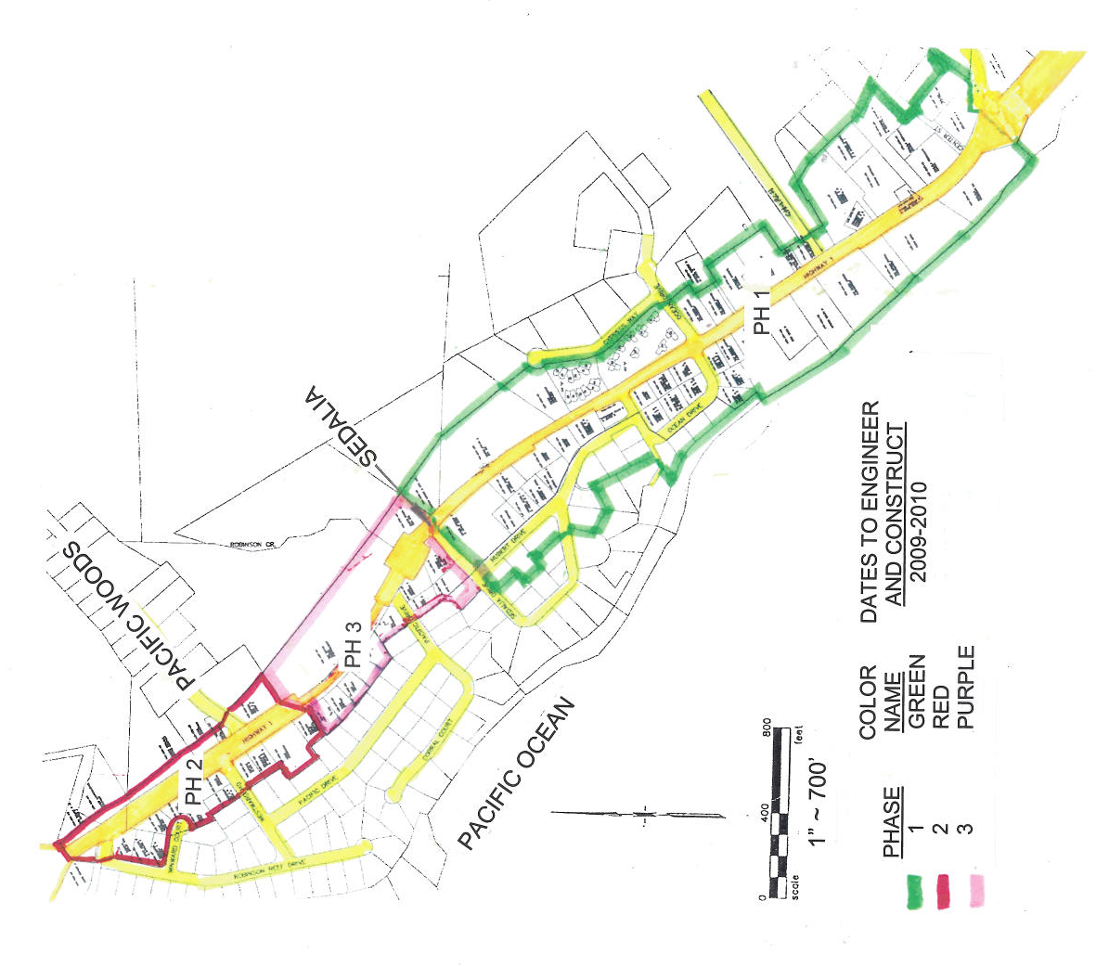

APPENDIX 3
Utility Undergrounding Project, Gualala, Mendocino County
Sequence of Community and Utility Planning Steps
County

APPENDIX 4
Consultation Guideline Between Community Agencies and Utilities

Before passing a resolution-

- Agency informs Utilities of potential Rule 20/32 project area.
- Agency holds a field meeting with Utilities to look over the proposed boundary area and provides preliminary plans for any new roadway, sidewalk, street lighting or agency underground facilities or relocations such as water, sewer, or storm drain.
- Agency takes the lead on environmental or other permit requirements if Agency will be making any improvements in the underground district. If the only improvements in the district will be undergrounding OH facilities, the Trench Lead will take the lead on permits.
- All parties discuss options related to who can or should be the Trench Lead. In general Agencies leave the Trench Lead role to one of the Utilities. In some cases an Agency takes the lead. However, Agencies cannot be reimbursed for their administrative costs such as project management, billing preparations, or contract administration (except for costs directly related to composite preparation).
- Utilities confirm the proposed boundary location qualifies and reviews possible trench, riser pole, and pad mounted equipment locations, and associated easements that may be needed.
- Agency provides additional property line and franchise limits data to allow utilities to confirm where facilities may be placed in franchise without need for easements and/or where easements are the only option.
- Agency provides the Trench Lead with acceptable drawings showing community owned improvements such as sewer, water, and storm drains if applicable. If drawings are not available the Agency is responsible for producing such information needed to complete the composite drawing.
- The Agency may wish to install facilities of their own in the joint trench, such as street light conduits. If so, the Agency will need to provide design plans for the composite drawing and pay their proportionate share of the trench costs.
- After further review of field meeting notes and technical analysis the Utilities make suggestions on boundary limits.
- Agency proceeds with the official resolution which includes the following – Legal property descriptions, an underground district boundary map, a list of affected property owners, notice of property owner responsibilities, and service conversion requirements of owners and utilities.
- Agency proceeds with EIR or other major filing. Utilities do not proceed with significant design work until Agency secures approval for EIR, related permits, and agreements from property owners to allow service conversion work to be performed.

After Agency passes a resolution-

- Utilities and Agency consult on final project boundary, main trench location, extent of undergrounding, including services, and confirm general locations requiring easements. Utilities do not proceed with significant design work or official easement requests until Agency secures approval for EIR and related permits.
- Utilities prepare easement documents and provide them to the agency who then negotiates agreements with property owners at agency expense
- After all easements are secured Utilities provide documents to Agency to send to property owners to allow Utilities and their contractors to work on service trenches and panel conversions.
- The Trench Lead can begin official engineering design work once data from the service trench and panel conversions contractor is received.
- The Trench Lead prepares a composite design and solicits design overlay engineering from the other utilities
- The Utilities confirm the final design and sign the Form B cost sharing agreements.
- If environmental contamination is encountered during trenching, work will stop until the Agency provides mitigation satisfactory to the Utilities including an acceptable place to temporarily store hazardous soils until the Agency sees to its disposal.

STATE OF CALIFORNIA ARNOLD SCHWARZENEGGER, Governor
PUBLIC UTILITIES COMMISSION
505 VAN NESS AVENUE
SAN FRANCISCO, CA 94102-3298

I.D. # 8069
Friday, October 31, 2008 RESOLUTION E-4180
Commission Meeting December 18, 2008

TO: PERSONS INTERESTED IN THE GUALALA, MENDOCINO COUNTY, UTILITY UNDERGROUNDING PROJECT UNDER RULE 32 OF AT&T AND RULE 20 OF PG&E

Enclosed is draft Resolution Number E-4180 of the Energy Division. I currently plan to place it on the Commission’s agenda for its meeting scheduled on December 18, 2008, which is at least 30 days after the date of this letter. The Commission may then vote on this Resolution or it may postpone a vote until later.

When the Commission votes on a draft Resolution, it may adopt all or part of it as written, amend, modify or set it aside and prepare a different Resolution. Only when the Commission acts does the Resolution become binding on the parties.

Persons may submit comments on the Draft Resolution. Comments on the Draft Resolution must be received by the Energy Division by Tuesday November 18, 2008. Those submitting comments must serve a copy of their comments on 1) the entire service list attached to the draft Resolution, 2) all Commissioners, and 3) the Director of the Energy Division, on the same date that the comments are submitted to the Energy Division.

Comments shall focus on factual, legal or technical errors in the proposed draft Resolution and be limited to five pages in length plus a subject index listing the recommended changes to the draft Resolution, a table of authorities and an appendix setting forth the proposed findings and ordering paragraphs.

Replies to comments on the draft resolution may be filed (i.e., received by the Energy Division) no later than Tuesday, November 25, 2008, and shall be limited to identifying misrepresentations of law or fact contained in the comments of other parties. Replies shall not exceed five pages in length, and shall be filed and served as set forth above for comments.

Late submitted comments or replies will not be considered.

An original and two copies of the comments and replies, with a certificate of service, should be submitted to:

Honesto Gatchalian
Energy Division
California Public Utilities Commission
505 Van Ness Avenue
San Francisco, CA 94102

A copy of the comments and replies should be submitted by email to:

Brian Schumacher
Energy Division
California Public Utilities Commission
505 Van Ness Avenue
San Francisco, CA 94102

Email: bds@cpuc.ca.gov
Fax: 415-703-2200

Please email an additional copy of comments and replies to:
David Lee at dkl@cpuc.ca.gov .

The fax machine is not attended. Please alert us by phone or email if you send us a fax.

If you have questions or need assistance please contact me by email or at 415-703-1226, or contact David Lee at dkl@cpuc.ca.gov or 415-703-1137.

Sincerely,

Brian Schumacher
Supervisor
Energy Division

Enclosure: Certificate of Service
Service List

CERTIFICATE OF SERVICE

I certify that I have by mail this day served a true copy of Draft Resolution E-4180 on all parties in these filings or their attorneys as shown on the attached list.

Dated October 31, 2008 at San Francisco, California.

____________________

Brian Schumacher

NOTICE

Parties should notify the Energy Division, Public Utilities
Commission, 505 Van Ness Avenue, Room 4002
San Francisco, CA 94102, of any change of address to
insure that they continue to receive documents. You
must indicate the Resolution number on the service list
on which your name appears.

Service List for Resolution E-4180

Service was made by email to the following persons:

Name Affiliation E-mail Address
Phone Number

Robert Juengling Oceanic Land Office robert@oceanicland.com
(707) 884-4757 Broker/Owner

William McCarthy Gualala Municipal Advisory Council wpm@northcst.com
(707) 884-3444 GMAC member

T. Keith Gurnee RRM Design Group tkgurnee@rrmdesign.com
(707) 696-2937 Principal

Tom Mitchell County of Mendocino mitchell@co.mendocino.ca.us
(707) 463-4441 Chief Executive Officer

Alison Glassey County of Mendocino glassea@co.mendocino.ca.us
(707) 463-4441 Assistant Chief Executive Officer

Jeanine Nadel County of Mendocino nadelj@co.mendocino.ca.us
(707) 463-4449 County Counsel

Howard Dashiell County of Mendocino dashielh@co.mendocino.ca.us
(707) 463-4363 Director, Dept. of Transportation

Bob Morgan County of Mendocino DOT morganb@co.mendocino.ca.us
(707) 463-5494 Engineering Technician

J. David Colfax County of Mendocino bos@co.mendocino.ca.us
(707) 463-4441 Board of Supervisors

Larry McDowell PG&E ldm6@pge.com
(707) 494-9115 Project Manager

Jim Dunlap PG&E jada@pge.com
(707) 577-7257 Land Agent

Sindy Mikkelsen PG&E slp6@pge.com
(707) 765-5110 Senior Program Manager

David Wong PG&E dlwt@pge.com
(707) 765-5112 Program Manager

Barbara Clement PG&E bhc4@pge.com
(415) 973-3660 Attorney

Charles Lewis IV PG&E crl2@pge.com
(415) 973-6610 Attorney

Micki Burton AT&T State Regulatory mb1469@att.com
(415) 778-1433 Associate Director

Name Affiliation E-mail Address
Phone Number____________________________________________

Carol Shaw AT&T cs1812@att.com
(707) 575-2077 Project Manager

Mike Schumacher AT&T ms4191@att.com
(707) 468-2999 Engineer

Joseph Tocco AT&T joseph.tocco@att.com
(via teleconference) General Attorney
(925) 823-8395

Lori Ortenstone AT&T lori.ortenstone@att.com
(via teleconference) General Attorney
(916) 341-3414

Maryliz DeJong AT&T maryliz.dejong@att.com
(via teleconference) Director Regulatory
(415) 778-1462

Brian Schumacher CPUC bds@cpuc.ca.gov
(415) 703-1226 Program and Project Supervisor

David Lee CPUC dkl@cpuc.ca.gov
(415) 703-1137 Utilities Engineer

For convenience, we refer to the conversion tariffs as “Rule 20” since all electric and telephone utilities have tariffs that mirror PG&E’s Rule 20.
Like all other utility investments, the utility does not collect from the ratepayers on undergrounding projects until the project is put into service. Under Rule 20, the Commission authorizes the utility to spend a certain amount of money each year on conversion projects, the utility records the cost of each project in its electric plant account for inclusion in its rate base upon completion of the project. Then, the Commission authorizes the utility to recover the cost from ratepayers until the project cost is fully depreciated.
Criterion d. was added to Rule 20 in 2001 but not to Rule 32 due to oversight.
AT&T, Verizon, SureWest and Frontier’s basic residential rates are capped until January 1, 2011.
First Mendocino County Resolution No. 00-145 dated August 2000. Besides AT&T and PG&E, unregulated cable services are a third utility service sharing the cost of this undergrounding project.
All three utilities (including cable service) share project costs but one of them on each project, often PG&E but AT&T in this case is the lead utility to secure permits and conduct trenching for example.
Second Mendocino County Resolution No. 06-206 dated October 24, 2006.
CPUC Resolution E-4100 dated June 21, 2007.
Third Mendocino County Resolution No. No. 07-163 dated August 14, 2007.

