Agenda ID# 8250

D R A F T

PUBLIC UTILITIES COMMISSION OF THE STATE OF CALIFORNIA

Communications Division | RESOLUTION T- 17187
Carrier Oversight and Programs Branch | February 20, 2009

R E S O L U T I O N

Resolution T-17187 Approval of Funding for the Highway 299 Broadband Network Project of Broadband Associates International, Inc., from California Advanced Services Fund (CASF) Amounting to $7,830,720
__________________________________________________________________

Summary

This Resolution adopts funding for the Highway 299 Broadband Network project of Broadband Associates, International, Inc., (Broadband Associates) amounting to $7,830,720 from the California Advanced Services Fund (CASF). The amount granted represents 40% of the total project cost of this unserved area application filed in accordance with Resolution T-17143.

Background

On December 20, 2007, the Commission approved Decision (D.) 07-12-054 which established the two-year CASF program to provide matching funds of up to 40% of the total project costs for the deployment of broadband infrastructure in unserved and underserved areas in California. Resolution T-17143, approved on June 12, 2008, adopted the application requirements, scoring criteria for the award of funds, and a prescribed timeline for other filings and notifications including a projected Commission Meeting date for final approval of award(s). This same Resolution directed interested applicants seeking funding for unserved projects to file their project proposals and funding requests on July 24, 2008. Twenty-three (23) project proposals were received that sought CASF funding for unserved areas. Of these, sixteen (16) were challenged by various parties contending that the areas proposed were already served. One (1) project proposed was not considered since the proponent was not a telephone corporation as defined under Public Utilities Code § 234. Six (6) unchallenged applications were approved by the Commission in Resolution T-17182.

The Highway 299 Broadband Network project was one of the 16 above-mentioned projects challenged. This resolution addresses the merits of the project and challenges and whether CASF funds should be awarded.

Notice/Protests

The CBG list appeared by county on the Commission’s CASF website page under “UNSERVED areas proposed to be served as of July 24, 2008: Census Block Groups (CBGs).” The CBGs covered by this project were formally challenged either by existing service providers or other interested parties. Therefore, CD proceeded with a review and analysis of this project area to verify that it was indeed unserved as of the applicant’s filing date.

Discussion

This Resolution adopts a total of $7,830,720 in CASF funding support for the Highway 299 Broadband Network project. The project is described in detail in Appendix A.

For qualification purposes under the CASF program, unserved areas are defined as areas not served by any form of facilities-based broadband or where Internet connectivity is available only through dial-up service or satellite. CD reviewed this project’s eligibility in the unserved review phase through the analysis of the required data submitted. These data include, but are not limited to: proof of CPCN registration; descriptions of current and proposed broadband infrastructure; Geographic Information System (GIS) formatted Shapefiles mapping the subject areas; assertion that the area is unserved; potential subscriber size and household incomes; project construction schedule; project budget; proposed pricing and commitment period for new subscribers; and, financial qualifications of the applicant. In addition, CD reviewed the Shapefiles submitted which mapped the broadband deployment proposed using United States 2000 Census data and the January, 2008, Broadband Task Force Report (BBTF) including its on-line maps, among others. Comparisons of submitted maps to that of the BBTF verified the existence or non-existence of broadband service as well as speeds in areas where broadband services are available.

When necessary, CD performed further verification with the applicant which included the submission of additional data and/or holding meetings with the applicant in order to clarify its project proposal.

Broadband Associates, a wireless corporation registered with the Commission since September, 2007, submitted its proposal for the Highway 299 Broadband Network project to provide broadband coverage in portions of Humboldt, Trinity, and Shasta Counties. Broadband Associates plans to offer wireless internet access via a backhaul constructed of new fiber optic lines connected to towers that will transmit signal to communities along the route. Potential subscribers include educational institutions, businesses, government entities, and residents along the 150 mile road. This project will be able to serve approximately 5,734 households covering an area of about 1,000 square miles in 18 CBGs at average speeds of 2 Megabits Per Second (MPBS) download and 2 MBPS upload. The 40% CASF subsidy for the project is $7,830,720 of the total project cost of $19,576,800.

Of the 40 CBGs proposed, 24 were challenged by other parties. The challenging parties asserted that some Census Block Groups (CBGs) and ZIP codes in the proposed area are already served. After additional analysis and review including, but not limited to, requesting information from challenger(s) and applicant, Communications Division (CD) resolved 2 challenged CBGs and Broadband Associates removed the remaining 22 challenged CBGs. In summary, CD has determined that 18 CBGs covering the proposed area, as modified, are qualified as unserved as defined in Resolution T-17143.

The Highway 299 Broadband Network project was evaluated using the scoring criteria adopted in Resolution T-17143. While the project’s metrics did not meet the 3 MBPS download and 1 MBPS upload speed, this project was the only proposal submitted for this unserved northern area of the State. As such, this proposal will expand broadband service to some unserved communities along Highway 299. Further, given that there is $100 million available for the CASF projects and the amount approved to date for CASF projects is only $372,976, approval of this project will not significantly affect the availability of funds for future CASF applications. The Highway 299 Broadband Network project is, therefore, recommended for approval and award of CASF funding.

The Application Requirements and Guidelines on the awarding of CASF Funds put forth the information required for each proposed broadband project filed including, but not limited to, documentation of an executed Performance Bond and California Environmental Quality Act (CEQA) compliance. In its application, Broadband Associates indicated that it shall obtain matching funds from outside funding sources for 60% of the total project costs and, therefore, is required to obtain a proper performance bond equal to the total amount payable under this CASF award, or 40% of the total project costs. The performance bond will ensure completion of the proposed project and does not extend to ensuring continued operations. Broadband Associates agrees to provide a copy of the executed bond within five (5) business days after the effective date of this award.

Broadband Associates is required to comply with all the other guidelines, requirements, and conditions associated with the granting of CASF funds as specified in T-17143 including the submission of FCC Form 477.

In addition, Broadband Associates agrees to comply with the CEQA requirement, essentially providing a Proponent’s Environmental Assessment (PEA) prior to the first 25% payment and will include any other special permits required cross referenced to the government agencies from which said permits are obtained for the project.

Payments to CASF Recipients

Submission of invoices from and payments to Broadband Associates shall be made in accordance with Section IX of Appendix A of Resolution T-17143 and according to the guidelines and supporting documentation required in Resolution T-17143.

Since CASF funding is limited to entities with a Certificate of Public Convenience and Necessity (CPCN) that qualify as a “telephone corporation” as defined under P. U. Code
§234 or wireless carriers registered with the Commission over which the Commission has jurisdiction, payment to Broadband Associates shall essentially follow the process adopted for funds created under Public Utilities Code §270. The following table describes the timeline for processing CASF payments.

Event | Payment Cycle 1  (Day/Month) | Payment Cycle 2  (Day/Month)
Invoices due from Broadband Associates to CD | 5th of Month 1 | 20th of Month 1
Payment letters from CD to Information and Management Services Division (IMSD) | On 19th of Month 1 | On 4th of Month 2
Invoices submitted from IMSD to State’s Controller Office (SCO) for payments | 20th through 26th of Month 1 | 5th through 13th of Month 2

Broadband Associates may submit its invoices under Payment Cycle 1 or 2.

If any date in this payment schedule falls on a weekend or holiday, that date will be advanced to the next business day but the remaining dates in the payment schedule will remain unchanged. SCO requires 14 to 21 days to issue payment from the day that requests are received by SCO.

Comments on Draft Resolution

In compliance with PU Code § 311(g), a notice letter was emailed on January 20, 2009, informing a) all applicants filing for unserved areas and b) parties on the service list of R.06-06-028 of the availability of the draft of this Resolution for public comments at the Commission's website http://www.cpuc.ca.gov/static/documents/index.htm. This letter also informed parties that the final conformed Resolution adopted by the Commission will be posted and will be available at this same website.

Responses to timely filed comments will be addressed in this resolution.

Findings

- The California Advanced Services Fund (CASF) was implemented by Decision (D.) 07-12-054. The CASF was established as a two-year program that will provide matching funds of up to 40% of the total project costs for the deployment of broadband infrastructure in unserved and underserved areas in California.
- Resolution T-17143, approved on June 12, 2008, adopts the application requirements and scoring criteria for the award of funds, a prescribed timeline for other filings, and notifications including a projected Commission Meeting date for final approval of award(s). T-17143 directed interested applicants seeking funding for unserved projects to file their project proposals and funding requests on July 24, 2008.
- Unserved areas are defined as areas which are not served by any form of facilities-based broadband or where Internet connectivity is available only through dial-up or satellite service.
- A list of census block groups (CBGs) appeared by county on the Commission’s CASF website page under “UNSERVED areas proposed to be served as of July 24, 2008: Census Block Groups (CBGs).” The Communications Division (CD) proceeded with its independent review and analysis of this project area to verify that it was unserved as of the applicant’s filing date.
- CD reviewed the Broadband Associates International, Inc., Highway 299 Broadband Network eligibility through the analysis of required data submitted. These data include, but are not limited to: proof of CPCN registration; descriptions of current and proposed broadband infrastructure; geographic information system (GIS) formatted Shapefiles mapping the subject areas; assertion that the area is unserved; potential subscriber size and household incomes; project construction schedule; project budget; proposed pricing and commitment period for new subscribers; and, financial qualifications of the applicant.
- Shapefiles, which mapped the broadband deployment, were reviewed by CD using sources including, but not limited to, the United States 2000 Census data and the January, 2008, Broadband Task Force Report and its available on-line maps. These maps helped to verify the existence or non-existence of broadband service areas and broadband speeds, where available.
- CD verified this project and, when necessary, requested additional information and/or meetings with the applicant to clarify its project proposal. Of the 40 CBGs in this project, 24 were formally challenged by either existing service providers or other interested parties. Of the 24 challenged CBGs, 2 were resolved and Broadband Associates International, Inc., removed the remaining 22 challenged CBGs. CD determined that 18 CBGs covering the proposed area, as modified, are qualified as unserved as defined in Resolution T-17143.
- After its review, CD determined the Highway 299 Broadband Network application for unserved areas covering 18 CBGs as eligible to receive funding under CASF.
- The posting of a performance bond by Broadband Associate International, Inc., should be required for this recipient in order to compensate the CASF in the event of project failure.
- Broadband Associates, International, Inc., should comply with all guidelines, requirements, and conditions associated with the granting of CASF funds as specified in Resolution T-17143 including the submission of FCC Form 477 and compliance with the California Environmental Quality Act, among others.
- A notice letter was emailed on January 20, 2009 informing a) all applicants filing for unserved areas and b) parties on the service list of R.06-06-028 of the availability of the draft of this Resolution for public comments at the Commission's website http://www.cpuc.ca.gov/static/documents/index.htm. This letter also informed parties that the final conformed Resolution adopted by the Commission will be posted and available at this same website.
12. The Commission finds CD’s recommendation of CASF award for the Highway 299 Broadband Network project summarized in Appendix A of this Resolution to be reasonable and consistent with Commission orders and should be adopted.

THEREFORE, IT IS ORDERED that:

- The California Advanced Services Fund shall award $7,830,720 to Broadband Associates International, Inc., for the Highway 299 Broadband Network project for unserved areas as described in the Discussion section and summarized in Appendix A of this Resolution.
- Broadband Associates, International, Inc., shall be required to post a performance bond.
- The program fund payment of $7,830,720 for this Commission-approved unserved project shall be paid out of the CASF fund in accordance with the guidelines adopted in Resolution T-17143.
- Payments to the CASF recipient shall be in accordance with Section IX of Appendix A of Resolution T-17143 and in accordance with the process defined in the “Payments to CASF Recipients” section of this Resolution.
- The CASF fund recipient, Broadband Associates International, Inc., shall comply with all guidelines, requirements and conditions associated with the CASF funds award as specified in Resolution T-17143.

This Resolution is effective today.

I hereby certify that this Resolution was adopted by the Public Utilities Commission at its regular meeting on February 20, 2009. The following Commissioners approved it:

PAUL CLANON

Executive Director

APPENDIX A
Resolution T- 17187
Highway 299 Broadband Network Key Information

1 | Project ID | Broadband Associates Int., Inc.
2 | Project Name | Highway 299 Broadband Network
3 | Project Plan | 150 mile fiber optic infrastructure construction along Highway 299 in and through Humboldt, Trinity, and Shasta counties
4 | Project Size (in square miles) | 1,000
5 | Download speed | 2 Mbps
6 | Upload speed | 2 Mbps
7 | Location | Hwy 299 between Redding and Eureka
 |  | a) Community Name | c) Zip Codes
 |  | Glendale/Blue Lake | 95525
 |  | Korbel | 95550
 |  | Willow Creek | 95573
 |  | Salyer | 95563
 |  | Burnt Ranch/Hawkins Bar/Trinity Village | 95527
 |  | Big Bar/Big Flat/Del Loma | 96010
 |  | Junction City | 96048
 |  | Weaverville | 96093
 |  | Douglas City | 96024
 |  | Lewiston | 96052
 |  | French Gulch | 96033
 |  | b) CBGs | Median Household Income
 |  | 60230101021 | $22,984
 |  | 60230101024 | $42,813
 |  | 60230103003 | $32,443
 |  | 60230103004 | $29,583
 |  | 60230103005 | $44,375
 |  | 60890124001 | $30,000
 |  | 60890124002 | $39,625
 |  | 61050001003 | $34,853
 |  | 61050001004 | $31,687
 |  | 61050001005 | $41,083
 |  | 61050001006 | $30,822
 |  | 61050001007 | $30,144
 |  | 61050001008 | $31,583
 |  | 61050001009 | $26,736
 |  | 61050002002 | $24,206
 |  | 61050002003 | $26,696
 |  | 61050002004 | $21,250
 |  | 61050002005 | $34,063

APPENDIX A
Resolution T- 17187
Highway 299 Broadband Network Key Information

8 | Estimated Potential Subscriber Size
a) | Households | 5,734
9 | Deployment Schedule (from Commission approval) | 11 months
10 | Proposed Project Budget
 | CASF (40%) | $7,830,720
 | CIAC
 | Amount of CASF Funds Requested | $7,830,720
APPENDIX A
Resolution T- 17187
Highway 299 Project Shapefiles

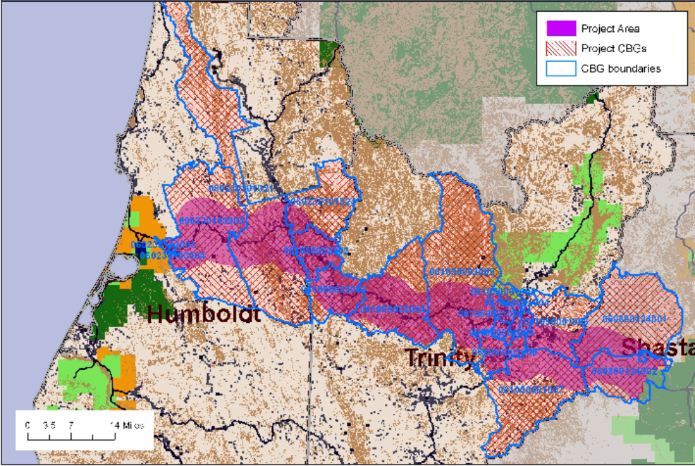

APPENDIX A
Resolution T- 17187
Highway 299 Statewide Map

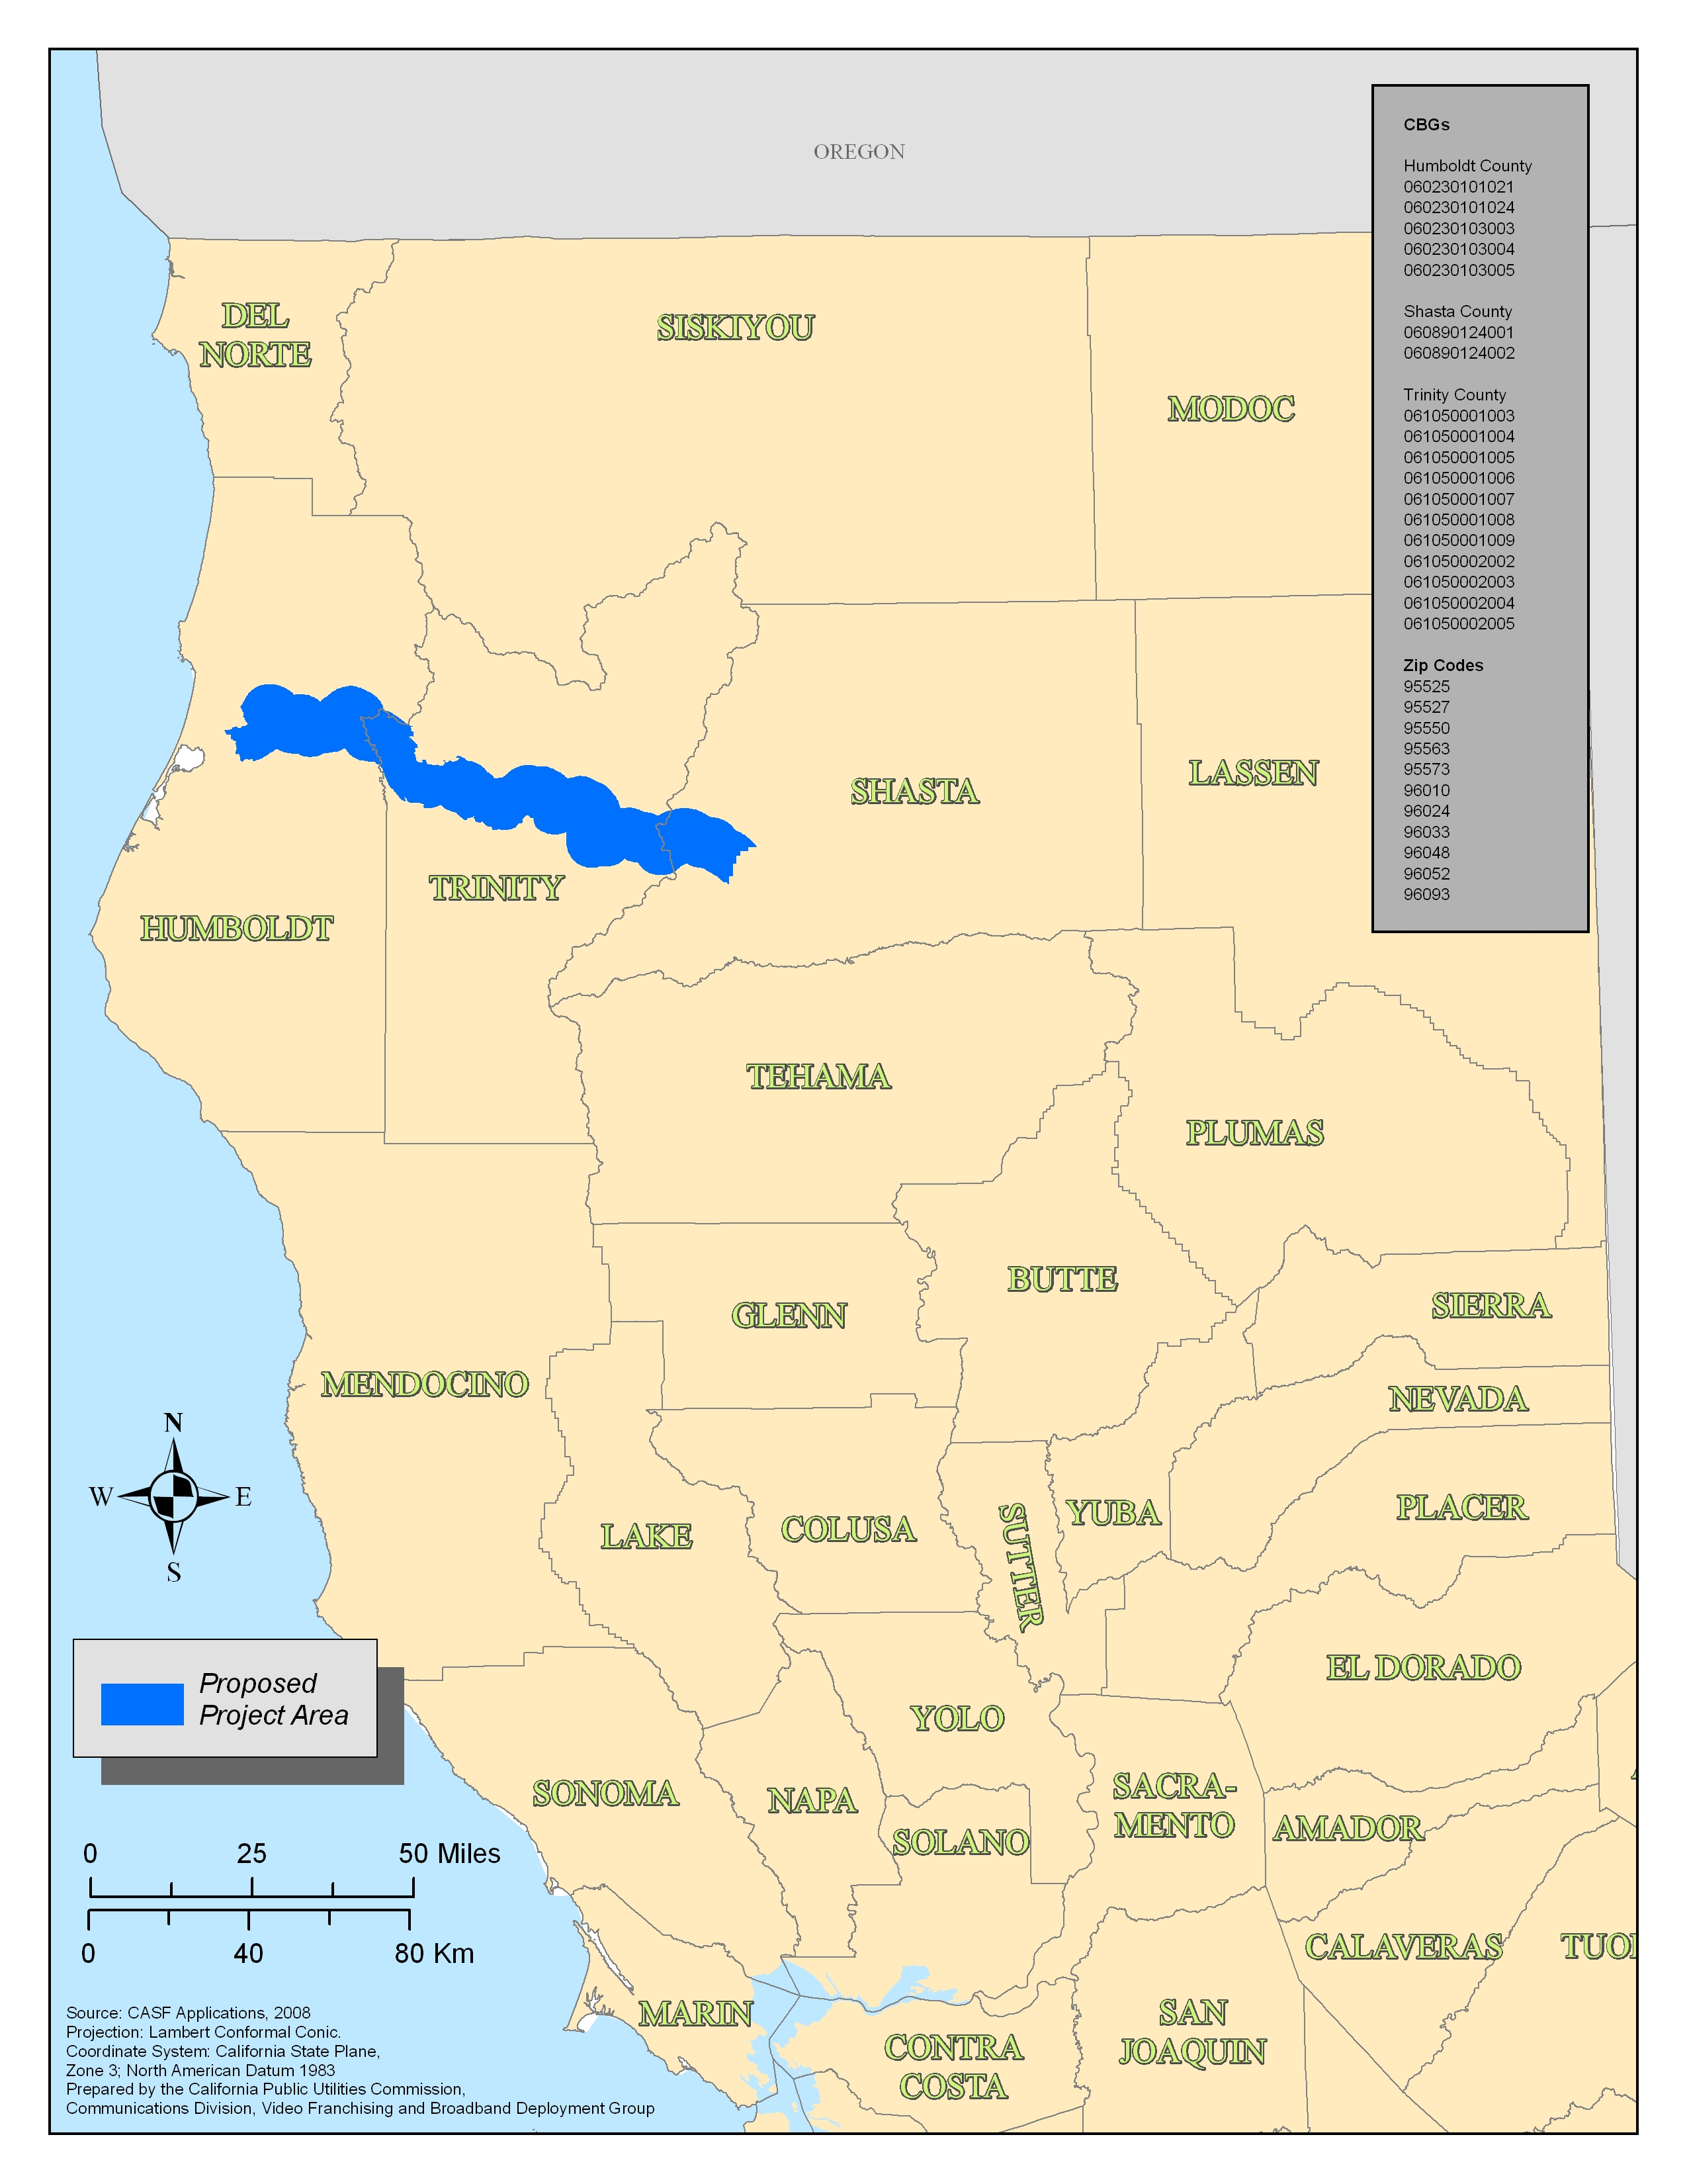

T-17187 CASF Notices of Availability.

SB 1193 (Chapter 393, Statutes of 2008) established the California Advanced Services Fund as a new public purpose program.
Resolution T-17143
The above schedule is contingent on the CASF recipient submitting clear, complete, an error free invoices to CD. Additional time to process payments may be necessary if CD finds problems with the submitted invoices.

