CPSD/RWC/HMJ/VSJ/vdl Mailed 11/22/02

Decision 02-11-063 November 21, 2002

BEFORE THE PUBLIC UTILITIES COMMISSION OF THE STATE OF CALIFORNIA

Application of the City of Placentia requesting approval of the installation of quad gates with pre signals and other crossing enhancements within Kellogg Drive, CPUC Crossing No. 2B-39.20 and Placentia Avenue, CPUC Crossing No. 2B-43.6, a distance of 4.4 miles. | Application 01-08-016  (Filed August 13, 2001;  Amended June 17, 2002;  Supplemented September 9, 2002)

O P I N I O N

Summary
The City of Placentia (Applicant) requests authority to upgrade eight highway-rail at-grade crossings over Burlington Northern Santa Fe Railway Company’s (BNSF) San Bernardino Subdivision (2B Line) tracks, in cities of Anaheim, Placentia, and unincorporated areas of County of Orange, in Orange County.

Discussion
On August 13, 2001, the Applicant filed Application (A.) 01-08-016 to request authority to modify 11 crossings along what is commonly know as the Placentia Corridor of BNSF’s 2B Line. A.01-08-016 originally stated that two of the 11 crossings are to be grade-separated and one is to be closed.
On September 17, 2001 Southern California Regional Rail Authority (SCRRA), which is a regional independent joint powers authority that operates Metrolink commuter trains over these crossings, filed a document titled “Response to Application.” In this document SCRRA stated that even though its trains use these crossings and their safety is directly impacted by the modifications described in A.01-08-016, it was not included in the Service List of the application. SCRRA further stated that it is not prepared to declare itself as a protestant, but instead its status for now is that of interested party/intervenor. However, at the end of the document SCRRA stated that it “expects to present evidence and witnesses supporting facts consistent with the full scope of its interest relative to the relief sought by the application.”
In a letter dated November 6, 2001, the Applicant requested that the Commission’s Consumer Protection and Safety Division – Rail Crossings Engineering Section staff (Staff) temporarily hold A.01-08-016 from further processing until discussions with SCRRA were completed.
On February 22, 2002, the Applicant filed A.02-02-022 to request Commission’s authority to grade-separate Melrose Street, one of the 11 crossings that was originally part of A.01-08-016. Commission authority was granted on June 27, 2002 by Decision 02-06-061.
On April 4, 2002, SCRRA filed a document titled “Withdrawal of Response.” It stated that after significant and lengthy discussions between the Applicant and SCRRA regarding A.01-08-016 the issues were resolved.
On June 17, 2002 the Applicant filed an Amended Application, a notice of which was published on the Commission’s June 25, 2002 Daily Calendar.
On August 27, 2002 the Applicant filed A.02-08-026 to grade-separate Placentia Ave, another one of the 11 crossings that was originally part of A.01-08-016.
On September 9, 2002 the Applicant filed a Supplement to A.01-08-016. The Supplement, among other things, states that the number of crossings subject to A.01-08-016 is reduced from 11 to eight. Of the three crossings eliminated from A.01-08-016, two (Melrose Street and Placentia Avenue) will be grade-separated, and one (Bradford Avenue) will be closed. Therefore, the project will include grade crossings between Kellogg Drive (Crossing No. 2B-39.20) and Kraemer Boulevard (Crossing No. 2B-42.50), a distance of 3.3 miles instead of the original 4.4 miles.
Throughout this entire process Staff participated in on-going meetings, telephone conversations, and written correspondences with BNSF, SCRRA, the Applicant, and Applicant’s consultants in order to resolve outstanding issues. Attached in Appendix D is a summary of these correspondences.
Appendix A lists the eight crossings subject to A.01-08-016, and proposed warning devices for each.
The Applicant, City of Placentia, is the lead agency for this project under the California Environmental Quality Act of 1970 (CEQA), as amended, Public Resources Code Section 21000 et seq. The Applicant claims categorical exemption from CEQA pursuant to the Commission’s Rules of Practice and Procedure, Rule 17.1(h), (A) 5, 6, and 7, which state:
(A) Class 1 Exemptions.
5. Alteration in railroad crossing protection.
6. Minor railroad crossing alterations as described in Guidelines Section 15101 (c) and (f), including, but not limited to filings under General Order No. 88-A.
- Installation of new railroad-highway signals or signs.
Furthermore, on October 18, 2001 the Applicant filed a Notice of Exemption (NOE) with the Office of Planning and Research and the Orange County Clerk. The NOE, which is included in Appendix C, claims categorical exemption pursuant to CEQA Guidelines, Section 15301(f), which states:
Article 19. Categorical Exemptions
15301. Existing Facilities
(f) Addition of safety or health protection devices for use during construction of or in conjunction with existing structures, facilities, or mechanical equipment, or topographical features including navigational devices;
The Commission is a responsible agency for this project under CEQA and has reviewed and considered the lead agency exemption determination. The Commission finds that the City’s Notice of Exemption from CEQA is adequate for our decision-making purposes and that the facts of this case appropriately warrant application of the CEQA exemption adopted by the Applicant. Therefore, we similarly adopt the CEQA Guidelines - Section 15301(f) exemption for purposes of our approval. Staff has inspected the sites of the proposed project, examined the safety of the proposed grade crossing, and recommends that A.01-08-016 be approved.
A.01-08-016 was found to be in compliance with the Commission's filing requirements, including Rules 38-41 of the Rules of Practice and Procedure, which relate to the construction of railroad crossings. A vicinity map is shown in Appendix B.
In Resolution ALJ 176-3069, dated August 23, 2001 and published in the Commission Daily Calendar on August 24, 2001, the Commission preliminarily categorized A.01-08-016 as ratesetting, and preliminarily determined that hearings were not necessary. Since no protests were filed and no hearings were held, this preliminary determination remains accurate. Given these developments a public hearing is not necessary, and it is not necessary to disturb the preliminary determinations made in Resolution ALJ 176-3069.
This is an uncontested matter in which the decision grants the relief requested. Accordingly, pursuant to Public Utilities Code Section 311(g)(2), the otherwise applicable 30-day period for public review and comment is being waived.
Assignment of Proceeding
Richard Clark is the assigned Examiner in this proceeding.
Findings of Fact
- Notice of A.01-08-016 was published in the Commission’s Daily Calendar on August 16, 2001. An Amended Application was filed on June 17, 2002, and published in the Commission’s Daily Calendar on June 25, 2002. Supplement to the A.01-08-016 was filed on September 9, 2002. There are no unresolved matters or protests; a public hearing is not necessary.
- The Applicant requests authority, under Public Utilities Code Sections 1201-1205, to upgrade eight at-grade crossings over BNSF’s 2B Line, in the cities of Anaheim, Placentia, and unincorporated areas of County of Orange, in Orange County.
- The proposed upgrades will enhance the safety of the crossings.
- The City filed an NOE on October 18, 2001, with the Office of Planning and Research and Orange County Clerk, which stated that the proposed project is categorically exempt pursuant to CEQA Guidelines Section 15301(f).
- The City is the lead agency for this project under CEQA, as amended.
- The Commission is a responsible agency for this project and has reviewed and considered the lead agency's exemption determination.
Conclusions of Law
- The Commission finds that the City’s NOE is adequate for our decision-making purposes and we adopt that exemption from CEQA for purposes of our approval.
- A.01-08-016 should be granted as set forth in the following order.
ORDER

IT IS ORDERED that:
- The City of Placentia (Applicant) is authorized to upgrade eight highway-rail at-grade crossings on Burlington Northern Santa Fe Railway Company’s (BNSF) San Bernardino Subdivision, as more fully described in Application (A.) 01-08-016 and Appendix A of this order, in cities of Anaheim, Placentia, and unincorporated areas of County of Orange, in Orange County.
- Construction and maintenance of the crossings shall be in accordance with the provisions of General Order (GO) 72-B
- Crossing warning devices shall be in accordance with the provisions of GO 75-C, and as set forth in Appendix A and as more fully described by the text and plans in A.01-08-016.
- Clearances shall be in accordance with GO 26-D. Walkways shall conform to GO 118.
- Construction and maintenance costs shall be borne in accordance with an agreement, which has been entered into between the parties. Applicant shall provide a copy of the agreement to the Commission’s Consumer Protection and Safety Division – Rail Crossings Engineering Section staff (Staff) prior to starting construction.
- Within 30 days after completion of the work under this order, BNSF shall notify Staff in writing, by submitting a completed standard Commission Form G (Report of Changes at Highway Grade Crossings and Separations), that the authorized work is completed.
- This authorization shall expire if not exercised within two years unless time is extended or if the above conditions are not complied with. Authorization may be revoked or modified if public convenience, necessity, or safety so require.
- The application is granted as set forth above.
- A.01-08-016 is closed.
This order becomes effective 30 days from today
Dated November 21, 2002, at San Francisco, California.

LORETTA M. LYNCH
President
HENRY M. DUQUE
CARL W. WOOD
MICHAEL R. PEEVEY
Commissioners

Commissioner Geoffrey F. Brown, being necessarily absent, did not participate.

Street Name | Crossing Number | City | Type and Number of Proposed Standard Warning Devices
Street Name | Crossing Number | City | Southeast Quadrant | Northeast Quadrant | Northwest Quadrant | Southwest Quadrant
Kellogg Drive | 2B-39.20 | Anaheim | 2 #9s | 1 #9 | 1 #9 | None
Lakeview Ave | 2B-39.90 | Anaheim | 1 #9A & 1 #9 | 2 #9s | 2 #9s | None
Richfield Rd | 2B-40.40 | Placentia | 1 #9A & 1 #9 | 2 #9s | 2 #9s | 1 #9
Van Buren St | 2B-40.70 | Placentia | 1 #9A & 1 #9 | 2 #9s | 1 #9 | None
Jefferson St | 2B-41.00 | Placentia | 1 #9A & 1 #9 | 2 #9s | 2 #9s | None
Tustin Ave/Rose Dr | 2B-41.50 | County | 2 #9As | 2 #9s | 1 #9A & 1 #9 | None
Orangethorpe Ave | 2B-41.80 | Anaheim | None | 1 #9A & 1 #9 | None | 1 #9A & 1 #9
Kraemer Blvd | 2B-42.50 | Anaheim | 2 #9s | None | 1 #9A & 1 #9 | 2 #9s

The following are definitions of Standard Warning Devices,
as Described in Commission General Order 75-C

#8 – Flashing light signal
# 9 – Same as #8, but with automatic gate
# 9A – Same as a #9, but with additional flashing lights on a cantilevered mast arm

Street Name | Crossing Number | Type and Number of Standard Warning Devices
Street Name | Crossing Number | Existing | Proposed | Comments
Kellogg Drive | 2B-39.20 | 4 #9s | 4 #9s | The existing median mounted #9 on the northwest quadrant will be turned around to cover the northeast quadrant. The existing curb mounted #9 on the northwest quadrant will be elongated to cover the entire quadrant.
Lakeview Ave | 2B-39.90 | 1 #9A & 3 #9s | 1 #9A & 5 #9s | Add two more #9s on the northeast quadrant
Richfield Rd | 2B-40.40 | 1 #9A & 3 #9s | 1 #9A & 6 #9s | Add two more #9s on the northeast quadrant, and 1 more #9 on the southwest quadrant.
Van Buren St | 2B-40.70 | 2 #9s & 2 #8s | 1 #9A & 4 #9s | Replace curb mounted #9 on southeast quadrant with a #9A. Replace median mounted #8 on south side of tracks with #9 to cover southeast quadrant. Replace median mounted #8 on north side of tracks with #9 to cover northeast quadrant. Add a curb mounted #9 for northeast quadrant.
Jefferson St | 2B-41.00 | 1 #9A & 3 #9s | 1 #9A & 5 #9s | Add two more #9s to cover northeast quadrant.
Tustin Ave/ Rose Dr | 2B-41.50 | 1 #9A & 3 #9s | 3 #9As & 3 #9s | Upgrade median mounted #9 on southeast quadrant to a #9A. Upgrade curb mounted #9 on northwest quadrant to a #9A. Add two more #9s to cover northeast quadrant.
Orangethorpe Ave | 2B-41.80 | 4 #9s | 2 #9As & 2 #9s | Replace 2 curb mounted #9s with #9As.
Kraemer Blvd | 2B-42.50 | 4 #9s | 1 #9A & 5 #9s | Replace curb mounted #9 on northwest quadrant with a #9A, and add two more #9s to cover southwest quadrant.

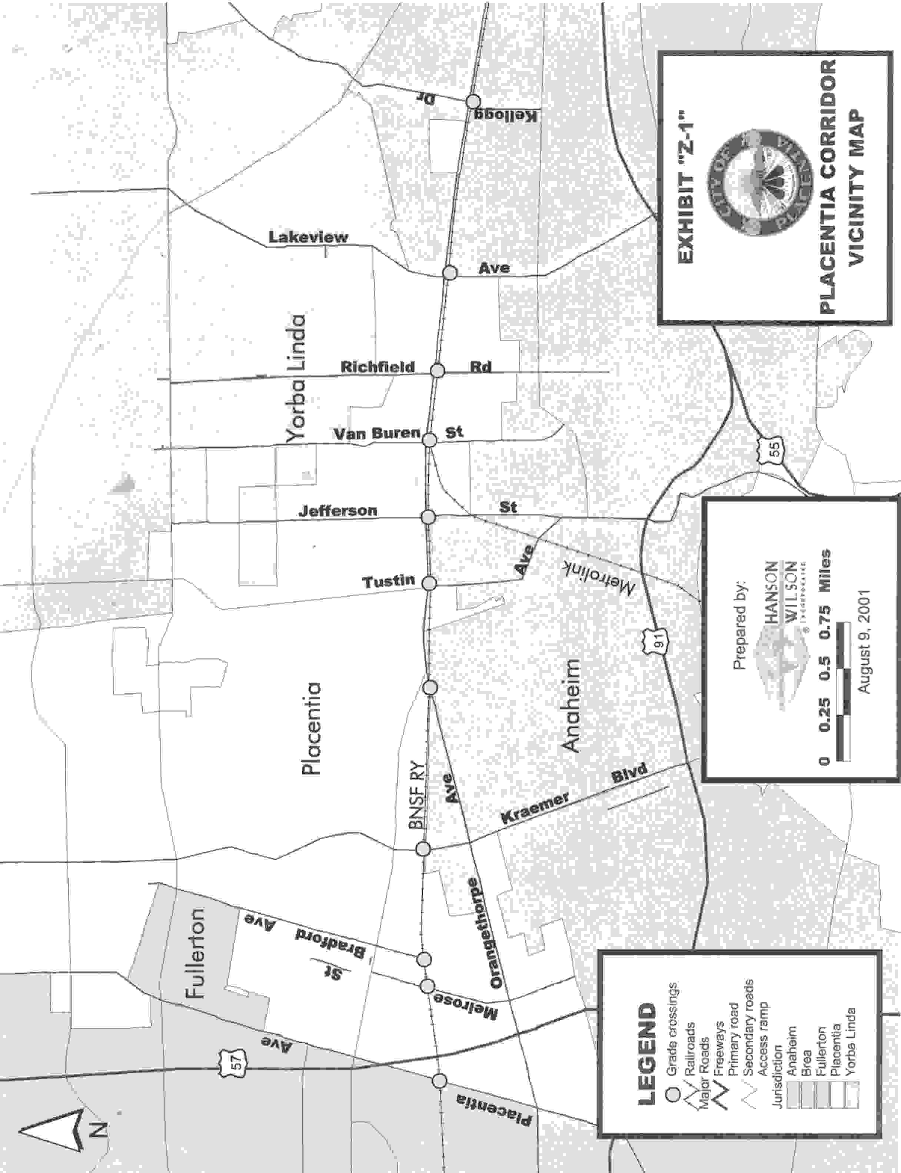

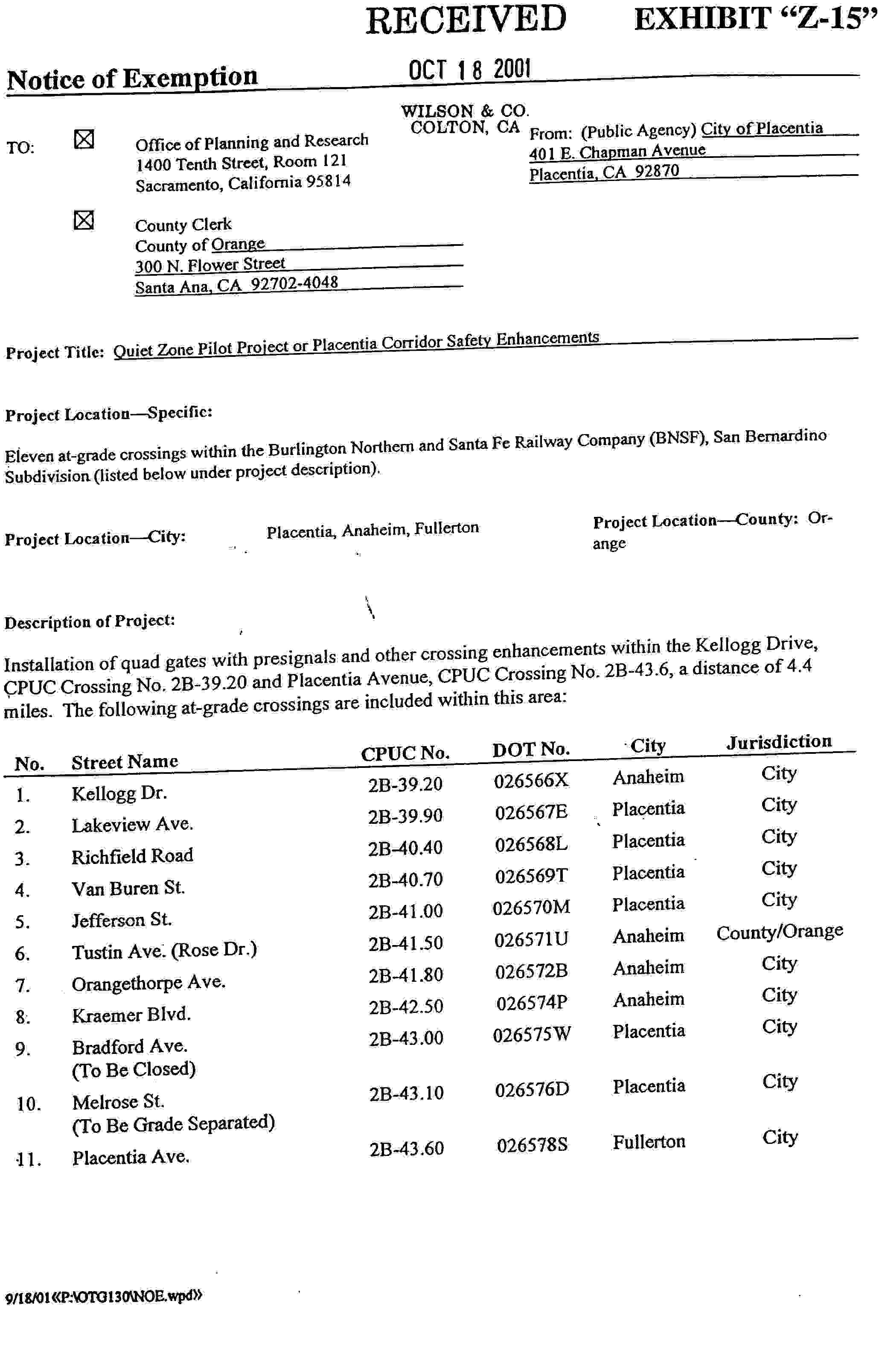

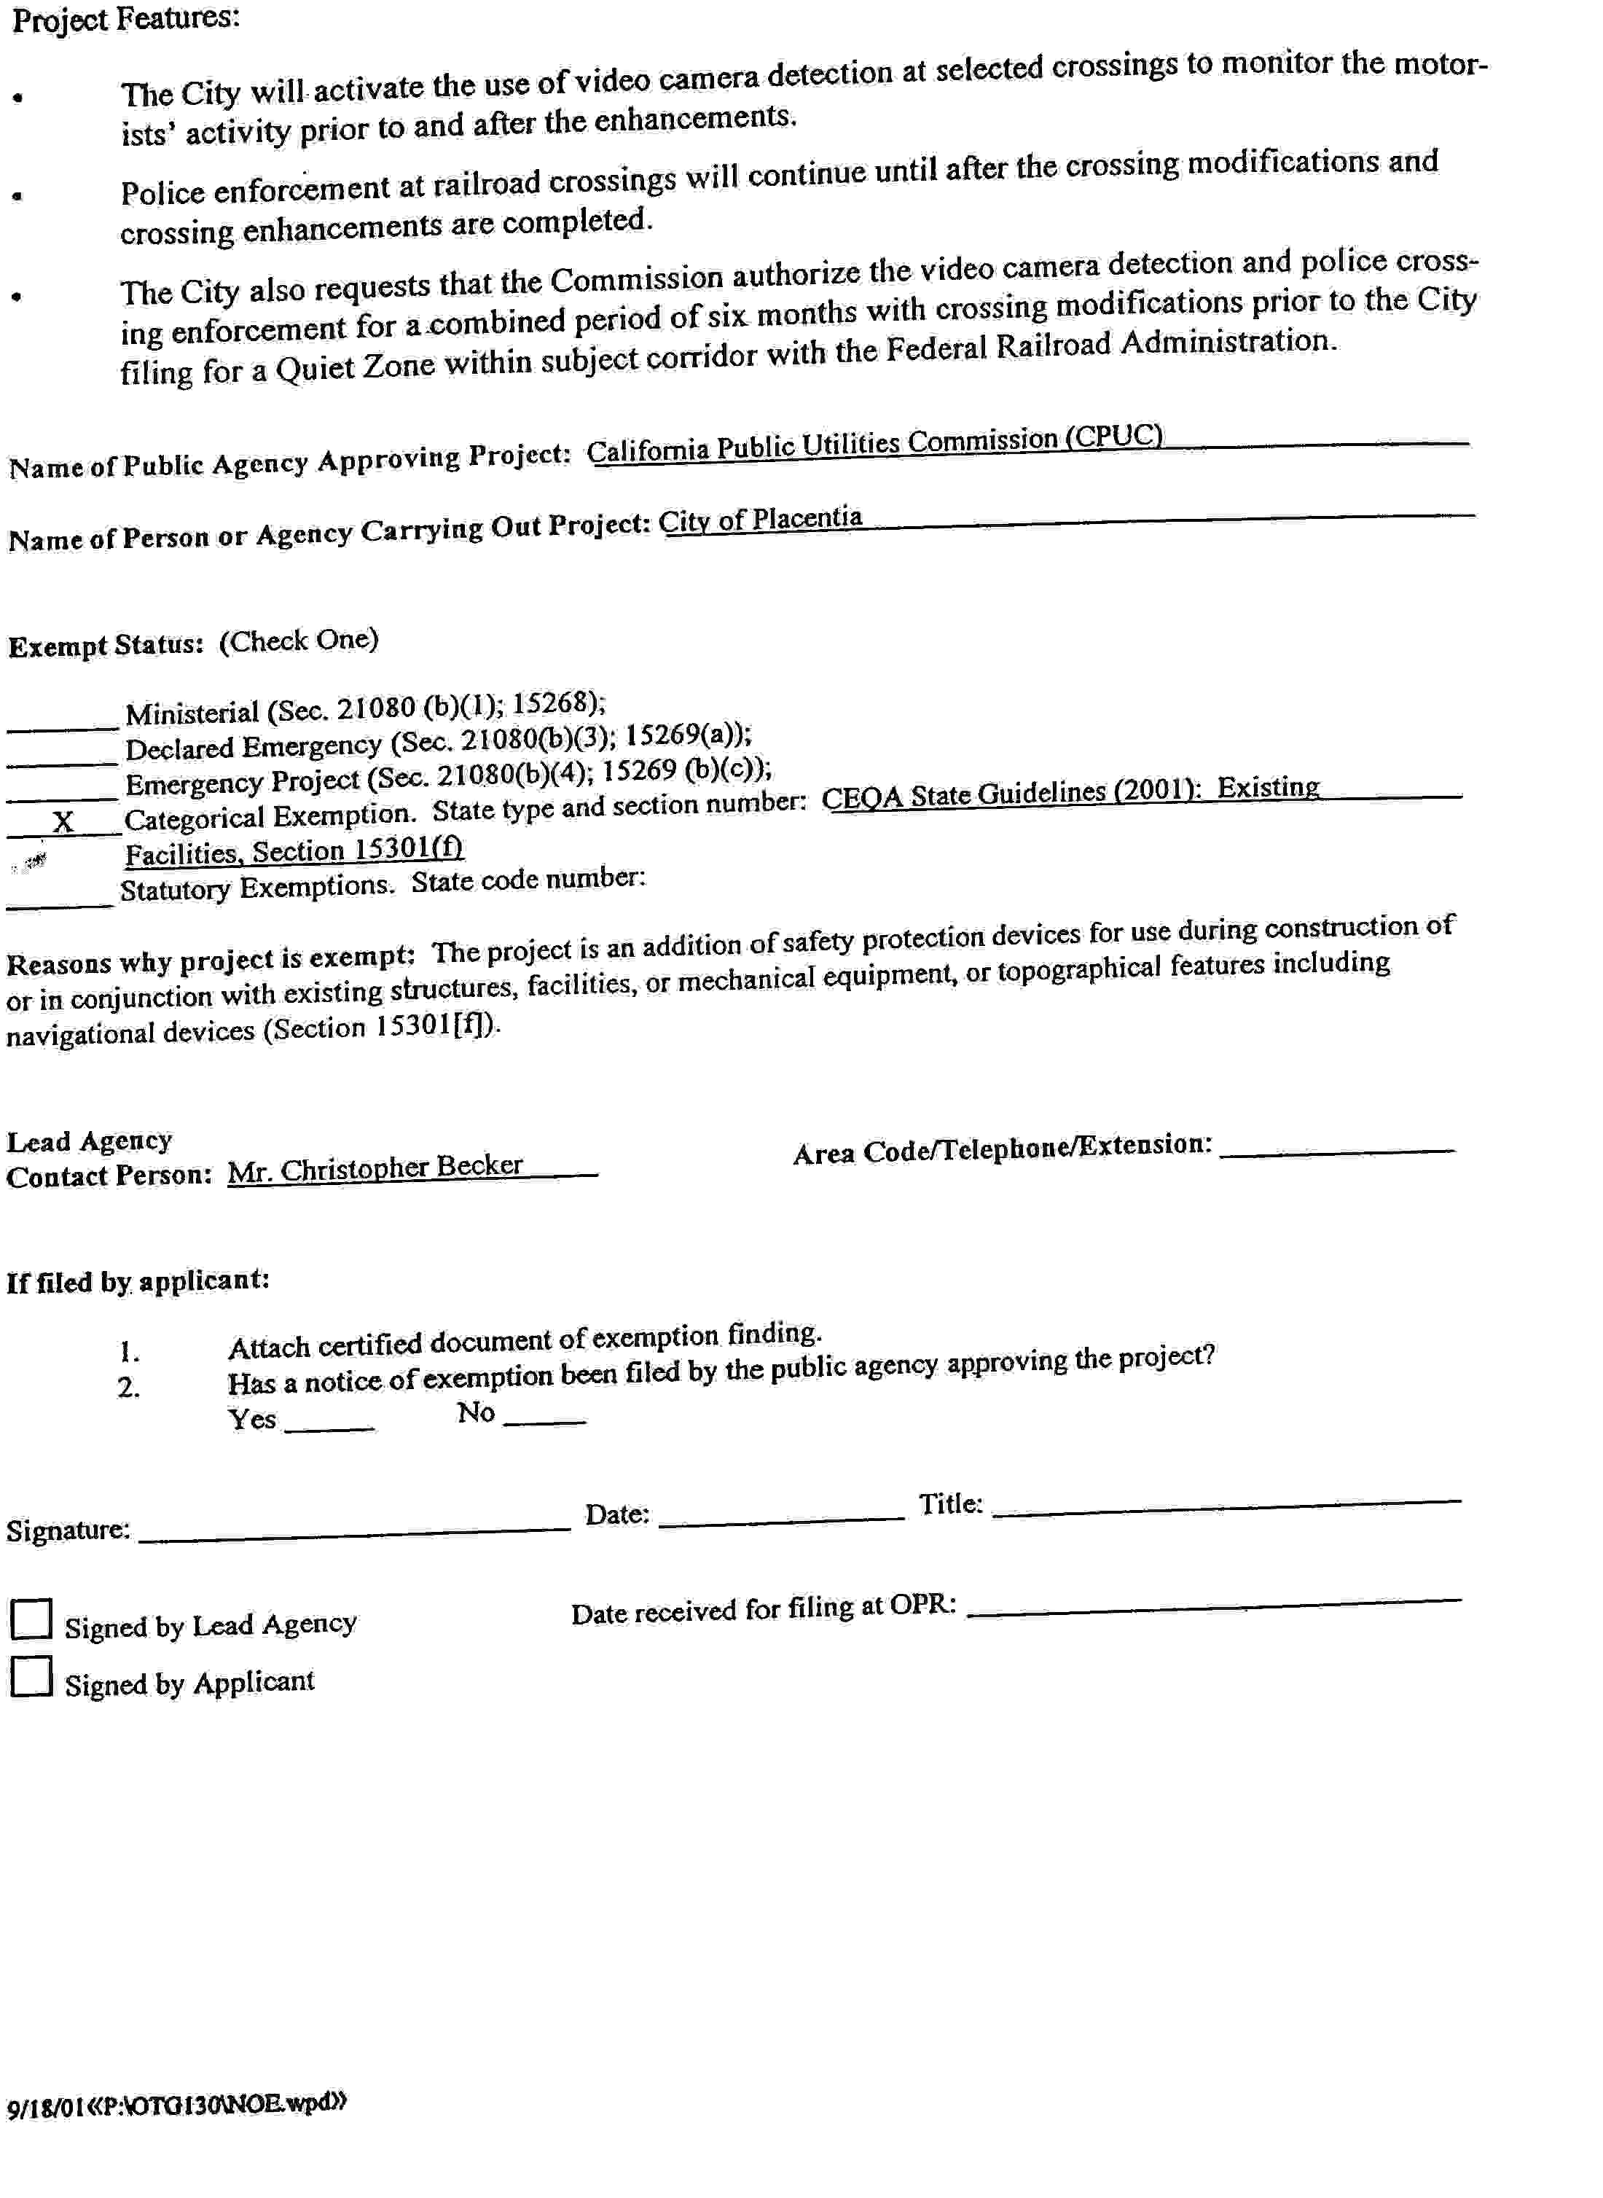
May 31, 2001
Meeting to discuss draft plans submitted by the City of Placentia (Applicant) to staff for review. Participants included Staff, City of Anaheim, the Applicant, KFM Engineering (the Applicant’s consultant), Hanson-Wilson (KFM’s subcontractor that drafted Commission filings on Applicant’s behalf), Federal Railroad Administration, and Burlington Northern Santa Fe Railway Company (BNSF).

August 13, 2001
A.01-08-016 filed.

August 29, 2001
Letter from Staff to Applicant listing deficiencies in A.01-08-016.

September 17, 2001
Southern California Regional Rail Authority (SCRRA) filed “Response to Application”.

October 23, 2001
Letter from the Applicant to Staff informing that they are working with SCRRA to resolve issues raised in the “Response to Application” filed by SCRRA on September 17, 2001. Letter also states that the SCRRA Board has plans to take formal action to support A.01-08-016.

October 25, 2001
Telephone conference call to discuss deficiencies in A.01-08-016 addressed in August 29, 2001 letter from Staff. Participants included Staff, the Applicant, KFM Engineering, and Hanson-Wilson.

November 5, 2001
Telephone discussion between Staff and Hanson-Wilson regarding items agreed upon during October 25, 2001 telephone conference call.

November 6, 2001
Letter from the Applicant to Staff requesting that Staff temporarily hold A.01-08-016 from further processing until the Applicant completes its discussions with SCRRA.

November 20, 2001
Meeting between Staff and Hanson-Wilson to discuss deficiencies with A.01-08-016 and design of safety measures at crossings.

November 26, 2001
Electronic mail from Staff to Hanson-Wilson indicating inconsistencies between data presented by the Applicant and Commission’s records, and requesting additional reports to substantiate data submitted by the Applicant.

November 27, 2001
Telephone conversation between Staff and SCRRA regarding SCRRA’s concerns with A.01-08-016.

Electronic mail from SCRRA to Staff providing a copy of a letter from SCRRA to Applicant, which includes the list of SCRRA’s concerns with A.01-08-016.

November 28, 2001
Telephone conversation between Staff and Hanson-Wilson regarding various issues with A.01-08-016.

November 29, 2001
Letter from Hanson-Wilson to Staff regarding concerns raised by SCRRA about A.01-08-016.

November 30, 2001
Telephone conference call to discuss issues raised by SCRRA in their “Response to Application”. Participants included Staff, Hanson-Wilson, SCRRA, and BNSF.

January 15, 2002
Letter from Applicant to Staff indicating that they intend to provide additional information to Staff.

March 8, 2002
Letter from Hanson-Wilson to Staff requesting information on the crossings subject of A.01-08-016. The information requested was if and when these crossings had received funding from the Federal Section 130 Highway-Rail Grade Crossing Improvement Fund.

March 11, 2002
Electronic mail from Staff to Hanson-Wilson providing information requested by Hanson-Wilson’s letter of March 8, 2002.

April 4, 2002
SCRRA filed a document titled “Withdrawal of Response to Application”.

April 19, 2002
Letter from Applicant to Staff informing that Applicant and SCRRA have concluded their discussions regarding A.01-08-016.

April 29, 2002
Telephone conversation between Staff and Hanson-Wilson regarding various issues with A.01-08-016.

May 7, 2002
Meeting between Staff and Hanson-Wilson to review information to be provided by the Amended Application.
May 13, 2002
Telephone conversation between Staff and Hanson-Wilson conveying the Rail Crossings Engineering Section’s (RCES) management’s position on items discussed during the May 7, 2002 meeting.

May 16, 2002
Letter from Applicant to Staff memorializing conversations between Staff and Hanson-Wilson.

May 17, 2002
Telephone conversation between Staff and Hanson-Wilson discussing the May 16, 2002 letter described above.

May 21, 2002
Electronic mail from Staff to Hanson-Wilson providing comments on draft copy of Amended Application provided to Staff for comments by Hanson-Wilson.

June 3, 2002
Telephone conversation between Staff and Hanson-Wilson regarding concerns raised by BNSF about the draft copy of Amended Application provided to BNSF by Hanson-Wilson.

June 7, 2002
Telephone conversation between Staff and Hanson-Wilson regarding BNSF’s concerns discussed during the June 3, 2002 telephone conversation described above.

June 13, 2002
Telephone conversation between Staff and Hanson-Wilson regarding resolution of BNSF’s concerns described above.

June 17, 2002
Amended Application filed.

June 18, 2002
Telephone conversation between Staff and BNSF regarding BNSF’s concerns with the Amended Application.

Telephone conversation between Staff and SCRRA regarding SCRRA’s concerns with the Amended Application.

June 19, 2002
Letter from BNSF to Staff regarding their concerns with the Amended Application.

July 8, 2002
Telephone conversation between Staff and Hanson-Wilson discussing the plans to widen Tustin/Rose Ave, one of the crossings subject of A.01-08-016.

Electronic mail from Staff to Hanson-Wilson memorializing telephone conversation described above, and also providing Staff’s concerns with the Amended Application.

July 11, 2002
Letter from Hanson-Wilson to Staff providing accident histories of crossings and also number of school buses traveling through the crossings.

July 15, 2002
Telephone conversation between Staff and the Applicant regarding the widening of Tustin/Rose Ave crossing.

July 25, 2002
Meeting to discuss deficiencies with the Amended Application. Participants included Staff, the Applicant, KFM Engineering, and Hanson-Wilson.
July 30, 2002
Telephone conversation between Staff and Hanson-Wilson to follow-up on items discussed during July 25, 2002 meeting.

August 2, 2002
Telephone conversation between Staff and Hanson-Wilson providing RCES Management’s position on items discussed during July 30, 2002 telephone conversation described above.

August 22, 2002
Telephone conversation between Staff and Hanson-Wilson regarding tri-party letter between Applicant, BNSF, and SCRRA.

September 3, 2002
Telephone conversation between Staff and Hanson-Wilson regarding format of the Supplement to the Application, and also concerns Staff has with the tri-party letter described above.

Electronic mail from Staff to Hanson-Wilson memorializing telephone conversation described above.

September 4, 2002
Letter from Applicant to Staff providing timelines for projects related to A.01-08-016.

September 5, 2002
Letter from Applicant to Staff regarding the tri-party letter and Supplement to the Application.

September 9, 2002
Supplement to the Application filed.

