CPSD/RWC/HMJ/LOO/mc1 Mailed 12/18/02

Decision 02-12-035 December 17, 2002

BEFORE THE PUBLIC UTILITIES COMMISSION OF THE STATE OF CALIFORNIA

Application of the City of Riverside for Authority to Install and Maintain Stationary Horn Warning Systems at Six Public Crossings over Union Pacific Railroad Company’s main line, Streeter Avenue, Palm Avenue, Brockton Avenue, Magnolia Avenue, Riverside Avenue and Panorama Road, City of Riverside, as a pilot project as permitted by SB 1491 for the Purpose of testing the utility an safety of stationary automated warning devices. | Application 02-11-004  (Filed November 4, 2002)

OPINION

Summary
The City of Riverside (City) requests authority for a pilot program to install and maintain Stationary Horn Warning Systems at Streeter Avenue, CPUC Crossing No. 003-53.8; Palm Avenue, CPUC Crossing No. 003-54.8; Brockton Avenue, CPUC Crossing No. 003-55.0; Magnolia Avenue, CPUC Crossing No. 003-55.2; Riverside Avenue, CPUC Crossing No. 003-55.6; and Panorama Road, CPUC Crossing No. 003-56.2, across the tracks of the Union Pacific Railroad (UPRR) in the City of Riverside, Riverside County.

Discussion
Public Utilities Code Section 7604 requires locomotive engineers to sound the train horn at a distance of at least 1,320 feet from an at-grade highway-rail crossing (crossing) and continue sounding the horn until the locomotive has crossed the street, road or highway. Previously, existing law imposed a civil fine on a railroad corporation that violated this provision and made it a misdemeanor for any person in charge of a locomotive engine that failed to sound the horn. This requirement was confirmed by the California Attorney General’s Opinion, Number 86-504 of August 19, 1986, which states that a city may not adopt an ordinance prohibiting the sounding of train whistles within the city limits.
Senate Bill (SB) 1491 recognized the growing need to mitigate train horn noise without compromising the safety of the public. SB 1491, followed by Assembly Bill 1249 and SB 62, effective October 9, 2001, amended Public Utilities Code Section 1202 with requirements for the Commission to authorize pilot projects on an application-by-application basis for testing the utility and safety of stationary automated audible warning devices as an alternative to the sounding of a train horn as a train approaches a crossing. Additionally SB 1491, and subsequently SB 62, amended Public Utilities Code Section 7604, eliminating the requirement that the warning device on a locomotive engine be sounded when approaching a crossing which has a permanently installed audible warning device that automatically sounds as a locomotive engine approaches a crossing. However, the locomotive engineer can still sound the locomotive-mounted horn at the crossing if necessary.
At the federal level, the Swift Rail Development Act of November 2, 1994 added Section 20153 to Title 49, Code of Federal Regulations, which directed the Secretary of Transportation, delegated to the Federal Railroad Administrator, to prescribe regulations requiring that a locomotive horn be sounded while each train is approaching and entering upon each public crossing. In addition, 49 U. S. C. 20153 provides the Federal Railroad Administration (FRA) the authority to exempt from this requirement, categories of rail operations or categories of crossings that: 1) are determined not to present significant risk with respect to loss of life or serious personal injury; 2) for which the use of a locomotive horn is impractical; or 3) for which supplementary safety measures fully compensate for the absence of the warning provided by the locomotive horn.
On January 13, 2000, the FRA published the Notice of Proposed Rulemaking and the Draft Environmental Impact Statement on the Use of Locomotive Horns at Highway-Rail Grade Crossings. The proposed rule required that locomotive horns be sounded at each at-grade crossing unless certain exceptions are met. Based on the study conducted by the Volpe National Transportation System Center of the Federal Department of Transportation, Field Evaluation of a Wayside Horn at a Highway Grade Crossing, June 1998, the FRA continues to identify opportunities for developing data analysis to ensure confidence that wayside horns fully compensate for the absence of train horns at crossings. In accordance with the proposed rule, the FRA will be an active participant in the design, monitoring and evaluation of this pilot project.
The City filed its application on November 4, 2002. The City requests authority to install Stationary Horn Warning Systems at Streeter Avenue, Palm Avenue, Brockton Avenue, Magnolia Avenue, Riverside Avenue, and Panorama Road, across the tracks of the UPRR in the City of Riverside. At present, the warning devices at the Streeter Avenue, Brockton Avenue, Magnolia Avenue, and Riverside Avenue crossings consist of two Standard No. 9s (automatic gate type signals), and wired with constant-time-warning circuitry. Palm Avenue is currently equipped with two Standard No. 9-As (Standard No. 9s with additional flashing lights on cantilevered mast arm), and wired with constant-time-warning circuitry. Panorama Road is equipped with three Standard No. 9s and wired with constant-time-warning circuitry. The existing warning devices at the crossings will remain in place.
Automatic horn indicators (indicators) will be installed at appropriate locations as determined and agreed to by all parties. On each indicator will be an orange colored 18-inch high “X” in Light Emitting Diodes. The indicators will remain activated at all times to indicate the proper functioning of the automatic horn system (AHS) for the locomotive engineers. If ever an AHS malfunctions at a particular crossing, the automatic horn indicator will go dark. The AHS and confirmation indicators will be placed on separate poles from the other devices and signals. The location of each AHS and indicator for each crossing will be determined through diagnostic meetings and agreed upon by all parties.
UPRR will instruct all locomotive engineers operating on this track as to the operation of the AHS and revise its operating rules accordingly. UPRR will also instruct all locomotive engineers to cease sounding the train mounted horn on approach to the crossings if the AHS is functioning properly as indicated by the automatic horn indicator; unless at the discretion of each engineer, it’s necessary to sound the train-mounted horn to provide additional warning. If under various weather or lighting conditions, a locomotive engineer cannot see the automatic horn indicator, the locomotive engineer will sound the train-mounted horn. UPRR will also install and maintain a sign; also referred to as a whistle board, down the track from the crossings to remind the locomotive engineers of the automated horn indicators and to ensure that the locomotive engineers have adequate time to decide to sound the train-mounted horn if necessary.
The City shall bear the full cost of installation and maintenance of the AHS during the pilot project. Prior to the start of the operation of the AHS, the City shall inform the local community as to the operation of the AHS. The City shall monitor the effectiveness of the AHS by use of video technology, event recorders, and resident and locomotive engineer surveys, as described in the Monitoring Program in Appendix B. The City will report, on a quarterly basis, the results of the Monitoring Program to UPRR, FRA, and the Commission’s Consumer Protection and Safety Division (CPSD). The City shall prepare a report of preliminary assessments and recommendations, and deliver it to CPSD no later than January 31, 2004, in order for the Commission to fulfill its obligation to report back to the Legislature in March of 2004. At the end of the pilot project, the City will prepare and deliver to CPSD a final report making recommendations as to the future use of the AHS.
The City and UPRR have entered into an agreement as to the cost, maintenance, and any liability as a result of the installation of the AHS. A copy of the agreement is attached as Appendix C.
The California Environmental Quality Act (Public Resources Code Section 21000 et seq., hereafter "CEQA") applies to discretionary projects to be carried out or approved by public agencies. A basic purpose of CEQA is to inform governmental decision-makers and the public about the potential significant environmental effects of the proposed activities. (CEQA Guideline Section 15002.)
This proposed project involves the installation of a wayside horn. Section 15301(f) of the CEQA Guidelines provides a categorical exemption from CEQA review, for the addition of safety or health protection devices used during construction or in conjunction with existing structures and facilities. In addition, the Commission Rules of Practice and Procedure 17.1(h)(A)(5) provides a CEQA exemption for alterations in railroad crossing protection, and Rule 17.1(h)(A)(6) provides a CEQA exemption for crossing alterations described in Guideline 15301(c) and (f). Based on these exemptions we find that installation of the wayside horn does not require a CEQA review.
The Rail Crossing Engineering Section (RCES) and Railroad Operations and Safety Section of the CPSD have inspected the site of the proposed project. As provided for in Public Utilities Code Section 1202, RCES examined the need for and safety of the proposed pilot project and recommends that the requested authority be granted as a pilot project to evaluate the AHS.
In Resolution ALJ 176-3099 dated November 7, 2002, the Commission preliminarily categorized this application as ratesetting, and preliminarily determined that hearings were not necessary. No protests have been received. CPSD recommends that this application be granted. Given these developments, a public hearing is not necessary, and is not necessary to disturb the preliminary determinations made in Resolution ALJ 176-3099.
Application 02-11-004 meets the filing requirements of the Commission’s Rules of Practice and Procedure.
This is an uncontested matter in which the decision grants the requested relief. Therefore, pursuant to Public Utilities Code Section 311(g)(2), the otherwise applicable 30-day period for public review and comment is being waived.
Assignment of Proceeding
Richard Clark is the assigned Examiner in this proceeding.
Findings of Fact
- Notice of the application was published in the Commission Daily Calendar on November 6, 2002. No protests have been filed.
- The City requests authority to install and maintain the AHS at Streeter Avenue, CPUC Crossing No. 003-53.8; Palm Avenue, CPUC Crossing No. 003-54.8; Brockton Avenue, CPUC Crossing No. 003-55.0; Magnolia Avenue, CPUC Crossing No. 003-55.2; Riverside Avenue, CPUC Crossing No. 003-55.6; and Panorama Road, CPUC Crossing No. 003-56.2, as a pilot project as permitted by Public Utilities Code Section 1202.
- The CPUC is a responsible agency for this project under the CEQA.
- This project is categorically exempt from the requirements of CEQA.
Conclusions of Law
- The application is uncontested and a public hearing is not necessary.
- The application should be granted as set forth in the following order.
ORDER

IT IS ORDERED that:
- The City of Riverside (City) is authorized to install and maintain a Stationary Horn Warning System at six public crossings over the Union Pacific Railroad Company’s main line at Streeter Avenue, CPUC Crossing No. 003-53.8; Palm Avenue, CPUC Crossing No. 003-54.8; Brockton Avenue, CPUC Crossing No. 003-55.0; Magnolia Avenue, CPUC Crossing No. 003-55.2; Riverside Avenue, CPUC Crossing No. 003-55.6; and Panorama Road, CPUC Crossing No. 003-56.2, in the City of Riverside for the purpose of testing the utility and safety of stationary automated warning devices as a pilot project as permitted by Public Utilities Code Section 1202.
- Automatic horn indicators (indicator) shall be installed where appropriate to inform locomotive engineers if the automated horn system (AHS) is functioning properly at each highway-rail crossing.
- The location of each AHS and indicator for each crossing will be determined through diagnostic meetings and agreed upon by all parties.
- The warning devices at the Streeter Avenue, Brockton Avenue, Magnolia Avenue, and Riverside Avenue crossings shall consist of two Standard No. 9s (automatic gate type signals), and wired with constant-time-warning circuitry. Palm Avenue shall be equipped with two Standard No. 9As (Standard No. 9s with additional flashing lights on cantilevered mast arm), and wired with constant-time-warning circuitry. Panorama Road shall be equipped with three Standard No. 9s and wired with constant-time-warning circuitry.
- Clearances shall be in accordance with California Public Utilities Commission General Order (GO) 26-D.
- Walkways shall conform to GO 118. Walkways adjacent to any trackage subject to rail operations shall be maintained free of obstructions and shall be promptly restored to their original condition in the event of damage during construction.
- Construction and maintenance costs shall be borne in accordance with the agreement that has been entered into between the parties as shown in Appendix C.
- The City shall report quarterly, submit a preliminary assessment report to the Consumer Protection and Safety Division no later than January 31, 2004, and submit a final report as detailed in the Monitoring Plan in Appendix B.
- This authorization shall expire if not exercised within three months unless time is extended or if the above conditions are not complied with. Authorization may be revoked or modified if public convenience, necessity, or safety so require.
- This application is granted as set forth above.
- Application 02-11-004 is closed.
This order is effective today.
Dated December 17, 2002 , at San Francisco, California.

LORETTA M. LYNCH
President
HENRY M. DUQUE
CARL W. WOOD
GEOFFREY F. BROWN
MICHAEL R. PEEVEY
Commissioners

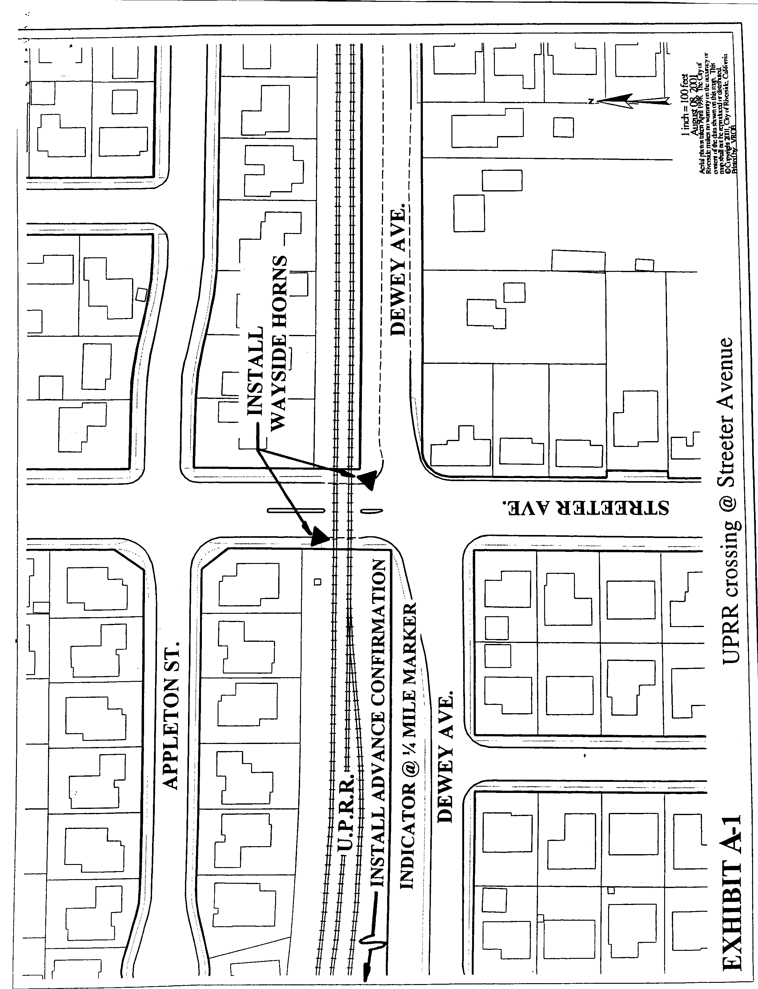
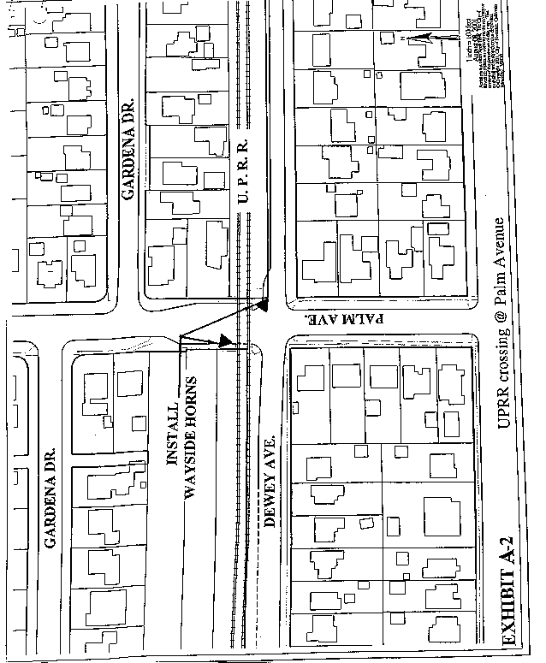
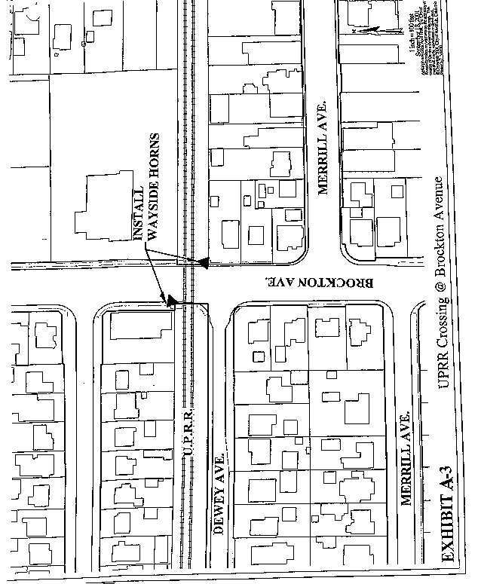

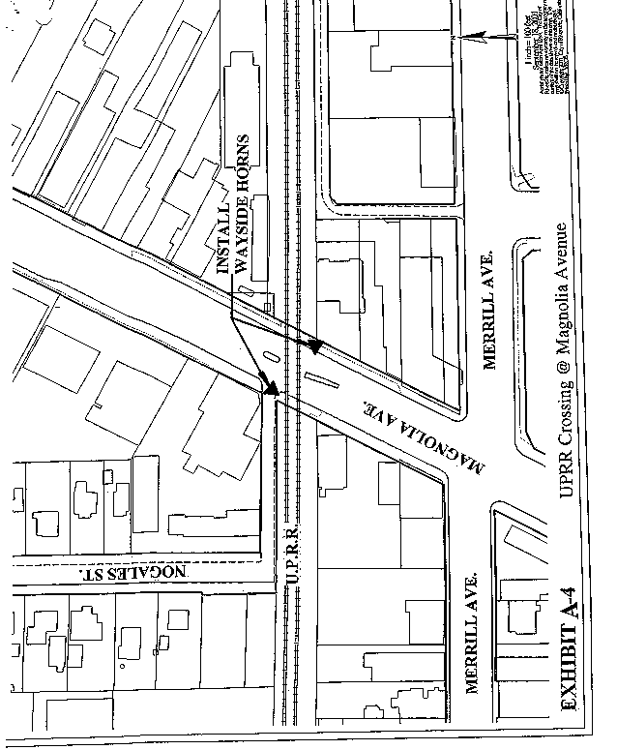
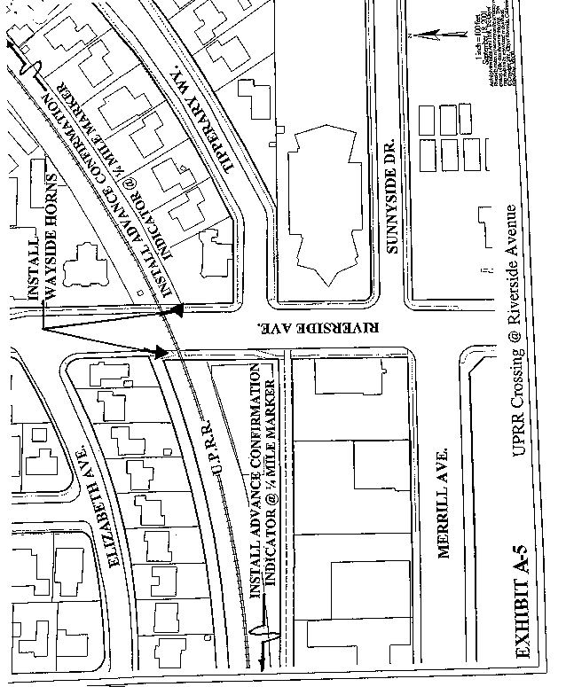

- 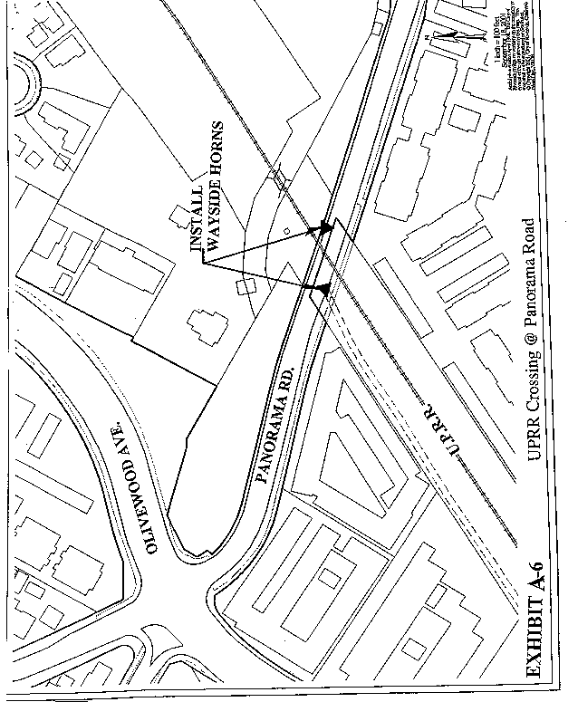

I. Background

The City of Riverside in conjunction with the Federal Railroad Administration (FRA) and California Public Utilities (PUC) will perform a six (6) month monitoring program of the Automated Horn System (AHS) proposed for installation at the Streeter Avenue, Palm Avenue, Brockton Avenue, Magnolia Avenue, Riverside Avenue and Panorama Road at grade crossings. The purpose of the monitoring is to evaluate the effectiveness of the (AHS) as a supplementary safety measure by the FRA and PUC as part of the Final Rule for Use of Locomotive Horns at Highway Rail Grade Crossings. The program will monitor effectiveness of the AHS in Roseville through collection of driver behavior data, train operator acceptance, and acceptance by adjacent residences and businesses.

II. Monitoring Program

The following tasks constitute the City of Riverside AHS monitoring program:

Task 1 – Video Monitoring Driver Behavior Prior to Activation of AHS
The video monitoring program will measure for three (3) months the effect of the train-mounted horn and existing gate and signal warning devices on driver behavior.

Task 1.1 Equipment
A video camera will be mounted on a pole at each of the six (6) at grade crossings to record driver behavior. Each camera should be mounted on the same utility pole as the wayside horn, but at a higher elevation. In each case, the video camera must capture driver behavior on both sides of the road between the gates on either side of the track(s). The video camera shall feed into some recording system or computer system located at the crossing. The system shall be located in a protected environment at the grade crossing. The track circuitry responsible for activating the gates and flashing lights also should activate a timer that starts the video/computer equipment to begin recording. The video equipment activated by the timer records the scene for duration of 60 seconds after train arrival at the crossing.

Task 1.2 Performance Measures And Data Collection
Two performance measures, number of aggressive driving behaviors and number of violations will be used to compare the existing warning system to one supplemented by the AHS. Aggressive driving behavior is defined as driving through the grade crossing while the gates are in the process of descending, but not yet completely descended. A violation is defined as a vehicle driving around the gates after they have descended. The more important of the two measures is the number of violations.

Data will be collected for three (3) months, using video cameras to capture driver behavior. The data will be collected for a period of 60 seconds following activation of the grade crossing signal.
The purpose of video analysis is to determine if the wayside horn provides warning comparable to existing train-mounted horns. To make this determination a comparison of the number of violations recorded during operation of the two warning systems will be made. For both warning systems answers to the following questions shall be documented:

- How many events were observed? (An event is defined as the crossing gate descending from the upright position and results in a train crossing the tracks before the gates return to their upright position).

- How many trains were observed?

Task 1.3 Aggressive Driving Analysis
How does the aggressive driving rate vary for the two types of auditory warnings?

Task 1.4 Driver Violation Analysis
What is the violation rate?
How does the violation rate vary for the two types of auditory warnings?

In addition to the above research questions, a summary of the data needed to conduct an analysis is as follows:

# of events
# of trains passing through the grade crossing
# of motor vehicles passing through grade crossing
(Average Daily Vehicle count to be performed at beginning of the monitoring period and at end of the monitoring period)
# of aggressive driving events
# of violations

Task 2 – Video Monitoring Driver Behavior During Use of AHS
The video monitoring program will measure for three (3) months the effect of the AHS on driver behavior.

Task 2.1 Equipment
The same video equipment installed for Task 1 will be used for Task 2.

Task 2.2 Data Collection
The same performance measures used for Task 1 will be used for Task 2

The follow data will be collected
1. # of train and vehicle exposure events

- # of trains passing through the grade crossing
- # of motor vehicles passing through grade crossing
- Duration of data recording equipment failure (i.e. data logger collecting data on track circuit activation and video recording equipment collecting driver behavior data).

Task 2.3 Data Recording Sheet
A data-recording sheet will be used to code information collected from videotape footage. The following information will be collected:

Type of Information Format
1. Tape # Number
2. Date Month/Day/Year
3. Event Start Time Military Time
4. Event # Number
5. Train arrived at crossing Yes/No
6. # of aggressive driving events Number
7. # of violations Number
8. Miscellaneous observations of driver behavior Text

Task 3 – Additional Surveys of Locomotive Engineers, Conductors and Adjacent Residents/Businesses
Three (3) surveys, will be conducted quarterly of locomotive engineers, conductors and residents/businesses adjacent to the Streeter Avenue, Palm Avenue, Brockton Avenue, Magnolia Avenue, Riverside Avenue and Panorama Road crossings at-grade crossings to identify their perceptions of AHS operations and effectiveness.

Task 3.1 Survey of Locomotive Engineers & Conductors
Within 60 days of AHS activation a survey of locomotive engineers and conductors will be conducted to identify their perceptions of the AHS. The survey will be performed three times on a quarterly basis, upon activation of the AHS. The survey will include the following questions:

- Have the locomotive engineers observed changes in motorist behavior at the crossing since the AHS has replaced locomotive-based horns?
- Is the confirmation signal an effective mechanism confirming AHS operation?
- Have the locomotive engineers had to use the locomotive horn at the Yosemite and Tahoe crossings since activation of the AHS?
  - Describe factors, which lead to use of locomotive horn.

Task 3.2 Survey of Residents and Businesses
Within 60 days of AHS activation a survey of residents and businesses adjacent to Streeter Avenue, Palm Avenue, Brockton Avenue, Magnolia Avenue, Riverside Avenue and Panorama Road crossings will be surveyed to identify their perception of the AHS. The survey will be performed three times on a quarterly basis, upon activation of the AHS. The survey will include the following questions:
- Have the residents and businesses observed changes in motorist behavior at the crossing since AHS has replaced locomotive-based horns?
- Have the residents and businesses observed the use of locomotive-based horns since activation of the AHS?

Task 3.3 Survey of Accident History
During the twelve (12) month monitoring program an accident history for the Yosemite and Tahoe at-grade-crossings will be maintained.

Task 4 - Final Report
The final report will review the monitoring results. The results will be provided to the FRA, PUC, Union Pacific, AHS manufacturers, and employee unions.

