CPSD/RWC/HMJ/SH/vdl Mailed 1/31/03

Decision 03-01-071 January 30, 2003

BEFORE THE PUBLIC UTILITIES COMMISSION OF THE STATE OF CALIFORNIA

Application of the San Bernardino Associated Governments for an Order authorizing construction of a crossing at separated grades between State Street/ University Parkway and the tracks of the Burlington Northern Santa Fe Railway Company, sometimes referred to as the State Street/University Parkway OVERHEAD [PUC CROSSING NO. 2-76.6]. | Application 02-07-028  (Filed July 11, 2002)

O P I N I O N

Summary
San Bernardino Associated Governments (SANBAG), in cooperation with the City and County of San Bernardino, requests authority to construct State Street/University Parkway Overhead grade-separated highway-rail crossing over the tracks of The Burlington Northern and Santa Fe Railway Company’s (BNSF) Cajon subdivision main line between San Bernardino and Barstow, in City of San Bernardino (University Parkway) and unincorporated area of the County of San Bernardino (State Street).

Discussion
SANBAG proposes to construct State Street/University Parkway Overhead grade-separated highway-rail crossing to accommodate the traffic flow in the City of San Bernardino (City) and an unincorporated area of the County of San Bernardino (County). State Street/University Parkway is a major north-south arterial with existing interchanges at Interstate (I) 215 Freeway and a proposed interchange at State Route (SR) 210 Freeway. Due to the increasing frequency of rail traffic to and from the Los Angeles Basin and heavy rail traffic generated by the Ports of Long Beach and Los Angeles, trains frequently block the existing State Street/University Parkway at-grade highway-rail crossing. Since the installation of automatic gates at the existing at-grade highway-rail crossing on July 25, 1967, 11 accidents between trains and motor vehicles occurred, resulting in a total of three fatalities and three injuries. Total rail traffic is approximately 98 trains (including Amtrak service) each day.
The proposed grade-separated highway-rail crossing will carry State Street/University Parkway over Cajon Boulevard, two existing tracks, and two proposed storage tracks by means of a four-span reinforced concrete structure. The total length of the bridge along the roadway will be approximately 494 feet, measured back-to-back of abutments. Abutments and bents will be reinforced concrete. The proposed overhead structure will include two 12-foot vehicular lanes, one 8-foot shoulder, and one 5-foot sidewalk in each direction of traffic and a 16-foot painted median, for a total width of 90 feet. SANBAG advised that construction may require timber falsework spanning the existing tracks. Consequently, SANBAG requested a temporary impaired vertical clearance of 21 feet, 6 inches during construction.
The existing State Street/University Parkway at-grade highway-rail crossing will remain open during construction. Upon completion of the grade-separated highway-rail crossing and its opening to vehicular traffic, City, County, and BNSF will close and abandon the existing State Street/University Parkway at-grade highway-rail crossing.
The State Street/University Parkway Overhead project ranks number 10 in the 2002-2003 Grade Separation Priority List adopted by Decision (D.) 02-06-041, dated June 27, 2002, in Order Instituting Investigation (I.) 01-07-008. The Grade Separation Priority List prioritized the projects most urgently in need of grade separation, pursuant to Section 2452 of the California Streets and Highways Code, for the fiscal year July 1, 2002, to June 30, 2003.
City, in cooperation with SANBAG and County, is the lead agency for this project under the California Environmental Quality Act of 1970 (CEQA, as amended in 1982), as stated in Public Resources (PR) Code Section 21000 et seq. City filed with the State Clearinghouse and San Bernardino County Clerk a Notice of Exemption, which finds that the project is Categorically Exempt from CEQA under CEQA Guideline Section 15302, Class 2. Appendix A of this order is a copy of the Notice of Exemption. Class 2 consists of replacement or reconstruction of existing structures and facilities where the new structure will be located on the same site as the structure replaced and will have substantially the same purpose and capacity as the structure replaced. The State Street/ University Parkway Overhead grade-separated highway-rail crossing project characteristics are consistent with the definition of a Class 2 Categorical Exemption. The Application further states that the project also has a Statutory Exemption under PR Code 21080.13, which exempts from CEQA “Any railroad grade separation project which eliminates an existing grade crossing or which reconstructs an existing grade separation.” This project will eliminate the existing State Street/University Parkway at-grade highway-rail crossing, CPUC Crossing No. 2-76.6.
The Commission is a responsible agency for this project under CEQA. CEQA requires that the Commission consider that portion of the environmental consequences of a project within its area of expertise subject to its discretionary approval. In particular, to comply with CEQA, a responsible agency must consider the lead agency’s Environmental Impact Report or Negative Declaration prior to acting upon or approving the project (CEQA Guideline Section 15050(b)). CEQA Guideline Section 15096 contains the specific activities that a responsible agency must conduct.
The Commission has reviewed and considered the lead agency’s Categorical Exemption determination and the applicant’s Statutory Exemption determination. We are not aware of any information that would suggest that the lead agency’s exemption classification was inappropriate in this instance. We find that the lead agency reasonably concluded, pursuant to CEQA Guideline Section 15302, Class 2, and that the applicant reasonably concluded, pursuant to PR Code Section 21080.13, that the proposed grade-separation project qualifies for an exemption from CEQA. Accordingly, we adopt the lead agency’s and applicant’s findings of exemption for purposes of our project approval.
The Commission’s Consumer Protection and Safety Division – Rail Crossings Engineering Section (RCES) has inspected the site of the existing State Street/University Parkway at-grade highway-rail crossing and the site of the proposed State Street/University Parkway Overhead grade-separated highway-rail crossing project. After reviewing the need for and the safety of the proposed State Street/University Parkway grade-separated highway-rail crossing, RCES recommends that the Commission grant SANBAG’s request.
The Application is in compliance with the Commission’s filing requirements, including Rule 38 of Rules of Practice and Procedure, which relates to the construction of public highway crossings and separations over a railroad. A site map and detailed drawings of the State Street/University Parkway Overhead grade-separated highway-rail crossing are shown in Appendix B attached to this order.
In Resolution ALJ 176-3092, dated August 8, 2002, and published in the Commission Daily Calendar on August 9, 2002, the Commission preliminarily categorized this Application as ratesetting, and preliminarily determined that hearings were not necessary. Since no protests were filed and no hearings were held, this preliminary determination remains accurate. Given these developments, it is not necessary to disturb the preliminary determinations made in Resolution ALJ 176-3092. The Commission’s Consumer Protection and Safety Division recommends that the Commission grant this Application.
This is an uncontested matter in which the decision grants the relief requested. Accordingly, pursuant to Public Utilities Code Section 311(g)(2), we waive the otherwise applicable 30-day period for public review and comment.

Assignment of Proceeding
Richard Clark is the assigned Examiner in this proceeding.
Findings of Fact
- The Commission published Notice of the Application in the Commission Daily Calendar on July 24, 2002. There are no unresolved matters or protests; a public hearing is not necessary.
- SANBAG requests authority, under Public Utilities Code Sections 1201-1205, to construct State Street/University Parkway Overhead grade-separated highway-rail crossing over the tracks of BNSF’s Cajon subdivision main line between San Bernardino and Barstow in City of San Bernardino (University Parkway) and unincorporated area of the County of San Bernardino (State Street).
- The construction of State Street/University Parkway Overhead grade-separated highway-rail crossing is required to reduce traffic delay and congestion and eliminate train/vehicle accidents. The proposed grade-separated highway-rail crossing of State Street/University Parkway, a major north-south arterial with existing interchanges at the I-215 Freeway and proposed interchange at the SR-210 Freeway, is necessary due to the frequency of rail traffic to and from the Los Angeles Basin, heavy rail traffic generated by the Ports of Long Beach and Los Angeles, and the frequent blockage by trains of the existing State Street/University Parkway at-grade highway-rail crossing.
- Public convenience, necessity, and safety require construction of State Street/University Parkway Overhead grade-separated highway-rail crossing.
- The State Street/University Parkway Overhead project ranks number 10 on the 2002-2003 Grade Separation Priority List adopted by D.02-06-041, dated June 27, 2002, in I.01-07-008. The Grade Separation Priority List prioritized the projects most urgently in need of grade separation, pursuant to Section 2452 of the Streets and Highways Code, for the fiscal year July 1, 2002, to June 30, 2003.
- During the period of construction, the existing State Street/University Parkway at-grade highway-rail crossing will remain open to vehicular traffic. Upon completion of State Street/University Parkway Overhead grade-separated highway-rail crossing, City, County, and BNSF will close and abandon the existing State Street/University Parkway at-grade highway-rail crossing.
- City, in cooperation with SANBAG and County, is the lead agency for this project under CEQA, as amended.
- City filed a Notice of Exemption exempting this project from CEQA review under CEQA Guideline Section 15302, Class 2, which consists of replacement or reconstruction of existing structures and facilities where the new structure will be located on the same site as the structure replaced and will have substantially the same purpose and capacity as the structure replaced.
- The Application further stated that the project has a Statutory Exemption under PR Code Section 21080.13, which exempts from CEQA “Any railroad grade separation project which eliminates an existing grade crossing or which reconstructs an existing grade separation.”
- The Commission is a responsible agency for this project and has reviewed and considered the lead agency's Categorical Exemption determination and the applicant’s Statutory Exemption determination.
Conclusions of Law
- We believe the lead agency reasonably concluded, pursuant to CEQA Guideline Section 15302, Class 2, and the applicant reasonably concluded, pursuant to PR Code Section 21080.13, that the proposed grade separation project is exempt from CEQA.
- The Application should be granted as set forth in the following order.
ORDER

IT IS ORDERED that:
- San Bernardino Associated Governments (SANBAG), in cooperation with the City and County of San Bernardino (City and County), is authorized to construct State Street/University Parkway Overhead grade-separated highway-rail crossing over the tracks of The Burlington Northern and Santa Fe Railway Company’s (BNSF) Cajon subdivision main line between San Bernardino and Barstow, in City of San Bernardino (University Parkway) and an unincorporated area of the County of San Bernardino (State Street), at the location and substantially as shown by plans attached to the Application and Appendix B of this order, identified as CPUC Crossing No. 2-76.6-A.
- During the period of construction, the existing State Street/University Parkway at-grade highway-rail crossing, CPUC Crossing No. 2-76.6, may remain open to vehicular traffic. Upon completion of State Street/University Parkway Overhead grade-separated highway-rail crossing and its opening to vehicular traffic, City, County, and BNSF shall close, abandon, and physically remove the existing State Street/University Parkway at-grade highway-rail crossing, CPUC Crossing No. 2-76.6.
- Clearances shall conform to General Order (GO) 26-D, except that during the period of construction the Commission authorizes a temporary impaired vertical clearance of not less than 21 feet, 6 inches above top of rail. The Commission authorizes BNSF to operate with such reduced overhead clearance provided that the railroad issues instructions and files, with Commission’s Rail Crossings Engineering Section (RCES), the instructions forbidding employees to ride on tops of cars beneath the structure.
- SANBAG shall notify RCES and BNSF at least 15, but not more than 30, days in advance of the date of the creation of the temporary impaired clearances.
- Walkways shall conform to GO 118. SANBAG, City, County, and BNSF shall maintain walkways adjacent to any trackage subject to rail operations free of obstructions and shall promptly restore walkways to their original condition in the event of damage during construction.
- SANBAG, in cooperation with City and County, and BNSF shall bear construction and maintenance costs in accordance with an agreement between SANBAG and BNSF (parties). SANBAG shall file a copy of the agreement, together with plans approved by BNSF, with RCES prior to commencing construction. Should the parties fail to agree, the Commission shall apportion the costs of construction and maintenance by further order.
- Within 30 days after completion of the work under this order, BNSF shall notify RCES in writing, by submitting a completed standard Commission Form G (Report of Changes at Highway Grade Crossings and Separations), of the completion of the authorized work.
- This authorization shall expire if not exercised within three years unless time is extended or if the above conditions are not complied with. The Commission may revoke or modify authorization if public convenience, necessity or safety so require.
- The Application is granted as set forth above.
- Application 02-07-028 is closed.
This order becomes effective 30 days from today.
Dated January 30, 2003, at San Francisco, California.

MICHAEL R. PEEVEY
President
CARL W. WOOD
LORETTA M. LYNCH
GEOFFREY F. BROWN
SUSAN P. KENNEDY
Commissioners

A P P E N D I X A
ENVIRONMENTAL DOCUMENT

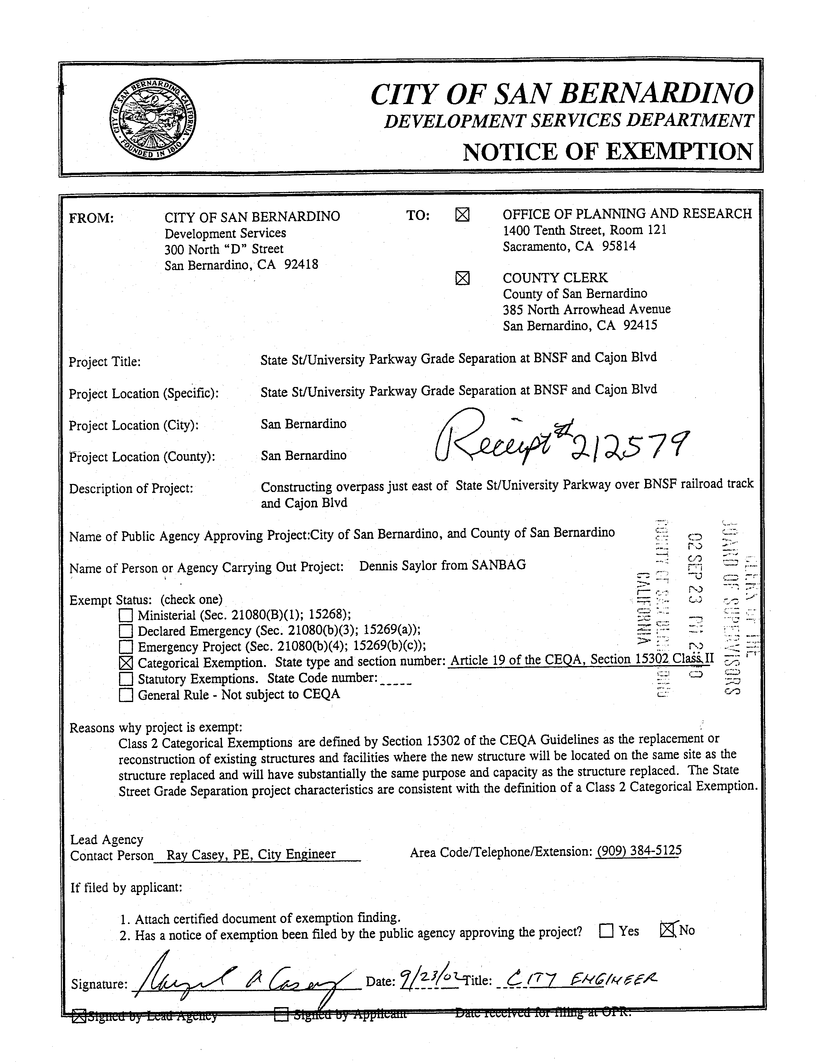

A P P E N D I X B
PLANS
