CPSD/RWC/HMJ/JFP/SH/vdl Mailed 10/31/03

Decision 03-10-075 October 30, 2003

BEFORE THE PUBLIC UTILITIES COMMISSION OF THE STATE OF CALIFORNIA

In the Matter of the Application of the Los Angeles County Metropolitan Transportation Authority for an order authorizing the construction of a two-track at-grade crossing for the Eastside Corridor Light Rail Transit Line across the westbound lanes of First Street in the City of Los Angeles, County of Los Angeles. | Application 02-09-047  (Filed September 30, 2002)
In the Matter of the Application of the Los Angeles County Metropolitan Transportation Authority for an order authorizing the construction of a two-track at-grade crossing for the Eastside Corridor Light Rail Transit Line across Temple Street and across Hewitt Street and the construction of a single track at grade crossing at two pedestrian walkways at the east side of the proposed Alameda Station in the City of Los Angeles County of Los Angeles. | Application 02-12-013  (Filed December 6, 2002)
In the Matter of the Application of the Los Angeles County Metropolitan Transportation Authority for an order authorizing the construction of a two-track at-grade crossing for the Eastside Corridor Light Rail Transit Line across Vignes Street in the City of Los Angeles. | Application 03-04-031  (Filed April 28, 2003)

O P I N I O N

Summary
As part of the project to construct the Eastside Corridor Light Rail Transit Line (ELRL), Los Angeles County Metropolitan Transportation Authority (MTA) requests authority to construct four proposed two-track at-grade highway-rail crossings across Temple, First (westbound lanes), Hewitt, and Vignes Streets and two proposed one-track at-grade pedestrian-rail crossings at two pedestrian walkways (North and South Pedestrian Crossings) at the east side of the proposed Alameda Station in the City of Los Angeles (City), Los Angeles County.

Discussion
MTA proposes to construct four at-grade highway-rail crossings and two at-grade pedestrian-rail crossings, described as follows:
- In Application (A.) 02-09-047, MTA proposes to construct one two-track at-grade highway-rail crossing across the westbound lanes of First Street (proposed CPUC Crossing No. 84E-0.62), with the tracks street-running adjacent to traffic within First Street.
- In A.02-12-013, MTA proposes to construct two two-track at-grade highway-rail crossings across Temple Street (proposed CPUC Crossing No. 84E-0.48) and Hewitt Street (proposed CPUC Crossing No. 84E-0.72), with the tracks street-running adjacent to traffic within First Street, and two one-track at-grade pedestrian-rail crossings, located at the east side of the proposed Alameda Station, at two pedestrian walkways, North Pedestrian Crossing (proposed CPUC Crossing No. 84E-0.49-D) and South Pedestrian Crossing (proposed CPUC Crossing No. 84E-0.58-D).
- In A.03-04-031, MTA proposes to construct one two-track at-grade highway-rail crossing across Vignes Street (proposed CPUC Crossing No. 84E-0.84), with the tracks street-running adjacent to traffic within First Street.
MTA is the primary provider of transit-related services in Los Angeles County. The State Legislature created MTA pursuant to Public Utilities Code Section 130050.2. In response to the State Legislature’s mandate to create an efficient and safe transportation system in Southern California, MTA constructed and is operating the Los Angeles to Long Beach Blue Line light rail transit line between City and the City of Long Beach. MTA also constructed and is operating the Metro Red Line heavy rail subway transit line, entirely within City, between Los Angeles Union Station (LAUS) and a station located near the intersection of Lankershim and Chandler Boulevards in North Hollywood. MTA also constructed and is operating the Metro Green Line light rail transit line between the Cities of Norwalk and El Segundo. Pursuant to Public Utilities Code Section 13240 et seq., the Los Angeles to Pasadena Metro Blue Line Construction Authority recently constructed, and MTA will operate, the Pasadena Gold Line between LAUS and Sierra Madre Villa Avenue, near the eastern boundary of the City of Pasadena.
LACMTA’s ELRL will be an eastward extension of the Pasadena Gold Line and will be six miles in length. The ELRL will begin at the end of the Pasadena Gold Line track northerly from State Route (SR) 101 freeway and will run on an aerial structure, southerly above SR 101, the bus way adjacent to and north of SR 101, and Commercial Street. At a point located southerly from Commercial Street and on a right-of-way that MTA will acquire adjacent to and easterly of Alameda Street, MTA will construct the ELRL street-running segment at ground level across Temple Street and the westbound lanes of First Street. MTA, in cooperation with City, will widen First Street to 106 feet easterly from Alameda Street to accommodate a bus pullout lane and will widen First Street from 94 feet to 100 feet easterly beyond the bus pullout lane. The ELRL street-running segment will continue easterly along the center of First Street for approximately 0.8 mile over the Los Angeles River to the west portal of a tunnel located beneath the City’s Boyle Heights district. The ELRL then will continue easterly within the tunnel aligned approximately beneath First Street 1.7 miles to the east portal of the tunnel at First and Lorena Streets in City. The ELRL street-running segment will resume and continue along the center of First Street to the First Street and Indiana Street intersection, which is approximately 2.96 miles from the beginning of the track at LAUS. The ELRL will continue southerly on right-of-way that MTA will acquire adjacent to and easterly of Indiana Street. The ELRL then will continue to Third Street in an unincorporated portion of the County of Los Angeles. The ELRL will continue easterly across the westbound lanes of Third Street. The ELRL then will continue easterly in the center portion of Third Street to Woods Avenue, where the name of Third Street changes to Pomona Boulevard. The ELRL will continue easterly along the center portion of Pomona Boulevard. The track ends at the westerly side of Atlantic Boulevard.
The ELRL will have a double track with overhead power distribution and will operate electrically powered cars 90 feet in length. MTA will construct transit stations at the intersections of First and Alameda Streets, First and Utah Streets, Third and Indiana Streets, Third Street and Ford Boulevard, Third Street and Mednik Avenue, and Pomona and Atlantic Boulevards. MTA will construct the First Street and Boyle Avenue station and the First and Soto Streets station within the 1.7-mile tunnel. All station platforms will be at car floor height above the top of rail and will accommodate up to three train cars. MTA also will install automatic train signaling in the 1.7-mile tunnel. In the remaining sections of the ELRL, trains will operate at a speed no greater than the allowable maximum automotive speed of the streets traveled with a maximum speed of thirty-five (35) miles per hour. MTA will enforce the maximum speed automatically by means of an over-speed protection system. Through system activation, the train subsequently will stop automatically, if the train exceeds the 35-mile-per-hour maximum speed and does not respond to the over-speed indication.
Each at-grade highway-rail crossing street intersection will have traffic signals for motorists and pedestrians and dedicated train signals (lunar white bar indications) for the train operators. For the four proposed at-grade highway-rail crossings referenced in A.02-09-047, A.02-12-013, and A.03-04-031, the tracks are street-running adjacent to traffic. To further enhance safety on the ELRL, the at-grade highway-rail street intersections will have train-activated fiber-optic or light emitting diode warning signs to give warning of approaching trains to motorists and pedestrians. Coordinated traffic signals within City will provide priority to the extent possible to train traffic.
Commission General Order (GO) 143-B provides for the operation of light rail transit lines. MTA proposes to adopt ELRL operations that will meet the requirements of GO 143-B, Section 9.04(b)(4) to construct the proposed light rail transit track at-grade highway-rail crossings across Temple, First (westbound lanes), Hewitt, and Vignes Streets and to construct the northbound track across two proposed at-grade pedestrian-rail crossings (North and South Pedestrian Crossings) for access to the Alameda Station.
To enhance the safety of the at-grade highway-rail crossing of the track across Temple Street, MTA proposes to acquire a right-of-way adjacent to and east of Alameda Street for operation of the light rail trains. Acquiring the rail right-of-way will result in removing the light rail train movements from within the intersection of Temple and Alameda Streets. MTA, in cooperation with City, will widen First Street on the north to allow for construction of two ELRL tracks in the center and for two vehicular traffic lanes in each direction. MTA will pave the tracks within First Street. Only light rail tracks normally will use these tracks. However, emergency response vehicles, such as fire trucks, police cars, and ambulances, also could access these tracks.
MTA filed three Applications, A.02-09-047, A.02-12-013, and A.03-04-031 to construct the four proposed two-track at-grade highway-rail crossings across Temple, First (westbound lanes), Hewitt, and Vignes Streets and the two proposed one-track at-grade pedestrian-rail crossings at two pedestrian walkways (North and South Pedestrian Crossings) at the east side of the proposed Alameda Station. Since the four proposed at-grade highway-rail crossings and the two proposed at-grade pedestrian-rail crossings are in the same vicinity; are located along MTA’s ELRL tracks; and are part of the same project, the three Applications involve related questions of fact. Consequently, pursuant to Rule 55 of the Commission’s Rules of Practice and Procedure, we will consolidate the three Applications and will prepare one Commission order authorizing construction of the four proposed at-grade highway-rail crossings and the two proposed at-grade pedestrian-rail crossings.
MTA is the lead agency for this project under California Environmental Quality Act of 1970 (CEQA), as amended in 1982 and as stated in Public Resources (PR) Code Section 21000 et seq. MTA prepared a Final Supplemental Environmental Impact Statement/Final Subsequent Environmental Impact Report (Final SEIS/SEIR), assigned State Clearinghouse (SCH) Number 1999081061, for the project on January 4, 2002. On February 28, 2002, the MTA Board of Directors approved the project and adopted the Final SEIS/SEIR. On March 1, 2002, in compliance with PR Code Section 21108 and 21152, MTA filed a Notice of Determination (NOD) with the State Clearinghouse and the Los Angeles County Clerk. The NOD is attached to Appendix C of the order. The NOD stated, “This project will have a significant effect on the environment in that:”
- Temporary impacts during construction will occur with regards to parking losses, traffic disruption, and sidewalk closures. MTA has identified mitigation measures to address these impacts, however, it is possible that some impacts during construction cannot be completely mitigated.
- Tunneling during construction of subway segment or pile driving for the aerial segment may result in the destruction of some fossils. MTA will make every effort to ensure that fossil recovery is maximized.
- Despite mitigation measures, temporary air quality, noise, and vibration impacts are possible during construction. Temporary visual impacts also may occur in the vicinity of the Chavez/Soto construction staging area if screening materials cannot prevent impacts on multi-story land uses.
- Ten traffic intersections will be significantly impacted and cannot be fully mitigated.
- Catenary system on the 1st Street Bridge will add to visual overhead clutter. However, no historical features will be adversely affected.
- Exterior noise levels and moderate sound impacts adjacent to special track work may occur if mitigation measures are not sufficient to eliminate impact. The MTA is committed to ensuring noise impacts are minimized.
- The project will require property acquisition and relocation of residents and businesses. There is the possibility that some residents and businesses may have to be relocated outside of the corridor.
The NOD further stated that mitigation measures were made a condition of the approval of the project, findings were made pursuant to the provisions of CEQA, and MTA adopted a “Statement of Overriding Considerations” (SOC) for this project.
The Commission is a responsible agency for this project under CEQA. CEQA requires that the Commission consider the environmental consequences of a project subject to its discretionary approval. In particular, to comply with CEQA, a responsible agency must consider the lead agency’s Environmental Impact Report or Negative Declaration prior to acting upon or approving the project (CEQA Guideline Section 15050(b)). The specific activities that a responsible agency must conduct are contained in CEQA Guideline Section 15096.
The Commission has reviewed the lead agency’s environmental documents, including the Final SEIS/SEIR for the Los Angeles Eastside Corridor (SCH No. 1999081061), prepared jointly by the United States Department of Transportation – Federal Transit Administration and MTA. We find these documents adequate for our decision-making process. In considering these documents, we note that the Final SEIS/SEIR developed and evaluated a range of alternatives as well as a “No-Build Alternative.” The Final SEIS/SEIR included an analysis of potential environmental impacts related to the project and alternatives related to, among other items, transportation, land use and development, economic and fiscal impacts, land acquisition/displacement and relocation, visual impacts and aesthetics, air quality, noise and vibration, geologic and seismic conditions, hazardous materials, water resources, and safety. Safety, transportation and noise are within the scope of the Commission’s permitting process. The Final SEIS/SEIR (Volume I) has statements pertaining to the affected environment, methodology for impact evaluation, impacts, and mitigation. MTA identified environmental impacts related to safety, transportation, and noise.
The “Findings Of Fact And Statement Of Overriding Considerations,” (FFSOC) contains statements pertaining to impacts, mitigation measures, and findings for each impact. The FFSOC categorized these impacts as “Significant Effects Determined to be Mitigated to a Less Than Significant Level,” “Significant Effects That Are Not Mitigated to a Less Than Significant Level,” and “Effects Determined Not to be Significant or Less Than Significant.” Included in the FFSOC are the SOC and “Mitigation Monitoring Plan” (MMP).
The MTA Board of Directors adopted the SOC with respect to significant and unavoidable adverse environmental impacts identified in the Final SEIS/SEIR and FFSOC and those impacts related to safety, transportation, and noise. In adopting the SOC, the Board of Directors noted the following benefits from the proposed project:
- The light rail transit (LRT) Build Alternative will provide light rail transit service to the Los Angeles Eastside communities. Implementing LRT service in the corridor would help to restore the balance of regional capital transportation expenditures as well as compensate for the adverse impacts that previous transportation planning decisions have caused. This is because, historically, there has been no major investment in transit service, either bus or rail, in the Eastside Corridor. Also, the corridor has borne the disproportionate effects of a regional freeway system that has cut through its neighborhoods to reach suburban destinations.
- The LRT Build Alternative is expected to increase the number of daily transit trips by 28,000 compared with the current bus service offered by the No-Build Alternative and reduce travel times. Light rail service will also offer improved access for area residents to local destinations as well as to the regional rail and bus system and, therefore, to regional destinations. It will also serve many educational and community centers in the corridor, enhancing mobility for young adults and school age children.
- Indicators of transit dependence, such as low-income households and zero-auto households, are nearly three times higher in the Eastside Corridor than for Los Angeles County as a whole. The LRT Build Alternative will provide a convenient and reliable transportation mode to these transit-dependent populations.
- The LRT Build Alternative is anticipated to decrease the annual regional vehicle miles traveled by 16 million when compared to the No-Build Alternative. This will result in beneficial effects on air quality.
- The LRT Build Alternative is anticipated to generate approximately 47,000 new construction jobs and, within the first 14 years of operation, over 1,000 permanent jobs to operate and maintain the LRT line. In addition, MTA is formulating a local hiring policy for the construction and operational related job opportunities for the corridor. Such a program will include resources for job development and training. MTA currently offers a series of programs designed to encourage minority and women-owned businesses to participate in the construction and operation of new transportation projects.
- The LRT Build Alternative includes eight new stations as well as the current Union Station. With proper incentives and with favorable market conditions, developers may consider the merits of constructing housing and commercial developments that are oriented to the light rail stations and that take advantage of the new light rail service. Station areas that have vacant land resulting from right-of-way acquisition for the suspended Metro Red Line project or for the construction of the LRT Build Alternative can be developed, in accordance with City and County of Los Angeles planning and redevelopment policies and Community Plans, to benefit the surrounding neighborhoods. In a corridor that has an extremely low vacancy rate and a great demand for affordable housing, such development could provide needed housing and space for retail and social service uses. The new development could offer larger units for families with children, helping to meet a dire need in the community. In addition, landscape treatments along the light rail line could enhance the urban design of the community, making opportunities for development more attractive.
The MTA Board of Directors found that the benefits of the proposed project outweigh the unavoidable significant adverse environmental impacts. The Board of Directors determined that each of the separate benefits identified in the SOC, in itself and independent of other project benefits, is a basis for overriding all unavoidable impacts identified in the Final SEIS/SEIR and noted in the Board of Directors’ findings.
In reviewing the Final SEIS/SEIR and MMP, we find that with respect to issues within the scope of our permitting process, MTA, where possible, adopted feasible mitigation measures to lessen the significant environmental impacts to less-than-significant levels. We will adopt MTA’s findings and mitigations for purposes of our approval.
With respect the SOC, we find that the Board of Directors enumerated several significant benefits associated with the proposed project which appeared, on balance, to reasonably override the unavoidable impacts. Therefore, we accept and adopt the findings of the SOC for purposes of our approval.
The Commission’s Consumer Protection and Safety Division – Rail Crossings Engineering Section (RCES) has inspected the sites of the four proposed at-grade highway-rail crossings at Temple, First (westbound lanes), Hewitt, and Vignes Streets and the two proposed at-grade pedestrian-rail crossings (North and South Pedestrian Crossings) at the east side of the proposed Alameda Station. After reviewing the need for and the safety of the proposed at-grade highway-rail crossings and at-grade pedestrian-rail crossings, RCES recommends that the Commission grant MTA’s requests.
The Applications are in compliance with the Commission’s filing requirements, including Rule 38 of Rules of Practice and Procedure, which relates to the construction of a public highways or walkways over railroad tracks. Shown in Appendix B attached to the order are site maps and detailed drawings of the four proposed at-grade highway-rail crossings and the two proposed at-grade pedestrian-rail crossings.
In Resolutions ALJ 176-3098, ALJ 176-3103, and ALJ 176-3112, dated October 24, 2002; December 17, 2002; and May 8, 2003, respectively, and published in the Commission Daily Calendar on October 25, 2002; December 18, 2002; and May 9, 2003, respectively, the Commission preliminarily categorized A.02-09-047, A.02-12-013, and A.03-04-031, as ratesetting, and preliminarily determined that hearings were not necessary. Since no protests were filed, these preliminary determinations remain correct. The Commission’s Consumer Protection and Safety Division recommends that the Commission grant these Applications. Given these developments, a public hearing is not necessary, and it is not necessary to disturb the preliminary determinations made in Resolutions ALJ 176-3098, ALJ 176-3103, and ALJ 176-3112.
These Applications are uncontested matters in which the decision grants the relief requested. Accordingly, pursuant to Public Utilities Code Section 311(g)(2), we waive the otherwise applicable 30-day period for public review and comment.

Assignment of Proceeding
Richard Clark is the assigned Examiner in this proceeding.
Findings of Fact
- The Commission published Notices of A.02-09-047, A.02-12-013, and A.03-04-031, respectively, in the Commission Daily Calendar on October 7, 2002; December 12, 2002; and April 30, 2003. There are no unresolved matters or protests; a public hearing is not necessary.
- MTA requests authority, under Public Utilities Code Sections 1201-1205, to construct, as part of MTA’s ELRL project, the four proposed two-track at-grade highway-rail crossings across Temple, First (westbound lanes), Hewitt, and Vignes Streets and the two proposed one-track at-grade pedestrian-rail crossings at the two pedestrian walkways (North and South Pedestrian Crossings) at the east side of the proposed Alameda Station in Los Angeles (City), Los Angeles County.
- Public convenience and necessity require construction of the four proposed at-grade highway-rail crossings and the two proposed at-grade pedestrian-rail crossings of MTA’s ELRL tracks.
- Public safety requires, at each proposed at-grade highway-rail crossing, the installation of traffic signals for motorists and pedestrians and dedicated train signals (lunar white bar indications) for the train operators. The tracks are street-running adjacent to traffic within First Street. To further enhance safety on the ELRL, each proposed at-grade highway-rail crossing will have train-actuated fiber-optic or light emitting diode warning signs to give motorists and pedestrians warning of approaching trains. For intersections within its jurisdiction, City will coordinate traffic signals to the extent possible to provide priority to train traffic.
- Public safety requires, at each proposed at-grade pedestrian-rail crossing, the installation of two CPUC Standard No. 8 (flashing light signals, as defined in GO 75-C) warning devices, each modified with one CPUC Standard No. 1-D (pedestrian and bicycle railroad grade crossing sign, as defined in GO 75-C) warning sign along with pedestrian swing gates with signs advising pedestrians to watch for trains.
- The distance between North Pedestrian Crossing and the south side of Temple Street will not accommodate one train length. Therefore, MTA will install a train signal at North Pedestrian Crossing to hold northbound trains clear of the crossing until there is clear trackage northbound, until the traffic signals at Temple Street stop automotive and pedestrian traffic, and until the train signal provides northbound trains with a lunar white bar train signal to proceed.
- MTA is the lead agency for this project under CEQA, as amended.
- In approving the project on February 28, 2002, the MTA Board of Directors adopted the Final SEIS/SEIR for the Los Angeles Eastside Corridor (SCH No. 1999081061) and found that “The project will have a significant effect on the environment.” Mitigation measures were made a condition of the approval of the project. Findings were made pursuant to the provisions of CEQA. An SOC was adopted for this project.
- The Commission is a responsible agency for this project and has reviewed and considered the lead agency's Final SEIS/SEIR, NOD, and the SOC.
- Safety, transportation and noise are within the scope of the Commission’s permitting process.
- For the approved project, the lead agency identified environmental impacts related to safety, transportation and noise.
Conclusions of Law
- With respect to significant impacts from safety, transportation and noise, we find that the lead agency adopted feasible mitigation measures where possible to substantially lessen the impacts to a less-than-significant level. As stated herein, we also accept and adopt the findings in the SOC for purpose of our approval.
- We consolidate A.02-09-047, A.02-12-013, and A.03-04-031, which involve related questions of fact, for purposes of issuing one decision.
- We grant consolidated A.02-09-047, A.02-12-013, and A.03-04-031 as set forth in the following order.
ORDER

IT IS ORDERED that:
- The Commission authorizes Los Angeles County Metropolitan Transportation Authority (MTA) to construct the four proposed two-track at-grade highway-rail crossings across Temple, First (westbound lanes), Hewitt, and Vignes Streets and the two proposed one-track at-grade pedestrian-rail crossings at two pedestrian walkways (North and South Pedestrian Crossings) at the east side of the proposed Alameda Station of MTA’s Eastside Corridor Light Rail Transit Line (ELRL), in the City of Los Angeles (City), Los Angeles County, at the locations and substantially as described in and as shown by plans attached to consolidated Application (A.) 02-09-047, A.02-12-013 and A.03-04-031; as described in Appendix A attached to this order; and as shown by plans in Appendix B attached to this order.
- MTA, in cooperation with City, shall ensure, at each proposed at-grade highway-rail crossing, the installation of traffic signals for motorists and pedestrians and dedicated train signals (lunar white bar indications) for train operators. To further enhance safety on the ELRL, MTA, at each proposed at-grade highway-rail crossing, shall install train-actuated fiber-optic or light emitting diode warning signs to give motorists and pedestrians warning of approaching trains. For intersections within its jurisdiction, City shall coordinate traffic signals to the extent possible to provide priority to train traffic.
- MTA shall ensure, at each proposed at-grade pedestrian-rail crossing, the installation of two CPUC Standard No. 8 (flashing light signals, as defined in Commission General Order (GO) 75-C) warning devices, each modified with one CPUC Standard No. 1-D (pedestrian and bicycle railroad grade crossing sign, as defined in GO 75-C) warning sign along with pedestrian swing gates with signs advising pedestrians to watch for trains.
- MTA shall install a train signal at North Pedestrian Crossing to hold northbound trains clear of the crossing until there is clear trackage northbound, until traffic signals at Temple Street stop automotive and pedestrian traffic, and until the train signal provides northbound trains with a lunar white bar train signal to proceed.
- Clearances and walkways shall conform to GO 143-B.
- Construction and maintenance of the crossings shall conform to GO 72-B.
- MTA and City (parties) shall bear construction and maintenance costs in accordance with an agreement into which the parties have entered. MTA shall file a copy of the agreement with the Rail Crossings Engineering Section (RCES) prior to construction. Should the parties fail to agree, the Commission shall apportion the costs of construction and maintenance by further order.
- Within 30 days after completion of the work under this order, MTA shall notify RCES in writing, by submitting a completed standard Commission Form G (Report of Changes at Highway Grade Crossings and Separations), of the completion of the authorized work.
- This authorization shall expire if not exercised within two years unless the Commission extends the time or if the parties do not comply with the above conditions. The Commission may revoke or modify authorization if public convenience, necessity or safety so require.
- The Commission grants consolidated A.02-09-047, A.02-12-013, and A.03-04-031 as set forth above.
- Consolidated A.02-09-047, A.02-12-013, and A.03-04-031 are closed.
This order becomes effective 30 days from today.
Dated October 30, 2003, at San Francisco, California.

MICHAEL R. PEEVEY
President
CARL W. WOOD
LORETTA M. LYNCH
GEOFFREY F. BROWN
SUSAN P. KENNEDY
Commissioners

A P P E N D I X A

As part of the project to construct the Eastside Corridor Light Rail Transit Line (ELRL), the Los Angeles County Metropolitan Transportation Authority (MTA) proposes to construct four two-track at-grade highway-rail crossings across Temple, First (westbound lanes), Hewitt, and Vignes Streets and two one-track at-grade pedestrian-rail crossings at two pedestrian walkways (North and South Pedestrian Crossings) at the east side of the proposed Alameda Station in City of Los Angeles (City), Los Angeles County. Consolidated Application (A.) 02-09-047, A.02-12-013, and A.03-04-031 indicate the full details of the four proposed at-grade highway-rail crossings and the two proposed at-grade pedestrian-rail crossings and more particularly as set forth below:

At-grade Crossing CPUC Crossing No. Application No.
Temple Street 84E-0.48 A.02-12-013
North Pedestrian Crossing 84E-0.49-D A.02-12-013
South Pedestrian Crossing 84E-0.58-D A.02-12-013
First Street 84E-0.62 A.02-09-047
Hewitt Street 84E-0.72 A.02-12-013
Vignes Street 84E-0.84 A.03-04-031

Note: MTA, in cooperation with City, shall ensure, at the proposed at-grade highway-rail crossings of Temple, First (westbound lanes), Hewitt, and Vignes Streets, the installation of traffic signals for motorists and pedestrians and dedicated train signals (lunar white bar indications) for the train operators. The tracks are street-running adjacent to traffic within First Street. To further enhance safety on the ELRL, the four proposed at-grade highway-rail crossings shall have train-actuated fiber-optic or light emitting diode warning signs to give warning of approaching trains to motor vehicle operators and pedestrians. For intersections within its jurisdiction, City shall coordinate traffic signals to the extent possible to provide priority to train traffic.
MTA shall ensure, at each of the two proposed at-grade pedestrian-rail crossings of North and South Pedestrian Crossings, the installation of two CPUC Standard No. 8 (flashing light signals, as defined in Commission General Order (GO) 75-C) warning devices, each modified with one CPUC Standard No. 1-D (pedestrian and bicycle railroad grade crossing sign, as defined in GO 75-C) warning sign along with pedestrian swing gates with signs advising pedestrians to watch for trains.
MTA shall install a train signal at North Pedestrian Crossing to hold northbound trains clear of the crossing until there is clear trackage northbound, until the traffic signals at Temple Street stop automotive and pedestrian traffic, and until the train signal provides northbound trains with a lunar white bar train signal to proceed.

A P P E N D I X B
PLANS
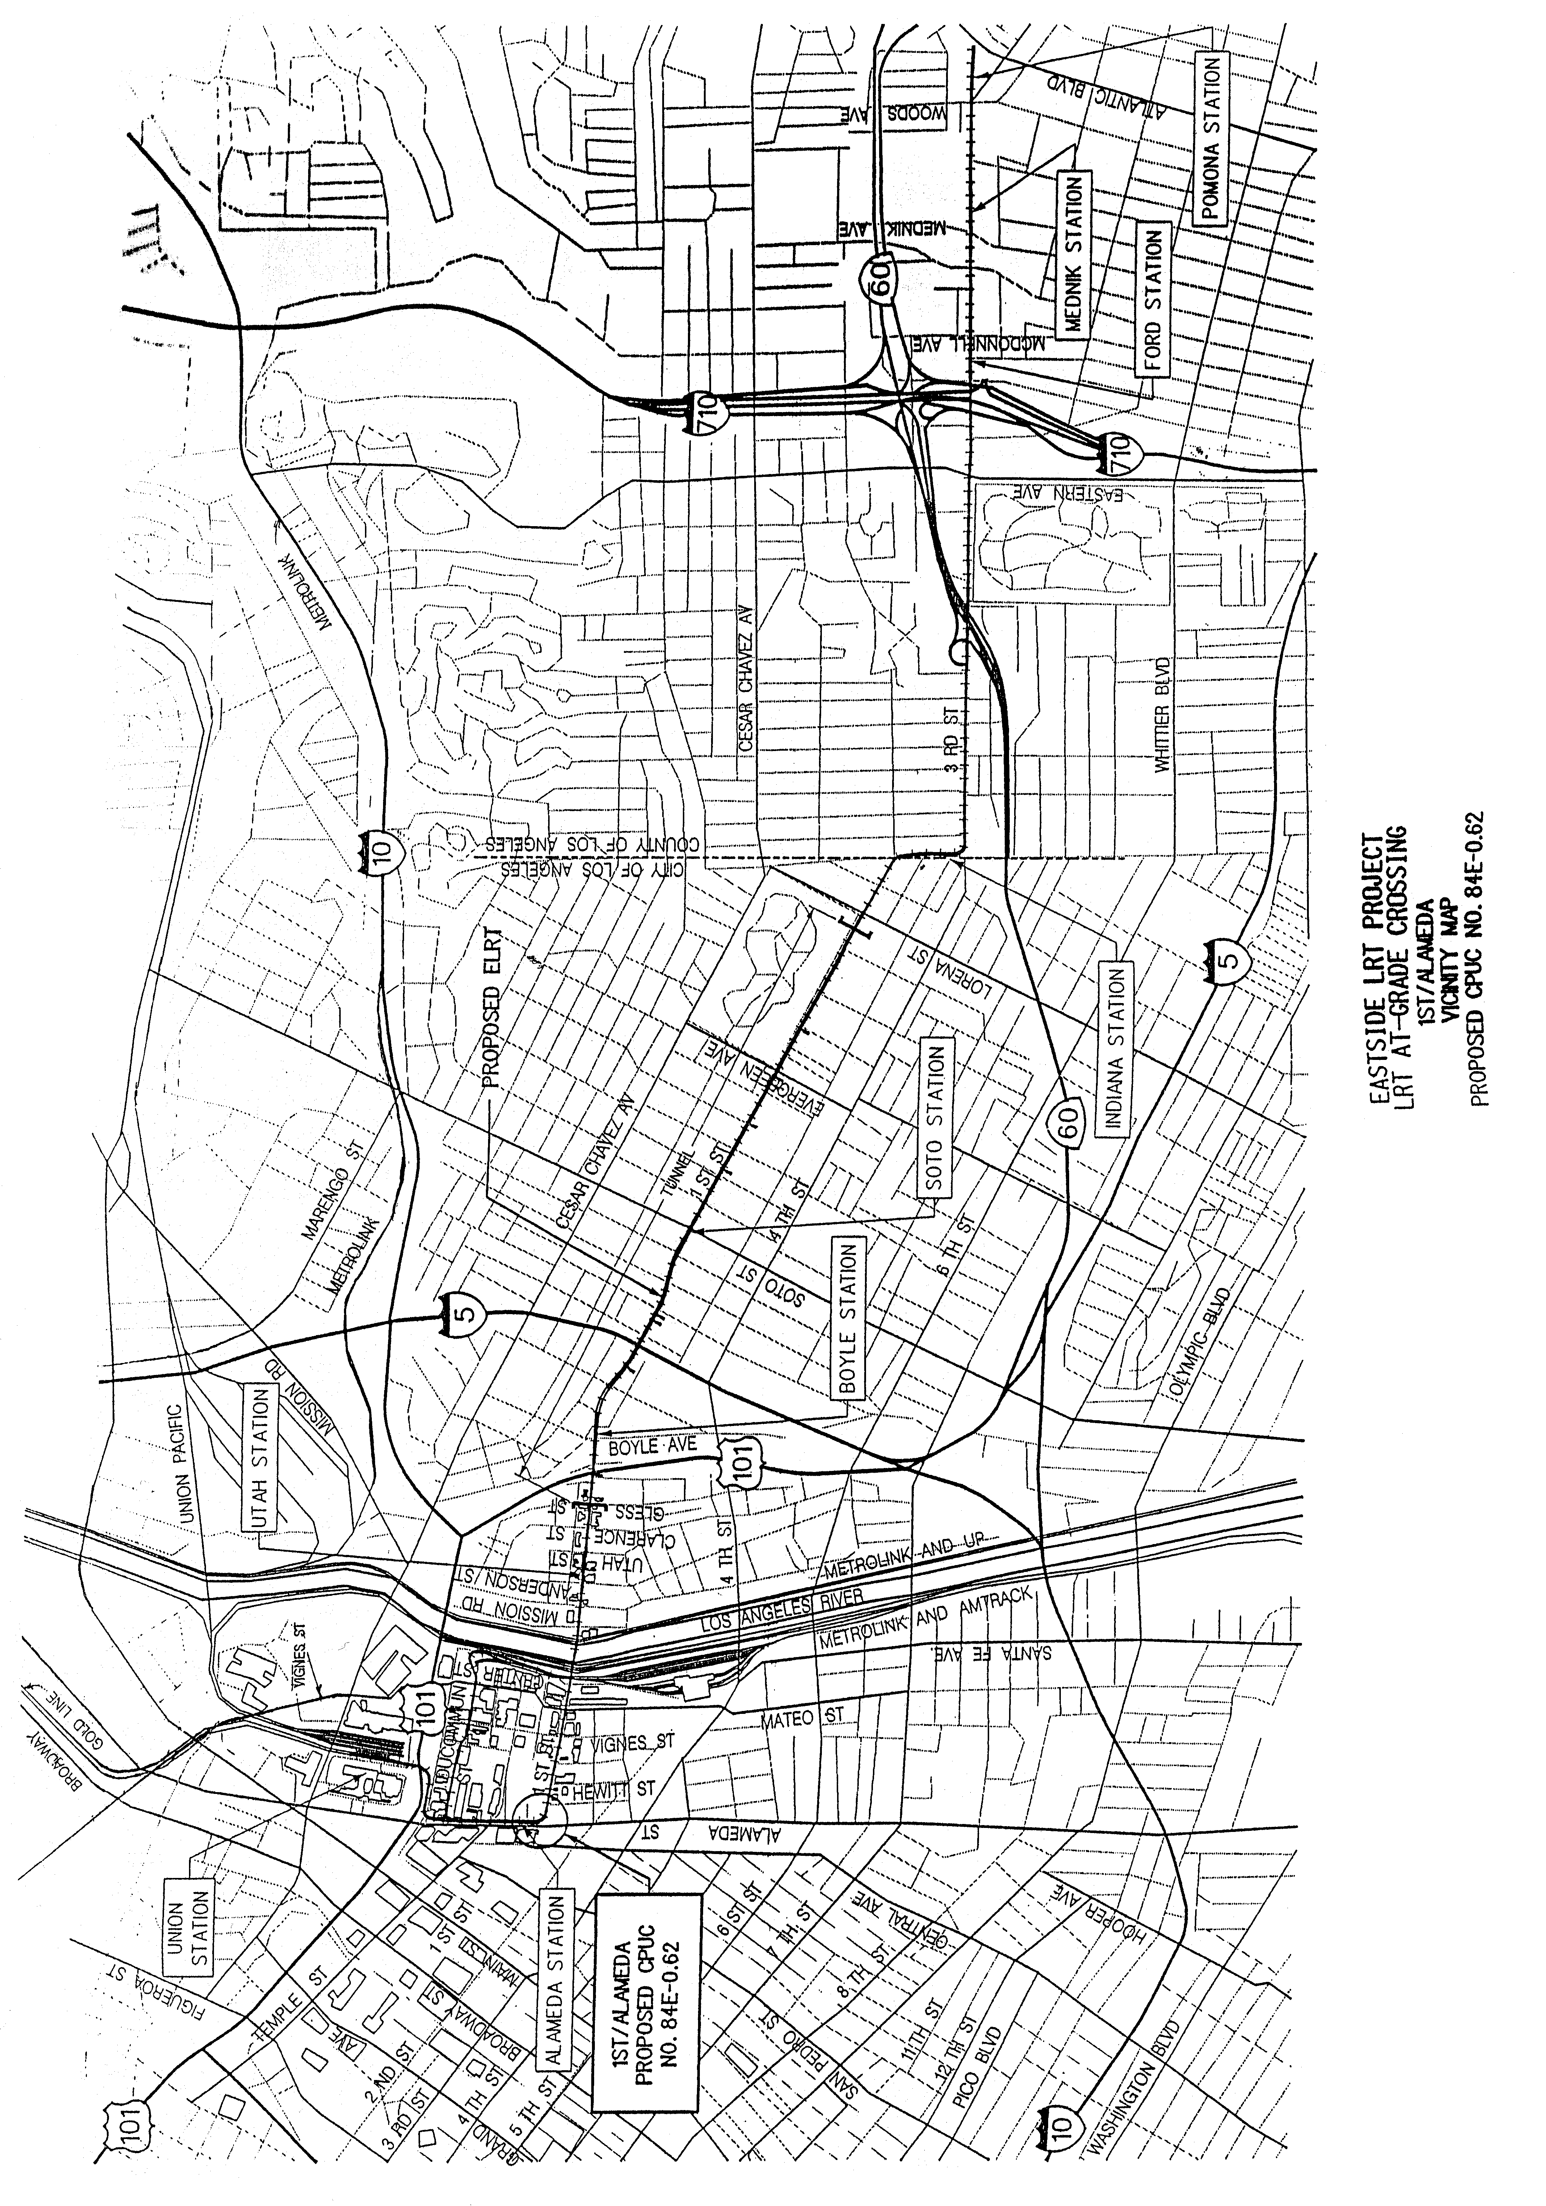
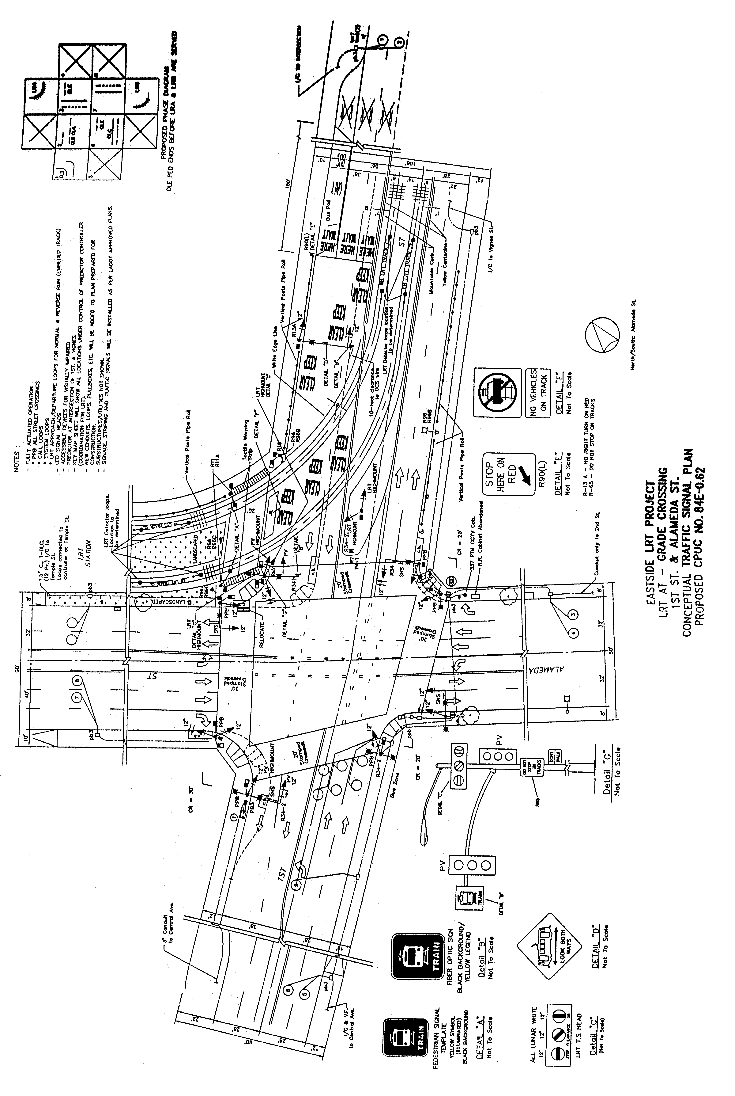
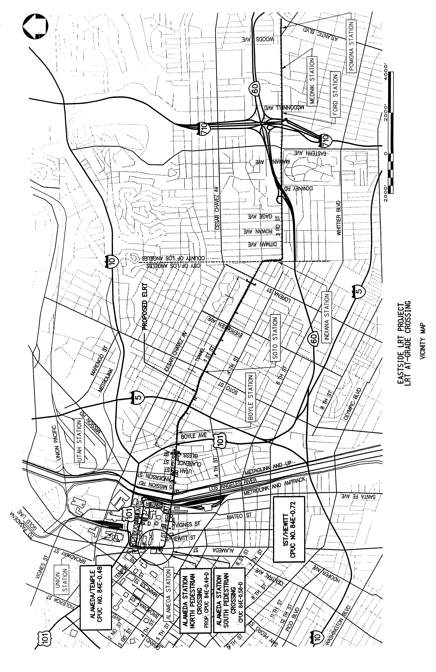
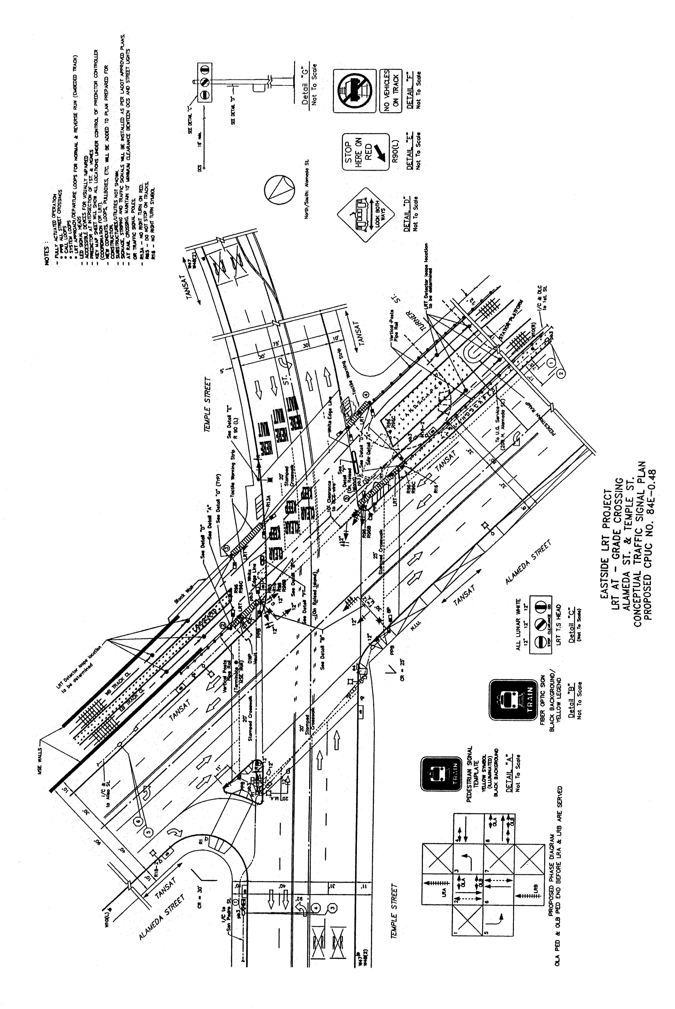
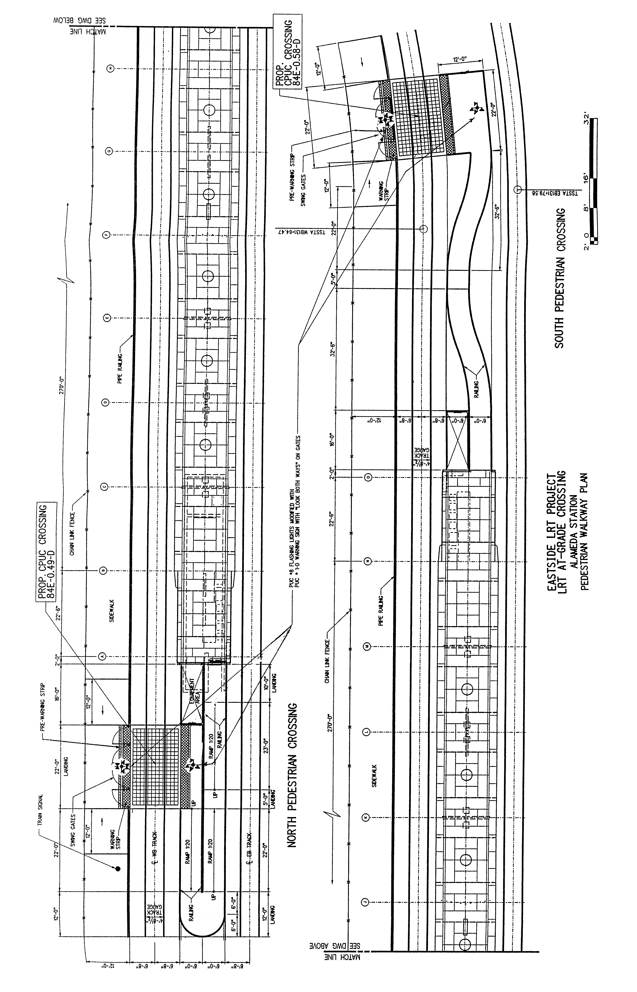
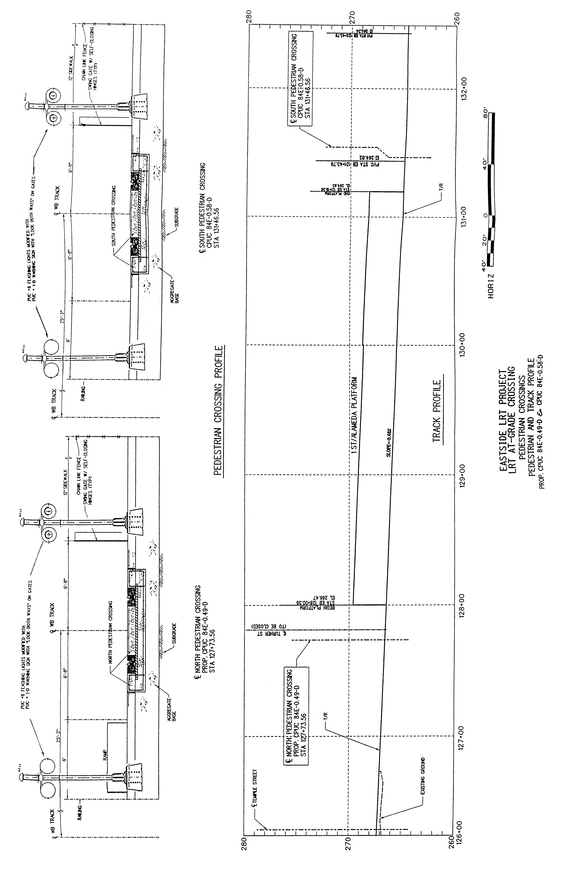
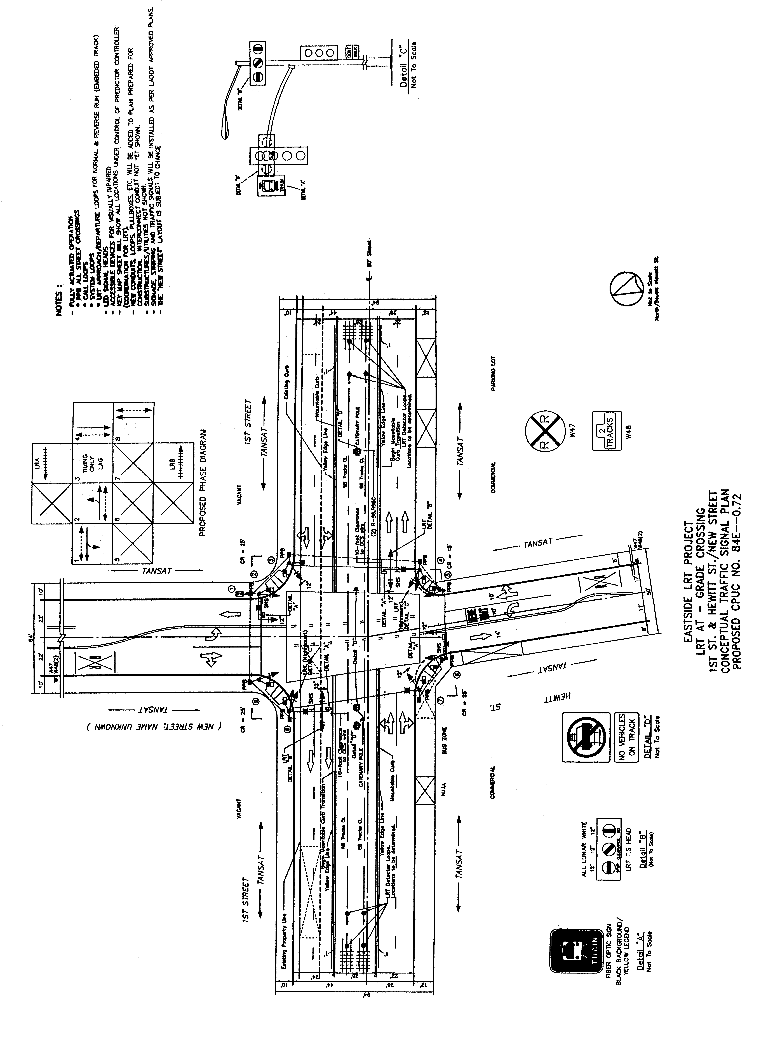
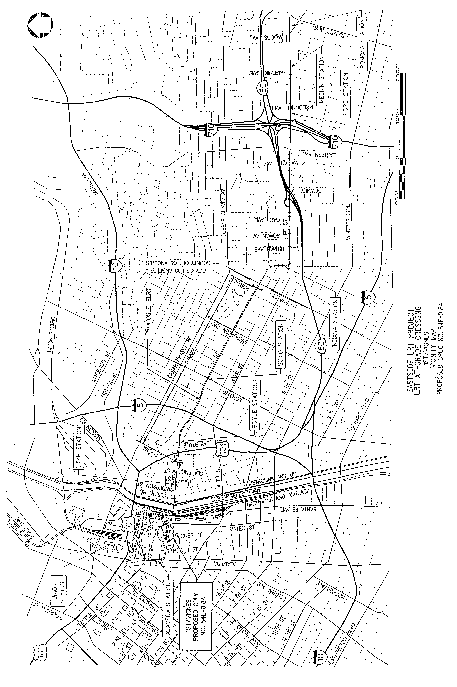
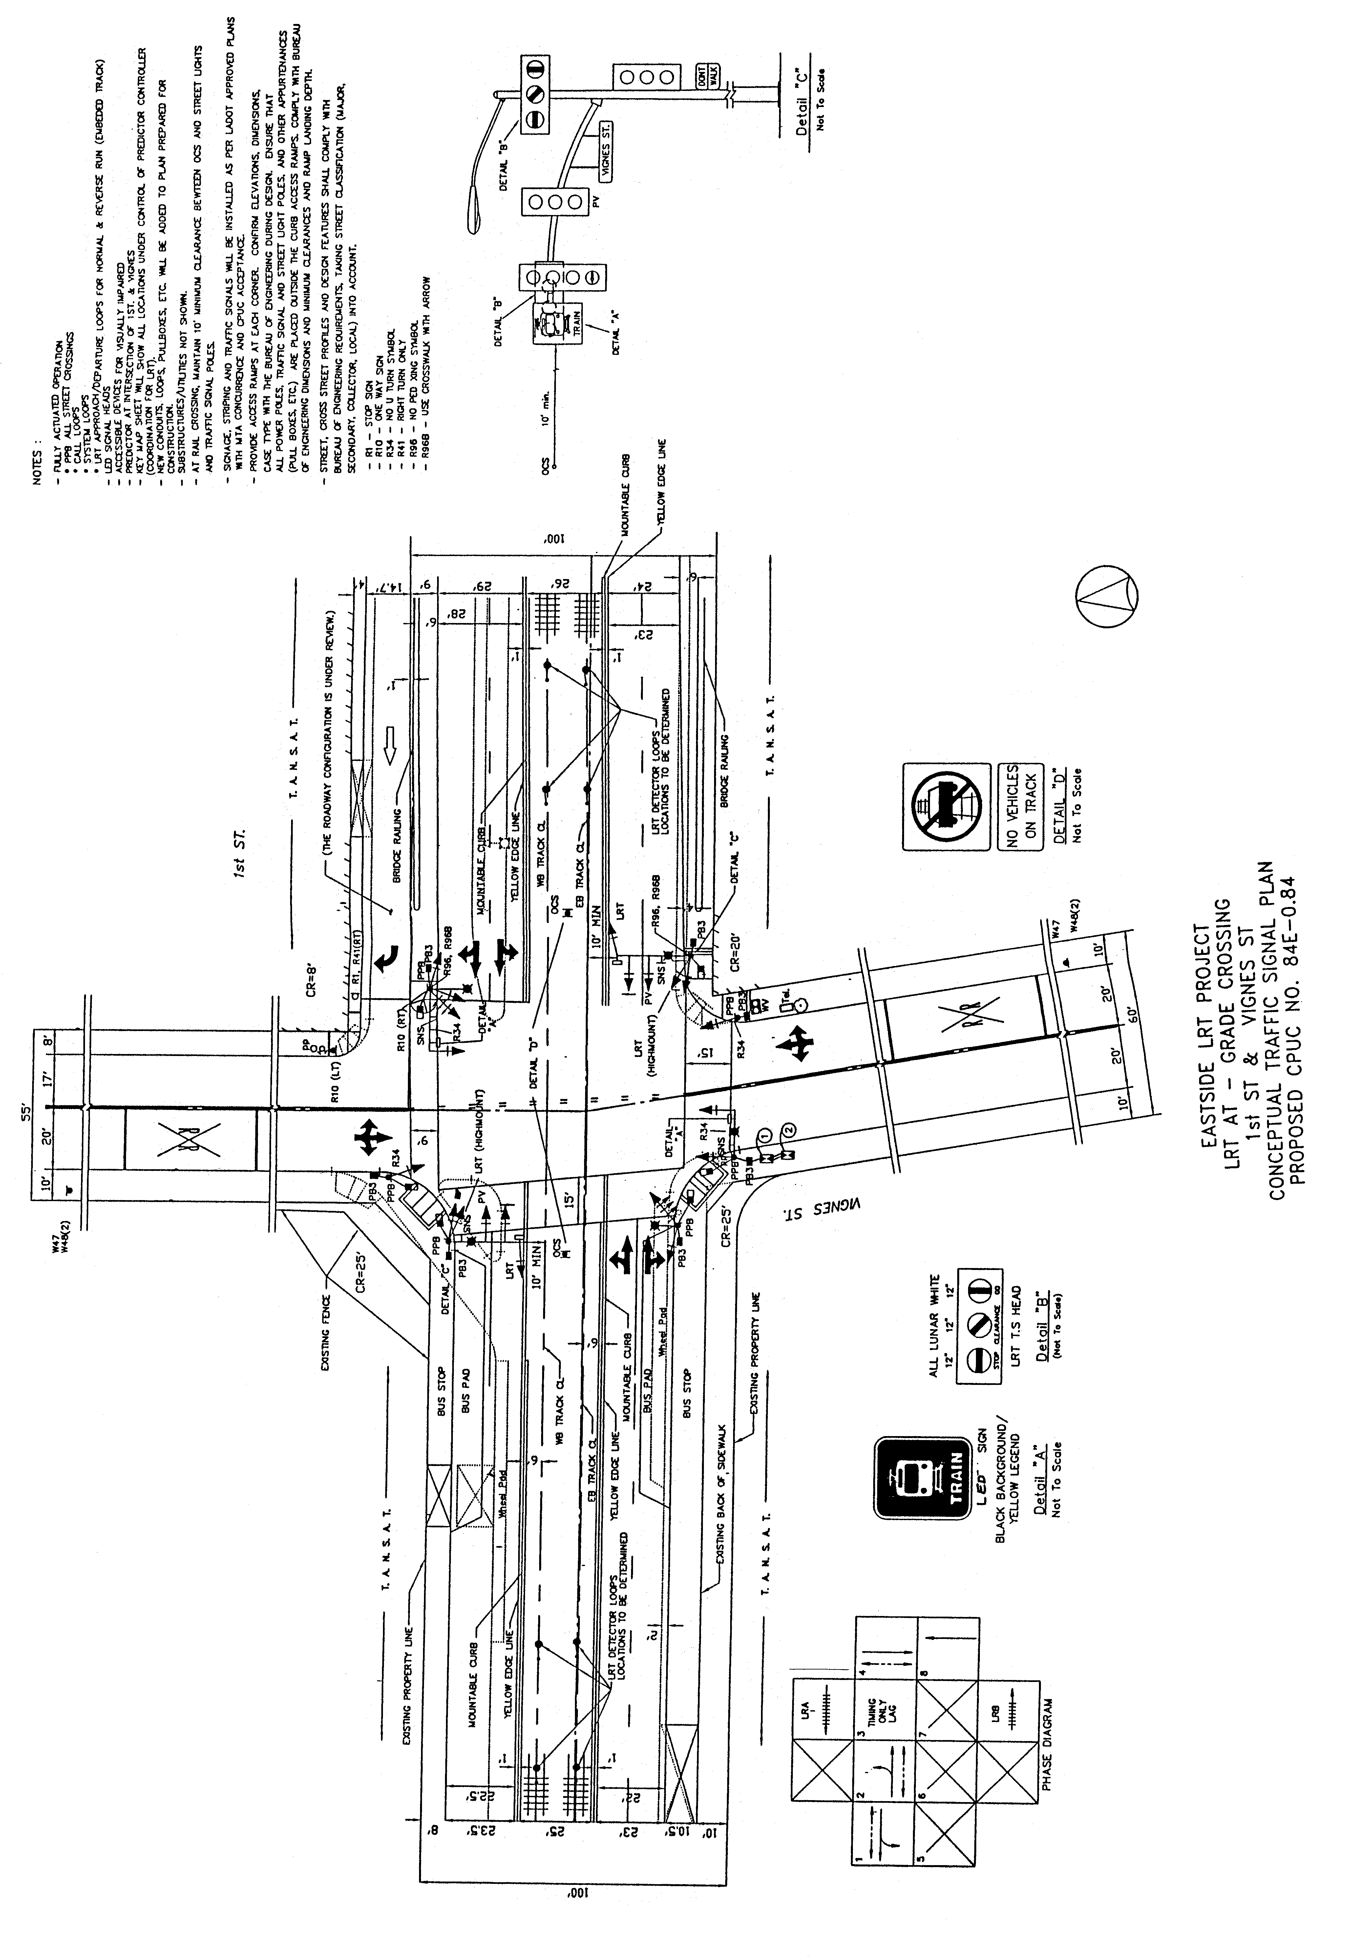

A P P E N D I X C
ENVIRONMENTAL DOCUMENTS
