CPSD/RWC/HMJ/JFP/SH/vdl Mailed 10/31/03

Decision 03-10-077 October 30, 2003

BEFORE THE PUBLIC UTILITIES COMMISSION OF THE STATE OF CALIFORNIA

In the Matter of the Application of the Los Angeles County Metropolitan Transportation Authority for an order authorizing the construction of a two-track grade separated crossing for the Eastside Corridor Light Rail Transit Line above and across the El Monte Busway, above and across the State 101 Freeway and above and across Commercial Street in the City of Los Angeles. | Application 03-07-013  (Filed July 10, 2003)

O P I N I O N

Summary
As part of the project to construct the Eastside Corridor Light Rail Transit Line (ELRL), Los Angeles County Metropolitan Transportation Authority (MTA) requests authority to construct three proposed two-track ELRL grade-separated highway-rail crossings (roadway underpasses) at El Monte Busway (Busway), U.S. Highway 101 Freeway (U.S. 101), and Commercial Street in City of Los Angeles, Los Angeles County.

Discussion
MTA proposes to construct three grade-separated highway-rail crossings (roadway underpasses) of the Busway, U.S. 101, and Commercial Street under MTA’s ELRL tracks in the vicinity of Los Angeles Union Station (LAUS).
MTA is the primary provider of transit-related services in Los Angeles County. The State Legislature created MTA pursuant to Public Utilities Code Section 130050.2. MTA funds and operates an extensive transit network, including the Pasadena Gold Line, in Los Angeles County.
MTA’s ELRL will be an eastward extension of the Pasadena Gold Line and will be six miles in length. The ELRL will begin at the end of the Pasadena Gold Line track northerly from U.S. 101 and will run on an aerial structure, southerly above the Busway, U.S. 101, and Commercial Street. MTA will install automatic train protection signaling with cab signals, as described in the Application, across the aerial structure across U.S. 101 and will terminate at ground level northerly from Temple Street.
Commission General Order (GO) 143-B provides for the operation of light rail transit lines. MTA proposes to adopt ELRL operations that will meet the requirements of GO 143-B, Section 9.04(b)(4) to construct the three proposed two-track grade-separated highway-rail crossings (roadway underpasses) at the Busway, U.S. 101, and Commercial Street.
MTA is authorized to utilize and cross public roadways and public right-of-ways, to construct and maintain a light rail transit line together with the appurtenances, and to relocate other facilities pursuant to Public Utilities Code Sections 30631, 30633, and 130231. The project for the grade-separated highway-rail crossing structure, designed by MTA, is included in a State of California, Department of Transportation (Caltrans) single construction contract. The structure will be part of the highway improvements on southbound U.S. 101 from Los Angeles Street to Center Street in the City. MTA will reimburse Caltrans for 100% of the costs of construction of the proposed grade-separated highway-rail crossing structure. At its entire expense, MTA will contract for track construction and overhead catenary power system. Upon completion of the construction of the grade-separated highway-rail crossing structure, Caltrans and MTA (parties) will bear maintenance and its associated cost, for that portion of the structure above the Busway and U.S. 101, pursuant to an agreement between the parties. For that portion of the structure above Commercial Street, City and MTA will abide by the provisions of the Master Cooperative Agreement between City and MTA.
MTA is the lead agency for this project under California Environmental Quality Act of 1970 (CEQA), as amended in 1982 and as stated in Public Resources (PR) Code Section 21000 et seq. MTA prepared a Final Supplemental Environmental Impact Statement/Final Subsequent Environmental Impact Report (Final SEIS/SEIR), assigned State Clearinghouse (SCH) Number 1999081061, for the project on January 4, 2002. On February 28, 2002, the MTA Board of Directors approved the project and adopted the Final SEIS/SEIR. On March 1, 2002, in compliance with PR Code Sections 21108 and 21152, MTA filed a Notice of Determination (NOD) with the State Clearinghouse and the Los Angeles County Clerk. The NOD is attached to Appendix A of the order. The NOD concluded that the project will have a significant effect on the environment and mitigation measures were made a condition for project approval. Findings were made pursuant to the provisions of CEQA, and MTA adopted a “Statement of Overriding Considerations” (SOC) for this project.
The Commission is a responsible agency for this project under CEQA. CEQA requires that the Commission consider the environmental consequences of a project subject to its discretionary approval. In particular, to comply with CEQA, a responsible agency must consider the lead agency’s Environmental Impact Report or Negative Declaration prior to acting upon or approving the project (CEQA Guideline Section 15050(b)). The specific activities that a responsible agency must conduct are contained in CEQA Guideline Section 15096.
The Commission has reviewed the lead agency’s environmental documents, and we find them adequate for our decision-making purposes. These documents include the Final SEIS/SEIR for the Los Angeles Eastside Corridor (SCH No. 1999081061), prepared jointly by the United States Department of Transportation – Federal Transit Administration and MTA. In considering this document, we note that the Final SEIS/SEIR developed and evaluated a range of alternatives as well as a “No-Build Alternative.” The Final SEIS/SEIR included an analysis of potential environmental impacts related to the project and alternatives related to, among other items, transportation, land use and development, economic and fiscal impacts, land acquisition/displacement and relocation, visual impacts and aesthetics, air quality, noise and vibration, geologic and seismic conditions, hazardous materials, water resources, and safety. Safety, transportation and noise are within the scope of the Commission’s permitting process. The Final SEIS/SEIR (Volume I) has statements pertaining to the affected environment, methodology for impact evaluation, impacts, and mitigation. MTA identified environmental impacts related to safety, transportation, and noise.
The “Findings Of Fact And Statement Of Overriding Considerations,” (FFSOC) contains statements pertaining to impacts, mitigation measures, and findings for each impact. The FFSOC categorized these impacts as “Significant Effects Determined to be Mitigated to a Less Than Significant Level,” “Significant Effects That Are Not Mitigated to a Less Than Significant Level,” and “Effects Determined Not to be Significant or Less Than Significant.” Included in the FFSOC are the SOC and “Mitigation Monitoring Plan” (MMP).
The MTA Board of Directors adopted the SOC with respect to significant and unavoidable adverse environmental impacts identified in the Final SEIS/SEIR and FFSOC and those impacts related to safety, transportation, and noise. In adopting the SOC, the Board of Directors noted the following benefits from the proposed project:
- Light rail transit (LRT) will provide LRT service to the eastside communities of Los Angeles.
- LRT service is expected to increase the number of daily transit trips by 28,000 trips and will reduce travel time. LRT as well as the regional rail and bus system also will provide area residents with improved access to local and regional destinations. By providing access to many educational and community centers in the Eastside Corridor, LRT service will enhance mobility for young adults and school-age children.
- LRT service will provide a convenient and reliable transportation mode to households and populations, such as low-income and no-auto households.
- LRT service is anticipated to decrease annual regional vehicle mile by 16 million thereby improving air quality.
- LRT service is anticipated to generate approximately 47,000 new construction jobs and, within the first 14 years of operation, over 1000 permanent jobs to operate and maintain the LRT line.
- As the Eastside Corridor is in an area with an extremely low vacancy rate and a great demand for affordable housing, development in the vicinity of the corridor could provide needed housing and space for retail and social service uses.
The MTA Board of Directors found that the benefits of the proposed project outweigh the unavoidable significant adverse environmental impacts. The Board of Directors determined that each of the separate benefits identified in the SOC, in itself and independent of other project benefits, is a basis for overriding all unavoidable impacts identified in the Final SEIS/SEIR and noted in the Board of Directors’ findings.
In reviewing the Final SEIS/SEIR and MMP, we find that with respect to issues within the scope of our permitting process, MTA, where possible, adopted feasible mitigation measures to lessen the significant environmental impacts to less-than-significant levels. We will adopt MTA’s findings and mitigations for purposes of our approval.
With respect the SOC, we find that the Board of Directors enumerated several significant benefits associated with the proposed project which appeared, on balance, to reasonably justify approval of the project despite certain significant and unavoidable impacts. Therefore, we accept and adopt the findings of the SOC for purposes of our approval.
The Commission’s Consumer Protection and Safety Division – Rail Crossings Engineering Section (RCES) has inspected the sites of the three proposed grade-separated highway-rail crossings (roadway underpasses) at the Busway, U.S. 101, and Commercial Street. After reviewing the need for and the safety of the proposed grade-separated highway-rail crossings, RCES recommends that the Commission grant MTA’s requests.
The Application is in compliance with the Commission’s filing requirements, including Rule 40 of Rules of Practice and Procedure, which relates to the construction of railroads tracks across public highways. A site map and detailed drawings of the three proposed grade-separated highway-rail crossings are shown in Appendix B attached to the order.
In Resolution ALJ 176-3117, dated August 21, 2003, and published in the Commission Daily Calendar on August 22, 2003, the Commission preliminarily categorized A.03-07-013 as ratesetting, and preliminarily determined that hearings were not necessary. Since no protests were filed, these preliminary determinations remain correct. The Commission’s Consumer Protection and Safety Division recommends that the Commission grant this Application. Given these developments, it is not necessary to revise the preliminary determinations made in Resolution ALJ 176-3117.
This Application is an uncontested matter in which the decision grants the relief requested. Accordingly, pursuant to Public Utilities Code Section 311(g)(2), we waive the otherwise applicable 30-day period for public review and comment.

Assignment of Proceeding
Richard Clark is the assigned Examiner in this proceeding.
Findings of Fact
- The Commission published Notice of Application 03-07-013 in the Commission Daily Calendar on July 15, 2003. There are no unresolved matters or protests; a public hearing is not necessary.
- MTA requests authority, under Public Utilities Code Sections 1201-1205, to construct, as part of MTA’s ELRL project, three proposed two-track grade-separated highway-rail crossings (roadway underpasses) of the Busway, U.S. 101, and Commercial Street in the vicinity of LAUS in Los Angeles, Los Angeles County.
- Public convenience, necessity, and safety require construction of the three proposed grade-separated highway-rail crossings under MTA’s ELRL tracks.
- MTA is the lead agency for this project under CEQA, as amended.
- In approving the project on February 28, 2002, the MTA Board of Directors adopted the Final SEIS/SEIR for the Los Angeles Eastside Corridor (SCH No. 1999081061) and found that “The project will have a significant effect on the environment.” Mitigation measures were made a condition of the approval of the project. Findings were made pursuant to the provisions of CEQA. An SOC was adopted for this project.
- The Commission is a responsible agency for this project and has reviewed and considered the lead agency's Final SEIS/SEIR, NOD, and the SOC. We find these documents to be adequate for our decision-making purposes.
- Safety, transportation and noise are within the scope of the Commission’s permitting process.
- For the approved project, the lead agency identified environmental impacts related to safety, transportation and noise.
Conclusions of Law
- With respect to significant impacts from safety, transportation and noise, we find that the lead agency adopted feasible mitigation measures where possible to substantially lessen the environmental impacts to a less-than-significant level. With respect to the significant and unavoidable environmental impacts, we find that MTA enumerated several significant benefits to justify project approval. Therefore, we also adopt the SOC for purposes of our approval.
- The Application should be granted as set forth in the following order.

ORDER

IT IS ORDERED that:
- The Commission authorizes Los Angeles County Metropolitan Transportation Authority (MTA) to construct the three proposed two-track grade-separated highway-rail crossings (roadway underpasses) of the El Monte Busway, U.S. Highway 101 Freeway, and Commercial Street under MTA’s Eastside Corridor Light Rail Transit Line tracks, in the City of Los Angeles, Los Angeles County, at the locations and substantially as described and shown by plans attached to the Application and Appendix B attached to this order, identified as CPUC Crossing Nos. 84E-0.12-B (Busway), 84E-0.15-B (U.S. 101), and 84E-0.29-B (Commercial Street).
- Clearances and walkways shall conform to Commission General Order (GO) 143-B.
- The State of California, Department of Transportation (Caltrans); MTA; and City (parties) shall bear construction and maintenance costs in accordance with agreements into which the parties have entered. MTA shall file a copy of the agreements with the Rail Crossings Engineering Section (RCES) prior to construction. Should the parties fail to agree, the Commission shall apportion the costs of construction and maintenance by further order.
- Within 30 days after completion of the work under this order, MTA shall notify RCES in writing, by submitting a completed standard Commission Form G (Report of Changes at Highway Grade Crossings and Separations), of the completion of the authorized work.
- This authorization shall expire if not exercised within three years unless the Commission extends the time or if the parties do not comply with the above conditions. The Commission may revoke or modify authorization if public convenience, necessity or safety so require.
- The Commission grants the Application as set forth above.
- Application 03-07-013 is closed.
This order becomes effective 30 days from today.
Dated October 30, 2003, at San Francisco, California.

MICHAEL R. PEEVEY
President
CARL W. WOOD
LORETTA M. LYNCH
GEOFFREY F. BROWN
SUSAN P. KENNEDY
Commissioners

A P P E N D I X A
ENVIRONMENTAL DOCUMENTS
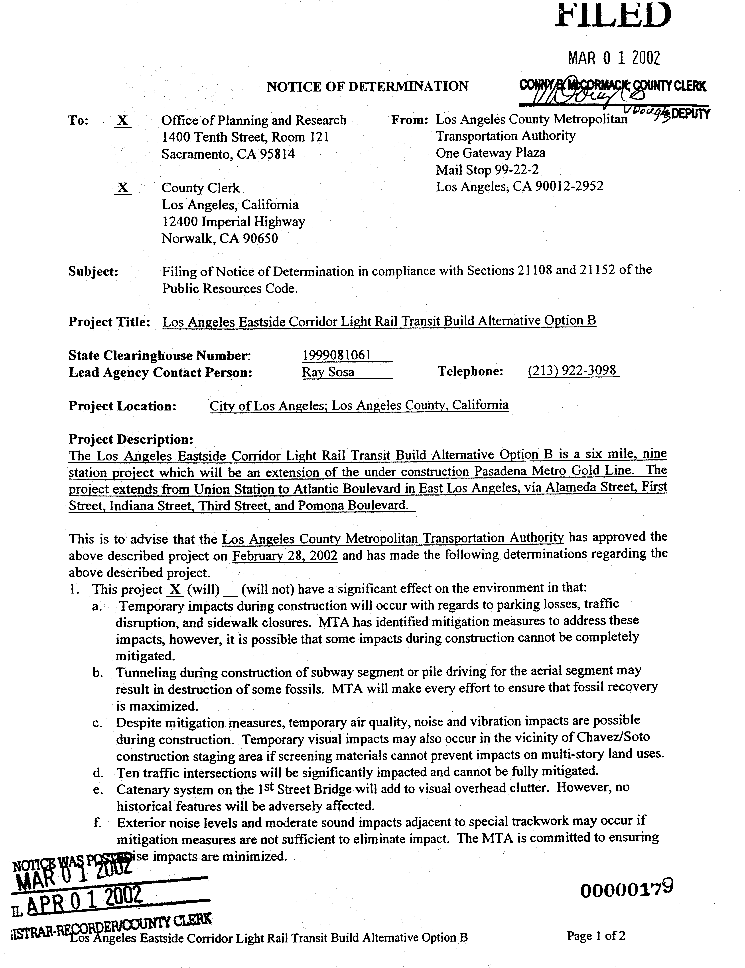
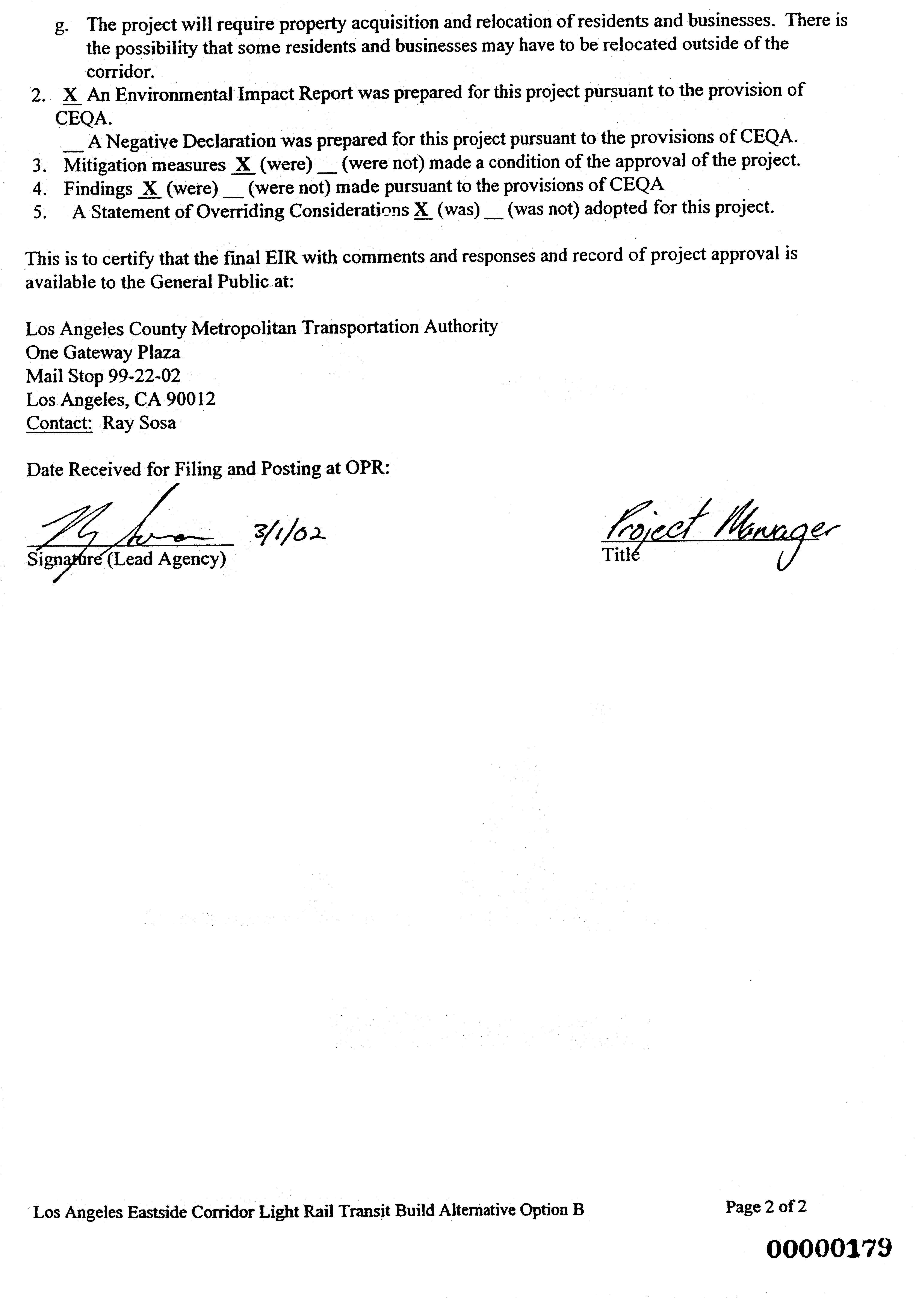
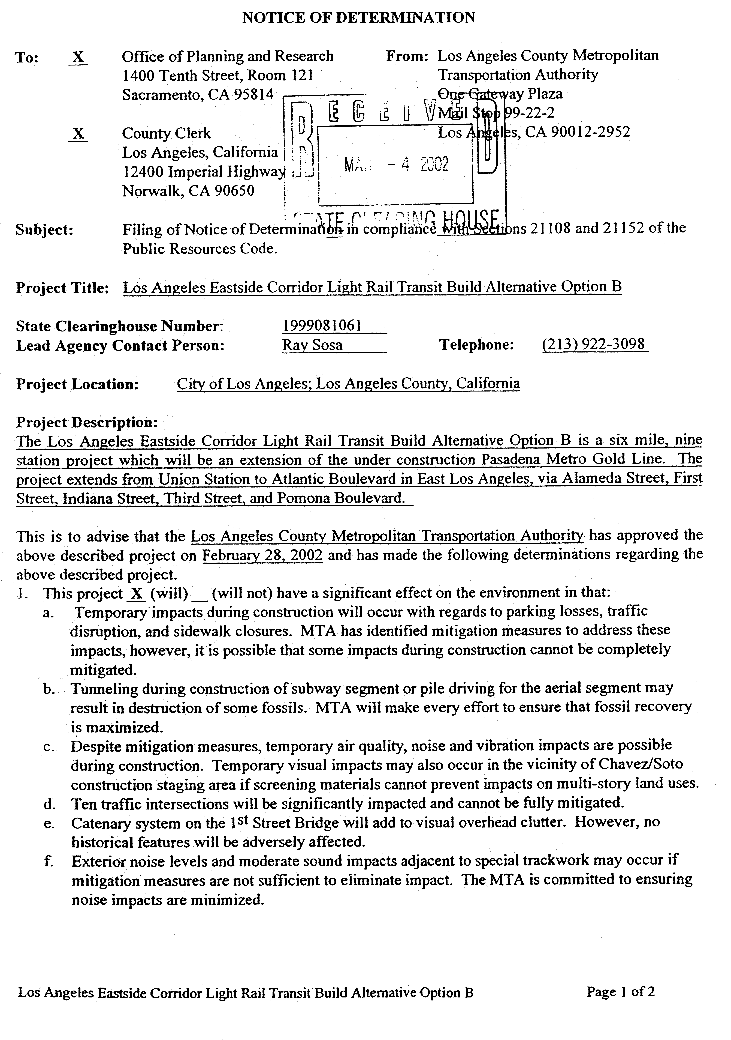
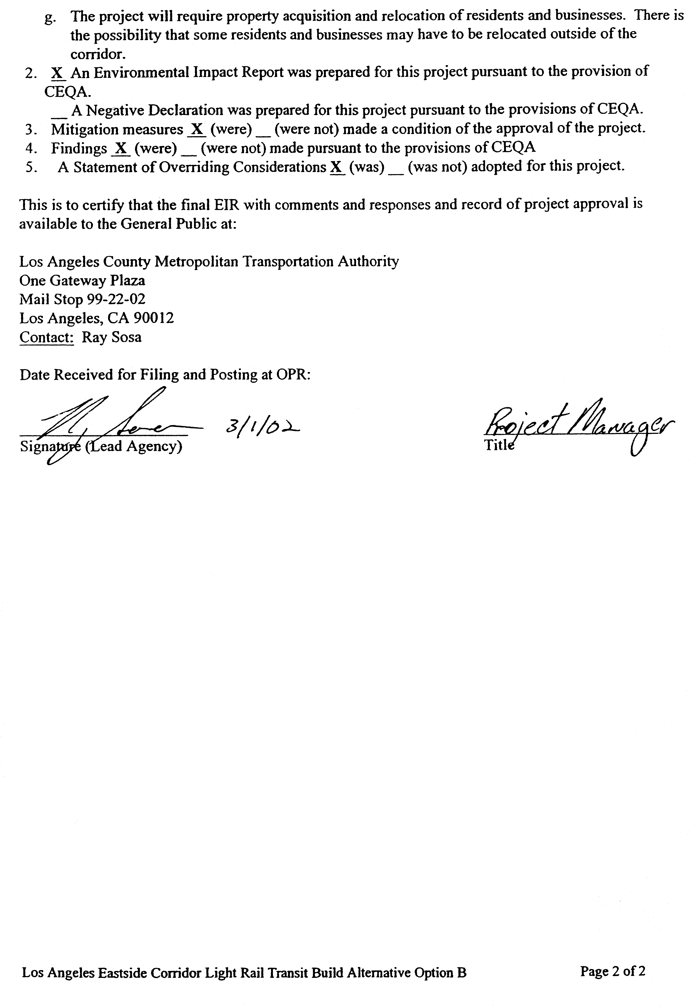
A P P E N D I X B
PLANS
