CPSD/RWC/RST/JFP/SH/vdl Mailed 5/28/04

Decision 04-05-044 May 27, 2004

BEFORE THE PUBLIC UTILITIES COMMISSION OF THE STATE OF CALIFORNIA

In the Matter of the Application of the Los Angeles County Metropolitan Transportation Authority for an order authorizing the construction of a two-track at-grade crossing for the Eastside Corridor Light Rail Transit Line across Lorena Street in the City of Los Angeles. | Application 03-06-022  (Filed June 19, 2003;  Supplement filed January 15, 2004)

O P I N I O N

Summary
This decision grants Los Angeles County Metropolitan Transportation Authority’s (MTA) request for authority to construct, as part of the Eastside Corridor Light Rail Transit Line (ELRL) project, the proposed two-track at-grade highway-rail crossing (crossing) across Lorena Street in Los Angeles, Los Angeles County.

Discussion
MTA proposes to construct Lorena Street crossing across MTA’s ELRL tracks at the intersection of First Street and Lorena Street. MTA’s ELRL will be an eastward extension of the Pasadena Gold Line and will be six miles in length. The ELRL will begin at the end of the Pasadena Gold Line track at Los Angeles Union Station (LAUS).
The portion of the ELRL in the vicinity of the proposed crossing will be either at grade along First Street or in a tunnel. Within the vicinity of the proposed crossing, the ELRL will run easterly along the center of First Street for approximately 0.8 miles across the Los Angeles River to the west portal of a tunnel beneath Boyle Heights. The ELRL will continue easterly within the tunnel aligned approximately beneath First Street for 1.7 miles to the east portal of the tunnel at the site of the proposed crossing. The ELRL will continue easterly along the center of First Street to the intersection of First Street and Indiana Street. The location of this intersection is 2.96 miles from the beginning of the ELRL at LAUS.
The ELRL will have a double track with overhead power distribution and will operate electrically powered cars 90 feet in length. As stated in General Order 143-B, Section 9.04(b)(4), the alignment classification is semi-exclusive. This alignment classification describes the situation of tracks “Within street right-of-way, but protected by mountable curbs, striping, or lane designation.” Furthermore, trains will operate at a speed no greater than the maximum allowable automotive speed of the streets traveled with a maximum speed of 35 miles per hour. MTA will utilize an over speed protection system in the event a train operator exceeds the 35 miles per hour speed and the operator does not respond to the over speed indication. In such instances, a train will stop automatically.
The intersection at the proposed crossing will have traffic signals for motorists and pedestrians and dedicated train signals (lunar white bar indications) for the train operators. The train signals display three phases using lunar white bars as indicators. The three phases are analogous to the three-colored phases used in traffic signals: a horizontal bar indicates a “red” or stop phase; a diagonal bar indicates a “yellow” or prepare to stop phase; and a vertical bar indicates a “green” or proceed phase. To further enhance safety on the ELRL, the proposed crossing will have train-actuated light emitting diode (LED) warning signs to give motorists and pedestrians warning of approaching trains. The train-actuated LED warning signs will flash and illuminate the silhouette of a train to warn of an approaching train. For intersections within its jurisdiction, City of Los Angeles (City) will coordinate traffic signals to the extent possible to provide priority to train traffic.
MTA is the lead agency for this project under California Environmental Quality Act of 1970 (CEQA), as amended in 1982 and as stated in Public Resources (PR) Code Section 21000 et seq. MTA prepared a Final Supplemental Environmental Impact Statement/Final Subsequent Environmental Impact Report (Final SEIS/SEIR), assigned State Clearinghouse (SCH) Number 1999081061, for the project on January 4, 2002. On February 28, 2002, the MTA Board of Directors approved the project and adopted the Final SEIS/SEIR. On March 1, 2002, in compliance with PR Code Sections 21108 and 21152, MTA filed a Notice of Determination (NOD) with the State Clearinghouse and the Los Angeles County Clerk. The NOD is attached to Appendix A of the order. The NOD concluded that the project will have a significant effect on the environment and mitigation measures were made a condition for project approval. Findings were made pursuant to the provisions of CEQA, and MTA adopted a “Statement of Overriding Considerations” (SOC) for this project.
The Commission is a responsible agency for this project under CEQA. CEQA requires that the Commission consider the environmental consequences of a project subject to its discretionary approval. In particular, to comply with CEQA, a responsible agency must consider the lead agency’s Environmental Impact Report or Negative Declaration prior to acting upon or approving the project (CEQA Guideline Section 15050(b)). The specific activities that a responsible agency must conduct are contained in CEQA Guideline Section 15096.
We reviewed the lead agency’s environmental documents, and we find them adequate for our decision-making purposes. These documents include the Final SEIS/SEIR for the Los Angeles Eastside Corridor (SCH No. 1999081061), prepared jointly by the United States Department of Transportation – Federal Transit Administration and MTA. In considering this document, we note that the Final SEIS/SEIR developed and evaluated a range of alternatives as well as a “No-Build Alternative.” The Final SEIS/SEIR included an analysis of potential environmental impacts related to the project and alternatives related to, among other items, transportation, land use and development, land acquisition/ displacement and relocation, air quality, noise and vibration, and safety. Safety, transportation and noise are within the scope of the Commission’s permitting process. The Final SEIS/SEIR (Volume I) has statements pertaining to the affected environment, methodology for impact evaluation, impacts, and mitigation. MTA identified environmental impacts related to safety, transportation, and noise.
Potential safety impacts relate to the number of light rail trains operating during weekday peak hours and the risk of collisions with vehicles on the public roadway portion of the system. To mitigate the potential impacts to less-than-significant levels, MTA will implement mitigation measures, including working with the City traffic control department; minimizing turns by vehicles across tracks; installing traffic controls, such as automatic signs and intersection surveillance cameras; and providing safety lighting where there is conflict between the movement of pedestrians, vehicles, and trains.
Potential transportation impacts relate to areas of vehicular back-ups during peak hours at certain intersections. To mitigate most impacts to less-than-significant levels, adopted mitigation measures include modified turn lanes and parking restrictions at specified locations.
Potential noise impacts are anticipated at various one-family and two-family residential buildings. Adopted mitigation measures to reduce most impacts to less-than-significant levels include rail grinding and replacement, rail vehicle wheel truing and replacement, vehicle maintenance, and sound insulation at impacted buildings.
The “Findings Of Fact And Statement Of Overriding Considerations,” (FFSOC) contains statements pertaining to impacts, mitigation measures, and findings for each impact. The FFSOC categorized these impacts as “Significant Effects Determined to be Mitigated to a Less Than Significant Level,” “Significant Effects That Are Not Mitigated to a Less Than Significant Level,” and “Effects Determined Not to be Significant or Less Than Significant.” Included in the FFSOC are the SOC and “Mitigation Monitoring Plan” (MMP). The MTA Board of Directors adopted the SOC to approve the project despite significant and unavoidable adverse environmental impacts identified in the Final SEIS/SEIR and FFSOC related to transportation and noise. Specifically, MTA determined that transportation mitigation measures adopted for the project would not fully reduce impacts to less-than-significant levels for residual traffic back-ups at a limited number of intersections. In addition, while adopted noise mitigations would fully mitigate noise impacts in interior areas of various one-family and two-family residential buildings, the mitigations would not reduce impacts to less-than-significant levels for the exterior areas of those buildings.
The MTA Board of Directors found that the benefits of the proposed project outweigh the unavoidable significant adverse environmental impacts. The Board of Directors determined that each of the separate benefits identified in the SOC, in itself and independent of other project benefits, is a basis for overriding all unavoidable impacts identified in the Final SEIS/SEIR and noted in the Board of Directors’ findings. Specific overriding benefits resulting from the project include restoring the balance of regional capital transportation expenditures, improving access for area residents to local destinations and regional rail and bus systems, providing convenient and reliable transportation, and decreasing annual regional vehicle miles traveled.
In reviewing the Final SEIS/SEIR and MMP, we find that with respect to issues within the scope of our permitting process, MTA, where possible, adopted feasible mitigation measures to lessen the significant environmental impacts to less-than-significant levels. We will adopt MTA’s findings and mitigations for purposes of our approval.
With respect to the SOC, we find that the Board of Directors enumerated several significant benefits associated with the proposed project which appeared, on balance, to reasonably justify approval of the project despite certain significant and unavoidable impacts. Therefore, we accept and adopt the findings of the SOC for purposes of our approval.
The Commission’s Consumer Protection and Safety Division – Rail Crossings Engineering Section (RCES) has inspected the site of the proposed crossing. After reviewing the need for and the safety of the proposed crossing, RCES recommends that the Commission grant MTA’s request.
RCES staff, in a letter dated September 18, 2003, to MTA, stated that MTA did not consider in the Application an alternative of continuing the ELRL tunnel segment to the east beneath Lorena Street. The staff requested that MTA file a Supplement to Application (Supplement) with the Commission’s Docket Office to provide detailed information on this alterative and to explain why MTA believes a separation of grades at Lorena Street is impracticable.
MTA filed a Supplement on January 15, 2004. RCES concurs with MTA’s assertion in the Application and Supplement that separation of grades of the proposed crossing would be impracticable. The existence of a 72-inch storm sewer in Lorena Street with the top of the storm sewer located approximately 17.6 feet below the street surface makes impracticable the separation of grades by means of continuing the ELRL tunnel segment to the east beneath Lorena Street. MTA found impossible the construction of the tracks beneath Lorena Street within this vertical clearance envelope of 23.6 feet while not exceeding a maximum ascending grade of 6 percent. Maintaining the 6 percent maximum grade would require the tunnel segment to extend east beyond the two at-grade crossings at Indiana and First Streets and at Indiana and Third Streets due to their close proximity (within 1000 feet).
The Application is in compliance with the Commission’s filing requirements, including Rule 40 of Rules of Practice and Procedure, which relates to the construction of railroad tracks across public highways. A site map and detailed drawings of the proposed crossing is shown in Appendix B attached to the order.
In Resolution ALJ 176-3116, dated July 10, 2003, and published in the Commission Daily Calendar on July 11, 2003, the Commission preliminarily categorized Application (A.) 03-06-022 as ratesetting, and preliminarily determined that hearings were not necessary. Since no protests were filed, these preliminary determinations remain correct. Given these developments, it is not necessary to revise the preliminary determinations made in Resolution ALJ 176-3116.
This Application is an uncontested matter in which the decision grants the relief requested. Accordingly, pursuant to Public Utilities Code Section 311(g)(2), we waive the otherwise applicable 30-day period for public review and comment.

Assignment of Proceeding
Richard Clark is the assigned Examiner in this proceeding.
Findings of Fact
- The Commission published Notice of A.03-06-022 in the Commission Daily Calendar on June 23, 2003. There are no unresolved matters or protests; a public hearing is not necessary.
- MTA requests authority, under Public Utilities Code Sections 1201-1205, to construct, as part of MTA’s ELRL project, the proposed Lorena Street crossing in Los Angeles, Los Angeles County.
- Public convenience and necessity require construction of the proposed crossing of MTA’s ELRL tracks.
- Public safety requires at the proposed crossing the installation of traffic signals for motorists and pedestrians and dedicated train signals (lunar white bar indications) for the train operators. To further enhance safety on the ELRL, the proposed crossing will have train-actuated light emitting diode warning signs to give motorists and pedestrians warning of approaching trains. For intersections within its jurisdiction, City will coordinate traffic signals to the extent possible to provide priority to train traffic.
- MTA is the lead agency for this project under CEQA, as amended.
- In approving the project on February 28, 2002, the MTA Board of Directors adopted the Final SEIS/SEIR for the Los Angeles Eastside Corridor (SCH No. 1999081061) and found that “The project will have a significant effect on the environment.” Mitigation measures were made a condition of the approval of the project. Findings were made pursuant to the provisions of CEQA. An SOC was adopted for this project.
- The Commission is a responsible agency for this project and has reviewed and considered the lead agency's Final SEIS/SEIR, NOD, and the SOC. We find these documents to be adequate for our decision-making purposes.
- Safety, transportation and noise are within the scope of the Commission’s permitting process.
- For the approved project, the lead agency identified environmental impacts related to safety, transportation and noise.
- In a letter dated September 18, 2003, to MTA, RCES staff stated that MTA did not consider in the Application an alternative of continuing the ELRL tunnel segment to the east beneath Lorena Street. The staff requested that MTA file a Supplement with the Commission’s Docket Office to provide detailed information on this alterative and to explain why MTA believes a separation of grades at Lorena Street is impracticable. MTA filed the Supplement on January 14, 2004.
- MTA stated in the Supplement that the existence of a 72-inch storm sewer in Lorena Street with the top of the storm sewer located approximately 17.6 feet below the street surface makes impracticable the separation of grades by means of continuing the ELRL tunnel segment to the east beneath Lorena Street. MTA found impossible the construction of the tracks beneath Lorena Street within this vertical clearance envelope of 23.6 feet.
Conclusions of Law
- With respect to significant impacts from safety, transportation and noise, we find that the lead agency adopted feasible mitigation measures where possible to substantially lessen the environmental impacts to a less-than-significant level. With respect to the significant and unavoidable environmental impacts, we find that MTA enumerated several significant benefits to justify project approval. Therefore, we also adopt the SOC for purposes of our approval.
- The Application is uncontested and a public hearing is not necessary.
- The Application should be granted as set forth in the following order.
ORDER
IT IS ORDERED that:
- Los Angeles County Metropolitan Transportation Authority (MTA) is authorized to construct the proposed Lorena Street at-grade highway-rail crossing (crossing) across MTA’s Eastside Corridor Light Rail Transit Line (ELRL) tracks, in Los Angeles, Los Angeles County, at the location and substantially as described and shown by plans attached to the Application and Appendix B attached to this order, identified as CPUC Crossing No. 84E-3.25.
- MTA, in cooperation with the City of Los Angeles (City), shall ensure, at the proposed crossing the installation of traffic signals for motorists and pedestrians and dedicated train signals (lunar white bar indications) for the train operators. To further enhance safety on the ELRL, MTA, at the proposed crossing, shall install train-actuated light emitting diode warning signs to give motorists and pedestrians warning of approaching trains. For intersections within its jurisdiction, City shall coordinate traffic signals to the extent possible to provide priority to train traffic.
- MTA and City (parties) shall bear construction and maintenance costs in accordance with an agreement into which the parties have entered. Should the parties fail to agree, the Commission shall apportion the costs of construction and maintenance by further order.
- Within 30 days after completion of the work under this order, MTA shall notify the Commission’s Consumer Protection and Safety Division-Rail Crossings Engineering Section in writing, by submitting a completed standard Commission Form G (Report of Changes at Highway Grade Crossings and Separations), of the completion of the authorized work.
- This authorization shall expire if not exercised within two years unless the Commission extends the time or if the parties do not comply with the above conditions. The Commission may revoke or modify authorization if public convenience, necessity or safety so require.
- The Commission grants the Application as set forth above.
- Application 03-06-022 is closed.
This order becomes effective 30 days from today.
Dated May 27, 2004, at San Francisco, California.

MICHAEL R. PEEVEY
President
CARL W. WOOD
LORETTA M. LYNCH
GEOFFREY F. BROWN
SUSAN P. KENNEDY
Commissioners

A P P E N D I X A
ENVIRONMENTAL DOCUMENTS
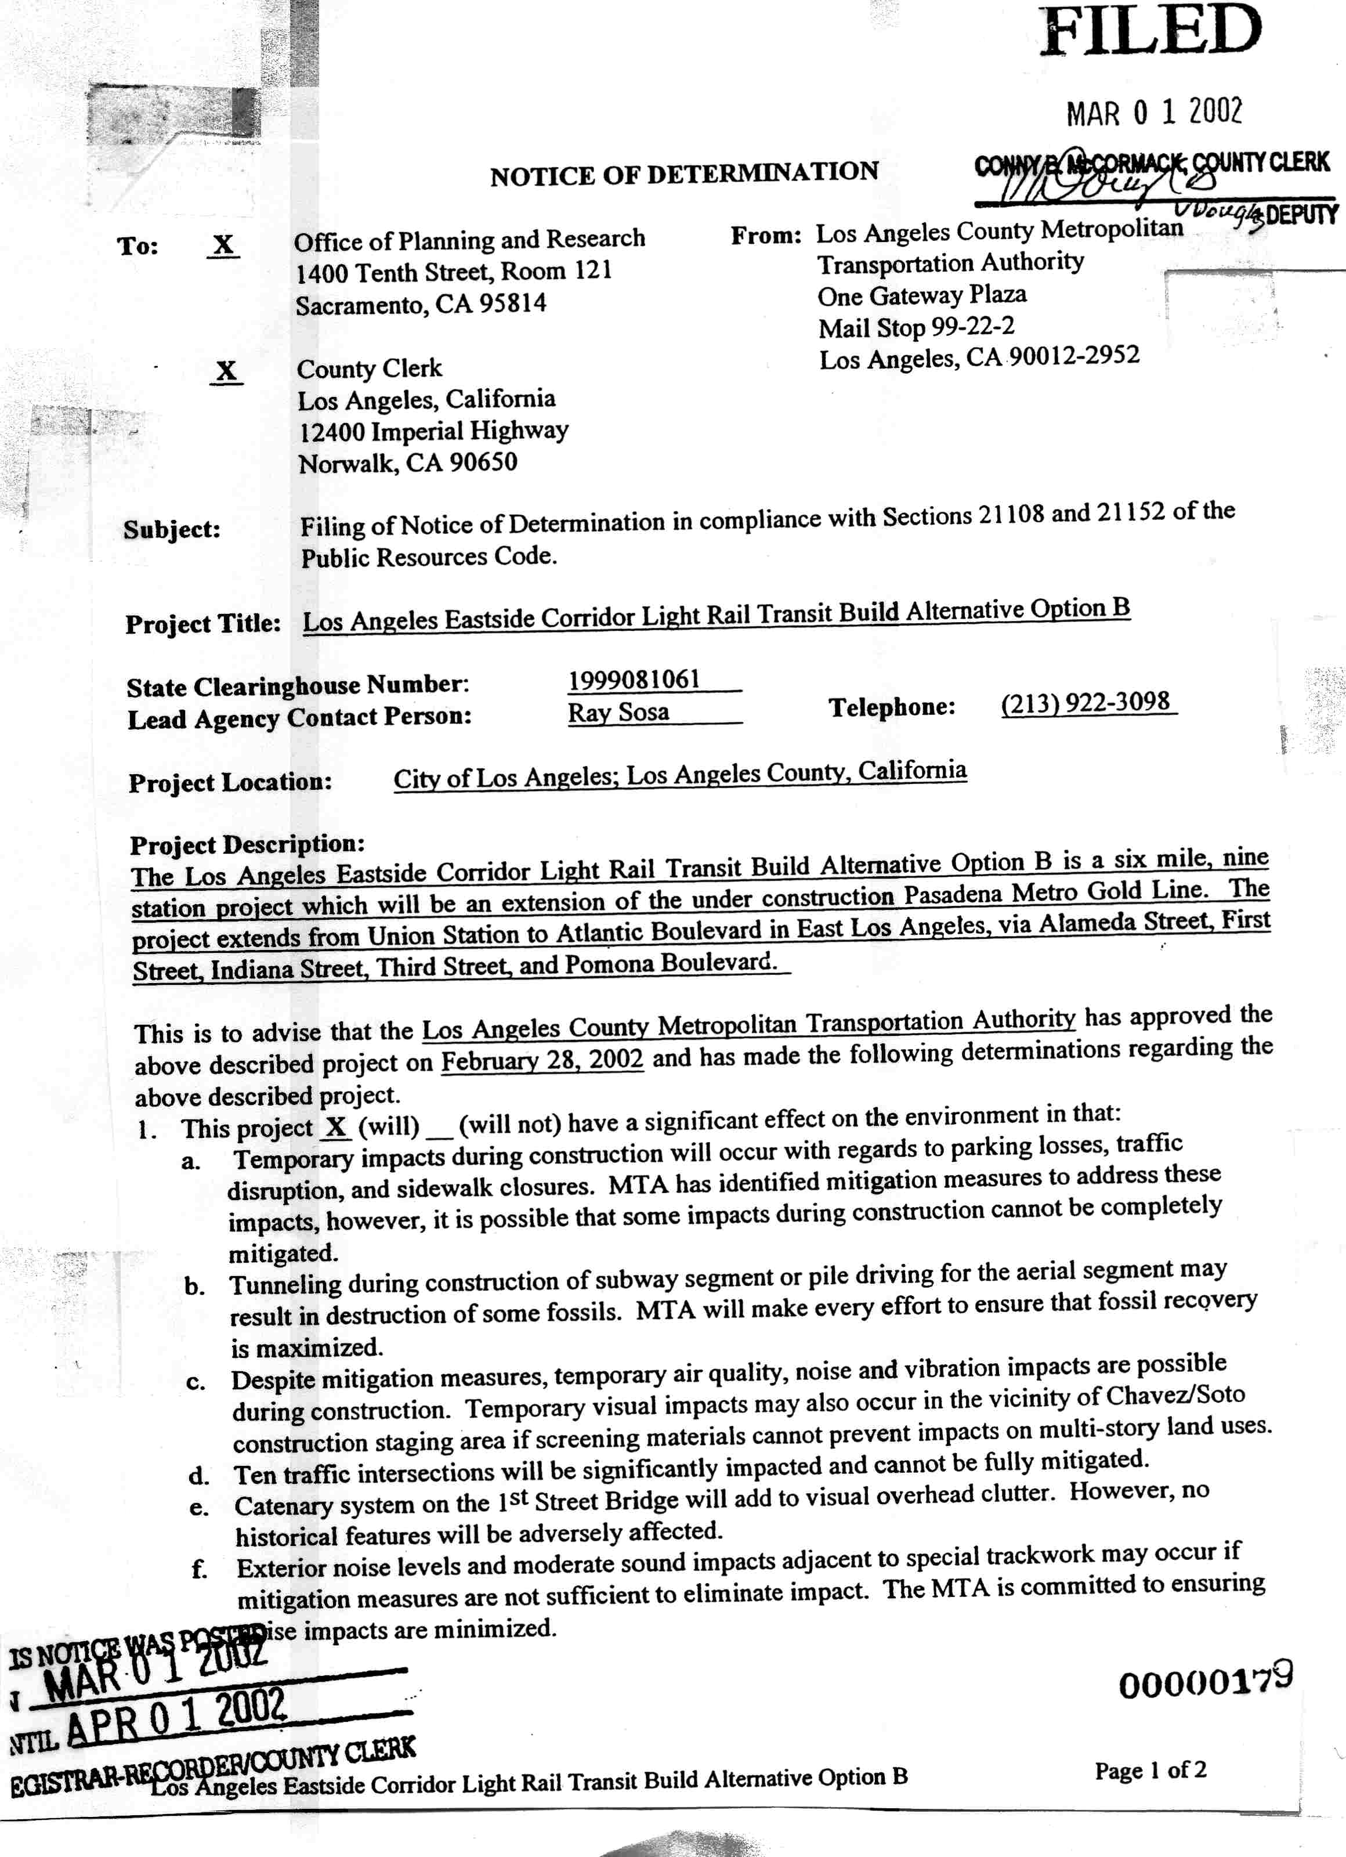
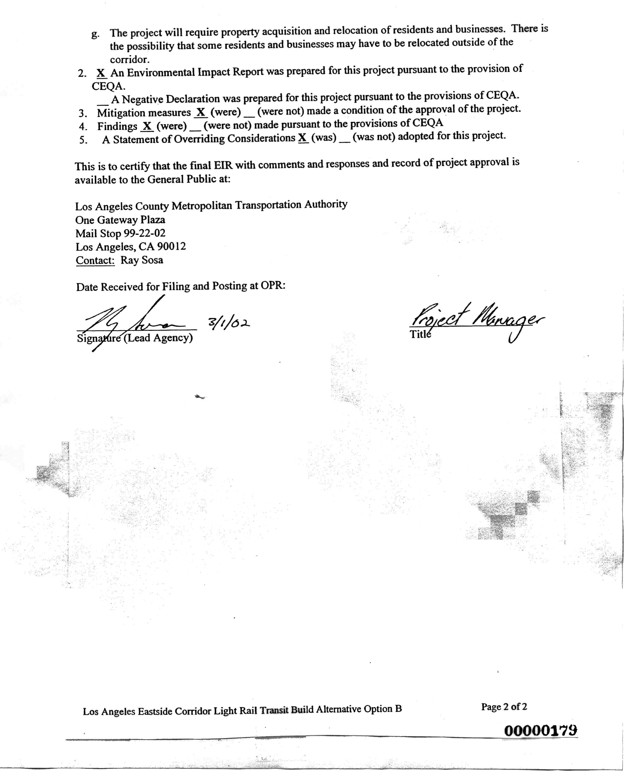
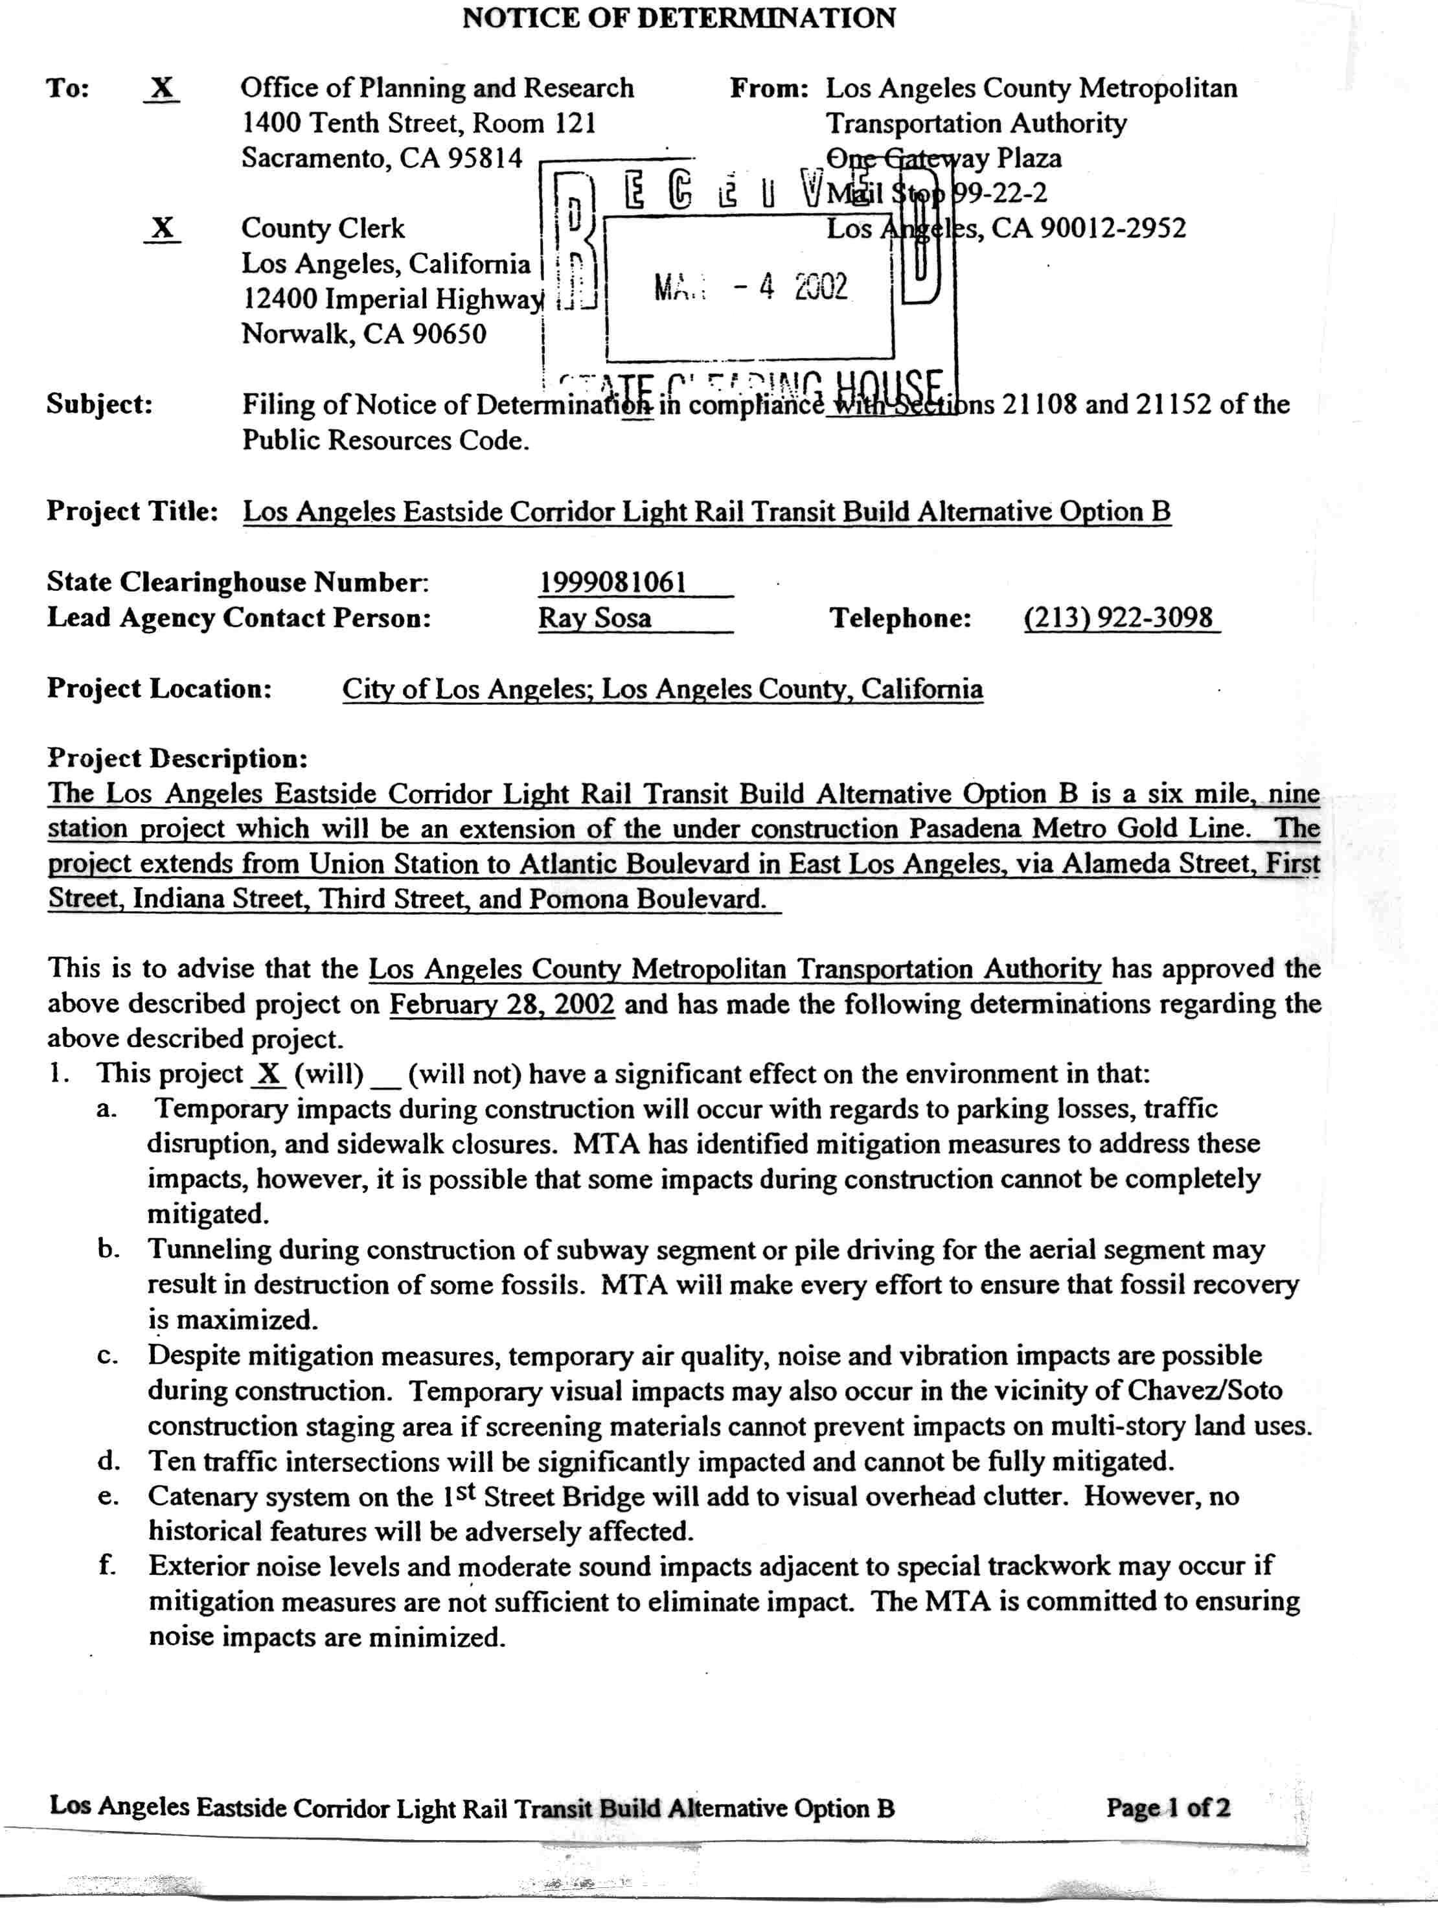
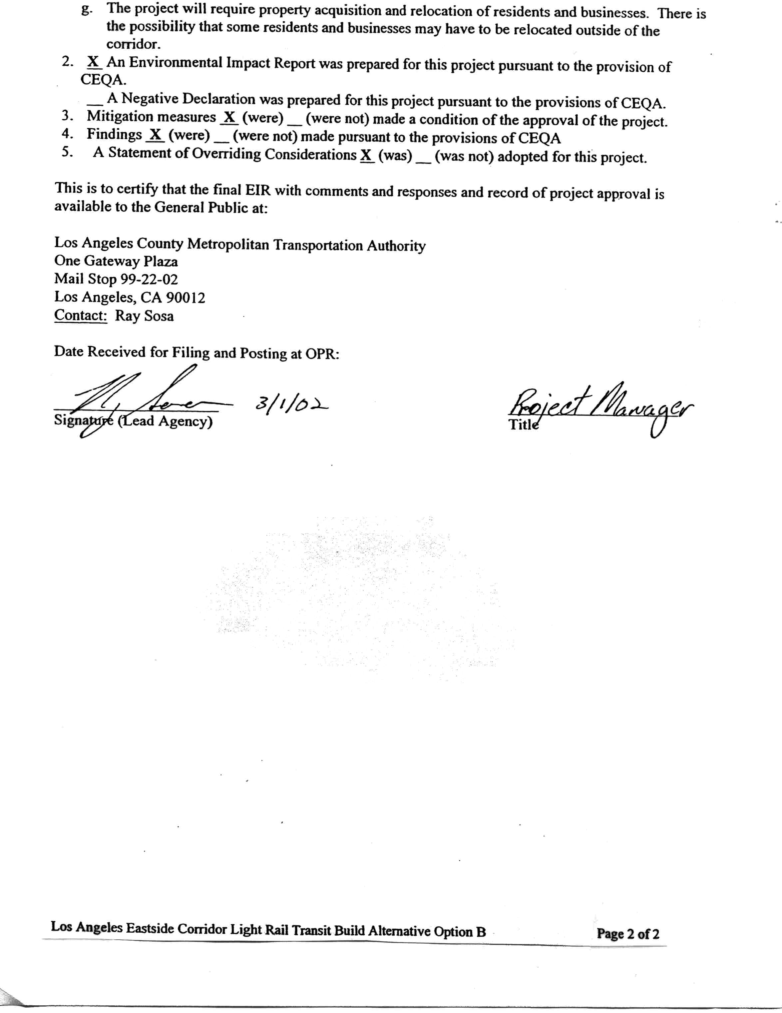
A P P E N D I X B
PLANS
