CPSD/RWC/VAP/JFP/SH/vdl Mailed 1/14/05

Decision 05-01-017 January 13, 2005

BEFORE THE PUBLIC UTILITIES COMMISSION OF THE STATE OF CALIFORNIA

Application of Los Angeles County Metropolitan Transportation Authority for authorization to construct a two-track at-grade crossing for the Eastside Corridor Light Rail Transit Line across the eastbound lanes of First Street, across Indiana Street, across the westbound lanes of Third Street and the construction of a pedestrian grade crossing across two tracks at the north and south ends of the Indiana Street Station in the City and County of Los Angeles. | Application 04-04-016  (Filed April 12, 2004; Supplement filed May 17, 2004 )

O P I N I O N

Summary
This decision grants Los Angeles County Metropolitan Transportation Authority’s (MTA) request for authority to construct, as part of MTA’s Eastside Corridor Light Rail Transit Line (ELRL) project, two at-grade highway-rail (highway) crossings, consisting of two proposed ELRL tracks, across the intersection of Indiana Street with the eastbound lanes of First Street and across the westbound lanes of Third Street and two at-grade pedestrian-rail (pedestrian) crossings across the north and south ends of MTA’s proposed Indiana Station, in City of Los Angeles (City) and an unincorporated area of Los Angeles County (County).

Discussion
MTA requests authority to construct two highway crossings, consisting of two proposed ELRL tracks, across the intersection of Indiana Street with the eastbound lanes of First Street and across the westbound lanes of Third Street, and two Indiana Station pedestrian crossings across the north and south ends of the proposed Indiana Station. Each pedestrian crossing will have two approaches into the station. The table in Appendix A attached to the order lists each proposed crossing and the identifying CPUC crossing number.
Based on the light rail transit operating plan, the ELRL train frequency will be one train every five minutes in each direction during peak times (Monday through Friday, except holidays) and one train every 12 minutes during non-peak times. The ELRL will have a double track with overhead power distribution and will operate electrically powered cars 90 feet in length. As stated in General Order (GO) 143-B, Section 9.04(b)(4), the alignment classification is semi-exclusive. This alignment classification describes the situation of tracks “Within street right-of-way, but protected by mountable curbs, striping, or lane designation.” Furthermore, trains will operate at a speed no greater than the maximum allowable automotive speed of the streets traveled with a maximum speed of 35 miles per hour. MTA will utilize an over speed protection system in the event a train operator exceeds the 35 miles per hour speed and the operator does not respond to the over speed indication. In such instances, a train will stop automatically.
The Indiana Street intersections, with First Street and Third Street, and both highway crossings will have traffic signals for motorists and pedestrians and dedicated train signals (lunar white bar indications) for the train operators. To further enhance safety on the ELRL, the highway crossings will have train-actuated light emitting diode (LED) warning signs to give motorists and pedestrians warning of approaching trains. The train-actuated LED warning signs will flash and illuminate the silhouette of a train to warn of an approaching train. The three phases of the dedicated train signals are analogous to the three-colored phases used in traffic signals: a horizontal bar indicates a “red” or stop phase; a diagonal bar indicates a “yellow” or prepare to stop phase; and a vertical bar indicates a “green” or proceed phase. For intersections within their respective jurisdictions, City and County will coordinate traffic signals to the extent possible to provide priority to train traffic.
Passengers will board MTA light rail vehicles from a center platform at the proposed Indiana Station. To access the center platform, MTA will construct two pedestrian crossings at the north and south ends of the station. MTA will install two CPUC Standard No. 8 (flashing light signals, as defined in GO 75-C) warning devices and 4-foot high self-closing gates on the approaches to each pedestrian crossing. MTA proposes to modify these warning devices by installing one CPUC Standard No. 1-D (pedestrian and bicycle railroad grade crossing sign, as defined in GO 75-C) sign at the location of, and in lieu of, each “RAILROAD CROSSING” sign and one “LOOK BOTH WAYS” sign beneath each set of flashing light signals. MTA also proposes to install one “LOOK BOTH WAYS” sign on each side of the self-closing gates. At each pedestrian crossing, MTA will mount one additional Standard No. 8 warning device adjacent to the terminus of each ramp connected to the center platform.
In accordance with two Master Cooperative Agreements, City and County separately and MTA will bear construction and design costs of the project. MTA will operate and maintain the tracks, traffic signal detector loops in the track area, facilities, appurtenances, and right-of-way. MTA will bear the costs associated with both proposed pedestrian crossings. For costs associated with train and vehicle traffic signal maintenance, City will bear such costs for the traffic intersection and proposed highway crossing of First Street and Indiana Street and County will bear such costs for the traffic intersection of Third Street and Indiana Street and for the proposed highway crossing across the westbound lanes of Third Street. MTA will share costs associated with roadway maintenance of each respective highway crossing with City and County.
MTA is the lead agency for this project under California Environmental Quality Act of 1970 (CEQA), as amended in 1982 and as stated in Public Resources (PR) Code Section 21000 et seq. MTA prepared a Final Supplemental Environmental Impact Statement/Final Subsequent Environmental Impact Report (Final SEIS/SEIR), assigned State Clearinghouse (SCH) Number 1999081061, for the project on January 4, 2002. On February 28, 2002, MTA Board of Directors approved the project and adopted the Final SEIS/SEIR. On March 1, 2002, in compliance with PR Code Sections 21108 and 21152, MTA filed a Notice of Determination (NOD) with the State Clearinghouse and Los Angeles County Clerk. The NOD is attached to Appendix C of the order. The NOD concluded that the project will have a significant effect on the environment and mitigation measures were made a condition for project approval. Findings were made pursuant to the provisions of CEQA, and MTA adopted a “Statement of Overriding Considerations” (SOC) for this project.
The Commission is a responsible agency for this project under CEQA. CEQA requires that the Commission consider the environmental consequences of a project subject to its discretionary approval. In particular, to comply with CEQA, a responsible agency must consider the lead agency’s Environmental Impact Report or Negative Declaration prior to acting upon or approving the project (CEQA Guideline Section 15050(b)). The specific activities that a responsible agency must conduct are contained in CEQA Guideline Section 15096.
The Commission reviewed the lead agency’s environmental documents, and we find them adequate for our decision-making purposes. These documents include the Final SEIS/SEIR for the Los Angeles Eastside Corridor (SCH No. 1999081061), prepared jointly by the United States Department of Transportation – Federal Transit Administration and MTA. In considering this document, we note that the Final SEIS/SEIR developed and evaluated a range of alternatives as well as a “No-Build Alternative.” The Final SEIS/SEIR included an analysis of potential environmental impacts related to the project and alternatives related to, among other items, transportation, land use and development, land acquisition/displacement and relocation, air quality, noise and vibration, and safety. Safety, transportation, and noise are within the scope of the Commission’s permitting process. The Final SEIS/SEIR (Volume I) contains statements pertaining to the affected environment, methodology for impact evaluation, impacts, and mitigation. MTA identified environmental impacts related to safety, transportation, and noise.
Potential safety impacts relate to the number of light rail trains operating during weekday peak hours and the risk of collisions with vehicles on the public roadway portion of the system. To mitigate the potential impacts to less-than-significant levels, MTA will implement mitigation measures, including working with the City and County traffic control departments; minimizing turns by vehicles across tracks; installing traffic controls, such as automatic signs and intersection surveillance cameras; and providing safety lighting where there is conflict between the movement of pedestrians, vehicles, and trains.
Potential transportation impacts relate to areas of vehicular back-ups during peak hours at certain intersections. To mitigate most impacts to less-than-significant levels, adopted mitigation measures include modified turn lanes and parking restrictions at specified locations.
Potential noise impacts are anticipated at various one-family and two-family residential buildings. Adopted mitigation measures to reduce most impacts to less-than-significant levels include rail grinding and replacement, rail vehicle wheel truing and replacement, vehicle maintenance, and sound insulation at impacted buildings.
To reduce noise at each pedestrian crossing and to provide for an adequate audible warning, MTA requests a deviation from Section 7.1 of GO 75-C, which requires the installation of a bell on each Standard No. 8 warning device. Section 7.8 of GO 75-C also requires the constant ringing of bells of at-grade crossings when passing trains activate the warning devices. MTA requests, for each pedestrian crossing, the elimination of the bells on the two proposed modified Standard No. 8 warning devices, each located at each Indiana Station entrance. As the adopted noise mitigation measures reduce most potential noise impacts to less-than-significant levels, we find that there is no need to grant MTA’s request for a deviation from Section 7.1 of GO 75-C. Due to the Indiana Station, the adjacent Ramona High School, residential community, and surrounding commercial establishments, the continuous sounding of the bells on the automatic warning devices is essential for public safety by providing an audible warning to pedestrians in the area.
The “Findings Of Fact And Statement Of Overriding Considerations,” (FFSOC) contains statements pertaining to impacts, mitigation measures, and findings for each impact. The FFSOC categorized these impacts as “Significant Effects Determined to be Mitigated to a Less Than Significant Level,” “Significant Effects That Are Not Mitigated to a Less Than Significant Level,” and “Effects Determined Not to be Significant or Less Than Significant.” Included in the FFSOC are the SOC and “Mitigation Monitoring Plan” (MMP). The MTA Board of Directors adopted the SOC to approve the project despite significant and unavoidable adverse environmental impacts identified in the Final SEIS/SEIR and FFSOC related to transportation and noise. Specifically, MTA determined that transportation mitigation measures adopted for the project would not fully reduce impacts to less-than-significant levels for residual traffic back-ups at a limited number of intersections. In addition, while adopted noise mitigations would fully mitigate noise impacts in interior areas of various one-family and two-family residential buildings, the mitigations would not reduce impacts to less-than-significant levels for the exterior areas of those buildings.
The MTA Board of Directors found that the benefits of the proposed project outweigh the unavoidable significant adverse environmental impacts. The Board of Directors determined that each of the separate benefits identified in the SOC, in itself and independent of other project benefits, is a basis for overriding all unavoidable impacts identified in the Final SEIS/SEIR and noted in the Board of Directors’ findings. Specific overriding benefits resulting from the project include restoring the balance of regional capital transportation expenditures, improving access for area residents to local destinations and regional rail and bus systems, providing convenient and reliable transportation, and decreasing annual regional vehicle miles traveled.
In reviewing the Final SEIS/SEIR and MMP, we find that with respect to issues within the scope of our permitting process, MTA, where possible, adopted feasible mitigation measures to lessen the significant environmental impacts to less-than-significant levels. We will adopt MTA’s findings and mitigations for purposes of our approval.
With respect to the SOC, we find that the Board of Directors enumerated several significant benefits associated with the proposed project which appeared, on balance, to reasonably justify approval of the project despite certain significant and unavoidable impacts. Therefore, we accept and adopt the findings of the SOC for purposes of our approval.
MTA examined several alternatives to at-grade crossings. Alternatives to at-grade crossings include depressing the streets below the tracks, raising the streets above tracks, depressing the tracks below the streets, and raising the tracks above the streets. Raising or lowering the streets with relation to the track grade would require a redesign of the immediate area to preserve the ability of vehicular traffic to access and to traverse the area. Such redesign would require additional right-of-way to preserve the existing traffic grid, would likely result in the displacement of residences and businesses, and would interfere with access to commercial establishments in the area. Furthermore, MTA designed the proposed at-grade crossings to accommodate the passage of emergency vehicles, including fire equipment.
The Commission’s Consumer Protection and Safety Division – Rail Crossings Engineering Section (RCES) inspected the sites of the two proposed highway crossings and the two proposed pedestrian crossings. After reviewing the need for and the safety of the four proposed crossings, RCES recommends that the Commission grant MTA’s requests.
The Application is in compliance with the Commission’s filing requirements, including Rule 40 of Rules of Practice and Procedure, which relates to the construction of railroad tracks across public highways. MTA filed a Supplement to Application on May 17, 2004, to include in this proceeding recent revisions to the site map and construction drawings attached to the Application. The site map and detailed drawings, including revisions, of the two proposed highway crossings and the two proposed pedestrian crossings are shown in Appendix B attached to the order.
Categorization and Need for Hearings
In Resolution ALJ 176-3132, dated April 22, 2004, and published in the Commission Daily Calendar on April 23, 2004, the Commission preliminarily categorized the Application as ratesetting, and preliminarily determined that hearings were not necessary. Since no protests were filed, this preliminary determination remains correct. It is not necessary to revise the preliminary determinations made in Resolution ALJ 176-3132.
Waiver of Comment Period
This Application is an uncontested matter in which the decision grants the relief requested. Accordingly, pursuant to Public Utilities Code Section 311(g)(2), we waive the otherwise applicable 30-day period for public review and comment.

Assignment of Proceeding
Richard Clark is the assigned Examiner in this proceeding.
Findings of Fact
- The Commission published Notice of the Application in the Commission Daily Calendar on April 20, 2004. There are no unresolved matters or protests; a public hearing is not necessary.
- MTA requests authority, under Public Utilities Code Sections 1201-1205, to construct, as part of MTA’s ELRL project, two highway crossings, each consisting of two proposed ELRL tracks, across the intersection of Indiana Street with the eastbound lanes of First Street and across the westbound lanes of Third Street, and two Indiana Station pedestrian crossings across the proposed station’s north and south ends, in the City of Los Angeles and an unincorporated area of Los Angeles County.
- MTA filed a Supplement to Application on May 17, 2004, to include, in this proceeding, recent revisions to the site map and construction drawings attached to the Application. The site map and detailed drawings, including revisions, of the proposed highway and pedestrian crossings are shown in Appendix B attached to the order.
- Public convenience and necessity require construction of the two proposed highway crossings and the two proposed pedestrian crossings of MTA’s ELRL tracks.
- MTA is the lead agency for this project under CEQA, as amended.
- In approving the project on February 28, 2002, the MTA Board of Directors adopted the Final SEIS/SEIR for the Los Angeles Eastside Corridor (SCH No. 1999081061) and found that “The project will have a significant effect on the environment.” Mitigation measures were made a condition of the approval of the project. Findings were made pursuant to the provisions of CEQA. An SOC was adopted for this project.
- The Commission is a responsible agency for this project and has reviewed and considered the lead agency's Final SEIS/SEIR, NOD, and SOC. We find these documents to be adequate for our decision-making purposes.
- Safety, transportation and noise are within the scope of the Commission’s permitting process.
- For the approved project, the lead agency identified environmental impacts related to safety, transportation and noise.
Conclusions of Law
- With respect to significant impacts from safety, transportation, and noise, we find that the lead agency adopted feasible mitigation measures where possible to substantially lessen the environmental impacts to a less-than-significant level. With respect to the significant and unavoidable environmental impacts, we find that MTA enumerated several significant benefits to justify project approval. Therefore, we also adopt the SOC for purposes of our approval.
- The Application is uncontested and a public hearing is not necessary.
- The Application should be granted as set forth in the following order.

ORDER

IT IS ORDERED that:
- Los Angeles County Metropolitan Transportation Authority (MTA) is authorized to construct two-track at-grade highway-rail (highway) crossings, as part of MTA’s proposed Eastside Corridor Light Rail Transit Line (ELRL), at the intersection of Indiana Street and the eastbound lanes of First Street and across the westbound lanes of Third Street, and two-track at-grade pedestrian-rail (pedestrian) crossings, at the north and south ends of MTA’s proposed Indiana Station, in City of Los Angeles (City) and an unincorporated area of Los Angeles County (County), at the locations and substantially as described in and as shown by plans attached to the Application, as described in Appendix A attached to this order and as shown by plans in Appendix B attached to this order.
- MTA, in cooperation with City (at CPUC Crossing No. 84E-3.42) and County (at CPUC Crossing No. 84E-3.61), shall ensure, at both of the two highway crossings and at both Indiana Street intersections with First Street (in City and County) and Third Street (in County), the installation of traffic signals for motorists and pedestrians and dedicated train signals (lunar white bar indications) for train operators. To further enhance safety on the ELRL, MTA, at each of the two highway crossings, shall install train-actuated light emitting diode warning signs to give motorists and pedestrians warning of approaching trains.
- For intersections within their respective jurisdictions, City and County shall coordinate traffic signals to the extent possible to provide priority to train traffic.
- MTA shall install, at each of the two pedestrian crossings, two CPUC Standard No. 8 (flashing light signals, as defined in General Order (GO) 75-C) warning devices. MTA shall modify these warning devices by installing one CPUC Standard No. 1-D (pedestrian and bicycle railroad grade crossing sign, as defined in GO 75-C) sign at the location of and in lieu of each “RAILROAD CROSSING” sign. At each pedestrian crossing, MTA shall install one additional Standard No. 8 warning device adjacent to the terminus of each ramp leading from the center platform.
- MTA shall further modify, at each of the two pedestrian crossings, the two modified CPUC Standard No. 8 warning devices by installing one “LOOK BOTH WAYS” sign beneath each set of flashing light signals. MTA also shall install 4-foot high self-closing gates on the approaches to each pedestrian crossing and shall install one “LOOK BOTH WAYS” sign on each side of the self-closing gates.
- MTA’s request for a deviation from Section 7.1 of GO 75-C is denied. MTA shall install bells on all of the Standard No. 8 warning devices at both pedestrian crossings. MTA also shall ensure, in compliance with Section 7.8 of GO 75-C, that all Standard No. 8 warning device bells ring constantly when passing trains activate the warning devices.
- In accordance with the two Master Cooperative Agreements, City and County separately and MTA shall bear construction and design costs of the project. MTA, City, and County shall bear costs more particularly as follows:
a. MTA shall operate, maintain, and bear the costs associated with the tracks, traffic signal detector loops in the track area, facilities, appurtenances, and right-of-way. MTA shall bear the costs associated with both pedestrian crossings. b. For costs associated with maintenance of the train signals and vehicle traffic signals, City shall bear such costs for the traffic intersection and highway crossing of First Street and Indiana Street. The County shall bear such costs for the traffic intersection of Third Street and Indiana Street and the highway crossing across the westbound lanes of Third Street.
c. City and County, respectively, and MTA shall share costs associated with the maintenance, to conform with GO 72-B, of the highway crossings, each across the intersection of Indiana Street with the eastbound lanes of First Street and across the westbound lanes of Third Street.
- Within 30 days after completion of the work under this order, MTA shall notify the Commission’s Consumer Protection and Safety Division - Rail Crossings Engineering Section in writing, by submitting a completed standard Commission Form G (Report of Changes at Highway Grade Crossings and Separations), of the completion of the authorized work.
- This authorization shall expire if not exercised within two years unless the Commission extends the time or if the parties do not comply with the above conditions. The Commission may revoke or modify authorization if public convenience, necessity or safety so require.
- The Commission grants the Application as set forth above.
- Application 04-04-016 is closed.
This order becomes effective 30 days from today.
Dated January 13, 2005, at San Francisco, California.

MICHAEL R. PEEVEY
President
GEOFFREY F. BROWN
SUSAN P. KENNEDY
Commissioners

A P P E N D I X A
As part of the project to construct the Eastside Corridor Light Rail Transit Line, the Los Angeles County Metropolitan Transportation Authority requests authority to construct two-track at-grade highway-rail (highway) crossings, each across the intersection of Indiana Street with the eastbound lanes of First Street and across the westbound lanes of Third Street, and two-track at-grade pedestrian-rail (pedestrian) crossings, each across the north and south ends of Indiana Station, in the City of Los Angeles and an unincorporated area of Los Angeles County. Application 04-04-016, the order, the table below, and the plans in Appendix B attached to the order indicate the full details of the two proposed highway crossings and the two proposed pedestrian crossings.

At-Grade Crossing Location/Local Agency Jurisdiction | CPUC Crossing No.
First Street (Eastbound Lanes) and Indiana Street Intersection/City and County of Los Angeles | 84E-3.42
Pedestrian Crossing north end of Indiana Station/County of Los Angeles | 84E-3.50-D
Pedestrian Crossing south end of Indiana Station/County of Los Angeles | 84E-3.53-D
Westbound Lanes of Third Street/County of Los Angeles | 84E-3.61

A P P E N D I X B
PLANS
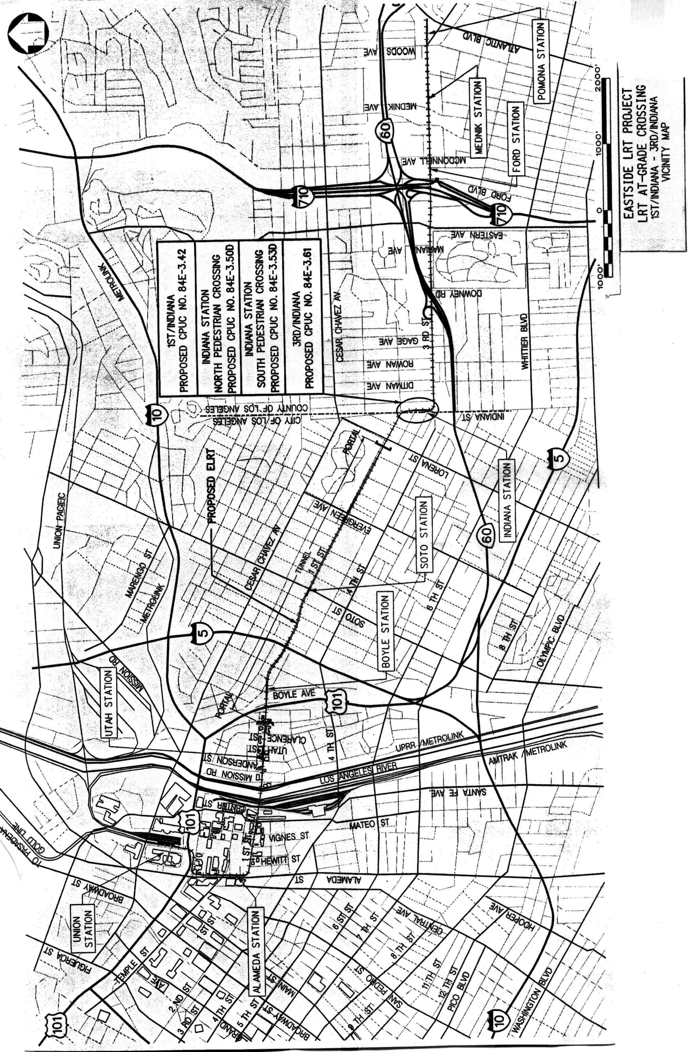
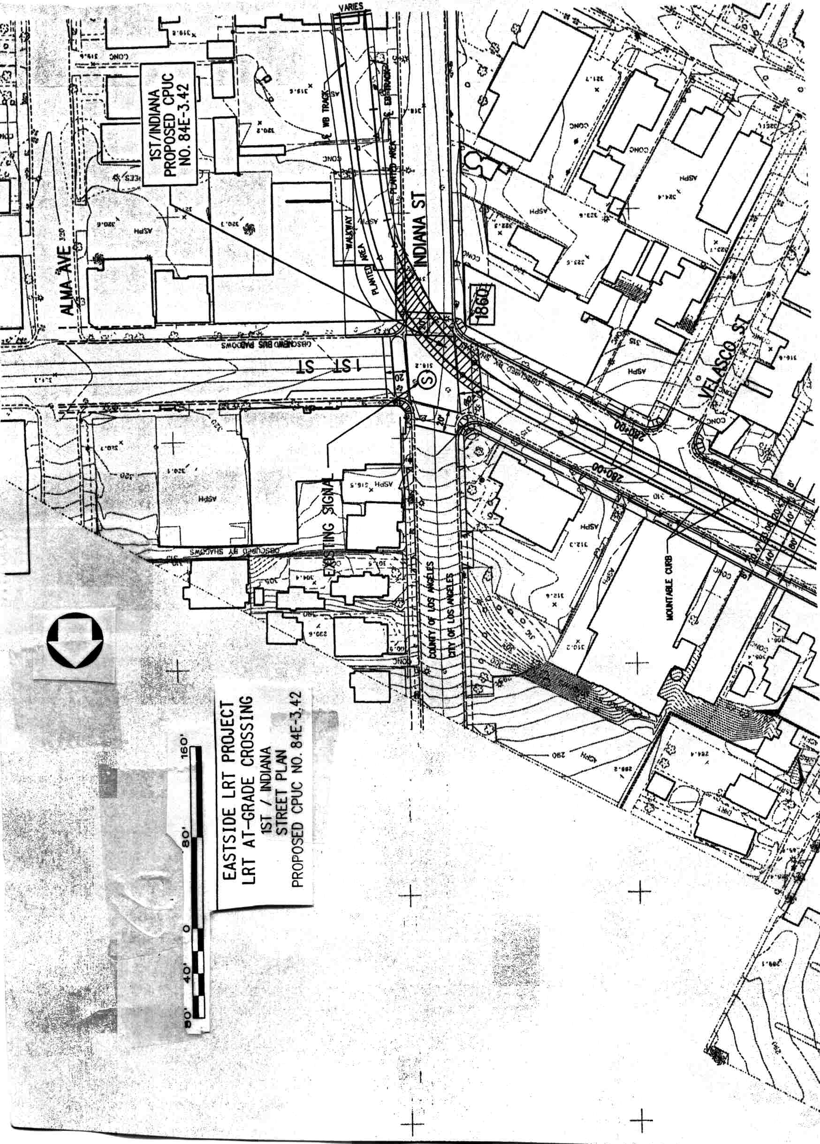
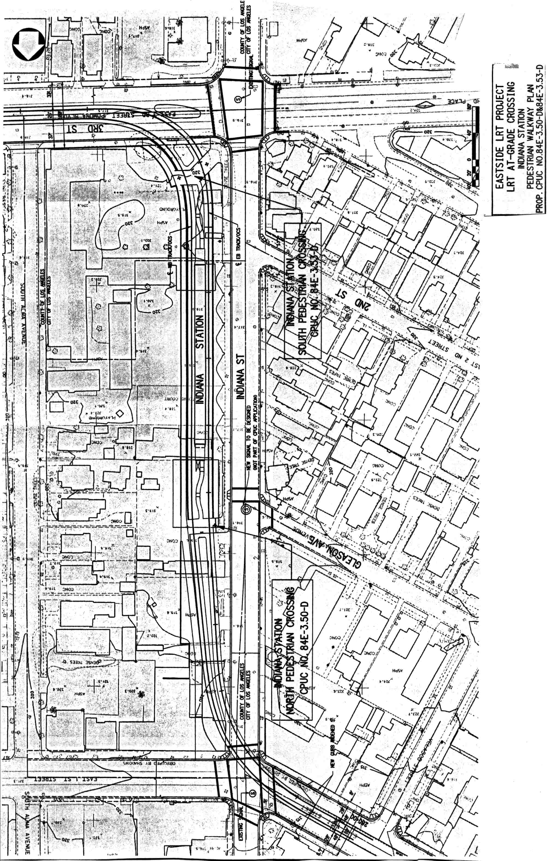
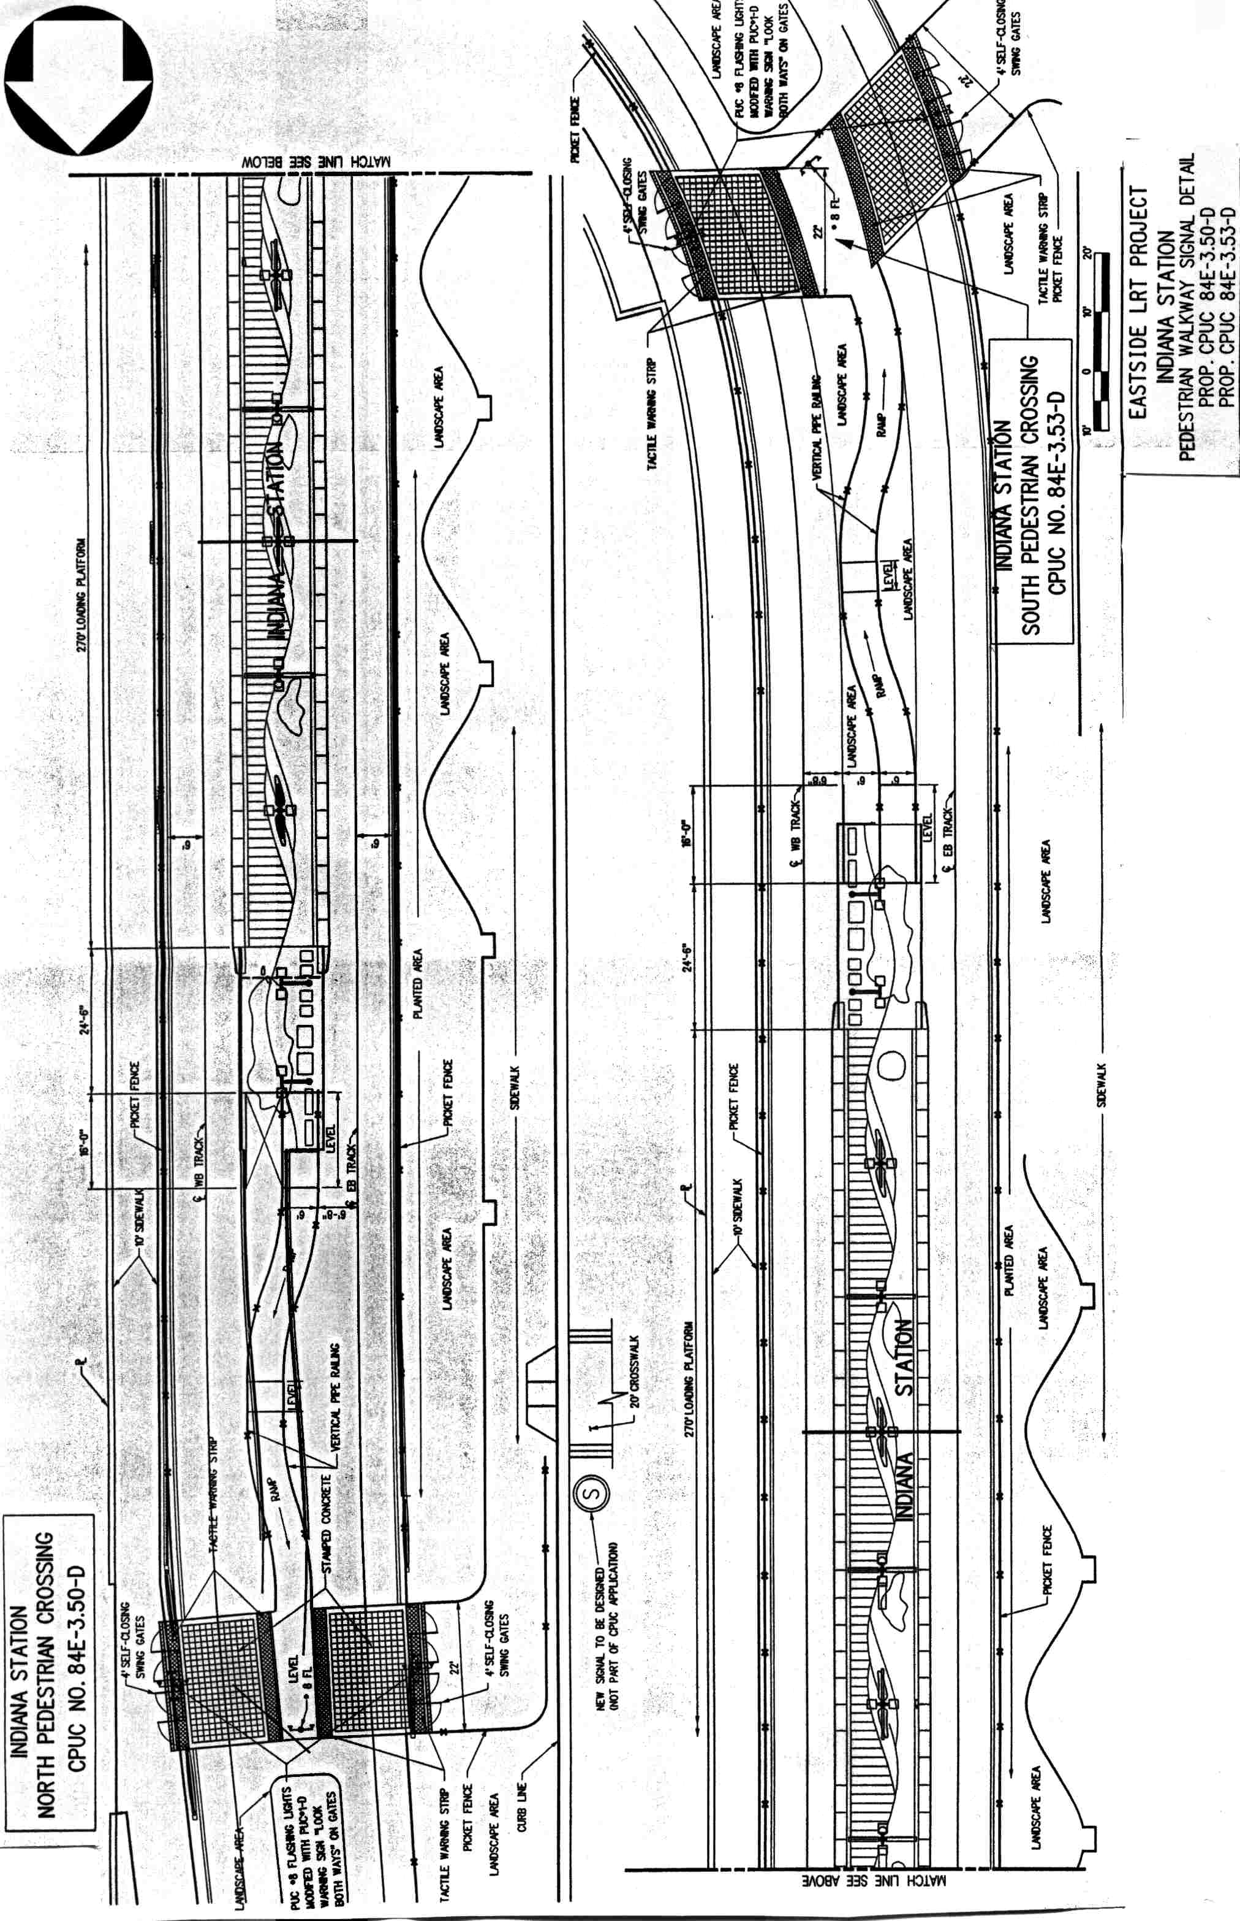
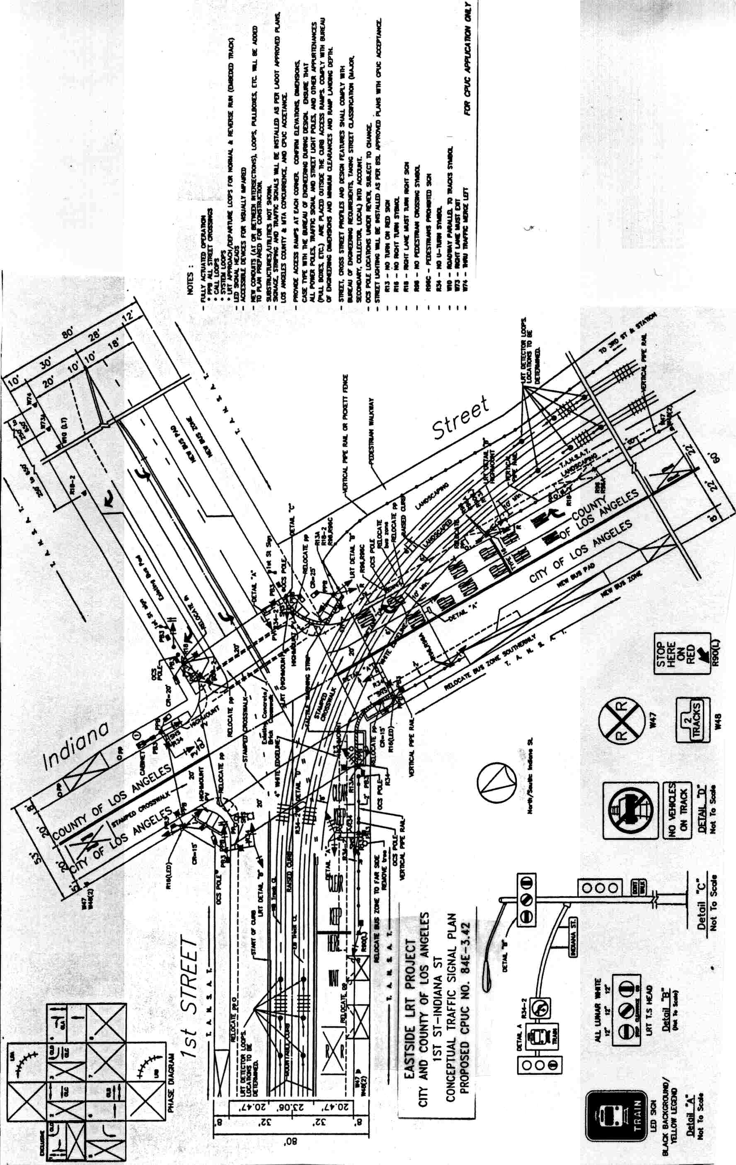
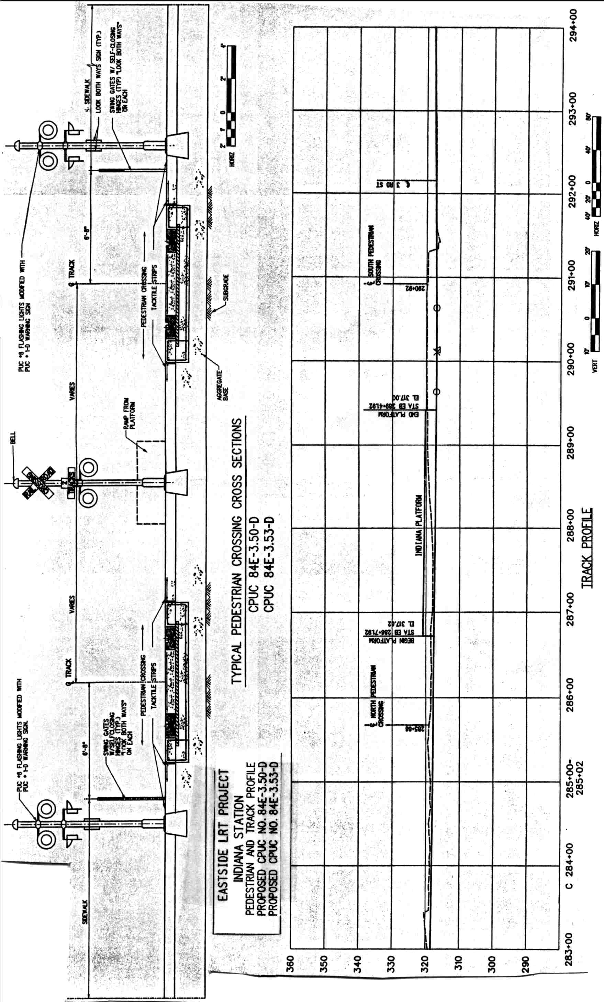
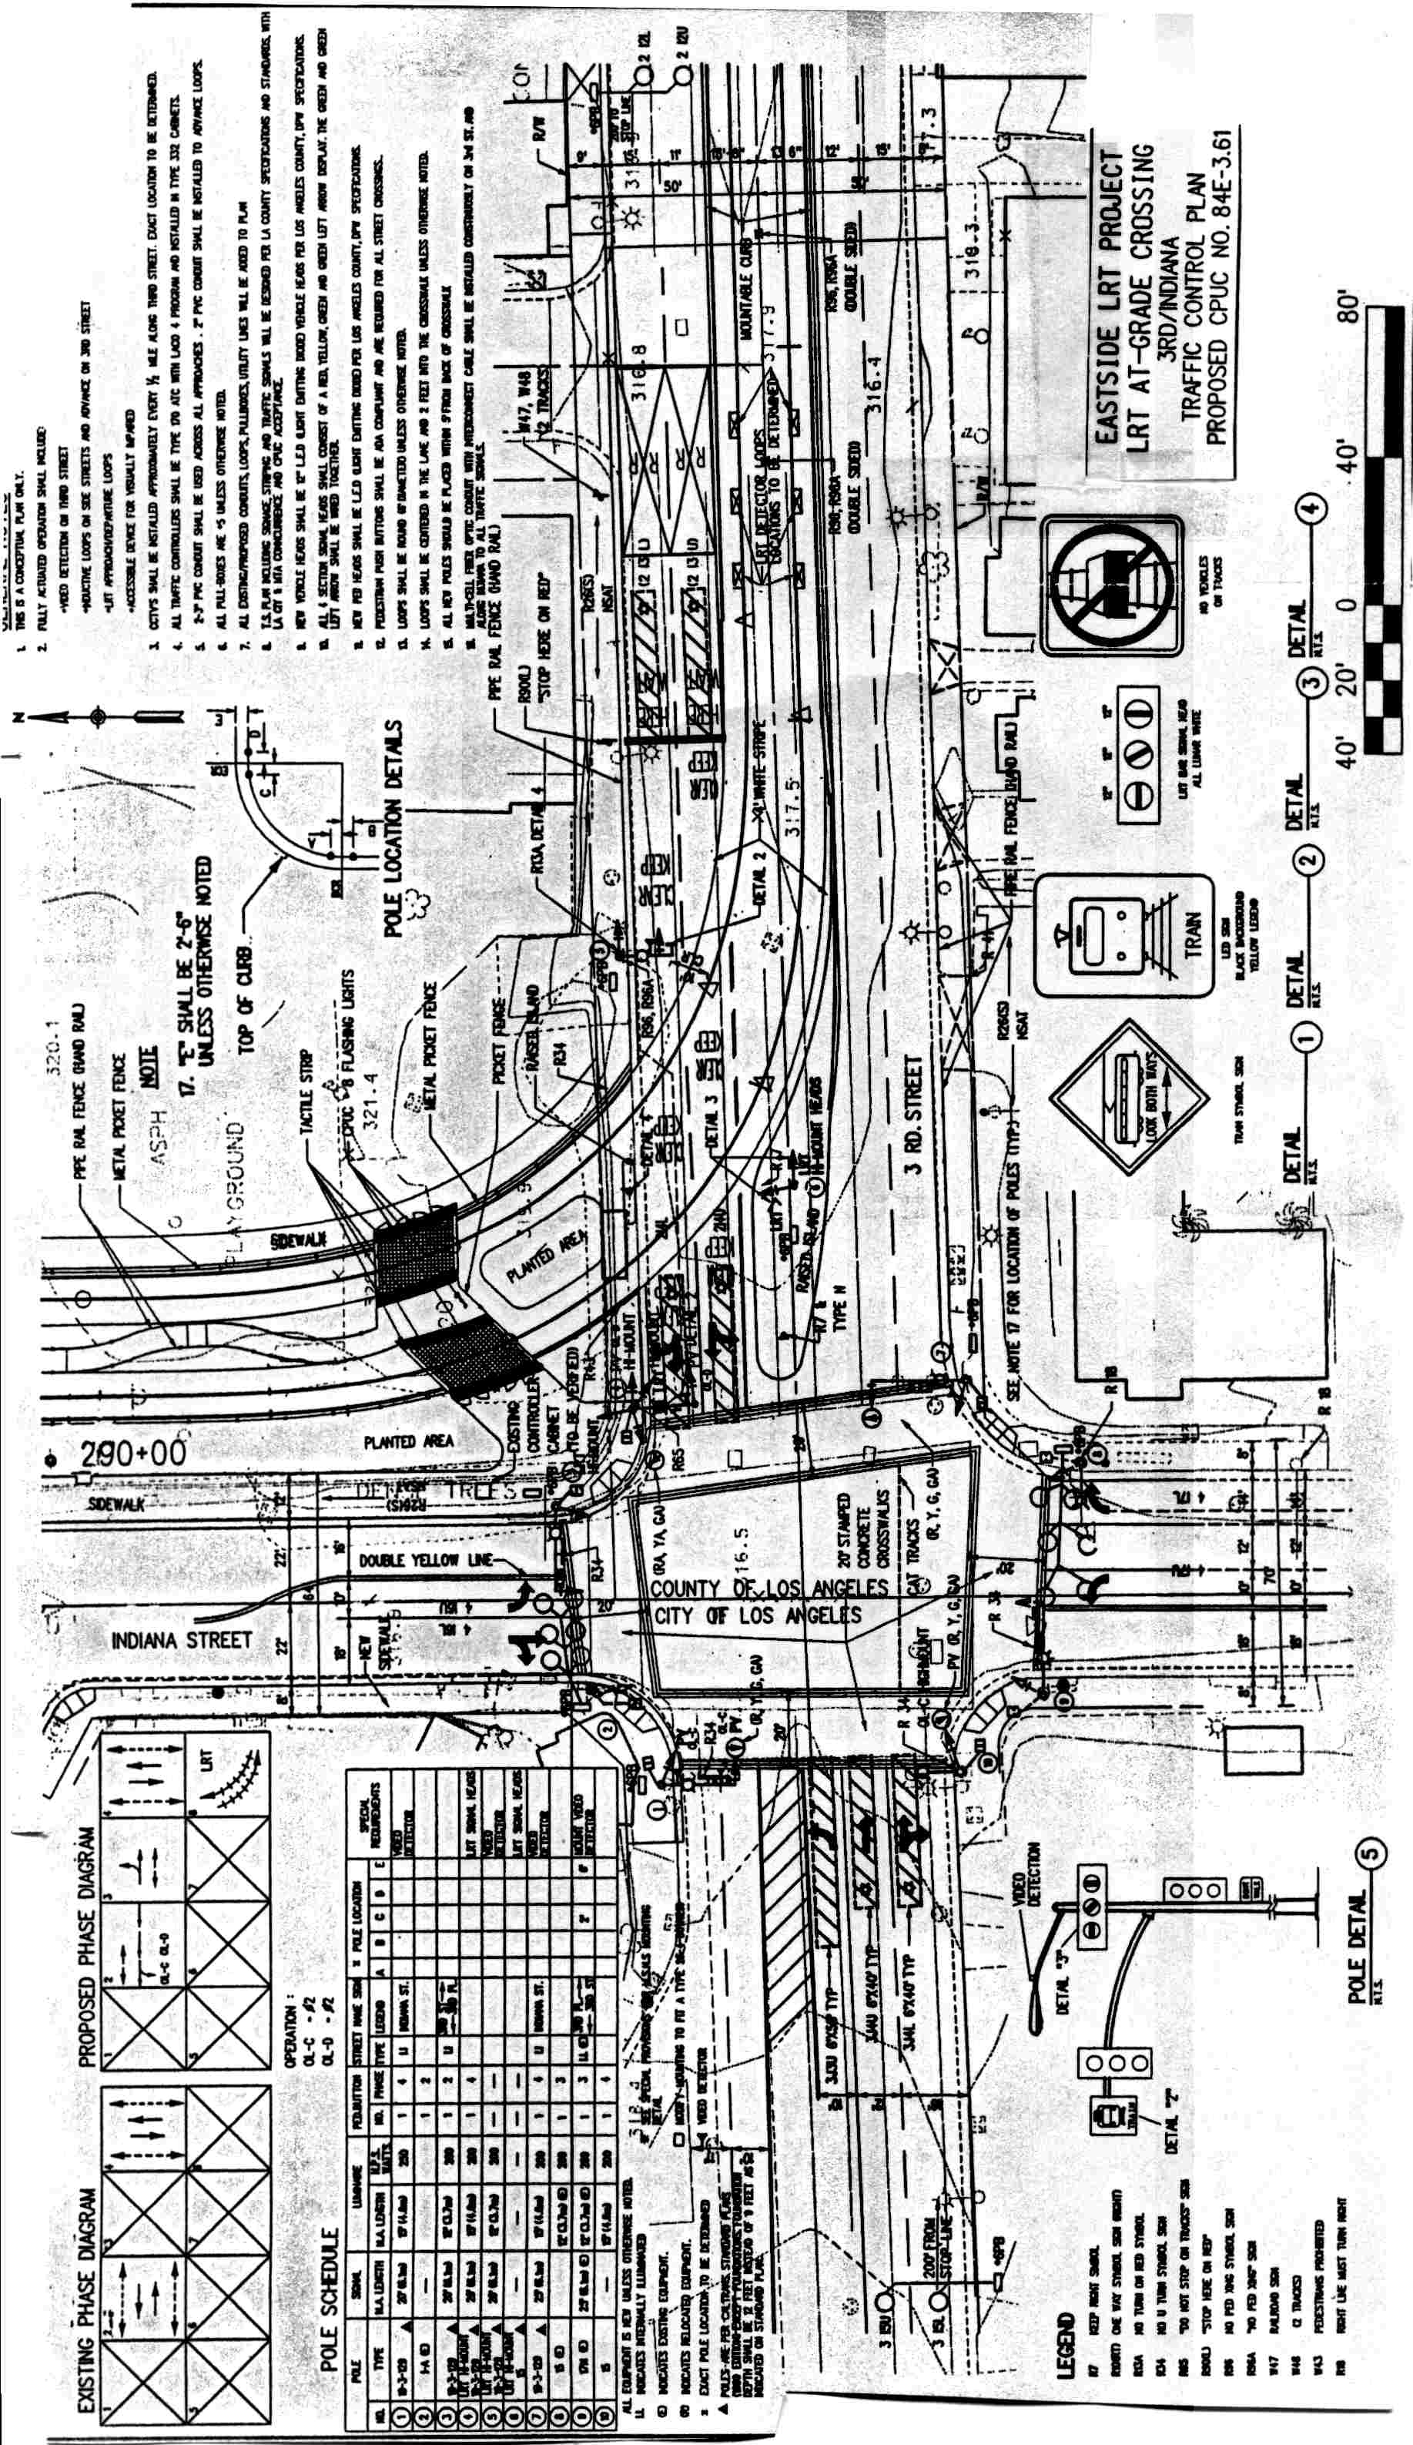
A P P E N D I X C
ENVIRONMENTAL DOCUMENTS

