CPSD/RWC/DAR/SH/vdl Mailed 8/30/05

Decision 05-08-019 August 25, 2005

BEFORE THE PUBLIC UTILITIES COMMISSION OF THE STATE OF CALIFORNIA

Application of ALAMEDA CORRIDOR – EAST CONSTRUCTION AUTHORITY for authority to eliminate two main line grade crossings over Union Pacific Railroad Company’s Alhambra subdivision; by construction of a grade separation and at-grade drill track at Sunset Avenue, addition of two tracks to an adjacent grade crossing at California Avenue and closure of Orange Avenue at the railroad, in the City of Industry, County of Los Angeles. | Application 04-09-013  (Filed September 10, 2004)

O P I N I O N

Summary
This decision grants Alameda Corridor – East Construction Authority’s (ACE) request for authority to alter the existing California Avenue at-grade highway-rail crossing (crossing) across Union Pacific Railroad Company’s (UP) Alhambra Subdivision main line track with the construction of one UP drill track and one detour track; to permanently close and physically remove the Orange Avenue crossing across UP’s main line track; to eliminate the existing Sunset Avenue crossing across UP’s main line track, by constructing a grade separation on a railroad bridge structure; and to construct a spur crossing at Sunset Avenue, north of the proposed grade separation, to accommodate the proposed UP drill track, in the City of Industry (City), Los Angeles County.

Discussion
ACE requests authority to eliminate the existing Sunset Avenue crossing across UP’s main line track by constructing a grade separation at the same location, to permanently close and physically remove the Orange Avenue crossing, to construct a spur crossing at Sunset Avenue to accommodate one proposed drill track, and to alter the California Avenue crossing with the addition of one detour track and the proposed drill track.
The project will divert over 90 percent of the current train movements at the existing Sunset Avenue crossing to the proposed grade separation. The proposed drill track will have an average of two round-trips per day, at 20 MPH. Train movements over the proposed altered California Avenue crossing will not change, except that local freight train movements will operate over the proposed drill track. The public benefit of eliminating main line train movements at Sunset Avenue and all train movements at Orange Avenue is the reduction in the hazard of train-vehicle collisions and in delays to motorists and pedestrians due to train movements.
The construction of the Sunset Avenue grade separation and the permanent closure and physical removal of the Orange Avenue crossing are among many ACE projects that will reduce or eliminate train traffic – motor vehicle traffic conflicts in the San Gabriel Valley area of Los Angeles County. ACE’s program includes projects at 54 public crossings and the elimination of 20 crossings through construction of grade separations (including the Sunset Avenue grade separation) and roadway closures (including the Orange Avenue crossing).
UP’s Alhambra Subdivision main line has approximately 30 freight trains per day. The main line also is the route of Amtrak’s intercontinental “Sunset Limited” passenger train with an average of one train per day. Main line freight trains and passenger trains have allowable timetable speeds of 60 MPH and 65 MPH, respectively.
The proposed Sunset Avenue grade separation will consist of a bridge structure adjacent to railroad embankments with lengths of 4,900 feet and 2,000 feet, northwest and southeast, respectively, of the grade separation. The railroad embankments leading to the bridge structure will have retaining walls. The railroad embankments and the bridge structure will provide width for walkways as required under Commission General Order (GO) 118. To protect railroad personnel from falls on walkways, the retaining walls and the bridge structure will have guard rails. ACE designed the railroad embankments and bridge structure to provide adequate cross-sectional width for UP’s future construction of a second main line track.
The construction of the embankment northwest of the Sunset Avenue grade separation will disconnect the existing lead track that connects the main line track to ten active spur tracks. To maintain rail service to the ten spur tracks, UP’s proposed drill track will reconnect the spur tracks to the main line track. The proposed drill track will be at-grade and will travel through both the proposed Sunset Avenue spur crossing and the proposed altered California Avenue crossing.
During construction of the Sunset Avenue grade separation, UP will construct the detour track to divert main line train movements from UP’s existing main line track, which will be out-of-service in the project area. UP will construct the detour track south of the embankments. Construction will require a temporary construction easement within Valley Boulevard to maintain clearances around the detour track. ACE and the City will reduce the width of Valley Boulevard, for a distance of approximately one mile, by one lane, between 4th Avenue and 8th Avenue, during the construction, use, and removal of the detour track. ACE and the City will use K-rail barriers, topped with a six-foot-high chain-link fence, to effect lane closure and to minimize encroachments into the detour track area. After UP relocates train movements to the realigned main line track on the new bridge structure, UP will remove the detour track and ACE and the City will restore Valley Boulevard to its original width.
ACE proposes to alter the existing California Avenue crossing to accommodate the proposed drill track and the proposed detour track, which UP will construct north and south, respectively, of the existing main line track, through the California Avenue crossing. The existing Sunset Avenue and Orange Avenue crossings will remain open and serve as vehicular traffic detours during the California Avenue crossing alteration.
The warning devices at the existing California Avenue crossing consist of two CPUC Standard No. 9s (flashing light signals with automatic gates, as defined in GO 75-C). ACE and UP will relocate both Standard No. 9 warning devices to accommodate the two additional tracks. ACE, UP, and the City will ensure that the advance warning time at the reopened California Avenue crossing and the traffic signal preemption time and phasing at the adjacent intersection of California Avenue and Valley Boulevard comply with GO 75-C and the American Railway Engineering and Maintenance of Way Association Communications and Signals Manual.
The California Avenue crossing alteration will include reconfiguration of the adjacent Valley Boulevard and California Avenue intersection. ACE and the City will improve the California Avenue roadway profile and level the roadway approaches to the California Avenue crossing in both directions. ACE and the City also will install new asphalt pavement, sidewalk, curb, gutter, signage, and striping.
ACE proposes to remove the detour track after UP resumes operations on the existing main line track. However, the portion of the detour track alignment within the altered California Avenue crossing will remain in place to accommodate UP’s future second main line track.
ACE claims that ACE, UP, and the City would need to alter the California Avenue crossing two additional times if UP removed the detour track and then added a second UP main line track in the future. Both alterations would require relocation of the warning devices and would result in significant costs and traffic disruption.
Upon the completion of the California Avenue crossing alteration, ACE, UP, and the City will reopen California Avenue to vehicular traffic and pedestrians, close Sunset Avenue temporarily to physically remove the Sunset Avenue crossing and to construct the grade separation and spur crossing, and to permanently close and physically remove the Orange Avenue crossing. During a later phase of the project, ACE and the City will build a cul-de-sac at the end of Orange Avenue, north of the tracks, to facilitate U-turns. The Orange Avenue cul-de-sac will have a barrier and fencing to minimize encroachment and trespassing onto the railroad right-of-way. ACE, UP, and the City will establish a temporary construction easement and work area traffic control along Valley Boulevard to allow construction of the proposed drill track and the proposed detour track.
As a result of the proposed drill track, ACE proposes to construct a new spur crossing at Sunset Avenue. The spur crossing warning devices will consist of two CPUC Standard No. 9s and two median-mounted CPUC Standard No. 9s. ACE, UP, and the City will electrically interconnect the traffic signals at the Sunset Avenue and Valley Boulevard intersection to the warning devices to provide railroad preemption of the traffic signals. ACE and UP will locate the warning devices for northbound Sunset Avenue north of the Sunset Avenue and Valley Boulevard intersection and south of the bridge structure to enhance the visibility of these warning devices for motorists and pedestrians. A raised center median will remain installed on Sunset Avenue between Valley Boulevard and Nelson Avenue, except where the proposed drill track will intersect with the median area.
Upon completion of the Sunset Avenue grade separation and spur crossing, removal of the detour track, and restoration of the pavement within Sunset Avenue and Valley Boulevard, ACE and the City will reopen Sunset Avenue and its intersection with Valley Boulevard to vehicular traffic and pedestrians.
The State of California, Department of Transportation (Caltrans) is the lead agency for this project under the California Environmental Quality Act of 1970 (CEQA, as amended in 1982) as stated in Public Resources Code Section 21000 et seq. On May 12, 2004, Caltrans determined that the project is categorically exempt under CEQA (CEQA Guideline Section 15301). CEQA Guideline Section 15301, “Existing Facilities,” lists Class 1 categorical exemptions and states “Class 1 consists of the operation, repair, maintenance, permitting, leasing, licensing, or minor alteration of existing public or private structures, facilities, mechanical equipment, or topographical features, involving negligible or no expansion of use beyond that existing at the time of the lead agency's determination.” CEQA Guideline Section 15301(c) specifies as Class 1 categorical exemptions, “Existing highways and streets, sidewalks, gutters, bicycle and pedestrian trails, and similar facilities (this includes road grading for the purpose of public safety).” Caltrans also determined that this project was exempt under the National Environmental Protection Act (NEPA) guidelines on May 12, 2004. Attached to the order in Appendix A is a copy of the Categorical Exemption.
The Commission is a responsible agency for this project under CEQA. CEQA requires that the Commission consider that portion of the environmental consequences of a project within its area of expertise that is subject to its discretionary approval.
We reviewed the lead agency’s Categorical Exemption and Programmatic Categorical Exclusion determinations. We are not aware of any information that would suggest Caltrans’ exemption and exclusion classifications were inappropriate in this instance. We find that Caltrans’ CEQA Categorical Exemption and NEPA Programmatic Categorical Exclusion determinations are adequate for our decision-making purposes. We adopt the lead agency’s findings of Categorical Exemption and Programmatic Categorical Exclusion for purposes of our project approval.
The Commission’s Consumer Protection and Safety Division – Rail Crossings Engineering Section (RCES) inspected the sites of the proposed project. After reviewing the need for and the safety of the proposed project, RCES recommends that the Commission grant ACE’s request.
The Application is in compliance with the Commission’s filing requirements, including Rules 39 and 40 of Rules of Practice and Procedure, which relate, respectively, to the widening or relocation of an existing crossing and to the construction of a railroad track across a public highway. Shown in Appendix B, attached to the order, are the crossing project plans.
Categorization and Need for Hearings
In Resolution ALJ 176-3139, dated September 23, 2004, and published in the Commission Daily Calendar on September 24, 2004, the Commission preliminarily categorized this Application as ratesetting, and preliminarily determined that hearings were not necessary. Since no protests were filed, these preliminary determinations remain correct. Given these developments, it is not necessary to revise the preliminary determinations made in Resolution ALJ 176-3139.
Waiver of Comment Period
This Application is an uncontested matter in which the decision grants the relief requested. Accordingly, pursuant to Public Utilities Code Section 311(g)(2), we waive the otherwise applicable 30-day period for public review and comment.
Assignment of Proceeding
Richard Clark is the assigned Examiner in this proceeding.
Findings of Fact
- The Commission published Notice of the Application in the Commission’s Daily Calendar on September 14, 2004. There are no unresolved matters or protests; a public hearing is not necessary.
- ACE requests authority, under Public Utilities Code Section 1201-1205, to eliminate the existing Sunset Avenue crossing across UP’s main line track by constructing a grade separation; to permanently close and physically remove the Orange Avenue crossing; to construct the Sunset Avenue spur crossing, north of the proposed grade separation, to accommodate one proposed drill track; and to alter the California Avenue crossing with the addition of the proposed drill track and one detour track; in the City, Los Angeles County.
- Public convenience, necessity, and safety require construction of the proposed Sunset Avenue grade separation.
- Public necessity and safety require, upon the reopening of the California Avenue crossing to vehicular traffic and pedestrians, the permanent closure and physical removal of the Orange Avenue crossing.
- Caltrans is the lead agency for this project under CEQA, as amended.
- Caltrans prepared a Categorical Exemption and Categorical Exclusion document for this project. On May 12, 2004, Caltrans determined that the project is categorically exempt under CEQA (CEQA Guideline Section 15301, which lists projects with a Class 1 categorical exemption). On May 12, 2004, Caltrans also determined that this project was exempt under the NEPA guidelines.
- The Commission is a responsible agency for this project and has reviewed and considered the lead agency’s Categorical Exemption and Programmatic Categorical Exclusion determinations.
Conclusions of Law
- The lead agency reasonably concluded that the project will not have a significant effect on the environment under CEQA. We adopt the lead agency’s CEQA Categorical Exemption and NEPA Programmatic Categorical Exclusion determinations for purposes of our approval.
- The Application is uncontested and a public hearing is not necessary.
- The Application should be granted as set forth in the following order.
ORDER

IT IS ORDERED that:
- Alameda Corridor – East Construction Authority (ACE) is authorized to alter the existing California Avenue at-grade highway-rail crossing (crossing), CPUC Crossing No. 001B-499.60, across the Union Pacific Railroad Company’s (UP) Alhambra Subdivision main line track with the construction of one drill track and one detour track; to eliminate the existing Sunset Avenue crossing across UP’s main line track by constructing a grade separation at Sunset Avenue on a railroad bridge structure to be referred as CPUC No. 001B-499.20-B; and to construct a spur crossing of UP’s proposed drill track across Sunset Avenue to be referred to as CPUC No. 001B-499.20-C, all in the City of Industry (City), Los Angeles County, at the locations shown by plans attached to the Application, and in Appendix B attached to this order.
- Prior to commencing the construction of the proposed drill track and detour track across the California Avenue crossing, ACE, UP, and the City (parties) shall close the crossing. Upon completion of the construction, the parties are authorized to reopen the crossing to vehicular traffic and pedestrians. The warning devices at the reopened crossing shall be two CPUC Standard No. 9s (flashing light signals with automatic gates, as defined in Commission General Order (GO) 75-C), which shall accommodate the drill track, main line track, and detour track.
- The parties shall ensure that the advance warning time at the reopened California Avenue crossing and the traffic signal preemption time and phasing at the intersection of California Avenue and Valley Boulevard comply with GO 75-C and the American Railway Engineering and Maintenance of Way Association Communications and Signals Manual.
- ACE and UP are authorized to leave in place the detour track alignment only within the reopened California Avenue crossing, to become part of a future second main line track.
- Upon the reopening of the California Avenue crossing, the parties shall permanently close and physically remove the existing Orange Avenue crossing, shall construct a cul-de-sac with a barrier and fencing along the cul-de-sac perimeter at the end of Orange Avenue north of UP’s right-of-way, and shall close and physically remove the existing Sunset Avenue crossing. Upon the closure of the Orange Avenue and Sunset Avenue crossings, ACE and UP are authorized to construct the drill track and detour track within UP’s right-of-way across the closed portions of Orange Avenue and Sunset Avenue.
- Upon the completion of the Sunset Avenue grade separation bridge structure and its opening to trains onto the realigned main line track, the completion of construction of the Sunset Avenue spur crossing, and the removal of the detour track across Sunset Avenue, the parties are authorized to reopen Sunset Avenue to vehicular traffic and pedestrians. The warning devices at Sunset Avenue spur crossing shall be two CPUC Standard No. 9s and two median-mounted CPUC Standard No. 9s. ACE and UP are authorized to construct the bridge structure to provide adequate cross-sectional width for UP’s future construction of a second main line track.
- The parties shall bear construction and maintenance costs in accordance with an agreement between the parties. Should the parties fail to agree, the Commission will apportion the costs of construction and maintenance by further order.
- Within 30 days after completion of the work under this order, UP shall notify the Commission’s Consumer Protection and Safety Division - Rail Crossings Engineering Section (RCES) in writing, by submitting a completed standard Commission Form G (Report of Changes at Highway Grade Crossings and Separations) of the completion of the authorized work.
- Prior to constructing the second main line track and connecting it to the detour track alignment left remaining within the California Avenue crossing, UP shall submit a GO 88-B request letter to RCES for authorization.
- This authorization shall expire if not exercised within three years unless the Commission extends the time or if the parties do not comply with the above conditions. The Commission may revoke or modify authorization if public convenience, necessity, or safety so require.
- The Application is granted as set forth above.
- Application 04-09-013 is closed.
This order becomes effective 30 days from today.
Dated August 25, 2005, at San Francisco, California.

MICHAEL R. PEEVEY
President
GEOFFREY F. BROWN
SUSAN P. KENNEDY
DIAN M. GRUENEICH
JOHN A. BOHN
Commissioners
A P P E N D I X A
ENVIRONMENTAL DOCUMENT
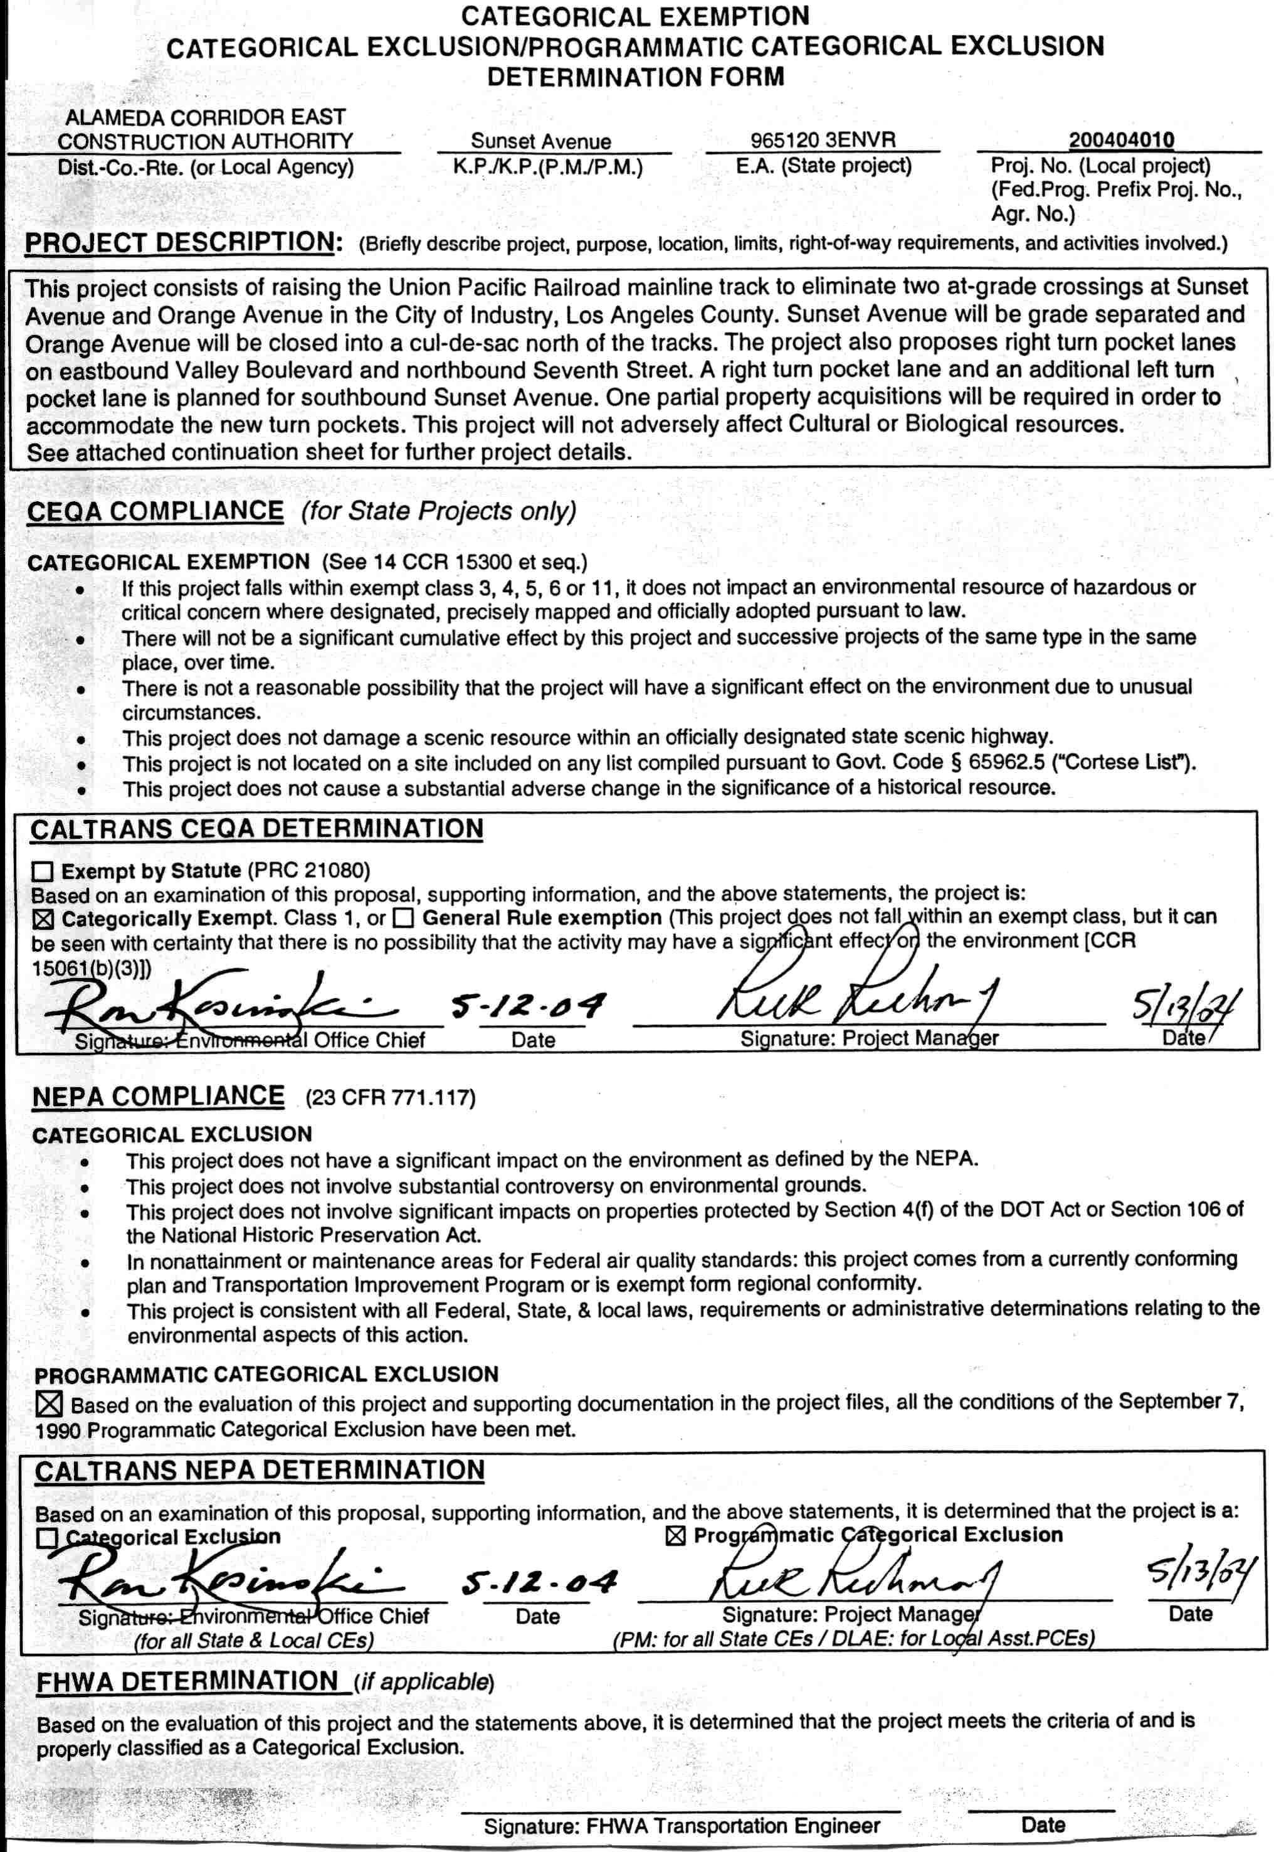
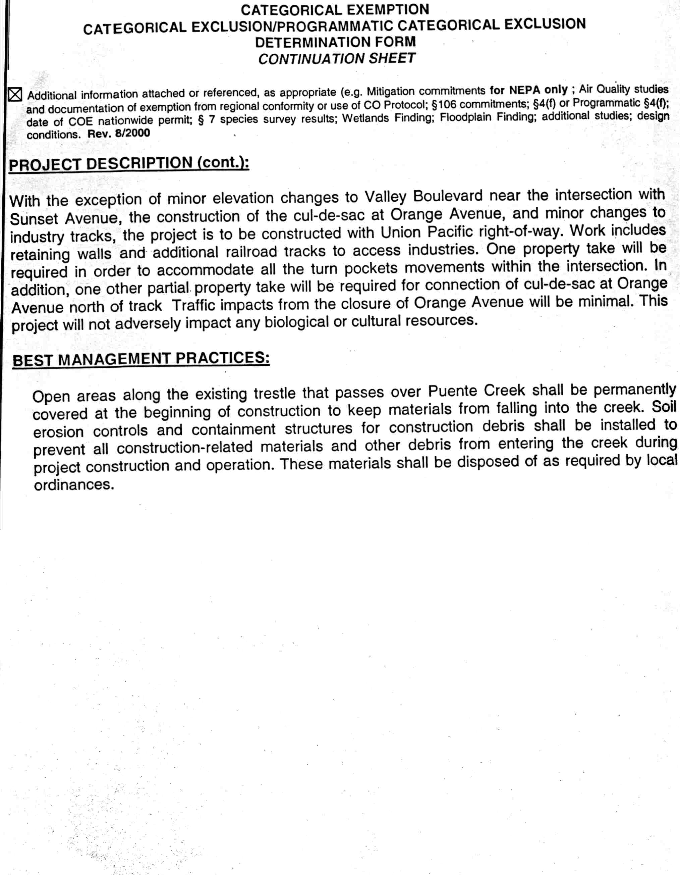

A P P E N D I X B
PLANS
